University of La Salette, Inc. - College of Information Technology
PFEBSIT 002 Integrative Programming and Technologies 2

Lost-and-Found Matching System
Week 17 - SA9: Solution Evaluation, User Acceptance Testing and API Documentation (Project 18)
Representative controlled scenarios, findings and dispositions, retests of the fixes, and the OpenAPI documentation.
Field | Entry
Student name | [Your full name]
ID number | [Your ID number]
Class section | [Your section]
Builds on | Weeks 13-16
Result | 14 of 14 scripted acceptance scenarios pass after fixes (13 before); 13 findings: 9 fixed and retested, 4 deferred with reasons
Data | Fictional, controlled data only

1. Summary
- User acceptance testing was run in two ways against the real system: a hands-on session in a real browser (sign-in, filing reports, reviewing and verifying a match) and a repeatable script of 14 scenarios (41 steps) run against a live server process, covering the cases that are impractical to click through (lockout, delivery failure and recovery, aging, two claimants, access control).
- Before any fix the scripted run passed 13 of 14 scenarios (40 of 41 steps). After the fixes it passes 14 of 14 (41 of 41).
- The hands-on session found the most important problems: the person verifying ownership could not see the two items on the Matches screen (F1), and a single click verified or refused a claim with an invented note (F2). The scripted run found that generic shared words created false candidates (F3). The retest found two more problems that only real use could reveal: a decision silently lost when the layout changed (F8) and stale app code served after a deploy (F9).
- Nine findings were fixed and retested; four low-severity items were deferred with reasons. The API is now fully documented in OpenAPI 3, and tests prove that the document matches the running API in both directions (a deliberate-error check caught 8 of 8 mistakes).
- Honest scope: the testing was done by the developer playing the roles, not by independent users. Section 8 lists what that does and does not show, and section 9 provides a sign-off sheet for the people who must actually accept the system.

2. Approach and Environment
Item | Detail
Personas (controlled test accounts) | Student stu1 and stu2, employee emp1, security officer sec1, custodian cust1. All fictional; passwords are test-only values in the seed file.
Method A: hands-on session | Real Chrome-based browser pane driving the Flutter Web app served by the reference static host, talking to the API over HTTP on localhost (the HTTPS path was verified in Weeks 14 and 16). Observations were recorded with screenshots.
Method B: scripted scenarios | uat/run-uat.js starts a fresh API process, signs in as each persona and checks expected against actual for each step; results are saved as JSON and Markdown (docs/w17/uat-results-*.json/.md).
Before / after | The "before" scripted run was reproduced on the original behaviour by temporarily disabling the new matching rule; the "after" run uses the final code. The UI findings have before/after screenshots.
Pass criteria | Each scenario lists acceptance criteria (section 3); a scenario passes only if every step matches its expected result.
Environment | Windows 11, Node 20.10, Flutter stable; dev mode; simulated instant notification channel.

3. Scenarios and Acceptance Criteria
ID | Scenario | Persona | Acceptance criteria
UAT-01 | Sign-in, wrong password, lockout and sign-out | Any user | Valid users reach their role; errors do not reveal whether the user exists; repeated failures lock the account; sign-out ends the session
UAT-02 | Student reports a lost item (validation and success) | Student (stu1) | Invalid input is explained field by field; a valid report is accepted and visible only to its owner and staff
UAT-03 | Security officer reports a matching found item | Security officer (sec1) | A found item that resembles an open lost item creates exactly one candidate match and notifies the owner
UAT-04 | Student sees the match and notification | Student (stu1) | The owner is told a candidate exists without seeing the finder or the found item's identifier
UAT-05 | Custodian verifies ownership and releases the item | Custodian (cust1) | Release is impossible before verification; after release both reports are closed and the owner sees the outcome; every step is audited
UAT-06 | Duplicate and different reports | Student (stu2) | Re-submitting the same report is refused with a pointer to the original; a different item is accepted
UAT-07 | People cannot do or see what their role does not allow | Student, anonymous | Staff functions and other people's data are not available to students; missing or forged identity is refused
UAT-08 | A notification that cannot be delivered reaches a human | Security officer, custodian | A permanent delivery failure creates a manual-queue item; the custodian can re-send and the item resolves
UAT-09 | A temporary delivery problem fixes itself | Security officer | A transient failure is retried automatically and no staff action is needed
UAT-10 | Staff cannot decide a match for their own lost item | Security officer (sec1) and custodian | A staff member who lost something cannot verify or release its match; another staff member can
UAT-11 | Wrong claimant rejected; one item, two claimants | Custodian, two students | Rejecting a match leaves the reports open; an item can only be released to one person
UAT-12 | Unrelated items are not matched; brief descriptions still are | Security officer | Different categories or generic shared words (a colour, "tag") do not create a candidate; a short lost description still matches a detailed found one
UAT-13 | Unclaimed items: reminder then disposal review | Custodian | At 30 days one reminder is raised; at 90 days a disposal review appears; the custodian can dispose; nothing repeats
UAT-14 | Forged or expired sign-in is refused | Any | A tampered token is rejected and never grants a higher role
Hands-on (UI) observations used the same ids where the scenario is the same journey: UAT-01 sign-in failure and sign-out, UAT-02 report with validation, UAT-03 found report, UAT-05 review, verify and release, UAT-06 notifications and reports lists, UAT-12 phone width, UAT-13 first load.

4. Results

4.1 Scripted scenarios, before and after the fixes
ID | Scenario | Steps | Before | After
UAT-01 | Sign-in, wrong password, lockout and sign-out | 7 | PASS | PASS
UAT-02 | Student reports a lost item (validation and success) | 3 | PASS | PASS
UAT-03 | Security officer reports a matching found item | 1 | PASS | PASS
UAT-04 | Student sees the match and notification | 2 | PASS | PASS
UAT-05 | Custodian verifies ownership and releases the item | 5 | PASS | PASS
UAT-06 | Duplicate and different reports | 2 | PASS | PASS
UAT-07 | People cannot do or see what their role does not allow | 4 | PASS | PASS
UAT-08 | A notification that cannot be delivered reaches a human | 2 | PASS | PASS
UAT-09 | A temporary delivery problem fixes itself | 1 | PASS | PASS
UAT-10 | Staff cannot decide a match for their own lost item | 2 | PASS | PASS
UAT-11 | Wrong claimant rejected; one item, two claimants | 4 | PASS | PASS
UAT-12 | Unrelated items are not matched; brief descriptions still are | 4 | FAIL (1 step) | PASS
UAT-13 | Unclaimed items: reminder then disposal review | 3 | PASS | PASS
UAT-14 | Forged or expired sign-in is refused | 1 | PASS | PASS
The one failing step before the fixes: UAT-12, "found keys sharing only generic words ("blue", "tag") are NOT a candidate for the silver house keys": matched lost reports: R-0005 (score 66), R-0007 (score 80).

4.2 Hands-on session in a real browser
Scenario | What was done | Observed | Result
UAT-01 | Signed in with a wrong password; later correctly; signed out | Clear message "Invalid user ID or password"; "You have been signed out" notice | Pass
UAT-02 | Submitted an empty report form, then a real lost-wallet report as a student | Field messages under both fields; report R-0001 accepted; form cleared. Confirmation banner is shown only for the 4-second default (F7), easy to miss | Pass with finding
UAT-03 | As security officer, filed the matching found wallet | Accepted; server created match M-0003 (score 82) and a delivered notification. A developer "Demo" panel was visible to everyone (F5) | Pass with finding
UAT-05 | As custodian: opened Matches, verified, released | Match card showed only ids (F1); one click verified with no dialog (F2); item released and both reports closed | Works; two High findings
UAT-06 | Opened Notifications and Reports | Notification text "N-0004 candidate_match, attempts: 1" (F4); Reports list correct but unfiltered (F10) | Pass with findings
UAT-12 | Phone-width window | Layout switched to bottom navigation; screenshots too small to judge legibility (F13) | Inconclusive
UAT-13 | First visit to the site | Blank white page for several seconds (F6) | Finding
Note on tester error: the text of report R-0001 was garbled ("black leather wallet with student black leather wallet ...") only because I typed into the same field twice while retrying; this is not an application defect.

5. Findings and Dispositions
Severity: High = blocks correct use or weakens the audit trail; Medium = causes mistakes, noise or confusion; Low = inconvenience. Dispositions are the tester's proposals; the "Approval" column must be completed by the instructor or product owner (section 9) - nothing here claims their sign-off.
ID | Severity | Finding | Found by | Disposition and fix | Status | Approval
F1 | High | The Matches screen showed only ids ("Lost report R-0001, Found report R-0002") and a score. The person verifying ownership could not compare the two items without leaving the screen. | UI, real browser (UAT-05) | Fix now: Match cards show both items side by side (description, place, date, reporter); staff see a plain status ("Needs verification"). API returns item summaries with each match. | Fixed | pending
F2 | High | Verify and Reject happened on one click with a fixed, invented note ("Ownership proof checked"), and Release had no confirmation. A mis-click changed state, and the audit trail did not record what was actually checked. | UI, real browser (UAT-05) | Fix now: Decision dialog shows both items and requires the proof (or the reason for refusing), 5-200 characters; the API rejects a decision without a note (422); Release asks for confirmation naming the claimant. | Fixed | pending
F3 | Medium | Weak candidates: a found "brass padlock key with blue tag" matched two unrelated lost keys (scores 66 and 80) because they shared generic words. Category plus date proximity already scores 49+, so one common word cleared the threshold of 50. | Scripted UAT-12 | Fix now: A candidate now needs at least half of the shorter description in the other (overlap coefficient 0.5). A brief lost description still matches a detailed found one (checked in the same scenario). | Fixed | pending
F4 | Medium | Notifications read "N-0004 candidate_match; Status: delivered, attempts: 1": internal ids and codes shown to ordinary users. | UI, real browser (UAT-06) | Fix now: Plain-language titles and states with a time ("Possible match found for your lost item"; "We could not reach you. Staff have been alerted."). Internal references only for staff. Notifications gained `createdAt`. | Fixed | pending
F5 | Medium | The "Demo: simulate notification delivery" panel was visible to every user, including students, in a release build. | UI, real browser (UAT-03) | Fix now: The panel is compiled in only with `--dart-define=DEMO_TOOLS=true`; the field is not sent otherwise (the server ignores it in production anyway). | Fixed | pending
F6 | Medium | On first load the page was blank white for several seconds with no sign of progress (the first visit downloads about 3.6 MB compressed). | UI, real browser (UAT-13) | Fix now: Loading screen with a spinner and a "taking longer than usual" message after 6 s; correct page title from the first moment. | Fixed | pending
F7 | Low | Success messages disappeared after the 4-second default; the submission confirmation was easy to miss (it was missed during testing). | UI, real browser (UAT-02/03) | Fix now: Messages stay 8 seconds and have a close button. | Fixed | pending
F8 | Medium | Found during the retest: if the layout changed (window resize or device rotation) while a decision dialog was open, the screen under it was rebuilt and the confirmed decision was silently dropped (nothing sent, nothing shown). | UI retest, real browser | Fix now: The action and its message no longer depend on the original widget still existing. | Fixed | pending
F9 | Medium | Found during the retest: the reference static host gave the (non-fingerprinted) app script a one-hour cache lifetime, so after a deploy browsers would run old app code against the new API for up to an hour. The browser really did show the old screen. | UI retest, real browser | Fix now: Always revalidate with an ETag (cheap 304), except renderer files; behaviour defined and tested as the specification for the real host. | Fixed | pending
F10 | Low | The Reports screen has no search, filter or sort (closed items are mixed with open ones). | UI (UAT-06) | Defer: Not needed for the pilot volume; the API already pages. | Open | pending
F11 | Low | Release records no handover detail (who collected the item, which ID was checked). | UI/process (UAT-05) | Defer: The proof note is recorded at verification; a handover record is a design extension. | Open | pending
F12 | Low | Sessions last 15 minutes with no warning or refresh; a user is told to sign in again only at the next action. | Design review | Defer: Short sessions are a deliberate security choice; refresh tokens belong with institutional sign-in. | Open | pending
F13 | Low | Phone-width legibility could not be judged from the small screenshots the browser pane produced; the app-bar title truncates. | UI (UAT-12) | Defer: An automated 400 px layout test shows no overflow and bottom navigation; check on a real phone with real users. | Open | pending

Not counted as findings: the first click after a page load or layout change was sometimes ignored while the browser was driven by automation, and keyboard input stopped reaching Flutter text fields late in the retest. Both look like properties of the automation of Flutter's canvas rather than application behaviour, and are recorded as a limitation of the retest (section 8).

6. Retest Evidence

6.1 Before and after in the browser
F6 - first load. Before: a blank page. After: a loading screen.

Before: blank page while the app downloads
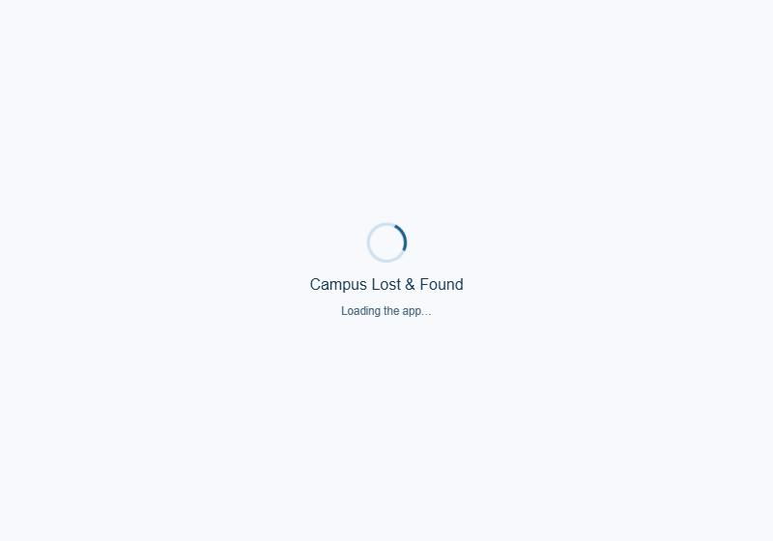
After: loading screen with a spinner
F1 - the Matches screen. Before: ids and a score only. After: both items side by side with reporter, place and date.
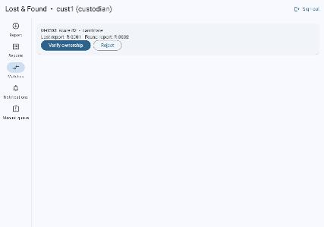
Before (custodian): ids only
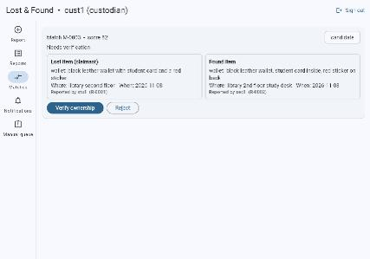
After (custodian): both items shown, status "Needs verification"
F2 - verifying ownership. After: a dialog that shows both items and refuses an empty proof note ("Write at least 5 characters").
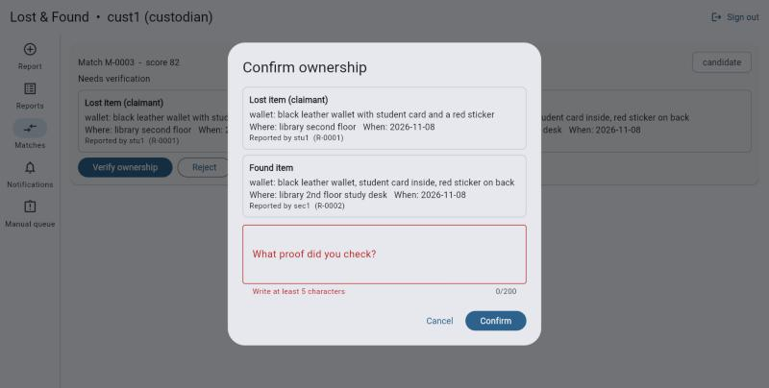
After: decision dialog requires the proof checked
F5 - the demo panel. Before: visible on the report form. After: gone.
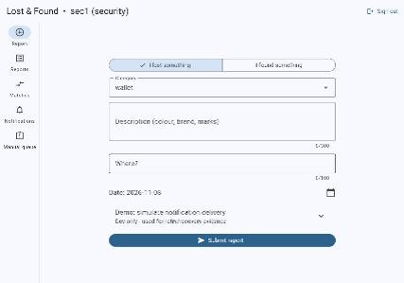
Before: "Demo: simulate notification delivery" visible
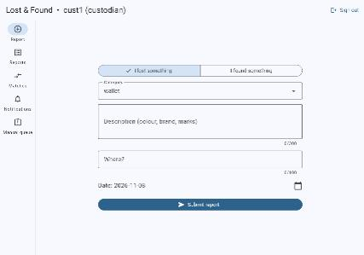
After: submit button directly under the date

6.2 Tests that lock the fixes in
Finding | Automated tests (all failed or were absent before the fix, pass now)
F1 | A05 (API match summaries and minimisation), U27 (staff see both items), U32 (owner sees only their own item in plain language)
F2 | A03, A04 (note required; stored trimmed), U28-U31 (dialog, validation, cancel posts nothing, release confirmation), contract C03
F3 | A01, A02 (boundary at exactly 50%), scripted UAT-12 before/after
F4 | A06 (createdAt), U33 (plain language; staff see references)
F5 | U34 (simulator hidden and never sent)
F6 | Visual retest (a loading screen is plain HTML, not covered by a Flutter widget test)
F7 | U35 (duration at least 6 s, dismissible)
F8 | U36 - proven to fail with the old code (the POST never happens) and pass with the fix
F9 | D01 (proven to fail with the old one-hour cache), D02-D04

6.3 Regression after all changes
Check | Result
Backend tests (functional, security, hardening, operability, performance, acceptance, contract, static host) | 95 of 95 pass (run twice before the static-host tests were added: 91 of 91 both times)
Flutter analyzer and tests | No issues; 37 of 37 tests pass
Scripted UAT, final code | 14 of 14 scenarios, 41 of 41 steps
Traceability gate | 32 requirements, 132 tests, no gaps
Dependency audit | 0 known vulnerabilities in runtime dependencies
Browser retest | F1, F2 (dialog and validation), F5, F6 verified visually. The final confirm, release and student-view steps could not be completed in the browser because automation stopped delivering keystrokes; those steps are covered by U29, U31-U33, U36 and by the scripted UAT against a live server (stated plainly so it is not mistaken for a full browser pass)
Two timing-based tests were found to be unreliable under CPU contention during this week (P01 event-loop stall, P07 speed at 10,000 reports) and were replaced by load-independent checks (counting calls to the blocking and non-blocking hash functions; the ratio of cost at two data sizes).

7. OpenAPI Documentation
The API is described by an OpenAPI 3.0.3 document: 20 operations and 24 schemas, with the role allowed for each operation, every documented response code (including the error envelope) and examples of the rules (for example the proof note, the conflict-of-interest refusal). It is served at GET /api/openapi.json and exported to docs/w17/openapi.yaml and openapi.json.
Method | Path | Roles | Responses | Purpose
GET | /health | anonymous | 200 | Liveness probe
GET | /ready | anonymous | 200 503 | Readiness probe
GET | /api/openapi.json | anonymous | 200 | This document
POST | /api/auth/login | anonymous | 200 400 401 413 422 429 500 | Sign in
GET | /api/auth/me | student, employee, security, custodian | 200 401 429 500 | Who am I
POST | /api/auth/logout | student, employee, security, custodian | 204 401 429 500 | Sign out (revoke this token)
GET | /api/reports | student, employee, security, custodian | 200 401 429 500 | List reports
POST | /api/reports | student, employee, security, custodian | 201 400 401 409 413 422 429 500 | Create a lost or found report
GET | /api/reports/{id} | student, employee, security, custodian | 200 401 404 429 500 | Get one report
GET | /api/matches | student, employee, security, custodian | 200 401 429 500 | List candidate matches
POST | /api/matches/{id}/verify | security, custodian | 200 400 401 403 404 409 413 422 429 500 | Verify ownership or refuse the claim
POST | /api/matches/{id}/release | security, custodian | 200 401 403 404 409 429 500 | Release the item to the verified owner
GET | /api/notifications | student, employee, security, custodian | 200 401 429 500 | List notifications
GET | /api/manual-queue | security, custodian | 200 401 403 429 500 | List items needing human action
POST | /api/manual-queue/{id}/resolve | security, custodian | 200 400 401 403 404 409 413 429 500 | Resolve a queue item
POST | /api/manual-queue/{id}/retry-notification | security, custodian | 200 401 403 404 409 429 500 | Re-send a failed notification
POST | /api/jobs/aging | custodian | 200 400 401 403 413 422 429 500 | Run the aging job now (custodian)
GET | /api/metrics | security, custodian | 200 401 403 429 500 | Operational metrics (staff)
GET | /api/logs | security, custodian | 200 401 403 429 500 | Recent structured log entries (staff)
GET | /api/audit | security, custodian | 200 401 403 429 500 | Audit trail of state changes (staff)

7.1 Example: verify a match
POST /api/matches/M-0003/verify
Authorization: Bearer <token>
Content-Type: application/json

{ "ownershipConfirmed": true, "note": "Student ID matched; described the red sticker" }

200 { "id": "M-0003", "status": "verified", "verifiedBy": "cust1", "note": "Student ID matched; ...", ... }
403 { "error": { "code": "CONFLICT_OF_INTEREST", "message": "You cannot decide a match for an item you reported" } }
409 { "error": { "code": "INVALID_STATE", ... } } 422 { "error": { "code": "VALIDATION_FAILED", "details": { "note": "..." } } }

7.2 How the document is kept honest
- C01: the document is valid OpenAPI 3 with resolvable references.
- C02: the set of documented operations equals the set of routes the server really has (nothing undocumented, nothing invented), and the document is served by the API.
- C03: through a full workflow (sign-in, report, match, notify, failure, re-send, verify, release, aging, disposal, metrics, sign-out, server error, not-ready), every real response, success and error, validates against the documented schema for its status code.
- C04: lockout and rate-limit (429) responses match the documented error schema.
- C05: every documented status code of every operation was produced by a test.
- C06: every operation except the four public ones documents bearer authentication and refuses a missing token with 401; staff-only operations refuse a student with 403 and operations documented as open to students do not (checked in both directions).
Mutation check (scripts/mutation-check-openapi.js): eight deliberate documentation errors were applied one at a time and each was caught by the contract tests:
CAUGHT Report.status loses "closed" (failing: C03, C05)
CAUGHT Report.status loses "disposed" (failing: C03, C05)
CAUGHT ClaimantMatch wrongly requires foundId (failing: C03, C05)
CAUGHT Match.score documented as string (failing: C03, C05)
CAUGHT /api/audit documented as open to students (failing: C06)
CAUGHT a phantom operation is documented (failing: C02, C05, C06)
CAUGHT 409 removed from the verify operation (failing: C03, C05)
CAUGHT Notification.attempts documented as boolean (failing: C03, C05)
8 of 8 deliberate documentation errors were caught.
The first version of the contract tests missed two of these: a status value (for example a closed report) that never appeared in any validated response, and roles checked in only one direction. Both gaps were found by this check and fixed, which is why the check exists.

8. Limits of this Evaluation
- Tester and developer are the same person playing the roles. This finds usability and logic problems but cannot show that real students, officers and custodians would accept the system. Section 9 is the real acceptance step.
- No independent timing of tasks, no satisfaction measure, no accessibility audit (screen reader, contrast, keyboard-only) and no test on a real phone.
- The browser session drove Flutter's canvas through automation, which makes some input unreliable; screenshots lag the screen by a frame; the pane was small, so phone-width legibility was inconclusive.
- The scripted runner uses a simulated, instant notification channel and fictional data.
- The hands-on session used HTTP on localhost; HTTPS, TLS, cookies and proxy behaviour were verified in earlier weeks, not repeated here.

9. Acceptance Recommendation and Sign-off
Recommendation: accept for a supervised pilot with controlled data, subject to the open items in KNOWN_LIMITATIONS.md and the operating conditions in the Week 16 report. Not recommended for unsupervised production use until the "must fix before production" items are done (see the advanced technical report).
The people below must complete this sheet. Nothing on it has been signed or approved yet.
Role | Name | Decision (accept / accept with conditions / reject) | Signature | Date
Instructor / product owner
Custodian (operations user)
Security officer
Student representative

Dispositions of findings F10-F13 (deferred) to be confirmed: ______ . Conditions attached: ______ .

Appendix A. Scripted UAT steps (final run)
Scenario | Step | Expected | Actual | Result
UAT-01 | stu1 identifies as student | 200, role student | 200 student | pass
UAT-01 | emp1 identifies as employee | 200, role employee | 200 employee | pass
UAT-01 | sec1 identifies as security | 200, role security | 200 security | pass
UAT-01 | cust1 identifies as custodian | 200, role custodian | 200 custodian | pass
UAT-01 | wrong password and unknown user look identical | 401 with same message | Invalid user ID or password | Invalid user ID or password | pass
UAT-01 | account locks after 5 failures, even with the right password | 429 ACCOUNT_LOCKED | 429 ACCOUNT_LOCKED | pass
UAT-01 | token is refused after sign-out | 401 | 401 | pass
UAT-02 | too-short description and empty location are rejected with field messages | 422 with description and location details | 422 description,location | pass
UAT-02 | valid lost report accepted | 201 status open | 201 R-0001 | pass
UAT-02 | owner sees it, another student does not | stu1: 1 report, stu2: 0 | stu1 1, stu2 0 | pass
UAT-03 | found report accepted and one candidate created | 201, 1 match, score >= 50 | 201 matches=1 score=81 | pass
UAT-04 | student sees the candidate match without the found-report id | 1 match, no foundId | {"id":"M-0003","lostId":"R-0001","score":81,"status":"candidate","createdAt":"2026-11-07T17:29:05.962Z","lost" | pass
UAT-04 | notification delivered | delivered on attempt 1 | {"s":"delivered","a":1} | pass
UAT-05 | release before verification is blocked | 409 | 409 | pass
UAT-05 | ownership verified | 200 verified | 200 verified | pass
UAT-05 | item released to the owner | 200 released to stu1 | 200 stu1 | pass
UAT-05 | owner sees the match as released | released | released | pass
UAT-05 | audit trail has created, verified, released | all three actions present | report.created,report.created,match.verified,match.released | pass
UAT-06 | same report again is refused | 409 DUPLICATE_REPORT naming the original | 409 DUPLICATE_REPORT R-0005 | pass
UAT-06 | a different item is accepted | 201 | 201 | pass
UAT-07 | student cannot verify | 403 | 403 | pass
UAT-07 | student cannot open the manual queue | 403 | 403 | pass
UAT-07 | no token | 401 | 401 | pass
UAT-07 | student cannot open another student's report | 404 (existence not revealed) | 404 | pass
UAT-08 | failure is routed to the manual queue | open notification_failure with a reason | {"id":"MQ-0012","reason":"Recipient mailbox unavailable"} | pass
UAT-08 | re-send delivers and resolves the item | delivered + resolved | 200 delivered | pass
UAT-09 | delivered after retries without staff action | delivered on attempt 3 | {"s":"delivered","a":3} | pass
UAT-10 | own match cannot be verified | 403 CONFLICT_OF_INTEREST | 403 CONFLICT_OF_INTEREST | pass
UAT-10 | another staff member can | 200 | 200 | pass
UAT-11 | both claimants become candidates | 2 matches | 2 | pass
UAT-11 | first claimant rejected | rejected | rejected | pass
UAT-11 | second claimant verified and released | 200 released | 200/200 | pass
UAT-11 | rejected claimant cannot be verified afterwards | 409 | 409 | pass
UAT-12 | different category never matches the books report | no match references the books report | none | pass
UAT-12 | same category, nothing in common: no match | 0 matches | 0 | pass
UAT-12 | found keys sharing only generic words ("blue", "tag") are NOT a candidate for the silver house keys | no match references that report | matched lost reports: R-0007 (score 80) | pass
UAT-12 | a brief lost description still matches a detailed found one | 1 match | 1 | pass
UAT-13 | 30-day reminder raised once | 1 then 0 | 8 then 0 | pass
UAT-13 | 90-day disposal review appears | open disposal_review | 8 | pass
UAT-13 | custodian disposes | resolved | 200 resolved | pass
UAT-14 | token with role changed to custodian | 401 | 401 | pass

Evidence files (docs/w17): uat-results-before-fixes.json/.md, uat-results-after-fixes.json/.md, screens/*.jpg|png, contract-mutation-check.txt, evidence-u36-before-fix.txt, evidence-backend-regression.txt, evidence-flutter-regression.txt, openapi.json, openapi.yaml.

