University of La Salette, Inc. - College of Information Technology
PFEBSIT 002 Integrative Programming and Technologies 2

Lost-and-Found Matching System
Week 18 - E3: Final Examination Portfolio and Defence Pack (Project 18)
Field | Entry
Student name | [Your full name]
ID number | [Your ID number]
Class section | [Your section]
Contents | Delivery check, evidence map, demonstration and fallback plan, defence summary, viva quick sheet, portfolio index, contribution record to complete
Status | 12 of 12 delivery gates pass (run 2026-11-07 19:25 UTC)
Data | Fictional, controlled data only

1. The Final Solution at a Glance
A Flutter Web client over a Node.js API lets owners report lost items and staff report found items. The API validates every report, finds candidate matches automatically, notifies the owner with bounded retries, and routes ownership verification through a staff member who must record the proof; the custodian releases the item and both reports close. Failures reach a person through a manual queue; everything is audited.
Fact | Value
Automated tests | 134 (97 API + 37 Flutter), all pass
Requirements and traceability | 32 requirements; every test mapped; every requirement tested (gate fails otherwise)
Acceptance scenarios | 14 of 14 pass (41 steps); 13 findings: 9 fixed and retested, 4 deferred
API documentation | 20 operations in OpenAPI; contract tests; 8 of 8 deliberate documentation errors caught
Peak performance (50 simulated users) | 52.3 to 169.9 requests/s; p95 1,283.5 ms to 108.3 ms
Durability | hard kill during 603 acknowledged writes: 0 lost; restart 0.9 s
Rollback | bad release rolled back in 2 s and 1.7 s with data intact
Decisions recorded | 6 architecture decision records; 24 known limitations with resolution triggers
Verdict | CONDITIONAL GO for a supervised single-instance pilot; NOT ready for unrestricted production

How to run it from a clean copy
cd api && npm install && sh scripts/gen-dev-cert.sh (copy .env.example to .env and set JWT_SECRET)
cd api && npm start (https://localhost:3000)
cd app && flutter pub get && flutter run -d chrome --dart-define=API_BASE=https://localhost:3000
node demo/preflight.js ; node demo/start-demo.js --seed (the defence setup)
node scripts/final-check.js (every quality gate and the deliverables check)

2. Delivery Check
Produced by node scripts/final-check.js (docs/w18/FINAL_DELIVERY_CHECK.md). Every gate must pass before submission.
Gate | Result | Detail | Time
API tests (functional, security, hardening, operability, performance, acceptance, contract, static host) | PASS | 97 of 97 pass | 15s
Flutter analyzer | PASS | no issues | 12.4s
Flutter tests | PASS | 37 of 37 pass | 10.9s
Traceability: every test maps to a requirement, every requirement has a test | PASS | 32 requirements, 134 tests, no gaps | 0.1s
OpenAPI export is current (regenerating changes nothing) | PASS | exports identical to the spec module | 0.1s
Contract tests catch deliberate OpenAPI mistakes (mutation check) | PASS | 8 of 8 caught; original spec restored and passing | 28.1s
Scripted user acceptance scenarios | PASS | 14 of 14 scenarios, 41 of 41 steps | 5.7s
Narrated end-to-end run (the prepared fallback) passes every check | PASS | 39 of 39 checks | 5.6s
Evidence map: every file, test id and decision record it names exists | PASS | 37 claims, 97 artifacts, 82 test ids | 0.1s
Dependency audit (runtime dependencies) | PASS | 0 known vulnerabilities | 2.7s
No secrets or private keys in the deliverable files | PASS | 121 files scanned; only the documented test-only accounts file contains passwords; .env.example has no secret | 0.1s
Minimum final deliverables and the six weekly reports exist | PASS | 26 required files present | 0s
12 of 12 gates pass.
The secrets gate was itself verified: a planted fake JWT secret and a fake private-key header were both detected, and the clean tree passed. The only file containing passwords is the documented test-only accounts file.

3. Evidence Map
Each claim names the files that prove it, the automated tests behind it, the decision record that explains it, and where it appears in the demonstration. docs/w18/EVIDENCE_MAP.md carries the same table with clickable paths; scripts/check-evidence-map.js fails if any named file, test id or decision record does not exist.
ID | Claim | Proof (files) | Tests | Demo
SA7-1 | A bounded workflow with clear boundary, roles and state model | docs/Project18_Week13_SA7_Evidence.docx; docs/w17/diagrams/state-machines.png; docs/w17/diagrams/data-flow.png | T01, T08 | 2:30
SA7-2 | Justified triggers: event-driven matching and notification, scheduled aging job | docs/Project18_Week13_SA7_Evidence.docx; api/src/workflow.js; api/src/server.js | T04, T10, H24 | 2:30
SA7-3 | Flutter Web screen flow with loading, empty, validation, authorisation, network and server-error states | app/lib/main.dart; app/test/ui_state_test.dart; docs/w17/screens/UAT-02a-validation-errors.png | U10, U11, U12, U13, U18, U20 | 2:30
SA7-4 | Bounded retries, recovery and manual handling of permanent failure | api/src/notifier.js; docs/evidence-demo-run.txt; docs/evidence-structured-logs.json (+1) | T06, T07, H13, H15 | 8:00
SA7-5 | Structured logs that never contain credentials, tokens or report text | api/src/logger.js; docs/evidence-structured-logs.json | S20, S21 | 10:00
SA7-6 | Maintainable structure: small modules, injectable delivery and clock, documented decisions | CONTRIBUTING.md; docs/w17/MAINTENANCE.md; api/src | P07 | 12:00
SA8-1 | Protected configuration: secrets only from the environment, production refuses unsafe settings | api/src/config.js; api/.env.example; docs/Project18_Week14_SA8_IA5_Evidence.docx | S25, S26 | 10:00
SA8-2 | HTTPS (TLS 1.2+) with HSTS and security headers; strict CORS | api/src/server.js; api/scripts/gen-dev-cert.sh; docs/evidence-w14-security-run.txt | S22, S23, S28 | 10:00
SA8-3 | Authentication and access control: signed expiring revocable tokens, roles only from the token, ownership checks | api/src/auth.js; api/src/app.js; docs/evidence-w14-security-logs.json | S01, S05, S06, S07, S08, S11... | 10:00
SA8-4 | Cryptography only where justified: scrypt for passwords, HMAC-signed tokens, TLS in transit; no field encryption (reasoned) | docs/Project18_Week14_SA8_IA5_Evidence.docx; api/src/auth.js | S27, P01 | 10:00
SA8-5 | Adverse tests: altered, expired, invalid and unauthorised behaviour demonstrated live and in 28 automated tests | api/test/security.test.js; docs/evidence-w14-security-run.txt; api/demo-security.js | S05, S06, S07, S08, S09, S10... | 10:00
SA8-6 | Residual risk documented and kept up to date | docs/Project18_Week14_SA8_IA5_Evidence.docx; docs/w17/KNOWN_LIMITATIONS.md | - | 14:00
IA6-1 | Requirements-to-tests traceability, machine-checked | docs/traceability.json; scripts/trace-check.js; docs/w15/traceability-matrix.md (+1) | - | 12:00
IA6-2 | Functional, invalid-input, boundary, interoperability, authentication, authorisation, reliability and security tests, API and Flutter | api/test/workflow.test.js; api/test/security.test.js; api/test/hardening.test.js (+2) | T01, S01, H01, H08, H13, H16... | 12:00
IA6-3 | Defects found by failing tests first, fixed, and the original failures re-run | docs/Project18_Week15_IA6_Hardening_Report.docx; docs/w15/evidence-before-fix.txt; docs/w15/evidence-after-fix.txt (+2) | H03, H05, H16, H17, U12, U16 | 12:00
IA6-4 | Regression evidence preserved and a hardening report written | docs/w15/evidence-regression-run.txt; docs/Project18_Week15_IA6_Hardening_Report.docx | - | 12:00
W16-1 | Ordinary, peak, login-burst, data-growth and stress workload models with targets set in advance | docs/Project18_Week16_Performance_Deployment_Evaluation.docx; perf/run-suite.js; perf/lib.js | - | 12:00
W16-2 | Response-time, throughput, error and resource evidence before and after fixes (peak 52 to 170 req/s) | docs/w16/results-baseline-dev-http.json; docs/w16/results-optimised-dev-http.json; perf/profile.js | P01, P02, P07 | 12:00
W16-3 | Monitoring and health signals: liveness, readiness, staff-only metrics, slow-request log, graceful shutdown | api/src/metrics.js; api/src/lifecycle.js; docs/w16/sample-monitoring.json | O01, O02, O03, O04, O05, P05... | 10:00
W16-4 | Environment comparison: HTTP, HTTPS and production mode; front-end bundle size | docs/w16/results-optimised-dev-https.json; docs/w16/results-optimised-prod-https.json; docs/w16/frontend-bundle.json | D01, D03, D05, D06 | 12:00
W16-5 | Rollback and recovery rehearsed: hard-kill durability, corruption recovery, bad-release rollback | perf/rehearse.js; docs/w16/rehearsal-results.json; docs/w16/console-rehearsal.txt (+1) | P03, P04, P08, H17, H18 | 8:00
W16-6 | Conditional readiness recommendation with limitations | docs/Project18_Week16_Performance_Deployment_Evaluation.docx; docs/w17/KNOWN_LIMITATIONS.md | - | 14:00
SA9-1 | UAT with representative controlled scenarios; findings and dispositions; fixes retested | docs/Project18_Week17_SA9_UAT_and_Evaluation.docx; uat/run-uat.js; docs/w17/uat-results-before-fixes.md (+2) | A01, A03, A05, U27, U28, U29... | 2:30
SA9-2 | OpenAPI documentation proven equal to the running API in both directions | api/openapi/spec.js; docs/w17/openapi.yaml; docs/w17/openapi.json (+2) | C01, C02, C03, C04, C05, C06 | 12:00
AS3-1 | Final architecture, data flow and state machines with trust boundaries | docs/w17/diagrams/architecture.png; docs/w17/diagrams/data-flow.png; docs/w17/diagrams/state-machines.png (+1) | - | 1:00
AS3-2 | Alternatives evaluated and decisions recorded | docs/w17/adr/ADR-001-storage.md; docs/w17/adr/ADR-002-notifications.md; docs/w17/adr/ADR-003-authentication.md (+3) | - | 1:00
AS3-3 | Repository guidance, known limitations, maintenance plan, final recommendation | README.md; CONTRIBUTING.md; CHANGELOG.md (+3) | - | 14:00
E3-1 | Final solution that runs from a clean checkout with documented commands | README.md; api/package.json; app/pubspec.yaml | T01, S01, U09 | 2:30
E3-2 | Demonstration of the complete workflow with controlled data | docs/w18/DEMO_SCRIPT.md; demo/start-demo.js; demo/seed.js (+1) | - | 2:30
E3-3 | Prepared fallback at four levels, rehearsed | docs/w18/FALLBACK_PLAN.md; demo/rehearse.js; docs/w18/fallback-transcript.txt | - | 2:30
E3-4 | Evidence map, portfolio and delivery check | docs/w18/EVIDENCE_MAP.md; docs/w18/evidence-map.json; scripts/check-evidence-map.js (+4) | - | 12:00
E3-5 | Individual technical viva preparation and contribution reflection (to be completed by the student in their own words) | docs/w18/VIVA_PREP.md; docs/w18/REFLECTION_TEMPLATE.md | - | 14:00
MD-1 | Flutter Web source and responsive workflow evidence | app/lib/main.dart; app/lib/api.dart; app/test/ui_state_test.dart (+1) | U25, U26 | 2:30
MD-2 | Backend API source, configuration example without secrets, OpenAPI documentation | api/src; api/.env.example; api/openapi/spec.js (+1) | C01, C02 | 12:00
MD-3 | Architecture and data-flow diagrams with decision records | docs/w17/diagrams; docs/w17/adr | - | 1:00
MD-4 | Automation, security, testing, performance, deployment, UAT and recovery evidence | docs/Project18_Week13_SA7_Evidence.docx; docs/Project18_Week14_SA8_IA5_Evidence.docx; docs/Project18_Week15_IA6_Hardening_Report.docx (+3) | - | 12:00
MD-5 | README, known limitations, residual risks, maintenance plan and individual contribution records | README.md; docs/w17/KNOWN_LIMITATIONS.md; docs/w17/MAINTENANCE.md (+1) | - | 14:00

4. Demonstration and Prepared Fallback
Time | Segment | What is shown
0:00 | Problem and scope | Four roles; one bounded workflow; human decision with recorded proof
1:00 | Architecture | Request pipeline, trust boundaries, the three decisions to defend (file store, in-request delivery, explainable matching)
2:30 | Live walkthrough | Student reports lost wallet (validation) -> security reports found wallet -> automatic match and notification -> owner view (own item only) -> custodian sees both items, proof dialog -> release with confirmation -> owner sees closed
8:00 | Resilience | Failed notification in the manual queue and guarded re-send; transient failure retried; hard-kill durability
10:00 | Security | Forged role, no token, wrong role, lockout, revoked token (narrated run segment)
12:00 | Evidence map | Tests and traceability, contract proof, performance before/after, acceptance, maintenance
14:00 | Recommendation | Conditional go; what must change before production

Level | What is shown | Needs | Switch when
L0 | Live web app, three tabs, seeded data | preflight GO; start-demo --seed | normal
L1 | Same after a restart | terminal | a tab misbehaves or the server is stuck
L2 | Narrated run of the same story in the terminal (39 checks, about 7 s of work) | Node only | the browser or the build is unusable
L3 | Screenshots, diagrams, results, the saved transcript | files only | Node cannot run
L4 | The weekly reports | any viewer | everything else fails
Details: docs/w18/DEMO_SCRIPT.md (step by step, what to say, what to expect) and docs/w18/FALLBACK_PLAN.md (symptoms and actions). The preflight (node demo/preflight.js) checks the build, ports and runs the narrated rehearsal, and prints GO or NO-GO.
Issues found and fixed while preparing the demo itself: the first load of the web app took 9-35 s because my static server compressed the 7 MB renderer synchronously at maximum quality (now asynchronous, moderate quality, pre-compressed at start; tests D05 and D06, each shown to fail against the old behaviour); and the demo build was verified to contain the failure simulator while the normal build does not contain it at all.

5. Defence Summary

Three decisions to defend
- Storage: a JSON file with group commit and atomic writes, behind one class, for the pilot (ADR-001). Strength: simple and crash-safe (no acknowledged write lost). Limit: every write serialises the whole file, one writer, about 10,000 reports. Plan: database before production.
- Notifications: delivered inside the request with three attempts and backoff, then a manual queue (ADR-002). Strength: easy to prove and test. Limit: a slow real gateway would slow every submission (measured: 3 s on a transient failure). Plan: outbox and worker before a real gateway.
- Matching: explainable word overlap with a floor, and a human decision with a recorded proof (ADR-005). Strength: deterministic, auditable, cheap. Limit: no synonyms or typo tolerance. Plan: measure in the pilot, then a synonym table.

What the evidence proves, and what it does not
Proves | Does not prove
Behaviour against 134 automated tests mapped to 32 requirements | That real users would accept it (acceptance testing was by the developer playing roles; a blank sign-off sheet is provided)
Throughput and recovery on one machine over loopback, with before/after numbers | Behaviour on the real network, with a real gateway, or over hours (no soak test)
The API document equals the API (both directions, mutation-checked) | That the documentation is easy to read for a new client developer
Controls against forged tokens, role abuse, injection-style input, lockout and revocation | Resistance to attacks beyond those tested; no multi-factor authentication; shared signing secret

Recommendation
Conditional go for a supervised, single-instance pilot with controlled data. Before production: a database, an outbox and worker for notifications, shared state for counters, institutional sign-in with multi-factor authentication, an approved retention policy, an accessibility audit and a real-browser end-to-end test. The limitations register (24 items) gives each item its trigger.

6. Viva Quick Sheet
The full guide with answers, where to point in the code, hands-on exercises and hard questions is docs/w18/VIVA_PREP.md. Practise saying these aloud and opening the file named.
Question | Answer in one or two sentences | Show me
Why a JSON file? | Simple, inspectable, crash-safe with group commit and atomic writes; fine for a pilot; ceiling about 10,000 reports; replace before production. | api/src/store.js, ADR-001
How do you stop a student verifying a match? | Role comes only from the signed token; staff-only routes return 403; tests S12 and C06 check every staff operation. | api/src/app.js need(), S12, C06
What is the durability gate? | A state-changing response is sent only after the data is on disk; concurrent requests share one write; so a crash cannot lose an acknowledged write. | app.js res.json wrapper, store.js commit(), P02-P04
Why 404 for someone else's report? | So report ids cannot be probed. | S13
What did performance testing find? | Blocking password hashing, re-tokenising every report each request, whole-file synchronous writes: fixed; peak 52 to 170 req/s. | docs/w16/results-*.json
How do you know a test can fail? | Tests written first with failing output kept; fixes proven by tests that fail on old code (U36, D05); OpenAPI mutation check caught 8 of 8. | docs/w15/evidence-before-fix.txt, contract-mutation-check.txt
What is the retry policy? | Three attempts, 1 s then 2 s, permanent errors stop at once, then the manual queue; a second re-send is refused. | api/src/notifier.js, H13, H15
How do you deploy and roll back? | Stop gracefully, start candidate, gate on /ready then an authenticated read, restart the previous release if the gate fails; rehearsed at about 2 s. | perf/rehearse.js, RUNBOOK.md
What changed after acceptance testing? | Both items shown when verifying; proof note required; weak matches removed; plain language; no demo tools in production; loading screen; two retest bugs fixed. | SA9 report section 5
Is it production-ready? | No. A supervised pilot only; the before-production list is explicit. | AS3 report section 9

7. Findings During Final Verification
Building and checking the submission found problems that the earlier weeks had not. They are listed because they show how the checks are used, and because two of them are about my own tests.
Found by | What was wrong | What was done
Preparing the demo: timing the first page load | The first request for the 7 MB renderer took 35 s: the reference static server compressed it synchronously at maximum quality, blocking every other request. The earlier 9 s blank first load in acceptance testing was part of this. | Asynchronous, moderate-quality, per-encoding compression, pre-compressed at start (tests D05 and D06; D05 fails against the old code, shown by restoring it).
Preparing the demo: checking the demo build | Confirmed the demo build contains the failure simulator and the normal build does not contain it at all. | Preflight checks this on every run.
The delivery check: secrets scanner | First version reported two false positives (a regex let whitespace span a line break; a deliberately fake test key). A scanner that cries wolf gets ignored. | Fixed precisely, then proven: a planted fake secret and a fake private-key header were both detected.
Clean-copy verification of the submission bundle | Extracting the bundle and running its tests from scratch: npm test hung for 15 minutes once, and later hung again. All tests had passed; the finished test process spun at 100% CPU (1,476 CPU seconds in 24 minutes). It happened 3 times in about 35 runs in node --test mode and never in 72 direct runs. The root cause was not found. | npm test now runs each file in its own process with a hard timeout, so a stuck file fails loudly (KNOWN_LIMITATIONS L-24). Recorded honestly as unexplained.
The same investigation | A random "fetch failed" in a security test, probably a pooled keep-alive connection to an earlier closed test server whose port number was reused. | Test clients no longer reuse connections. 0 failures in 20 consecutive full runs afterwards (before: about 1 in 3 with the old runner).
The same investigation | My Week 17 speed guard for report creation (a ratio between two data sizes) failed intermittently: the small case is so fast that noise dominates it. Its old title also claimed a "30x" ratio that I had never measured. | Replaced by the best of five batches against an absolute limit; the unsupported claim removed; the changelog records the correction to the Week 16 and 17 reports.
Lesson for the viva: a check that has never failed is not yet evidence, and a green result is only as trustworthy as the weakest assumption in it. Each fix above comes with a test that fails on the old behaviour, except the test-runner hang, which is a mitigation for a cause I could not identify.

8. Portfolio Index
Location | Contents
README.md, CONTRIBUTING.md, CHANGELOG.md | Run, change and history
api/ | API source (src), OpenAPI module (openapi/spec.js), seed accounts (test-only), .env.example (no secrets), tests
app/ | Flutter Web source (lib), widget and UI-state tests
docs/Project18_Week13..17_*.docx | Weekly assessment reports (SA7, SA8/IA5, IA6, Week 16, SA9, AS3)
docs/Project18_Week18_E3_Defense_Pack.docx (this document) | Delivery check, evidence map, demonstration, defence summary, viva sheet, contribution record
docs/w13-w17 evidence (docs root, w15, w16, w17) | Logs, run transcripts, results, screenshots, diagrams, ADRs, OpenAPI export, runbook, maintenance plan, limitations
docs/w18/ | DEMO_SCRIPT, FALLBACK_PLAN, EVIDENCE_MAP, FINAL_DELIVERY_CHECK, VIVA_PREP, REFLECTION_TEMPLATE, evidence-map.json, fallback transcript
demo/, perf/, uat/, scripts/ | Demo kit and narrated fallback; load, profiling and rehearsal tools; acceptance scenarios; gates and generators
Project18_Submission.zip | Bundle of the above without node_modules, certificates, .env or runtime data (see section 8)

9. Individual Contribution Record and Reflection (to be completed by the student)
This section cannot be completed on your behalf: it must describe what you did and understand, in your own words. The template with guidance is docs/w18/REFLECTION_TEMPLATE.md. Complete the disclosure first: the repository was built in a working session with an AI assistant at your direction, and the course says the work is individual, so check the policy and state the position accurately; tell your instructor beforehand if you are unsure.
Week | What I did myself | What I directed or reviewed, and what I can explain without notes
13
14
15
16
17
18

Reflection (about 300-500 words): the most important decision and the alternatives; a failure that surprised me; a mistake in my own work and how it was corrected; what the evidence does not prove; what I would do next; what I understand least.
______________________________________________________________________________________
______________________________________________________________________________________
______________________________________________________________________________________
Assistance disclosure: ____________________________________________________________
Student signature: ______________________ Date: ____________
Figure 1. Final architecture and trust boundaries
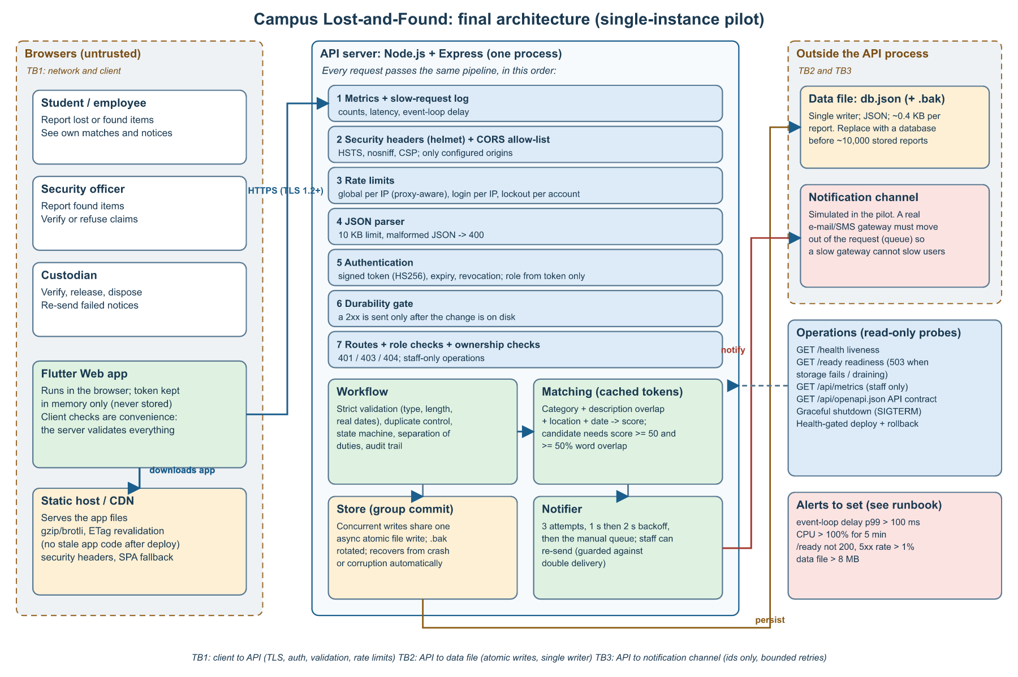
docs/w17/diagrams/architecture.svg|png
Figure 2. Main journey and automation
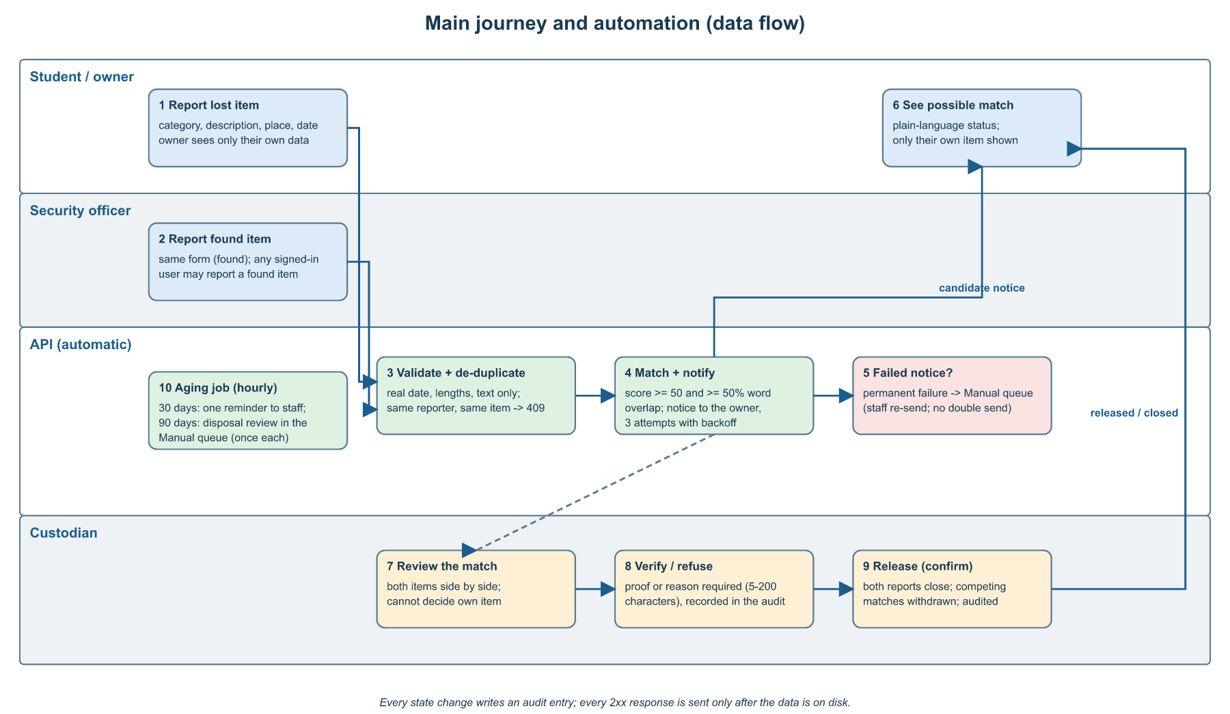
docs/w17/diagrams/data-flow.svg|png

