# Cayman Casteel

CS 255

25th February 2024

# CS 255 Project 2 System Design Document

## UML Diagrams

### UML Use Case Diagram

### UML Activity Diagrams

### UML Sequence Diagram

### UML Class Diagram

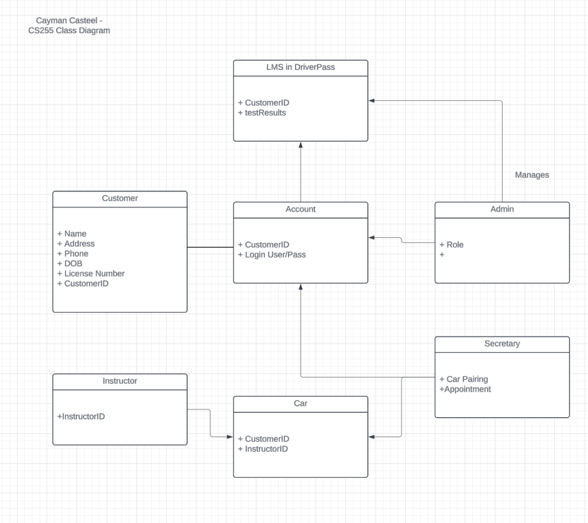

## Technical Requirements

For this system to work functionally and without problems, there are technical requirements that must be met. These include hardware, software, tools, and infrastructure.

**Hardware:**

* A dedicated server to run the online portion of the system.
* Reliable Internet connection

**Software:**

* Web Application Framework
* Database Management for downloaded reports

**Tools:**

* LMS that will be used within DriverPass

**Infrastructure:**

* Cloud Based alongside the Web App
* A type of Backup system.