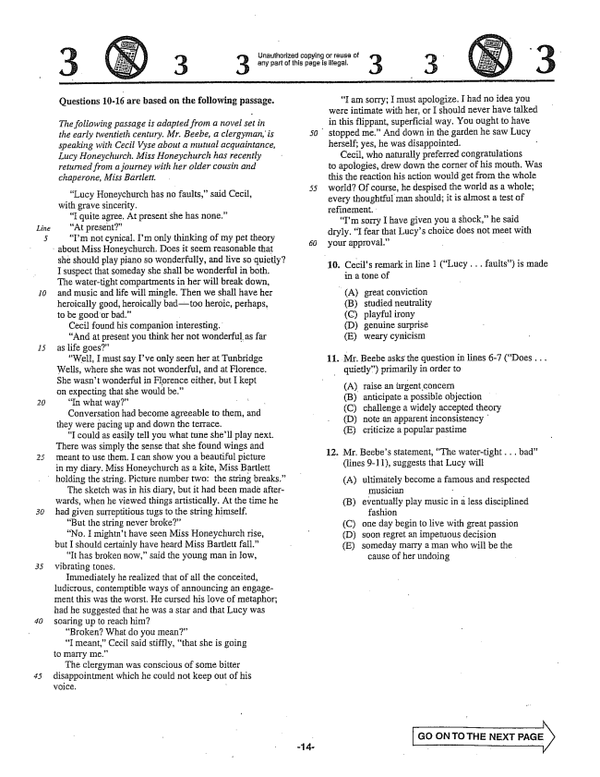

*Iline*

*10*

**Questions 10-16 are based on the following passage.**

*The following passage is adapted from a novel set in the early twentieth century. Mr. Beebe, a clergyman, is speaking with Cecil Vyse about a mutual acquaintance, Lucy Honeychurch, Miss Honeychurch has recently returned from a journey with her older cousin and chaperone, Miss Bartlett.*

Lucy Honeychurch has no faults,said Cecil, with grave sincerity.

I quite agree. At present she has none.” “At present” “Im not cynical, Im only thinking of my pet theory

*50*

about Miss Honeychurch. Does it seem reasonable that

she should play piano so wonderfully, and live so quietly? I suspect that someday she shall be wonderful in both. The watertight compartments in her will break down, and music and life will mingle, Then we shall have her heroically good, heroically badtoo heroic, perhaps, to be good or bad.”

Cecil found his companion interesting. And at present you think her not wonderful as far as life goes”

“Well, I must say Ive only seen her at Tunbridge Wells, where she was not wonderful, and at Florence. She wasnt wonderful in Florence either, but I kept on expecting that she would be.”

“In what way" - Conversation had become agreeable to thern, and they were pacing up and down the terrace.

I could as easily tell you what tune shell play next. There was simply the sense that she found wings and Theant to use them. I can show you a beautiful picture in my diary. Miss Honeychurch as a kite, Miss Bartlett holding the string, Picture number two: the string breaks.” The sketch was in his diary, but it had been inade afterwards, when he viewed things artistically. At the time he had given surreptitious tugs to the string himself.

But the string never broke” “No. I mightnt have seen Miss Honeychurch rise, but I should certainly have heard Miss Bartlett fall."

It has broken now,” said the young man in low, Vibrating tones.

Immediately he realized that of all the conceited, ludicrous, contemptible ways of announcing an engagement this was the worst. He cursed his love of metaphor; had he suggested that he was a star and that Lucy was soaring up to reach him?

Broken? What do you mean” “I meant," Cecil said stiffly, that she is going to marry me”

The clergyman was conscious of some bitter disappointment which he could not keep out of his voice. -

Unauthorized copying or reuse of any part of this paga is illegal.

3

I am ; must apologize. I had N0 idea you were intimate with her, or I should never have talked in this flippant, superficial way, You Ought to have

stopped me” And down in the garden he saw Lucy

herself, yes, he was disappointed.

Cecil, who naturally preferred congratulations to apologies, drew down the corner of his mouth, Was this the reaction his action would get from the whole world? Of course, he despised the world as a whole; every thoughtful man should; it is almost a test of IefineITient.

Im sorry I have given you a shock,he said dryly. I fear that Lucys choice does not meet with

your approval.”

10. Cecils remark in line 1 (Lucy .. faults) is made

in a tone of

(A) (B) (C) (D) (E)

Mr. Beebe asks the question in lines -7 (Does . . . quietly) primarily in order to

(A) (B) (C) (D) (E)

12. Mr. Beebes statement, The watertight... bad"

(lines -11), suggests that Lucy will

great conviction studied neutrality playful irony genuine Surprise weary cynicism

**11.**

raise an urgent concern anticipate a possible objection challenge a widely accepted theory note an apparent inconsistency criticize a popular pastine

(A) ultimately become a famous and respected

musician - eventually play music in a less disciplined

fashion one day begin to live with great passion soon regret an impetuous decision someday marry a man who will be the

cause of her undoing

(B)

(C) (D) (E)

**GO ON TO THE NEXT**

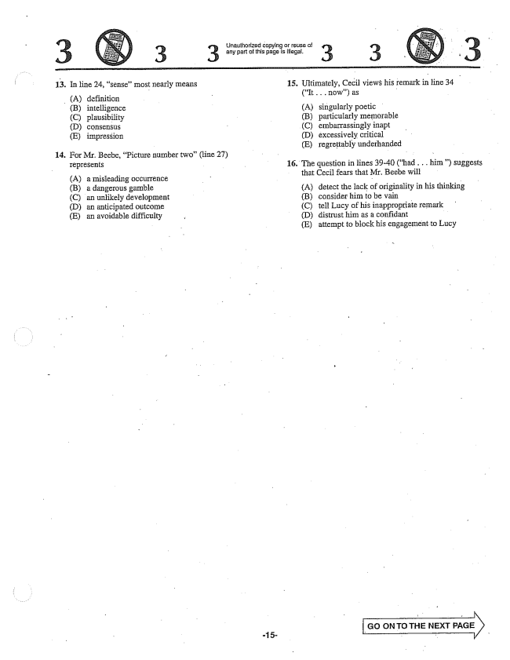

13. In line 24, sense” most nearly means

(A) definition (B) intelligence (C) plausibility (D) consensus (E) impression

14. For Mr. Beebe, Picture number two(line 27)

Iepresents

(A) a misleading occurrence (B) a dangerous gamble (C) an unlikely development (D) an anticipated outcome (E) an avoidable difficulty

-15

Unauthorized copying or reuse of 3 3 any part of this page is illegal. 3 3

**15.**

**16.**

Ultimately, Cecil views his remark in line 34 (It . . . now) as -

A) singularly poetic (B) particularly memorable (C) embarrassingly inapt (D) excessively critical (E) regrettably underhanded

The question in lines 39-40 (had . . . him) suggests

that Cecil fears that Mr. Beebe will

(A) detect the lack of originality in his thinking (B) consider him to be vain (C) tell Lucy of his inappropriate remark (D) distrust him as a confidant (E) attempt to block his engagement to Lucy

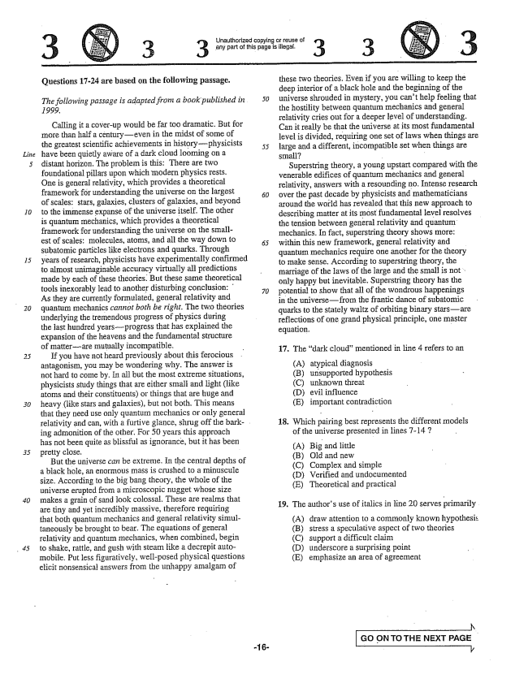

*Line*

*30*

Questions 17-24 are based on the following passage.

*The following passage is adapted from a book published in 50*

*1999,*

Calling it a cover-up would be far too dramatic. But for more than half a centuryeven in the midst of some of the greatest scientific achievements in historyphysicists have been quietly aware of a dark cloud looming on a distant horizon. The problem is this: There are two foundational pillars upon which modern physics rests. One is general relativity, which provides a theoretical framework för understanding the universe on the largest of scales: stars, galaxies, clusters of galaxies, and beyond to the immense expanse of the universe itself. The other is quantum mechanics, which provides a theoretical framework for understanding the universe on the smallest of scales: molecules, atoms, and all the way down to 65 subatomic particles like electrons and quarks. Through years of research, physicists have experimentally confirmed to almost unimaginable accuracy virtually all predictions made by each of these theories. But these same theoretical tools inexorably lead to another disturbing conclusion: 70 As they are currently formulated, general relativity and quantum mechanics cannot both be right. The two theories underlying the tremendous progress of physics during the last hundred yearsprogress that has explained the expansion of the heavens and the fundamental structure of matterare mutually incompatible.

If you have not heard previously about this ferocious antagonism, you may be wondering why. The answer is not hard to come by. In all but the most extreme situations, physicists study things that are either small and light (like atoms and their constituents) or things that are huge and heavy (like stars and galaxies), but not both. This means that they need use only quantum mechanics or only general relativity and can, with a furtive glance, shrug off the bark- ing admonition of the other. For 50 years this approach has not been quite as blissful as ignorance, but it has been pretty close.

But the universe can be extreme. In the central depths of a black hole, an enormous mass is crushed to a minuscule size. According to the big bang theory, the whole of the universe erupted from a microscopic nugget whose size makes a grain of sand look colossal. These are realms that are tiny and yet incredibly massive, therefore requiring that both quantum mechanics and general relativity simultaneously be brought to bear. The equations of general relativity and quantum mechanics, when combined, begin to shake, rattle, and gush with steam like a decrepit automobile. Put less figuratively, well-posed physical questions elicit nonsensical answers from the unhappy amalgam of

55

**-16**

Unauthorized copying or reuse of any part of this page is illegal.

3

these two theories. Even if you are willing to keep the deep interior of a black hole and the beginning of the universe shrouded in Inystery, you cant help feeling that the hostility between quantum mechanics and general relativity cries out for a deeper level of understanding. Can it really be that the universe at its most fundamental level is divided, requiring one set of laws when things are large and a different, incompatible set when things are - -

SuperString theory, a young upstart compared with the venerable edifices of quantum mechanics and general relativity, answers with a resounding no. Intense research over the past decade by physicists and mathematicians around the world has revealed that this new approach to describing matter at its most fundamental level resolves the tension between general relativity and quantum mechanics. In fact, superstring theory shows more: within this new framework, general relativity and quantum mechanics require one another for the theory to make Sense. According to SuperString theory, the marriage of the laws of the large and the small is not : only happy but inevitable. Superstring theory has the potential to show that all of the wondrous happenings in the universefrom the frantic dance of subatomic quarks to the stately waltz of orbiting binary starsare reflections of one grand physical principle, one master equation. -

17. The dark cloud” mentioned in line 4 refers to an

(A) (B) (C) (D) (E)

atypical diagnosis unsupported hypothesis unknown threat evil influence important contradiction

18. Which pairing best represents the different models

of the universe presented in lines -147

(A) Big and little (B) Old and new (C) Complex and simple (D) Verified and undocumented (E) Theoretical and practical

19. The authors use of italics in line 20 Serves primarily

A) draw attention to a commonly known hypothesis (B) stress a speculative aspect of two theories (C) support a difficult claim (D) underscore a surprising point (E) emphasize an area of agreement

Go ON TO THE NEXT PAGE

**-**

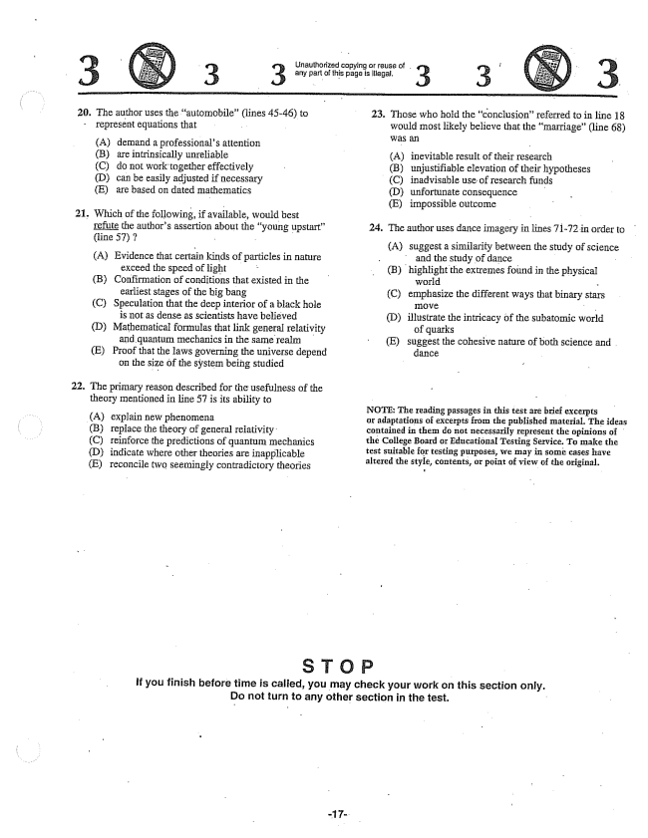

**20,**

**22.**

The author uses the automobile” (lines 45-46) to represent equations that

(A) demand a professionals attention (B) are intrinsically unreliable (C) do not work together effectively (D) can be easily adjusted if necessary (E) are based on dated mathematics

Which of the following, if available, would best refute the authors assertion about the young upstart” (line 57) - -

(A) Evidence that certain kinds of particles in nature

exceed the speed of light (B) Confirmation of conditions that existed in the

earliest stages of the big bang (C) Speculation that the deep interior of a black hole is not as dense as scientists have believed (D) Mathematical formulas that link general relativity and quantum mechanics in the same realm (E) Proof that the Haws governing the universe depend

on the size of the system being studied

The primary reason described for the usefulness of the theory mentioned in line 57 is its ability to

(A) explain new phenomena (B) replace the theory of general relativity (C) reinforce the predictions of quantum mechanics (D) indicate where other theories are inapplicable (E) reconcile two seemingly contradictory theories

- Unauthorized copying or reuse of . i 3 3 any part of this paga is lilegai. 3 3

23. Those who hold the conclusionreferred to in line 18 would most likely believe that the marriage” (line 68) was an (A) inevitable result of their research (B) unjustifiable elevation of their hypotheses (C) inadvisable use of research funds (D) unfortunate consequence - E) impossible outcome

24. The author uses dance imagery in lines 71-72 in order to

(A) suggest a similarity between the study of Science - and the study of dance -

(B) highlight the extremes found in the physical world -

(C) emphasize the different ways that binary stars

(D) illustrate the intricacy of the subatomic world

of quarks

(E) suggest the cohesive nature of both science and .

dance

NOTE: The reading passages in this test are brief excerpts ur adaptations of excerpts from tlie published material. The ideas contained in them do not necessarily represent the opinions of the College Board or Educational Testing Service. To make the test suitable for testing purposes, we may in some cases have altered the style, contents, or point of view of the original.

**If you finish before time is called, you may check your work on this section only. Do not turn to any other section in the test.**

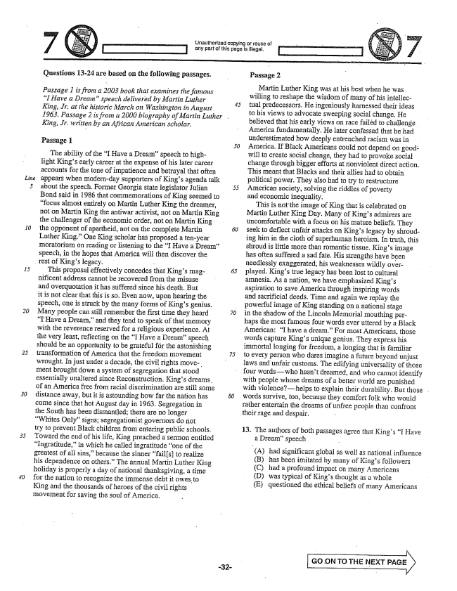

*Line*

*20*

*30*

Questions 13-24 are based on the following passages.

*Passage 1 is from a 2003 book that examines the famous I Have a Dreamspeech delivered by Martin Luther King, . at the historic March on Washington in August 1963, Passage 2 is from a 2000 biography of Martin Luther . King, . written by an African American scholar,*

Passage 1

The ability of the I Have a Dreamspeech to highlight Kings early career at the expense of his later career accounts for the tone of impatience and betrayal that often appears when modernday supporters of Kings agenda talk about the speech. Former Georgia state legislator Julian Bond said in 1986 that commemorations of King seemed to focus almost entirely on Martin Luther King the dreamer, not on Martin King the antiwar activist, not on Martin King the challenger of the economic order, not on Martin King the opponent of apartheid, not on the complete Martin Luther King.” One King scholar has proposed a tenyear moratorium on reading or listening to the I Have a Dream” Speech, in the hopes that America will then discover the rest of Kings legacy. -

This proposal effectively concedes that Kings magnificent address cannot be recovered from the misuse and overquotation it has suffered since his death. But it is not clear that this is so. Even now, upon hearing the speech, one is struck by the many forms of Kings genius. - Many people can still remember the first time they heard 70 I Have a Dream,and they tend to speak of that memory with the reverence reserved for a religious experience. At the very least, reflecting on the I Have a Dreamspeech should be an opportunity to be grateful för the astonishing transformation of America that the freedom movement 25 wrought. In just under a decade, the civil rights move, - ment brought down a system of segregation that stood essentially unaltered since Reconstruction, Kings dreams. of an America free from racial discrimination are still some distance away, but it is astounding how far the nation has ] come since that hot August day in 1963. Segregation in the South has been dismantled; there are no longer Whites Only" signs; segregationist governors do not try to prevent Black children from entering public schools. Toward the end of his life, King preached a sermon entitled Ingratitude,in which he called ingratitude one of the greatest of all sins,because the sinner fails] to realize his dependence on others.” The annual Martin Luther King holiday is properly a day of national thanksgiving, a time for the nation to recognize the immense debt it owes to King and the thousands of heroes of the civil rights movement for saving the soul of America.

*50*

Unauthorized copying or reuse of

Passage 2

Martin Luther King was at his best when he was willing to reshape the wisdom of many of his intellectual predecessors. He ingeniously harnessed their ideas to his views to advocate Sweeping social change. He believed that his early views on race failéd to challenge America fundamentally. He later confessed that he had underestimated how deeply entrenched racism was in America. If Black Americans could not depend on goodwill to create social change, they had to provoke social change through bigger efforts at nonviolent direct action. This meant that Blacks and their aflies had to obtain political power. They also had to try to restructure American Society, solving the riddles of poverty and economic inequality. -

This is not the image of King that is celebrated on Martin Luther King Day. Many of Kings admirers are uncomfortable with a focus on his mature beliefs. They seek to deflect unfair attacks on Kings legacy by shrouding him in the cloth of superhuman heroism. In truth, this shroud is little more than romantic tissue. Kings image has often suffered a sad fate. His strengths have been needlessly exaggerated, his weaknesses wildly overplayed. Kings true legacy has been lost to cultural amnesia. As a nation, we have emphasized Kings aspiration to save America through inspiring words and sacrificial deeds. Time and again we replay the powerful image of King standing on a national stage in the shadow of the Lincoln Memorial mouthing perhaps the most famous four words ever uttered by a Black

American: I have a dream.” For most Americans, those

words capture Kings unique genius. They express his immortal songing for freedom, a longing that is familiar to every person who dares imagine a future beyond unjust laws and unfair customs. The edifying universality of those four wordswho hasn't dreamed, and who cannot identify with people whose dreams of a better world are punished with violencehelps to explain their durability. But those . words survive, too, because they comfort folk who would rather entertain the dreams of unfree people than confront their rage and despair,

13. The authors of both passages agree that Kings I Have

a Dreamspeech

(A) had significant global as well as national influence (B) has been imitated by many of Kings followers (C) had a profound impact on many Americans (D) was typical of Kings thought as a whole (E) questioned the ethical beliefs of many Americans

Go ON TO THE NEXT )

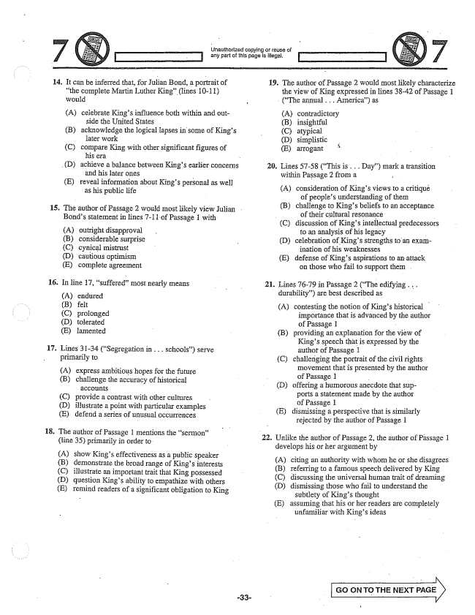

14.

**15.**

**16.**

**17.**

48.

(D)

It can be inferred that, for Julian Bond, a portrait the complete Martin Luther King” (lines 10-11) would

A) celebrate Kings influence both within and out

side the United States

acknowledge the logical lapses in some of Kings

later work

compare King with other significant figures of

his era -

achieve a balance between Kings earlier concerns

and his later ones

reveal information about Kings personal as well

as his public life

(B)

(C)

(E)

The author of Passage 2 would most likely view Julian Bonds statement in lines -11-of Passage 1 with

In line 17, suffered” most nearly means

(A) endured (B) felt (C) prolonged (D) tolerated (E) lamented

outright disapproval considerable surprise cynical mistrust cautious optimism complete agreement

Lines 31-34 (Segregation in . . . schools) serve primarily to

(A) express ambitious hopes for the future (B) challenge the accuracy of historical

(C) provide a contrast with other cultures (D) illustrate a point with particular examples (E) defend a series of unusual occurrences

The author of Passage 1 mentions the sermon” (line 35) primarily in order to:

(A) show Kings effectiveness as a public speaker (B) demonstrate the broad range of Kings interests (C) illustrate an important trait that King possessed (D) question Kings ability to empathize with others (E) remind readers of a significant obligation to King

Unauthorized copying or reuse of any part of this page is illegal.

22.

19. The author of Passage 2 would most likely characterize

the view of King expressed in lines 38-42 of Passage 1 (The annual . . . America) as

(A) (B) (C) (D) (E)

Lines 57-58 (This is . . . Day) mark a transition within Passage 2 from a -

contradictory insightful atypical

simplistic arrogant “

20.

(A) consideration of Kings views to a critiqué of peoples understanding of them

(B) challenge to Kings beliefs to an acceptance

- of their cultural resonance -

(C) discussion of Kings intellectual predecessors

to an analysis of his legacy -

(D) celebration of Kings strengths to an exam

ination of his weaknesses -

E) defense of Kings aspirations to an attack on those who fail to support them

Lines 76-79 in Passage 2 (The edifying . . . durability) are best described as

21.

(A) contesting the notion of Kings historical

importance that is advanced by the author of Passage 1 - (B) providing an explanation for the view of

Kings speech that is expressed by the author of Passage 1 (C) challenging the portrait of the civil rights

movement that is presented by the author of Passage 1 - (D) offering a humorous anecdote that Sup

ports a statement made by the author of Passage 1 (E) dismissing a perspective that is similarly

rejected by the author of Passage 1

Unlike the author of Passage 2, the author of Passage 1 develops his or her argument by

(A) citing an authority with whom he or she disagrees (B) referring to a famous speech delivered by King (C) discussing the universal human trait of dreaming (D) dismissing those who fail to understand the

subtlety of Kings thought (E) assuming that his or her readers are completely

unfamiliar with Kings ideas

Go ON To THE NEXT

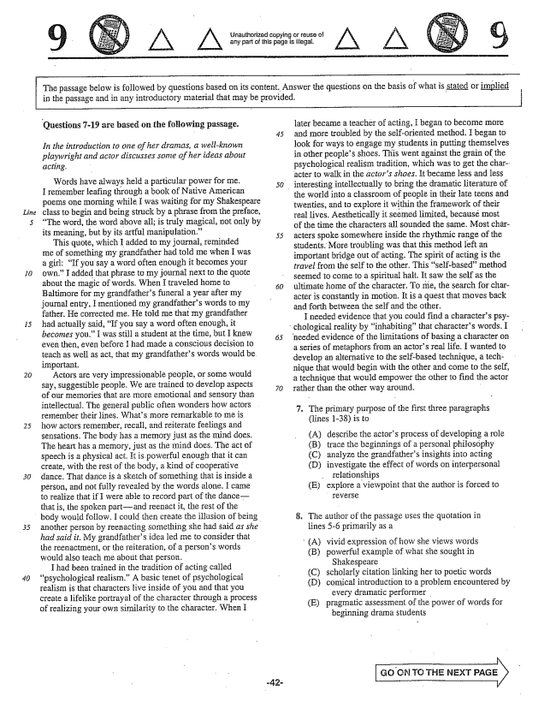

Ljnauthorized copying or reuse of any part of this page is illegal,

*Line*

25

*30*

The passage below is followed by questions based on its content. Answer the questions on the basis of what is stated or implied in the passage and in any introductory material that may be provided.

Questions -19 are based on the following passage.

*- In the introduction to one of her dramas, a well-known playwright and actor discusses some of her ideas about*

*acting.*

Words have always held a particular power forme. 50 I remember leafing through a book of Native American poems one morning while I was waiting for my Shakespeare class to begin and being struck by a phrase from the preface, The word, the word above all; is truly magical, not only by its meaning, but by its artful manipulation.” 55

This quote, which I added to my journal, reminded me of something my grandfather had told me when I was a girl: If you say a word often enough it becomes your own.” I added that phrase to my journal next to the quote - about the magic of words. When I traveled home to Baltimore for my grandfathers funeral a year after my journal entry, I mentioned my grandfathers words to my father. He corrected me. He told me that my grandfather had actually said, If you say a word often enough, it becomes you." I was still a student at the time, but I knew 65 even then, even before I had made a conscious decision to teach as well as act, that my grandfathers words would be important.

Actors are very impressionable people, or some would Say, suggestible people. We are trained to develop aspects 70 of our memories that are more emotional and sensory than intellectual. The general public often wonders how actors remember their lines, Whats more remarkable to me is how actors remember, recall, and reiterate feelings and Sensations. The body has a memory just as the mind does, The heart has a memory, just as the mind does. The act of speech is a physical act. It is powerful enough that it can create, with the rest of the body, a kind of cooperative dance. That dance is a sketch of something that is inside a person, and not fully revealed by the words alone. I came to realize that if I were able to record part of the dancethat is, the spoken partand reenact it, the rest of the body would follow. I could then create the illusion of being another person by reenacting something she had said as she had said it, My grandfathers idea led me to consider that the reenactment, or the reiteration, of a persons words would also teach me about that person.

I had been trained in the tradition of acting called psychological realism.” A basic tenet of psychological realism is that characters Hive inside of you and that you create a lifelike portrayal of the character through a process of realizing your own similarity to the character. When I

later became a of acting, I began to become more and more troubled by the self-oriented method. I began to look for ways to engage my students in putting themselves in other peoples shoes. This went against the grain of the psychological realism tradition, which was to get the character to walk in the actors shoes. It became less and less

interesting intellectually to bring the dramatic literature of

the world into a classroom of people in their late teens and twenties, and to explore it within the framework of their real lives. Aesthetically it seemed limited, because most of the time the characters all sounded the same. Most châracters spoke somewhere inside the rhythmic range of the students. More troubling was that this method left an important bridge out of acting. The spirit of acting is the travel from the self to the other. This self-basedmethod seemed to come to a spiritual halt. It saw the self as the ultimate home of the character. To me, the search for character is constantly in motion. It is a quest that moves back and forth between the self and the other.

I needed evidence that you could find a characters psy

chological reality by inhabitingthat characters words. I

needed evidence of the limitations of basing a character on a series of metaphors from an actors real life. I wanted to develop an alternative to the self-based technique, a technique that would begin with the other and come to the self, a technique that would empower the other to find the actor rather than the other way around, -

. The primary purpose of the first three paragraphs

(lines 138) is to

(A) describe the actors process of developing a role

(B) trace the beginnings of a personal philosophy

(C) analyze the grandfathers insights into acting

(D) investigate the effect of words on interpersonal

relationships

(E) explore a viewpoint that the author is forced to

TEVEFSE

. The author of the passage uses the quotation in

lines -6 primarily as a

(A) vivid expression of how she views words (B) powerful example of what she sought in

Shakespeare (C) scholarly citation linking her to poetic words (D) comical introduction to a problem encountered by

every dramatic performer (E) pragmatic assessment of the power of words for

beginning drama students

, CN TO THE NEXT

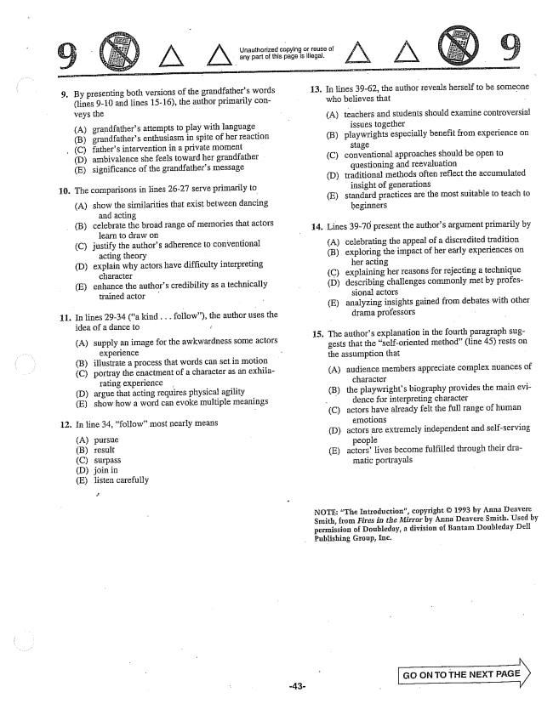

. By presenting both versions of the grandfathers words

(lines -10 and lines 15-16), the author primarily conveys the

(A) grandfathers attempts to play with language (B) grandfathers enthusiasm in spite of her reaction

, C) fathers intervention in a private moment

(D) ambivalence she feels toward her grandfather (E) significance of the grandfathers message

The comparisons in lines 26-27 serve primarily to

(A) show the similarities that exist between dancing

and acting

(B) celebrate the broad range of memories that actors

**11**

learn to draw on (C) justify the authors adherence to conventional

acting theory (D) explain why actors have difficulty interpreting

character (E) enhance the authors credibility as a technically

trained actor

In lines 2934 (a kind . . . follow), the author uses the idea of a dance to

(A) supply an image for the awkwardness some actors

experience (B) illustrate a process that words can set in motion (C) portray the enactment of a character as an exhila

rating experience . (D) argue that acting requires physical agility (E) show how a word can evoke multiple meanings

. În line 34, followInost nearly means

(A) (B) (C) (D) (E)

pursue result

Surpass

join in listen carefully

Unauthorized copying or reuse of any part of this page is illegal.

**13,**

**14.**

с.

In lines 39-62, the author reveals herself to be someone who believes that

(A)

(3)

(C)

(D)

(E)

teachers and students should examine controversial

issues together

playwrights especially benefit from experience on

***-***

conventional approaches should be open to

questioning and reevaluation

traditional Ilethods often reflect the accumulated

insight of generations

standard practices are the most suitable to teach to

beginners

Lines 39-70 present the authors argument primarily by

(A) celebrating the appeal of a discredited tradition (B) exploring the impact of her early experiences on

her acting (C) explaining her reasons for rejecting a technique (D) describing challenges commonly met by profes

sional actors (E) analyzing insights gained from debates with other

drama professors -

The authors explanation in the fourth paragraph suggests that the self-oriented method" (line 45) rests om the assumption that -

A) audience members appreciate complex nuances of

character

the playwrights biography provides the main evi

dence for interpreting character

actors have already felt the full range of human

emotions

actors are extremely independent and self-serving

people

actorslives become fulfilled through their dra

matic portrayals

(B)

(D)

(E)

NOTE: "The Introduction, copyright © 1993 by Anna Deavere Smith, from Fires in the Mirror by Anna Deavere Smith. Used by permission of Dotihleday, a division of Bantam Doubleday Geli Publishing Group, Inc.

Go ON TO THE NEXT PAGE X

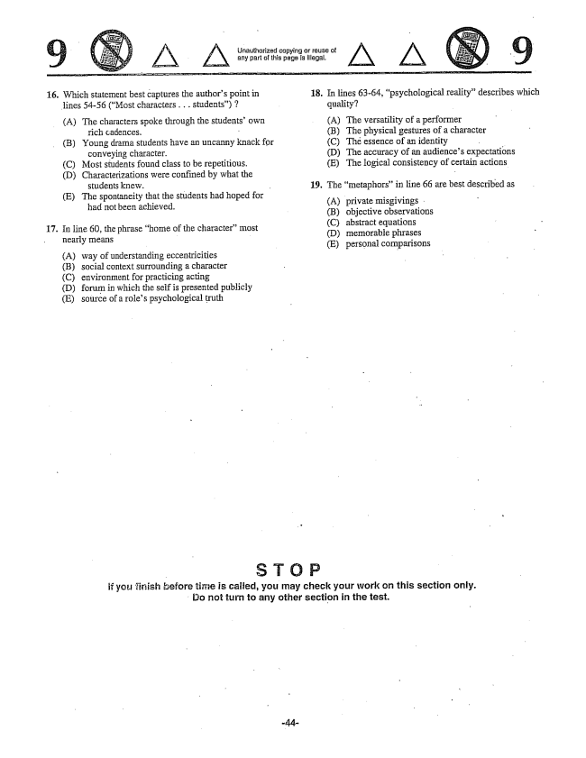

*A A*

16. Which statement best captures the authors point in

lines 54-56 (Most characters . . . students)

(A) The characters spoke through the studentsown rich Cadences. -

(B) Young drama students have an uncanny knack for

conveying character. (C) Most students found class to be repetitious. (D) Characterizations were confined by what the

students knew.

(E) The spontaneity that the students had hoped for -

had not been achieved.

17. In line 60, the phrase home of the character" most

nearly means -

A) way of understanding eccentricities (B) social context surrounding a character (C) environment for practicing acting (D) forum in which the self is presented publicly (E) source of a roles psychological truth

Unauthorized copying or reuse of any part of this page is illegal.

18.

**19,**

În lines 63-64, psychological reality” describes which quality?

(A) The versatility of a performer (B) The physical gestures of a character (C) Thé essence of an identity (D) The accuracy of an audiences expectations (E) The logical consistency of certain actions

The metaphors” in line 66 are best described as

(A) private misgivings . (B) objective observations (C) abstract equations (D) memorable phrases (E) personal comparisons

if you firsish Hefore time is calfed, you may check your work on this section only. Do not turn to any other section in the test.

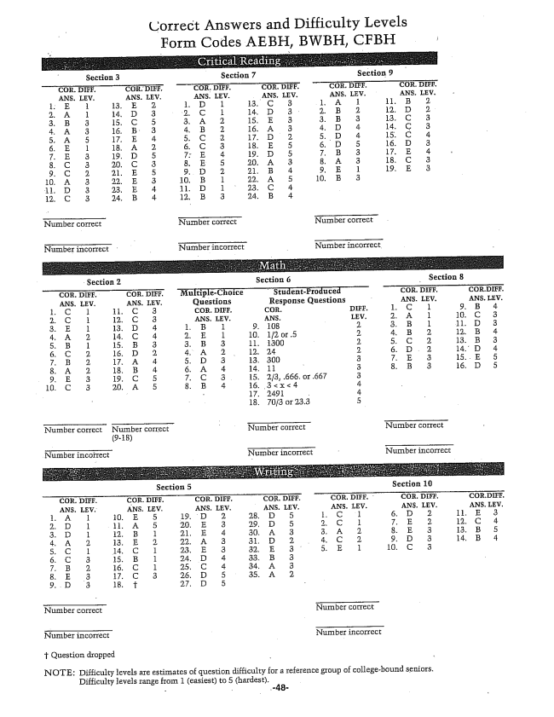

Correct Answers and Difficulty Levels Form Codes AEBH, BWBH, CFBH

Section 2 Sectinn 6 Section 8 . DIFF. . DiFF. MultipleChoice StudentProduced COR. PJIFF, COR.DIFF. ANS. LEV. ANS, IEV. Questions Response Questions - ANS. LEW. ANS. LEV. 1. C 1 11. C EOR. DIFF. CUR. DEFE. 1. C l , 4 2. C 12. C 3 ANS. LEV. ANS. . 2. А l 10. C 3 3。E I 13. D . E. B. l . {8 - 2. 1 11. D 3 , А 2. . 1 10, 12 or 5 ,2. 12. B 4 i 3 11, 1300 . C 2. 13。3 , C 2. 16. D 2. . A 2 12, 24 14. D 4 2. 17. А 4 3 13. 300 3 . A 2. 18. В . . A 4 14. 11 . . B 3 , D 5 . E. 3. 19, C 5 . C 15. 23, 666. or 667 10. C . 16. , 3 4 - 17. 1491 - 4 18. 70/3 or 23.3 5

Number correct Number correct - Nurnber correct Number correct

(9-18)

Number incorrect NuTTaber incDTrect - NuIIaber incorrect

f Question dropped

NOTE: Difficulty levels are estimates of question difficulty for a reference group of collegebound seniors.

Difficulty levels range from 1 (easiest) to 5 (hardest.