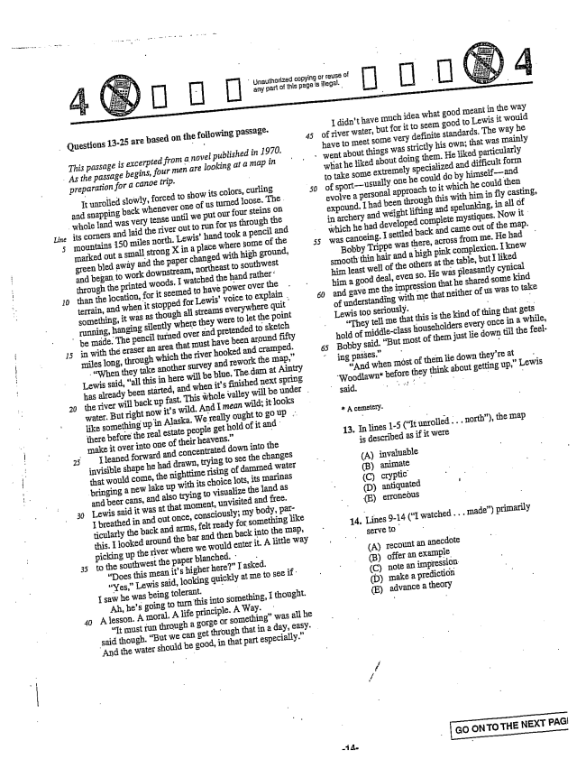

Questions 13-25 are based on the following passage.

*Line*

*This passage is excerpted from a novel published in 1970.*

*As the passage begins, four men are looking at a miap in*

*preparation for a canoe trip.*

It unrolled slowly, forced to show its colors, curling and Snapping back whenever one of us turned loose. The

whole land was very tense until we put our four steins on

its corners and laid the river out to run for ps through the mountains 150 miles north. Lewishand took a pencil and marked out a small strong Xin a place where some of the green bled away and the paper changed with high ground, and began to work downstream, northeast to Southwest through the printed woods, I watched the hand rather: than the location, for it seemed to have power over the terrain, and when it stopped for Lewisvoice to explain . something, it was as though all streams everywhere quit running, hanging silently where they were to let the point

be made. The pencil turned over and pretended to sketch

25

*30*

in with the eraser an area that must have been around fifty miles long, through which the river hooked and Cramped. When they take another survey and rework the map,

Lewis said, all this in here will be blue. The dam at Aintry

has already been started, and when its finished next spring

the river will back up fast. This whole valley will be under .

water. But right now its wild. And I mean wild; it looks like something up in Alaska. We really ought to go up . there before the real estate people get hold of it and make it over into one of their heavens.”

Ileaned forward and concentrated down into the invisible shape he had drawn, trying to see the changes that would corne, the nighttime rising of dammed water

bringing a new lake up with its choice lots, its marinas

and beer cans, and also trying to visualize the land as Lewis said it was at that moment, unvisited and free. I breathed in and out once, consciously; my body, particularly the back and arms, felt ready for something like this. I looked around the bar and then back into the map, picking up the river where we would enter it. A little way to the southwest the paper blanched. ' -

Does this mean its higher here” I asked. Yes,Lewis said, looking quickly at me to see if I saw he was being tolerant,

Ah, hes going to turn this into something, I thought. A lesson. A moral. A life principle. A Way.

It must run through a gorge or something" was all he said though. But we can get through that in a day, easy.

And the water should be good, in that part especially.”

Unauthorized copying or reuse of any part of this page is illegal.

*45*

I didn't have much idea what good meant in the way of river water, but for it to seem good to Lewis it would have to meet some very definite standards. The way he

went about things was strictly his own; that was mainly

*50*

what he liked about doing them. He liked particularly to take some extremely specialized and difficult form of sportusually one he could do by himselfand evolve a personal approach to it which he could then expound. Ihad been through this with him in fly casting, in archery and weightlifting and spelunking, in all of which he had developed complete mystiques. Now it was canoeing. Isettled back and came out of the map. Bobby Trippe was there, across from me. He had smooth thin hair and a high pink complexion. I knew him least well of the others at the table, but I liked him a good deal, even so, He was pleasantly cynical and gave me the impression that he shared some kind of understanding with me that neither of us was to take Lewis top seriously. - They tell me that this is the kind of thing that gets hold of middle-class householders every once in a while, Bobby said. But most of them just lie down till the feeling passes." -

And when měst of them lie down theyre at

Woodlawn" before they think about getting up,Lewis

said.

A cemetery.

13. In lines 1-5 (It unrolled... north), the map

is described as if it were

(A) invaluable (B) animate

(D) antiquated (E) erroneöus

14. Lines -14 (I watched .. made) primarily

serve to

(A) recount an anecdote (B) offer an example (C) note an impression. (D) make a prediction (E) advance a theory

**GO ON TO THE NEXT PAG**

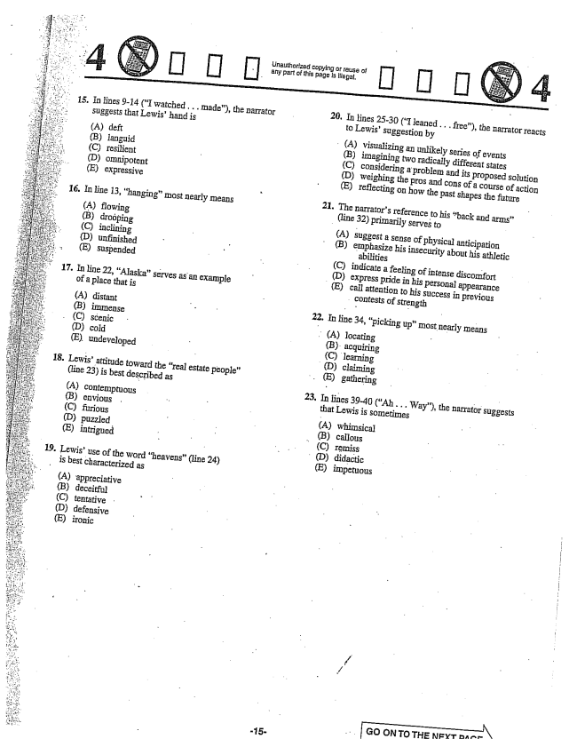

15. In lines -14 (I watched .. made), the narrator

suggests that Lewishand is

(A) deft (B) languid (C) resilient (D) Omnipotent (E) expressive

16. In line 13, hanging” most nearly means

(A) flowing (B) droöping (C) inclining (D) unfinished (E) suspended

17. În line 22, Alaskaserves as an example

of a place that is

(A) distant (B) immense (C) scenic (D) cold (E) undeveloped

Lewis' attitude toward the real estate people" (line 23) is best described as

(A) contemptuous (B) envious (C) furious (D) puzzled (E) intrigued

- 19. Lewisuse of the word heavens(line 24)

is best characterized as

18

(A) appreciative (B) deceitful (C) tentative (D) defensive (E) ironic

**-15**

Unauthorized Copying or reuse of any part of this page is illegal.

20. In lines 25-30 (I leaned . . . free), the narrator reacts

to LewisSuggestion by

(A) visualizing an unlikely series of events

**21.**

**22**

**23**

(B) imagining two radically different states (C) considering a problem and its proposed solution (D) weighing the pros and cons of a course of action (E) reflecting on how the past shapes the future

The narrators reference to his back and arms” (line 32) primarily serves to

(A) suggest a sense of physical anticipation (B) emphasize his insecurity about his athletic abilities - C) indicate a feeling of intense discomfort (D) express pride in his personal appearance

(E) call attention to his success in previous

contests of strength

In line 34, picking up” most nearly means

(A) locating

(B) acquiring (C) learning

(D) claiming

(E) gathering

In lines 39-40 (Ah... Way), the narrator suggests that Lewis is sometimes

(A) whimsical

(B) callous

(C) ręmiss

. (D) didactic

(E) impetuous

**Go ON TO THE NFYT Bar**

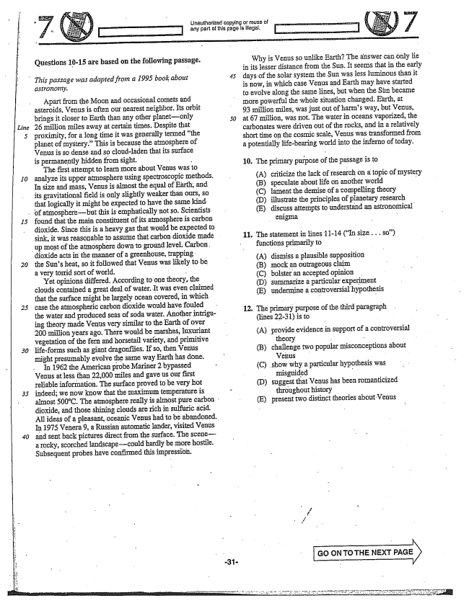

*Line*

*10*

Questions 10-15 are based on the following passage.

*This passage was adapted from a 1995 book about*

*astronomy.*

Apart from the Moon and occasional comets and asteroids, Venus is often our nearest neighbor. Its orbit brings it closer to Earth than any other planetonly 26 million miles away at certain times. Despite that proximity, for a long time it was generally termed the planet of mystery.” This is because the atmosphere of Venus is so dense and so cloudladen that its surface is permanently hidden from sight. -

The first attempt to learn more about Venus was to analyze its upper atmosphere using spectroscopic methods. In size and Inass, Venus is almost the equal of Earth, and its gravitational field is only slightly weaker than ours, so that logically it might be expected to have the same kind

of atmospherebut this is emphatically not so. Scientists

15

*20*

*25*

found that the main constituent of its atmosphere is carbon dioxide. Since this is a heavy gas that would be expected to sink, it was reasonable to assume that carbon dioxide made

up most of the atmosphere downto ground level. Carbon.

dioxide acts in the manner of a greenhouse, trapping. . the Suns heat, so it followed that Venus was likely to be a very torrid sort of world. -

Yet opinions differed. According to one theory, the clouds contained a great deal of water. It was even claimed that the surface might be largely ocean covered, in which case the atmospheric carbon dioxide would have fouled the water and produced seas of soda water. Another intriguing theory made Venus very similar to the Earth of over 200 million years ago. There would be marshes, luxuriant vegetation of the fern and horsetail variety, and primitive lifeforms such as giant dragonflies. If so, then Venus might presumably evolve the same way Earth has done. In 1962 the American probe Mariner 2 bypassed Venus at less than 22,000 miles and gave us our first reliable information. The surface proved to be very hot indeed; we now know that the maximum temperature is

almost 500°C. The atmosphere really is almost pure carbon .

dioxide, and those shining clouds are rich in sulfuric acid,

All ideas of a pleasant, oceanic Venus had to be abandoned.

In 1975 Venera , a Russian automatic lander, visited Venus and sent back pictures direct from the surface. The scenea rocky, scorched landscapecould hardly be more hostile.

Subsequent probes have confirmed this impression.

LIrauthorized copying or reuse of

*50*

Why is Venus so unlike Earth? The answer can only lie in its lesser distance from the Sun. It seems that in the early days of the solar system the Sun was dess luminous than it is now, in which case Venus and Earth may have started to evolve along the same Hines, but when the Sun became more powerful the whole situation changed. Earth, at 93 million Iniles, was just out of harms way, but Venus, at 67 million, was not. The water in oceans vaporized, the carbonates were driven out of the rocks, and in a relatively short time on the cosmic scale, Venus was transformed from a potentially lifebearing world into the inferno of today,

10. The primary purpose of the passage is to

(A) criticize the lack of research on a topic of mystery

(B) speculate about life on another world -

C) lament the demise of a compelling theory

(D) illustrate the principles of planetary research

(E) discuss attempts to understand an astronomical enigma -

11. The statement in lines 11-14 (size . . . so)

functions primarily to

(A) dismiss a plausible supposition (B) mock an outrageous claim (C) bolster an accepted opinion . (D) summarize a particular experiment (E) undermine a controversial hypothesis

12. The primary purpose of the third paragraph

(lines 22-31) is to

(A) provide evidence in support of a controversial

theory - - (B) challenge two popular misconceptions about

Venus - - (C) show why a particular hypothesis was

misguided (D) suggest that Venus has been romanticized

throughout history (E) present two distinct theories about Venus

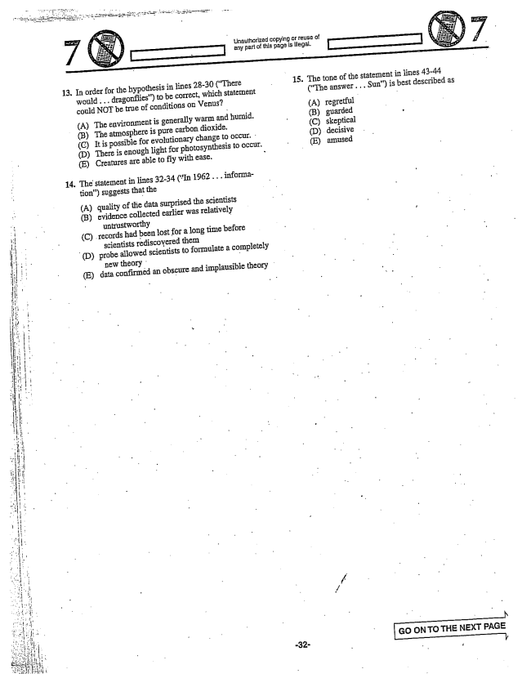

13. In order for the hypothesis in lines 28-30 (There

14

would... dragonflies) to be correct, which statement could NOT be true of conditions on Venus?

(A) The environment is generally warm and humid. (B) The atmosphere is pure carbon dioxide. (C) It is possible for evolutionary change to occur. (D) There is enough light for photosynthesis to occur. (E) Creatures are able to fly with ease.

The statement in lines 32-34 (In 1962... information) suggests that the

(A) quality of the data surprised the Scientists

(B) evidence collected earlier was relatively untrustworthy -

(C) records had been lost for a long time before

scientists rediscovered them

(D) probe allowed scientists to formulate a completely

new theory : (E) data confirmed an obscure and implausible theory

Unaulhorized copying or reuse of

- 15. The tone of the statement in lines 43-44

(The answer... Sun) is best described as

(A) regretful (B) guarded (C) skeptical (D) decisive (E) amused

- - N GO ON TO THE NEXT PAGE

***I***

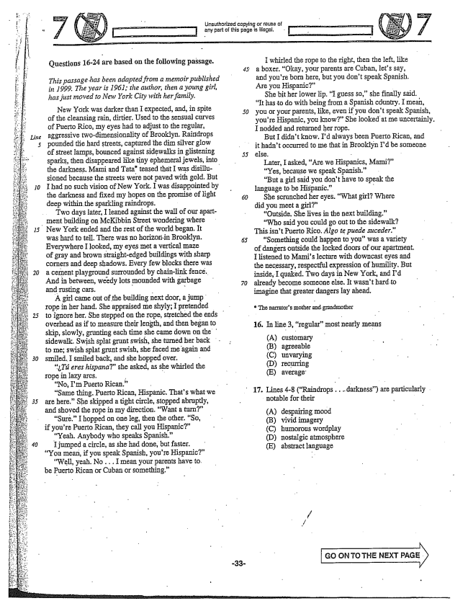

*Line 5*

*| 20*

*30*

Questions 16-24 are based on the following passage.

*This passage has been adapted from a memoir published in 1999. The year is 1961; the author, then a young girl, has just moved to New York City with her family,*

New York was darker than I expected, and, in spite of the cleansing rain, dirtier. Used to the sensual curves of Puerto Rico, Iny eyes had to adjust to the regular, aggressive twodimensionality of Brooklyn. Raindrops pounded the hard streets, captured the dim silver glow of street lamps, bounced against Sidewalks in glistening sparks, then disappeared like tiny ephemeral jewels, into

the darkness. Mami and Tata" teased that I was disillu

sioned because the streets were not paved with gold. But I had no such vision of New York. I was disappointed by the darkness and fixed my hopes on the promise of light deep within the sparkling raindrops.

Two days later, Ileaned against the wall of our apartment building on McKibbin Street wondering where

New York ended and the rest of the world began. It

was hard to teil. There was no horizorin Brooklyn. Everywhere Ilooked, my eyes met avertical maze of gray and brown straight-edged buildings with sharp corners and deep shadows. Every few blocks there was a cement playground surrounded by chainlink fence. And in between, weedy lots mounded with garbage and rusting cars. - -

A girl came out of the building next door, a jump rope in her hand. She appraised me shyly; I pretended

to ignore her. She stepped on the rope, stretched the ends

overhead as if to measure their length, and then began to

skip, slowly, grunting each time she came down on the

sidewalk. Swish splat grunt swish, she turned her back

to meSwish splat grunt Swish, she faced me again and

Smiled, I Smiled back, and she hopped over.

Tú eres hispana” she asked, as she whirled the

rope in lazy arcs. - -

No, Im Puerto Rican.”

“Same thing. Puerto Rican, Hispanic. Thats what we -

are here.” She skipped a tight circle, stopped abruptly, and shoved the rope in my direction. Want a turn”

“Sure.” I hopped on one leg, then the other. So,

if youre Puerto Rican, they call you Hispanic"

Yeah. Anybody who speaks Spanish.”

I jumped a circle, as she had done, but faster. You mean, if you speak Spanish, youre Hispanic”

“Well, yeah. No. .. IIIlean your parents have to. be Puerto Rican or Cuban or something.” -

Unauthorized copying or reuse of any part of this page is illegal.

*45.*

*50*

whirled the rope to the right, then the left, like a boxer. Okay, your parents are Cuban, lets say, and youre born here, but you don't speak Spanish. Are you Hispanic”

She bit her lower lip. I guess soshe finally said. It has to do with being from a Spanish cóuntry. I mean, you or your parents, like, even if you don't speak Spanish, youre Hispanic, you know” She looked at me uncertainly. I nodded and returned her rope.

But I didn't know. Id always been Puerto Rican, and

it hadn't occurred to me that in Brooklyn Id be someone

else. -

Later, I asked, Are we Hispanics, Mami“ Yes, because we speak Spanish.” “But a girl said you don't have to speak the language to be Hispanic.” -

She scrunched her eyes. What girl? Where did you meet a girl"

Outside. She lives in the next building.” “Who said you could go out to the sidewalk? Thisisnt Puerto Rico, Algo te puede suceder.”

“Something could happen to youwas a variety of dangers outside the locked doors of our apartment. I listened to Mamis lecture with downcast eyes and the necessary, respectful expression of humility. But inside, I quaked. Two days in New York, and Id already become someone else. It wasn't hard to imagine that greater dangers lay ahead.

The narrators mother and grandmother

16. In line 3, regular" most nearly means

(A) customary (B) agreeable (D) recurring (E) average.

17. Lines -8 (Raindrops . darkness) are particularly notable for their -

A) despairing mood (B) vivid imagery (C) humorous wordplay (D) nostalgic atmosphere (E) abstract language

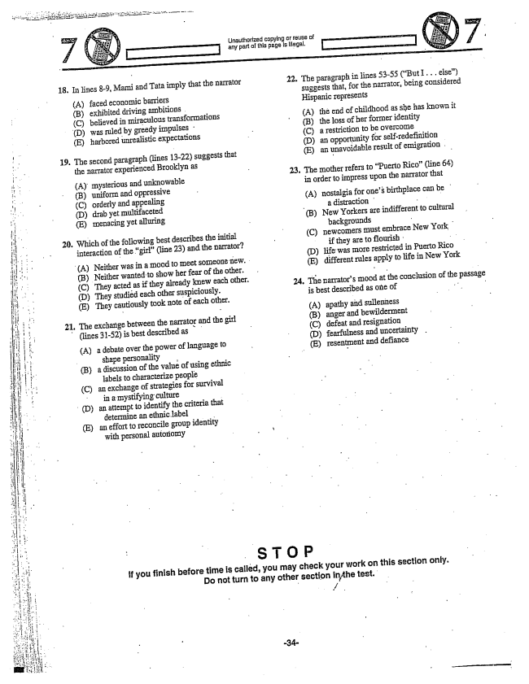

18. In lines -9, Mami and Tata imply that the narrator

(A) faced economic barriers (B) exhibited driving ambitions . (C) believed in miraculous transformations (D) was ruled by greedy impulses : (E) harbored unrealistic expectations

The second paragraph (lines 1322) suggests that the narrator experienced Brooklyn as

(A) mysterious and unknowable (B) uniform and oppressive (C) orderly and appealing (D) drab yet multifaceted (E) Inenacing yet alluring

Which of the following best describes the initial interaction of the girl" (line 23) and the narrator?

(A) Neither was in a mood to meet someone new. (B) Neither wanted to show her fear of the other.

(C) They acted as if they already knew each other.

(D) They studièd each other suspiciously. (E) They cautiously took note of each other.

l. The exchange between the namator and the girl

(lines 31-52) is best described as

(A) a debate over the power of language to shape personality s

(B) a discussion of the value of using ethnic

labels to characterize people (C) an exchange of strategies for survival in a mystifying culture - (D) an attempt to identify the criteria that

determine an ethnic label - E) an effort to reconcile group identity

with personal autonomy

Unauthorized copying or reuse of

22. The paragraph in lines 53-55 (But I... else)

Suggests that, for the narrator, being considered

Hispanic represents

(A) the end of childhood as she has known it (B) the loss of her former identity (C) a restriction to be overcome (D) an opportunity for self-redefinition (E) an unavoidable result of emigration .

23. The mother refers to Puerto Rico(line 64) in order to impress upon the narrator that

(A) nostalgia for ones birthplace can be

- a distraction -

B) New Yorkers are indifferent to cultural

backgrounds -

(C) newcomers must embrace New York

if they are to flourish .. "

(D) life was more restricted in Puerto Rico

(E) different rules apply to life in New York

24. The narrators mood at the conclusion of the passage is best described as One of .. "

(A) apathy and sullenness (B) anger and bewilderment (C) defeat and resignation (D) fearfulness and uncertainty . (E) resentment and defiance

If you finish before time is called, you may check your work on this section only. Do not turn to any other section in the test.

*A*

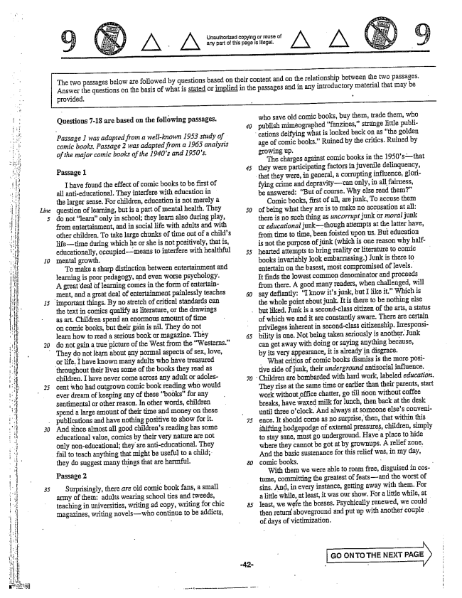

*10*

*20*

Unaulhorized copying or reuse of any part of this page is illegal,

The two passages below are followed by questions based on their content and on the relationship between the two passages. Answer the questions on the basis of what is stated or implied in the passages and in any introductory material that may be

provided.

Questions -18 are based on the following passages,

*Passage I was adapted from a well-known 1953 study of comic books. Passage 2 was adapted from a 1965 analysis of the major comic books of the 1940s and 1950s.*

Passage 1

I have found the effect of comic books to be first of all anti-educational. They interfere with education in the larger sense. For children, education is not merely a question of learning, but is a part of mental health. They do not learn" only in school; they learn also during play, from entertainment, and in social life with adults and with other children. To take large chunks of time out of a childs lifetime during which he or she is not positively, that is, educationally, occupiedmeans to interfere with healthful mental growth. -

To make a sharp distinction between entertainment and learning is poor pedagogy, and even worse psychology. A great deal of learning comes in the form of entertainment, and a great deal of entertainment painlessly teaches

important things. By no stretch of critical standards can

the text in comics qualify as literature, or the drawings as art. Children spend an enormous amount of time On comic books, but their gain is nil. They do not learn how to read a serious book or magazine. They do not gain a true picture of the West from the Westerns.”

They do not learn about any normal aspects of sex, love,

25

*30*

or life. I have known many adults who have treasured throughout their lives some of the books they read as children. I have never come across any adult or adolescent who had outgrown comic book reading who would ever dream of keeping any of these books" for any sentimental or other reason. In other words, children spend a large amount of their time and money on these publications and have nothing positive to show for it. And since almost all good childrens reading has some educational value, comics by their very nature are not only non-educational; they are anti-educational. They fail to teach anything that might be useful to a child; they do suggest manythings that are harmful.

Passage 2

Surprisingly, there are old comic book fans, a small army of them: adults wearing school ties and tweeds, teaching in universities, writing ad copy, writing for chic magazines, writing novelswho continue to be addicts,

who save old comic books, buy them, trade them, who publish miméographed fanzines,strange little publi

cations deifying what is looked back on as the golden

age of comic books.” Ruined by the critics. Ruined by

growing up.

The charges against comic books in the 1950sthat

they were participating factors in juvenile delinquency,

that they were, in general, a corrupting influence, glori

fying crime and depravitycan only, in all fairness, be answered: But of course. Why else read them”

Comic books, first of all, are junk. To accuse them of being what they are is to make no accusation at all: there is no such thing as uncorrupt junk or moral junk or educational junkthough attempts at the latter have, from time to time, been foisted upon us. But education is not the purpose of junk (which is one reason why halfhearted attempts to bring Teality or literature to comic books invariably look embarrassing.) Junk is there to entertain on the basest, most compromised of levels. It finds the lowest common denominator and proceeds from there. A good many readers, when challenged, will say defiantly: I know its junk, but I like it.” Which is the whole point about junk. It is there to be nothing else

but liked. Junk is a secondclass citizen of the arts, a status

of which we and it are constantly aware. There are certain privileges inherent in secondclass citizenship. Irresponsibility is one. Not being taken seriously is another. Junk can get away with doing or saying anything because, by its very appearance, it is already in disgrace,

What critics of comic books dismiss is the more positive side of junk, their underground antisocial influence.

Children are bombarded with hard work, labeled education.

They rise at the same time or earlier than their parents, start work without office chatter, go till noon without coffee breaks, have waxed milk for lunch, then back at the desk until three oclock. And always at someone elses convenience. It should come as no surprise, then, that within this shifting hodgepodge of external pressures, children, simply to stay sane, must go underground, Have a place to hide where they cannot be got at by grownups. A relief zone, And the basic sustenance for this relief was, in my day, comic books. -

With them we were able to roam free, disguised in costume, committing the greatest of featsand the worst of sins, And, in every instance, getting away with them. For a little while, at least, it was our show. For a little while, at least, we wife the bosses. Psychically renewed, we could then aboveground and put up with another couple of days of victimization.

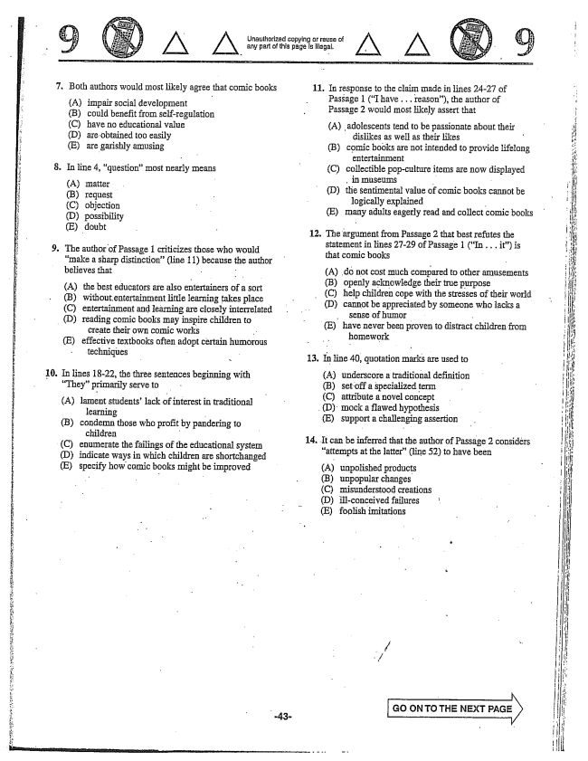

. Both authors would most likely agree that comic books

**10**

(A) (B)

impair social development could benefit from self-regulation (C) have no educational value (D) are obtained too easily (E) are garishly amusing

. In line , questionInost nearly means

(A) matter (B) request (C) objection

(D) possibility (E) doubt

The author of Passage 1 criticizes those who would make a sharp distinction(line 11) because the author believes that - -

A) the best educators are also entertainerS of a sort (B) without.entertainment little learning takes place (C) entertainment and learning are closely interrelated

(D) reading comic books may inspire children to

create their own comic works (E) effective textbooks often adopt certain humorous

techniques -

In lines 18-22, the three sentences beginning with They” primarily serve to

(A) lament students' lack of interest in traditional

learning - (B) condemn those who profit by pandering to

children - (C) enumerate the failings of the educational system (D) indicate ways in which children are shortchanged (E) specify how comic books might be improved

- Lnaulhorized copying or reuse of

any part of this page Is Illegal.

11. In response to the claim made in lines 2427 of

Passage 1 (I have .. reason), the author of Passage 2 would most likely assert that

(A) adolescents tend to be passionate about their

dislikes as well as their likes n (B) comic books are not intended to provide lifelong

entertainment (C) collectible pop-culture items are now displayed

, in Imuseums - (D) the sentimental value of comic books cannot be

logically explained - E) many adults eagerly read and collect comic books

12. The argument from Passage 2 that best refutes the

statement in lines 27-29 of Passage 1 (In . . . it) is that comic books

(A) do not cost much compared to other amusements (B) openly acknowledge their true purpose (C) help children cope with the stresses of their world (D) cannot be appreciated by someone who lacks a

sense of humor - E) have never been proven to distract children from

homework

13. În line 40, quotation marks are used to

underscore a traditional definition (B) set off a specialized term (C) attribute a novel concept

(D) mock a flawed hypothesis (E) support a challenging assertion

(A)

14. It can be inferred that the author of Passage 2 considers

attempts at the latter(line 52) to have been

(A) unpolished products (B) unpopular changes (C) misunderstood creations (D) illconceived failures t (E) foolish imitations

:

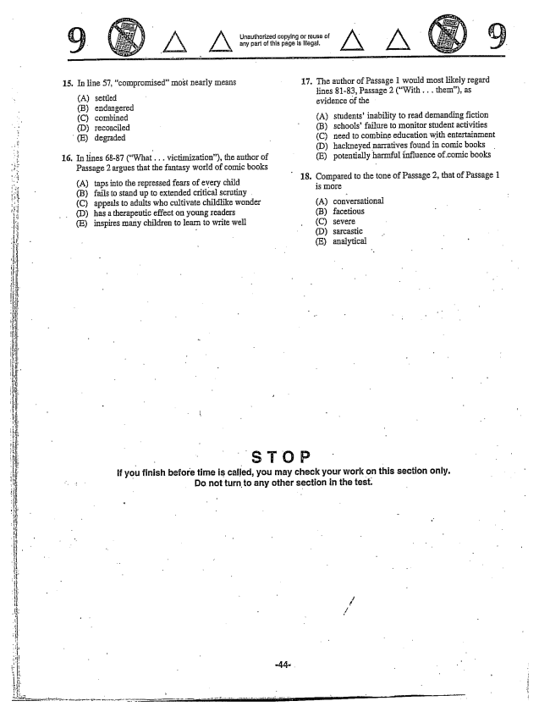

**-**

15.

**16.**

In line 57, compromisedInost nearly IIleans 17.

(A) settled (B) endangered (C) combined (D) reconciled

(E) degraded

In lines 68-87 (What. .. victimization), the author of

Passage 2 argues that the fantasy world of comic books (A) taps into the repressed fears of every child 18.

(B) fails to stand up to extended critical scrutiny . (C) appeals to adults who cultivate childlike wonder (D) has a therapeutic effect on young readers (E) inspires many children to learn to write well

Unauthorized cupying or tause of - - - any part of this page ls llegal.

The author of Passage 1 would most likely regard lines 81-83, Passage 2 (With .. them), as evidence of the

(A) students' inability to read demanding fiction (B) schoolsfailure to monitor student activities (C) need to combine education with entertainment (D) hackneyed narratives found in comic books . (E) potentially harmful influence of comic books

Compared to the tone of Passage 2, that of Passage 1 is IIlore

(A) conversational (B) facetious (C) severe (D) sarcastic - E) analytical

**you finish before time is called, you may check your work on this section . Do not turn to any other section in the test.**

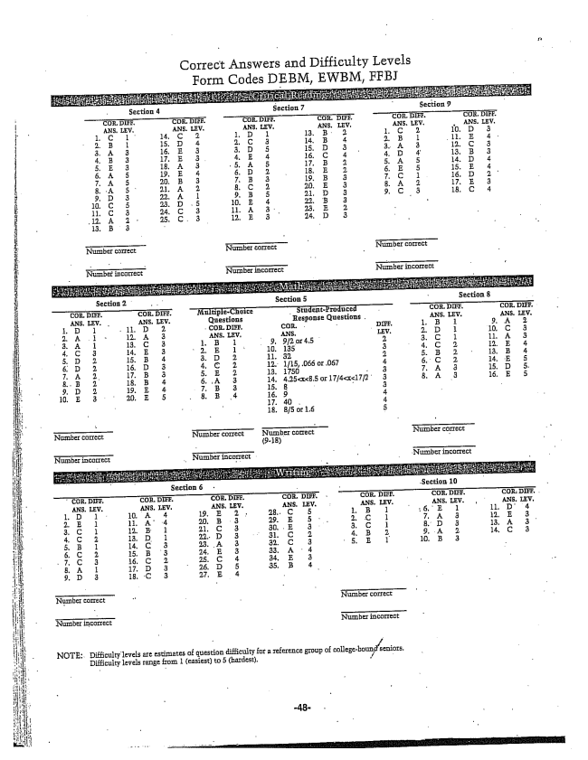

Correct Answers and Difficulty Levels Form Codes DEBM, EwBM, FFBI

Number correct Number correct

Number incorrect Number incorrect

NOTE: Difficulty levels are estimates of question difficulty for a reference group Df collegebounseniors,

Difficulty level5 range from 1 (easiest) to 5 (hardest. -