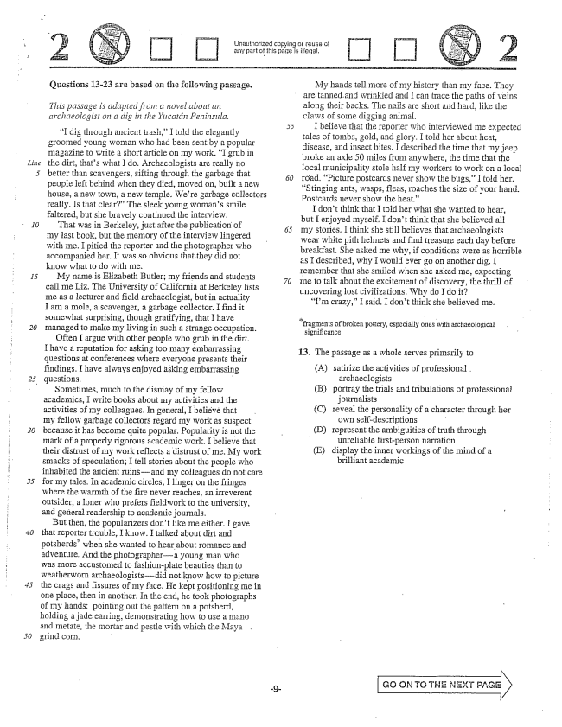

*Line*

*20*

Unauthorized copying or reuse of any part of this page is illegal,

Questions 1323 are based on the following passage.

*This passage is adapted froin a novel about aii archaeologist on a dig in the Yucatán Peninsula.*

I dig through ancient trash,” I told the elegantly groomed young woman who had been sent by a popular magazine to write a short article on my work. I grub in the dirt, thats what I do, Archaeologists are really no better than Scavengers, sifting through the garbage that people left behind when they died, moved on, built a new house, a new town, a new temple. Were garbage collectors really. Is that clear” The sleek young womans Smile faltered, but she bravely continued the interview.

That was in Berkeley, just after the publication of my last book, but the memory of the interview lingered with Ine. I pitied the reporter and the photographer who accompanied her. It was so obvious that they did not know what to do with me.

My name is Elizabeth Butler; my friends and students call me Liz. The University of California at Berkeley lists me as a lecturer and field archaeologist, but in actuality I am a mole, a scavenger, a garbage collector, I find it somewhat Surprising, though gratifying, that I have managed to Inake my living in Such a strange occupation.

Often I argue with other people who grub in the dirt. I have a reputation for asking too many embarrassing questions at conferences where everyone presents their findings. I have always enjoyed asking embarrassing questions.

Sometimes, much to the dismay of my fellow academics, I write books about my activities and the activities of my colleagues. In general, I believe that my fellow garbage collectors regard my work as suspect because it has become quite popular. Popularity is not the mark of a properly rigorous academic work. I believe that their distrust of my work reflects a distrust of me. My work Smacks of speculation; I tell stories about the people who inhabited the ancient ruinsand my colleagues do not care for my tales. In academic circles, I linger on the fringes where the warmth of the fire never reaches, an irreverent Outsider, a loner who prefers fieldwork to the university, and general readership to academic journals.

But them, the popularizers dont like me either. I gave that reporter trouble, I know. I talked about dirt potsherds" when she wanted to hear about romance and adventure, And the photographer--a young man who was more accustomed to fashionplate beauties than to weatherworn archaeologistsdid not know how to picture the crags and fissures of my face. He kept positioning me in One place, then in another. In the end, he took photographs of my hands; pointing out the pattern on a potsherd, holding a jade earring, demonstrating how to use a mano and metate, the mortar and pestle with which the Maya grind corn, -

My hands tell more of my history than my face. They are tanned.and wrinkied and I can frace the paths of veins along their backs. The nails are short and hard, like the claws of some digging animal.

I believe that the reporter who interviewed me expected tales of tombs, gold, and glory. I told her about heat, disease, and insect bites, I described the time that my jeep broke an axle 50 miles from anywhere, the time that the local municipality stole half my workers to work on a local road. Picture postcards never show the bugs,I told her. Stinging ants, wasps, fleas, roaches the size of your hand, Postcards never show the heat.”

I dont think that I told her what she wanted to hear, but I enjoyed myself. I don't think that she believed all my stories. I think she still believes that archaeologists wear white pith helmets and find treasure each day before breakfast. She asked Ine why, if conditions were as horrible as I described, why I would ever go on another dig. I remember that she smiled when she asked me, expecting me to talk about the excitement of discovery, the thrifl of uncovering lost civilizations. Why do I do it?

Im crazy,I said. I dont think she believed me.

**- - -**

fragments of broken pottery, especially ones with archaeological

significance

13. The passage as a whole serves primarily to

(A) satirize the activities of professional .

archaeologists

(B) portray the trials and tribulations of professional

journalists

(C) reveal the personality of a character through her

own self-descriptions -

D) represent the ambiguities of truth through

- unreliable firstperson narration

(E) display the inner workings of the mind of a

brilliant academic

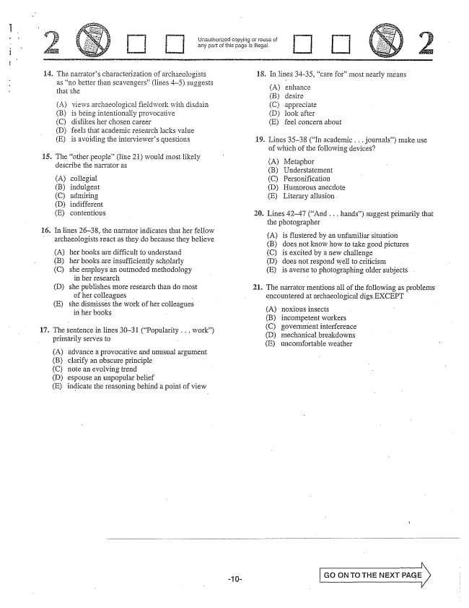

Lriauthorized copying réuse of any part of this page is illegal.

14. The narrators characterization of archaeologists

as no better than Scavengers” (lines ) suggests that she

(A) views archaeological fieldwork with disdain (B) is being intentionally provocative (C) dislikes her chosen career (D) feels that academic research lacks value (E) is avoiding the interviewers questions

15. The other people(line 21) would most likely

describe the narrator as

(A) còllegial (B) indulgent (Cadmiring (i)indifferent (E) contentious

fö. In lines 2638, the narrator indicates that her fellow archaeologists react as they do because they believe

(A) her books are difficult to understand

(B) her books are insufficiently scholarly

(C) she employs an outmoded methodology

in her research

(D) she publishes more research than do most

of her colleagues -

E) she dismisses the work of her colleagues

in her books

17. The sentence in lines 3031 (Popularity . . . work)

primarily serves to -

A) advance a provocative and unusual argumen (B) clarify an obscure principle C) note an evolving trend (D) espouse an unpopular belief (E) indicate the reasoning behind a point of view

18. In lines 34-35, care formost nearly means

(A) enhance (B) desire (C) appreciate (D) look after (E) feel concern about

19. Lines 3538 (In academic ..journals) make use

of which of the following devices?

(A) Metaphor (B) Understatement (C) Personification (i) Humorous anecdote (E) Literary allusion

20. Lines 4247 (And . . . hands) suggest primarily that

the photographer

(A) is flustered by an unfamiliar situation (B) does not know how to take good pictures (C) is excited by a new challenge (D) does not respond well to criticism (E) is averse to photographing older subjects .

21. The narrator mentions all of the following as problems

encountered at archaeological digs EXCEPT

(A) noxious insects (B) incompetent workers (C) government interference (D) mechanical breakdowns (E) uncomfortable weather

Go ON TO THE NEXT PAGE



Unauthorized copying relišć of any part of this page is illegal.

22. The tone of lines 63-64 (I don't

described as

(A) humble (B) inquisitive (C) diffident (D) didactic (E) cavalier

. . . myself) is best 23. In context, the reporter would probably characterize

the narrators remark in line 72 as

(A) pompous (B) deferential (C) despondent (D) flippant

if you finish before time is called, you may check your work on this section only.

Do not turn to any other section in the test.

**- f**

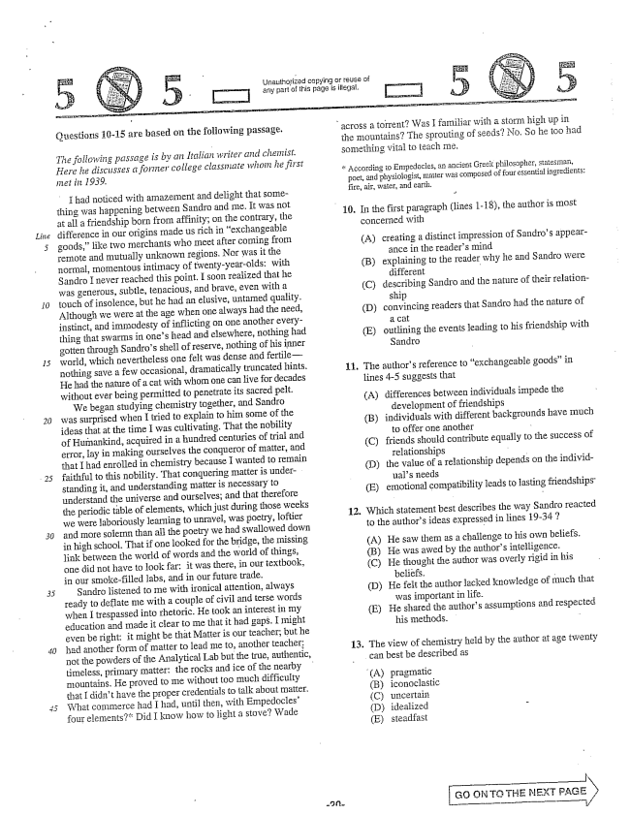

*Line*

*30*

}uestions 10-15 are based on the following passage.

*The following passage is by an Italian writer and chemist. Here he discusses a fortner college classmate whom he first*

I had noticed with amazement and delight that something was happening between Sandro and me. It was not at all a friendship born from affinity; on the contrary, the difference in our origins made us rich in exchangeable goods,like two merchants who meet after coming from remote and mutually unknown regions. Nor was it the normal, momentous intimacy of twenty-year-olds: with Sandro I never reached this point, I soon realized that he was generous, Subtle, tenacious, and brave, even with a touch of insolence, but he had an elusive, untamed quality. Although we were at the age when one always had the need, instinct, and immodesty of inflicting on One another everything that swarms in ones head and elsewhere, nothing had gotten through Sandros shell of reserve, nothing of his inner world, which nevertheless one felt was dense and fertilenothing save a few occasional, dramatically truncated hints. He had the nature of a cat with whom one can live for decades without ever being permitted to penetrate its sacred pelt.

We began studying chemistry together, and Sandro was surprised when I tried to explain to him some of the ideas that at the time I was cultivating, That the nobility of Humankind, acquired in a hundred centuries of trial and error, Iay in making ourselves the conqueror of matter, and that I had enrolled in chemistry because I wanted to remain faithful to this nobility. That conquering matter is underStanding it, and IInderstanding matter is necessary to understand the universe and ourselves; and that therefore the periodic table of elements, which just during those weeks we were laboriously learning to unravel, was poetry, loftier and more Soiernn than all the poetry we had swallowed down in high school. That if one looked for the bridge, the missing link between the world of words and the world of things, one did not have to look far: it was there, in our textbook, in Our Smokefilled labs, and in our future trade.

Sandro listened to me with ironical attention, always ready to deflate me with a couple of civil and terse words when I trespassed into rhetoric. He took an interest in my education and made it clear to me that it had gaps. I might even be right: it might be that Matter is our teacher; but he had another form of matter to lead me to, another teacher: not the powders of the Analytical Lab but the true, authentic, timeless, primary matter: the rocks and ice of the nearby mountains. He proved to me without too much difficulty that I didn't have the proper credentials to talk about matter. What conumerce had had, until then, with Empedocles" four elements” Did I know How to light a stove? Wade

Unauthorized copying or reuse of

any part of this page is illegal,

across a torrentWas I familiar with a storm high up in

the mountainsThe sprouting of seeds? No. So he too had something vital to teach me,

According to Empedocles, an ancient Greek philosopher, statesman,

poet, and physiologist, matter was composed of four essential ingredients: fire, air, water, and earth.

ع

10. In the first paragraph (lines 1-18), the author is most

concerned with

(A) creating a distinct impression of Sandros appear

ance in the readers mind

(B) explaining to the reader why he and Sandro were

different

(C) describing Sandro and the nature of their relation

ship

(D) convincing readers that Sandro had the nature of

1 CHf

(E) outlining the events leading to his friendship with

Sandro

The authors reference to exchangeable goods” in lines -5 suggests that

(A) differences between individuals impede the

development of friendships (B) individuals with different backgrounds have much

to offer one another - (C) friends should contribute equally to the success of

relationships (D) the value of a relationship depends on the individ

uals needs (E) emotional compatibility leads to lasting friendships:

**11.**

Which statement best describes the way Sandro reacted to the authors ideas expressed in lines 19-347

(A) He saw thern as a challenge to his own beliefs. (B) He was awed by the authors intelligence. (C) He thought the author was overly rigid in his

beliëfs. (D) He felt the author lacked knowledge of much that

was important in life. (E) He shared the authors assumptions and respected

his methods. -

The view of chemistry held by the author at age twenty can best be described as

(A) (B) (C) (D) (E)

13.

pragmatic

iconoclastic

uncertain

idealized - steadfast

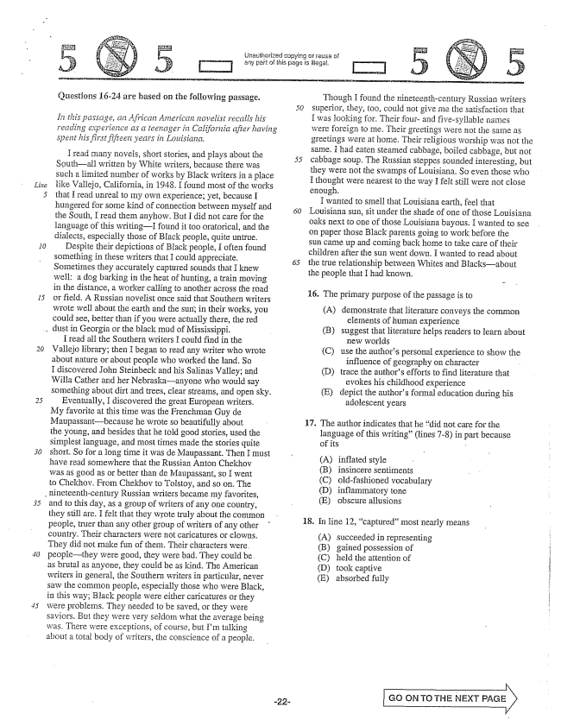

*Lin*

*15*

*30*

*.*

Questions 16-24 are based on the following passage.

*In this passage, an African American novelist recalls his reading experience as a teenager in California after having spent his first fifteen years in Louisiana,*

I read many novels, short stories, and plays about the 55

Southall written by White writers, because there was such a limited Turnber of works by Black writers in a place like Vallejo, California, in 1948. I found most of the works that I read unreal to my own experience; yet, because I hungered for some kind of connection between myself and 60 the South, I read them anyhow. But I did not care for the language of this writingI found it too oratorical, and the dialects, especially those of Black people, quite untrue.

Despite their depictions of Black people, I often found Something in these writers that I could appreciate. 65 Sometimes they accurately captured sounds that I knew well: a dog barking in the heat of hunting, a train moving in the distance, a worker calling to another across the road or field. A Russian novelist once said that Southern writers wrote well about the earth and the Sunin their works, you could see, better than if you were actually there, the red dust in Georgia or the black Inud of Mississippi.

I read all the Southern writers I could find in the Vallejo library; then I began to read any writer who wrote about nature or about people who worked the land. So I discovered John Steinbeck and his Salinas Valley; and Willa Cather and her Nebraskaanyone who would say something about dirt and trees, clear streams, and open sky.

Eventually, I discovered the great European writers. My favorite at this time was the Frenchman Guy de Maupassant-because he wrote so beautifully about the young, and besides that he told good stories, used the simplest language, and most times made the stories quite short. So for a long time it was de Maupassant. Then I must have read somewhere that the Russian Anton Chekhov was as good as or better than de Maupassant, so I went to Chekhov. From Chekhov to Tolstoy, and so on. The

, nineteenth-century Russian writers became my favorites,

and to this day, as a group of Writers of any OIle country, they still are. I felt that they wrote truly about the common people, truer than any other group of writers of any other country. Their characters were not caricatures or clowns. They did not make fun of them. Their characters were. peoplethey were good, they were bad. They could be. as brutal as anyone, they could be as kind. The American writers in general, the Southern writers in particular, never saw the common people, especially those who were Black, in this way; Black people were either caricatures or they were problems. They needed to be saved, or they were saviors. But they were very seldom what the average being was. There were exceptions, of course, but Im talking about a total body of writers, the conscience of a people.

Urlauthorized copying or réuse of

[L] any part of this page is illegal,

Though I found the nineteenth-century Russian writers superior, they, too, could not give më the satisfaction that I was looking for. Their four- and five-syllable names were foreign to me. Their greetings were not the same as greetings were at home. Their religious worship was not the Same, I had eaten Steamed cabbage, boiled cabbage, but not cabbage Soup. The RIISSian Steppes sounded interesting, but they were not the swamps of Louisiana. So even those who I thought were nearest to the way I felt still were not close enough.

I wanted to smell that Louisiana earth, feel that Louisiana Sun, sit under the shade of one of those Louisiana oaks next to one of those Louisiana bayous. I wanted to see on paper those Black parents going to work before the Sun came up and coming back home to take care of their children after the Sun went down. I wanted to read about the true relationship between Whites and Blacksabout the people that I had known.

16. The primary purpose of the passage is to

(A) demonstrate that literature conveys the common

elements of human experience

(B) suggest that literature helps readers to learn about

new worlds

(C) use the authors personal experience to show the

influence of geography on character

(D) trace the authors efforts to find literature that

evokes his childhood experience

(E) depict the authors formal education during his

adolescent years

The author indicates that he did not care for the Hanguage of this writing(Hines -8) in part because of its

17.

(A) (B) (C) (D) (E)

inflated style insincere sentiments oldfashioned vocabulary inflammatory tone obscure allusions

In line 12, captured” most nearly means

(A) (B) (C) (D) (E)

18.

succeeded in representing gained possession of held the attention of took captive absorbed fully

Go ON To THE NEXT PAGE

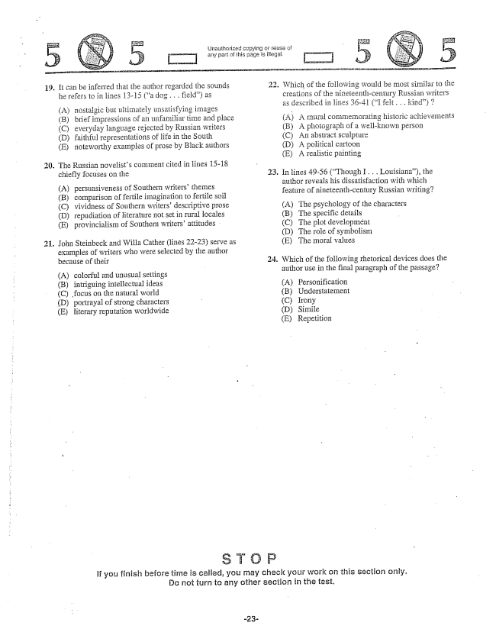

19. It can be inferred that the author regarded the Sounds

he refers to in lines 13-15 (a dog , , , field) as

(A) nostalgic but ultimately unsatisfying images (B) brief impressions of an unfamiliar time and place (C) everyday language rejected by Russian writers (D) faithful representations of life in the South (E) noteworthy examples of prose by Black authors

. The Russian novelists comment cited in lines 15-18

chiefly focuses on the

(A) persuasiveness of Southern writers' themes (B) comparison offertile imagination to fertile soil (C) vividness of Southern writers' descriptive prose (D) repudiation of literature not set in rural locales (E) provincialism of Southern writers' attitudes

. John Steinbeck and Willa Cather (lines 2223) serve as

examples of writers who were selected by the author because of their

(A) colorful and unusual settings (B) intriguing intellectual ideas (C) focus on the natural world (D) portrayal of strong characters (E) literary reputation worldwide

Unauthorized copying or reuse of

III] any part this page is illegal,

22. Which of the following would be most similar to the

creations of the nineteenth-century Russian writers as described in lines 36-41 (I felt. . . kind) 7

(A) A mural commemorating historic achievements (B) A photograph of a well-known person (C) An abstract Sculpture

(D) A political cartoon

(E) A realistic painting

In lines 49-56 (Though I. . . Louisiana), the author reveals his dissatisfaction with which feature of nineteenth-century Russian writing?

(A) The psychology of the characters (B) The specific details (C) The plot development (D) The role of symbolism (E) The moral values

. Which of the following rhetorical devices does the

If you finish before time is called, you may check your work on this section only. Do not turn to any other section in the test.

author use in the final paragraph of the passage?

(A) Personification (B) Understatement (C) Irony (D) Simile (E) Repetition

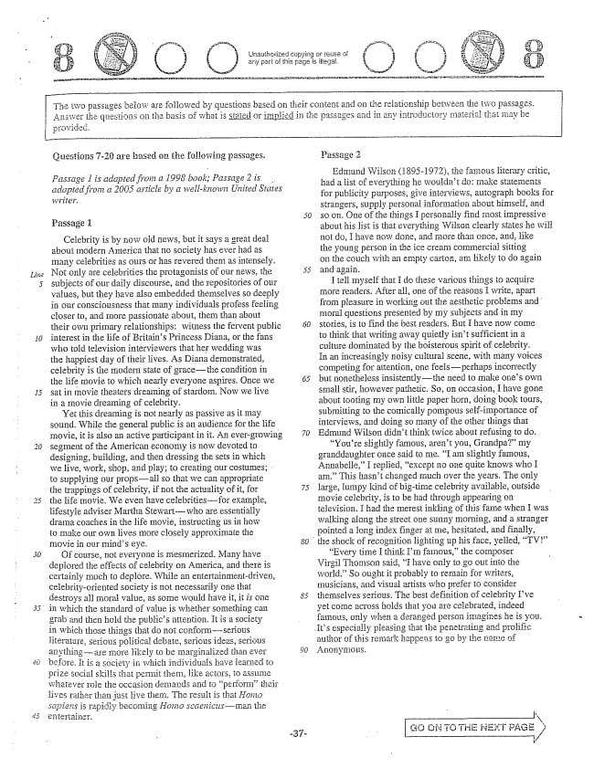

Urlauthorized or retise of any part of this page is illegal,

Questions -are based on the following passages.

*Passage 1 is adapted from a 1998 book; Passage 2 is . adapted from a 2005 article by a well-known United States Wiiter.*

Celebrity is by now old news, but it says a great deal about modern America that no society has ever had as many celebrities as ours or has revered them as intensely. Not only are celebrities the protagonists of our news, the subjects of our discourse, and the repositories of our values, but they have also embedded themselves so deeply in our consciousness that many individuals profess feeling closer to, and more passionäte about, them than about their own primary relationships: witness the fervent public interest in the life of Britains Princess Diana, or the fans who told television interviewers that her wedding was the happiest day of their lives. As Diana demonstrated, celebrity is the modern state of gracethe condition in the life movie to which nearly everyone aspires. Once we sat în movie fheaters dreaming of stardom, Now we live in a movie dreaming of celebrity.

Yet this dreaming is not nearly as passive as it may sound. While the general public is an audience for the life movie, it is also an active participant in it. An evergrowing Segment of the American economy is now devoted to designing, building, and then dressing the sets in which we live, work, shop, and play; to creating our costumes; to supplying Our propsall so that we can appropriate the trappings of celebrity, if not the actuality of it, for the fife movie. We even have celebritiesfor example, lifestyle adviser Martha Stewartwho are essentially drama coaches in the fife movie, instructing us in how to make our own lives more closely approximate the movie in our minds eye.

Of course, not everyone is Inesmerized. Many have deplored the effects of celebrity on America, and there is Certainly much to deplore. While an entertainmentdriven, £elebrityoriented society is not necessarily one that destroys all moral value, as some would have it, it is one

in which the standard of value is whether something can

grab and then hold the publics attention. It is a society in which those things that do not conformserious literature, serious poiitical debate, serious ideas, serious anythingare more likely to be marginalized than ever before. It is a society in which individuals have learned to Prize Social skills that permit them, like actors, to assume whatever role the occasion demands and to performtheir lives rather than just live them. The result is that Hoing sapiens is rapidly becoming Hojno Scaenicits--man the

**-**

The two passages below are followed by questions based on their content and on the relationship between the two passages. Answer the questions on the basis of what is stated or implied in the passag

es āfici in any introductory matērial that may be

Passage 2

Edmund Wilson (18951972), the famous literary critic, had a list of everything he wouldnt do: make statements for publicity purposes, give interviews, autograph books for strangers, Supply personal information about himself, and so on. One of the things I personally find most impressive about his list is that everything Wilson clearly states he wili not do, I have now done, and more than once, and, like the young person in the ice cream commercial sitting on the colich with an empty carton, am likely to do again and again.

I tell myself that I do these various things to acquire more readers. After all, one of the reasons ; write, apart from pleasure in working out the aesthetic problems and moral questions presented by my subjects and in my stories, is to find the best readers. But I have now come to think that writing away quietly isnt sufficient in a culture dominated by the boisterous spirit of celebrity. In an increasingly noisy cultural scene, with many voices competing for attention, one feelsperhaps incorrectly but nonetheless insistentlythe need to make ones own small stir, however pathetic. So, on occasion, I have gone about tooting my own little paper horn, doing book tours, Submitting to the comically pormpotis Self-importance of interviews, and doing SQ many of the other things that Edmund Wilson didnt think twice about refusing to do.

Youre slightly famous, arent you, Grandpa” my granddaughter once said to me. I am slightly famous, Annabelie,I replied, except no one quite knows who I an” This hasnt changed Inuch over the years. The only large, lumpy kind of bigtime celebrity available, outside movie celebrity, is to be had through appearing on television. I had the merestinkling of this fame when I was walking along the Street one sunny morning, and a stranger pointed a long index finger at me, hesitated, and finally,

the shock of recognition lighting up his face, yelled, TV”

“Every time I think IIn fainous,the composer Virgil Thornson said, I have only to go out into the world.” So ought it probably to remain for writers, musicians, and visual artists who prefer to consider themselves serious. The best definition of celebrity fve yet come across holds that you are celebrated, indeed famous, Only when a deranged person imagines he is you.

. Its especially pleasing that the penetrating and prolific

author of this remark happens to go by the Ilarize of Anonymous.

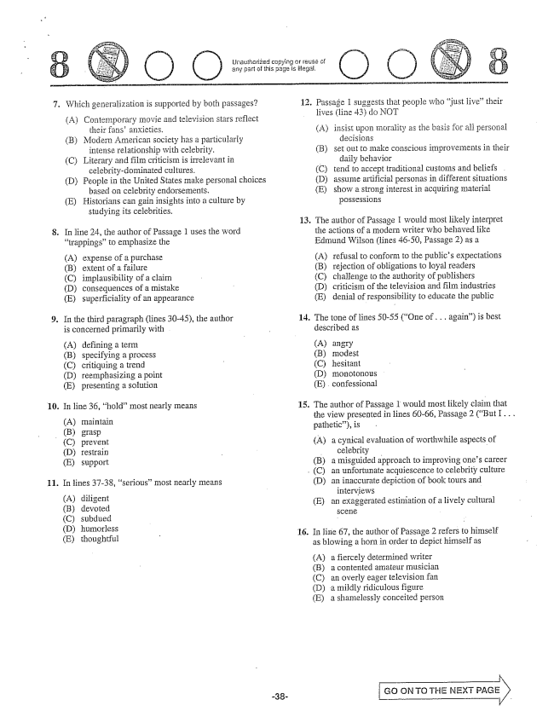

Unauthorized copying rause of any part of this page is ilegal.

7.

10.

(C)

**11.**

Which generalization is supported by both passages?

(A) Contemporary movie and television stars reflect

their fans' anxieties.

(B) Modern American Society has a particularly

intense relationship with ceiebrity.

(C) Literary and film criticism is irrelevant in

celebrity-dominated cultures.

(D) People in the United States make personal choices

based on celebrity endorsements.

(E) Historians can gain insights into a culture by

studying its celebrities.

. In line 24, the author of Passage 1 uses the word

trappings” to emphasize the

(A) (B) (C) (D) (E)

In the third paragraph (lines 30-45), the author is concerned primarily with

(A) (B) (C) (D) (E)

In line 36, hold” most nearly means

(A) (B)

expense of a purchase extent of a failure implausibility of a claim consequences of a mistake superficiality of an appearance

defining a term specifying a process critiquing a trend reemphasizing a point presenting a Solution

maintain

grasp prevent restrain Տաpport

(D) (E)

In lines 37-38, serious” most nearly means

(A) diligent (B) devoted (C) Subdued (D) humorless (E) thoughtful

12.

**13,**

**14.**

16.

Passage 1 suggests that people who just live” their lives (line 43) do NOT

(A) insist upon Inorality as the basis for all personal

decisions

(B) Set out to make conscious improvements in their

(faily behavior

(C) tend to accept traditional customs and beliefs .

(D) assume artificial personas in different situations

(E) show a strong interest in acquiring material

possessions

The author of Passage I would most likely interpret the actions of a modern writer who behaved like Edmund Wilson (lines 46-50, Passage 2) as a

(A) (B) (C) (D) (E)

The tone of lines 50-55 (One of . . . again) is best

described as

(A) (B)

refusal to conform to the publics expectations rejection of obligations to loyal readers challenge to the authority of publishers criticism of the television and film industries denial of responsibility to educate the public

angry modest (C) hesitant (D) monotonous (E) confessional

. The author of Passage 1 would most Hikely claim that

the view presented in lines 60-66, Passage 2 (But I . . . pathetic), is

(A) a cynical evaluation of worthwhile aspects of

celebrity -

a misguided approach to improving ones career

an unfortunate acquiescence to celebrity culture

an inaccurate depiction of book tours and

interviews

an exaggerated estimation of a lively cultural

(В)

(D)

(E)

In line 67, the author of Passage 2 refers to himself as blowing a horn in order to depict himself as

(A) a fiercely determined writer (B) a contented amateur musician (C) an overly eager television fan (D) a mildly ridiculous figure (E) a shamelessly conceited person

GO ON TO THE INEXT PAGE

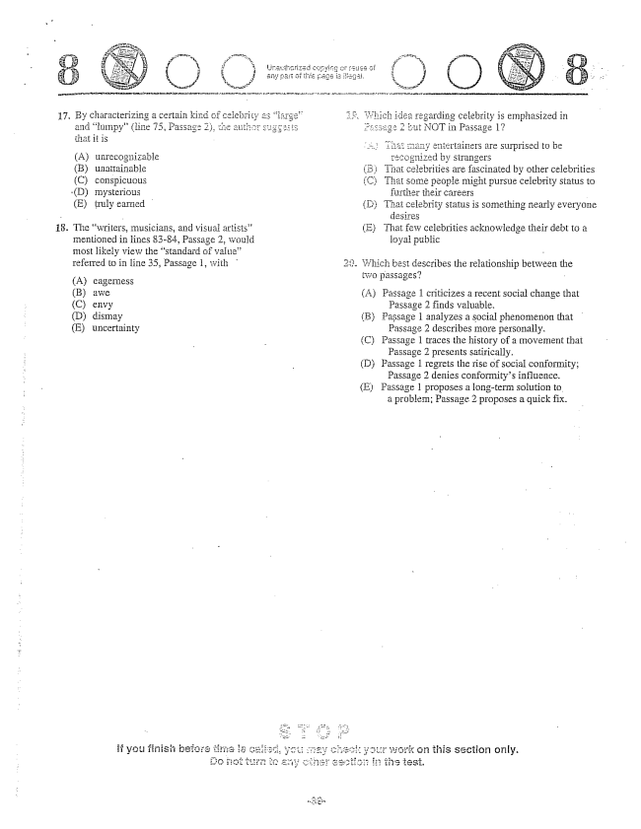

By chârâcterizing a cer and lumpy” (line 75, that it is

(A) unrecognizable (B) linattainable (C) conspicuous

(D) mysterious

(E) truly earned

. The writers, musicians, and visual artists”

mentioned in lines 83-84, Passage 2, would most likely view the standard of value” referred to in line 35, Passage I, with

Aeagerness (B) awe (C) envy (D) dismay Euncertainty

£rtainers are surprised to be

Strangers That celebrities are fascinated by other celebrities some people might pursue celebrity status to further their careers (D) Thai celebrity status is something nearly everyone

dësires

(E) That few celebrities acknowledge their debt to a

loyai public

Which best describes the relationship between the two passages? -

A) Passage 1 criticizes a recent social change that

Passage 2 finds valuable. BPassage 1 analyzes a social phenomenon that Passage 2 describes more personally. (C) Passage 1 traces the history of a IIIovement that

Passage 2 presents satirically. (D) Passage 1 regrets the rise of social conformity;

Passage 2 denies conformitys influence. (E) Passage 1 proposes a longterm solution to

a problem; Passage 2 proposes a quick fix.

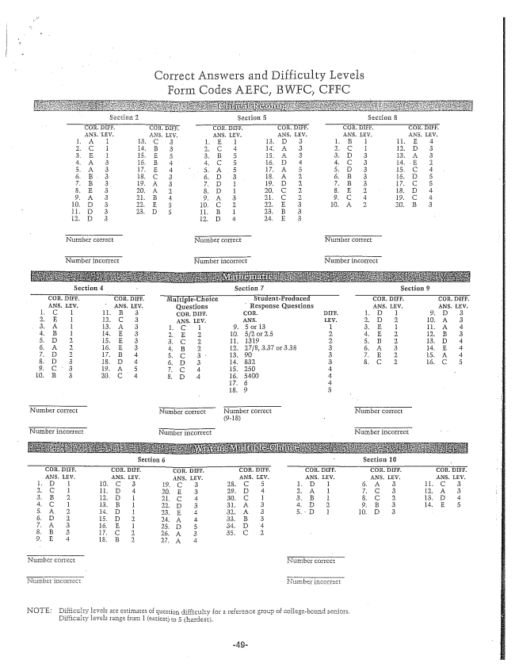

Correct Answers and Difficulty Levels Form Codes AEFC, BWFC, CFFC

Nurther correct bjumber correct

Nutribër incorrect Number incorrect

NOTE: Difficulty ièvels are estimates of question difficulty for a reference group of collegebound seniors.

Difficulty levels range from 1 (easiest) to 5 (hardest.