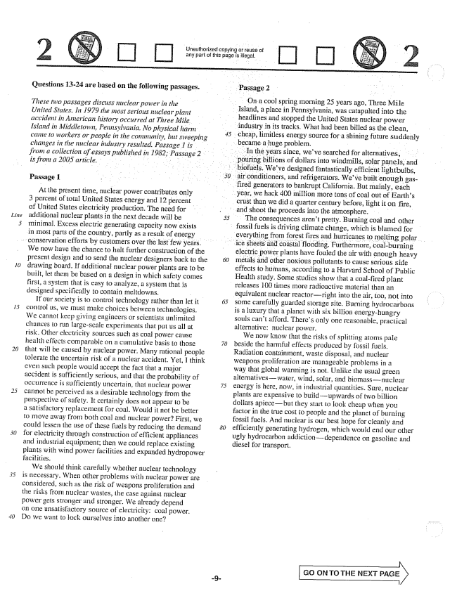

*fling*

Unauthorized copying or reuse of arly part of this page is illegal.

**Questions 13-24 are based on the following passages.**

*These two passages discuss nuclear power in the United States. In 1979 the most serious nuclear plant accident in American history occurred at Three Mile. Island in Middletown, Pennsylvania. No physical harm . came to workers or people in the cominunity, but sweeping changes in the nuclear industry resulted. Passage 1 is . . from a collection of essays published in 1982; Passage 2 is from a 2005 article.*

Passage 1

At the present time, nuclear power contributes only 3 percent of total United States energy and 12 percent of United States electricity production. The need for additional nuclear plants in the next decade will be minimal. Excess electric generating capacity now exists in most parts of the country, partly as a result of energy

conservation efforts by customers over the last few years.

We now have the chance to halt further construction of the present design and to send the nuclear designers back to the drawing board. If additional nuclear power plants are to be built, let them be based on a design in which safety comes first, a system that is easy to analyze, a system that is designed specifically to contain meltdowns. -

If our society is to control technology rather than let it control us, we must make choices between technologies. We cannot keep giving engineers or scientists unlimited chances to run largescale experiments that put us all at risk. Other electricity sources such as coal power cause health effects comparable on a cumulative basis to those that will be caused by nuclear power. Many rational people tolerate the uncertain risk of a nuclear accident. Yet, I think even such people would accept the fact that a major accident is sufficiently serious, and that the probability of occurrence is sufficiently uncertain, that nuclear power cannot be perceived as a desirable technology from the perspective of safety. It certainly does not appear to be a satisfactory replacement for coal. Would it not be better to move away from both coal and nuclear power? First, we could lessen the use of these fuels by reducing the demand for electricity through construction of efficient appliances and industrial equipment; then we could replace existing plants with wind power facilities and expanded hydropower facilities.

We should think carefully whether nuclear technology is necessary. When other problems with nuclear power are considered, such as the risk of weapons proliferation and the risks from nuclear wastes, the case against nuclear power gets stronger and stronger. We already depend on one unsatisfactory source of electricity: coal power. Do we want to lock ourselves into another one?

- Passage 2

On a cool spring morning 25 years ago, Three Mile

Island, a place in Pennsylvania, was catapulted into the headlines and stopped the United States nuclear power industry in its tracks. What had been billed as the clean,

became a huge problem.

cheap, limitless energy source for a shining future suddenly

In the years since, weve searched for alternatives, uring billions of dollars into windmills, solar panels, and

biofuels. Weve designed fantastically efficient lightbulbs, air conditioners, and refrigerators. Weve built enough gasfired generators to bankrupt California. But mainly, each year, we hack 400 million more tons of coal out of Earths crust than we did a quarter century before, light it on fire, . . . and shoot the proceeds into the atmosphere. -

55

The consequences arent pretty. Burning coal and other fossil fuels is driving climate change, which is blamed for everything from forest fires and hurricanes to melting polar

ice sheets and coastal flooding. Furthermore, coalburning

electric power plants have fouled the air with enough heavy metals and other noxious pollutants to cause serious side effects to humans, according to a Harvard School of Public Health study. Some studies show that a coalfired plant releases 100 times more radioactive material than an

equivalent nuclear reactorright into the air, too, not into

some carefully guarded storage site. Burning hydrocarbons is a luxury that a planet with six billion energyhungry Souls cant afford. Theres only one reasonable, practical alternative: nuclear power.

We now know that the risks of splitting atoms pale beside the harmful effects produced by fossil fuels. Radiation containment, waste disposal, and nuclear weapons proliferation are manageable problems in a way that global warming is not. Unlike the usual green alternativeswater, wind, solar, and biomassnuclear energy is here, now, in industrial quantities. Sure, nuclear plants are expensive to build-upwards of two billion dollars apiecebut they start to look cheap when you factor in the true cost to people and the planet of burning fossil fuels. And nuclear is our best hope for cleanly and efficiently generating hydrogen, which would end our other ugly hydrocarbon addictiondependence on gasoline and diesel for transport.

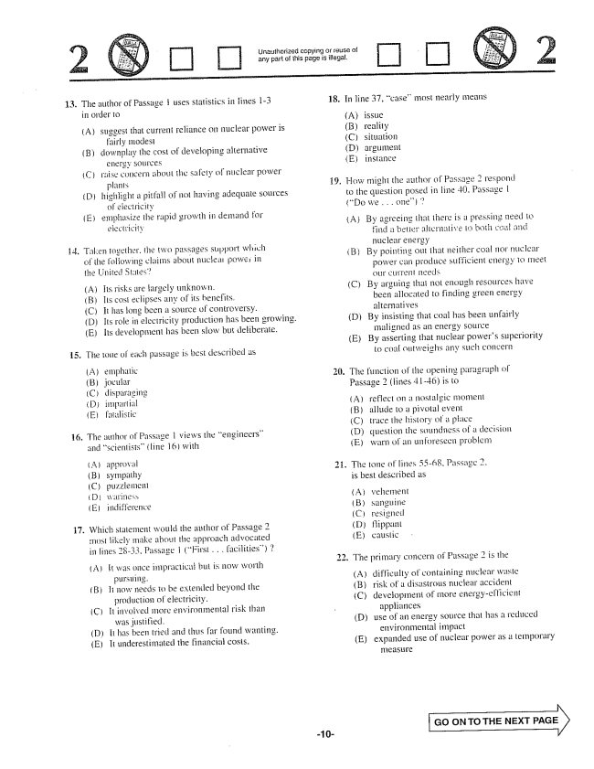

Unauthorized cr reuse of any part of this page is illegal.

13. The author of Passage uses statistics in fines 1-3

in order to

(A) suggest that current reliance on nuclear power is

fairly modesi

downplay the cost of developing alternative

energy sources

raise concern about the safety of nuclear power

plants

highlight a pitfail of not having adequate Sources

of eiecificity

emphasize the rapid growth in demand for

electricity

. Taken together, the two passages support which

17.

of the following claims about nuclear power in the United Stilles”

(A) Its risks are largely unknown. (B) Its cost eclipses any of its benefits. (C) It has long been a source of controversy.

(D) Its role in electricity production has been growing.

(E) Its development has been slow but deliberate.

The totle of each passage is best described as

(A) emphalie (B) jocular (C) dispăraging (D) imparțial (E) faialistic

The author of Passage 1 views the engineers” and Scientists” (line 16) with

(A) apprøväl (B) sympathy (C) puzzlement ( Diriness, E) indifference

Which stalement would the author of Passage 2 most likely make about the approach advocated in lines 28-33, Passage i (First . . . facilities)

(AIt was once impractical but is now Worth

pursuing. (B) li Ilow needs to be extended beyond the

production of electricity. (C) II invoi ved more environmental risk than

was justified. (D) It has been tried and thus found wanting. (E) It underestimated the financial costs.

-10

18.

19

In line 37, case” most nearly means

A(B) (C) (D) (E)

reality situation argument instance

How might the author of Passage 2 respond to the question posed in lime 40, Passage | (Do we . . . one)

ABy agreeing that there is a pressing need to

find a better alscrilative to both coal and nuclear energy (B) By pointing out that neither coal nor nuclear

power can produce sufficient energy to meet (C) By arguing that not enough resources have

been allocated to finding green energy alternatives (DBy insisting that coal has been unfairly maligned as an energy Source (E) By asserting that nuclear powers Superiority to coal outweighs any such concern

The function of the opening paragraph of Passage 2 (lines 41-46) is to

(A) reflect on a nostalgic moment (B) allude to a pivotal event (C) trace the history a piace (D) question the soundness of a decision Ewarn of an unsoreseen problem

. The tone of lines 5568. Passage 2.

is best described as

anguine resigned Пірранl caustic

The primary concern of Passage 2 is the

(A) (C)

difficulty of containing nuclear waste

risk of a clist1strous nuclear accident

development of more energy-esficient

appliances

use of an energy source that has a reduced

environmental impact

expanded use of nuclear power as a temporary

::

(D)

(E)

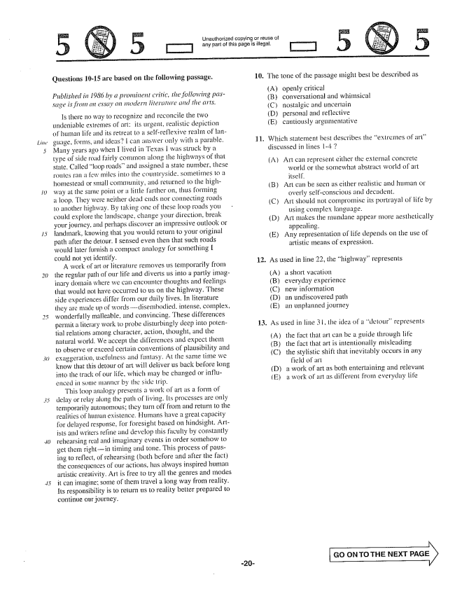

Unauthorized copying or reuse of

[T] any part of this page is illegal.

[T]

**Questions 10-15 are based on the following passage.**

*Published in 1986 by a pronuinent critic, the following passage is from an essay on modern literature and the arts.*

Is there no way to recognize and reconcile the two undeniable extremes of art: its urgent, realistic depiction of human Hife and its retreat to il Seifreflexive realm of language, forms, and ideas? I can alswer Gilly with a parable, Many years ago when I lived in Texas I was struck by a type of side road fairly common along the highways of that state. Called loop roads” and assigned a state number, these routes ran a few miles into the countryside, sometimes to a homestead or small community, and returned to the highway at the same point or a little farther on, thus forming a loop. They were neither dead ends hor connecting roads to another highway. By taking one of illese loop roads you could explore the landscape, change your direction, break your journey, and perhaps discover an impressive outlook or landmark, knowing that you would return to your original path after the detour. I sensed even then that such roads would later furnish a compact analogy for something I could not yet identify.

A work of art or literature removes us temporarily from the regular path of our life and diverts us into a partly imaginary domain where we can encounter thoughts and feelings that would not have occurred to us on the highway. These side experiences from our daily lives. In literature they are made up of wordsdisembodied, intense, complex, wonderfully malleable, and convincing. These differences permit a literary work io probe disturbingly deep into polential relations among character, action, thought, and the natural world. We accept the differences and expect them to observe or exceed certain conventions of plausibility and exaggeration, usefulness and fantasy. At the same time we know that this detour of art will deliver us back before long into the track of our life, which may be changed or influemced iri some maniler by Ille side trip.

This loop analogy presents a work of art as a form of delay or relay along the path of living. Its processes are only temporarily autonomous; they turn off from and return to the realitics of human existence. Humans have a great capacity for delayed response, foresight based on hindsight. Artisis and writers refine and develop this faculty by constantly rehearsing real and imaginary events in order Somehow to get them right-in timing and tone. This process of pausing to reflect, of rehearsing (both before and after the fact) the consequences of our actions, has always inspired human artistic creativity. Art is free to try all the genres and modes it can imagine; some of them travel a long way from reality, Its responsibility is to return us to reality better prepared to continue our journey.

16. The tone of the passage inight best be described as

(A) openly critical

(B) conversational and whimsical (C) nostalgic and uncertain D) personal and reflective

11. Which Statement best describes the extremes of art

discussed in lines 1-4 2 (A) Art can represent either the external concrete world or ille somewhat abstract world of art (B) Art can be seen as either realistic and human or

overly self-conscious and decadent. (C) Art should not compromise its portrayal of ife by

using complex language. (D) Art Imakes the Islundane appear more aesthetically

appealing. (E) Any representation of Hife depends on the use of

artistic means of expression.

12. As used in line 22, the highway” represents

(A) a short vacation (B) everyday experience (C) new information (D) an undiscovered path (E) an unplanned journey

13. As used in line 3 l, the idea of a detour” represents

(A) the fact that art can be a guide through life (B) the fact that art is intentionally misleading (C) the stylistic shift that inevitably occurs in any

field of art a work of art as both entertaining and relevant a work of art as different from everyday life

(D) (E)

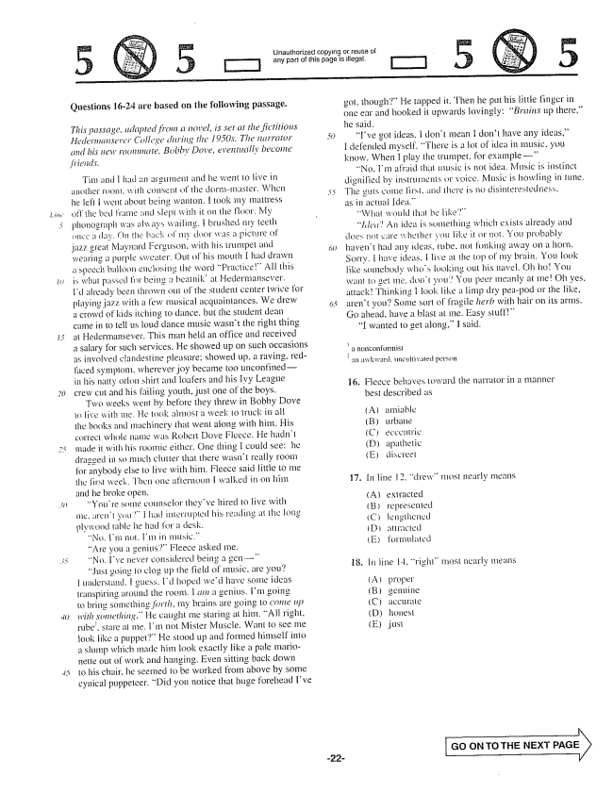

*line*

*:*

5

Unauthorized copying or reuse of

any part of this page is illegal.

Questions 16-24 are based on the following passage.

*This passage, adapted froin a novel, is set at the fictitious Hedermansever College during the 1950s. The narrator and his new roommate, Bobby Dove, eventually become*

*friends,*

TIM Incil hud Än argument und he went to live in ałłother room, will conseill the dormmaster. When he left I went about being wanton, I took my mattress off the bell frame and slept with it on the floor. My phonograph was always wailing, brushed my teeth (Hee a day. On the back of my door was a picture of jazz great Maynard Ferguson. with his trumpet and wearing a purple sweater. Out of his mouth I had drawn a speech bailotin enclosing the word Practice” All this is what passed for being a beatnikat Hedermansever. Id already been ; out of the student center twice for playing jazz with a few musical acquaintances. We drew a crowd of kids itching to dance, but the student dean came in to tell us loud dance music wasnt the right thing at Hedermansever. This man held an office and received a salary for such services. He showed up on such occasions as involved clandestine pleasure: showed up, a raving. redfaced symptom, whereverjoy became too unconfinedin his matty orlon shirt and loafers and his Ivy League crew cut and his sailing youth, just one of the boys.

Two weeks went by before they threw in Bobby Dove to live with me, lie took aimost a Week to truck in all the books and machinery that went along with him. His correct whole name was ikolier Dove Fleece. He hadn't made it with his roomie either. One thing I could see: he dragged in so much clutter that there wasnt really room for anybody else 10 live with him. Fleece said little to me tle first week. Then one afternoon I Walked in on him and be broke open.

Youre some counselor theyve hired to live with me. aren i ti i had interrupted his reading at the long plywood table he had for a desk.

"Nei, lIn nol. Im in music.” “Are you a genius” Fleece asked me. "No, Ive never considered being a gen – Just going to clog up the field of music, are you? transpiring around the room. I am a genius. Im going to bring something forth, my brains are going to come up with something.” He caught me staring at him. All right, rube, stare al me. Im not Mister Muscle. Want to see me look like a puppet” He stood up and formed himself into a slump which made him look exactly like a pale marionette out of work and hanging. Even sitting back down to his chair, he seemed to be worked from above by some cynical puppeteer. Did you notice that huge forehead Ive

got, though" He tapped it. Then he put his little finger in one ear and hooked it upwards lovingly: Brains up there.he said.

Ive got ideas. I don't mean I don't have any ideas,” I defended myself. There is a lot of idea in music, you know. When I play the trumpet, for example

“No. Im afraid that Illusic is not idea. Music is instinct dignified by instruments or voice. Music is howling in tune. The guts corne first, and ihere is no disinterestedness, as in actuai Idea."

“ldedAn idea is something which exists already and døes care whether you like it or mot. You probably havent had any ideas, rube, not fonking away on a horn. Sorry. Hilave ideas, I live at the of my brain. You jook like somebody whos looking out his havel. Oh HoYou want to get me. don't you! You peer IIleanly at meOh yes, attackThinking I look like a limp dry peapod or the like, arent you? Some sort of fragile herb with hair on its arms. Go ahead, have a blast at me. Easy stuff”

“I wanted to get along.” I said.

***-***

a Ildtycomfwrimisi an awkward. uncultivated person

16. Fleece behaves toward the narrator in a manner

best described as

amiahle Lirballë eccentric apathetic

most nearly means

representelengthened ättracted formulated

18. In line 14, right” most nearly means

(B) (C) (D) (E)

**GO ON TO THE NEXT PAGE**

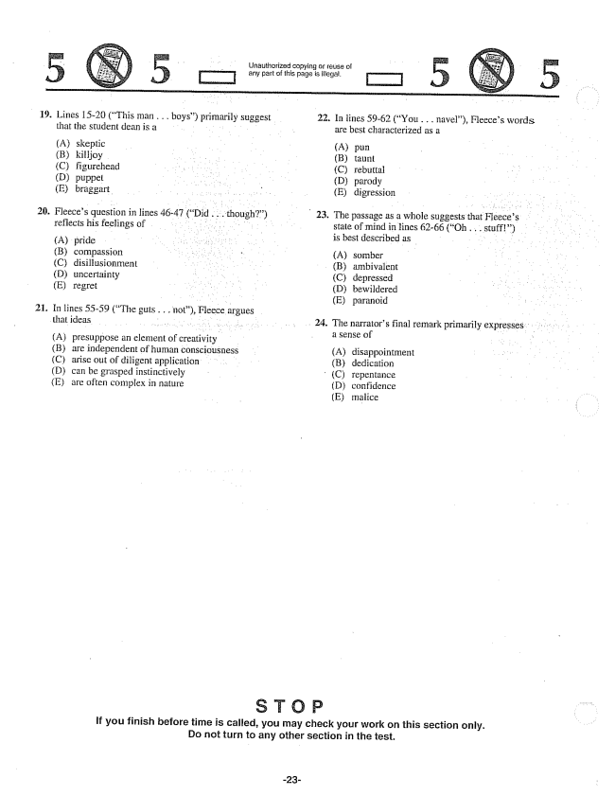

o - Unauthorized copying or of - - D any part of this page is illegal.

19. Lines 15-20 (This man . . . boys) primarily suggest 22. In lines 59-62 (You . . . navel), Fleeces words

that the student dean is a are best characterized as a (A) skeptic - - (A) pun (B) killjoy (B) taunt C) figurehead - C) rebuttal (D) puppet - . . (D) parody (E) braggart - - E) digression

20. Fleeces question in fines 46-47 (Did ... though) . 23. The passage as a whole suggests that Fleeces ..

. . . . .

reflects his feelings of . . . . .

- - - - is best described as

(A) pride - . , - B) compassion (A) somber

(C) disillusionment (B) ambivalent (D) uncertainty (C) depressed (E) regret . . . . - (D) bewildered

- E) paranoid 21. In lines 55-59 (The guts... not), Fleece argues

that ideas 24. The narrators final remark primarily expresses

- - a sense of (A) presuppose an element of creativity (B) are independent of human consciousness (A) disappointment (C) arise out of diligent application (B) dedication (D) can be grasped instinctively - C) repentance (E) are often complex in nature (D) confidence

(E) malice

if you finish before time is called, you may check your work on this section only. Do not turn to any other section in the test.

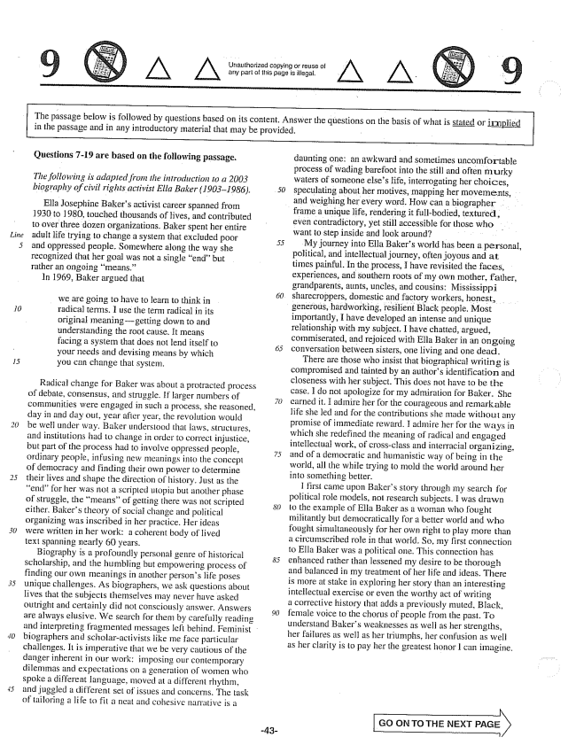

*Line*

*30*

Unauthorized copying or reuse of any part of this page is illegal.

The passage below is followed by questions based on its content. Answer the questions on the basis of what is stated or inplied in the passage and in any introductory material that may be provided. -

**Questions -19 are based on the following passage.**

*The following is adapted from the introduction to a 2003*

*biography of civil rights activist Ella Baker (19031986). }*

Ella Josephine Bakers activist career spanned from 1930 to 1980, touched thousands of lives, and contributed to over three dozen organizations. Baker spent her entire adult life trying to change a system that excluded poor and oppressed people. Somewhere along the way she recognized that her goal was not a single endbut rather an ongoing means.”

In 1969, Baker argued that

- - - - ) we are going to have to learn to think in radical terms. I use the term radical in its original meaninggetting down to and understanding the root cause. It means facing a system that does not lend itself to your needs and devising means by which you can change thal Systern.

Radical change for Baker was about a protracted process of debate, consensus, and struggle. If larger numbers of communities were engaged in such a process, she reasoned, day in and day out, year after year, the revolution would be well under way. Baker understood that laws, structures, and institutions had 10 change in order to correct injustice, but part of the process had to involve oppressed people, ordinary people, infusing new meanings into the concept of democracy and finding their own power to determine their lives and shape the direction of history. Just as the endfor her was not a scripted utopia but another phase of struggle, the meansof getting there was not scripted either. Bakers theory of social change and political organizing was inscribed in her practice. Her ideas were written in her work: a coherent body of lived text spanning nearly 60 years.

Biography is a profoundly personal genre of historical scholarship, and the humbling but empowering process of finding our own meanings in another persons life poses unique challenges. As biographers, we ask questions about lives that the subjects themselves may never have asked outright and certainly did not consciously answer. Answers are always elusive. We search for them by carefully reading and interpreting fragmented messages left behind. Feminist biographers and scholaractivists like me face particular challenges. It is imperative that we be very cautious of the danger inherent in our work: imposing our contemporary dilemmas and expectations on a generation of women who spoke a different sanguage, moved at a different rhythm, and juggled a different set of issues and concerns. The task of tailoring a life to fit a heat and cohesive narrative is a

daunting one; an awkward and sometimes uncomfortable process of wading barefoot into the still and often murky waters of someone elses life, interrogating her choices, speculating about her motives, mapping her movements, and weighing her every word. How can a biographer frame a unique life, rendering it full-bodied, textured, even contradictory, yet still accessible for those who want to step inside and look around. . . . .

My journey into Ella Bakers world has been a personal, political, and intellectual journey, often joyous and at times painful. In the process, I have revisited the faces, experiences, and southern roots of my own mother, father, grandparents, aunts, uncles, and cousins: Mississippi sharecroppers, domestic and factory workers, honest, generous, hardworking, resilient Black people. Most importantly, I have developed an intense and unique relationship with my subject, I have chatted, argued, commiserated, and rejoiced with Ella Baker in an ongoing conversation between sisters, one living and one dead.

There are those who insist that biographical writing is compromised and tainted by an authors identification and closeness with her subject. This does not have to be the case. I do not apologize for my admiration for Baker. She earned it. I admire her for the courageous and remarkable life she led and for the contributions she made without any promise of immediate reward. Hadmire her for the ways in which she redefined the meaning of radical and engaged intellectual work, of cross-class and interracial organizing, and of a democratic and humanistic way of being in the world, all the while trying to mold the world around her into something better.

first came upon Bakers story through my search for political role Inodels, not research Subjects. I was drawn to the example of Ella Baker as a woman who fought militantly but democratically for a better world and who fought simultaneously for her own right to play more than a circumscribed role in that world. So, my first connection to Ella Baker was a political one. This connection has enhanced rather than lessened my desire to be thorough and balanced in my treatment of her life and ideas. There is more at stake in exploring her story than an interesting intellectual exercise or even the worthy act of writing a corrective history that adds a previously muted, Black, female voice to the chorus of people from the past. To understand Bakers weaknesses as well as her Strengths, her failures as well as her triumphs, her confusion as well as her clarity is to pay her the greatest honor l can imagine.

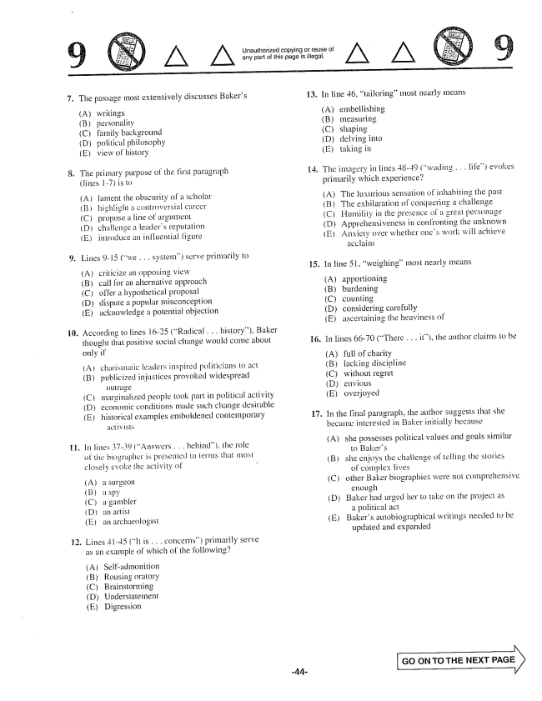

Unaulhorized copying or reuse of arly part of this page is illegal.

The passage most extensively discusses Bakers

(A) writings (B) personality (C) family background (D) politicaphilosophy (E) view of history

The primary purpose of the first paragraph (lines 1-) is to

(A) lament the obscurity of a SUholar (B) highlight a controversial career (Cpropose a lime of argumemt (D) challenge a leaders reputation (E) introduce an influential figure

Lines 9-15 (we . . . system) serve primarily to

(A) criticize an opposing view (B) call for an alternative approach (C) a hypothetical proposal (D) dispute a popular misconception (E) acknowledge a potential objection

According to lines 16-25 (Radical . . . history), Baker

thought that positive social change would come about only if

(A) charismatic leaders inspired politicians to act

(B) publicized injustices provoked widespread

outrage

(C) marginalized people took part in political activity

Deconomic conditions made such change desirable

(E) historical examples emboldened contemporary

In lines 3739 (Answers . . . helmind), the role of the biographer is presented in terms that most closely evoke the activity of -

A) a Surgeon Bá spy (C) a gambler Dan artist (E) an archaeologist

Lines -45 (it is . . . concerns) primarily serve as an example of which of the following?

(A) Self-admonition (B) Rousing oratory (C) Brainstorming EDigression

13. In line 46, tailoring” Inost nearly means

(A) embellishing (B) measuring (C) shaping (D) delving into (E) taking in

4. The imagery in lines 48-49 (wading . . . Hife) evokes

primarily which experience?

(A) The luxurious sensation of inhabiting the past

(B) The exhilaration of conquering a challenge

(C) Humility in the presence of a greal personage

(D) Apprehensiveness in confronting the unknown

(E) Anxiety over whether ones work will achieve

acclaim

In line 51, weighing” most nearly means

(A) apportioning (B) burdening

(C) counting (D) considering carefully (E) ascertaining the heaviness of

In lines 66-70 (There . . . it), the author claims to be

(A) full of charity (B) lacking discipline (Cwithout regret (D) envious (E) overjoyed

In the final paragraph, the author Suggests that she became interested in Baker initially because

(A) she possesses political values and goals similar

to Bakers

(3) she enjoys the challenge of telling the Stories

of complex lives

Cother Baker biographies were not comprehensive

enough

(D) Baker had urged her to take on the project as

a political act

(E) Bakers autobiographical writings needed to be

updated and expanded

GO ON TO THE NEXT PAGE

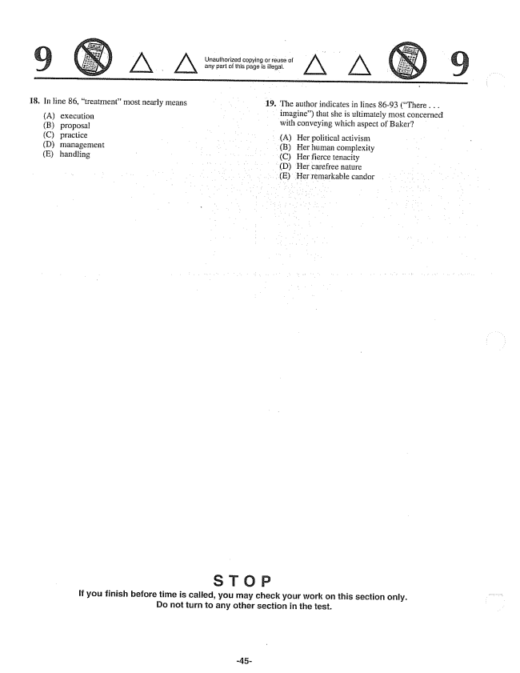

Unauthorized copying or reuse of any parl of this page is illegal.

18. In line 86, treatmentmost nearly means 19. The author indicates in lines 86-93 (There . . .

- imagine) that she is ultimately most concerned

(A) execution with conveying which aspect of Baker?

(B) proposal

(C) practice - A) Her political activism (D) management - - (B) Her human complexity (E) handling (C) Her fierce tenacity

(D) Her carefree nature (E) Her remarkable candor

If you finish before time is called, you may check your work on this section only. Do not turn to any other section in the test.

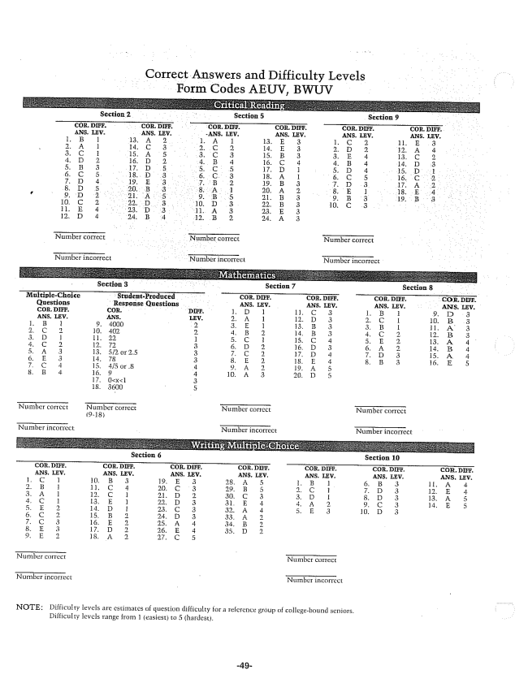

Correct Answers and Difficulty Levels Form Codes AEUV, BWUV

**Section 2 Section 5 Section 9**

**Tត្7 Section 8**

**Section 6 - Section 10**

NOTE: Difficulty levels are estimates of question difficulty for a reserence group of collegebound seniors.

Disficulty levels range from 1 easiest) to 5 (hardest.