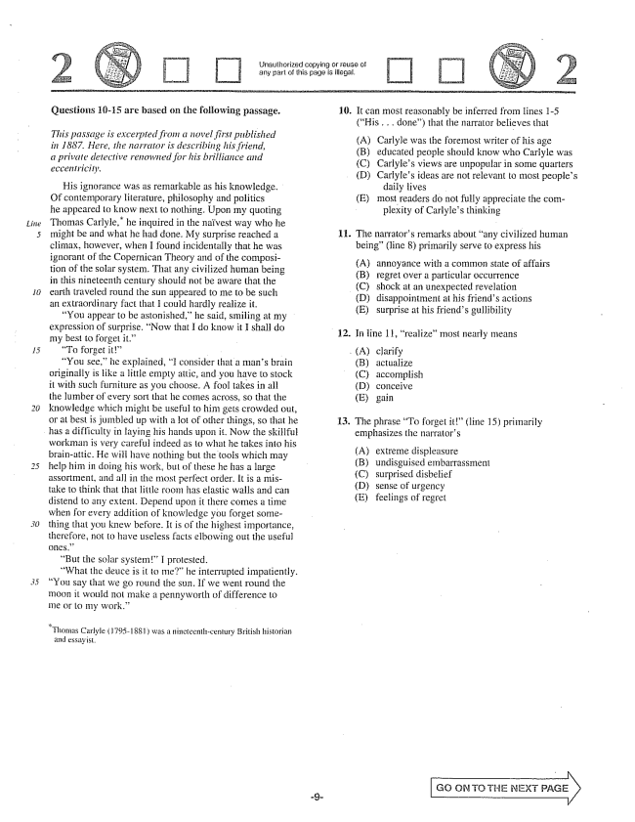

*Linie*

Unauthorized copying or reuse of any part of this page is illegal.

**Questions 16-15 are based on the following passage.**

*This passage is excerpted from a novel first published in 1887. Here, the narrator is describing his friend, a private detective renowned for his brilliance and eccentricity.*

His ignorance was as remarkable as his knowledge. Of contemporary literature, philosophy and politics he appeared to know next to nothing. Upon my quoting Thomas Carlyle," he inquired in the naïvest way who he might be and what he had done. My surprise reached a climax, however, when I found incidentally that he was ignorant of the Copernican Theory and of the composition of the solar system. That any civilized human being in this nineteenth century should not be aware that the earth traveled round the sun appeared to me to be such an extraordinary fact that I could hardly realize it.

You appear to be astonished,he said, Smiling at my expression of surprise. Now that I do know it I shall do my best to forget it.”

“To forget it”

“You See,he explained, I consider that a mans brain originally is Hike a little empty attic, and you have to stock it with such furniture as you choose. A fool takes in all the lumber of every sort that he comes across, so that the knowledge which might be useful to him gets crowded out, or at best is jumbled up with a lot of other things, so that he

has a difficulty in laying his hands upon it. Now the skillful

workman is very careful indeed as to what he takes into his brainattic. He will have nothing but the tools which may help him in doing his work, but of these he has a large assortment, and all in the most perfect order. It is a mistake to think that that little room has elastic walls and can distend to any extent. Depend upon it there comes a time when for every addition of knowledge you forget something that you knew before. It is of the highest importance, therefore, not to have useless facts elbowing out the useful GHES.”

“But the solar system” I protested.

What the deuce is it to me” he interrupted impatiently. You say that we go round the sun. If we went round the moon it would not make a pennyworth of difference to me or to my work.”

- Thonias Carlyle ( 1795-1881) was a nimeteenilicenlury British historiam

and essayist.

10. It can most reasonably be inferred from lines 1-5

(His .. done) that the narrator believes that

(A) (B) (C) (D)

Carlyle was the foremost writer of his age educated people should know who Carlyle was Carlyles views are unpopular in some quarters Carlyles ideas are not relevant to most peoples

daily lives most readers do not fully appreciate the com

plexity of Carlyles thinking

(E)

11. The narrators remarks about any civilized human

being" (line ) primarily serve to express his

annoyance with a common state of affairs regret over a particular occurrence shock at an unexpected revelation disappointment at his friends actions surprise at his friends gullibility

12. In line 11, realizeInost nearly means

(A) (B) (C) (D) (E)

clarify actualize accomplish conceive gain

13. The phrase To forget it” (line 15) primarily

emphasizes the narrators

(A) (B) (C) (D) (E)

extreme displeasure undisguised embarrassment surprised disbelief Sense of urgency feelings of regret

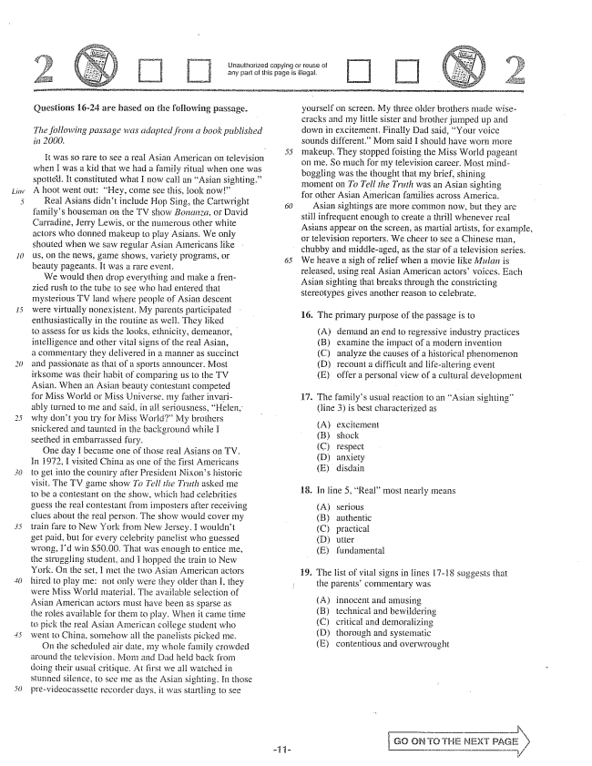

Unauthorized copying reuse ol any part of this page is illegal.

Questions 16-24 are based on the following passage.

*The following passage was adapted from a book published in 2000.*

It was so rare to see a real Asian American on television when I was a kid that we had a family ritual when one was spotted. It constituted what I now call an Asian sighting.” A hoot went out: Hey, come see this, look now"

Real Asians didn't include Hop Sing, the Cartwright familys houseman on the TV show Bonanza, or David Carradine, Jerry Lewis, or the munierous other white actors who donned makeup to play Asians. We only shouled when we saw regular Asian Americans like us, on the news, game shows, variety programs, Of beauty pageants. It was a rare event.

We would then drop everything and make a frenzied rush to the tube to see who had entered that mysterious TV land where people of Asian descent were virtually nonexistent. My parents participated enthusiastically in the routine as well. They liked to assess for us kids the looks. ethnicity, demeanor, intelligence and other vital signs of the real Asian, a commentary they delivered in a manner as succinct and passionate as that of a sports announcer. Most irksome was their habit of comparing us to the TV Asian. When an Asian beauty contestant competed for Miss World or Miss Universe, my father invariably turned to me and said, in all seriousness, Helen, why don't you try for Miss World” My brothers snickered and taunted in the background while I Seethed in embarrassed fury.

One day I became one of those real Asians on TV. In 1972, I visited China as one of the first Americans to get into the country after President Nixons historic visit. The TV game show To Tell the Truth asked me to be a contestant on the show, which had celebrities guess the real contestant from imposters after receiving clues about the real person. The show would cover my train fare to New York from New Jersey. I wouldn't get paid, but for every celebrity pastelist who guessed wrong, Pd win 50.00, That was enough to entice me, the Struggling student, and I hopped the train to New York. On the set, 1 met the two Asian American actors hired to play me: not only were they older than I, they were Miss World material. The available selection of Asian American actors must have been as sparse as the roies available for them to play. When it came time to pick the Asian American college student who went to China. Somehow all the panelists picked me.

On the scheduled air date, my whole family crowded around the television. and Dad held back from doing their usual critique. At first we all watched in Stunned silence, to see me as the Asian sighting. In those prevideocassetle recorder days, it was startling to see

*50*

yourself on screen. My three older brothers made wisecracks and my little sister and brother jumped up and down in excitement. Finally Dad said, Your voice sounds different.” Morn said I should have worn more makeup. They stopped foisting the Miss World pageant on me. So much for my television career. Most mindboggling was the thought that Iny brief, shining moment on To Tell the Truth was an Asian sighting for other Asian American families across America.

Asian sightings are more common now, but they are still infrequent enough to create a thrill whenever real Asians appear on the screen, as martial artists, for example, or television reporters. We cheer to see a Chinese man, chubby and middle-aged, as the star of a television series, We heave a sigh of relief when a movie like Mulan is released, using reaf Asian American actorsvoices. Each Asian sighting that breaks through the constricting Stereotypes gives another reason to celebrate.

16. The primary purpose of the passage is to

(Α) (B)

demand an end to regressive industry practices examine the impact of a modern invention (C) analyze the causes of a historical phenomenon (D) recount a difficult and lifealtering event (E) offer a personal view of a cultural development

17. The familys usual reaction to an Asian sighting”

(line 3) is best characterized as

excitemená shock respect anxiety disdain

18. In line , Real” most nearly means

(A) (B) (C) (D) (E)

serious authentic practical U EF fundamental

19. The list of vital signs in lines 17-18 suggests that

the parents' commentary was

(A) (B) (C) (D) (E)

innocent and amusing technical and bewildering critical and demoralizing thorough and systematic contentious and overwrought

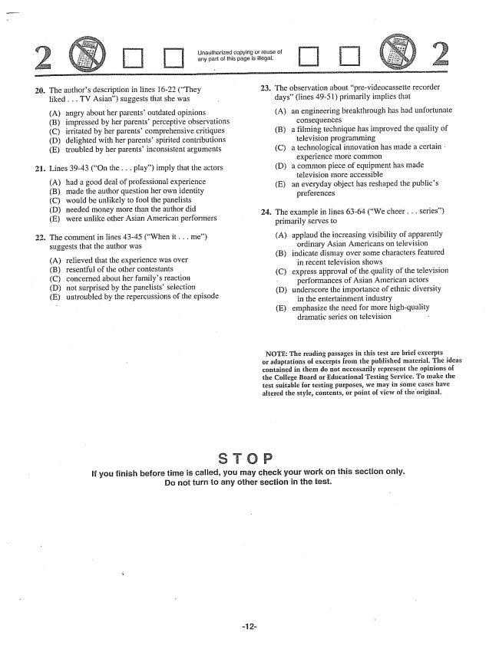

Unauthorized copying or reuse of any part of this page is illegal.

20. The authors description in lines 16-22 (They 23. The observation about prevideocassette recorder

liked . . . TV Asian) suggests that she was - days(lines 49-51) primarily implies that (A) angry about her parentsoutdated opinions (A), an engineering breakthrough has had unfortunate (B) impressed by her parents' perceptive observations consequences (C) irritated by her parents' comprehensive critiques (B) a filming technique has improved the quality of (D) delighted with her parentsspirited contributions television programming (E) troubled by her parentsinconsistent arguments (C) a technological innovation has made a certain -

- experience more common 21. Lines 39-43 (On the . . . play) imply that the actors (D) a common piece of equipment has made

~~~ - television more accessible (A) had a good deal of professional experience (Ean everyday object has reshaped the publics (B) made the author question her own identity preferences (C) would be unlikely to fool the panelists (D) needed money more than the author did 24. The example in lines 63-64 (We cheer . . . series) (E) were unlike other Asian American performers - - -

primarily serves to 22. The comment in lines 43-45 (When it. . . me) (A) applaud the increasing visibility of apparently suggests that the author was ordinary Asian Americans on television

- - (B) indicate dismay over some characters featured (A) relieved that the experience was over in recent television shows (C) express approval of the quality of the television

- - у performances of Asian American actors (D) not surprised by the panelists selection - (D) underscore the importance of ethnic diversity

untroubled by the repercussions of the episode in the entertainment industry

(E) emphasize the need for more highquality dramatic series on television -

NOTE: The reading passages in this test are brief excerpts or adaptations of excerpts from the published material. The ideas contained in them do not necessarily represent the opinions of the College Board or Educational Testing Service. To make the test suitable for testing purposes, we may in some cases have altered the style, contents, or point of view of the original.

If you finish before time is called, you may check your work on this section only. Do not turn to any other section in the test.

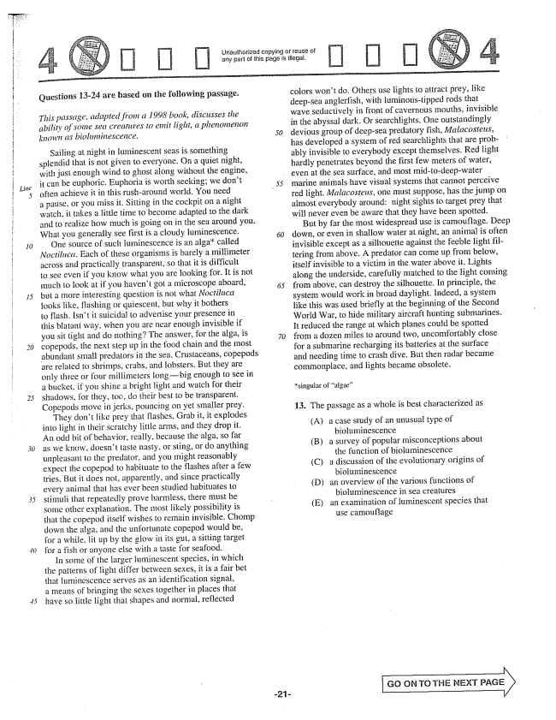

*30*

Questions 13-24 are based on the following passage.

*This passage, adapted from a 1998 book, discusses the ability of some sea creatures to emit light, a phenomenon known as biohtniiliescence,*

Sailing at night in luminescent seas is something splendid that is not given to everyone. On a quiet night, with just enough wind to ghost along without the engine, it can be euphoric. Euphoria is worth seeking; we dont often achieve it in this rush-around world. You need a pause, or you miss it. Sitting in the cockpit on a night watch. it takes a little time to become adapted to the dark and to realize how much is going on in the sea around you. What you generally see first is a cloudy luminescence. One source of such luminescence is an algacalled Noctilica. Each of these organisms is barely a millimeter across and practically transparent, so that it is difficult to see even if you know what you are looking for. It is not Inuch to look at if you havent got a microscope aboard, but a more interesting question is not what Noctiluca looks like, flashing or quiescent, but why it bothers to flash. Isnt it suicidal to advertise your presence in this blatant way, when you are near enough invisible if you sit tight and do nothing? The answer, for the alga, is copepods, the next step up in the food chain and the most abundant small predators in the sea. Crustaceans, copepods are related to shrimps, crabs, and lobsters. But they are only three or four millimeters longbig enough to see in a bucket, if you shine a bright light and watch for their shadows, for they, too, do their best to be transparent. Copepods move in jerks, pouncing on yet smaller prey.

They dont like prey that flashes. Grab it, it explodes into light in their scratchy little arms, and they drop it. An odd bit of behavior, really, because the alga, so far as we know, doesn't taste nasty, or sting, or do anything unpleasant to the predator, and you might reasonably expect the copepod to habituate to the flashes after a few tries. But it does not, apparently, and since practically every animal that has ever been studied habituates to stimuli that repeatedly prove harmless, there must be Some other explanation. The most likely possibility is that the copepod itself wishes to remain invisible. Chomp down the alga, and the unfortunate copepod would be, for a while, lit up by the glow in its gut, a sitting target for a fish or anyone else with a taste for seafood.

In some of the larger luminescent species, in which the patterns of light differ between sexes, it is a fair bet that luminescence serves as an identification signal, a means of bringing the sexes together in places that have so littie light that shapes and normal, reflected

Unauthorized copying or reuse of any part of this page is illegal.

colors won't do. Others use lights to attract prey, like deepsea angierfish, with luminous-tipped rods that wave seductively in front of cavernous mouths, invisible in the abyssal dark. Or searchlights. One outstandingly devious group of deepsea predatory fish, Malacostetis, has developed a system of red searchlights that are probably invisible to everybody except themselves. Red light hardly penetrates beyond the first few meters of water, even at the sea surface, and most mid-to-deep-water marine animals have visual Systems that cannot perceive red light. Malacosteus, one must Suppose, has the jump on almost everybody around: light sights to target prey that will never even be aware that they have been spotted.

But by far the most widespread use is camouflage. Deep down, or even in shallow water at night, an animal is often invisible except as a silhouette against the feeble light filtering from above. A predator can come up from below, itself invisible to a victim in the water above it. Lights along the underside, carefully matched to the light coming from above, can destroy the silhouette. In principle, the system would work in broad daylight. Indeed, a system Hke this was used briefly at the beginning of the Second World War, to hide military aircraft hunting submarines. It reduced the range at which planes could be spotted from a dozen miles to around two, uncomfortably close for a submarine recharging its batteries at the surface and needing time to crash dive. But then radar became commonplace, and lights became obsolete.

13. The passage as a whole is best characterized as

(A) a case study of an unusual type of

bioluminescence

(B) a survey of popular misconceptions about

the function of bioluminescence

(C) a discussion of the evolutionary origins of

bioluminescence

(D) an overview of the various functions of

bioluminescence in sea creatures

(E) an examination of luminescent species that

use camouflage

GO ON TO THE NEXT PAGE

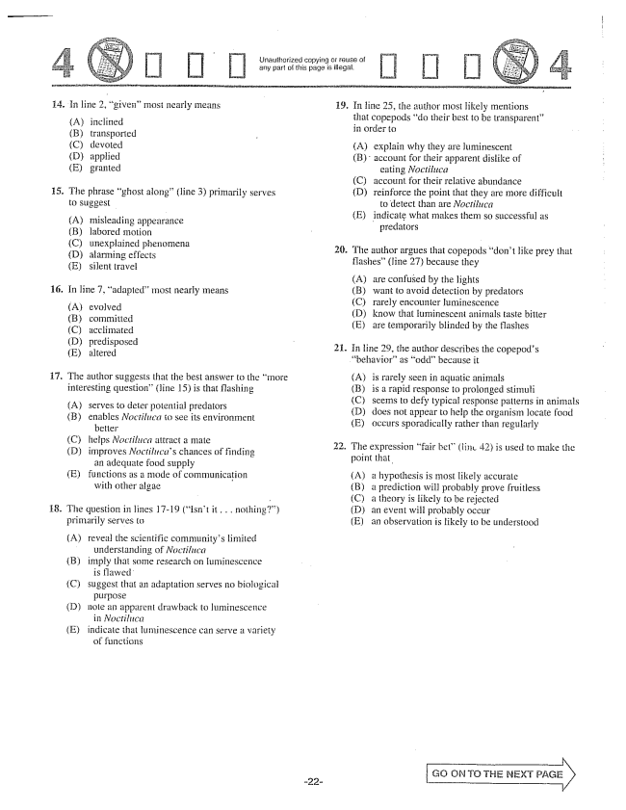

Unauthorized copying or reuse of any part of this page is illegal.

14.

În line 2, giveiimost nearly means

inclined transported devoted applied granted

The phrase ghost along(line 3) primarily serves

misleading appearance labored motion unexplained phenomena alarming effects silent travel

In line , adapted" most nearly means

(A) (B) (C) () (E)

evolved committed acclimated predisposed altered

The author suggests that the best answer to the more interesting question(line 15) is that flashing

(A) (B)

Serves to deter potential predators

enables Noctiluca to see its environment

better

helps Noctiluca attract a mate

improves Noctilitcas chances of finding

an adequate food supply

functions as a mode of communication

with other algae

(C) (D)

(E)

The question in lines 17-19 (isnt it. . . nothing”) primarily serves to

(A) reveal the scientific communitys limited

understanding of Noctiluca

imply that some research on luminescence

is flawed

Suggest that an adaptation serves no biological

purpose

mole an apparent drawback to luminescence

indicate that luminescence can serve a variety

of functions

(B)

(C)

(D)

(E)

19. In line 25, the author most Hikely mentions

2

that copepods do their best to be transparent” in order to

(A) explain why they are luminescent (B) account for their apparent dislike of

eating Noctiluca account for their relative abundance reinforce the point that they are more difficult

to detect than are Noctiluca indicate what makes them so successful as

predators

(C) (D)

(E)

The author argues that copepods dont like prey that flashes” (line 27) because they

(A) (B) (C) (D) (E)

are confused by the lights want to avoid detection by predators rarely encounter luminescence know that luminescent animals taste bitter are temporarily blinded by the flashes

. In line 29, the author describes the copepods

(A) (В) (C) (D) (E)

is rarely seen in aquatic animals is a rapid response to prolonged stimuli seems to defy typical response patterns in animals does not appear to help the organism locate food occurs sporadicaily rather than regularly

. The expression fair bet” (line 42) is used to make the

point that

(A) a hypothesis is most likely accurate (B) a prediction will probably prove fruitless (C) a theory is likely to be rejected (Dan event will probably occur (E) an observation is likely to be understood

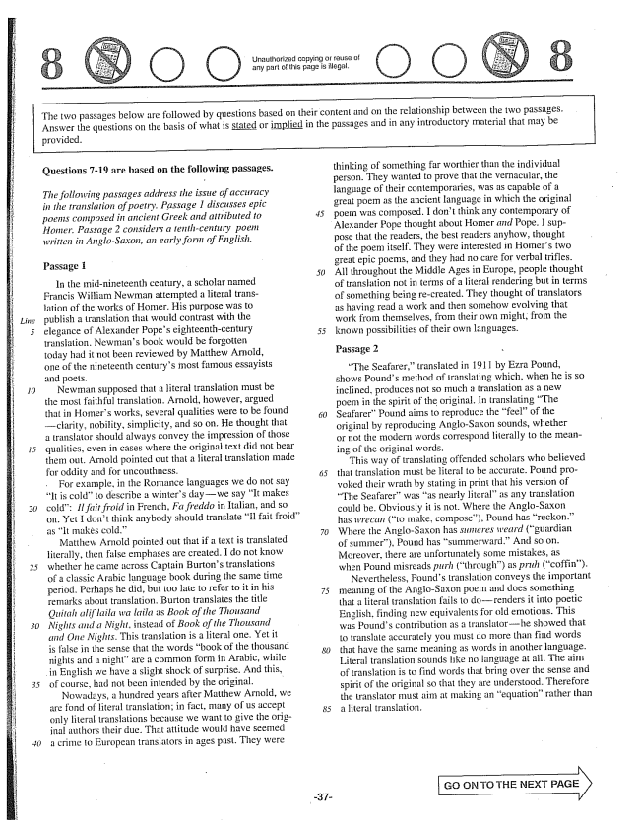

*15*

*30*

Unauthorized copying of reuse of any part of this page is illegal.

The two passages below are followed by questions based on their content and on the relationship between the two passages. Answer the questions on the basis of what is stated or implied in the passages and in any introductory material that may be

provided.

**Questions -19 are based on the following passages.**

*The following passages address the issue of accuracy in the translation of poetry. Passage 1 discusses epic poems composed in ancient Greek and attributed to Homer. Passage 2 considers a tenth-century poem written in Anglo-Saxon, an early forin of English.*

Passage 1

In the mid-nineteenth century, a scholar named Francis William Newman attempted a literal translation of the works of Homer. His purpose was to publish a translation that would contrast with the elegance of Alexander Popes eighteenth-century translation. Newmans book would be forgotten today had it not been reviewed by Matthew Arnold, one of the nineteenth centurys most famous essayists and poets.

Newman supposed that a literal translation must be the most faithful translation. Arnold, however, argued that in Homers works, several qualities were to be found clarity, nobility, simplicity, and so on. He thought that a translator should always convey the impression of those qualities, even in cases where the original text did not bear them out. Arnold pointed out that a literal translation made for oddity and for uncouthness.

For example, in the Romance languages we do not say It is cold” to describe a winters daywe say It makes cold: Il fait froid in French, Fa freddo in Italian, and so on. Yet I dont think anybody should translate Il fait froid as It makes cold.”

Matthew Arnold pointed out that if a text is translated literally, then false emphases are created. I do not know whether he came across Captain Burtons translations of a classic Arabic language book during the same time period, Perhaps he did, but too late to refer to it in his remarks about translation. Burton translates the title Quitah alif laila wa laila as Book of the Thousand Nights and a Night, instead of Book of the Thousand and One Nights. This translation is a literal one. Yet it is false in the Sense that the words book of the thousand nights and a night” are a common form in Arabic, while in English we have a slight shock of surprise. And this, of course, had not been intended by the original. -

Nowadays, a hundred years after Matthew Arnold, we are fond of literal translation; in fact, many of us accept only literal translations because we want to give the original authors their due. That attitude would have seemed a crime io European translators in ages past. They were

*50*

thinking of something far worthier than the individual person. They wanted to prove that the vernacular, the language of their contemporaries, was as capable of a great poem as the ancient language in which the original poem was composed. I dont think any contemporary of Alexander Pope thought about Homer and Pope. I suppose that the readers, the best readers anyhow, thought of the poem itself. They were interested in Homers two great epic poems, and they had no care for verbal trifles. All throughout the Middle Ages in Europe, people thought of translation not in terms of a literal rendering but in terms of something being recreated. They thought of translators as having read a work and then somehow evolving that work from themselves, from their own might, from the known possibilities of their own languages.

Passage 2 -

The Seafarer,translated in 1911 by Ezra Pound, shows Pounds method of translating which, when he is so inclined, produces not so much a translation as a new poem in the spirit of the original. In translating The Seafarer" Pound aims to reproduce the feelof the original by reproducing Anglo-Saxon Sounds, whether or not the modern words correspond literally to the meaning of the original words.

This way of translating offended scholars who believed that translation must be literaf to be accurate. Pound provoked their wrath by Stating in print that his version of The Seafarerwas as nearly literalas any translation could be. Obviously it is not. Where the Anglo-Saxon has wrecan (to make, compose), Pound has reckon.” Where the Anglo-Saxon has summeres weard (guardian of summer), Pound has summerward.” And so on. Moreover, there are unfortunately some mistakes, as when Pound misreads purh (through) as pruh (coffin).

Nevertheless, Pounds translation conveys the important meaning of the Anglo-Saxon poem and does something that a literal translation fails to dorenders it into poetic English, finding new equivalents for old emotions. This was Pounds contribution as a translatorhe showed that to translate accurately you must do more than find words that have the same meaning as words in another language. Literal translation sounds like no language at all. The aim of translation is to find words that bring over the sense and spirit of the original so that they are understood. Therefore the translator must aim at making an equation" rather than a literal translation.

GO ON TO THE NEXT PAGE

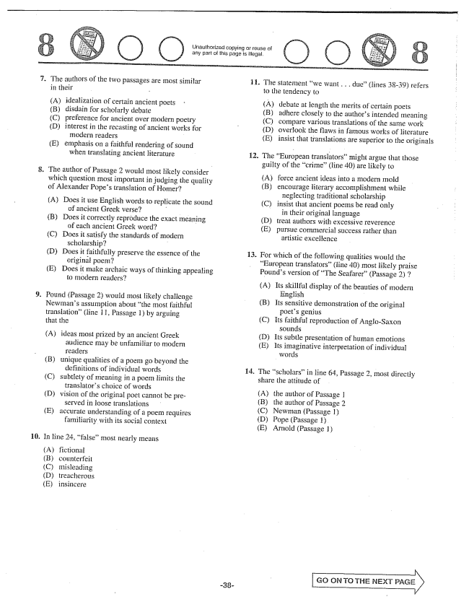

Unauthorized copying or of any part of this page is illegal.

O O

.

The authors of the two passages are most similar in their

(A) idealization of certain ancient poets (B) disdain for scholarly debate (C) preference for ancient over modern poetry (D) interest in the recasting of ancient works for modern readers - E) emphasis on a faithful rendering of sound when translating ăncient literature

The author of Passage 2 would most likely consider - which question most important in judging the quality of Alexander Popes translation of Homer?

(A) Does it use English words to replicate the sound

of ancient Greek verse?

(B) Does it correctly reproduce the exact meaning

of each ancient Greek word?

(C) Does it satisfy the standards of modern

scholarship? -

(D) Does it faithfully preserve the essence of the

originál poem?

(E) Does it make archaic ways of thinking appealing

to modern readers?

Pound (Passage 2) would most likely challenge Newmans assumption about the most faithful translation" (line II, Passage 1by arguing that the

(A) ideas most prized by an ancient Greek

audience may be unfamiliar to modern readers unique qualities of a poem go beyond the

definitions of individual words subtlety of meaning in a poem limits the

translators choice of words vision of the original poet cannot be pre

served in loose translations accurate understanding of a poem requires

familiarity with its social context

(B)

(C)

(D)

(E)

In line 24, false” most nearly means

(A) (B) (C) (D) (E)

fictional misleading treacherous insincere

The statement we want . . . due” (lines 3839) refers to the tendency to

(A) (B) (C) (D) (E)

debate at length the Inerits of certain poets adhere closely to the authors intended meaning compare various translations of the same work overlook the flaws in famous works of literature insist that translations are superior to the originals

The European translators” might argue that those guilty of the crime(line 40) are likely to

(A) force ancient ideas into a modern mold

(B) encourage literary accomplishment while neglecting traditional scholarship

(C) insist that ancient poems be read only

in their original language

(Dtreat authors with excessive reverence

(E) pursue commercial success rather than

artistic excellence

For which of the following qualities would the European translators(line 40) most likely praise Pounds version of The Seafarer" (Passage 2)

(A) Its skillful display of the beauties of modern

English

(B) Its sensitive demonstration of the original

poets genius

(C) its faithful reproduction of Anglo-Saxon

sounds

(D) Its subtle presentation of human emotions

(E) Its imaginative interpretation of individual

words

The scholars" in line 64, Passage 2, most directly share the attitude of

(A) (В) (C) (D) (E)

the author of Passage 1 the author of Passage 2 Newman (Passage I) Pope (Passage 1) Arnold (Passage 1)

GO ON TO THE NEXT

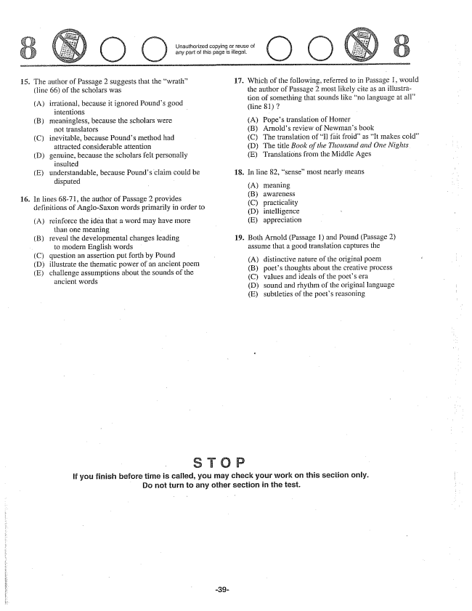

The author of Passage 2 suggests that the wrath(line 66) of the scholars was

(A) irrational, because it ignored Pounds good

intentions -

meaningless, because the scholars were

not translators

inevitable, because Pounds method had

attracted considerable attention

genuine, because the scholars felt personally

insulted

understandable, because Pounds claim could be

disputed

(B)

(C)

(D)

In lines 68-71, the author of Passage 2 provides definitions of Anglo-Saxon words primarily in order to

(A) reinforce the idea that a word may have more

than one meaning

reveal the developmental changes leading

to modern English words

question an assertion put forth by Pound

illustrate the thematic power of an ancient poem

challenge assumptions about the sounds of the

ancient words

(B)

(C) (D) (E)

Urlauthorized copying or reuse ol any part of this page is illegal.

**17.**

**18.**

**19.**

O O

Which of the following, referred to in Passage I, would the author of Passage 2 most likely cite as an illustration of something that sounds like no language at (line 81

(A) Popes translation of Homer (B) Arnolds review of Newmans book (C) The translation of Il fait froidas It makes cold” (D) The title Book of the Thousand and One Nights (E) Translations from the Middle Ages

Hn line 82, sense” most nearly means

(A) (B) (C) (D) (E)

meaning awāTêTheSS practicality intelligence appreciation

Both Arnold (Passage 1) and Pound (Passage 2) assume that a good translation captures the

(A) (B) (C) (D) (E)

distinctive nature of the original poem poets thoughts about the creative process values and ideals of the poets era sound and rhythm of the original language subtleties of the poeis reasoning

**If you finish before time is caffed, you may check your work on this section only. Do not turn to any other section in the test.**

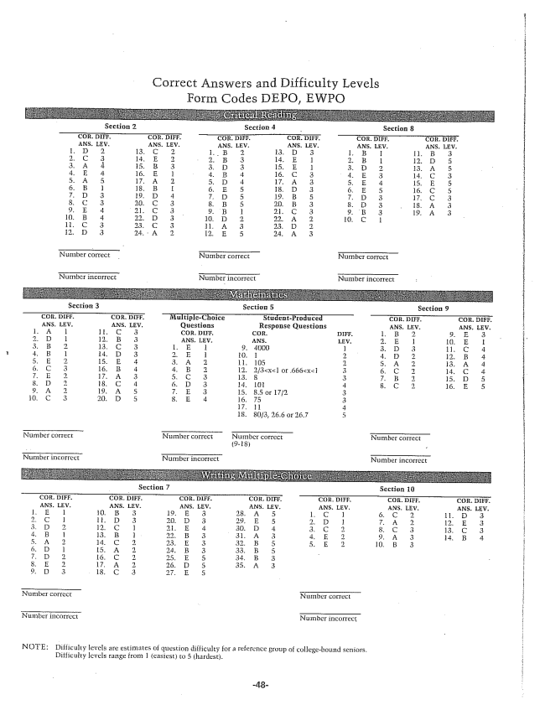

Correct Answers and Difficulty Levels Form Codes DEPO, EWPO

**Sectiura 3 Sectiora 5 Section 9**

**Section 7 Section 10**

NOTE: Difficulty levels are estimates of question difficulty for a reference group of collegebound seniors.

Difficulty levels range from 1 (easiest) to 5 (hardest.