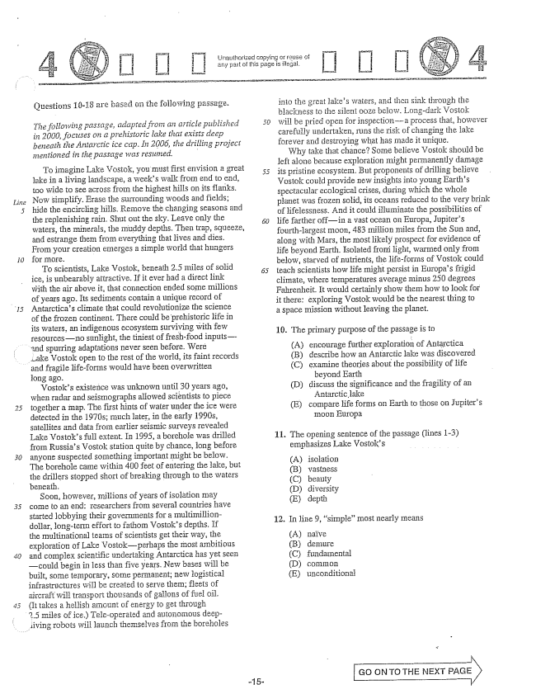

*Line*

*15*

口 口

Questions 10-18 are based Gil the following passage.

*The following passage, adapted from an article published in 2000, focuses on a prehistoric lake that exists deep beneath the Antarctic ice cap. In 2006, the drilling project mentioned in the passage was resumed.*

To imagine Lake Vostok, you must first envision a great 55

lake in a living landscape, a weeks walk from end to end, too wide to see across from the highest hills on its flanks. Now simplify. Erase the Surrounding woods and fields; hide the encircling hills. Remove the changing Seasons and the replenishing rain. Shut out the sky. Leave only the waters, the minerals, the Inuddy depths. Then trap, Squeeze, and estrange them from everything that lives and dies. From your creation emerges a simple world that hungers for more.

To scientists, Lake Vostok, beneath 2.5 miles of Solid ice, is unbearably attractive. If it ever had a direct link with the air above it, that connection ended some millions of years ago. Its sediments contain a unique record of Antarcticas climate that could revolutionize the Science of the frozen continent. There could be prehistoric life in its waters, an indigenous ecosystem surviving with few resourcesno sunlight, the tiniest of fresh-food inputs

and spurring adaptations never seen before. Weré

Lake Vostok open to the rest of the world, its faint records

and fragile lifeforms would have been overwritten

long ago.

Vostoks existence was unknown until 30 years ago, when radar and seismographs allowed scientists to piece together a map. The first hints of water under the ice were detected in the 1970s; much later, in the early 1990s, satellites and data from earlier seismic surveys revealed Lake Vostoks full extent. In 1995, a borehoje was drilled from Russias Vostok station quite by chance, long before anyone suspected something important might be below. The borehole came within 400 feet of entering the lake, but the drillers stopped short of breaking through to the waters beneath.

Soon, however, III.iiiions of years of isolation may come to an end: researchers from several countries have started lobbying their governments for a multimilliondollar, long-term effort to fathom Vostoks depths. If the multinational teams of scientists get their way, the exploration of Lake Vostokperhaps the Inost ambitious and complex scientific undertaking Antarctica has yet seen could begin in less than five years. New bases will be built, some temporary, Some permanent; new logistical infrastructures will be created to Serve them; fleets of aircraft will transport thousands of gallons of fuel oil. (It takes a hellish armount of energy to get through 2.5 miles of ice.) Teleoperated and autonomous deep

living robots will launch themselves from the boreholes

-15

Unauthorized copying or réuse ci any part of this page is illegal.

into the great lakes waters, and then sink through the blackness to the silent ooze below. Long-dark Vostok will be pried open for inspectiona process that, however carefully undertaken, runs the risk of changing the lake forever and destroying what has made it unique.

Why take that chance? Some believe Vostok should be left alone because exploration might permanently damage its pristine ecosystem. But proponents of drilling believe Vostok could provide new insights into young Earths spectacular ecological Crises, during which the whole planet was frozen Solid, its oceans reduced to the very brink of lifelessness. And it could illuminate the possibilities of life farther offin a vast ocean on Europa, Jupiters fourth-largest moon, 483 million miles from the Sun and, along with Mars, the most likely prospect for evidence of life beyond Earth. Isolated from light, warmed only from below, starved of nutrients, the lifeforms of Vostok could teach scientists how fife might persíst in Europas frigid climate, where temperatures average minus 250 degrees Fahrenheit. It would certainly show them how to look for it there: exploring Vostok would be the nearest thing to a space mission without leaving the planet.

10. The primary purpose of the passage is to

(A) encourage further exploration of Antarctica

(B) describe how an Antarctic lake was discovered

(C) examine theories about the possibility of Hife

beyond Earth

discuss the significance and the fragility of an

Antarctic lake

compare life forms on Earth to those on Jupiters

Inoon Europa

(D)

(E)

The opening sentence of the passage (lines 1-3) emphasizes Lake Vostoks

In line , simple” most nearly means

isolation beauty diversity depth

12.

(A) naïve (B) demure (C) fundannental

(D) common (E) un conditionał

GO ON TO THE NEXT Pass)

|

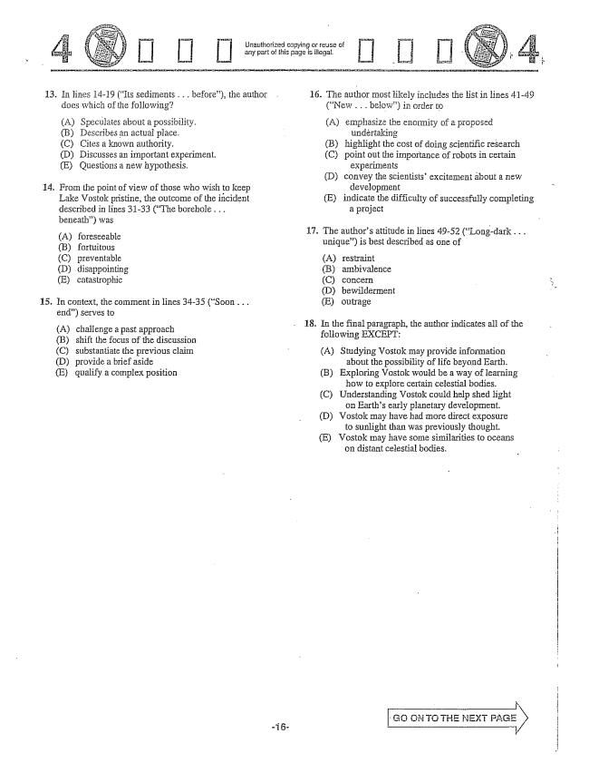

Jnauthorized copying or reuse of any part of this page is illegal.

13. In lines 14-19 (Its sediments . . . before), the author

14.

**15.**

does which of the following?

(A) Spectilates about a possibility. (B) Describes an actual place. (C) Cites a known authority, D) Discusses an important experiment. (E) Questions a new hypothesis.

From the point of view of those who wish to keep Lake Vostok pristine, the outcome of the incident

described in Lines 3133 (The borehole . . . beneath) was

(A) foreseeable (B) fortuitous (C) preventable (D) disappointing (E) catastrophic

In context, the comment in lines 34-35 (Soon . . .

end) serves to

(A) challenge a past approach (B) shift the focus of the discussion (C) substantiate the previous claim (D) provide a brief aside (E) qualify a complex position

16. The author most likely includes the listin lines 41-49

17.

18.

(New .. below) in order to

(A) emphasize the enormity of a proposed

(B) highlight the cost of doing scientific research

(C) point out the importance of robots in certain

experiments

(D) convey the scientistsexcitement about a new

development

(E) indicate the difficulty of successfully completing

a project

The authors attitude in lines 49-52 (Long-dark . . . unique) is best described as one of

(A) (B) (C) (D) (E)

In the final paragraph, the author indicates all of the following EXCEPT:

(A) Studying Vostok may provide information

about the possibility of life beyond Earth. (B) Exploring Vostok would be a way of learning how to explore certain celestial bodies. (C) Understanding Vostok could help shed light

on Earths early planetary development. (D) Vostok may have had more direct exposure

to sunlight than was previously thought. (E) Vostok may have some similarities to oceans

om distant celestial bodies.

restraint ambivalence

outrage

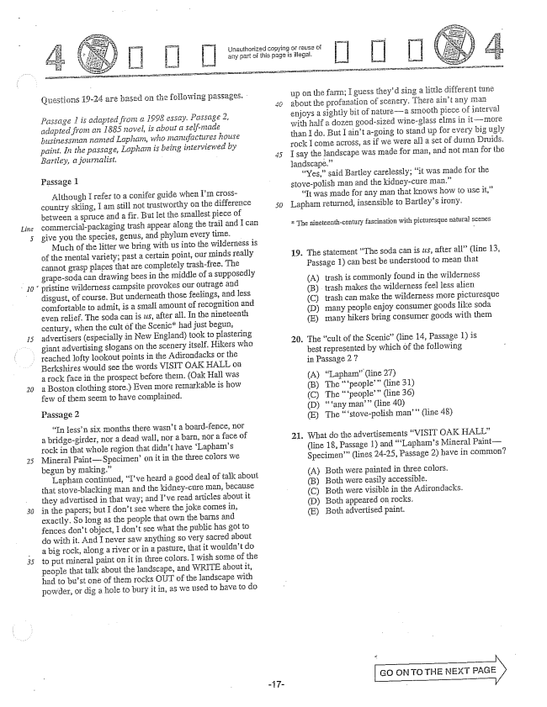

*Line*

*Passage 1 is adapted from a 1998 assay, Passage 2, adapted from an 1885 novel, is about a self-made businessman named Lapham, who manufactitres house pairli. In the passage, Laphais being interviewed by Bartley, a journalist, -*

Passage 1

Although I refer to a conifer guide when IIn crosscountry skiing, Iain still not tristworthy on the difference between a spruce and a fit. But let the Smallest piece of commercial-packaging trash appear along the trail and I can give you the species, genus, and phylum every time.

Much of the litter we bring with us into the wilderness is of the Inental variety; past a certain point, our minds really cannot grasp places that are completely trash-free. The grapesoda can drawing bees in the middle of a Supposedly pristine wilderness campsite provokes our Gufrage and disgust, of course. But underneath those feelings, and less comfortable to admit, is a small amount of recognition and even relief. The soda can is us, after all. In the nineteenth century, when the cult of the Scenichad just begun, advertisers (especially in New England) took to plastering giant advertising slogans on the scenery itself. Hikers who

*50*

lofty lookout points in the Adirondacks or the

Berkshires would see the words VISIT OAK HALF, on a rock face in the prospect before them. (Oak Hall was a Boston clothing store.) Even Inore remarkable is how few of them seem to have complained.

Passage 2

In lessn six months there wasn't a board-fence, nor a bridge-girder, nor a dead wall, nor a , nor a face of rock in that whole region that didnt have Laphams Mineral PaintSpecimenOn it in the three coiors we begun by IIIaking.”

Lapham continued, Ive heard a good deal of talk about that Stoveblacking Inan and the kidney-cure man, because they advertised in that way; and Ive read articles about it in the papers; but I dont see where the joke comes in, exactly. So long as the people that own the barns and fences dont object, I dont see what the public has got to do with it. And I never saw anything so very Sacred about a big rock, along a river or in a pasture, that it wouldn't do to put mineral paint on it in three colors. I wish some of the

eople that talk about the landscape, and WRITE about it,

had to bust one of them rocks OUT of the landscape with powder, or dig a hole to bury it in, as we used to have to do

Unauthorized copying or reusa of any part of this page is illegal.

up on the farm; I guess theyd sing a little different tune about the profanation of scenery. There aint any man enjoys a sightly bit of naturea smooth piece of interval with half a dozen good-sized wineglass elms in itmore than I do. But I aint agoing to stand up for every big ugly Tock I Come across, as if we were all a set of dumn Druids. Í say the landscape was made for man, and not man for the landscapë.”

“Yes,said Bartley carelessly; it was made for the stovepolish man and the kidney-cure man.”

“It was made for any Inan that knows how to use it,Lapham returned, insensible to Bartleys irony.

The nineteenth-century fascination with picturesque natural scenes

19. The statement The soda can is us, after all(line 13,

Passage 1) can best be understood to mean that

(A) trash is commonly found in the wilderness (B) ; trash makes the wilderness feel less alieil (C) trash can make the wilderness more picturesque (D) many people enjoy consumer goods like soda (E) Imany hikers bring consumer goods with them

. The cult of the Scenic(line 14, Passage 1) is

best represented by which of the following

in Passage 27

(A) Lapham(line 27) (B) The people(line 31) (C) The people” (line 36) (D) any man” (line 40) (E) The stovepolish man” (line 48)

. What do the advertisements VISIT OAK HAT I "

(line 18, Passage 1) and Laphams Mineral Paint— Specimen(lines 24-25, Passage 2) have in common?

(A) Both were painted in three colors. (B) Both were easily accessible. (C) Both were visible in the Adirondacks. (D) Both appeared on rocks. (E) Both advertised paint.

, ON TO THE REXT PAGE

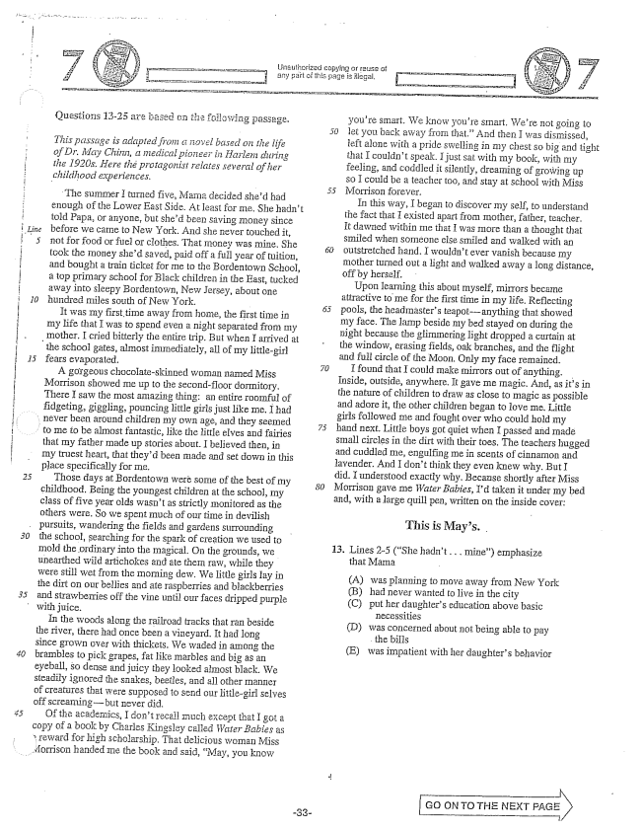

*This passage is adapted from a riovel based on the life of Dr. May Chinji, a medical pioneer in Harlem during the 1920s. Here the protagonist relates several of her childhood experiences.*

The Summer I tuTIled five, Mama decided shed had enough of the Lower East Side. At least for me, She hadn't told Papa, or anyone, but shed been saving Inoney since before we came to New York. And she never touched it, not for food or fuel or clothes. That money was mine. She took the money shed saved, paid off a full year of tuition, and bought a train ticket for me to the Bordentown School, a top primary School for Black children in the East, tucked away into sleepy Borderstown, New Jersey, about one hundred miles south of New York.

It was my first time away from home, the first time in my life that I was to spend even a night separated from my

mother. I cried bitterly the entire trip. But when I arrived at

the school gates, almost immediately, all of my littlegirl fears evaporated.

A gorgeous chocolateskinned woman named Miss Morrison showed Ine up to the secondfloor dormitory. There I saw the most amazing thing: an entire roomful of fidgeting, giggling, pouncing little girls just like me, I had

- never been around children my own age, and they seemed to me to be almost fantastic, like the little elves and fairies

that my father made up stories about. I believed then, in my truest heart, that theyd been made and set down in this place specifically for Ine.

Those days at Bordentown werè some of the best of my childhood. Being the youngest children at the school, my class of five year olds wasnt as strictly monitored as the others were. So we spent much of our time in devilish

pursuits, wandering the fields and gardens Surrounding

*30*

the school, Searching for the spark of creation we used to Inold the Ordinary into the magical. On the grounds, we unearthed wild artichokes and ate thern raw, while they were still wet from the morning dew. We little girls lay in the dirt on our bellies and ate raspberries and blackberries and strawberries off the vine until our faces dripped purple with juice.

In the woods along the railroad tracks that ran beside the river, there had once been a vineyard. It had long since grown over with thickets. We Waded in among the brambies to pick grapes, fat like marbles and big as an eyeball, so dense and juicy they looked almost black. We steadily ignored the snakes, beetles, and all other Inanner of creatures that were supposed to send our littlegirl selves off screaming-but never did.

Of the academics, I dont recall Inuch except that I got a copy of a book by Charles Kingsley called Water Babies as reward for high Scholarship. That delicious woman Miss

Morrison handed the book and said, May, you know

youre Smart. We know youre smart. Were not going to let you back away , that.” And then I was dismissed, left alone with a pride swelling in my chest so big and tight that I couldnt speak. I just sat with my book, with my feeling, and coddled it silently, dreamling of growing up so I could be a teacher too, and stay at school with Miss Morrison forever.

In this way, I began to discover my self, to understand the fact that I existed apart from mother, father, teacher. It dawned within me that I was more than a thought that Smiled when someone else smiled and walked with an Outstretched hand. I wouldnt ever vanish because my mother turned out a light and walked away a long distance, off by herself.

Upon learning this about myself, mirrors became attractive to me for the first time in my life. Reflecting pools, the headmasters teapot--anything that showed my face. The lamp beside my bed stayed on during the Hight because the glimmering light dropped a curtain at the window, erasing fields, oak branches, and the flight and full circle of the Moon. Only my face remained. found that I could make mirrors out of anything. Inside, outside, anywhere. It gave me Inagic. And, as its in the nature of children to draw as close to magic as possible and adore it, the other children began to love me, Little girls followed me and fought over who could hold my hand next. Little boys got quiet when I passed and made small circles in the dirt with their toes. The teachers hugged and cuddled me, engulfing me in scents of cinnamon and lavender, And I dont think they even knew why. But I did. I understood exactly why. Because shortly after Miss Morrison gave me Water Babies, Id taken it under my bed and, with a large quill pen, written on the inside cover:

This is Mays.

13. Lines 2-5 (She hadn't. . . mine) emphasize

that Mama

(A) was planning to move away from New York (B) had never wanted to live in the city (C) put her daughters education above basic

necessities (D) was concerned about not being able to pay

the bills (E) was impatient with her daughters behavior

GO ON TO THE NEXT

i

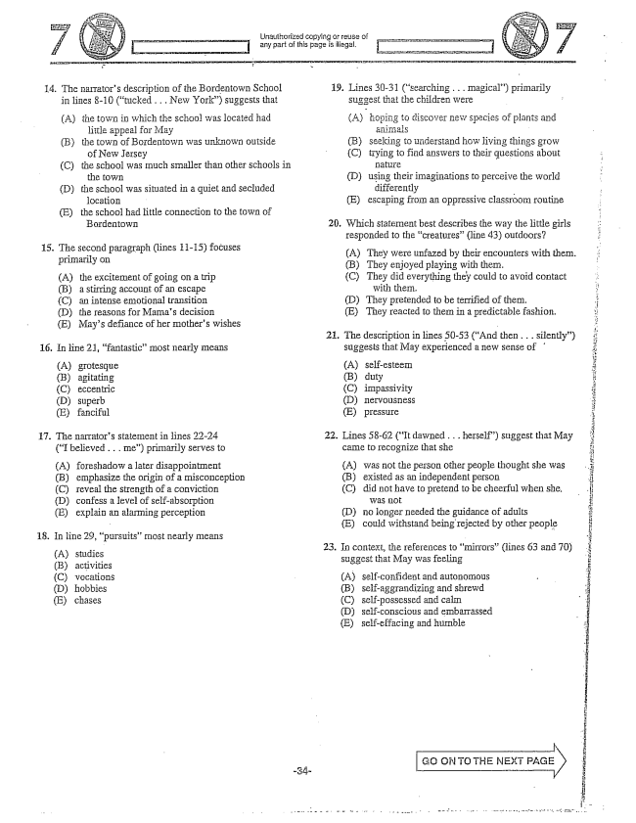

Unauthorized copying of reuse of .., any part of this page is iliagal, i

19. Lines 30-31 (searching . . . magical) primarily

14. The narrators description of the Bordentown School

suggest that the children were

in lines -10 (tucked . . . New York) suggests that

(A) hoping to discover new species of plants and . (B) seeking to understand how living things grow (C) trying to find answers to their questions about

(A) the town in which the school was located had

little appeal for May

(B) the town of Bordentown was unknown outside

of New Jersey

(C) the School was much smaller than other schools in

the town (D) using their imaginations to perceive the world (D) the school was situated in a quiet and secluded differently

location (E) escaping from an oppressive classroom routine (E) the school had little connection to the town of

Bordentown 20. Which statement best describes the way the little girls

responded to the creatures” (line 43) outdoors? 15. The paragraph (lines 11-15) focuses (A) They were unfazed by their encounters with them.

primarily On (B) They enjoyed playing with them. (A) the excitement of going om a trip (C) They did everything they could to avoid contact

with them.

(B) a stirring account of an escape (C) an intense emotional transition (D) the reasons for Mamas decision (E) Mays defiance of her mothers wishes

(D) They pretended to be terrified of them. (E) They reacted to them in a predictable fashion. :

22. Lines 58-62 (It dawned . . . herself) suggest that May

came to recognize that she

21. The description in lines 50-53 (And then . . . silently) 16. In line 21, fantasticmost nearly means suggests that May experienced a new sense of

(A) grotesque (B) agitating (B) duty (C) eccentric (C) impassivity (D) superb (D) nervousness (E) fanciful (E) pressure i

. The narrators statement in lines 22-24

(I believed . . . me) primarily serves to

(A) was not the person other people thought she was

existed as an independent person did not have to pretend to be cheerful when she.

WaS Indi (D) no longer needed the guidance of adults E) could withstand being rejected by other people

(A) foreshadow a later disappointment (B) emphasize the origin of a misconception (B) (C) reveal the strength of a conviction (C) (D) confess a level of self-absorption (E) explain an alarming perception

18. In line 29, pursuits” most nearly means

. 23. In context, the references to mirrors” (lines 63 and 70)

suggest that May was feeling

(C) vocations (A) self-confident and autonomous

(D) hobbies (B) self-aggrandizing and shrewd

(E) chases (C) self-possessed and calm

(D) self-conscious and embassassed (E) self-effacing and hurrible

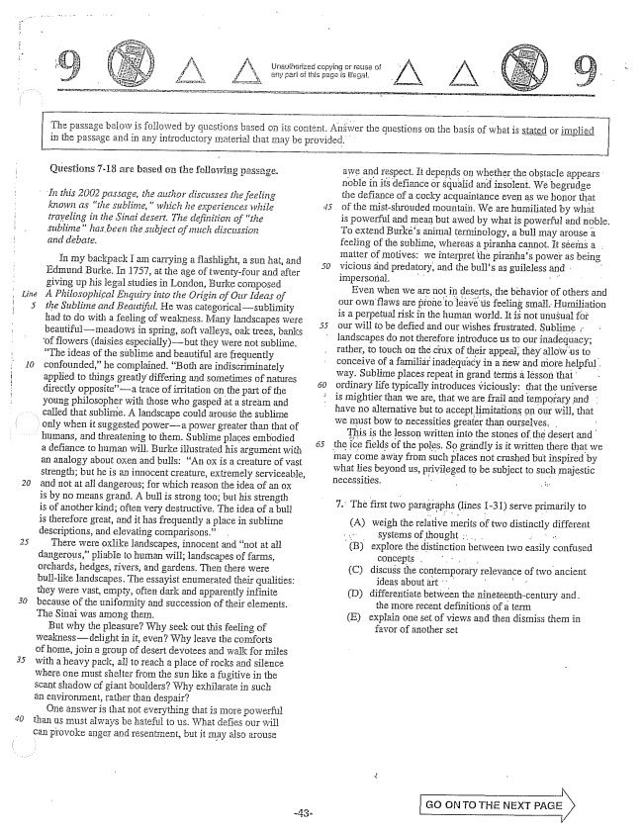

*Line*

Unauthorized copying Cr reuse of any part of this page is illegål.

The passage beioW is followed by questions based on its

in the passage and in any introductory Islaterial that may be provided.

*In this 2002 passage, the author discusses the feeling*

*known as the sublime,which he experiences while traveling in the Sinai desert. The definition of the sublimehas been the subject of much discussion £irid debate.*

In my backpack I am carrying a flashlight, a Sun hat, and Edmund Burke. In 1757, at the age of twenty-four and after giving up his legal studies in London, Burke composed A Philosophical Enquiry into the Origin of Our Häeas of the Sublime and Beautiful. He was categoricalsublimity had to do with a feeling of weakness. Many landscapes were beautifulIneadows in spring, soft valleys, oak trees, banks

of flowers (daisies especially)but they were not sublime,

The ideas of the sublime and beautiful are frequently confounded,he complained. Both are indiscriminately applied to things greatly differing and sometimes of natures directly oppositea trace of irritation on the part of the young philosopher with those who gasped at a stream and

called that Sublime. A landscape could arouse the subline

only when it suggested powera power greater than that of humans, and threatening to them. Sublime places embodied

a defiance to human will. Burke illustrated his argument with an analogy about oxen and bulls: An Ox is a creature of vast strength; but he is an innocent creature, extremely Serviceable, and not at all dangerous; for which reason the idea of an Ox is by no means grand. A bull is strong too; but his strength is of another kind; often very destructive. The idea of a bull is therefore great, and it has frequently a place in subline descriptions, and elevating comparisons.”

There were oxlike landscapes, innocent and Hot at all dangerous,pliable to human will; landscapes of farms, orchards, hedges, rivers, and gardens. Then there were bull-like landscapes. The essayist enumerated their qualities: they were vast, empty, often dark and apparently infinite because of the uniformity and succession of their elements. The Sinai was among them.

But why the pleasure? Why seek out this feeling of weaknessdelight in it, even? Why leave the comforts of home, join a group of desert devotees and walk for miles with a heavy pack, all to reach a place of rocks and silence where one must shelter from the Sun like a fugitive in the Scant shadow of giant boulders? Why exhilarate in such an environment, rather than despair?

One answer is that not everything that is more powerful than us must always be hateful to us. What defies our will can provoke and resentinent, but it may also arouse

nt. Answer the questions on the basis of what is stated or implied

*5*

awe and respect. It depends on whether the obstacle appears noble in its defiance or squalid and insolent. We begrudge the defiance of a cocky acquaintance even as we honor that of the mistshrouded mountain. We are humiliated by whât is powerful and mean but awed by what is powerful and noble. To extend Burkes animal terminology, a bull may arouse a feeling of the sublime, whereas a piranha cannot. It séems a Inatter of motives: we interpret the piratihas power as being vicious and predatory, and the bulls as guileless and - impersoñal.

Even when we are not in deserts, the behavior of others and our own flaws are prone to leave us feeling small. Humiliation is a perpetual risk in the human world. It is not unusual for our will to be defied and our wishes frustrated. Sublime landscapes do not therefore introduce us to our inadequacy; rather, touch DIi thế of their appeal, they allow us to conceive of a familiar inadequacy in a new and more helpful. way. Sublime places repeatin grand terms à lesson that ordinary life typically introduces viciously: that the universe is mightier than we are, that we are frail and temporary and have no alternative but to accept limitations on our will, that we must bow to necessities greater than ourselves, . -

This is the lesson written into the stones of the desert and the ice fields of the poles. So grändly is it written there that we may come away from such places not crushed but inspired by what lies beyond us, privileged to be subject to such majestic necessities. .

. The first paragraphs (lines 1-31) serve primarily f

(A) different

weigh the relative merits of two distinctly

**..**

explore the distinction between two easily confused

Concepts - . . .

discuss the contemporary

ideas about art

differentiate between the nineteenth-century and .

the more recent definitions of a term

explain one set of views and then dismiss them in

favor of another set

(C) relevance of two ancient

(D)

(E)

GO ON TO THE NEXT PAGE X

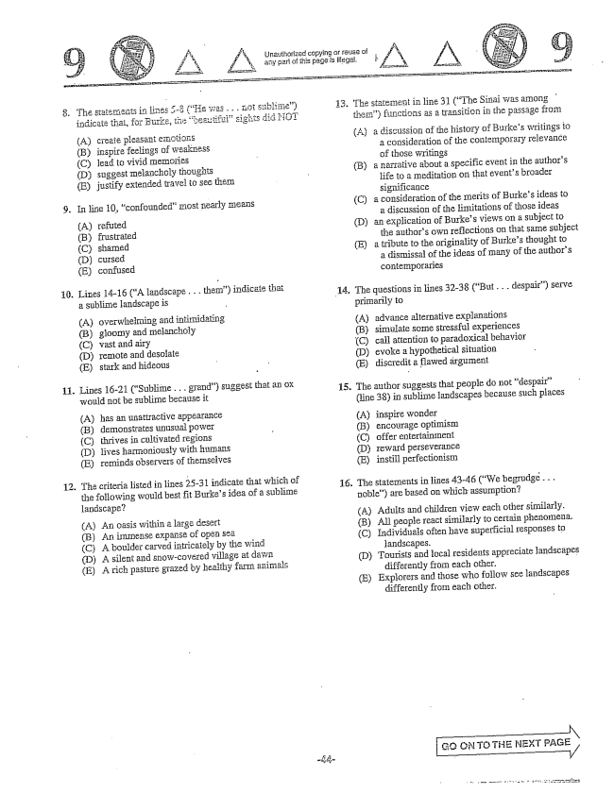

A) create pleasant emotions (B) inspire feelings of weakness (C) lead to vivid Hermories (D) suggest Inelancholy thoughts (E) justify extended travel to see them

. In line 10, confounded” most nearly Imeans

(Arefuted (B) frustrated (C) shamed (D) cursed (E) confused

. Lines 1416 (A landscape . . . them) indicate that

**11**

**12**

a sublime landscape is

(A) (B) (C)

(D) (E)

overwhelming and intimidating gloomy and Inelancholy

vast and airy

Temote and desolate

stark and hideous

Lines 16-21 (Sublime . . . grand) suggest that an ox would not be sublime because it

(A) has an unattractive appearance (B) demonstrates unusual power (C) thrives in cultivated regions (D) lives harmoniously with humans (E) reminds observers of themselves

The criterialisted in lines 25-31 indicate that which of the following would best fit Burkes idea of a sublime

landscape?

(A) An oasis within a large desert (B) An immense expanse of open sea (C) A boulder carved intricately by the wind (D) A silent and snowcovered village at dawn (E) A rich pasture grazed by healthy farm animals

15

Unauthorized copying or reuse of any part of this page is illegal.

The statement in line 31 (The Sinai was among thern) functions as a transition in the passage from

(A) a discussion of the history of Burkes writings to a consideration of the contemporary relevance of those writings

(B) a narrative about a specific event in the authors

life to a meditation on that events broader Significance

(C) a consideration of the merits of Burkes ideas to

a discussion of the limitations of those ideas

(D) aTi explication of Burkes views om a subject to

the authors own reflections on that same subject

(E) a tribute to the Originality of Burkes thought to

a dismissal of the ideas of many of the authors contemporaries

The questions in lines 3233 (But . . . despair) serve primarily to

(A) (B) (C) (D) (E)

The author suggests that people do not despair” (line 38) in Sublime landscapes because such places

(A) (B) (C) (D) (E)

The statements in lines 4346 (We begrudge . . . Roble) are based on which assumption?

advance alternative explanations simulate some stressful experiences calf attention to paradoxical behavior evoke a hypothetical situation discredit a flawed argument

inspire wonder encourage optimism offer entertainment reward perseverance instill perfectionism

(A) Adults and children view each other similarly. (B) All people react similarly to certain phenomena. (C) Individuals often have superficial responses to

landscapes. (D) Tourists and local residents appreciate landscapes

differently from each other. (E) Explorers and those who follow see landscapes

differently from each other.

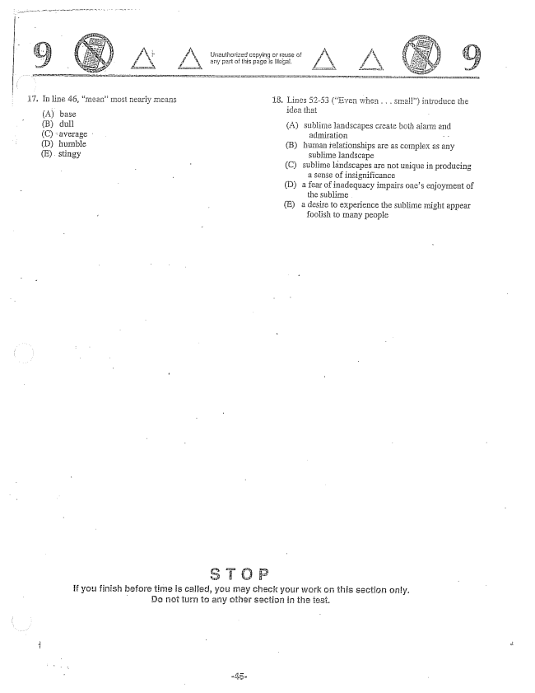

A

Af A. Unauthorized copying crpause of A

- any part of this page is illégé,

. Lines 52-53 (Evel when . . . sInail) introduce the

(A) base (B) dull (A) Sublime landscapes create both alarm and (C) average admiration - - D) humble (B) human relationships are as complex as any sublime landscapë

- (C) Sublime landscapes are not unique in producing

a Sense of insignificance (D) a fear of inadequacy impairs ones enjoyment of

the sublime . (E) a desire to experience the sublime might appear

foolish to many people

if you finish before time is called, you may check your work this section only.

- Do not turn te any other section in the est.

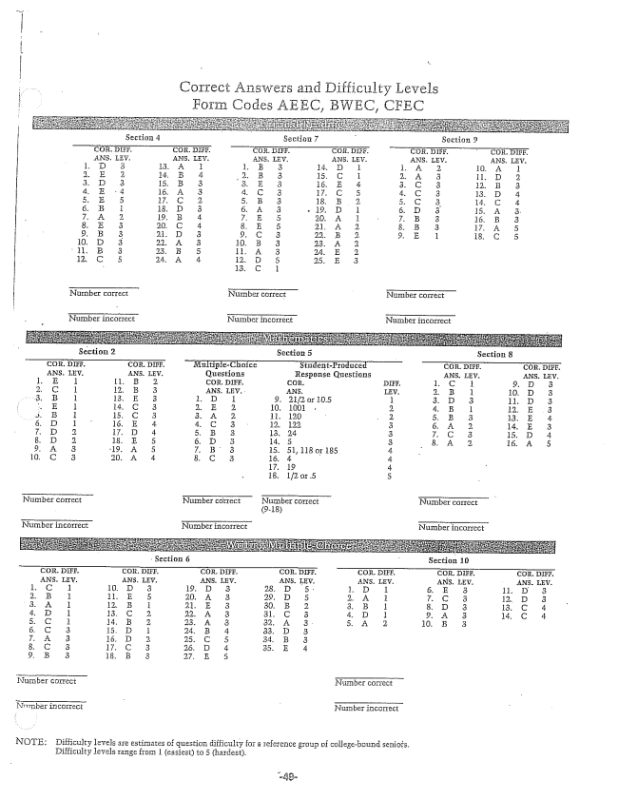

Correct Answers and Difficulty Levels

Form Codes AEEC, BWEC, CFE

Nurnber correct Number correct NuITıber correct

Nurnber incorrect Number incorrect

Number incorrect

Number incorrect

Number incorrect NuTribēr incorrect

Section 10

Nurnber correct

NOTE: Difficulty levels are estimates of question difficulty for a reference group of collegebound senios,

Difficulty levels range from 1 (easiest) to 5 (hardest.