

*Line*

*15*

I am a painter, I paint portraits and townscapes - of the inner city, of Shabby Streets, Srilall, dusty parks, crumbling tenements. That is IIIy art, my reason for living, Unhappily, it is not productive in the crude sense. In spite of kindiy reviews of my occasional exhibitions and the loyal response of Gld friends who attend the private views and buy the Smaller paintings, Illy work. Only brings in a pittance. The trade that I live by, that pays the bilis and the mortgage, that gives my mother the necessary allowance to keep her in reasonable comfortin her Small house, is that of a copyist.

I am (I must make this clear) an honest craftsman; not a cheat, not a forger. I am no Tom Keating,aging a picture with a spoonful of instant coffee, spraying on fly specks with a mixture of asphalt and turpentine, pretesiding to have come upon an unknown Old Master in a junk shop of attic. I paint copies of famous paintings, sometimes for private persons or institutions, but mostly for the directors of companies who want an impressive decoration to hang in their boardroorns. Deception of an innocent kind is their intention; asked if the picture is genuine, few of them, I imagine, would lie, Nor would they be wise to. Whether they know it Dr Ilot (and in Some cases I am sure that they do know, collaborating with Ime in a further, minor deception out of pleasure and a shared Sense of humor, Iny copies are never exact.

That is where vanity comes in. One wants to leave ones Inark on the world. Like Imany another craftsman, like an apprentice stonecutter carving a gargoyle on a cathedral, I want to my individual contribution to the grand design. I copy the painting with all the skill at Iny disposal, all the tricks; squaring up, measuring with Calipers, using photographs, a projector, a light box for tTansparencies to get as near as I can to the true color. I try to match the pigments used by the artist, grinding my own Naples yellow, or buying it in a tube from Budapest where it is still legal to sell it ready made with lead and antimony. But instead of adding my signature, I change some insignificant feature. I alter the expression of a man in a crowd, add a tiny animal face in a dim corner, a mouse or a weasef, replace the diamond on a womans hand with a ruby, paint a watch on a wrist in an eighteenth-century portrait. How many casual observers would notice? Or care if they did? Most people chortle to see experts Confounded.

All art, of course, is full of deception. Nature, too, and human behavior, but more of that later. Remember the

Unauthorized CCpying of rétise of any part of this page is iiiągal.

story of ZeuxisNoThen Ill tell you. (Bear with me. The tale will develop, I hope, when I can find Iny way into it, bit I am only a painter, unused to the art narrative flow.)

invited another painter to witHess a repeat performance, A rival, whose name was Parrhasius. He affected to be unimpressed. To cheat sparrows was nothing extraordinary. Bird brainedwas his buzzword. The birth of a cliché?

Parrhasius went Home and brooded. His turn to ask his friend Zeuxis to inspect a painting. It was concealed behind a curtain. Zeuxis tried to unveil it and failed; the draperies had been painted. Zeuxis, who was either a fool, or a very mice man, or simply somewhat shortsighted, was generous with praise. I was Gnly able to deceive a few sparrows, but you have deceived me, a Eman and artist.”

This Hoary oli legend has its quirky, private significance for me. Ever since I first heard it, at school, it made me want to be an artist good enough to fool the experts.

Keating (1918-1984) was an art restorer and famous art forger who claimed to have forged over 2,000 paintings by over 100 different artists.

12. In line , Unhappily” most nearly means

(A) Inappropriately (B) Mournfully (C) Unfortunately (D) Awkwardiy (E) Unexpectedly

35. The narrator portrays the friends” (line ) as generally bëing - -

A) (B) (C) (D) (E)

14. The narrators attitude toward Tom Keating (line 13)

is primarily one of

(A) (B) (C) (D) (E)

imaginative artistic amusing reflective supportive

Sympathy fascination regret disdain exasperation



15.

17.

18.

In line 16, the narrator uses the phrase an unknown QId Masterto refer to

(A) a forgotten teacher who once wielded great

influence

(B) a formerly prominent artist has now become

obscure

(C) any painting found in an outof-the-way place

Dan artwork so damaged that it has lost its aesthetic

appeal

(E) a painting by a famous artist that had previously

been unrecognized

The attitude of those people collaborating” (line 24)

in the deception” (line 25) is one of

(A) (B) (C) (D) (E)

As described in lines 31-37 (I copy . . . antimony), the narrators approach to copying is best

feigned innocence ironic detachment wry amusement naked ambition unmitigated greed

characterized as

(A) painstaking (B) grudging (C) innovative (D) simplistic (E) slipshod

The watch” (line 42) is best characterized as

(A) an allegory (B) an anachròilisn (C) a metaphor (D) a symbol (E) a cOnundrum

19, The statement in line 45 (All art. . . deception)

21.

signals a shift from

(A) a discussion about a vocation to a discussion

about private life (B) a description of a person to a description of

a Can analysis of a deception to a rumination on that

deceptions consequences (D) an account of a particular individuals actions to

an explanatory anecdote (E) a historical consideration of a trade to a rhythical

tale of that trades Origins

. În line 55, cheat” nlost nearly means

Inislead Swindle deprive elude victirmize

(A) (B) (C) (D) (E)

In lines 5457 (He affected . . . brooded), the narrator implies that Parrhasius was

(A) annoyed at having been summoned to judge

Zelaxiswork

(B) regretful that he had not worked harder to perfect

his own artistic skills

(C) proud that a fellow artist had created such a

realistic work

(D) secretly jealous of Zeuxisaccomplishment

(E) more knowledgeable about the behavior of birds

than Zeuxis was

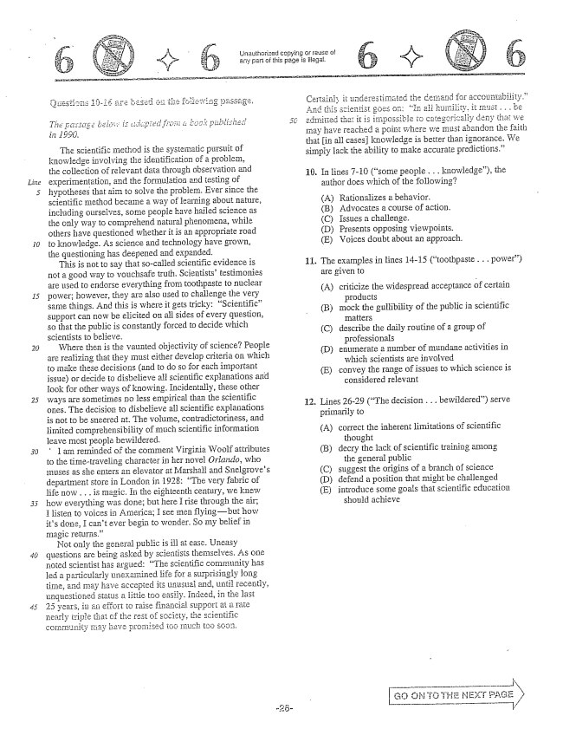

*Life*

*30*

*The pas Eggé baigi i:*

The scientific method is the systematic pursuit of knowledge involving the identification of a problem, the collection of relevant data through Gbservation and experimentation, and the formulation and testing of hypotheses that aim to solve the problem. Ever since the Scientific method became a way of learning about nature, including ourselves, some people have hailed science as the Chly way to comprehend natural phenomena, while others have questioned whether it is an appropriate road to knowledge. As Science and technology have grown, the questioning has deepened and expanded.

This is not to say that socalled scientific evidence is not a good way to vouchsafe truth. Scientiststestimonies are used to endorse everything from toothpaste to nuclear power; however, they are also used to challenge the very same things. And this is where it gets tricky: Scientificsupport can now be elicited on all sides of every question, so that the public is constantly forced to decide which scientists to believe.

Where then is the vaunted objectivity of Science? People are realizing that they must either develop criteria on which to make these decisions (and to do so for each important issue) or decide to disbelieve scientific explanations and look for other ways of knowing. Incidentally, these other ways are sometimes no less empirical than the scientific ones. The decision to disbelieve all scientific explanations is not to be sneered at. The volume, contradictoriness, and limited comprehensibiiity of much scientific information leave most people bewildered.

" I am reminded of the comment Virginia Woolf attributes to the timetraveling character in her Ilovel Orlando, who muses as she enters an elevator at Marshall and Snelgroves department store in London in 1928: The very fabric of life now . . . is magic. the eighteenth century, we knew how everything was done; but herë I rise through the air; I listen to voices in America; I see Hien flyingbut how its done, I cant ever begin to wonder. So my belief in magic returns.”

Not only the general public is ill at ease. Uneasy questions are being asked by scientists themselves. As one noted Scientist has argued: The Scientific community has led a pārticularly unexamined life for a surprisingly long time, and II ay have accepted unusuai and, until Tecently, unquestioned status a littie easily. Indééd, in the last 25 years, in effort to raise financial support at a rate nearly triple that cf the rest of society, the scientific

f

coffIgnity Tigy havë promised tog much too scon.

Urlauthorized or reuse of any part of this page is illegal, #

admitted that it is imp may have reached a point where we Inu that in all casesknowledge is better than ignorance. We

simply lack the ability to make accurate predictions.”

16. In lines -10 (SOITle people . . . knowledge), the

author does which of the following?

(A) Rationalizes a behavior, B) Advocates a course of action. (C) Issues a challenge. (D) Presents opposing viewpoints. (E) Voices doubt about an approach.

The examples in lines 14-15 (toothpaste . . . power) are given to

11.

(A) criticize the widespread acceptance of certain

products -

mock the guilibility of the public in scientific

IT1:litèIS

describe the daily routine of a group of

professionals enumerate a number of Inundane activities in

which scientists are involved convey the range of issues to which science is

considered relevant

(E)

Lines 26-29 (The decision . . . bewildered) serve primarily to (A) correct the inherent limitations of scientific

thought (B) decry the lack of scientific training among

the general public (C) suggest the origins of a branch of science (D) defend a position that might be challenged (E) introduce some goals that scientific education

should achieve

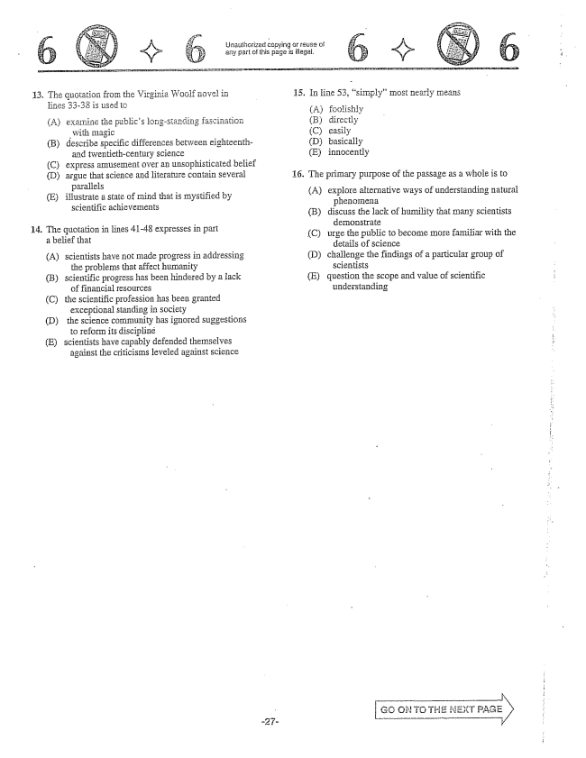

13. The quotation from the Virginia Woolf Hovel in 15. In line 53, simply” most nearly sneans

with magic (B) describe specific differences between eighteenth- D) basically

and twentieth-century science (E) innocently (C) express amusement over an unsophisticated belief

(D) argue that science and literature contain several 16. The primary purpose of the passage as a whole is to

allel - - (E) state of Hind that is mystified by (A) explore alternative ways of understanding natural

- - - - - henoInena

- - - Scientific achië Weinents (B) discuss the lack of humility that many scientists

- - - - - demonstrate . - 4 - in lines 41-48 expresses in part (C) urge the public to become more familiar with the

details of Science (D) challenge the findings of a particular group of

(A) Scientists have not made progress in addressing

the problems that affect humanity scientists (B) Scientific progress has been hindered by a lack (E) question the scope and value of scientific

understanding

of financial resolirces (C) the scientific profession has been granted

exceptional standing in Society (D) the science community has ignored suggestions

to reform its discipliné (E) scientists have capably defended themselves

against the criticisms leveled against scielice

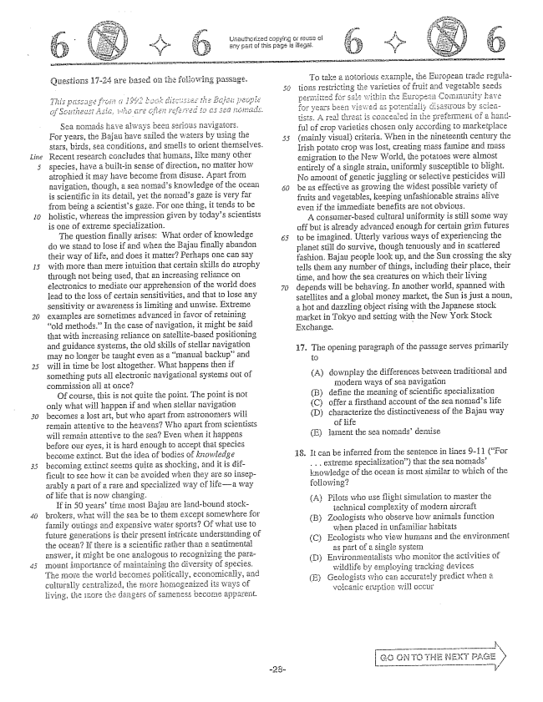

*30*

الله

5

Sea Homads have always been serious For years, the Bajau have sailed the Wa stars, birds, Sea conditions, and SHleils to Orient themselves. Recent research concludes that humans, like many other species, have a builtin sense of direction, no matter how atrophied it may have become from disuse. Apart from navigation, though, a sea nomads knowledge of the ocean is scientific in its detail, yet the nomads gaze is very far from being a scientists gaze. For one thing, it tends to be holistic, whereas the impression given by todays scientists is one of extreme specialization.

The question finally arises: What order of Knowledge do we stand to lose if and when the Bajau finally abandon their way of life, and does it matter? Perhaps one can say with more than Imere intuition that certain skills do atrophy through not being used, that an increasing reliasice on electronics to mediate our apprehension of the world does lead to the loss of certain sensitivities, and that to fose any sensitivity or awareness is limiting and unwise. Extreme exampies are sometimes advanced in favor of retaining old methods.” In the case of navigation, it might be said that with increasing reliance on Satellitebased positioning and guidance systerns, the old skills of Stellar navigation may no longer be taught even as a manual backup” and will in time be fostaltogether. What happens then if Something puts all electronic navigational systems out of commission all at once?

Of course, this is not quite the point. The point is not only what will happen if and when stellar navigation becomes a lost art, but who apart from: astronomers will remain attentive to the Beavens? Who apart from scientists will remain attentive to the sea? Even when it happens before our eyes, it is hard enough to accept that species become extinct. But the idea bodies of knowledge becoming extinct seems quité as shocking, and it is difficult to see how it can be avoided when they are so inseparably a part of a rare and specialized way Cf lifea way of life that is now changing.

If in 50 years' tirnë Inosi Bajau are landbound stockbrokers, what will the sea be to them except somewhere for family outings and expensive water sports? Gf what use to future generations is their present intricate understanding of the ocean? if there is a Scientific rather than a Sentimental answer, it might be one analogous to recognizing the paramount importance of ITiaintaining the diversity of species, The more the world becCIñés politically, economically, and culturally centralized, the more homogenized its ways of living, the IECT: the dangers of tiecCIle apparent.

rade regularuit and vegetable seed . ប្រែៈ ខ្វេះ ful of crop varieties chosen CIly according to marketplace (Inainly visual) criteria. When in the nineteenth century the Irish potato crop was lost, creating famine and mass emigration to the New World, the potatoes were almost entirely of a single strain, uniformly susceptible to blight. No amount of genetic juggling Or selective pesticides will be as effective as growing the widest possible variety of fruits and vegetables, keeping unfashionable strains alive even if the immediate benefits are not obvious.

A consisterbased cultural uniformity is still some way off but is already advanced enough for certain grin futures to be imagined. Utterly various ways of experiencing the planet still do survive, though tenuously and in scattered fashion. Bajau people look up, and the Sun crossing the sky tells them any number of things, including their place, their time, and how the sea creatures on which their living depends wifi be behaving. In another world, spanned with satellites and a global Inoney Imarket, the Sun is just a nGun, a hot and dazzling object rising with the Japanese stock market in Tokyo and setting with the New York Stock Exchange.

3.

17. The opening paragraph of the passage serves primarily

(A)

(B) (C) (D)

downplay the differences between traditional and

Inodern ways of Sea navigation

define the Ineaning of scientific specialization

offer a firsthand account of the sea nomads life

characterize the distinctiveness of the Bajali way

of ife

lament the sea nomadsdeniise

E)

be inferTed the sẽmĩence in Hines 9-11 (For . . . extreme specialization) that the sea nomadsl, nowledge of the Ocean is most similar to which of the following?

18.

(A) Pilots who use flight simulation to master the

ièchnical complexity of Inodern aircraft Zoologists who observe how animals function

when placed in unfamiliar habitats Ecologists who view humans and the environment

as part of a single system Ervinonmentalists who monitor the activities of

wildlife by employing tracking devices (E) Geologists who can accurately predict when a

voicanic eruption will Occur

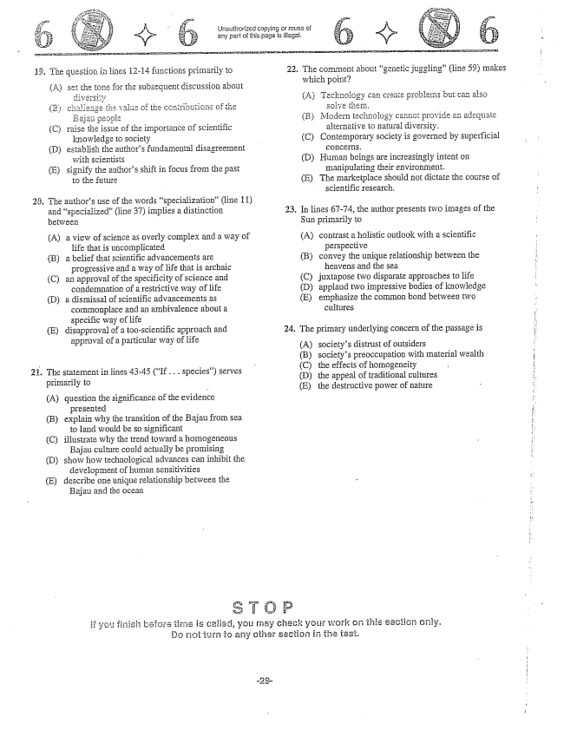

**الانعتيبي**

Unauthorized copying or reuse of

ఖైడిరి

(C) raise the issue of the importance of scientific

knowiedge to Society

(D) establish the aiithors fundamental disagreement

with scientists

(E) signify the authors shift in focus from the past

to the future

23. The authors use of the words specialization(line 11)

and specialized” (line 37) implies a distinction between

(A) a view of science as overly complex and a way of

life that is uncomplicated (B) a belief that scientific advancements are

progressive and a way of life that is archaic (Can approval of the specificity of science and

condernnation of a restrictive way of life (D) a dismissal of scientific advancements as

commonplace and an ambivalence about a specific way of life (E) disapproval of a tooscientific approach and approval of a particular way of life

21. The statement in lines 43-45 (If... species) serves

primarily to

(A) question the significance of the evidence

presented

(B) explain why the transition of the Bajau from sea

to iand would be so significant

(C) illustrate why the trend toward a homogeneous

Bajau culture could actually be promising

(D) show how technological advances can inhibit the

development of human sensitivities

(E) describe one unique relationship between the

Bajau and the Ocean

22. The CCIIlment about genetic juggling” (line 59) makes

which point

alternative to matural diversity. (C) Contemporary society is governed by superficial

CGHICETTES. (D) Human beings are increasingly intent on Imanipulating their environment. (E) The Imarketplace should not dictate the course of

scientific research.

23. In lines 67-74, the author presents two images of the

Sun primarily to

(A) contrast a holistic outlook with a scientific

perspective

(B) convey the unique relationship between the |

heavens and the Sea

(C) juxtapose two disparate approaches to life

(D) applaud two impressive bodies of knowledge

(E) emphasize the common bond between two

cultures

24. The primary underlying concern of the passage is i.

(A) societys distrust of outsiders (B) societys preoccupation with material wealth f (C) the effects of homogeneity i. (D) the appeal of traditional cultures - E) the destructive power of nature

*:*

check your work on this section only.



*15*

the basis of what is Stated

Unauthorized pupying or reuse of any part of this page is illegal.

are foliowed by questions based on their content and on the relationship between the two passages.

d or implied in the passages and in any introductory Islaterial that may be

Questions -2iare based on the following passages.

*These passages are excerpts frain tivo different histories of rock-and-roll music in the United States. Both passages were written in the 1980s.*

Passage 1

As I was passing as unconsciously as possible through one of humanitys IHost insidious institutions, junior high school, something dramatic yet subtle was taking place in my teenage consciousness. I didnt recognize it for what it was at the time. Nobody dici. But it was happening to all of us, just the same. It didn't take iong for adults to tell us what it was, however, and they werent very happy. They called it primitive, communistic, filthy, SITutiy, and obscene; we called it rock and roll. We were both right.

Today, with over 30 years of hindsight available, the whole phenomenon seems relatively clear and, if possible, even Inore provocative than it seemed at its inception. What I and Iny fellow sufferers were experiencing was the beginning of Americas first genuine cultural revolution. This statement may seem exaggerated for two somewhat contradictory reasons. First, weve always been taught that Americas war of independence from England was a true revolution, something of an exaggeration in itself. Second, and more important, were Teluctant to give up the American myth of a slow and steady (but inevitable) progress toward an earthly perfection. Americans have always tolerated many more disagreements over the nature of their goals than over how they could be achieved. The process was expected to be rational, well ordered, and continuous. So even to suggest the possibility of a cultural revolution in America must appear not only factually absurd but biasphemous as well. Revolution is as heretical a doctrine in America as abolishing the monarchy would be in England. Nevertheless, despite the overwhelmingly conservative assumptions of most Americans, we are in fact in the throes of a genuine and dramatic revolution in our clilture, and it behooves us to understand it before passing judgInênt. -

From its beginnings, rock music has challenged the basic values of the culture in which it emerged: not ail at once, not always Self-cOTısciously, cértainly not programmatically, but Surely and steadily nevertheless. First chailenges to the accepted beliefs about sex, race, and workthen nationalism, war, and econdinics

By implication, of course, the entire

these waitiès was

convictions about destiny, inevitable progress, absolutist InOrality, and fixed social positions. Sociologists had been studying and criticizing this value scheme. Rock and roll, however, didnt propose to study itrock and Toil proposed to abolish it.

Passage 2

In its beginnings, rock and Toll was the music of teens and very young adults. But as we entered the 1970s, an inevitable fact became obvious; those 1950s teenagers were entering middle age and they still liked rock. A baby born in 1940 was fifteen years old when Rock Around the Clock” hit number one; in 1970 that same person turned thirty but very likely still liked Elvis, the Beach Boys, Dylan, and the Beatles. And in 1985 that baby” was solidly middle-aged and in all probability still liked those artists as well as a few newer onesestablished groups and performers such as Chicago, Fleetwood Mac, and Lionel Richie. Notice the number of classic rock” and adult rock” radio stations on your FM dial? Those are aimed at a relatively affluent segment of the adult population that is roughly thirty-five to fifty years old. These people are hitting their peak earning years (a fact of considerable interest to radio advertisers), and they want to hear their favorite artists from the 1950s and 1960s, as well as a few of the more conservative acts of the 1970s and 1980s. Indeed, the rock market now extends to people in their fifties. -

At the other end of this demographic expansion are the preteens. The lowering of the age of rock consumerism has accelerated with the coming of MTV and other televised rock video formats. It should come as no surprise to anyone that childrenlittle childrenlike television. While parents and older siblings are at work, at school, of elsewhere, younger kids have a choice of cartoons, reruns, game shows, or the most upto-date rock videos. The television rock videos have brought an increasingly younger population into the world of rock and roll.

What this means is that rock and is no longer a teenOriented countercultural phenomenon. It now pervades Inuch of American culture. It cuts across economic groups, social levels, and ethnic groups. The rock style permeates movie music, Thusic for television, advertising music, jazz, music at athletic events, church music, and country music. Granted, loithiii rock there are countercultural trends, but as a generic entity, rock So permeates our entire culture that other styles of musicsuch as jazz, classical, and pure Country and Westernare considered to be on the fringe, admired by Siriali Subcultirai groups.



Unauthorized copying or reuse of - any part of this page is illegal. أمسيا f

. Which of the following best states the relationship

between the two passages?

perspective on that same phenomenon.

(B) Passage 1 sketches the historical causes of an

event, whereas Passage 2 considers that event from a contemporary perspective.

(C) Passage I criticizes the existence of a certain

Originai

31. The authors Strategy in the first paragraph of

Passage 1 is best described as one that uses

attitude, whereas Passage 2 argues that this - - -

, gueS tn (A) a series of hypothetical questions to Set

- - up a debate

(D) Passage 1 provides a personal reflection on a 1: - -

ခါးျမိဳ႕, whereas Passage 2 predicts the (B) a set of well-established facts to persuade

**pi**

implications of that II ovement. C the -- gage the Tead (E) Passage 1 urges readers to undertake a particular (C) personał

course of action, whereas Passage 2 offers a (D) exaggerated ridicule to discredit an idea

- (E) understatement to satirize a point of view

sober consideration of the dangers of doing so.

**- - - - S - - - - 2.**

. The two authors would Inost likely agree with which of the following Statements? гуі

(A) Americans are critical of their countrys

* - - جتتر (A) question personal revolution but do not fully understand the (B) The effect that rock and roll would have on revolutions signក្ee

society was not anticipated in the 1950s (B) No cultural revolution has taken place, but - - there are signs of one. (C) A phenomenon Such as popular music Qught - .1. - . -

to be appreciated for what it is, not studied or (C) like to think of their cłassified having been by revolution, yet

- they do not believe in sudden change. DEven those people who once strongly objected - - to Tock will eventually co . - - (D) Adults who publicly railed against rock

appreciate if and roll had to admit that they privately

- - .: - : enjoyed it. (E) Were it not for radio and television, rock milisic - i- - -

would not have had such a major influence on (E) Although rock began as a rebellion culturë against authority, it has become an arbiter

- of societal norms.

. . In lines 2529 (So even . . . England), the author of rock music of the adults(line , Passage I) and -

Passage I Suggests that Tlost Americans are essentially

the people(line 64, Passage 2) 7

(A) suggestible

(A) Apathetic . . passionate B) Ambivalent . . accepting (C) Intrigued . . uninterested D - D) Disapproving . . appreciative (D) unorthodox

(E) illogicał

(E) Fearful . . baffled

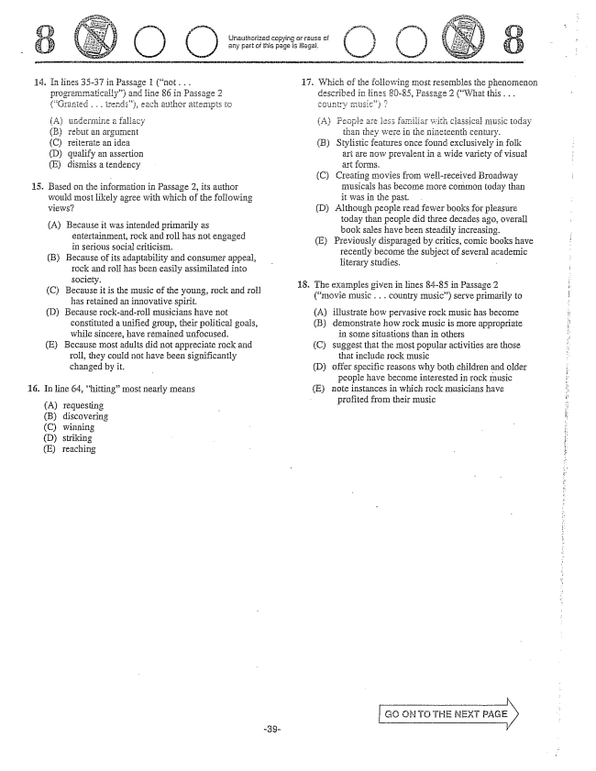

14. In lines 35-37 in Passage 1 (not . . .

**-**

programmatically) and line 86 in Passage 2 - - - trends), each author attempts

(A) underminē a fallacy (B) rebut an argument (C) Teiterate än idea (D) qualify an assertion (E) dismiss a tendency

Based on the information in Passage 2, its author would Ingst likely agree with which of the following

(A) Because it was intended primarily as

entertainment, rock and Toll has not engaged in serious social criticism,

B) Because of its adaptability and consumer appeal,

rock and roli has been easily assimilated into society.

(C) Because it is the music of the young, rock and roll

has retained an innovative spirit.

(D) Because rock-and-roll musicians have not

constituted a unified group, their political goals, while sincere, have remained unfocused.

(E) Because most adults did not appreciate rock and

roll, they could not have been significantly changed by it.

In line 64, hitting” most nearly means

requesting discovering winning Striking

reaching

Unauthorized copying rUse any part of this page is illegal.

. Which of the following most resembles the phenomenon

described in lines 80-85, Passage 2 (What this . . . cgញុំ ត្បo) ?

(A) are 1355 familiar with Ciassical music today

tian they were in the nineteenth century. (B) Stylistic features once found exclusively in folk

art are now prevalent in a wide variety of visual art forms. (C) Creating movies from well-received Broadway

Imusicals has become more corninon today than it was in the past. (D) Although people read fewer books for pleasure

today than people did three decades ago, overall book sales have been steadily increasing. (E) Previously disparaged by critics, comic books have

recently become the subject of several academic Eiterary studies. -

. The examples given in lines 84-85 in Passage 2

(movie music . . . country music) serve primarily to

illustrate how pervasive rock music has become demonstrate how rock music is more appropriate

in some situations than in others suggest that the most popular activities are those

that include rock music offer specific reasons why both children and older

people have become interested in rock music note instances in which rock musicians have

profited from their music

(C)

(D)

(E)

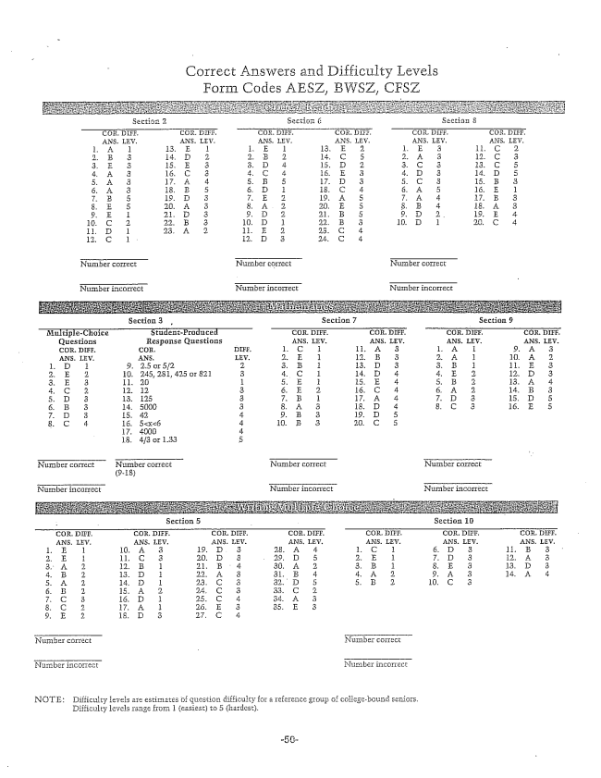

Form Codes AESZ, BWSZ, CFSZ

Number correct Number correct Number correct

Nurmber incurrect Number incorrect

Number incorrect

(9-18)

Number incorrect Number incorrect

NLIII, her incorrect

Hegebound seniors.

NOTE: Difficulty levels are estimates question difficulty for a reference group of co

Difficulty levels range from 1 (easiest) to 5 (iiardest,