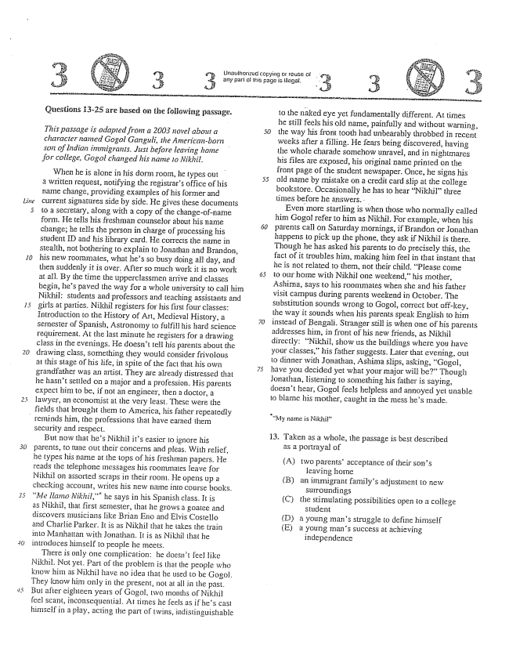

*20*

Questions 13-25 are based on the following passage.

*This passage is adapted from a 2003 novel about a character nanted Gogol Ganguli, the AmericanborTi son of Indian immigrants. Just before leaving home for college, Gogol changed his name to Nikhil.*

When he is alone in his dorm room, he types out a written request, notifying the registrars office of his name change, providing examples of his former and current signatures side by side. He gives these documents to a secretary, along with a copy of the changeof-name form. He tells his freshman counselor about his name change; he tells the person in charge of processing his student ID and his library card. He corrects the name in stealth, not bothering to explain to Jonathan and Brandon, his new roominates, what hes So busy doing aft day, and then suddenly it is over. After so much work it is no work at all. By the time the upperclassmen arrive and classes begin, hes paved the way for a whole university to call him Nikhii: Students and professors and teaching assistants and girls at parties. Nikhil registers for his first four classes: Introduction to the History of Art, Medieval History, a sernester of Spanish, Astronomy to fulfill his hard Science requirement. At the last minute he registers for a drawing class in the evenings. He doesn't tell his parents about the drawing class, something they would consider frivolous at this stage of his life, in spite of the fact that his own grandfather was an artist. They are already distressed that he hasn't Settled on a major and a profession. His parents expect him to be, if not an engineer, then a doctor, a lawyer, an economist at the very least. These were the fields that brought them to America, his father repeatedly

reminds him, the professions that have earned them

security and respect.

But now that hes Nikhil its easier to ignore his parents, to tune out their concerns and pleas. With relief, he types his name at the tops of his freshman papers. He reads the telephone messages his roommates leave for Nikhil on assorted scraps in their room. He opens up a checking accolint, writes his new name into course books. Me llamo Nikhil,” he says in his Spanish class. It is as Nikhil, that first semester, that he grows a goatee and discovers Imusicians like Brian Eno and Elvis Costello and Charlie Parker. HI is as Nikhil that he takes the train into Manhattan with Jonathan. It is as Nikhil that he introduces himself to people he meets,

There is only one complication: he doesnt feel like Nikhil. Not yet. Part of the problem is that the people who know him as Nikhil have no idea that he used to be Gogol. They know him only in the present, not at all in the past. But after eighteen years of Gogol, two months of Nikhil feel scant, inconsequential. At tiInes he feels asif hes casi himself in a play, acting the part of twins, indistinguishable

to the naked eye yet fundamentally different. At times he still feels his old name, painfully and without warning, the way his front tooth had unbearably throbbed in recent weeks after a filling. He fears being discovered, having the whole charade somehow unravei, and in nightmares his files are exposed, his original name printed on the front page of the Student newspaper. Önce, he signs his old maine by mistake on a credit card ship at the college bookstore. Occasionally he has to hear Nikhilthree times before he answers. . . -

Even Inore startling is when those who normally called him Gogol refer to him as Nikhil. For example, when his parents call on Saturday mornings, if Brandon or Jonathan happens to pick up the phone, they ask if Nikhil is there. Though he has asked his parents to do precisely this, the fact of it troubles him, making him in that instant that he is not related to them, not their child. Please corne to our home with Nikhil One weekendhis mother, Ashima, says to his roommates when she and his father visit campus during parents weekend in October. The substitution sounds wrong to Gogol, correct but offkey, the way it sounds when his parents speak English to him instead of Bengali. Stranger still is when one of his parents addresses him, in front of his new friends, as Nikhil directly: Nikhil, show us the buildings where you have your classes,his father suggests. Later that evening, Out to dinner with Jonatham, Ashima slips, asking, Gogol, have you decided yet what your major will be” Though Jonathan, listening to something his father is saying, doesnt hear, Gogol feels helpless and annoyed yet unable to blame his mother, caught in the mess hes Inade.

My name is Nikhil."

13. Taken as a whole, the passage is best described

as a portrayal of

(A) two parentsacceptance of their sons

leaving home

an immigrant familys adjustment to new

Surroundings -

the Stimulating possibilities open to a college

Student

a young mans struggle to define himself

a young mans success at achieving

independence

(B)

(C)

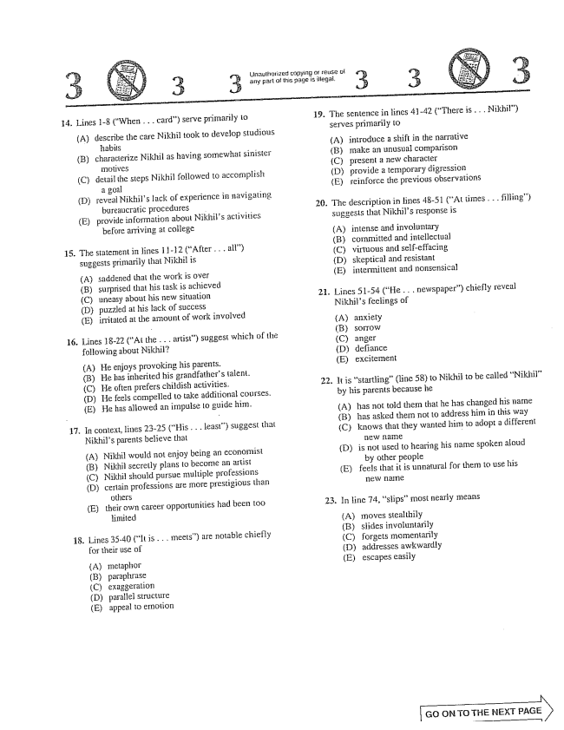

Unauthorized copying of reuse of 3. any part of this page is illegal. 3.

15.

17.

18.

. Hines 1-8 (When . . . card) serve primarily to

(A) describe the care Nikhil took to develop studious

habils (B) characterize Nikhil as having somewhat sinister

(C) detail the steps Nikhil followed to accornplish

a goal

(D) reveal Nikhils lack of experience in navigating

bureaucratic procedures .

(E) provide information about Nikhils activities

before arriving at college

The statement in lines 11-12 (After . . . all) suggests primarily that Nikhil is

(A) saddened that the work is over (B) surprised that his task is achieved (C) uneasy about his new situation (D) puzzled at his lack of success (E) irritated at the amount of work involved

Lines 18-22 (At the . . . artist) suggest which of the following about Nikhil?

(A) He enjoys provoking his parents. (B) He has inherited his grandfathers talent. (C) He often prefers childish activities. (D) He feels compelled to take additional courses. (E) He has allowed an impulse to guide him.

In context, lines 23-25 (His . . . least) suggest that Nikhils parents believe that

(A) Nikhil would not enjoy being an economist

(B) Nikhil Secretly plans to become an artist

(C) Nikhil should pursue multiple professions

(D) certain professions are more prestigious than

others

(E) their own career opportunities had been 100

limited

Lines 35-40 (It is . . . meets) are notable chiefly for their use of

(A) metaphor (B) paraphrase (C) exaggeralion (D) parallel structure (E) appeal to emotion

19. The sentence in lines 4142 (There is . . . Nikhil)

serves primarily to

(A) introduce a shift in the narrative (B) make an unusual comparison (C) present a new character (D) provide a temporary digression (E) reinforce the previous observations

. The description in lines 48-51 (At times . . . filling)

suggests that Nikhils response is

(A) intense and involuntary (B) committed and intellectua; (C) virtuous and self-effacing (D) skeptical and resistant (E) intermittent and nonsensical

- Lines 51-54 (He . . . newspaper) chiefly reveal

Nikhils feelings of

(A) anxiety (C) anger (D) defiance (E) excitement

. It is starting" (line 58) to Nikhil to be called Nikhil”

by his parents because he

(A) has not told them that he has changed his name

(B) has asked them not to address him in this way

(C) knows that they wanted him to adopt a different

H1EVA :: -

(D) is not used to hearing his name spoken aloud

by other people

(E) feels that it is unnatural for them to use his

TlEW Ilf:

. In line 74, siips” most nearly means

(A) moves stealthily (B) slides involuntarily (C) forgets momentarily (D) addresses awkwardly (E) escapes easily

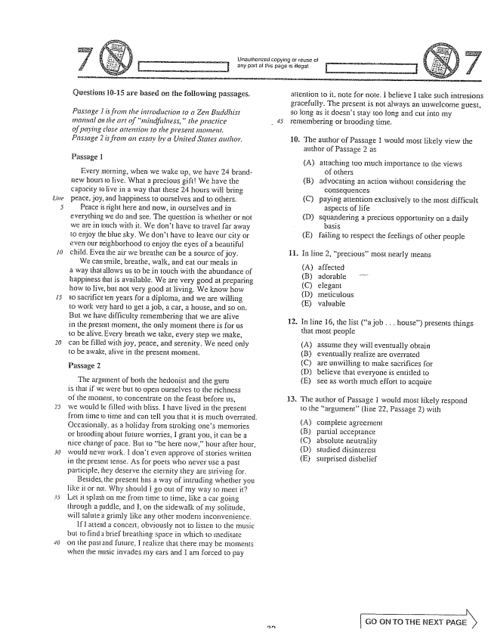

Unauthorized copying or reuse of any part of this page is illegal.

Questions 10-15 are based on the foliowing passages,

*Passage 1 is from the introduction to a 2en Buddhist manual on the art of mindfulness," the practice 45 of paying close attention to the present montent. Passage 2 is from an essay by a United States author.*

Passage 1

Every morning, when we wake up, we have 24 brandnew hours to live. What a precious giftWe have the capacity to live in a way that these 24 hours will bring peace, joy, and happiness to ourselves and to others.

Peace is right here and now, in ourselves and in everything we do and see. The question is whether or Hot we are in louch with it. We dont have to travel far away to enjoy the blue sky. We don't have to leave our city or even Our neighborhood to enjoy the eyes of a beautiful child. Even lhe air we breathe can be a source of joy.

We can Smile, breathe, walk, and eat our meals in a way that allows us to be in touch with the abundance of happiness that is available. We are very good at preparing how to live, but not very good at living. We know how to sacrifice ten years for a diploma, and we are willing to work very hard to get a job, a car, a house, and so on. But we have difficulty remembering that we are alive in the present moment, the only moment there is for us to be alive. Every breath we take, every step we make, can be filled with joy, peace, and serenity. We need only to be awake, alive in the present moment.

Passage 2

The argument of both the hedonist and the guru is that if we were but to open ourselves to the richness of the noment, to concentrate on the feast before us, we would be filled with bliss. I have lived in the present from time to time and can tell you that it is much overrated. Occasionally, as a holiday from stroking ones memories or brooding about future worries, I grant you, it can be a nice change of pace. But to be here now,” hour after hour, would never work. I don't even approve of stories written in the present tense. As for poets who never use a past participle, they deserve the etermity they are striving for.

Besides, the present has a way of intruding whether you like it or not. Why should I go out of my way to it? Let it splash on me from time to time, like a car going through a puddle, and 1, on the sidewalk of my solitude, will salute it grimly like any other Inodern inconvenience.

If lattend a concert, obviously not to listen to the music but to find a brief breathing space in which to meditate on the past and future. I realize that there may be mornents when the music invades Hīyears and I am forced to pay

**רא בה.**

attention to it, note for hole. I believe I take such intrusions gracefully. The present is not always an unwelcome guest, So long as it doesnt stay too long and cut into my Temembering or brooding time.

10. The author of Passage I would most likely view the

author of Passage 2 as

(A) attaching too much importance to the views

of others (B) advocating an action without considering the

consequences (C) paying attention exclusively to the Imost difficult

aspects of life - (D) squandering a precious opportunity on a daily

basis (E) failing to respect the feelings of other people

I i. In fine 2, precious” most hearly means

(A) (B) (C) (E)) (E)

affected adorable elegant meliculous valuable

12. In line 16, the list (a job . . . house) presents things

that most people

(A) (B) (C) (D) (E)

assume they will eventually obtain eventually realize are overrated are unwilling to make sacrifices for believe that everyone is entitled to See as worth much effort to acquire

13

The author of Passage 1 would most likely respond to the argument(line 22, Passage 2) with

(B) (C) (D) (E)

complete agreement partial acceptance absolute neutrality studied disinterest surprised disbelief

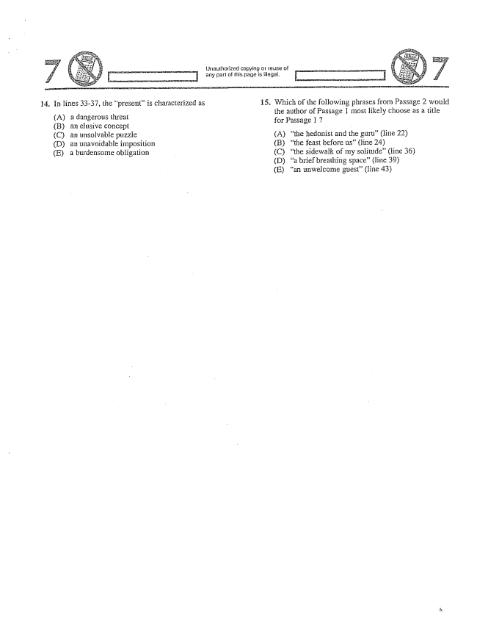

*/*

14. In lines 33-37, the present” is characterized as

(A) a dangerous threat (B) an elusive concept (C) an unsolvable puzzie (D) an unavoidable imposition (E) a burdensome obligation

Unauthorized copying of reuse of any pari of this page is illegal.

15. Which of the following phrases from Passage 2 would

the author of Passage 1 most likely choose as a title for Passage 1 7

(A) the hedonist and the guru(Hine 22) (B) the feast before us(Hine 24) (C) the sidewalk of my solitude(line 36) (D) a brief breathing space” (fine 39) (E) an unwelcome guest(line 43)

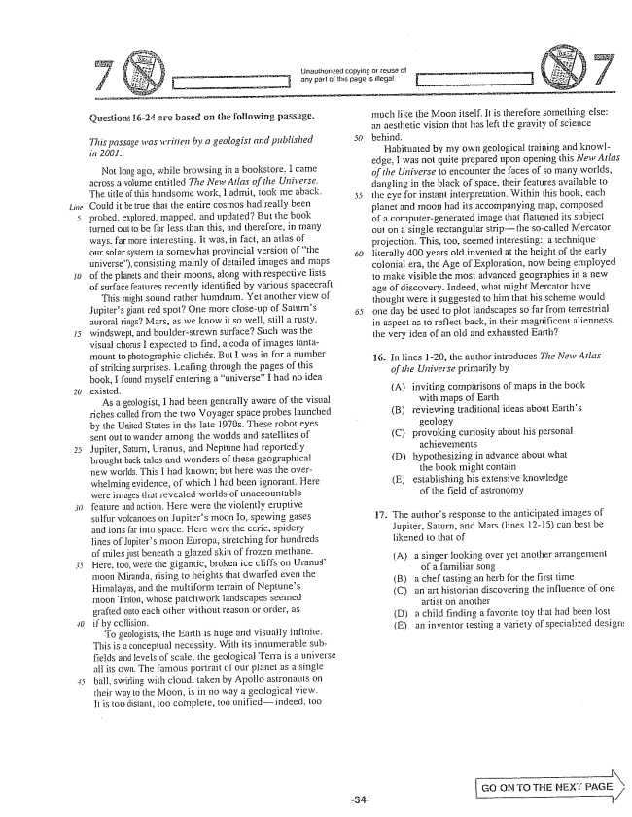

*Line*

Çuestions 1624 are based on the following passage.

*This passage was written by a geologist and published in 2007.*

Not long ago, while browsing in a bookstore, I came across a volume entitled The New Atlas of the Universe. The title of this handsome work, admit, took me aback. Could it be true that the entire cosmos had really been probed, explored, Inapped, and updated? But the book turned out to be less than this, and therefore, in many ways, far more interesting. It was, in fact, an atlas of Our SoIarsystem (a sornewhat provincial versioil of the universe), consisting mainly of detailed images and maps of the planets and their moons, along with respective lists of surface seatures recently identified by various spacecraft.

This might sound rather humdrum. Yet another view of Jupiters giant red spotOne more closeup of Salums auroral rings? Mars, as we know it so well, Still a rusty, windswepl, and boulderstrewn surface? Such was the visual chOIus I expected to find, a coda ofimages tantamount to photographic clichés. But I was in for a number of striking surprises. Leafing through the pages of this book, I found myself entering a universehad no idea existed.

As a geologist, I had been generally aware of the visual riches Culled from the two Voyager space probes launched by the United States in the late 1970s. These robot eyes sent out to wander among the worlds and satellites of Jupiter, Saturn, Uranus, and Neptune had reportedly brought back tales and wonders of these geographical new worlds. This I Had known; but here was the overwhelming evidence, of which I had been ignorant. Here were images that revealed worlds of unaccountable feature and action. Here were the violently eruptive sulfur volcanoes on jupiters Toor Io, spewing gases and ions far into space. Here were the eerie, spidery lines of Jupiters moon Europa, stretching for hundreds of miles just beneath a glazed skin of frozen methane. Here, too, were the gigantic, broken ice cliffs on Uranus' moon Miranda, rising to heights that dwarfed even the Himalayas, and the multiform terrain of Neptunes moon Trilon, whose patchwork landscapes seemed grafted onto each other without reason or order, as if by collision.

To geologists, the Earth is huge and visually infinite. This is a conceptual necessity. With its innumerable subfields and levels of scale, the geological Terra is a universe alits own. The famous portrait of our planet as a single ball, swirling with cloud, taken by Apollo astronauts on their way to the Moon, is in no way a geological view. It is too distant, too complete, 100 unifiedindeed, too

Inuch like the Moom itself. It is therefore something else: an aesthetic vision that has left the gravity of science behind. -

Habituated by my own geological training and knowledge, I was not quite prepared upon opening this New Atlas of the Universe to encounter the faces of so many worlds, dangjing in the black of space, their features available to the eye for instant interpretation. Within this book, each planet and moon had its accompanying map, composed of a computergenerated image that fiattened its subject Out On a single rectangular strip-the socalled Mercator projection. This, too, seemed interesting: a technique literally 400 years old invented at the height of the early colonial era, the Age of Exploration, now being eruployed to make visible the most advanced geographies in a new age of discovery. Indeed, what might Mercator have thought were it suggested to him that his scheme would one day be used to plot landscapes so far from terrestrial in aspect as to reflect back, in their magnificent alienness, the very idea of an old and exhausted Earth?

16. In lines 120, the author introduces The New Atlas

*of the Universe primarily by*

(A) inviting comparisons of maps in the book

with maps of Earth (B) reviewing traditional ideas about Earths

geology (C) provoking curiosity about his personal

achievements (D) hypothesizing in advance about what

the book night contain (E) establishing his extensive knowledge

of the field of astronomy

17. The authors response to the anticipated images of Jupiter, Saturn, and Mars (lines 12-15) can best be Hikened to that of

(A) a singer looking over yet another arrangement

of a familiar Song a chef tasting an herb for the first time an art historian discovering the influence of one

artist on another (D) a child finding a favorite toy that had been lost Ean inventor testing a variety of specialized design:

(B) (C)

|

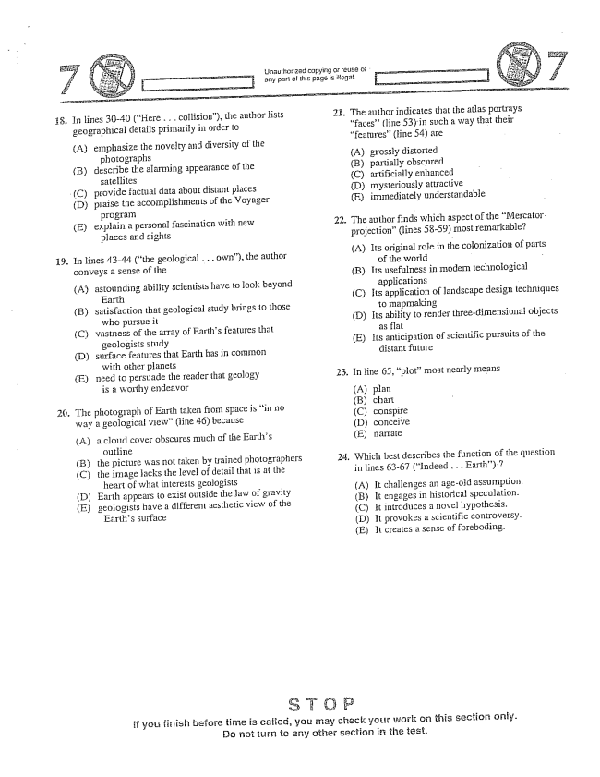

ŁJnauthorized copying or reuse of . any part of this page is illegal. .

În lines 30-40 (Here . . - collision), the author lists geographical details primarily in order to

(A) emphasize the novelty and diversity of the

photographs (B) describe the alarming appearance of the

satellites

(C) provide factual data about distant places

(D) praise the accomplishinents of the Voyager

program

(E) explain a personal fascination with new

places and sights

În lines 43-44 (the geological . . . own), the author conveys a sense of the

(A) astounding ability scientists have to look beyond

Earth

(B) satisfaction that geological study brings to those

who pursue it

(C) wastness of the array of Earths features that

geologists study

(D) Surface features that Earth has in cosminon

with other pianets

Eneed to persuade the reader that geology

is a worthy endeavor

The photograph of Earth taken from space is in no way a geological view(line 46) because

(A) a cloud cover obscures much of the Earths

(B) the picture was not taken by trained photographers

(C) the image jacks the level of detail that is at the

heart of what interests geologists

(D) Earth appears to exist outside the Jaw of gravity

Egeologists have a different aesthetic view of the

Earths surface

2. The authorindicates that the atlas portrays

faces” (line 53) in such a way that their features” (line 54) are

(A) grossly distorted (B) partially obscured (C) artificially enhanced D) mysteriously attractive (E) immediately understandable

22. The author finds which aspect Ofthe Mercator. projection" (lines 5859) most remarkable?

(A) Its original role in the colonization of parts

of the world - -

(B) Its usefulness in modern technological

applications

(C) Its application of landscape design techniques

to mapmaking

(D) Its ability to render three-dimensional objects

as flat

(E) Its anticipation of scientific pursuits of the

distant future

23. In line 65, plot” most nearly means

(A) plan (B) chart (C) conspire (D) conceive (E) narrate

24. Which best describes the function of the question

in lines 63-67 (Indeed . . . Earth).7

(A) It challenges an ageold assumption. (B) it engages in historical speculation. (C) It introduces a novel hypothesis. (D) It provokes a scientific controversy. (E) It creates a sense of foreboding.

if you finish before time is called, you may check your work on this section ority. Do not turn to any other section in the test.

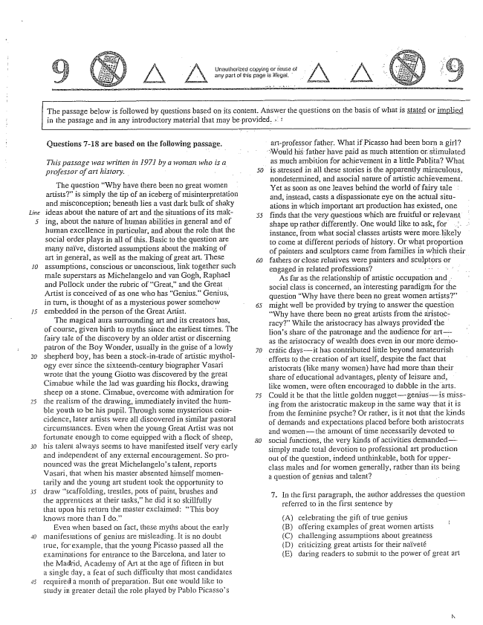

Unauthorized copying or reuse of any part of this page is illegal.

The passage below is followed by questions based on its content. Answer the questions on the basis of what is stated or implied in the passage and in any introductory material that may be provided. x i -

Questions -18 are based on the following passage.

*This passage was written in 1971 by a woman who is a professor of art history.*

The question Why have there been no great women artists” is simply the tip of an iceberg of misinterpretation and misconception; beneath Íies a vast dark bulk of shaky ideas about the nature of art and the situations of its making, about the nature of human abilities in general and of human excellence in particular, and about the role that the social order plays in all of this. Basic to the question are many naïve, distorted assumptions about the making of art in general, as well as the making of great art. These assumptions, conscious or unconscious, link together such Tnale superstars as Michelangelo and van Gogh, Raphael and Pollock under the rubric of Great,and the Great Artist is conceived of as one who has Genius.” Genius, in turn, is thought of as a mysterious power somehow embedded in the person of the Great Artist, .

The magical aura surrounding art and its creators has, of course, given birth to myths since the earliest times. The fairy tale of the discovery by an older artist or discerning patron of the Boy Wonder, usually in the guise of a lowly shepherd boy, has been a stock-in-trade of artistic mythoiogy ever since the sixteenth-century biographer Vasari wrote that the young Giotto was discovered by the great Cimabue while the lad was guarding his flocks, drawing sheep on a stone. Cimabue, overcome with admiration for the realism of the drawing, immediately invited the humble youth to be his pupil. Through some mysterious coincidence. Hater artists were all discovered in similar pastoral circumstances. Even when the young Great Artist was not fortunate enough to come equipped with a flock of sheep, his talent always seems to have manifested itself very early and independent of any external encouragemnent. So pronounced was the great Michelangelos talent, reports Vasari, that when his master absented himself momentarily and the young art student took the opportunity to draw scaffolding, trestles, pots of paint, brushes and the apprentices at their tasks,he did it so skillfully that upon his return the master exclaimed: “This boy Qws IIore than I do'

Even when based on fact, these myths about the early manifestations of genius are misleading. It is no doubt true, for example, that the young Picasso passed all the examinations for entrance to the Barcelona, and later to the Madrid, Academy of Art at the age of fifteen in but a single day, a feat of such difficulty that most candidates required a month of preparation. But one would like to study in greater detail the role played by Pablo Picassos

*50*

artprofessor father. What if Picasso had been born a girl?

"Would his father have paid as much attention or stimulated

as much ambition for achievement in a little Pabłita? What is stressed in all these stories is the apparently miraculous, nondetermined, and asocial nature of artistic achievement. Yet as soon as one leaves behind the world of fairy tale and, instead, casts a dispassionate eye on the actual situations in which important art production has existed, one finds that the very questions which are fruitful or relevant shape up rather differently. One would like to ask, for . . instance, from what social classes artists were more likely to come at different periods of history. Or what proportion of painters and sculptors came from families in which their fathers or close relatives were painters and sculptors or engaged in related professions? - - - - - , ” As far as the relationship of artistic occupation and . social class is concerned, an interesting paradigm for the question Why have there been no great women artists” might well be provided by trying to answer the question Why have there been no great artists from the aristočracy" While the aristocracy has always provided the lions share of the patronage and the audience for art— as the aristocracy of wealth does even in our more democrátic daysit has contributed little beyond amateurish

efforts to the creation of art itself, despite the fact that

aristocrats (like many women) have had more than their share of educational advantages, plenty of leisure and, like women, were often encouraged to dabble in the arts. Could it be that the little godden nuggetgeniusis missing from the aristocratic makeup in the same way that it is from the feminine psyche? Or rather, is it not that the kinds of demands and expectations placed before both aristocrats and womenthe amount of time necessarily devoted to social functions, the very kinds of activities demandedsimply inade total devotion to professional art production out of the question, indeed unthinkable, both for upperclass majes and for women generałły, rather than its being a question of genius and talent? -

. In the first paragraph, the author addresses the question

referred to in the first sentence by

celebrating the gift of true genius offering examples of great women artists (C) challenging assumpliosis about greatness (D) criticizing great artists for their naïveté (E) daring readers to submit to the power of great art

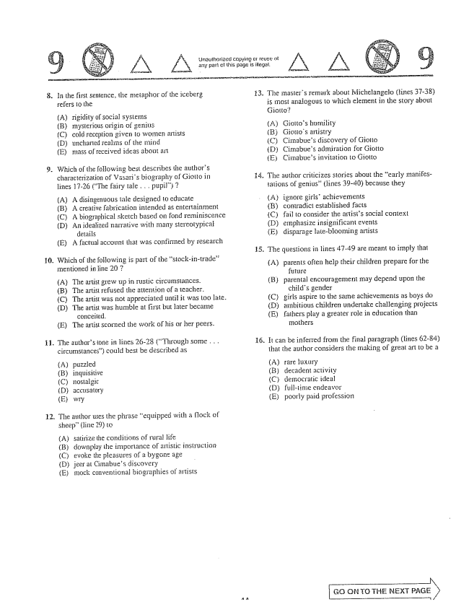

12.

In the first sentence, the metaphor of the iceberg refers to the

(A) (B) (C) (D) (E)

rigidity of Social systems Inysterious origin genins cold reception given to women artists uncharted realms of the mass of received ideas about arī

Which of the following best describes the authors characterization of Vasarjs biography of Giotto in lines 17-26 (The fairy tale . . . pupil)

(A) A disingenuous tale designed to educate (B) A creative fabrication intended as entertainment (C) A biographical sketch based on fond reminiscence (D) An idealized narrative with many stereotypical

details (E) A factual account that was confirmed by research

Which of the following is part of the stock-in-trade” Irientioned in jine 20 ?

AThe artist grew up in rustic circumstances. (B) The artist refused the attention of a teacher. (C) The artist was not appreciated until it was too late. (D) The artist was humble at first but later became

conceited. (E) The artist scorned the work of his or her peers.

. The authors tone in lines 26-28 (Through some . . .

circumstances) could best be described as

(A) (B) (C) (D) (E)

puzzled inquisitive mostalgic accusatory

The author uses the phrase equipped with a flock of sheep(line 29) to

(A) (B) (C) (D) (E)

satirize the conditions of rural life downplay the importance of artistic instruction evoke the pieasures of a bygone age jeer at Cimabues discovery mock conventionai biographies of artists

. The masters TeIIIark about Michelangejo (lines 37-38)

is most analogous to which element in the story about Giotto?

(A) Giottos humility (B) Giottos artistry (C) Cimabues discovery of Giotto (D) Cimabues admiration for Giotto ECimabues invitation to Giotto

14. The author criticizes stories about the early manifes

lations of genius(Hines 39-40) because they

(A) ignore girls' achievements (B) contradict established facts (C) fail to consider the artists social context (D) emphasize insignificant events í E) disparage laieblooming artists

. The questions in lines 47-49 are meant to imply that

(A) parents often help their children prepare for the

future (B) parental encouragernent may depend upon the

childs gender (C) girls aspire to the same achievements as boys do (Dambitious children undertake challenging projects (E) fathers play a greater role in education than

In others

16. It cari be inferred frorn the final paragraph (lines 62-84) that the author considers the making of great art to be a

(A) (B) (C) (E)) (E)

rare luxury decadent activity deirocratic ideal full-time endeavor poorly paid profession

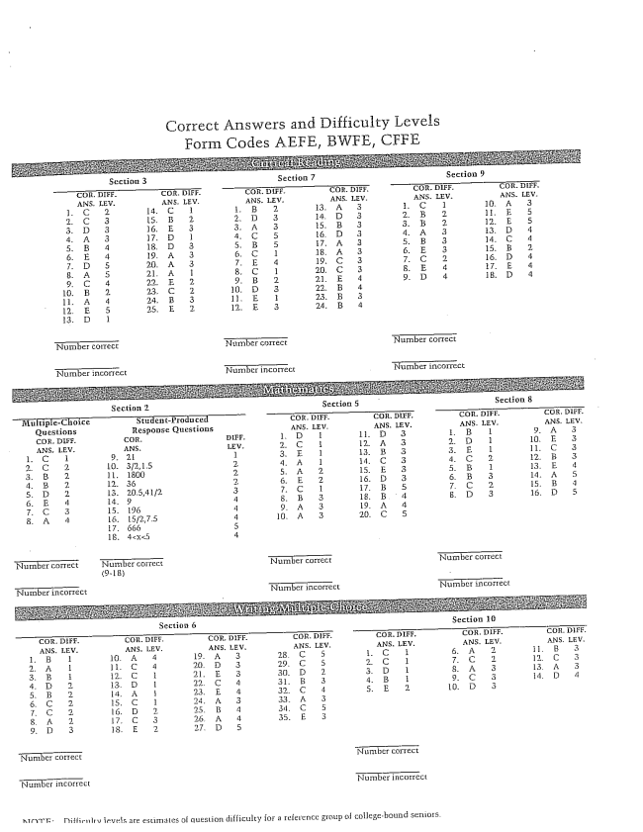

Correct Answers and Difficulty Levels

Form Codes AEFE

Section 6 Section }

^T F. Thiéfirmlrvievels are estimates of question difficulty for a reserence of collegebound seniors.