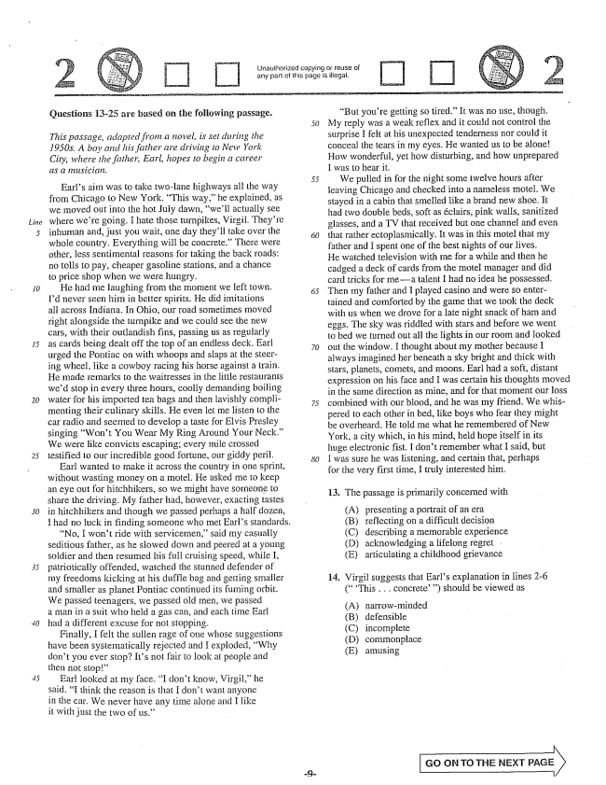

*Line*

Urlauthorized copying or reuse of any part of this page is illegal.

Questions 13-25 are based on the following passage.

*5) This passage, adapted from a novel, is set during the 1950s. A boy and his father are driving to New York City, where the father, Earl, hopes to begin a career*

from Chicago to New York, This way,he explained, as we moved out into the hot July dawn, well actually see where were going. I hate those turnpikes, Virgil. Theyre inhuman and, just you wait, one day theyll take over the whole country. Everything will be concrete.” There were other, less sentimental reasons for taking the back roads: no tolls to pay, cheaper gasoline stations, and a chance to price shop when we were hungry.

He had me laughing from the moment we left town. Id never seen him in better spirits. He did imitations all across Indiana. In Ohio, our road sometimes moved right alongside the turnpike and we could see the new cars, with their outlandish fins, passing us as regularly as cards being dealt off the top of an endless deck. Earl 70 urged the Pontiac on with whoops and slaps at the steering wheel, like a cowboy racing his horse against a train. He made remarks to the waitresses in the little restaurants wed stop in every three hours, coolly demanding boiling water for his imported tea bags and then lavishly compli- 75 menting their culinary skills. He even let me listen to the car radio and seemed to develop a taste for Elvis Presley singing Won't You Wear My Ring Around Your Neck.” We were like convicts escaping; every mile crossed testified to our incredible good fortune, our giddy perii. 80

Earl wanted to make it across the country in one sprint, without wasting money on a motel. He asked me to keep an eye out for hitchhikers, so we might have someone to share the driving. My father had, however, exacting tastes in hitchhikers and though we passed perhaps a half dozen, I had no luck in finding someone who met Earls standards. No, I won't ride with servicemensaid Iny casually Seditious father, as he slowed down and peered at a young Soldier and then resumed his full cruising speed, while I, patriotically offended, watched the stunned defender of my freedoms kicking at his duffle bag and getting smaller and Smaller as planet Pontiac continued its fuming orbit. We passed teenagers, we passed old men, we passed a man in a suit who held a gas can, and each time Earl had a different excuse for not stopping.

Finally, I felt the sullen rage of one whose suggestions have been systematically rejected and I exploded, Why don't you ever stop? Its not fair to look at people and then not stop”

Earl looked at my face. I don't know, Virgil,he said. I think the reason is that I don't want anyone in the car. We never have any time alone and I like it with just the two of us.”

But youre getting so tired.” It was no use, though. My reply was a weak reflex and it could not control the surprise I felt at his unexpected tenderness nor could it conceal the tears in my eyes. He wanted us to be alone! How wonderful, yet how disturbing, and how unprepared I was to hear it.

We pulled in for the night some twelve hours after leaving Chicago and checked into a nameless motel. We stayed in a cabin that smelled like a brand new shoe. It had two double beds, soft as éclairs, pink walls, sanitized glasses, and a TV that received but one channel and even that rather ectoplasmically. It was in this motel that my father and I spent one of the best nights of our lives. He watched television with me for a while and then he cadged a deck of cards from the motel manager and did card tricks for mea talent I had no idea he possessed. Then my father and I played casino and were So entertained and comforted by the game that we took the deck with us when we drove for a late night snack of ham and eggs. The sky was riddled with stars and before we went to bed we turned out all the lights in our room and looked out the window. I thought about my mother because I always imagined her beneath a sky bright and thick with stars, planets, comets, and noons. Earl had a soft, distant expression on his face and I was certain his thoughts moved in the same direction as mine, and for that moment our loss combined with our blood, and he was my friend. We whispered to each other in bed, like boys who fear they might be overheard. He told Ine what he remembered of New York, a city which, in his mind, held hope itself in its huge electronic fist. I don't remember what I said, but I was sure he was listening, and certain that, perhaps for the very first time, I truly interested him.

13. The passage is primarily concerned with

presenting a portrait of an era reflecting on a difficuit decision describing a memorable experience acknowledging a lifelong regret articulating a childhood grievance

14. Virgil suggests that Earls explanation in lines 2-6

(This . . . concrete) should be viewed as

(A) (В) (C) (D) (E)

narrowminded defensible incomplete commonplace amusing

GO ON TO THE NEXT PAGE

|

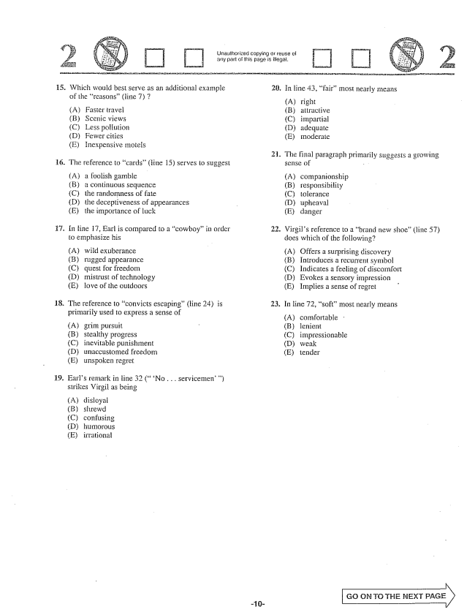

Unauthorized copying or reuse of any part of this page is illegal.

15. Which would best serve as an additional example

of the reasons(line ) 7

(A) Faster travel (B) Scenic views (C) Less pollution DFewer cities (E) Inexpensive motels

16. The reference to cards” (ittle 15) serves to suggest

(A) a foolish gamble (B) a continuous sequence (C) the randomness of fate (D) the deceptiveness of appearances (E) the importance of luck

17. In line 17, Earl is compared to a cowboy” in order

to emphasize his

(A) wild exuberance (B) rugged appearance (C) quest for freedom (D) mistrust of technology (E) love of the outdoors

18. The reference to convicts escaping” (line 24) is

primarily used to express a sense of

(A) grim pursuit (B) Stealthy progress (C) inevitable punishment (D) unaccustomed freedom (E) unspoken regret

19. Farls remark in line 32 (No . . . servicemen)

strikes Virgil as being

(Adisloyal (B) shtewd (C) confusing (D) humorous (E) irTational

20.

21.

22.

23.

In Hine 43, fairmost nearly means

(A) right

B) aLİractive (C) impartial (D) adequate (E) moderale

The final paragraph primarily suggests a growing sense of -

A) companionship (B) responsibility (C) tolerance (D) upheaval (E) danger

Virgils reference to a brand new shoe” (line 57) does which of the following?

(A) Offers a surprising discovery (B) Introduces a recurrent symbol (C) Indicates a feeling of discomfort (D) Evokes a sensory impression (E) Implies a sense of regret

In line 72, soft” most nearly means

(A) comfortable (B) lenient (C) impressionable (D) weak (E) tender

GO ON TO THE MÉXT

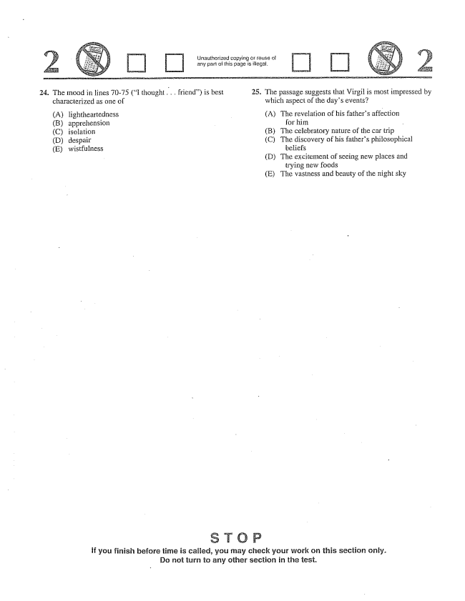

Unauthorized copying or reuse of any part of this page is illegal.

24. The mood in lines 70-75 (I thought .. friend) is best 25. The passage suggests that Virgil is most impressed by

characterized as one of

(A) lightheartedness (B) apprehension (C) isolation (D) despair (E) wistfulness

which aspect of the days events?

(A) The revelation of his fathers affection

for him (B) The celebratory nature of the car trip (C) The discovery of his fathers philosophical

beliefs (D) The excitement of seeing new places and

trying new foods (E) The vastness and beauty of the night sky

if you finish before time is called, you may check your work on this section only. Do not turn to any other section in the tesi.

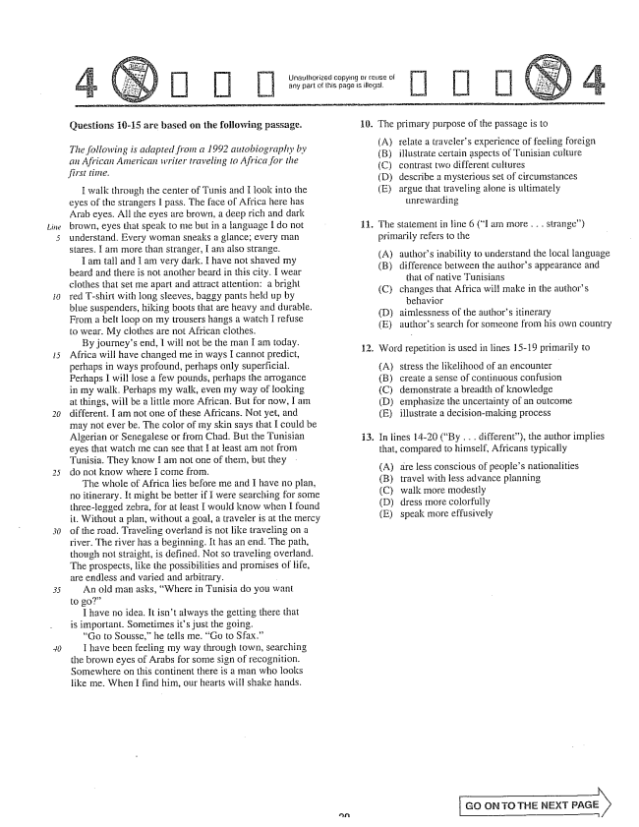

*Line*

*30*

Unaulhorized copying or reuse ol

any part of this page is illegal.

Questions 16-15 are based on the following passage.

*The following is adapted from a 1992 autobiography by an African American writer traveling to Africa for the*

*first time.*

I walk through the center of Tunis and I look into the eyes of the Strangers I pass. The face of Africa here has Arab eyes. All the eyes are brown, a deep rich and dark brown, eyes that speak to me but in a language I do not understand. Every woman sneaks a glance; every man

Stares. I am more than Stranger, I am also strange.

I am tall and I am very dark. I have not shaved my beard and there is not another beard in this city. I wear clothes that set me apart and attract attention: a bright red Tshirt with long sleeves, baggy pants held up by blue suspenders, hiking boots that are heavy and durable. From a belt loop on my trousers hangs a watch I refuse

to wear. My clothes are mot African clothes.

By journeys end, I will not be the man I am today. Africa will have changed me in ways I cannot predict,

perhaps in ways profound, perhaps only Superficial.

Perhaps I will lose a few pounds, perhaps the arrogance in my walk. Perhaps my walk, even my way of fooking

at things, will be a little more African. But for now,

I am

different. I am not one of these Africans. Not yet, and may not ever be. The color of my skin says that I could be Algerian or Senegalese or from Chad. But the Tunisian eyes that watch me can see that I at least am not from

Tunisia. They know I am not one of them, but they do not know where I come from.

The whole of Africa lies before me and I have no plan, no itinerary. It might be better if I were searching for some three-legged zebra, for at feast I would know when I found it. Without a plan, without a goal, a traveler is at the mercy of the road. Traveling overland is not like traveling on a river. The river has a beginning. It has an end. The path, though not straight, is defined. Not so traveling overland. The prospects, like the possibilities and promises of life,

are endless and varied and arbitrary. -

An old man asks, Where in Tunisia do you want

I have no idea. It isn't always the getting there that

is important. Sometimes its just the going.

Go to Sousse,he teils me. Go to Sfax.”

I have been feeling my way through town, searching the brown eyes of Arabs for some sign of recognition. Somewhere on this continent there is a man who looks iike me. When I find him, our hearts will shake hands.

10. The primary purpose of the passage is to

(A) (B) (C) (D) (E)

relate a travelers experience of feeling foreign

illustrate certain aspects of Tunisian culture

contrast two different cultures

describe a mysterious set of circumstances

argue that traveling alone is ultimately

unrewarding

The statement in line 6 (I am more . . . strange)

primarily refers to the

(A) (B)

(C)

(B) (C) (D) (E)

authors inability to understand the local language

difference between the authors appearance and

that of native Tunisians

changes that Africa will make in the authors

behavior

aimlessness of the authors itinerary

authors search for someone from his own country

2. Word repetition is used in lines H5-19 primarily to

stress the likelihood of an encounter create a sense of continuous confusion demonstrate a breadth of knowledge emphasize the uncertainty of an outcome illustrate a decisionmaking process

In lines 14-20 (By . . . different), the author implies

that, compared to himself, Africans typically

are less conscious of peoples nationalities travel with less advance planning walk Inore modestly dress more colorfully speak more effusively

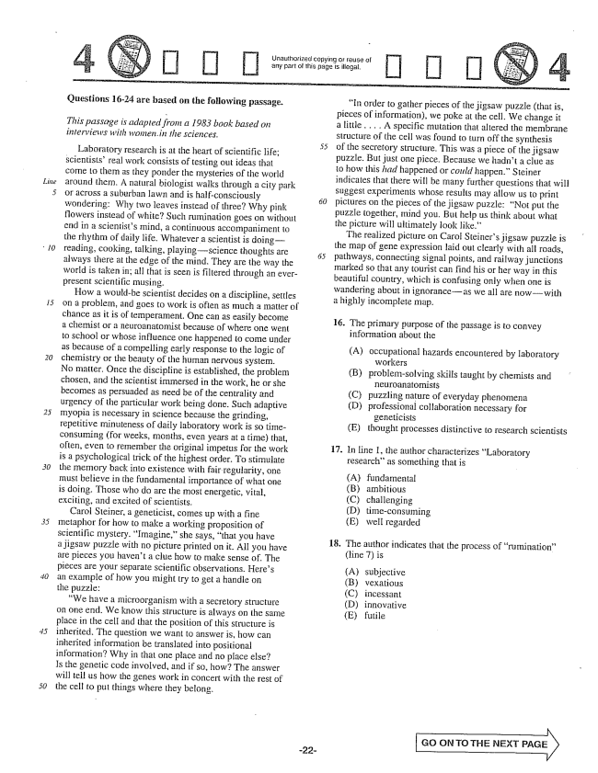

*Line*

*30*

[] [] []

**Questions 16-24 are based on the following passage.**

*This passage is adapted from a 1983 book based on interviews with women, in the sciences.*

- - - - - 55 Laboratory research is at the heart of scientific life;

scientists' real work consists of testing out ideas that come to them as they ponder the mysteries of the world around them. A natural biologist walks through a city park or across a suburban lawn and is half-consciously wondering: Why two leaves instead of three? Why pink flowers instead of white? Such rumination goes on without end in a scientists Imind, a continuous accompaniment 10 the rhythm of daily life. Whatever a scientist is doing— reading, cooking, talking, playingScience thoughts are always there at the edge of the mind. They are the way the world is taken inall that is seen is filtered through an everpresent scientific musing.

How a wouldbe scientist decides on a discipline, settles on a problem, and goes to work is often as much a matter of chance as it is of temperament. One can as easily become a chemist or a neuroanatomist because of where one went to school or whose influence one happened to come under as because of a compelling early response to the logic of chemistry or the beauty of the human nervous system. No matter. Once the discipline is established, the problem chosen, and the scientist immersed in the work, he or she becomes as persuaded as need be of the centrality and urgency of the particular work being done. Such adaptive myopia is necessary in science because the grinding, repetitive minuteness of daily laboratory work is so timeconsuming (for weeks, months, even years at a time) that, often, even to remember the original impetus for the work is a psychological trick of the highest order. To stimulate the memory back into existence with fair regularity, one must believe in the fundamental importance of what one is doing. Those who do are the most energetic, vital, exciting, and excited of scientists.

Carol Steiner, a geneticist, comes up with a fine metaphor for how to make a working proposition of scientific mystery. Imagine,she says, that you have a jigsaw puzzle with no picture printed on it. All you have are pieces you havent a clue how to make sense of. The pieces are your separate scientific observations. Heres an example of how you might try to get a handle on the puzzle:

We have a microorganism with a secretory structure on one end. We know this structure is always on the same place in the cell and that the position of this structure is inherited. The question we want to answer is, how can inherited information be translated into positional information? Why in that one place and no place else? Is the genetic code involved, and if so, how? The answer will fell us how the genes work in concert with the rest of the cell to put things where they belong.

在5

In order to gather pieces of the jigsaw puzzle (that is, pieces of information, we poke at the cell. We change it a little . . . . A specific mutation that altered the membrane structure of the cell was found to turn off the synthesis of the secretory structure. This was a piece of the jigsaw puzzle. But just one piece. Because we hadn't a clue as to how this had happened or could happen.” Steiner indicates that there will be many further questions that will suggest experiments whose results may allow us to print pictures on the pieces of the jigsaw puzzle: Not put the puzzle together, mind you. But help us think about what the picture will ultimately look like.”

The realized picture on Carol Steiners jigsaw puzzle is the map of gene expression laid out clearly with all roads, pathways, connecting signal points, and railway junctions marked so that any tourist can find his or her way in this beautiful country, which is confusing only when one is wandering about in ignoranceas we all are nowwith a highly incomplete map.

16. The primary purpose of the passage is to convey

information about the

(A) occupational hazards encountered by laboratory

workers (B) problemsolving skills taught by chemists and

neuroanatornists (C) puzzling nature of everyday phenomena (D) professional collaboration necessary for

geneticists (E) thought processes distinctive to research Scientists

17. In Line , the author characterizes Laboratory

researchas something that is

fundamental ambitious challenging timeconsuming well regarded

18. The author indicates that the process of rumination”

(line ) is

(A) subjective (B) vexatious (C) incessant (D) innovative (E) futile

GO CN TO THE NEXT PAGE

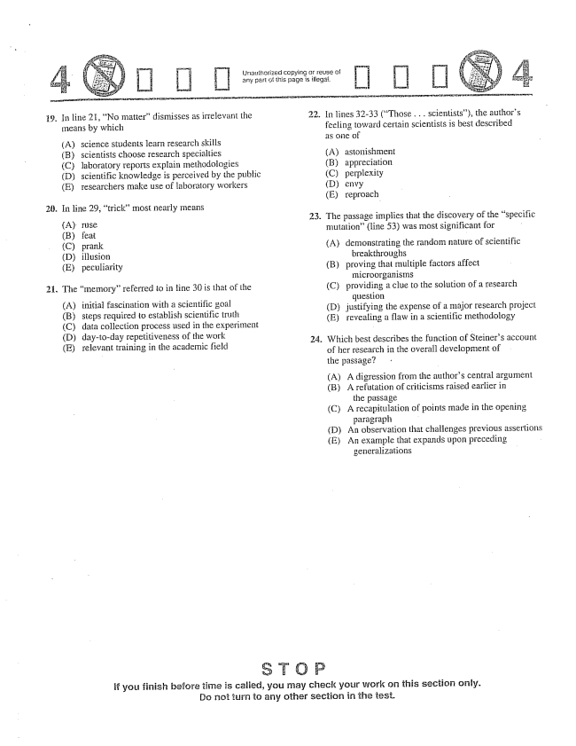

Unatthorized copying or reuse of : arly part of this page is illegal.

[] []

9. In line 21, No matterdismisses as irrelevant the

means by which

Ascience students learn research skiils (B) scientists choose research specialties (C) laboratory reports explain methodologies (D) scientific knowledge is perceived by the public (E) researchers make use of laboratory workers

26. In line 29, trick” most nearly means

(A) ruse (B) feat (C) prank (D) illusion (E) peculiarity

21. The memory” referred to in line 30 is that of the

(A) initial fascination with a scientific goal (B) steps required to establish scientific truth (C) data collection process used in the experiment (D) day-to-day repetitiveness of the work (E) relevant training in the academic field

22.

23.

In lines 32-33 (Those . . . scientists), the authors feeling toward certain scientists is best described as one of

(A) astonishment (B) appreciation (C) perplexity (D) envy (E) reproach

The passage implies that the discovery of the specific mutation(line 53) was most significant for

(A) demonstrating the random nature of scientific

breakthroughs (B) proving that multiple factors affect

microorganisms (C) providing a clue to the solution of a research

question () justifying the expense of a major research project (Erevealing a flaw in a scientific methodology

Which best describes the function of Steiners account of her research in the overall development of the passage?

(A) A digression from the authors central argument

(B) A refutation of criticisms raised earlier in

the passage

(C) A recapitulation of points made in the opening

paragraph

(D) An observation that challenges previous assertions

(E) An example that expands upon preceding

generalizations

if you finish before time is caiied, you may check your work on this section only. Do not turn to any other section in the test.

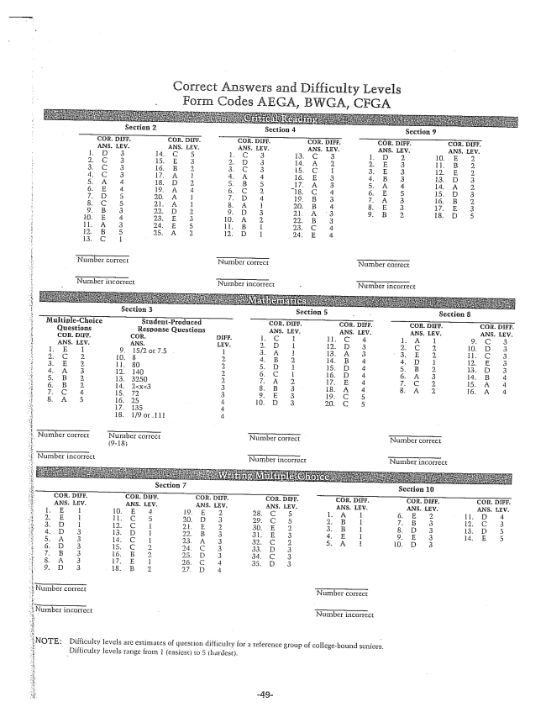

Correct Answers and Difficulty Levels Codes AEGA, BWGA, CFGA

:NOTE: Difficulty levels are estimates of question difficulty for a reference group of collegebound seniors.

Difficulty levels from l (easiest) to 5 thadest.