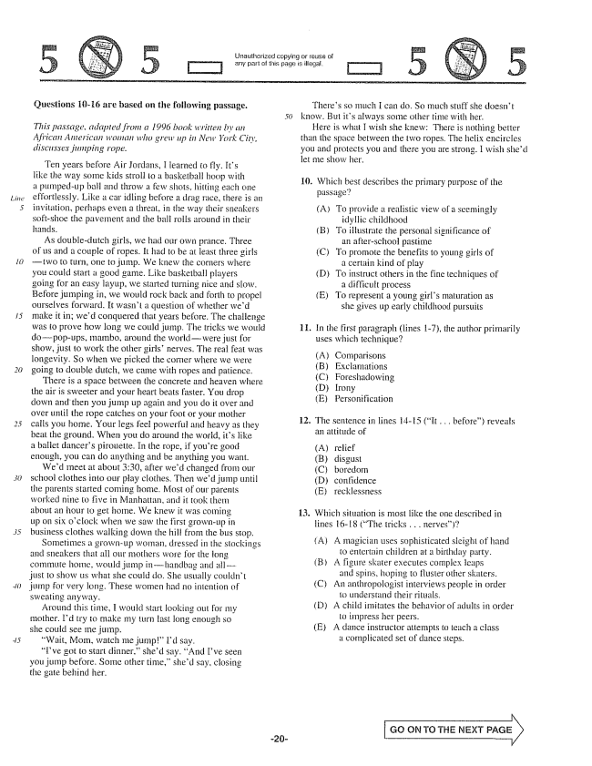

20

Unauthorized copying or reuse of any part of this page is illegal,

**Questions it16 are based on the following passage.**

*This passage, adapted from a 1996 book written by an African American woman who grew up in New York City, discityses jumping rope.*

Ten years before Air Jordans, I learned to fly. Its like the way some kids stroll to a basketball hoop with a pumpedup ball and throw a few shots, hitting each one effortlessly. Like a car idling before a drag race, there is an invitation, perhaps even a threat, in the way their sneakers soft-shoe the pavement and the ball rolls around in their hands.

As doubledutch girls, we had our own prance. Three of us and a couple of ropes. It had to be at least three girls two to turn, one to jump. We knew the corners where you could start a good game. Like basketball players going for an easy layup, we started turning nice and slow. Before jumping in, we would rock back and forth to propel ourselves forward. It wasn't a question of whether wed make it inwed conquered that years before. The challenge was to prove how long we could jump. The tricks we would dopop-ups, mambo, around the worldwere just for show, just to work the other girlsnerves. The real feat was longevity. So when we picked the corner where we were going to double dutch, we came with ropes and patience.

There is a space between the concrete and heaven where the air is sweeter and your heart beats faster. You drop down and then you jump up again and you do it over and over until the rope catches on your foot or your mother calls you home. Your legs feel powerful and heavy as they beat the ground. When you do around the world, its like a ballet dancers pirouette. In the rope, if youre good enough, you can do anything and be anything you want.

Wed meet at about :30, after wed changed from our school clothes into our play clothes. Then wed jump until the parents started coining home. Most of our parents worked nine to five in Manhattan, and it took them about an hour to get home. We knew it was coming up on six oclock when we saw the first grown-up in business clothes walking down the hill from the bus stop.

Sometimes a grown-up woman, dressed in the stockings and sneakers that all our mothers wore for the long commute home, would jump inhandbag and alljust to show us what she could do. She usually couldn't jump for very long. These women had no intention of Sweating anyway,

Around this time, I would start looking out for my mother. Id try to make my turn last long enough so she could see me jump.

Wait, Mom, watch me jump” Id say. Ive got to start dinner,shed say. And Ive seen you jump before. Some other time,shed say, closing the gate behind her.

-20

Theres so much I can do. So much stuff she doesnt know. But its always some other time with her.

Here is what I wish she knew: There is nothing better than the space between the two ropes. The helix encircles you and protects you and there you are strong. I wish shed det me show her.

10. Which best describes the primary purpose of the

passage?

(A) To provide a realistic view of a seemingly

idyllic childhood (B) To illustrate the personal significance of

an after-school pastime (C) To promote the benefits to young girls of

a certain kind of play (D) To instruct others in the fine techniques of

a difficult process (E) To represent a young girls maluration as

she gives up early childhood pursuits

11. In the first paragraph (lines I), the author primarily

uses which technique?

(A) Comparisons BExclamations (C) Foreshadowing (D) İrony (E) Personification

12. The sentence in lines 14-15 (It . . . before) reveals

an attitude of

relief disgust boredom considence Tecklessness

13. Which situation is most like the one described in

lines 16-18 (The tricks . . . nerves)?

(A) A magician uses Sophisticated sleight of hand

to entertain children at a birthday party. (B) A figure skater executes complex leaps

and spins, hoping to fluster other skaters. (C) An anthropologist interviews people in order

to understand their rituals. (i). A child imitates the behavior of acililts in order

to impress her peers. (E) A dance instructor attempts to teach a class

a complicated Set of dance steps.

GO CN TO THE NEXT PAGE

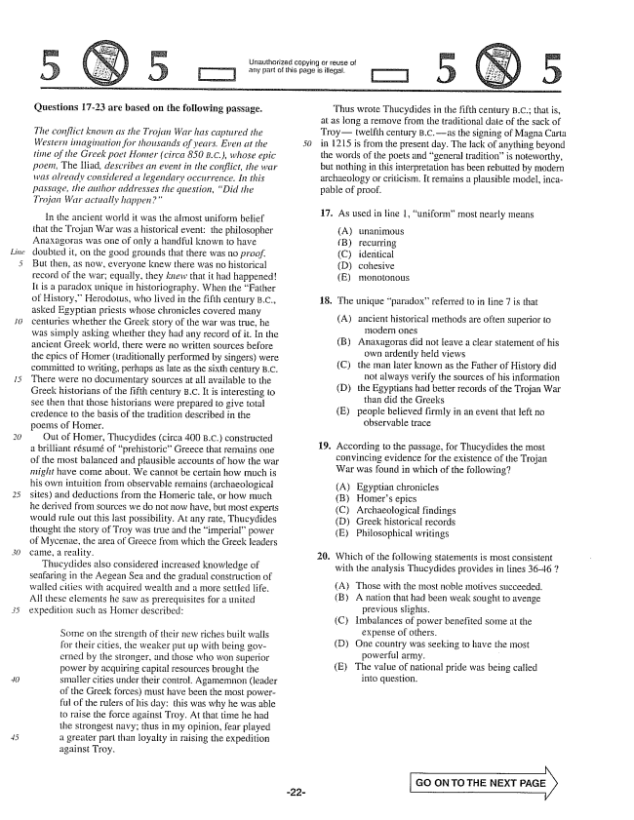

*Line*

Unauthorized copying or reuse of

DJ any part of this page is illegal,

TI

**Questions 17-23 are based on the following passage.**

*The conflict known as the Trojan War has captured the Western intagination for thousands of years. Even at the time of the Greek poet Homer (circa 850 B.C.), whose epic poem, The Iliad, describes an event in the conflict, war was already considered a legendary occurrence. In this passage, the attthor addresses the question, Did the Trojan War actually happen"*

In the ancient world it was the almost uniform belief that the Trojan War was a historical event: the philosopher Anaxagoras was one of only a handful known to have doubted it, on the good grounds that there was no proof. But then, as now, everyone knew there was no historical record of the warequally, they knew that it had happenedit is a paradox unique in historiography. When the Father of History.” Herodotus, who lived in the fifth century B.C., asked Egyptian priests whose chronicles covered many centuries whether the Greek story of the war was true, he was simply asking whether they had any record of it. In the ancient Greek world, there were no written sources before the epics of Homer (traditionally performed by singers) were committed to writing, perhaps as late as the sixth century B.C. There were no documentary sources at all available to the Greek historians of the fifth century B.C. It is interesting to See then that those historians were prepared to give total credefice to the basis of the tradition described in the poems of Homer.

Out of Homer, Thucydides (circa 400 B.C.) constructed a brilliant résumé of prehistoricGreece that remains one of the most balanced and plausible accounts of how the war might have come about. We cannot be certain how much is his own intuition from observable remains (archaeological sites) and deductions from the Homeric tale, or how much he derived from sources we do not now have, but most experts would rule out this last possibility. At any rate, Thucydides thought the story of Troy was true and the imperiałpower of Mycenae, the area of Greece from which the Greek leaders came, a reality.

Thucydides also considered increased knowledge of seafaring in the Aegean Sea and the gradual construction of walled cities with acquired wealth and it more settled life. Ali these elements he saw as prerequisites for a united expedition such as Homer described:

Sørne on the strength of their new riches built walls for their cities, the weaker put up with being governed by the stronger, and those who won superior power by acquiring capital resources brought the smaller cities under their control. Agamemnon (leader of the Greek forces) must have been the most powerful of the rulers of his day: this was why he was able to raise the force against Troy. At that time he had the strongest navy; thus in my opinion, fear played a greater part than loyalty in raising the expedition against Troy.

Thus wrote Thucydides in the fifth century B.C.; that is, at as long a remove from the traditional date of the sack of Troytwelfth century B.C.as the signing of Magna Carta in 1215 is from the present day. The lack of anything beyond the words of the poets and general traditionis noteworthy, but nothing in this interpretation has been rebutted by modern archaeology or criticism. It remains a plausible model, incapable of proof.

17. As used in line 1, uniformmost nearly ineans

(A) unanimous B) recurring (C) identical (D) cohesive (E) monotonous

18. The unique paradox” referred to in line 7 is that

(A) ancient historical methods are often superior to

modern ones (B) Anaxagoras did not leave a clear statement ofhis

own ardently held views (C) the man later known as the Father of History did

not always verify the sources of his information (D) the Egyptians had better records of the Trojan War

than did the Greeks (E) people believed firmly in an event that left no

observable trace

19. According to the passage, for Thucydides the most convincing evidence for the existence of the Trojan War was found in which of the following?

(A) Egyptian chronicles (B) Homers epics (C) Archaeological findings (D) Greek historical records (E) Philosophicaf writings

Which of the following statements is most consistent with the analysis Thucydides provides in lines 3646 7

(A) Those with the most noble motives succeeded.

(B) A nation that had been weak sought to avenge

previous slights.

(C) Imbalances of power benefited some at the

expense of others.

(D) One country was seeking to have the most

powerful army.

(E) The value of national pride was being called

into question.

GO ON TO THE NEXT PAGE

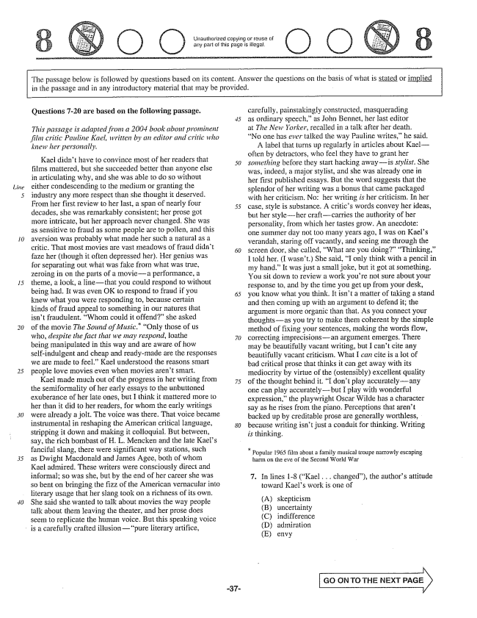

*Line*

Unauthorized copying or reuse of any part of this page is illegal.

The passage below is followed by questions based on its content. Answer the questions on the basis of what is stated or implied in the passage and in any introductory material that may be provided.

**Questions -20 are based on the following passage.**

*This passage is adapted from a 2004 book about prominent*

*film critic Pauline Kael, written by an editor and critic who*

*knew her personally,*

Kael didnt have to convince most Of her readers that films mattered, but she succeeded better than anyone else in articulating why, and she was able to do so without either condescending to the medium or granting the industry any more respect than she thought it deserved. From her first review to her last, a span of nearly four decades, she was remarkably consistent; her prose got more intricate, but her approach never changed. She was as sensitive to fraud as some people are to pollen, and this aversion was probably what made her such a natural as a critic. That most movies are vast meadows of fraud didn't faze her (though it often depressed her. Her genius was for separating out what was fake from what was true, zeroing in on the parts of a moviea performance, a theme, a look, a linethat you could respond to without being had. It was even OK to respond to fraud if you knew what you were responding to, because certain kinds of fraud appeal to something in our natures that isn't fraudulent. Whom could it offend” she asked of the movie The Sound of Music.” “Only those of us who, despite the fact that we may respond, loathe being manipulated in this way and are aware of how Self-indulgent and cheap and ready-made are the responses we are made to feel.” Kael understood the reasons smart people love movies even when movies arent smart.

Kael made much out of the progress in her writing from the semiformality of her early essays to the unbuttoned exuberance of her late ones, but I think it mattered more to her than it did to her readers, for whom the early writings were already a jolt. The voice was there. That voice became instrumental in reshaping the American critical language, stripping it down and making it colloquial. But between, say, the rich bombast of H. L. Mencken and the late Kaels fanciful slang, there were significant way stations, such as Dwight Macdonald and James Agee, both of whom Kael admired. These writers were consciously direct and informal; so was she, but by the end of her career she was so bent on bringing the fizz of the American vernacular into literary usage that her slang took on a richness of its own, She said she wanted to talk about movies the way people talk about them leaving the theater, and her prose does seem to replicate the human voice. But this speaking voice

is a carefully crafted illusionpure literary artifice,

*30*

carefully, painstakingly constructed, Inasquerading as ordinary speech,as John Bennet, her last editor at The New Yorker, recalled in a talk after her death. No one has ever talked the way Pauline writes,he said.

A label that turns up regularly in articles about Kael– often by detractors, who feel they have to grant her something before they start hacking awayis stylist. She was, indeed, a major stylist, and she was already one in her first published essays. But the word suggests that the splendor of her writing was a bonus that came packaged with her criticisin. No: her writing is her criticism. In her case, style is substance. A critics words convey her ideas, but her styleher craftcarries the authority of her personality, from which her tastes grow. An anecdote: one summer day not too many years ago, I was on Kaels verandah, staring off vacantly, and seeing me through the screen door, she called, What are you doing” “Thinking,I told her. (I wasnt.) She said, I only think with a pencil in my hand.” It was just a small joke, but it got at something. You sit down to review a work youre not sure about your response to, and by the time you get up from your desk, you know what you think. It isn't a matter of taking a stand and then coming up with an argument to defend it; the argument is more organic than that. As you connect your thoughtsas you try to make thern coherent by the simple method of fixing your sentences, making the words flow, correcting imprecisionsan argument emerges. There Inay be beautifully vacant writing, but I cant cite any beautifully vacant criticism. What I can cite is a lot of bad critical prose that thinks it can get away with its mediocrity by virtue of the (ostensibly) excellent quality of the thought behind it. I dont play accuratelyany one can play accuratelybut I play with wonderful expression,the playwright Oscar Wilde has a character say as he rises from the piano. Perceptions that arent backed up by creditable prose are generally worthless, because writing isnt just a conduit for thinking. Writing is thinking.

Popular 1965 film about a family musical troupe narrowly escaping

harm on the eye of the Second World War

. In lines 1-8 (Kael , , . changed), the authors attitude

toward Kaels work is one of

(A) (B) (C) (D) (E)

skepticism uncertainty indifference admiration

**envy**

GO GN TO THE NEXT PAGE

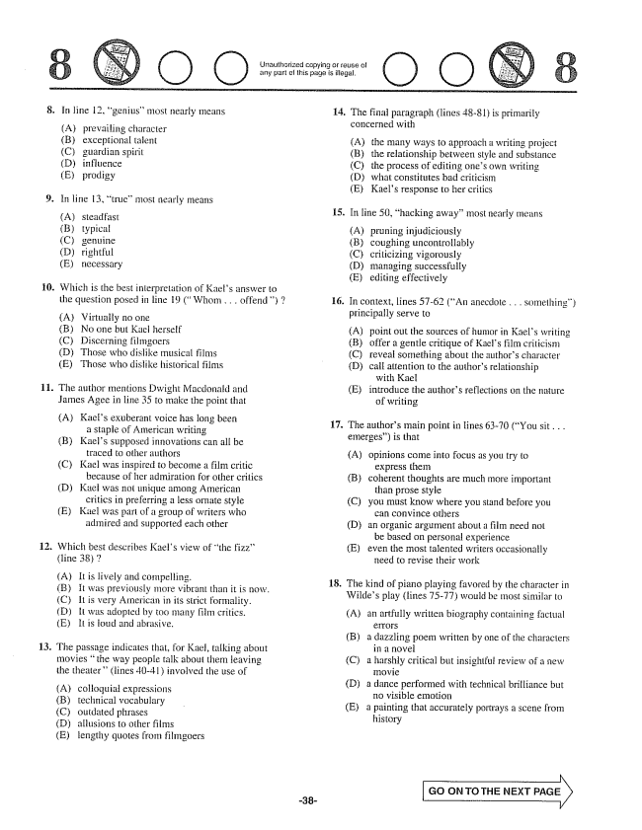

tjnauthorized copying or reuse of any part of this page is .

O O

**11.**

13.

In line 12, genius' most nearly means

prevailing character exceptional talent guardian spirit influence

prodigy

In line 13, true” most nearly means

(A) (B) (C) (D) (E)

steadfast typical rightful necessary

Which is the best interpretation of Kaets answer to the question posed in line 19 (Whom . . . offend) 7

(A) Virtually no one (B) No one but Kael herself (C) Discerning filmgoers E} Those who dislike musical films (E) Those who dislike historical films

The author mentions Dwight Macdonaté and James Agee in line 35 to make the point that

(A) Kaels exuberant voice has long been a staple of American writing (B) Kaels supposed innovations can all be

traced to other authors (C) Kael was inspired to become a film critic

because of her admiration for other critics (D) Kael was not unique among American

critics in preferring a less ornate style (E) Kael was part of a group of writers who

admired and supported each other

. Which best describes Kaeis view of the fizz”

(line 38) 2

(A) it is lively and compelling. (B) It was previously more vibrant than it is now. (C) It is very American in its strict formality. (D) it was adopted by too many film critics. (E) It is foud and abrasive.

The passage indicates that, for Kael, talking about movies the way people talk about them leaving the theater(lines 4041) involved the use of

(A) (B)

colloquial expressions technical vocabulary (C) outdated phrases (D) allusions to other films (E) lengthy quotes from filmgoers

14. The final paragraph (lines 48-81) is primarily

concerned with

(A) (B) (C) (D) (E)

the many ways to approach a writing project the relationship between style and substance the process of editing ones own writing what constitutes bad criticism Kaels response to her critics

15. In line 50, hacking away” most nearly means

pruning injudiciously coughing uncontrollably criticizing vigorously managing successfully editing effectively

16. In context, lines 57-62 (An anecdote . . . something)

principafly serve to

point out the sources of humor in Kaels writing

offer a gentle critique of Kaels film criticism

reveal something about the authors character

attention to the authors relationship

with Kael

introduce the authors reflections on the nature

of writing

(E)

17. The authors main point in lines 63-70 (You sit . . .

emerges) is that

(A) opinions come into focus as you try to

express them (B) coherent thoughts are much more important

than prose style (C) you must know where you stand before you

can convince others (D) an organic argument about a film need not

be based on personal experience (E) even the most talented writers occasionally

need to revise their work

18. The kind of piano playing favored by the character in

Wildes play (fines 75-77) would be most similar to

(A) an artfully written biography containing factual

CIFQIS

a dazzling poem written by one of the characters

in a novel

a harshly critical but insightsui review of a new

Inovie

a dance performed with technical brilliance but

no visible emotion

a painting that accurately portrays a scene from

history

(B)

(C)

(D)

(E)

GO ON TO THE NEXT

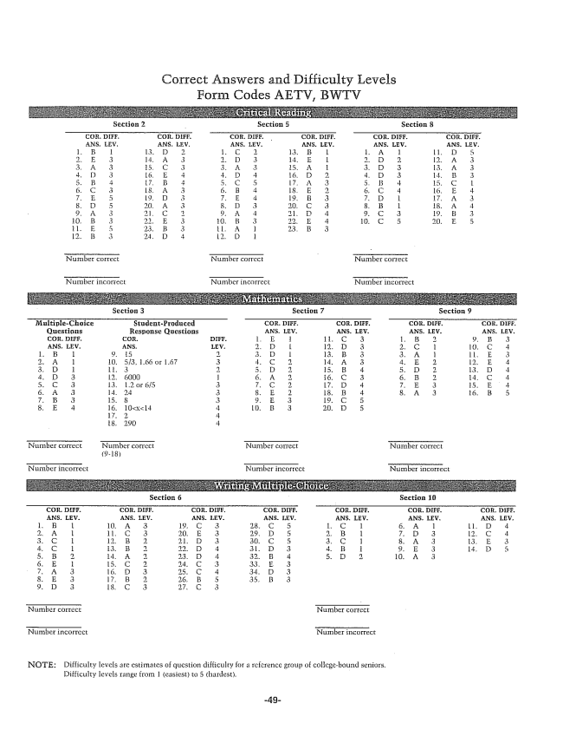

Correct Answers and Difficulty Levels Form Codes AETV, BWTV

**Seeting, 2 Section 5 Section 8**

**Section 3 Seetion 7 Section 9**

NOTE: Difficulty levels are estimates of question difficulty for a reference group of collegebound seniors.

Difficulty levels Iange from 1 (easiest) to 5 (hardest.