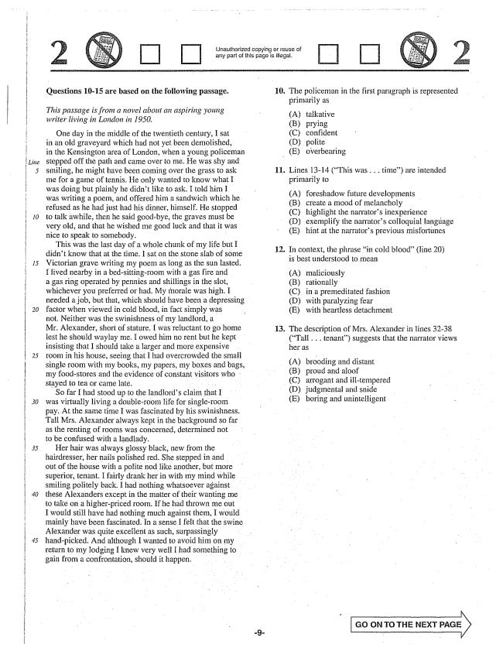

*20*

Unauthorized copying or reuse of arly part of this is illegal.

**Questions 10-15 are based on the following passage.**

*This passage is from a novel about an aspiring young writer living in London in 1950.*

One day in the middle of the twentieth century, I sat in an old graveyard which had not yet been demolished, in the Kensington area of London, when a young policeman stepped off the path and came over to me. He was shy and smiling, he might have been coming over the grass to ask më for a game of tennis. He only wanted to know what I was doing but plainly he didnt like to ask. I told him I was writing a poem, and offered him a sandwich which he refused as he had just had his dinner, himself. He stopped to talk awhile, then he said good-bye, the graves must be very old, and that he wished me good luck and that it was nice to speak to somebody.

This was the last day of a whole chunk of my life but I didnt know that at the time. I sat on the stone slab of some Victorian grave writing my poem as long as the sun lasted. I lived nearby in a bedsittingroom with a gas fire and a gas ring operated by pennies and shillings in the slot, whichever you preferred or had. My morale was high. I needed a job, but that, which should have been a depressing factor when viewed in cold blood, in fact simply was not. Neither was the swinishness of my landlord, a Mr. Alexander, short of stature. I was reluctant to go home lest he should waylay me. I owed him no rent but he kept insisting that I should take a larger and more expensive room in his house, seeing that I had overcrowded the small single room with my books, my papers, my boxes and bags, my food-stores and the evidence of constant visitors who stayed to tea or came late. .

So far f had stood up to the landlords claim that I was virtually living a doubleroom life for single-room pay. At the same time I was fascinated by his swinishness. Tall Mrs. Alexander always kept in the background so far as the renting of rooms was concerned, determined not to be confused with a landlady,

Her hair was always glossy black, new from the hairdresser, her nails polished red. She stepped in and out of the house with a polite nod like another, but more superior, tenant. I fairly drank her in with my mind while smiling politely back. I had nothing whatsoever against these Alexanders except in the matter of their wanting me to take on a higherpriced room. If he had thrown me out I would still have had nothing much against them, I would mainly have been fascinated. In a sense I felt that the swine Alexander was quite excellent as such, surpassingly handpicked. And although I wanted to avoid him on my return to my lodging I knew very well I had something to gain from a confrontation, should it happen. .

10. The policeman in the first paragraph is represented

primarily as

(A) talkative

(B) prying

(C) confident

(D) polite

(E) overbearing

11. Lines 13-14 (This was . . . time) are intended

primarily to

(A) foreshadow future developments

(B) create a mood of melancholy

(C) highlight the narrators inexperience

(D) exemplify the narrators colloquial language

(E) hint at the narrators previous misfortunes

12. In context, the phrase in cold blood” (line 20)

is best understood to mean

(A) (B) (C) (D) (E)

13. The description of Mrs. Alexander in lines 3238

(Tall . . . tenant) suggests that the narrator views her as

maficiously

rationally in a premeditated fashion with paralyzing fear with heartless detachment

(A) brooding and distant (B) proud and aloof (C) arrogant and illtempered (D) judgmental and snide (E) boring and unintelligent

**Go ON TO THE NEXT**



Unauthorized copying or reuse arly part of this page is illega.

14. In context, the statement in line 38 (I fairly . . . mind) 15. The narrators attitude toward her situation

indicates that the narrator is best described as

(A) feels connected intellectually to Mrs. Alexander (A) incredulous (B) wishes she could be like Mrs. Alexander (B) apprehensive (C) feels self-conscious in Mrs. Alexanders presence (C) contented (D) shuns Mrs. Alexanders company (D) ambivalent

(E)

is captivated by Mrs. Alexanders style

(E) self-congratulatory

GO ON TO THE NEXT o -10–

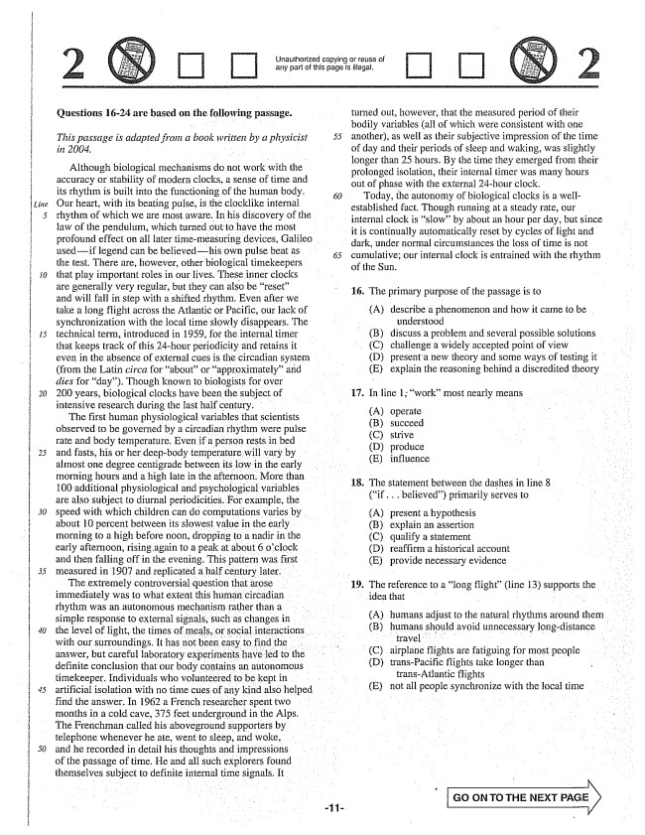

*Line*

*20*

*30*

*50*

Unauthorized copying or reuse of any part of this page is illegal.

**Questions 16-24 are based on the following passage.**

*This passage is adapted from a book written by a physicist in 2004. .*

Although biological mechanisms do not work with the accuracy or stability of modern clocks, a sense of time and its rhythm is built into the functioning of the human body.

Our heart, with its beating pulse, is the clocklike internal

rhythm of which we are most aware. In his discovery of the law of the pendulum, which turned out to have the most

profound effect on all later timemeasuring devices, Galileo

usedif legend can be believedhis own pulse beat as the test. There are, however, other biological timekeepers that play important roles in our lives. These inner clocks are generally very regular, but they can also be reset” and will fall in step with a shifted rhythm. Even after we take a long flight across the Atlantic or Pacific, our lack of synchronization with the local time slowly disappears. The technical term, introduced in 1959, for the internal timer that keeps track of this 24-hour periodicity and retains it even in the absence of external cues is the circadian system (from the Latin circa for aboutor approximately” arid dies for day). Though known to biologists for over 200 years, biological clocks have been the subject of intensive research during the last half century.

The first human physiological variables that scientists observed to be governed by a circadian rhythm were pulse rate and body temperature. Even if a person rests in bed and fasts, his or her deepbody temperature will vary by almost one degree centigrade between its low in the early

morning hours and a high late in the afternoon. More than

100 additional physiological and psychological variables are also subject to diurnal periodicities. For example, the speed with which children can do computations varies by about 10 percent between its slowest value in the early morning to a high before noon, dropping to a nadir in the early afternoon, rising again to a peak at about 6 oclock and then falling off in the evening. This pattern was first measured in 1907 and replicated a half century later. The extremely controversial question that arose immediately was to what extent this human circadian rhythm was an autonomous mechanism rather than a simple response to external signals, such as changes in

the level of light, the times of meals, or social interactions. . . . .

with our surroundings. It has not been easy to find the answer, but careful laboratory experiments have led to the definite conclusion that our body contains an autonomous timekeeper. Individuals who volunteered to be kept in artificial isolation with no time cues of any kind also helped find the answer. In 1962 a French researcher spent two months in a cold cave, 375 feet underground in the Alps. The Frenchman called his aboveground supporters by telephone whenever he ate, went to sleep, and woke, and he recorded in detail his thoughts and impressions of the passage of time. He and all such explorers found themselves subject to definite internal time signals. It

turned out, however, that the measured period of their bodily variables (all of which were consistent with one another, as well as their subjective impression of the time of day and their periods of sleep and waking, was slightly longer than 25 hours. By the time they emerged from their prolonged isolation, their internal timer was many hours out of phase with the external 24-hour clock.

Today, the autonomy of biological clocks is a wellestablished fact. Though running at a steady rate, our internal clock is slowby about an hour per day, but since it is continually automatically reset by cycles of light and dark, under normal circumstances the loss of time is not cumulative; our internal clock is entrained with the rhythm of the Sun. .

16. The primary purpose of the passage is to

(A) describe a phenomenon and how it came to be

understood (B) discuss a problem and several possible solutions (C) challenge a widely accepted point of view (D) present a new theory and some ways of testing it (E) explain the reasoning behind a discredited theory

17. In line 1; work” most nearly means

(A) operate (B) succeed (C) strive (D) produce (E) influence

18. The statement between the dashes in line 8 (if .. believed) primarily serves to .

(A) present a hypothesis (B) explain an assertion (C) qualify a statement (D) reaffirm a historicai account (E) provide necessary evidence

19. The reference to a long flight” (line 13) supports the

idea that

(A) humans adjust to the natural rhythms around them (B) humans should avoid unnecessary long-distance

. . . . . . . (C) airplane flights are fatiguing for most people (D) transPacific flights take longer than

transAtlantic flights (E) not all people synchronize with the local time

**GO ON TO THE NEXT PAGE**

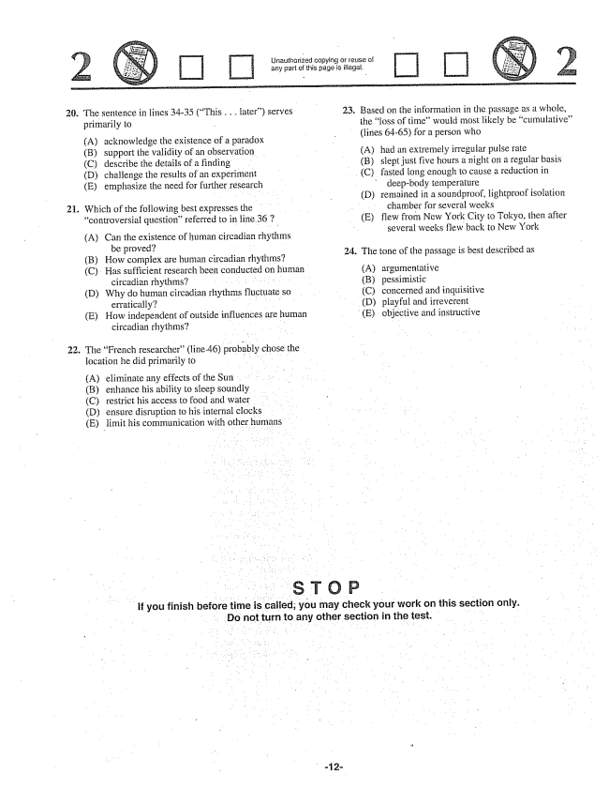

Unauthorized copying or reuse of any part of this page is illegal.

20.

22.

The sentence in lines 34-35 (This . . . later) serves primarily to

(A) acknowledge the existence of a paradox Bsupport the validity of an observation (C) describe the details of a finding - D) challenge the results of an experiment (E) emphasize the need for further research

.. Which of the following best expresses the

controversial questionreferred to in line 36 7

(A) Can the existence of human circadian rhythms

be proved? (B) How complex are human circadian rhythms?

(C) Has sufficient research been conducted on human

circadian rhythms? . . . . . . . . . . . . (D) Why do human circadian rhythms fluctuate so

erratically? . . . . . (E) How independent of outside influences are human

circadian rhythms? - - - -

The French researcher" (line 46) probably chose the location he did primarily to

(A) eliminate any effects of the Sun (B) enhance his ability to sleep soundly (C) restrict his access to food and water - D) ensure disruption to his internal clocks (E) limit his communication with other humans

23. Based on the information in the passage as a whole,

the loss of timewould most likely be cumulative(lines 64-65) for a person who

(A) had an extremely irregular pulse rate (B) slept just five hours a night on a regular basis

(C) fasted long enough to cause a reduction in

deepbody temperature (D) remained in a soundproof, lightproof isolation

chamber for several weeks (E) flew from New York City to Tokyo, then after

several weeks flew back to New York

. The tone of the passage is best described as

(A) argumentative (B) pessimistic (C) concerned and inquisitive (D) playful and irreverent

(E) objective and instructive

If you finish before time is called, you may check your work on this section only.

Do not turn to any other section in the test. -

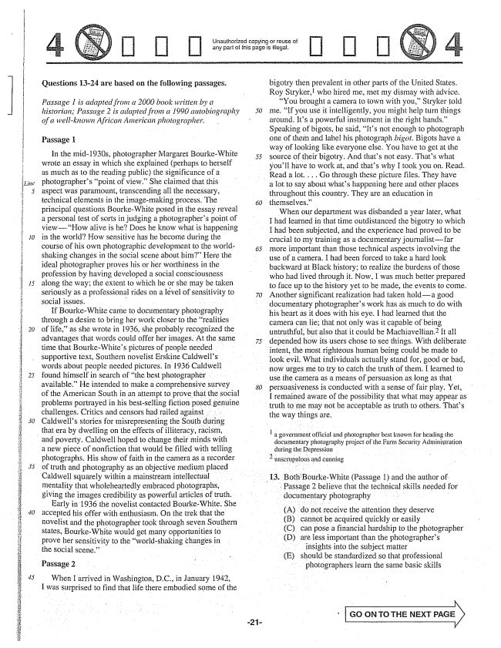

*30*

ūnauthorized copying or reuse of any part of inis page is illegat,

Questions 13-24 are based on the following passages.

*Passage 1 is adapted from a 2000 book written by a historian; Passage 2 is adapted from a 1990 autobiography of a well-known African American photographer.*

Passage 1

In the mid-1930s, photographer Margaret BourkeWhite wrote an essay in which she explained (perhaps to herself as much as to the reading public) the significance of a photographers point of view.” She claimed that this aspect was paramount, transcending all the necessary, technical elements in the imagemaking process. The principal questions BourkeWhite posed in the essay reveal a personal test of sorts in judging a photographers point of viewHow alive is heDoes he know what is happening in the world? How sensitive has he become during the course of his own photographic development to the worldshaking changes in the social scene about him” Here the ideal photographer proves his or her worthiness in the profession by having developed a social consciousness along the way; the extent to which he or she may be taken seriously as a professional rides on a level of sensitivity to social issues. .

If BourkeWhite came to documentary photography through a desire to bring her work closer to the realities of life,as she wrote in 1936, she probably recognized the advantages that words could offer her images. At the same time that BourkeWhites pictures of people needed supportive text, Southern novelist Erskine Caldwells words about people needed pictures. In 1936 Caldwell found himself in search of the best photographer available.” He intended to make a comprehensive survey of the American South in an attempt to prove that the social problems portrayed in his bestselling fiction posed genuine challenges. Critics and censors had railed against . . . Caldwells stories for misrepresenting the South during

that era by dwelling on the effects of illiteracy, racism,

and poverty. Caldwell hoped to change their minds with a new piece of nonfiction that would be filled with telling photographs. His show of faith in the camera as a recorder of truth and photography as an objective medium placed

Caldwell squarely within a mainstream intellectual

mentality that wholeheartedly embraced photographs,

giving the images credibility as powerful articles of truth.

Early in 1936 the novelist contacted BourkeWhite. She

accepted his offer with enthusiasm. On the trek that the

novelist and the photographer took through seven Southern

states, BourkeWhite would get many opportunities to prove her sensitivity to the world-shaking changes in the Social scene.” . .

Passage 2

When I arrived in Washington, DC., in January 1942, I was surprised to find that life there embodied some of the

bigotry then prevalent in other parts of the United States. Roy Stryker, who hired me, met my dismay with advice.

You brought a camera to town with you,Stryker told me, If you use it intelligently, you might help turn things around. Its a powerful instrument in the right hands.” Speaking of bigots, he said, Its not enough to photograph one of thein and label his photograph bigot. Bigots have a way of looking like everyone else. You have to get at the source of their bigotry. And thats not easy. Thats what youll have to work at, and thats why I took you on. Read,

Read a lot... . . Go through these picture files. They have

a lot to say about whats happening here and other places throughout this country. They are an education in themselves.”

When our department was disbanded a year later, what I had Îearned in that time outdistanced the bigotry to which I had been subjected, and the experience had proved to be crucial to my training as a documentary journalistfar more important than those technical aspects involving the

use of a camera. I had been forced to take a hard iodk backward at Black history; to realize the burdens of those

who had lived through it. Now, I was much better prepared to face up to the history yet to be made, the events to come. Another significant realization had taken holda good

documentary photographers work has as much to do with

his heart as it does with his eye. I had learned that the

camera can lie; that not only was it capable of being

untruthful, but also that it could be Machiavellian.” It all depended how its users chose to see things. With deliberate

intent, the most righteous human being could be made to

lookevil. What individuals actually stand for, good or bad, now urges me to try to catch the truth of them. I learned to use the camera as a means of persuasion as long as that persuasiveness is conducted with a sense of fair play. Yet, I remained aware of the possibility that what may appear as truth to me may not be acceptable as truth to others. Thats

the way things are.

| a government official and photographer best known for heading the

documentary photography project of the Farm Security Administration during the Depression . .

Both BourkeWhite (Passage I) and the author of

... Passage 2 believe that the technical skills needed for

" documentary photography

(A) do not receive the attention they deserve (B) cannot be acquired quickly or easily (C) can pose a financial hardship to the photographer (D) are less important than the photographers . insights into the subject matter (E) should be standardized so that professional photographers learn the same basic skills

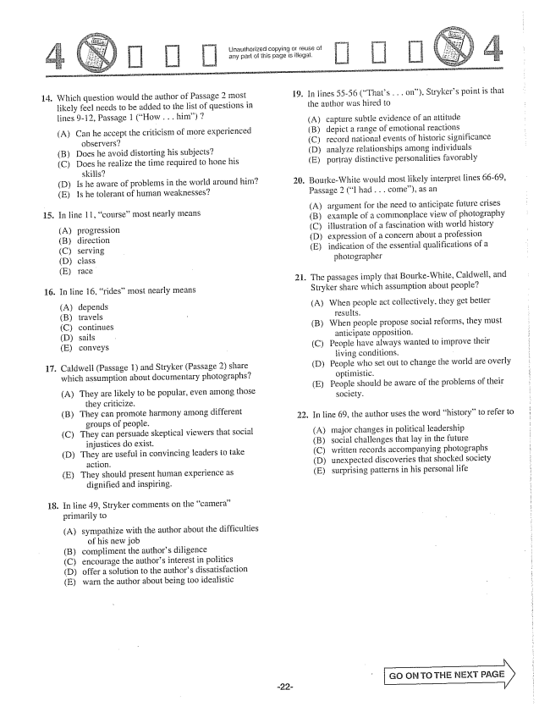

Unauthorized copying of reuse of any part of this page is illegal.

14. Which question would the author of Passage 2 most

15

**16.**

17.

likely feel needs to be added to the list of questions in lines -12, Passage 1 (How . . . him) 7

(A) Can he accept the criticism of more experienced

observers- B) Does he avoid distorting his subjects? (C) Does he realize the time required to home his

skiiis? (D) Is he aware of problems in the world around him? (E) 1s he tolerant of hurman weaknesses?

In line ll, course” most nearly means

progression direction serving ciass

таce

In line 16, rides” most nearly means

(A) (B) (D) (E)

depends travels continues sails conveys

Caldwell (Passage 1) and Stryker (Passage 2) share which assumption about documentary photographs?

(A) They are likely to be popular, even among those

they criticize. (B) They can promote harmony among different

groups of people. (C) They can persuade skeptical viewers that social

injustices do exist. (D) They are useful in convincing leaders to take

action, E) They should present human experience as

dignified and inspiring.

In line 49, Stryker comments on the camera” primarily to (A) sympathize with the author about the difficulties

of his new job compliment the authors diligence encourage the authors interest in politics offer a solution to the authors dissatisfaction warn the author about being too idealistic

(B) (C) (D) (E)

19.

23.

In fines 55-56 (Thats . . the author was hired to

on), Strykers point is that

capture subtle evidence of an attitude depict a range of emotional reactions record national events of historic significance analyze relationships among individuals portray distinctive personalities favorably

BourkeWhite would most likely interpret fines 66-69, Passage 2 (I had . . . come), as an

(А) (B) (C) (E)

argument for the need to anticipate future crises

example of a commonplace view of photography

illustration of a fascination with world history

expression of a concern about a profession

indication of the essential qualifications of a

photographer

.. The passages imply that BourkeWhite, Caldwell, and

Stryker share which assumption about people?

(A) When people act collectively, they get better

results.

(B) When people propose social reforms, they must

anticipate opposition.

(C) People have always wanted to improve their

iiving conditions. -

(D) People who set out to change the world are overly

optimistic.

(E) People should be aware of the problems of their

Society.

. In line 69, the author uses the word history” to refer to

(A) (B) (C) (D) (E)

major changes in political leadership social challenges that lay in the future written records accompanying photographs unexpected discoveries that shocked society Surprising patterns in his personal life

GO GV TO THE NEXT PAGE

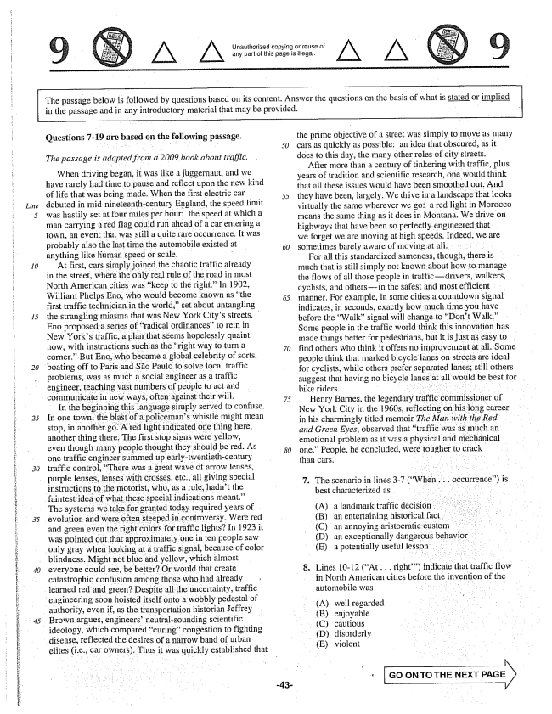

A A

Unauthorized copying Grrèuse of any part of this page is illegal.

The passage below is followed by questions based on its content. Answer the questions on the basis of what is stated or implied in the passage and in any introductory material that may be provided.

*Line*

*10*

*15*

*30*

evolution and were

**Questions -19 are based on the following passage.**

*The passage is adapted from a 2009 book about traffic,*

When driving began, it was like a juggernaut, and we have rarely had time to pause and reflect upon the new kind of life that was being made. When the first electric car 5 debuted in mid-nineteenth-century England, the speed limit was hastily set at four miles per hour: the speed at which a man carrying a red flag could run ahead of a car entering a town, an event that was still a quite rare occurrence. It was probably also the last time the automobile existed at - ) anything like human speed or scale. -

At first, cars simply joined the chaotic traffic already in the street, where the only real rule of the road in most North American cities was keep to the right.” In 1902, William Phelps Eno, who would become known as the first traffic technician in the world,set about untangling the strangling miasma that was New York Citys streets. Eno proposed a series of radical ordinancesto rein in New Yorks traffic, a plan that seems hopelessly quaint now, with instructions such as the rightway to turn a corner.” But Eno, who became a global celebrity of sorts,

boating off to Paris and São Paulo to solve local traffic

problems, was as much a social engineer as a traffic engineer, teaching vast numbers of people to act and communicate in new ways, often against their will. 75

In the beginning this language simply served to confuse. In one town, the blast of a policemans whistle might mean stop, in another go. A red light indicated one thing here, another thing there. The first stop signs were yellow, even though many people thought they should be red. As one traffic engineer summed up earlytwentieth-century traffic control, There was a great wave of arrow lenses, purple lenses, lenses with crosses, etc., all giving special instructions to the motorist, who, as a rule, hadnt the

faintest idea of what these special indications meant.”

The systems we take for granted today required years of

3ften steeped in controversy. Were red and green even the right colors for traffic lights? In 1923 it was pointed out that approximately one in ten people saw

only gray when looking at a traffic signal, because of color

blindness. Might not blue and yellow, which almost everyone could see, be better? Or would that create catastrophic confusion among those who had already learned red and green? Despite all the uncertainty, traffic

engineering soon hoisted itself onto a wobbly pedestal of

authority, even if, as the transportation historian Jeffrey Brown argues, engineers' neutralsounding scientific ideology, which compared curingcongestion to fighting disease, reflected the desires of a narrow band of urban elites (i.e., car owners). Thus it was quickly established that

the prime objective of a street was simply to move as many cars as quickly as possible: an idea that obscured, as it does to this day, the many other roles of city streets.

After more than a century of tinkering with traffic, plus years of tradition and scientific research, one would think that all these issues would have been smoothed out. And they have been, largely. We drive in a landscape that looks virtually the same wherever we go: a red light in Morocco means the same thing as it does in Montana. We drive on highways that have been so perfectly engineered that we forget we are moving at high speeds. Indeed, we are sometimes barely aware of moving at all. -

For all this standardized sameness, though, there is much that is still simply not known about how to manage the flows of all those people in trafficdrivers, walkers, cyclists, and othersin the safest and most efficient manner. For example, in some cities a countdown signal indicates, in seconds, exactly how much time you have before the Walksignal will change to Dont Walk.” Some people in the traffic world think this innovation has made things better for pedestrians, but it is just as easy to find others who think it offers no improvement at all. Some people think that marked bicycle lanes on streets are ideal for cyclists, while others prefer separated lanes; still others suggest that having no bicycle lanes at all would be best for bike riders. .

Henry Barnes, the legendary traffic commissioner of New York City in the 1960s, reflecting on his long career in his charmingly titled memoir The Man with the Red and Green Eyes, observed that traffic was as much an emotional problem as it was a physical and mechanical one.” People, he concluded, were tougher to crack, - than cars. . . . . .

7. The scenario in lines -7 (When .. occurrence) is best characterized as , (A) a landmark traffic decision. (B) an entertaining historical fact (C) an annoying aristocratic custom .

(D) an exceptionally dangerous behavior (E) a potentially useful lesson

8. Lines 10-12 (At... right) indicate that traffic flow

in North American cities before the invention of the automobile was . . .

(A) (B) (C) (D) (E)

well regarded enjoyable cautious disorderly violent

**GO ON TO THE NEXT PAGE**

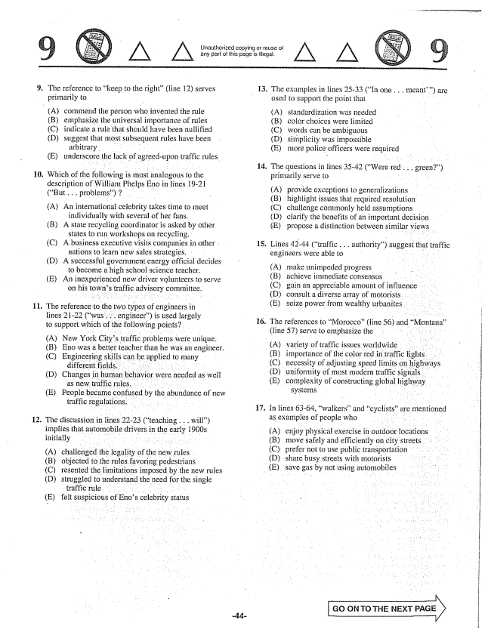

Unauthorized copying or reuse of any part of this page is illegal.

11.

(A)

The reference to keep to the right" (line 12) serves primarily to - -

commend the person who invented the rule emphasize the universal importance of rules indicate a rule that should have been nullified suggest that most subsequent rules have been

arbitrary (E) underscore the lack of agreed-upon traffic rules.

(B) (C) (D)

which of the following is most analogous to the description of William Phelps Eno in lines 19-21 (But... problems) 7 - -

(A) An international celebrity takes time to meet individually with several of her fans. (B) A state recycling coordinator is asked by other states to run workshops on recycling. (C) A business executive visits companies in other

nations to learn new sales strategies. (D) A successful government energy official decides to become a high school science teacher. (E) An inexperienced new driver volunteers to serve on his towns traffic advisory committee.

The reference to the two types of engineers in lines 21-22 (was , , , engineer) is used largely to support which of the following points?

(A) New York Citys traffic problems were unique. (B) Eno was a better teacher than he was an engineer. (C) Engineering skills can be applied to many

different fields. . . (D) Changes in human behavior were needed as well -

(E) People became confused by the abundance of new

traffic regulations. -

. The discussion in lines 22-23 (teaching . . . will)

initially . . . . . . . . . . . . . . . . . . .

(A) (B)

(C) (D)

challenged the legality of the new rules objected to the rules favoring pedestrians resented the limitations imposed by the new rules struggled to understand the need for the single

traffic rule felt suspicious of Enos celebrity status

(E)

13.

**14.**

15.

**16.**

17.

(A)

(D) share busy streets with motorists (E) save gas by not using automobiles

The examples in lines 25-33 (In one . . . meant) are

used to support the point that

(A) (B) (C) (D) (E)

standardization was needed color choices were limited words can be ambiguous simplicity was impossible moré police officers were required

The questions in lines 35-42 (Were red. primarily serve to

(Α) (B) (C) (D) (E)

provide exceptions to generalizations highlight issues that required resolution challenge commonly held assumptions clarify the benefits of an important decision propose a distinction between similar views

Lines 42-44 (traffic... authority) suggest that traffic engineers were able to . . .

(A) (C) (D) (E)

make unimpeded progress achieve ininediate consensus . . . . . . . gain an appreciable amount of influence consult a diverse array of motorists. seize power from wealthy urbanites

The references to Morocco(line 56) and Montana" (line 57) serve to emphasize the . . . . .

(A) (B)

variety of traffic issues worldwide . . . importance of the color red in traffic lights. . . necessity of adjusting speed limits on highways (D) uniformity of most modern traffic signals (E) complexity of constructing global highway

systems

In lines 63-64, walkersand cyclists” are mentioned as examples of people who

enjoy physical exercise in outdoor locations move safely and efficiently on city streets prefer not to use public transportation

GO ON TO THE NEXT PAGE