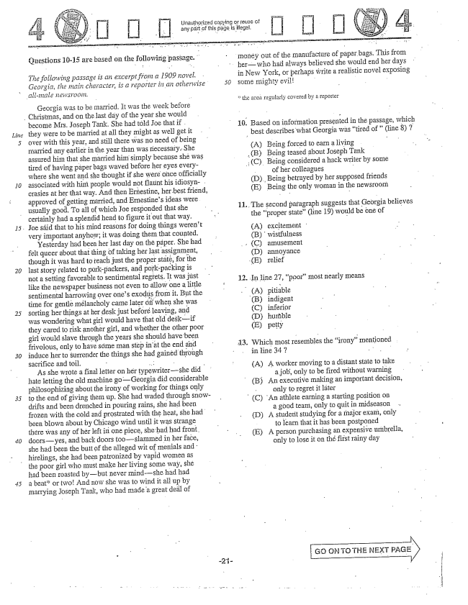

Unauthorized copying or reuse of

any part of this page is illegal. f

money out of the manufacture of paper bags. This from

herwho had always believed she would end her days

in New York, or perhaps write a realistic novel exposing 50 some mighty evil- -

Questions 10-15 are based on the following passage."

*The following passage is an excerpt from a 1909 Hovel. Georgia, the Riain character, is a reporter in an otherwise*

*.allImale newsroðiri.*

the area regularly covered by a reporter

###

Georgia was to be married. It was the week before

Christmas, and on the last day of the year she would

become Mrs. Joseph Tank. She had told Joe that if . they were to be married at all they as well get it

marrying Joseph Tank, who had made a great deal of

10. Based on information presented in the passage, which

best describes what Georgia was tired of" (line ) ;

*Line*

5 over with this year, and still there was no need of being - - -

married any earlier in the year than was necessary. She (A) Being forced ear living - assured him that she married him simply because she was .B) Being teased about Joseph Tank tired of having påper bags waved before her eyes every- (C) Being considered a hack writer by some where she went and she thought if she were once officially of her colleagues - 10 associated with him people would not flaunt his idiosyn- D), Beng betrayed by her supposed friends crasies at her that way, And then Ernestine, her best friend, E) Being the only woman in the newsroom approved of getting married, and Ernestines ideas were .. " . - usually good. To all of which Joe responded that she beecodಚ್ಡಣ್ಣಾSಜ್ಜೇಟ್ಲಿಜ್ಜಳ್ತbelieves certainly had a splendid head to figure it out that way. the proper state(line 19) would be öne of . Joe sáid that to his mind reasons for doing things werent (A) excitement

very important anyhowit was doing them that counted. . . .

- - - B) wistfulness Yesterday had been her last day on the paper. She had felt queer about that thing of taking her last assignmង្គnt, D) annoyance though it was hard to reach just the proper state, for the (E) relief 20 last story related to porkpackers, and porkpacking is -

setting favorable sentimental regrets. . In line 27, poofmost nearly means like the newspaper business not even to allow one a little w sentinental harrowing over ones exodus from it. But the (A) pitiable time for gentle mélancholy came later off when she was (B) indigent 25 sorting her things at her desk just before leaving, and (C) inferior was wondering what girl would have that old deskif (D) humible they cared to risk another girl, and whether the other poor (E) petty girl would slave through the years she should have been - - frivolous, only to have söme Inan step in at the end and . Which most resembles the irony” Inentioned 30 induce her to Surrender the things she had gained through in line 34 3 - -

Sacrifice and toil, .. - 1. - - -

As she wrote a final letter on her typewritershe did (Α) . tG ke hate letting the old machine goGeorgia did considerable - y -ឈ្មោឃៈ

- - - (B) An executive making an important decision, philosophizing about the irony of working for things only 1 : احیه - only to regret it låter 35 to the end of giving them up. She had waded through snow- r - - 1. - - -

- - ---- جی سب - - (C) An athlete earning a starting position on drifts and been drenched in pouring rains, she had been a good team, only to quit in midseason frozen with the cold and prostrated with the heat, she had - , only to quit - - - .. . . . - (D) A studerit studying for a major , only

een blown about by Chicago wind until it was strange to learn that it has been postponed there was any of her left in one piece, she had had front. as been postponed - - - - - (E) A person purchasing an expensive umbrella, 40 doorsyes, and back doors tooslammed in her face, only to lose it on the first rainy da

she had been the butt of the alleged wit of menials and y day hirelings, she had been patronized by vapid women as the poor girl who must Imake her living some way, she had been roasted bybut never mindshe had had 45 a beator twoAnd now she was to wind it all up by

Go ON TO THE NEXT PAGE

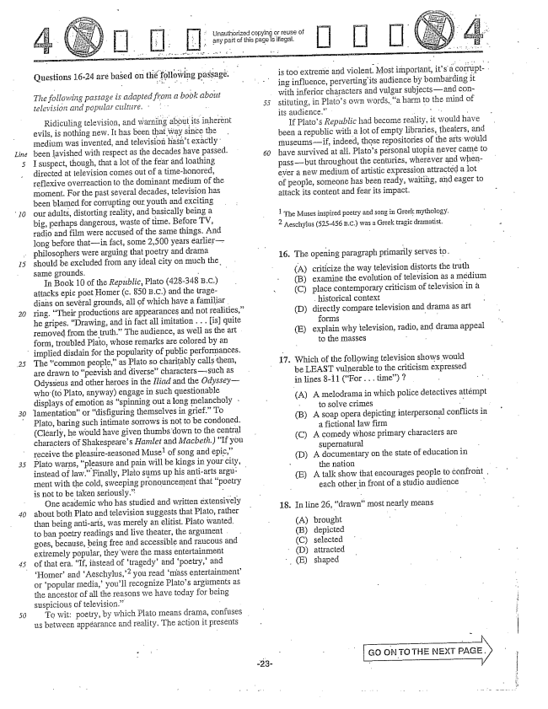

*Line*

Questions 16-24 are based on passagé.

*The following passage is adapted from a book about television and popular cultitre. . . . .*

5

Ridiculing television, and warning about its inherent evils, is nothing new. It has been that way since the medium was invented, and television hasnt exactly: been lavished with respect as the decades have passed. I suspect, though, that a lot of the fear and loathing directed at television comes out of a timehonored, reflexive overreaction to the dominant medium of the moment. For the past several decades, television has been blamed for corrupting our youth and exciting our adults, distorting reality, and basically being a big, perhaps dangerous, waste of time. Before TV, radio and film were accused of the same things. And long before thatin fact, some 2,500 years earlierphilosophers were arguing that poetry and drama should be excluded from any ideal city on much the Same grounds. - -

In Book 10 of the Republic, Plato (428-348 B.C.) attacks epic poet HoIner (c. 850 B.C.) and the tragedians on several grounds, all of which have a familiar. ring. Their productions are appearances and not realities, he gripes. Drawing, and in fact all imitation . . . [is] quite removed from the truth.” The audience, as welI as the art form, troubled Plato, whose remarks are colored by an

implied disdain for the popularity of public performances.

*30*

The common people,as Plato so charitably calls them, are drawn to peevish and diversecharacterssuch as Odysseus and other heroes in the Iliad and the Odysseywho (Plato, anyway) engage in such questionable displays of emotion as spinning out a long melancholy . lamentation" or disfiguring themselves in grief.” To Plato, baring such intimate sorrows is not to be condoned. (Clearly, he would have given thumbs-down to the central characters of Shakespeares Hamlet and Macbeth.) If you receive the pleastireseasoned Musel of Song and epic,Plato warps, pleasure and pain will be kings in your city, instead of law.” Finally, Plato sums up his anti-arts argu: . ment with the cold, sweeping pronouncement that poetry is not to be taken seriously.” -

One academic who has studied and written extensively about both Plato and television suggests that Plato, rather than being anti-arts, was merely an elitist. Plato wanted. to ban poetry readings and live theater, the argument goes, because, being free and accessible and raucous and extremely popular, they were the mass entertainment of that era. If, instead of tragedy' and poetry,and Homerand Aeschylus,you read mass entertainmentor popular Imedia,youll recognize Platos arguments as the ancestor of all the reasons we have today for being suspicious of television.” -

To wit: poetry, by which Plato means drama, confuses us between appearance and reality. The action it presents

Unauthorized copying or reuse of arly part of this page is illegal.

is too extreme and violent. Most important, its a corrupting influence, perverting its audience by bombarding it with inferior characters and vulgar subjects--and constituting, in Platos own words, a harm to the mind of its audience.” . . . . -

If Platos Republic had become reality, it would have been a republic with a Hot of empty libraries, theaters, and museumsif, indeed, those repositories of the arts would have survived at all, Platos personal utopia never came to passbut throughout the centuries, wherever and whenever a new medium of artistic expression attracted a lot of people, someone has been ready, waiting, and eager to attack its content and fear its impact.

inspired poetry and song in Greek mythology, Aeschylus (525-456 B.C.) was a Greek tragic dramatist.

16. The opening paragraph primarily serves to.

(A) (B) (C)

(D)

criticize the way television distorts the truth

examine the evolution of television as a medium

place contemporary criticism of television in a

Historical context

directly compare television and drama as art

forms

explain why television, radio, and drama appeal

to the masses - -

(E)

17. which of the following television shows would be LEAST vulnerable to the criticism expressed in lines -11 (For . . . time) 7

(A) A melodrama in which police detectives attéImpt to solve crimes - - (B) A soap opera depicting interpersonal

a fictional law firm 1. (C) A comedy whose primary characters are

supernatūral (D) A documentary on the state of education in - the nation

(E) A talk show that encourages people to confront .

each other in front of a studio audience

conflicts in

18. In line 26, drawn” most nearly means

(A) (B) (C) (D) (E)

brought depicted selected attracted shaped

Go ON TO THE NEXT - |

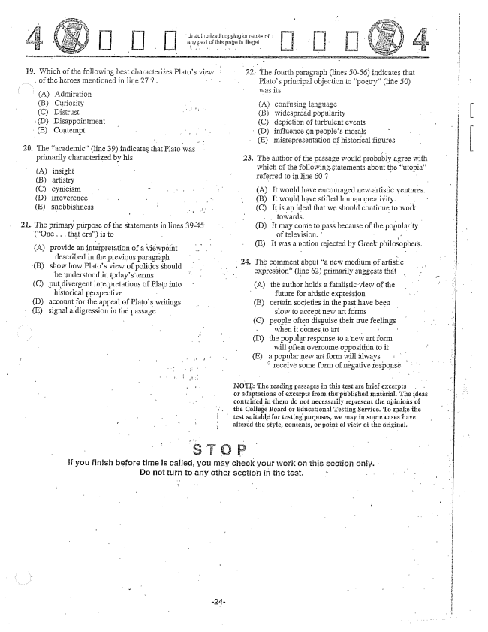

19. Which of the following best characterizes Platos view

of the heroes mentioned in line 27 ? .

(A). Admiration

(B) Curiosity

(C) Distrlist (DDisappointment (E) Contempt

20. The academic(line 39) indicates that Plato was

primarily characterized by his - -

A) insight (B) artistry (C) cynicism (D) irreverence - - E) snobbishness

21. The primary purpose of the statements in lines 39-45

(One .. that era) is to -

A) provide an interpretation of a viewpoint

described in the previous paragraph (B) show how Platos view of politics should

be understood in todays terms (C) put divergent interpretations of Plato into

historical perspective D) account for the appeal of Platos writings (E) signal a digression in the passage

22. The fourth paragraph (lines 50-56) indicates that

Platos principal objection to poetry” (50) was its

(Aconfusiៗដ្ឋ ឆែកឆ្វង (B) widespread popularity (C) depiction of turbulent events

(D) influence on peoples morals (E) misrepresentation of historical figures

23. The author of the passage would probably agree with which of the following statements about the utopia” referred to in line 607 -

A) It would have encouraged new artistic ventures. (B) It would have stifled human creativity. - (C) It is an ideal that we should continue to work. towards, - (D) It may come to pass because of the popularity of television. , E) It was a notion rejected by Greek philosophers.

24. The comment about a new medium of artistic

expression(line 62) primarily suggests that

(A) the author holds a fatalistic view of the - future for artistic expression

(B) certain societies in the past have been slow to accept new art forms (C) people often disguise their true feelings

when it comes to art - (D) the popular response to a new art form

will pften overcome opposition to it (E) a popular new artform will always

receive some form of negative response

NOTE: The reading passages in this test are brief excerpts or adaptations of excerpts from the published inăterial. The ideas contained in them do not necessarily represent the opinions of the College Board or Educational Testing Service. To make the

i test Suitable for testing purposes, we may in sogne cases have

altered the style, contents, or point of view of the original.

If you finish before time is called, you may check your work on this section only.

Do not turn to any other section in the iast.

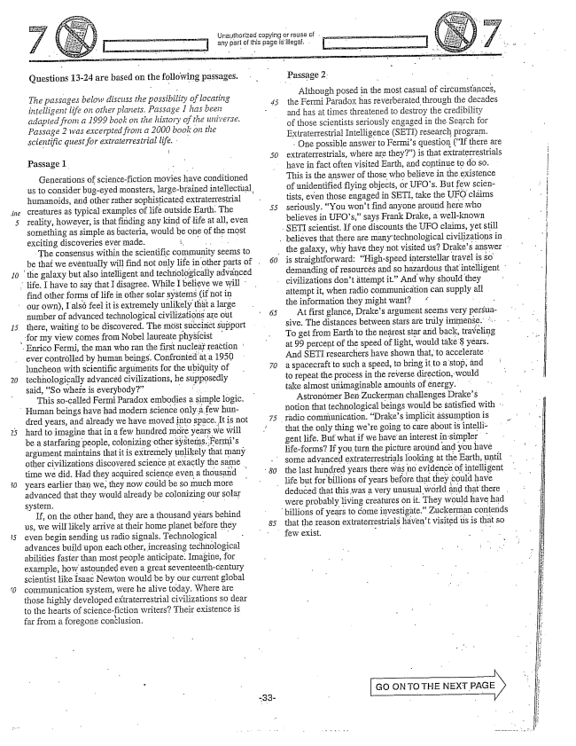

Questions 13-24 are based on the following passages.

*The passages below discuss the possibility of locating intelligent life an other planety. Passage I has been adapted from a 1999 book on the history of the universe. Passage 2 was excerpted from a 2000 book on the scientific quest for extraterrestrial life.*

**l**

Passage 1.

Generations of science-fiction movies have conditioned

us to consider bugeyed monsters, largebrained intellectilal,

humanoids, and other rather sophisticated extraterrestrial creatures as typical examples of life outside Earth. The reality, however, is that finding any kind of life at all, even something as simple as bacteria, would be one of the most exciting discoveries ever made. .. . . . . .

The consensus within the scientific community seems to

be that we eventually will find not only life in other parts of . the galaxy but also intelligent and technologically advanced life. I have to say that I disagree. While I believe we will

find other forms of life in other solar systems (if not in our own), I also feel it is extremely unlikely that a large number of advanced technological civilizations are out there, waiting to be discovered. The most succinct support

for my view comes from Nobel laureate physicist Enrico Fermi, the man who ran the first nuclear reaction

ever controlled by human beings. Confronted at a 1950 luncheon with scientific arguments for the ubiquity of technologically advanced civilizations, he supposedly said, So where is everybody”

This socalled Fermi Paradox embodies a simple logic.

Human beings have had modern science only a few hun

dred years, and already we have moved into Space. It is not hard to imagine that in a few hundred more years we will be a starfaring people, colonizing other systems. Fermis argument maintains that it is extremely unlikely that many other civilizations discovered science at exactly the same time we did. Had they acquired science even a thousand years earlier than we, they now could be so much more advanced that they would already be colonizing our solar system, -

If, on the other hand, they are a thousand years behind us, we will likely arrive at their home planet before they even begin sending us radio signals. Technological advances build upon each other, increasing technological abilities faster than most people anticipate. Imagine, for example, how astounded even a great seventeenth-century scientist like Isaac Newton would be by our current global communication system, were he alive today. Where are those highly developed extraterrestrial civilizations so dear to the hearts of Science-fiction writers? Their existence is far from a foregone conclusion.

Unauthorized copying or reuse of . . any part of this page is illegal.

Passage 2.

Although posed in the most casual of circumstances,

the Fermi Paradox has reverberated through the decades and has at times threatened to destroy the credibility of those scientists seriously engaged in the Search for ExtraterTestrial Intelligence (SETI) research prograpn.

One possible answer to Fermis question (If there are extraterrestrials, where are they") is that extraterrestrials have in fact often visited Earth, and continue to do so. This is the answer of those who believe in the existence of unidentified flying objects, or UFOs. But few scientists, even those engaged in SETI, take the UFO claims seriously. You wont find anyone around here who believes in UFOs,says Frank Drake, a well-known

SETI scientist. If one discounts the UFO claims, yet still .. believes that there are manytechnological civilizations in

the galaxy, why have they not visited usDrakes answer is straightforward: Highspeed interstellar travel is so demanding of resources and so hazardous that intelligent civilizations dont attempt it.” And why should they attempt it, when radio communication can supply all the information they might want? “

At first glance, Drakes argument seems very persuasive. The distances between stars are truly immense. .. To get from Earthto the nearest star and back, traveling at 99 percent of the speed of light, would 8 years. And SETI researchers have shown that, to accelerate a spacecraft to such a speed, to bring it to a stop, and to repeat the process in the reverse direction, would take almost unimaginable amounts of energy.

Astronómer Ben Zuckerman challenges Drakes notion that technological beings would be satisfied with .

radio communication. Drakes implicit assumption is

that the only thing were going to care about is intelligent life. But what if we have an interest in simpler lifeforms? If you turn the picture around and you have some advanced extraterrestrials looking at the Earth, until the last hundred years there was no evidence of intelligent life but for billions of years before that they could have

deduced that this was a very unusual world ånd that there .

were probably living creatures on it. They would have had

billions of years to come investigate." Zuckerman contends

that the reason extraterrestrials havent visited is is that so

few exist.

Go ON TO THE NEXT PAGE

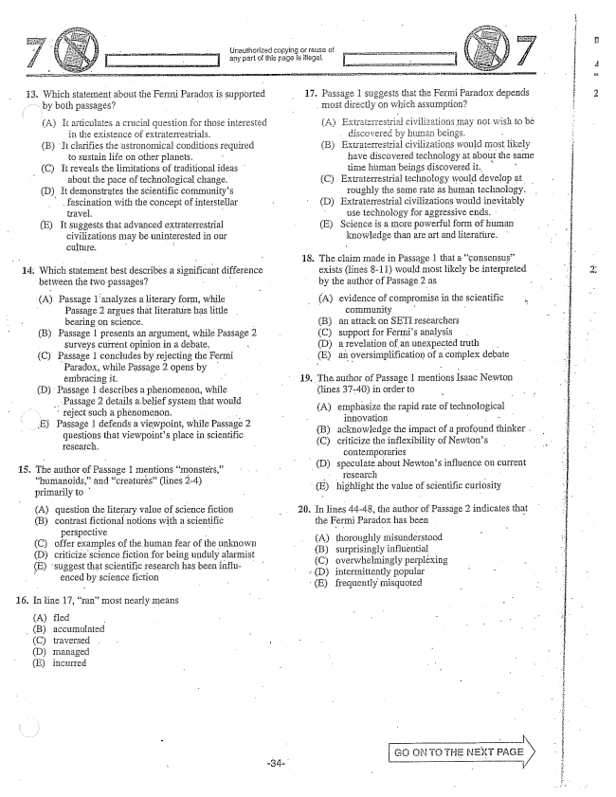

13. Which statement about the Fermi Paradox is Supported

by both passages? -

A) It articulates a crucial question for those interested

in the existence of extratesTestrials.

(B) . It clarifies the astronomical conditions required

to Sustain life On other planets.

(C) it reveals the limitations of traditional ideas

about the pace of technological change.

(D). It demonstrates the scientific communitys

fascination with the concept of interstellar

travej. -

(E) It suggests that advanced extraterrestrial

civilizations may be uninterested in Our culture. ".

14. Which statement best describes a significant difference

between the two passages? - l

(A) Passage 1 analyzes a literary form, while

- Passage 2 argues thất literature little

bearing on Science, -

(B) Passage 1 presents an argument, while Passage 2

Surveys current opinion in a debate.

(C) Passage 1 concludes by rejecting the Fermi Paradox, while Passage 2 opens by embracing it.

(D) Passage 1 describes a phenomenon, while

.. Passage 2 details abelief system that would

reject such a phenomenon. -

E) Passage 1 defends a viewpoint, while Passage 2

questions that viewpoints place in scientific research.

15. The author of Passage 1 Inentions monsters,“humanoids,and creatures” (lines 2-4) primarily to - A) question the Hiterary value of Science fiction (B) contrast fictional notions with a scientific

perspective

(C) offer examples of the human fear of the unknown (D) criticize science fiction for being unduly alarmist (E) suggest that scientific research has been influ- enced by science fiction

16. In line 17, ranmost nearly Ineans

(A) fled (B) accumulated (C) traversed (D) managëd (E) incurred

Unauthorized copying or reuse of - - any part of this page is illegal, - -

17. Passage 1 suggests that the Fermi Paradox depends

most directly on which assumption?

(A) Extraterrestrial civilizations may not wish to bë

discovered by human beings. (B) Extraterrestrial civilizations would most likely

have discovered technology at about the same time Hilman beings discovered it. - (C) Extraterrestrial technology would develop at .

roughly the same rate as human technology. (D) Extraterrestrial civilizations would inevitably

use technology for aggressive ends. (E) Science is a more powerful form of human

knowledge than are art and literatiure.

18. The claim Inade in Passage 1 that a consensus.”

exists (lines -11) would most likely be interpreted - by the author of Passage 2 as -

A) evidence of compromise in the scientific

- community - B) an attack on SETI researchers (C) support for Fermis analysis . (D) a revelation of an unexpected truth - E) an oversimplification of a complex debate

19. The author of Passage 1 mentions Isaac Newton

(lines 37-40) in order to

(A) emphasize the rapid rate of technological

innovation (B) acknowledge the impact of a profound thinker . (C) criticize the inflexibility of Newtons

contemporaries (D) speculate about Newtons influence on current

- (E) highlight the value of scientific curiosity

20. In lines 44-48, the author of Passage 2 indicates that

the Fermi Paradox has been

(A) thoroughly misunderstood

(B) surprisingly influential

(C) overwhelmingly perpléxing , D) intermittently popular (E) frequently misquoted

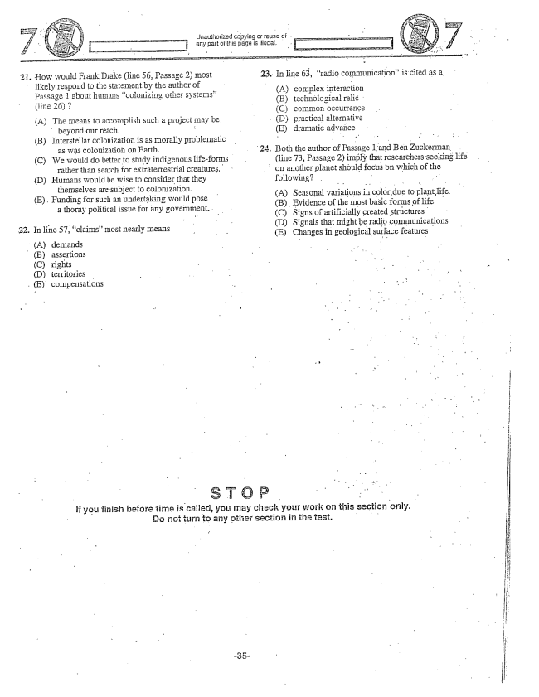

21.

How would Frank Drake (line 56, Passage 2) Inost likely respond to the statement by the author of Passage 1 about hormans colonizing other systems” (line 26) 7

(A) The Imeans to accomplish Such a project may be beyond our reach. (B) Interstellar colonization is as morally problematic

as was colonization on Earth.

(C) We would do better to study indigenous lifeforms

rather than search for extraterrestrial creatures, D) Humans would be wise to consider that they

themselves are subject to colonization. (E), Funding for such an undertaking would pose

a thorny political issue for any government. .

. In line 57, claims” most nearly means

Unauthorized copying or reuse of .

i - any part of this page is illegal.

23. In fine 63, radio communication" is cited as a

(A) complex interaction (B) technological relic (C) comrrion occurrence

(D) practical alternative

(E) dramatic advance

24. Both the author of Passage 1 and Ben Zuckerman

(line 73, Passage 2) imply that researchers seeking life

on another planet should focus on which of the

following?

(A) Seasonal variations in color dueto plantlife. (B) Evidence of the most basic forms of life (C) Signs of artificially created structures (D) Signals that might be radio communications (E) Changes in geological surface features

(A) demands (B) assertions (C) rights - - . . . . . ... " - D) territories . - - - - .. . . . . . . (E) compensations * - - . . . .

If you finish before time is called, you may check your work on this section only.

Do not turn to any other section in the test. - - -

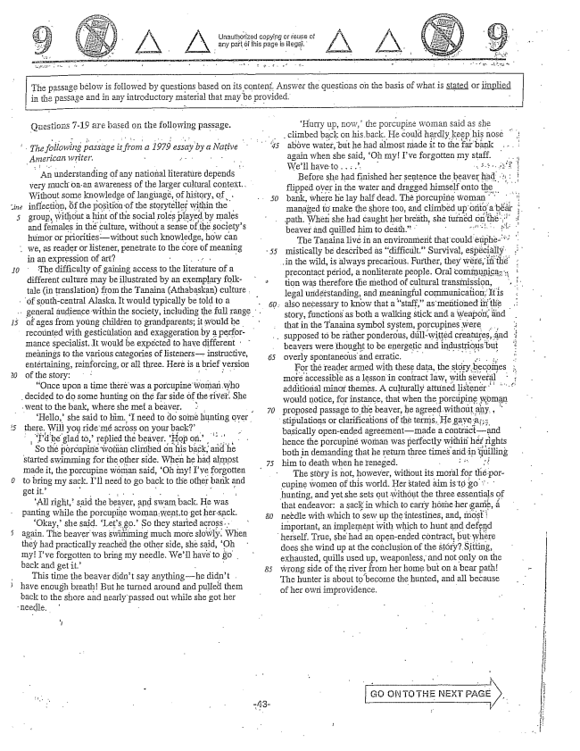

The passage below is followed by questions based on its content. Answer the questions on the basis of what is stated or implied in the passage and in any introductory material that Hlay be provided.

as -19 are based on the following passage.

*The föllowing passage is from a 1979 essay by a Native American writer. - .. - - - -*

An understanding of any national literature depends very Inuch onan awareness of the larger Cultural context. Without some knowledge of language, of history, of . inflection, the position of the storyteller within the group, withdut a hint of the social roles played by males and females in thẻ culture, vithout a sense pfthe societys humor or prioritieswithout such knowledge, how can

.. we, as reader or listener, penetrate to the core of Ineaning

in an expression of art

The difficulty of gaining access to the literature of a different culture may be illustrated by an exemplary folk

tale (in translation) from the Tanaina (Athabaskan) culture

of sputh-central Alaska. It would typically be told to a

*15*

.. general audience within the society, including the full range

of ages from young children to grandparents; it would be

recounted with gesticulation and exaggeration by a perfor

needle.

Inance specialist. It would be expected to have different meäningsto the varioiis categories oflistemersinstructiye, entertaining, reinforcing, or all three. Here is a brief version of the story:

Once upon a time theré was a porcupine woman who

decided to do some hunting on the far side of the river. She went to the bank, where she met a beaver.

Hello, she said to him, I need to do some hunting over therę,Will yoride méacross on your back'

Id be glad , replied the beaver. Hop on

. . . So thë pòrcupine woñan clirribed on his ; andhè started swimming for the other side. When he had almost made it, the porcupine woman said, Oh myIve forgotten to bring my sack. Ill need to go back to the other bank and getit.” - - : * . . .

All right,said the beaver, and swam back. He was panting while the porcupine woman Went,together sack. Okay,she said. Lets go” So they started across. again. The beaver was swimming much more slowly. When they had practically reached the other side, she said, Oh my! Ive forgotten to bring my needle. Well have to go . back and get it.” - -

This time the beaver didnt say anythinghe didnt . have enough breathBut he turned around and pulled them back to the shore and nearly passed out while she got her

"Hurry up, now, the porcupine woman said as she climbed back on his back. He could hardly keep his nose

5 above water, but he had almost made it to the far bank . . . .

again when she said, Oh my! Ive forgotten my staff

*3. , , ,*

Before she had finished her sentence the beaver had :

flipped over in the water and dragged himself onto the

50 bank, where he lay half dead. The porcupine woman

beaver and quilled him to death.”

The Tanaina livéin an environment that could eliphe

55 mistically be described as difficult.” Survival, espécially

in the wild, is always precarious. Further, they were, iii the

precontact period, a nonliterate people. Oral communiga: tion was therefore the method of cultural transmission, , , ,

legal understanding, and meaningful communication. It is 60, also necessary to know that a staff,as mentioned in the

story, functions as both a walking stick and a weapon, and that in the Tanaina symbol system, porcupines were supposed to be rather ponderous, dillwitted creatures, find beavers were thought to be energetic and industriotis but 65 overly spontaneous and erratic. . . . .

For the reader armed with these data, the ecoffes s

more accessible as a lesson in contract law, with several

*i*

additional minor themes. A culturally attuned listener’ ’’’

would notice, for instance, that when the porcupine woman 70 proposed passage to the beaver, he agreed without any,

stipulations or clarifications of the terms. He gaye : basically openended agreementmade a contráci-and hence the porcupine woman was perfectly within hér fights both in demanding that he return three times and in quilling 75 him to death when he reneged. . . . . .

The störy is not, however, without its moral for thë porcupine women of this world. Her stated aim is to go hunting, and yet she sets out without the three essentials of that endeavor: a sack in which to carry hôthe her game, 80 needle with which to sew up the intestines, and, Íñosti

important, an implement with which to hunt and defend herself. True, she had an openended contract, but where does she wind up at the conclusion of the Störy? Sitting, exhausted, quills used up, weaponless, and not only on the 85 wrong side of the river from her home but on a bear path! The hunter is about to become the hunted, and all because of her own improvidence, -

Go ON TO THE NEXT PAGE

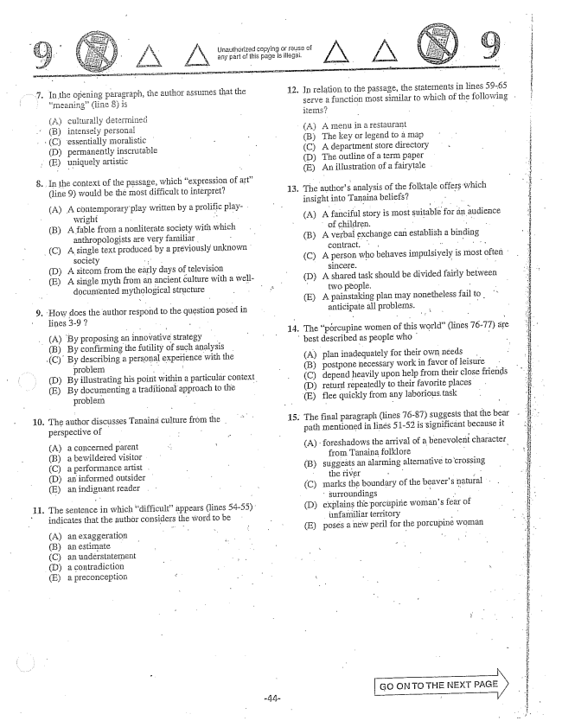

In the opening paragraph, the author assumes that the In the Opening graph, fi th that tl

meaning(line ) is

(A) culturally determined Bintensely personal

(C) essentially Hioralistic

(D) permanentiy inscrutable

, E) uniquely artistic

In the context of the passage, which expression of art

(line ) would be the most difficult to interpret?

(A) A contemporary play written by a prolific play

wright - . . .

(B) A fable from a nonliterate society with which

anthropologists are very familiar.

(C) A single text produced by a previously unknown

society : . (D) A sitcom from the early days of television

(E) A single myth from an ancient culture with a well

documented mythological structure

How does the author respond to the question posed in

lines -9 |

(A) By proposing an innovative strategy

(B) By confirming the futility of such analysis

10.

**11.**

(C). By describing a personal experience with the

problem (D) By illustrating his point within a particular context. (E) By documenting a traditional approach to the

problem

The author discusses Tanaina culture from the perspective of -

A) a concernëd parent (B) a bewildered visitor (C) a performance artist (D) an informed outsider (E) an indignant reader

The sentence in which difficultappears (lines 54-55). indicates that the author considers the word to be

(A) an exaggeration (B) an estimate (C) an undérstatement (D) a contradiction (E) a preconception

Unauthorized copying or reuse of any part of this page is ilegal.

12. In relation to the passage, the statements in lines 59-65

serve a function most similar to which of the following .

(A) A menu in a restaurant (B) The key or legend to a map (C) A department store directory (D) The outline of a term paper

(E) An illustration of a fairytale

. The authors analysis of the folktale offers which

insight into Tanaina beliefs? -- (A) A fanciful story is most suitable for an audience

of children, . . . .

(B) A verbai exchange cari establish a binding

contract, -

(C) A person who behaves impulsively is most often

sincere. (D) A shared task should be divided fairly between

- two people. -

(E) A painstäking plan may nonetheless fail to .

anticipate all problems. .

. The pércupine women of this world” (lines 76-77) are

best described as people who -

A) plan inadequately for their own needs . (B) postpone necessary work in favor of leisure (C) depend heavily upon help from their close friends (D) return repeatedly to their favorite places (E) flee quickly from any laborious task

. The final paragraph (lines 76-87) suggests that the bear

path mentioned in lines 51-52 is significant because it

(A) foreshadows the arrival of a benevolent character,

from Tanaina folklore (B) suggests an alarming alternative to crossing

the river - - (C) marks the boundary of the beavers natural .

surroundings T. (D) explains the porcupińe womans fear of

unfamiliar territory - (E) poses a new peril for the porcupine woman

GO ON TO THE NEXT PAGE

i

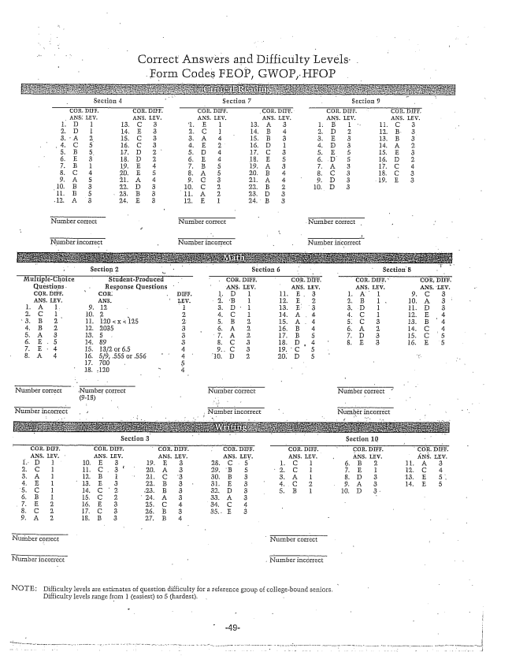

Correct Answers and Difficulty Levels.

Nürnber correct Number correct

Number incorrect

NOTE: Difficulty levels are estimates of question difficulty for a reference group of collegebound seniors,

Difficulty levels range fram 1 (easiest) to 5 (hardest. -