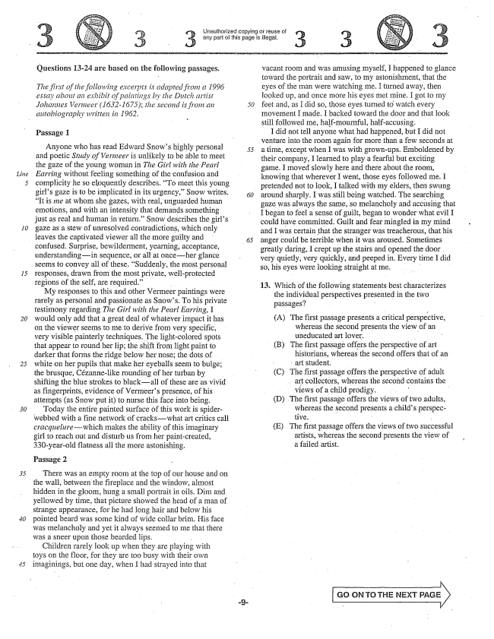

Questions 13-24 are based on the following passages.

*The first of the following excerpts is adapted from a 1996 essay about an exhibit of paintings by the Dutch artist Johannes Vernieer (1632-1675); the second is from an 50 autobiography written in 1962.*

Passage 1

Anyone who has read Edward Snows highly personal 55 and poetic Study of Vermeer is unlikely to be able to meet the gaze of the young woman in The Girl with the Pearl Earring without feeling something of the confusion and complicity he so eloquently describes. To meet this young

girls gaze is to be implicated in its urgency.” Snow writes. 60

It is me at whom she gazes, with real, unguarded human emotions, and with an intensity that demands something just as real and human in return.” Snow describes the girls gaze as a stew of unresolved contradictions, which only leaves the captivated viewer all the more guilty and confused. Surprise, bewilderment, yearning, acceptance, understandingin sequence, or all at onceher glance seems to convey all of these. Suddenly, the most personal responses, drawn from the most private, well-protected regions of the self, are required.” - .

My responses to this and other Vermeer paintings were rarely as personal and passionate as Snows. To his private testimony regarding The Girl with the Pearl Earring, I would only add that a great deal of whatever impact it has on the viewer seems to me to derive from very specific, very visible painterly techniques. The light-colored spots that appear to round her lip; the shift from light paint to darker that forms the ridge below her nose; the dots of white on her pupils that make her eyeballs seem to bulge; the brusque, Cézannelike rounding of her turban by shifting the blue strokes to blackall of these are as vivid as fingerprints, evidence of Vermeers presence, of his attempts (as Snow put it) to nurse this face into being.

Today the entire painted surface of this work is spiderwebbed with a fine network of crackswhat art critics call. cracquelure--which makes the ability of this imaginary girl to reach out and disturb us from her paintcreated, 330-year-old flatness all the more astonishing.

Passage 2

There was an empty room at the top of our house and on the wall, between the fireplace and the window, almost hidden in the gloom, hung a small portrait in oils. Dim and yellowed by time, that picture showed the head of a man of strange appearance, for he had long hair and below his pointed beard was some kind of wide collar brim. His face was melancholy and yet it always seemed to me that there was a sneer upon those bearded lips, -

Children rarely look up when they are playing with toys on the floor, for they are too busy with their own imaginings, but one day, when I had strayed into that

ūnauthorized copying or reuse of any part of this page is illegal,

vacant room and was amusing myself, I happened to glance toward the portrait and saw, to my astonishment, that the eyes of the man were watching me. I turned away, then Hooked up, and once more his eyes met mine. I got to my feet and, as I did so, those eyes turned to watch every movement I made. I backed toward the door and that look still followed me, half-mournful, half-accusing.

I did not tell anyone what had happened, but I did not venture into the room again for more than a few seconds at a time, except when I was with grown-ups. Emboldened by their company, I learned to play a fearful but exciting game. I moved slowly here and there about the room, knowing that wherever I went, those eyes followed me. I pretended not to look, I talked with my elders, then swung around sharply. I was still being watched. The searching gaze was always the same, so melancholy and accusing that I began to feel a sense of guilt, began to wonder what evil I could have committed. Guilt and fear mingled in my mind and 1 was certain that the stranger was treacherous, that his anger could be terrible when it was aroused. Sometimes greatly daring, I crept up the stairs and opened the door . very quietly, very quickly, and peeped in, Every time I did so, his eyes were looking straight at me, -

13. Which of the following statements best characterizes the individual perspectives presented in the two passages?

(A) The first passage presents a critical perspective,

whereas the second presents the view of an uneducated art lover, B) The first passage offers the perspective of art

historians, whereas the second offers that of an art student. . (C) The first passage offers the perspective of adult art collectors, whereas the second contains the views of a child prodigy. - (D) The first passage offers the views of two adults, whereas the second presents a childs perspective. - (E) The first passage offers the views of two successful

artists, whereas the second presents the view of a failed artist,

Go ON TO THE NEXT PAGE

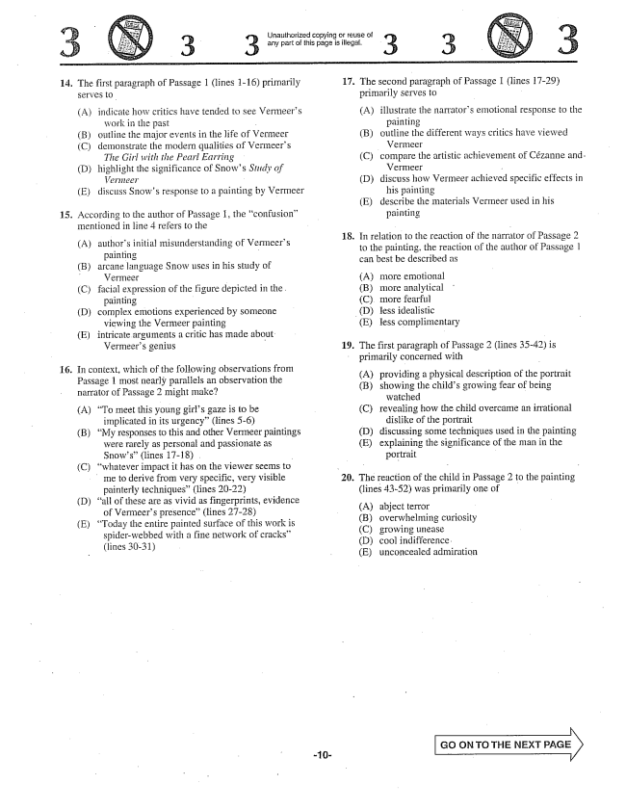

**14.**

16.

The first paragraph of Passage 1 (lines 1-16) primarily serves to

(A) indicate how critics have tended to see Vermeers

work in the past - B) outline the major events in the life of Vermeer (C) demonstrate the modern qualities of Vermeers

The Girl with the Pearl Earring (D) highlight the significance of Snows Study of

- E) discuss Snows response to a painting by Vermeer

. According to the author of Passage I, the confusion”

mentioned in line 4 refers to the

(A) authors initial misunderstanding of Vermeers

painting arcane language Snow uses in his study of

Vermeer - facial expression of the figure depicted in the .

painting cornplex emotions experienced by someone

viewing the Vermeer painting intricate arguments a critic has made about Vermeers genius

(B)

(C)

(D)

(E)

In context, which of the following observations from Passage 1 most nearly parallels an observation the narrator of Passage 2 might make?

(A) To meet this young girls gaze is to be

implicated in its urgency” (lines -6)

(B) My responses to this and other Vermeer paintings were rarely as personal and passionate as Snows(lines 1718) . -

(C) whatever impact it has on the viewer seems to

me to derive from very specific, very visible

painterly techniques(lines 2022)

(D) all of these are as vivid as fingerprints, evidence

of Vermeers presence” (lines 27-28)

(E) Today the entire painted surface of this work is

spider-webbed with a fine network of cracks” (lines 3031)

-10

Unauthorized copying or reuse of any part of this page is illegal,

17.

18.

**19.**

(D)

The second paragraph of Passage 1 (lines 1729) primarily serves to

(A) illustrate the narrators emotional response to the

painting

(B) outline the different ways critics have viewed

Vermeer

(C) compare the artistic achievement of Cézanne and.

Vermeer -

(D) discuss how Vermeer achieved specific effects in

his painting

(E) describe the materials Vermeer used in his

painting

In relation to the reaction of the narrator of Passage 2 to the painting, the reaction of the author of Passage | can best be described as

(A) (B) (C)

more emotional more analytical more fearful less idealistic (E) less complimentary

The first paragraph of Passage 2 (lines 3542) is primarily concerned with

(A) (B)

(C)

providing a physical description of the portrait

showing the childs growing fear of being

watched

revealing how the child overcame an irrational

dislike of the portrait

discussing some techniques used in the painting

explaining the significance of the man in the

portrait

(D) (E)

20. The reaction of the child in Passage 2 to the painting

(lines 4352) was primarily one of

(A) (B) (C) (D) (E)

abject terror overwhelming curiosity growing unease cool indifference. unconcealed admiration

GO ON TO THE NEXT PAGE

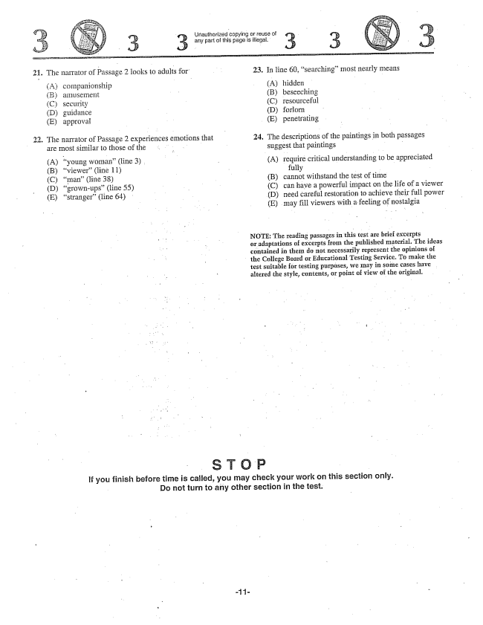

Uriauthorized Copying or reuse of 3. 3 any part of this page is illegal. 3 3

21. The narrator of Passage 2 looks to adults for 23. In line 60, searching" most nearly means

Acompanionship A) hidden (B) amusenlent - B) beseeching (C) security (C) resourceful (D) guidance - - D) foríorn - E) approvat (E) penetrating 22. The narrator of Passage 2 experiences emotions that - 24. The descriptions of the paintings in both passages

are most similar to those of the . suggest that paintings . - A) "young woman(line 3) . - A) require critical understanding to be appreciated (B) viewer(line 11) - - - fully - (C) man(line 38) - (B) cannot withstand the test of time (D) grown-ups” (line 55) - (C) can have a powerful impact on the life of a viewer (E) stranger(line 64) (D) need careful restoration to achieve their full power

(E) may fill viewers with a feeling of nostalgia

NOTE: The reading passages in this test are brief excerpts or adaptations of excerpts from the published material. The ideas contained in them do not necessarily represent the opinions of the College Board or Educational Testing Service. To make the test suitable for testing purposes, we may in some cases have altered the style, contents, or point of view of the original.

If you finish before time is called, you may check your work on this section only. Do not turn to any other section in the test.

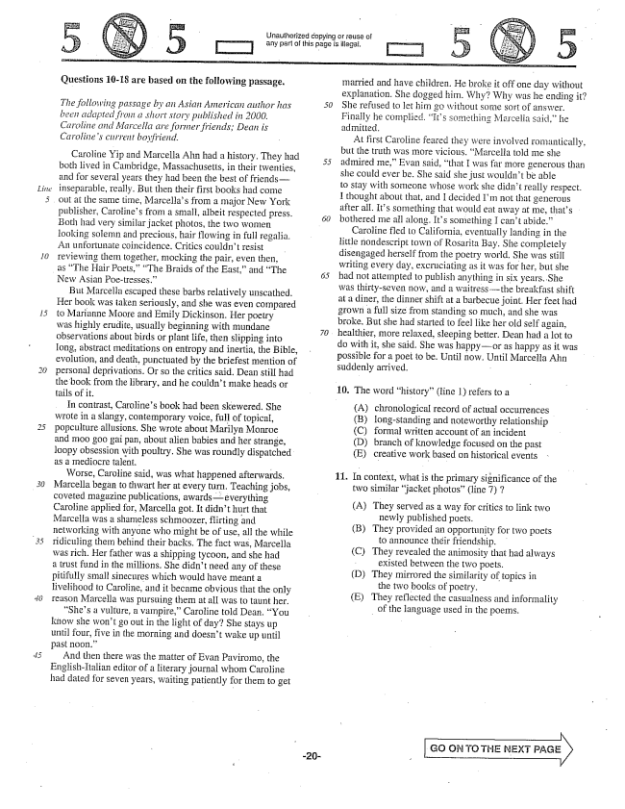

*Litte*

*30*

Unauthorized copying or reuse ci

T] any part of this page is illegal.

Questions 10-18 are based on the following passage.

*The following passage by an Asian American aitthor has been adapted from a short story published in 2000. Caroline and Marcella are former friends; Dean is Carolines current boyfriend.*

Caroline Yip and Marcella Alın had a history. They had both lived in Cambridge, Massachusetts, in their twenties, and for several years they had been the best of friendsinseparable, really. But then their first books had come out at the same time, Marcellas from a major New York publisher, Carolines from a small, albeit respected press. Both had very similar jacket photos, the two women looking solemn and precious, hair flowing in full regalia. An unfortunate coincidence. Critics couldn't resist reviewing them together, mocking the pair, even then,

as The Hair Poets,“The Braids of the East,and The

New Asian Poetresses.”

But Marcella escaped these barbs relatively unscathed. Her book was taken seriously, and she was even compared to Marianne Moore and Emily Dickinson. Her poetry was highly erudite, usually beginning with mundane observations about birds of plant life, then slipping into Iong, abstract meditations on entropy and inertia, the Bible, evolution, and death, punctuated by the briefest mention of personal deprivations. Or so the critics said. Dean still had the book from the library, and he couldnt make heads or tails of it.

In contrast, Carolines book had been skewered. She wrote in a slangy, contemporary voice, full of topical, popculture allusions. She wrote about Marilyn Monroe and moo goo gaipan, about alien babies and her strange, loopy obsession with poultry. She was roundly dispatched as a Inediocre talent. -

Worse, Caroline said, was what happened afterwards. Marcella began to thwart her at every turn. Teaching jobs, coveted magazine publications, awardseverything Caroline applied for, Marcella got. It didn't hurt that Marcelia was a shameless schmoozer, flirting and networking with anyone who might be of use, all the while ridiculing them behind their backs. The fact was, Marcella was rich. Her father was a shipping tycoon, and she had a trust fund in the milions. She didnt need any of these pitifully small sinecures which would have meant a livelihood to Caroline, and it became obvious that the only reason Marcella was pursuing them at all was to taunt her. Shes a vulture, a vampire,Caroline told Dean. You she won't go out in the light of day? She stays up until four, five in the morning and doesnt wake up until past noon.”

And then there was the matter of Evan Paviromo, the English-Italian editor of a literary journal whom Caroline had dated for seven years, waiting patiently for them to get

5

-20

married and have children. He broke it off one day without explanation. She dogged him. Why? Why was he ending it? She refused to let him go without some sort of answer. Finally he complied, Its something Marcelia said,he admitted.

At first Caroline feared they were involved romantically, but the truth was more vicious. Marcella told me she admired meEvan said, that I was far more generous than she could ever be. She said she just wouldn't be able to stay with someone whose work she didn't really respect. I thought about that, and I decided Im not that generous after all. Its something that would eat away at me, thats bothered me all along. Its something I cant abide.”

Caroline fled to California, eventually landing in the little nondescript town of Rosarita Bay. She completely disengaged herself from the poetry world. She was still writing every day, excruciating as it was for her, but she had not attempted to publish anything in six years. She was thirty-seven now, and a waitressthe breakfast shift at a diner, the dinner shift at a barbecue joint. Her feet had grown a full size from standing so much, and she was broke. But she had started to feel like her old self again, healthier, more relaxed, sleeping better. Dean had a lot to do with it, she said. She was happyor as happy as it was possible for a poet to be. Until now. Until Marcella Ahn suddenly arrived. -

10. The word history” (line 1) refers to a

chronological record of actual occurrences Iong-standing and noteworthy relationship formal written account of an incident branch of knowledge focused on the past creative work based on historical events

(A) (B) (C) (D) (E)

11. In context, what is the primary significance of the

two similar jacket photos” (line ) 7

(A) They served as a way for critics to link two

newly published poets. (B) They provided an opportunity for two poets

to announce their friendship. (C) They revealed the animosity that had always

existed between the two poets. (D) They mirrored the similarity of topics in

the two books of poetry. (E) They reflected the casualness and informality

of the language used in the poems.

GO ON TO THE EXT PAGE

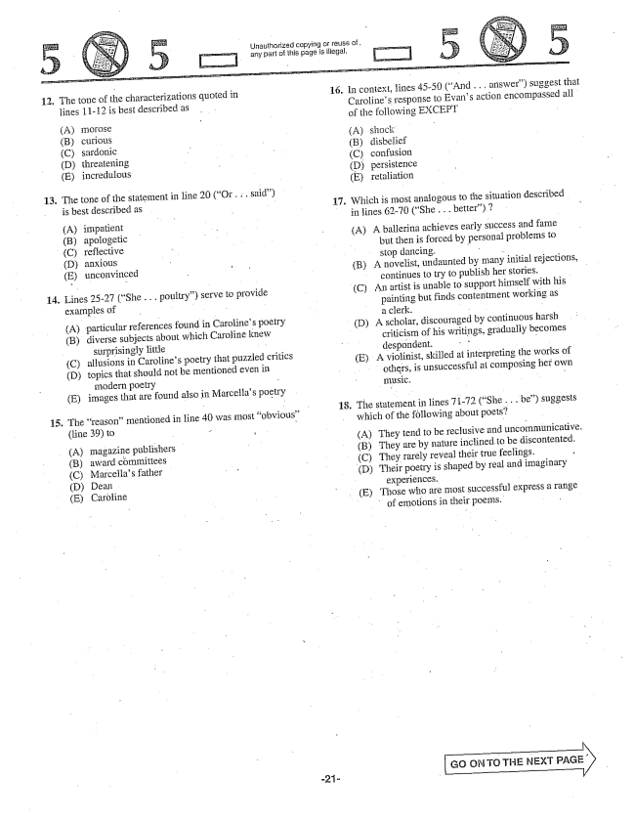

Unauthorized copying or reuse of . any part of this page is illegal.

12.

(C)

**14.**

15.

The tone of the characterizations quoted in lines 11-12 is best described as

() (B) (C) (D) (E)

curious sardonic threatening incredulous

The tone of the statement in line 20 (Or . . . said) - is best described as -

A) (B)

impatient apologetic Teflective anxious unconvinced

Lines 25-27 (She . . . poultry) serve to provide examples of - - - -

A) particular references found in Carolines poetry (B) diverse subjects about which Caroline knew surprisingly little (C) allusions in Carolines poetry that puzzled critics (D) topics that should not be mentioned even in

modern poetry - E) images that are found also in Marcellas poetry

The reason” mentioned in line 40 was most obvious”

(line 39) to

(A) magazine publishers (B) award cömmittees (C) Marcellas father (D) Dean (E) Caröline

**17.**

18.

In context, lines 45-50 (And . . . answer) suggest that Carolines response to Evans action encompassed all of the following EXCEPT

(A) (B) (C) (D) (E)

silock disbelief confusion persistence retaliation

Which is most analogous to the situation described in lines 62-70 (She . . . better) 7

(A) A ballerina achieves early success and fame but then is forced by personal problems to stop dancing. -

(B) A novelist, undaunted by many initial rejections,

continues to try to publish her stories. -

(C) An artist is unable to support himself with his

painting but finds contentinent working as a clerk.

(D) A scholar, discouraged by continuous harsh

criticism of his writings, gradually becomes despondent. -, (E) A violinist, skilled at interpreting the works of others, is unsuccessful at composing her own music. - -

The statement in lines 71-72 (She .. be) Suggests which of the following about poets? (A) They tend to be reclusive and uncommunicative,

B) They are by nature inclined to be discontented. (C) They rarely reveal their true feelings.

(D) Their poetry is shaped by real and imaginary

experiences.

(E) Those who are most successful express a range

of emotions in their poems.

Go ON TO THE NEXT

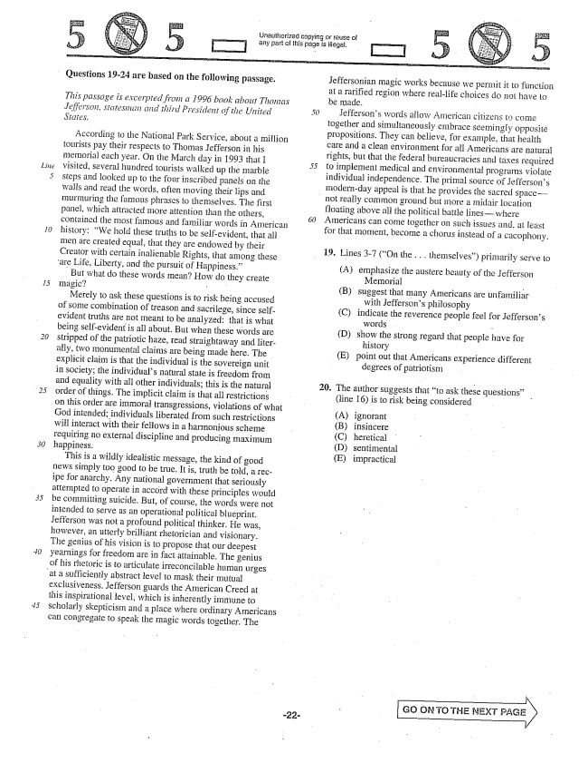

*Line*

..)

*30*

Unauthorized copying or reuse of any part of this page is illegal.

Questions 19-24 are based on the following passage.

*This passage is excerpted from a 1996 book about Thomas Jefferson, statesman aid third President of the United*

According to the National Park Service, about a million tourists pay their respects to Thomas Jefferson in his memorial each year. On the March day in 1993 that I visited, several hundred tourists walked up the marble steps and looked up to the four inscribed panels on the walls and read the words, often moving their lips and murmuring the famous phrases to themselves. The first panel, which attracted more attention than the others, contained the Inost famous and familiar words in American history: We hold these truths to be self-evident, that all. men are created equal, that they are endowed by their Creator with certain inalienable Rights, that among these

are Life, Liberty, and the pursuit of Happiness.”

But what do these words mean? How do they create magic-

Merely to ask these questions is to risk being accused of some combination of treason and sacrilege, since selfevident truths are not meant to be analyzed: that is what being self-evident is all about. But when these words are stripped of the patriotic haze, read straightaway and literally, two monumental claims are being made here. The explicit claim is that the individual is the sovereign unit in society; the individuals natural state is freedom from and equality with all other individuals; this is the natural order of things. The implicit claim is that all restrictions on this order are immoral transgressions, violations of what God intended; individuals liberated from such restrictions interact with their fellows in a harmonious scheme requiring no external discipline and producing maximum happiness. -

This is a wildly idealistic message, the kind of good news simply too good to be true. It is, truth be told, a recipe for anarchy. Any national government that seriously attempted to operate in accord with these principles would be committing suicide. But, of course, the words were not intended to serve as an operational political blueprint. Jefferson was not a profound political thinker. He was, however, an utterly brilliant rhetorician and visionary. The genius of his vision is to propose that our deepest yearnings for freedom are in fact attainable. The genius of his rhetoric is to articulate irreconcilable human urges

at a sufficiently abstract level to mask their mutual

exclusiveness. Jefferson guards the American Creed at this inspirational level, which is inherently immune to Scholarly skepticism and a place where ordinary Americans can congregate to speak the magic words together. The

5

Jeffersonian magic works because we permit it to function at a rarified region where reallife choices do not have to be Iliade.

Jeffersons words allow American citizeńs to come together and simultaneously embrace seemingly opposite propositions. They can believe, for example, that healtli care and a clean environment for all Americans are natural rights, but that the federal bureaucracies and taxes required to implement medical and environmental programs violate individual independence. The primal source of Jeffersons modernday appeal is that he provides the sacred space

not really common ground but more a midair location

floating above all the political battle lineswhere Americans can come together on such issues and, at feast for that Inoment, become a chorus instead of a cacophony.

19. Lines -7 (On the . . . themselves) primarily serve to

(A) emphasize the austere beauty of the Jefferson

Memorial - (B) suggest that many Americans are unfamiliar

with Jeffersons philosophy (C) indicate the reverence people feel for Jeffersons

words r (D) show the strong regard that people have for

history - - (E) point out that Americans experience different

degrees of patriotism

. The author suggests that to ask these questions” -

line 16) is to risk being considered

(A) ignorant (B) insincere (C) heretical (D) sentimental (E) impractical

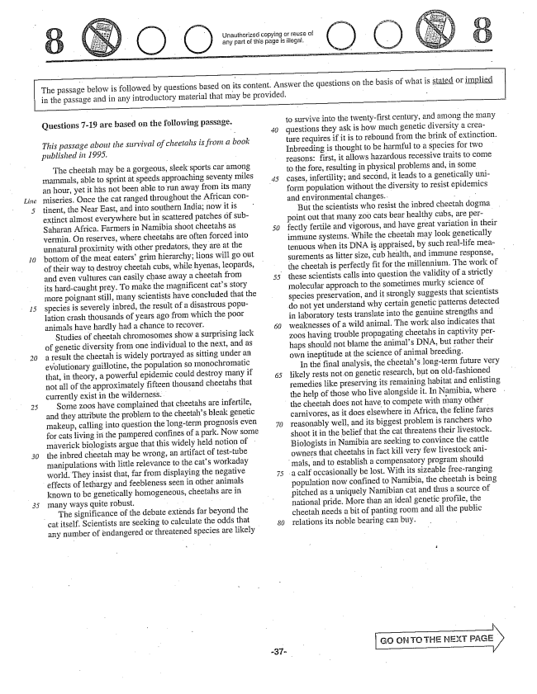

Unauthorized copying or reuse of any part of this page is illegal.

The passage below is followed by questions based on its content. Answer the questions on the basis of what is stated or implied in the passage and in any introductory material that may be provided, -

5

Questions -19 are based on the following passage.

*This passage about the survival of cheetahs is from a book published in 1995.*

The cheetah may be a gorgeous, sleek sports car among mammals, able to sprint at speeds approaching Seventy miles an hour, yet it has not been able to run away from its many miseries. Once the cat ranged throughout the African contiment, the Near East, and into southern India; now it is extinct almost everywhere but in scattered patches of subSaharan Africa, Farmers in Namibia shoot cheetahs as Vermin. On reserves, where cheetahs are often forced into unnatural proximity with other predators, they are at the bottom of the meat eaters' grim hierarchy; lions will go out of their way to destroy cheetah cubs, while hyenas, leopards, and even vultures can easily chase away a cheetah from its hard-caught prey. To make the magnificent cats story more poignant still, many scientists have concluded that the species is severely inbred, the result of a disastrous population crash thousands of years ago from which the poor animals have hardly had a chance to recover.

Studies of cheetah chromosomes show a surprising Jack of genetic diversity from one individual to the next, and as a result the cheetah is widely portrayed as sitting under an evolutionary guillotine, the population so monochromatic that, in theory, a powerful epidemic could destroy many if not all of the approximately fifteen thousand cheetahs that currently exist in the wilderness. -

Some zoos have complained that cheetahs are infertile, and they attribute the problem to the cheetahs bleak genetic makeup, calling into question the long-term prognosis even for cats living in the pampered confines of a park. Now some maverick biologists argue that this widely held notion of the inbred cheetah may be wrong, an artifact of testtube manipulations with little relevance to the cats workaday world. They insist that, far from displaying the negative effects of lethargy and feebleness seen in other animals known to be genetically homogeneous, cheetahs are in many ways quite robust.

The significance of the debate extends far beyond the

cat itself. Scientists are seeking to calculate the odds that

any number of endangered or threatened species are likely

*50*

*30*

to survive into the twenty-first century, and among the inany questions they ask is how much genetic diversity a creature requires if it is to rebound from the brink of extinction. Inbreeding is thought to be harmful to a species for two reasons: first, it allows hazardous recessive traits to come to the fore, resulting in physical problems and, in some cases, infertility; and second, it leads to a genetically uniform population without the diversity to resist epidemics and environmental changes. - -

But the scientists who resist the inbred cheetah dogma . point out that many zoo cats bear healthy cubs, are perfectly fertile and vigorous, and have great variation in their immune systems. While the cheetah may look genetically tenuous when its DNA is appraised, by such reallife measurements as litter size, cub health, and immune response, the cheetah is perfectly fit for the millennium. The work of these scientists calls into question the validity of a strictly molecular approach to the sometimes murky Science of species preservation, and it strongly suggests that Scientists

do not yet understand why certain genetic patterns detected

in laboratory tests translate into the genuine strengths and weaknesses of a wild animal. The work also indicates that zoos having trouble propagating cheetahs in captivity perhaps should not blame the animals DNA, but rather their own ineptitude at the science of animal breeding.

In the final analysis, the cheetahs long-term future very likely rests not on genetic research, but on old-fashioned remedies like preserving its reinaining habitat and enlisting the help of those who live alongside it. In Namibia, where

the cheetah does not have to compete with many other

carnivores, as it does elsewhere in Africa, the feline fares reasonably well, and its biggest problem is ranchers who shoot it in the belief that the cat threatens their livestock. Biologists in Namibia are seeking to convince the cattle owners that cheetahs in fact kill very few livestock ani

mais, and to establish a compensatory program should a calf occasionally be lost. With its sizeable free-ranging

population now confined to Namibia, the cheetah is being

pitched as a uniquely Namibian cat and thus a source of

national pride. More than an ideal genetic profile, the cheetah needs a bit of panting room and all the public relations its noble bearing can buy.

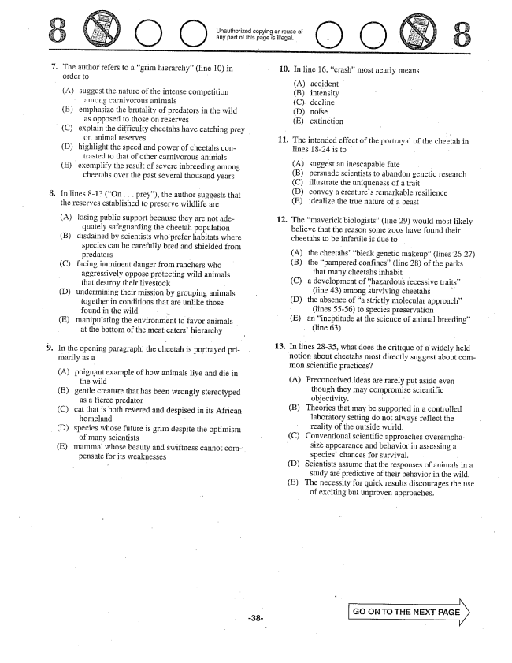

Unauthorized copying or reuse of any part of this page is illegal.

7.

(D)

The author refers to a grim hierarchy” (line ) in order to

(A) suggest the nature of the intense competition

anlong carnivorous animals emphasize the brutality of predators in the wild

as opposed to those on reserves explain the difficulty cheetahs have catching prey

on animal reserves highlight the speed and power of cheetahs con

trasted to that of other carnivorous animals exemplify the result of severe inbreeding among cheetahs over the past several thousand years

(B)

(C)

(D)

(E)

In lines -13 (On . . . prey), the author suggests that the reserves established to preserve wildlife are

(A) losing public support because they are not ade

quately safeguarding the cheetah population (B) disdained by scientists who prefer habitats where species can be carefully bred and shielded from predators - (C) facing imminent danger from ranchers who

aggressively oppose protecting wild animalso that destroy their livestock - (D) undermining their mission by grouping animals

together in conditions that are unlike those found in the wild - (E) manipulating the environment to favor animals

at the bottom of the meat eaters' hierarchy

In the opening paragraph, the cheetah is portrayed primarily as a -

A) poignant example of how animals live and die in

the wild gentle creature that has been wrongly stereotyped

as a fierce predator cat that is both revered and despised in its African

homeland - species whose future is grim despite the optimism

of many scientists

(B)

(C)

(E)

pensate for its weaknesses

mammal whose beauty and Swiftness cannot com

10. In line 16, crash” most nearly means

**11**

**13**

accident intensity decline noise extinction

The intended effect of the portrayal of the cheetah in lines 824 is to - -

A) (B) (C) (D) (E)

suggest an inescapable fate - persuade scientists to abandon genetic research illustrate the uniqueness of a trait convey a creatures remarkable resilience idealize the true nature of a beast

. The maverick biologists” (line 29) would most likely

believe that the reason some zoos have found their cheetahs to be infertile is due to

(A) (B)

the cheetahsbleak genetic makeup(lines 26-27)

the pampered confines(line 28) of the parks

that many cheetahs inhabit

a development of hazardous recessive traits”

(line 43) among surviving Cheetahs

the absence of a strictly molecular approach

(lines 55-56) species preservation -

an ineptitude at the science of animal breeding”

(line 63)

In lines 2835, what does the critique of a widely held notion about cheetahs most directly suggest about common scientific practices?

(A) Preconceived ideas are rarely put aside even

though they may compromise scientific objectivity. -

(B) Theories that may be supported in a controlled

laboratory setting do not always reflect the reality of the outside world.

(C) Conventional scientific approaches overempha

size appearance and behavior in assessing a species' chances for survival. - (D) Scientists assume that the responses of animals in a

study are predictive of their behavior in the wild. (E) The necessity for quick results discourages the use

of exciting but unproven approaches.

GO ON TO THE NEXT PAGE

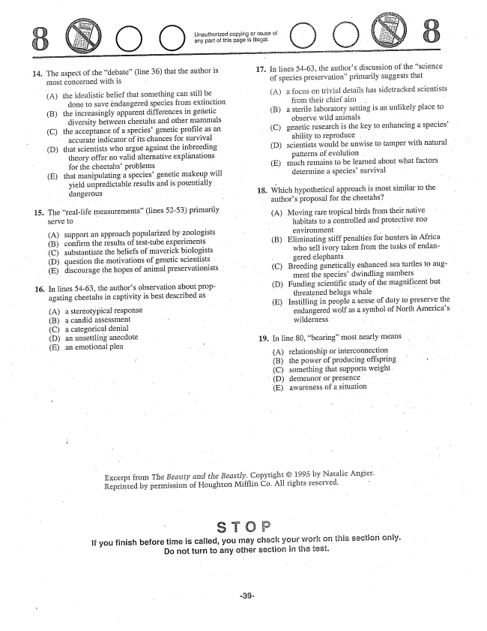

Unauthorized copying or reuse of any part of this page is illegal,

17. Ín lines 54-63, the authors discussion of the science

14. The aspect of the debate” (line 36) that the author is

- of species preservationprimarily suggests that

most concerned with is

Athe idealistic belief that something can still be

done to save endangered species from extinction

(B) the increasingly apparent differences in genetic

diversity between cheetahs and other mammals

(C) the acceptance of a species' genetic profile as an

accurate indicator of its chances for Survival

(D) that scientists who argue against the inbreeding theory offer no valid alternative explanations for the cheetahs problems - -

(E) that manipulating a species' genetic makeup will

yield unpredictable results and is potentially - - dangerous .. " 18. Which hypothetical approach is most similar to the

- - authors proposal for the cheetahs? . .

(A) a focus on trivial details has sidetracked scientists

from their chief aim . - (B) a sterile laboratory setting is an unlikely place to

observe wild animals - (C) genetic research is the key to enhancing a species'

ability to reproduce . . . . (D) scientists would be unwise to tamper with natural

patterns of evolution . - (E) much remains to be learned about what factors determine a species' survival -

15. The reallife measurements” (lines 52-53) primarily

SEITVE C (A) Moving rare tropical birds from their native

- - - habitats to a controlled and protective zoo (A) support an approach popularized by zoologists - - environment -

(B) confirm the results of testtube experiments (C) substantiate the beliefs of maverick biologists (D) question the motivations of genetic scientists

(B) Eliminating stiff penalties for hunters in Africa who sell ivory taken from the tusks of endangered elephants - -

(C) Breeding genetically enhanced sea turtles to aug

ment the speciesdwindling numbers

(D) Funding scientific study of the magnificent but

threatened beluga whale

(E) Instilling in people a sense of duty to preserve the endangered wolf as a symbol of North Americas

(E) discourage the hopes of animal preservationists

In lines 5463, the authors observation about propagating cheetahs in captivity is best described as

**16**

(A) a stereotypical response

(B) a candid assessment - | Wil - C) a categorical denial wilderness (D) an unsettling anecdote 19. In line 80, bearing” most nearly means

- A) relationship or interconnection

(B) the power of producing offspring :

(C) something that supports weight (D) demeanor or presence -

E) awareness of a situation

Excerpt from The Beauty and the Beastly. Copyright © 1995 by Natalie Reprinted by permission of Houghton Mifflin Co. All rights reserved. -

If you finish before time is called, you may check your Work on this section only. Do not turn to any other section in the test.

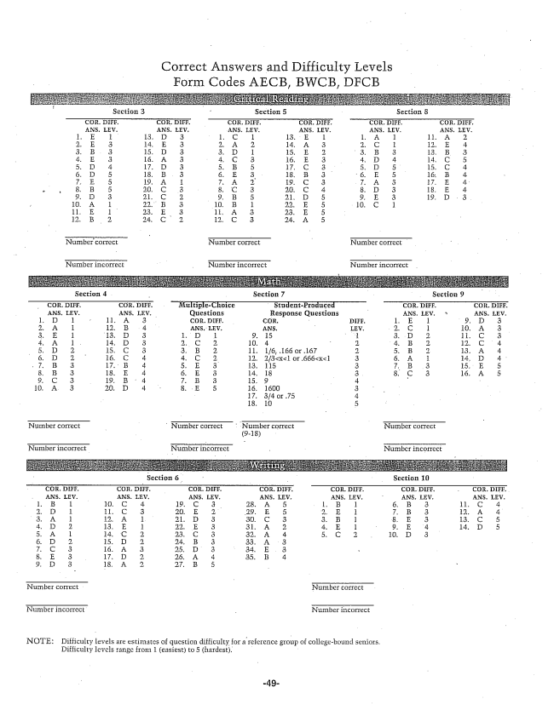

Correct Answers and Difficulty Levels Form Codes AECB, BWCB, DFCB

Nicorreci: Number correct

Number incorrect Number incorrect

NOTE: Difficulty levels are estimates of question difficulty for a reference group of collegebound seniors.

Difficulty levels range from 1 (easiest) to 5 (hardest.