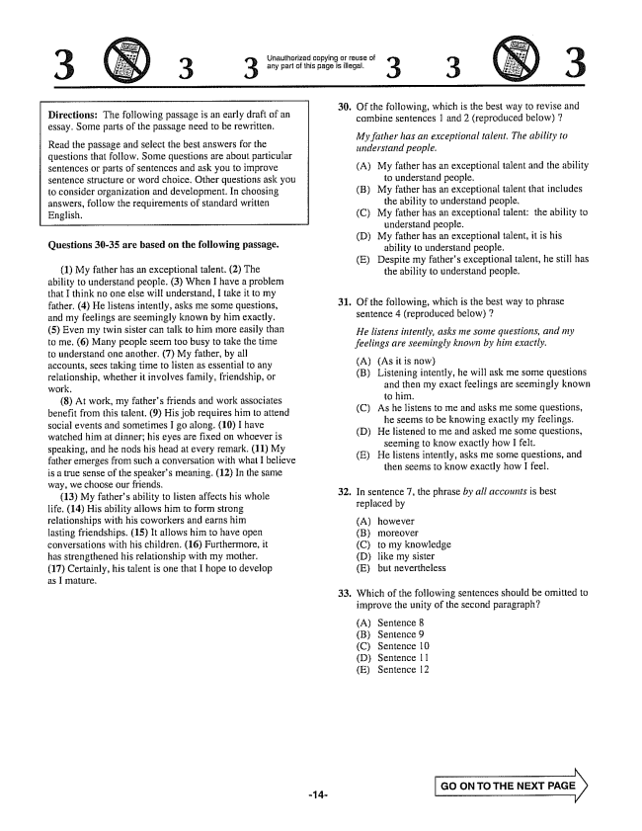

3 (S) 3 3

Unauthorized copying or reuse of any part of this page is illegal.

3

Directions: The following passage is an early draft of an essay. Some parts of the passage need to be rewritten.

Read the passage and select the best answers for the questions that follow. Some questions are about particular Sentences or parts of sentences and ask you to improve sentence structure or word choice. Other questions ask you to consider organization and development. In choosing answers, follow the requirements of standard written English,

**Questions 30-35 are based on the following passage.**

(1) My father has an exceptional talent, 2) The ability to understand people. (3) When I have a problem that I think no one else will understand, I take it to my father. (4) He listens intently, asks me some questions, and my feelings are seemingly known by him exactly. (5) Even my twin sister can talk to him more easily than to me. (6) Many people seem too busy to take the time to understand one another. (7) My father, by all accounts, sees taking time to listen as essential to any relationship, whether it involves family, friendship, or work,

8) At work, my fathers friends and work associates benefit from this talent. (9) His job requires him to attend social events and sometimes I go along. (10) I have watched him at dinnerhis eyes are fixed on whoever is Speaking, and he nods his head at every remark. (11) My father emerges from such a conversation with what I believe is a true Sense of the speakers meaning. (12) In the same way, we choose our friends.

(13) My fathers ability to listen affects his whole life. (14) His ability allows him to form strong relationships with his coworkers and earns him lasting friendships, 15) It allows him to have open conversations with his children. (16) Furthermore, it has strengthened his relationship with my mother. (17) Certainly, his talent is one that I hope to develop as I mature.

30. Of the following, which is the best way to revise and combine sentences 1 and 2 (reproduced below) 7

*My father has an exceptional talent. The ability to understand people.*

(A) My father has an exceptional talent and the ability

to understand people, B) My father has an exceptional talent that includes

the ability to understand people, C) My father has an exceptional talent; the ability to

understand people. (D) My father has an exceptional talent, it is his

ability to understand people. (E) Despite my fathers exceptional talent, he still has

the ability to understand people.

31. Of the following, which is the best way to phrase

sentence 4 (reproduced below) 7

*He listens intently, asks me some questions, and my feelings are seemingly known by hint exactly.*

(A) (As it is now) (B) Listening intently, he will ask me some questions

and then my exact feelings are seemingly known to him. (C) As he listens to me and asks me some questions,

he seems to be knowing exactly my feelings. (D) He listened to me and asked me some questions,

seeming to know exactly how I felt. (E) He listens intently, asks me some questions, and

then seems to know exactly how I feel.

32. In sentence , the phrase by all accounts is best

replaced by

(A) however (B) moreover (C) to my knowledge (D) like my sister (E) but nevertheless

33. Which of the following sentences should be omitted to

improve the unity of the second paragraph?

(A) Sentence 8 (B) Sentence 9 (C) Sentence 10 (D) Sentence 11 (E) Sentence 12

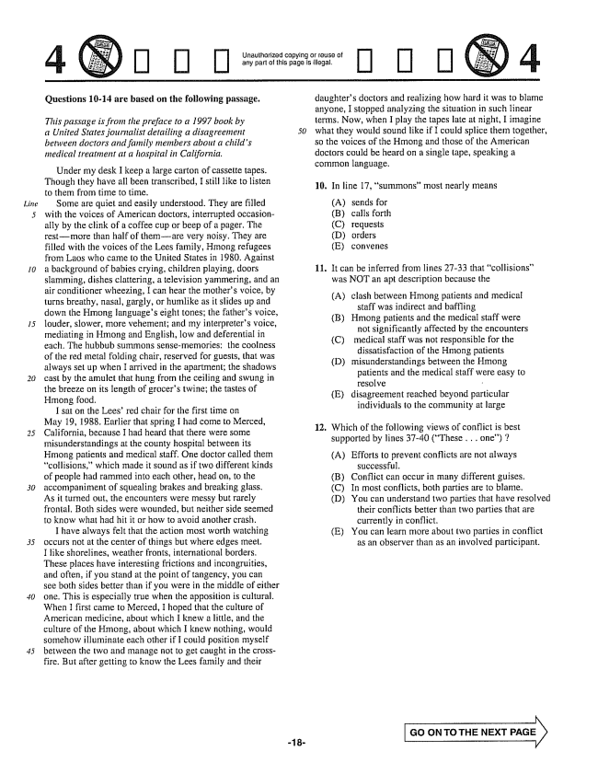

*Line*

**Questions 10-14 are based on the following passage.**

*This passage is from the preface to a 1997 book by a United States journalist detailing a disagreement between doctors and family members about a childs medical treatment at a hospital in California.*

*50*

Under my desk I keep a large carton of cassette tapes. Though they have all been transcribed, I still like to listen to them from time to time.

Some are quiet and easily understood. They are filled with the voices of American doctors, interrupted occasionally by the clink of a coffee cup or beep of a pager. The restmore than half of themare very noisy, They are filled with the voices of the Lees family, Hinong refugees from Laos who came to the United States in 1980. Against a background of babies crying, children playing, doors slamming, dishes clattering, a television yammering, and an air conditioner wheezing, I can hear the mothers voice, by turns breathy, nasal, gargly, or humlike as it slides up and down the Hmong languages eight tones; the fathers voice, louder, slower, more vehement; and my interpreters voice, mediating in Hmong and English, low and deferential in each. The hubbub summons sensememories: the coolness of the red metal folding chair, reserved for guests, that was always set up when I arrived in the apartment; the shadows cast by the amulet that hung from the ceiling and swung in the breeze on its length of grocers twine; the tastes of Hmong food.

I sat on the Lees’ red chair for the first time on May 19, 1988. Earlier that spring I had come to Merced, California, because I had heard that there were some misunderstandings at the county hospital between its Hmong patients and medical staff. One doctor called them collisions,which made it sound as if two different kinds of people had rammed into each other, head on, to the accompaniment of squealing brakes and breaking glass, As it turned out, the encounters were messy but rarely frontal. Both sides were wounded, but neither side seemed to know what had hit it or how to avoid another crash,

I have always felt that the action most worth watching occurs not at the center of things but where edges meet. I like shorelines, weather fronts, international borders. These places have interesting frictions and incongruities, and often, if you stand at the point of tangency, you can see both sides better than if you were in the middle of either dne. This is especiaily true when the apposition is cultural, When I first came to Merced, I hoped that the culture of American medicine, about which I knew a little, and the culture of the Hmong, about which I knew nothing, would somehow illuminate each other if I could position myself between the two and manage not to get caught in the crossfire. But after getting to know the Lees family and their

Unauthorized copying or reuse of any part of this page is illegal.

п п п08) 4

daughters doctors and realizing how hard it was to blame anyone, I stopped analyzing the situation in such linear terms. Now, when I play the tapes late at night, I imagine what they would sound like if I could splice them together, so the voices of the Hmong and those of the American doctors could be heard on a single tape, speaking a common language.

10. In line 17, summons” most nearly means

(A) (B) (C) (D) (E)

It can be inferred from lines 27-33 that collisions” was NOT an apt description because the

11.

(A) clash between Hmong patients and medical

staff was indirect and baffling (B) Hmong patients and the medical staff were

not significantly affected by the encounters (C) medical staff was not responsible for the

dissatisfaction of the Hmong patients (D) misunderstandings between the Hmong

patients and the medical staff were easy to resolve - E) disagreement reached beyond particular

individuals to the community at large

12. Which of the following views of conflict is best

supported by lines 37-40 (These , , , one) ;

(A) Efforts to prevent conflicts are not always

successful. (B) Conflict can occur in many different guises. (C) In most conflicts, both parties are to blame. (D) You can understand two parties that have resolved

their conflicts better than two parties that are currently in conflict, E) You can learn more about two parties in conflict

as an observer than as an involved participant.

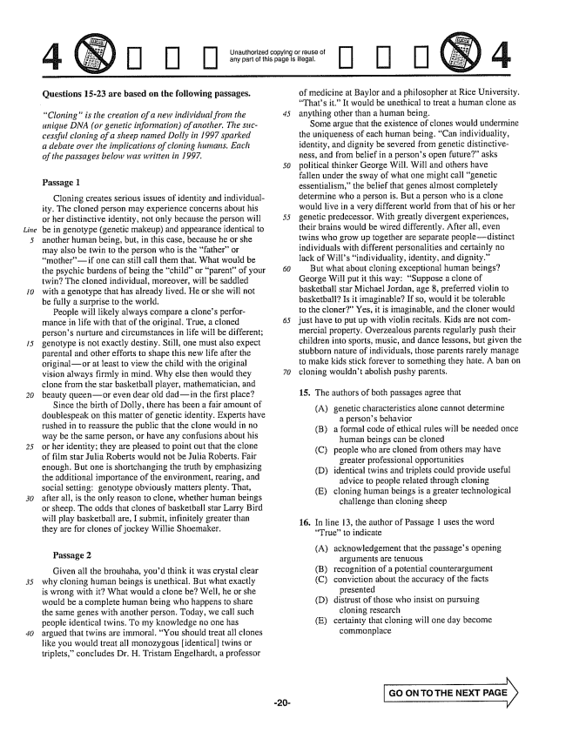

*Line*

*30*

**Questions 15-23 are based on the following passages.**

*Cloningis the creation of a new individual from the unique DNA (or genetic information) of another. The sticcessful cloning of a sheep named Dally in 1997 sparked a debate over the implications of cloning humans. Each of the passages below was written in 1997.*

Passage 1

Cloning creates serious issues of identity and individuality. The cloned person may experience concerns about his or her distinctive identity, not only because the person will be in genotype (genetic makeup) and appearance identical to another human being, but, in this case, because he or she may also be twin to the person who is the fatheror motherif one can still call them that. What would be the psychic burdens of being the childor parentof your twin? The cloned individual, moreover, will be saddled with a genotype that has already lived. He or she will not be fully a surprise to the world,

People will likely always compare a clones performance in life with that of the original, True, a cloned persons nurture and circumstances in life will be different; genotype is not exactly destiny. Still, one must also expect parental and other efforts to shape this new life after the originalor at least to view the child with the original vision always firmly in mind. Why else then would they clone from the star basketball player, mathematician, and beauty queenor even dear old dadin the first place?

Since the birth of Polly, there has been a fair amount of doublespeak on this matter of genetic identity, Experts have rushed in to reassure the public that the clone would in no way be the same person, or have any confusions about his or her identity; they are pleased to point out that the clone of film star Julia Roberts would not be Julia Roberts. Fair enough. But one is shortchanging the truth by emphasizing the additional importance of the environment, rearing, and social setting: genotype obviously matters plenty. That, after all, is the only reason to clone, whether human beings or sheep. The odds that clones of basketball star Larry Bird will play basketball are, I submit, infinitely greater than they are for clones of jockey Willie Shoemaker.

Passage 2

Given all the brouhaha, youd think it was crystal clear why cloning human beings is unethical. But what exactly is wrong with it? What would a clone beWell, he or she would be a complete human being who happens to share the same genes with another person. Today, we call such people identical twins. To my knowledge no one has argued that twins are immoral. You should treat all clones like you would treat all monozygous identicall twins or triplets,concludes Dr. H. Tristam Engelhardt, a professor

Unaulhorized copying or of any part of this page is illegal,

of medicine at Baylor and a philosopher at Rice University. Thats it” It would be unethical to treat a human clone as anything other than a human being.

Some argue that the existence of clones would undermine the uniqueness of each human being. Can individuality, identity, and dignity be severed from genetic distinctiveness, and from belief in a persons open future” asks political thinker George Will. Will and others have fallen under the sway of what one might call genetic essentialism,the belief that genes almost completely determine who a person is. But a person who is a clone would live in a very different world from that of his or her genetic predecessor. With greatly divergent experiences, their brains would be wired differently. After all, even twins who grow up together are separate people--distinct individuals with different personalities and certainly no lack of Wills individuality, identity, and dignity.”

But what about cloning exceptional human beings? George Will put it this way: Suppose a clone of basketball star Michael Jordan, age 8, preferred violin to basketball? Is it imaginable? If so, would it be tolerable to the cloner" Yes, it is imaginable, and the cloner would just have to put up with violin recitals. Kids are not cornmercial property. Overzealous parents regularly push their children into sports, music, and dance lessons, but given the stubborn nature of individuals, those parents rarely manage to make kids stick forever to something they hate. A ban on cloning wouldn't abolish pushy parents.

15. The authors of both passages agree that

(A) genetic characteristics alone cannot determine

a persons behavior (B) a formal code of ethical rules will be needed once

human beings can be cloned (C) people who are cloned from others may have

greater professional opportunities (D) identical twins and triplets could provide useful advice to people related through cloning (E) cloning human beings is a greater technological

challenge than cloning sheep

16. In line 13, the author of Passage 1 uses the word

Trueto indicate

(A) acknowledgement that the passages opening

arguments are tenuous

(B) recognition of a potential counterargument

(C) conviction about the accuracy of the facts

presented

(D) distrust of those who insist on pursuing

cioning research

(E) certainty that cloning will one day become

commonplace

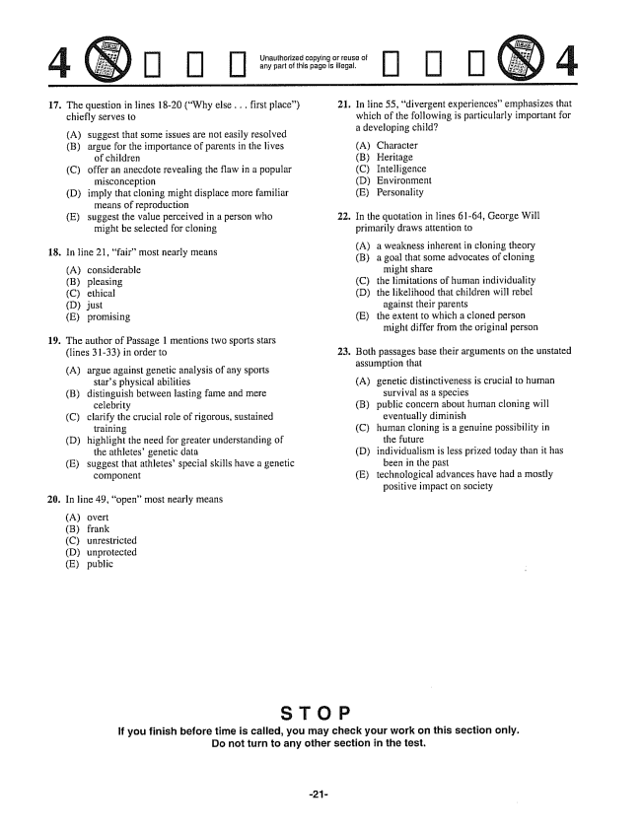

17. The question in lines 18-20 (Why else . . . first place)

**18.**

**19.**

**20.**

chiefly serves to

(A) suggest that some issues are not easily resolved (B) argue for the importance of parents in the lives

of children (C) offer an anecdote revealing the flaw in a popular

misconception (D) imply that cloning might displace more familiar

means of reproduction (E) suggest the value perceived in a person who

might be selected for cloning

In line 21, fairmost nearly means

(A) considerable (B) pleasing (C) ethical (D) just (E) promising

The author of Passage 1 mentions two sports stars (lines 3133) in order to

(A) argue against genetic analysis of any sports

stars physical abilities

(B) distinguish between lasting fame and mere

celebrity

(C) clarify the crucial role of rigorous, sustained

training

(D) highlight the need for greater understanding of

the athletesgenetic data

(E) suggest that athletes' special skills have a genetic

component

In line 49, open” most nearly means

(A) overt (B) frank (C) unrestricted (D) unprotected (E) public

Unauthorized copying or reuse of any part of this page is illegal.

**21.**

**22.**

23.

[] [] []

In line 55, divergent experiences” emphasizes that which of the following is particularly important for a developing child?

(A) Character (B) Heritage (C) Intelligence (D) Environment (E) Personality

In the quotation in lines 61-64, George Will primarily draws attention to

(A) a weakness inherent in cloning theory (B) a goal that some advocates of cloning

might share (C) the limitations of human individuality (D) the likelihood that children will rebel

against their parents (E) the extent to which a cloned person

might differ from the original person

Both passages base their arguments on the unstated assumption that

(A) genetic distinctiveness is crucial to human

survival as a species (B) public concern about human cloning will

eventually diminish (C) human cloning is a genuine possibility in

the future (D) individualism is less prized today than it has

been in the past (E) technological advances have had a mostly

positive impact on Society

**If you finish before time is called, you may check your work on this section only. Do not turn to any other section in the test,**

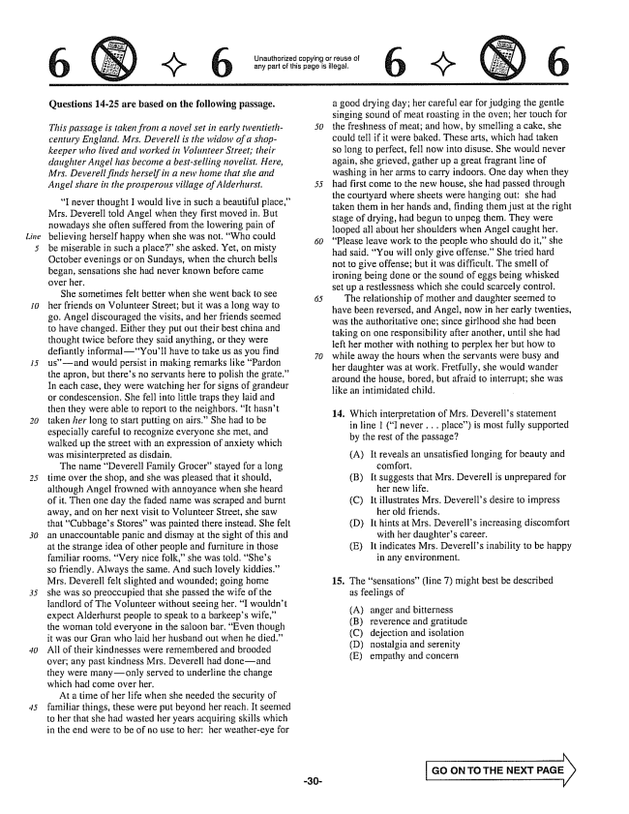

*15*

**Questions 14-25 are based on the following passage.**

*This passage is taken from a novel set in early twentieth- century England. Mrs. Deverell is the widow of a shopkeeper who lived and worked in Volunteer Street; their daughter Angel has become a bestselling novelist. Here, Mrs. Deverell finds herself in a new home that she and*

*Angel share in the prosperous village of Alderhurst. 55*

I never thought I would live in such a beautiful place,Mrs. Deverell told Angel when they first moved in. But nowadays she often suffered from the lowering pain of believing herself happy when she was not. Who could be miserable in such a place" she asked. Yet, on misty October evenings or on Sundays, when the church bells began, sensations she had never known before came over her.

She sometimes felt better when she went back to see her friends on Volunteer Street; but it was a long way to go. Angel discouraged the visits, and her friends seemed to have changed. Either they put out their best china and thought twice before they said anything, or they were defiantly informalYoull have to take us as you find usand would persist in making remarks like Pardon the apron, but theres no servants here to polish the grate." In each case, they were watching her for signs of grandeur or condescension. She fell into little traps they laid and then they were able to report to the neighbors. It hasn't taken her long to start putting on airs.” She had to be especially careful to recognize everyone she met, and walked up the street with an expression of anxiety which was misinterpreted as disdain,

The name Deverell Family Grocer” stayed for a long time over the shop, and she was pleased that it should, although Angel frowned with annoyance when she heard of it. Then one day the faded name was scraped and burnt away, and on her next visit to Volunteer Street, she saw that Cubbages Storeswas painted there instead. She felt an unaccountable panic and dismay at the sight of this and at the strange idea of other people and furniture in those familiar rooms. Very nice folk,she was told. Shes so friendly, Always the same. And such lovely kiddies.” Mrs. Deverell felt slighted and wounded; going home she was so preoccupied that she passed the wife of the landlord of The Volunteer without seeing her. I wouldnt expect Alderhurst people to speak to a barkeeps wife,the woman told everyone in the saloon bar. Even though it was our Gran who laid her husband out when he died.” All of their kindnesses were remembered and brooded overany past kindness Mrs. Deverell had doneand they were manyonly served to underline the change which had come over her,

At a time of her life when she needed the security of familiar things, these were put beyond her reach. It seemed to her that she had wasted her years acquiring skills which in the end were to be of no use to her; her weathereye for

Unauthorized copying or réUSB of any part of this page is illegal.

a good drying day; her careful ear for judging the gentle singing sound of meat roasting in the oven; her touch for the freshness of meat; and how, by smelling a cake, she could tell if it were baked. These arts, which had taken so long to perfect, fell now into disuse. She would never again, she grieved, gather up a great fragrant line of washing in her arms to carry indoors. One day when they had first come to the new house, she had passed through the courtyard where sheets were hanging out: she had taken them in her hands and, finding them just at the right stage of drying, had begun to unpeg them. They were looped all about her shoulders when Angel caught her, Please leave work to the people who should do it,she had said, You will only give offense.” She tried hard not to give offense; but it was difficult. The smell of ironing being done or the sound of eggs being whisked set up a restlessness which she could scarcely control.

The relationship of mother and daughter seemed to have been reversed, and Angel, now in her early twenties, was the authoritative one; since girlhood she had been taking on one responsibility after another, until she had left her mother with nothing to perplex her but how to while away the hours when the servants were busy and her daughter was at work, Fretfully, she would wander around the house, bored, but afraid to interrupt; she was like an intimidated child.

14. Which interpretation of Mrs. Deverells statement

in line i (I never . . . place) is most fully supported by the rest of the passage?

(A) It reveals an unsatisfied longing for beauty and

comfort. (B) It suggests that Mrs. Deverell is unprepared for

her new life. (C) It illustrates Mrs. Deverells desire to impress

her old friends. (D) It hints at Mrs. Deverells increasing discomfort

with her daughters career. (E) It indicates Mrs. Deverells inability to be happy

in any environment,

15. The sensations” (line ) might best be described

as feelings of

(A) (B)

anger and bitterness reverence and gratitude (C) dejection and isolation (D) nostalgia and serenity (E) empathy and concern

**GO ON TO THE NEXT**

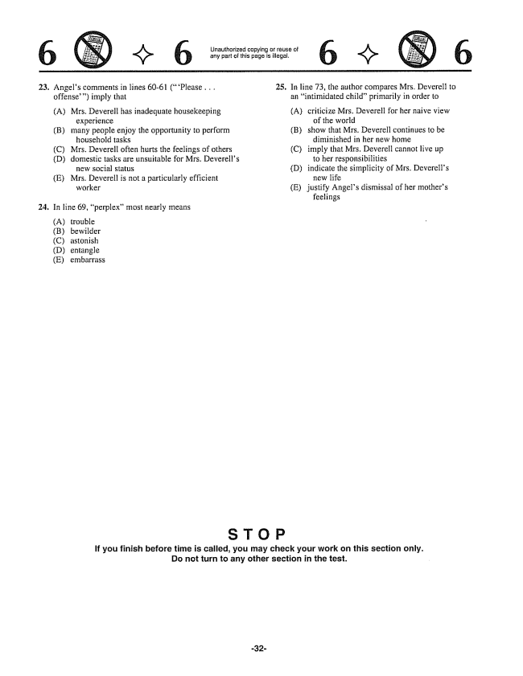

Unauthorized copying or reuse of any part of this page is illegal,

6 : (S) 6

**23.**

24,

Angels comments in lines 60-61 (Please . . . offense) imply that

(A) Mrs. Deverell has inadequate housekeeping

experience

(B) many people enjoy the opportunity to perform

household tasks

(C) Mrs. Deverell often hurts the feelings of others

(D) domestic tasks are unsuitable for Mrs. Deverells

new social status

(E) Mrs. Deverell is not a particularly efficient

worker

In line 69, perplex" most nearly means

(A) trouble (B) bewilder (C) astonish (D) entangle (E) embarrass

25. In line 73, the author compares Mrs. Deverell to

an intimidated childprimarily in order to

(A) criticize Mrs. Deverell for her naive view

of the world

(B) show that Mrs. Deverell continues to be

diminished in her new home

(C) imply that Mrs. Deverell cannot live up

to her responsibilities

(D) indicate the simplicity of Mrs. Deverells

new life

(E) justify Angels dismissal of her mothers

feelings

**If you finish before time is called, you may check your work on this section only. Do not turn to any other section in the test.**

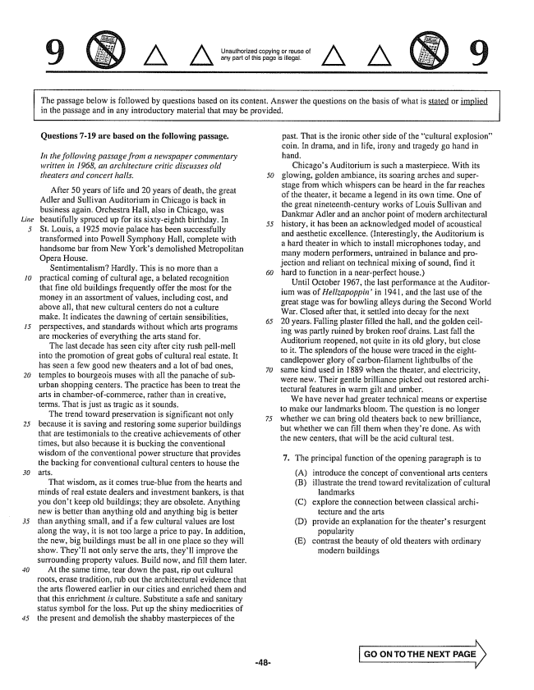

Unauthorized copying or reuse of any part of this page is illegal.

The passage below is followed by questions based on its content. Answer the questions on the basis of what is stated or implied in the passage and in any introductory material that may be provided.

*Line*

*15*

*20*

*30*

**Questions -19 are based on the following passage.**

*In the following passage from a newspaper commentary written in 1968, an architecture critic discusses old theatery and concert halls.*

After 50 years of life and 20 years of death, the great Adler and Sullivan Auditorium in Chicago is back in business again. Orchestra Hall, also in Chicago, was beautifully spruced up for its sixty-eighth birthday. In St. Louis, a 1925 movie palace has been successfully transformed into Powell Symphony Hall, complete with handsome bar from New Yorks demolished Metropolitan Орега Ноuse.

Sentimentalism? Hardly. This is no more than a practical coming of cultural age, a belated recognition that fine old buildings frequently offer the most for the money in an assortment of values, including cost, and above all, that new cultural centers do not a culture make. It indicates the dawning of certain sensibilities, perspectives, and standards without which arts programs are mockeries of everything the arts stand for.

The last decade has seen city after city rush pell-mell into the promotion of great gobs of cultural real estate. It has seen a few good new theaters and a lot of bad ones, temples to bourgeois muses with all the panache of suburban shopping centers. The practice has been to treat the arts in chamberof-commerce, rather than in creative, terms. That is just as tragic as it sounds.

The trend toward preservation is significant not only because it is saving and restoring some superior buildings that are testimonials to the creative achievements of other times, but also because it is bucking the conventional wisdom of the conventional power structure that provides the backing for conventional cultural centers to house the

That wisdom, as it comes trueblue from the hearts and minds of real estate dealers and investment bankers, is that you don't keep old buildings; they are obsolete. Anything new is better than anything old and anything big is better than anything small, and if a few cultural values are lost along the way, it is not too large a price to pay. In addition, the new, big buildings must be all in one place so they will show. Theyll not only serve the arts, theyll improve the surrounding property values. Build now, and fill them later, At the same time, tear down the past, rip out cultural roots, erase tradition, rub out the architectural evidence that the arts flowered earlier in our cities and enriched them and that this enrichment is culture. Substitute a safe and sanitary status symbol for the loss, Put up the shiny mediocrities of the present and demolish the shabby masterpieces of the

past. That is the ironic other side of the cultural explosion" coin. In drama, and in life, irony and tragedy go hand in hand.

Chicagos Auditorium is such a masterpiece. With its glowing, golden ambiance, its soaring arches and superstage from which whispers can be heard in the far reaches of the theater, it became a legend in its own time. One of the great nineteenth-century works of Louis Sullivan and Dankmar Adler and an anchor point of modern architectural history, it has been an acknowledged model of acoustical and aesthetic excellence. (Interestingly, the Auditorium is a hard theater in which to install microphones today, and many modern performers, untrained in balance and projection and reliant on technical mixing of sound, find it hard to function in a near-perfect house.)

Until October 1967, the last performance at the Auditorium was of Hellzapoppinin 1941, and the last use of the great stage was for bowling alleys during the Second World War. Closed after that, it settled into decay for the next 20 years, Falling plaster filled the hall, and the golden ceiling was partly ruined by broken roof drains, Last fall the Auditorium reopened, not quite in its old glory, but close to it. The splendors of the house were traced in the eightcandlepower glory of carbonfilament lightbulbs of the same kind used in 1889 when the theater, and electricity, were new. Their gentle brilliance picked out restored architectural features in warm gilt and umber.

We have never had greater technical means or expertise to make our landmarks bloom. The question is no longer whether we can bring old theaters back to new brilliance, but whether we can fill them when theyre done. As with the new centers, that will be the acid cultural test.

7. The principal function of the opening paragraph is to

(A) (B)

(C)

(D)

introduce the concept of conventional arts centers

illustrate the trend toward revitalization of cultural

landmarks

explore the connection between classical archi

tecture and the arts

provide an explanation for the theaters resurgent

popularity

contrast the beauty of old theaters with ordinary

modern buildings

(E)

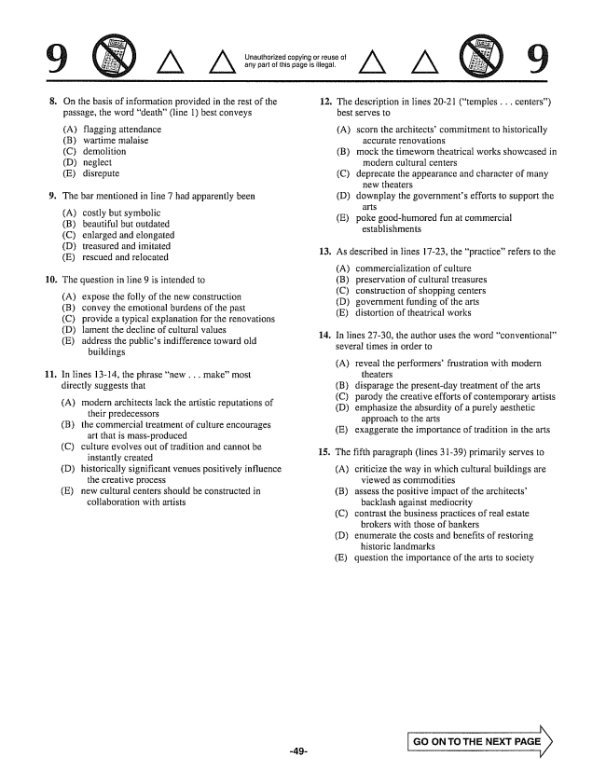

Unauthorized copying or reuse of any part of this page is illegal,

. On the basis of information provided in the rest of the

**11**

passage, the word death(line 1) best conveys

(A) flagging attendance (B) wartime malaise (C) demolition (D) neglect (E) disrepute

The bar mentioned in line 7 had apparently been

(A) costly but symbolic (B) beautiful but outdated (C) enlarged and elongated (D) treasured and imitated (E) rescued and relocated

The question in line 9 is intended to

(A) expose the folly of the new construction

(B) convey the emotional burdens of the past

(C) provide a typical explanation for the renovations

(D) lament the decline of cultural values

(E) address the publics indifference toward old

buildings

In lines 13-14, the phrase new . . . make” most directly suggests that

(A) modern architects lack the artistic reputations of

their predecessors (B) the commercial treatment of culture encourages

art that is mass-produced (C) culture evolves out of tradition and cannot be

instantly created (D) historically significant venues positively influence

the creative process (E) new cultural centers should be constructed in

collaboration with artists

12. The description in lines 20-21 (temples . . . centers)

**14.**

best serves to

(A) scorn the architects' commitment to historically

accurate renovations

(B) mock the timeworn theatrical works showcased in

modern cultural centers

(C) deprecate the appearance and character of many

new theaters

(D) downplay the governments efforts to support the

arts

(E) poke good-humored fun at commercial

establishments

As described in lines 1723, the practice” refers to the

(A) (B) (C) (D) (E)

commercialization of culture preservation of cultural treasures construction of shopping centers government funding of the arts distortion of theatrical works

In lines 2730, the author uses the word conventional” several times in order to

(A) reveal the performers' frustration with modern

theaters (B) disparage the presentday treatment of the arts (C) parody the creative efforts of contemporary artists (D) emphasize the absurdity of a purely aesthetic

approach to the arts (E) exaggerate the importance of tradition in the arts

The fifth paragraph (lines 3139) primarily serves to

(A) criticize the way in which cultural buildings are

viewed as commodities (B) assess the positive impact of the architects’

backlash against mediocrity (C) contrast the business practices of real estate

brokers with those of bankers (D) enumerate the costs and benefits of restoring

historic landmarks (E) question the importance of the arts to society

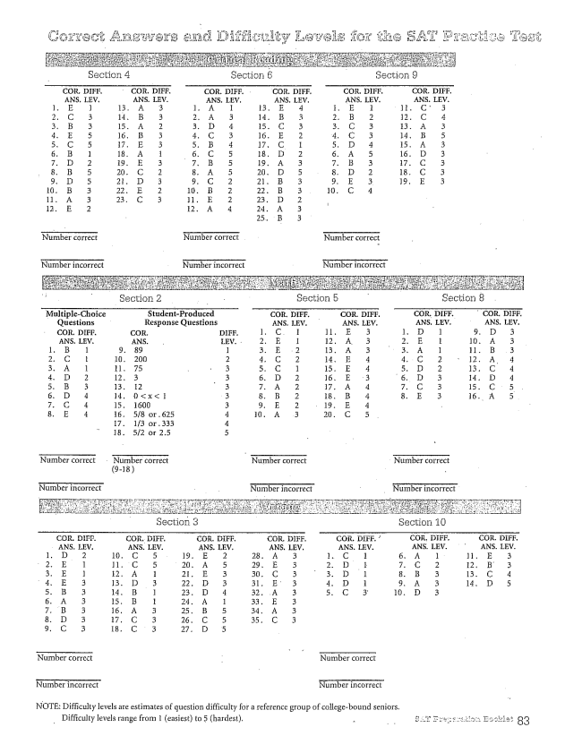

Number correct Number correct

Number incorrect Number incorrect

NOTE: Difficulty levels are estimates of question difficulty for a reference group of collegebound seniors.

Difficulty levels range from 1 (easiest) to 5 (hardest). -