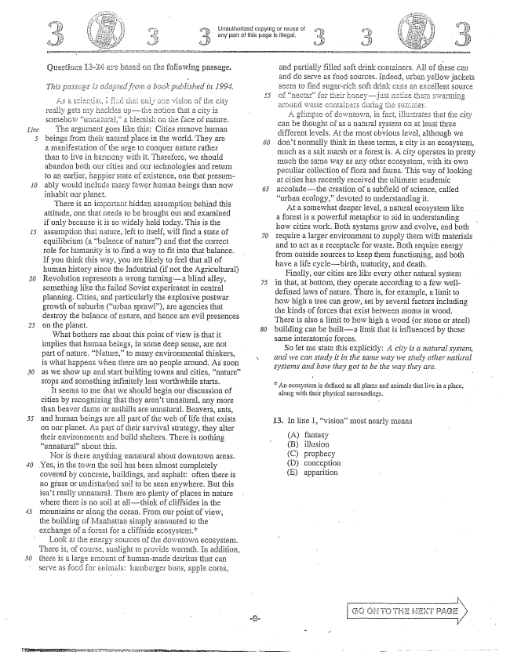

A .

*30*

Urlauthorized copying or Gi any part of this page is illegal,

*a book published in 1994.*

És a ,

y my hackles upti - somehow unnatural,a biotish Oil the fice of nature, The argument goes like this: Cities remove human beings from their natural place in the world. They are a manifestation of the urge to conquer nature rather than to live in harinofly witin it. Therefore, we shouldi abandon both our cities and Our technologies and return to an earlier, State of existence, one that presurnably would ificlude many fewer human beings than now inhabit our planët. -

There is an importarit hicideIi assumption behind this attitude, one that needs to be brought out and examined if only because it is so widely held today. This is the assumption that nature, left to itself, will find a state of equilibrium (a balance of nature) and that the correct role for humanity is to find a way to fit into that balance. If you think this way, you are likely to feel that all of human history since the Industrial (if not the Agricultural) Revolution represents a wrong turninga blind alley, something like the failed Soviet experiment in central planning. Cities, and particularly the explosive postwar growth of Suburbs (urban sprawl), are agencies that destroy the balance of nature, and Hence are evil presences GII thë planet. -

What bothers me about this point of view is that it implies that human beings, in Some deep sense, are not part of nature. Nature,to many environmental thinkers, is what happens WiléII there are no people around. As soon as we show up and start building towns and cities, nature” stops and something infinitely less worthwhile starts.

It seems to më that we should begin our discussion of cities by recognizing that they arent unnatural, any more than beaver dams or anthills are unnatural. Beavers, ants, and human beings are ail part of the web of life that exists on our planet. As part of their survival Strategy, they alter their environments and build shelters. There is nothing unmaturalabout this.

Nor is there anything unnatural about downtown areas. Yes, in the town the soif has been almost completely covered by concrète, buildings, and asphalt: often there is no grass or undisturbed soii to be seen anywhere. But this isn't really unnatural. There are plenty of places in nature where there is no soil at allthink of cliffsides in the mountains or aiong the ocean. From our point of view, the building of Manhattan simply amounted to the exchange a forest for a cliffside ecosystem.

Look at the energy sources of the downtown ecosystem. There is, of course, sunlight to provide warmth. In addition, there is a largă amount of humanmade detritus that can Serve as fogd för animals: hamburgër buns, apple cores,

and partially filled soft drink containers. All of these can and do Serve as food sources. Indeed, urban yellow jackets Seern to find sugarrich soft drink cans excellent source of nectarfor their honey-jast 1icth around waste containers during the .er.

A gli Ipse of downtown, in fact, illustrates that the city can be thought of as a natural . On at least three differentiewels. At the most obvious level, although we dont normally think in these terms, a city is an ecosystem, much as a salt marsh or a forest is. A city operates in pretty much the same way as any other ecosystem, with its own peculiar collection of flora and fauna. This way of looking at cities has recently received the ultimate academic accoladethe creation of a subfield of Science, called urban ecology,devoted to understanding it,

At a somewhat deeper level, a natural ecosystem like a forest is a powerful metaphor to aid in understanding How cities work. Both systems grow and evolve, and both require a larger environment to Supply them with materials and to act as a receptacle for waste. Both require energy from outside sources to keep them functioning, and both have a life cyclebirth, maturity, and death.

Finally, cuf cities likother natural systeııı in that, at bottom, they Operate according to a few welldefined laws of nature. There is, for example, a limit to how high a tree can grow, set by several factors including the kinds of forces that exist between atomis in wood, There is also a limit to how high a wood (or stone or steel) building can be builta limit that is influenced by those same interatomic forces.

*So let më statë this explicitly: A city is a natiiral systein, and we can study it in the same way we stildy other natitral systems and how they got to be the way they are.*

An ecosystem is defined as all plants and animals that live in a place,

along with their physical surroundings.

13. In line 1, vision” most nearly means

(A) fantasy (B) illusion (C) prophecy (D) conception (E) apparition

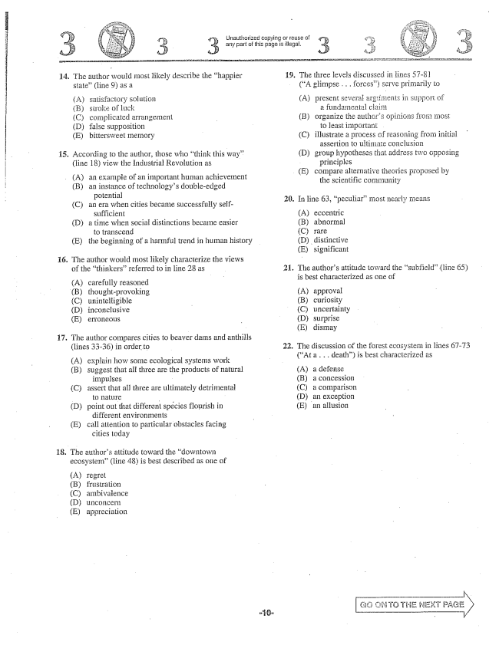

H , Unauthorized copying or réuse of 3. - 3. any part of this page is illegal. 3

14. The author would most likely describe the happier 19. The three levels discussed state(line ) as a (A glimpse . . . forcës) s

in fines 57-8 l erve primarily to

(A) satisfactory Solution (A) present several argtiments support of (B) stroke of luck a fundamental claim (C) complicated arrangement (B) organize the authors opinions from most (D) false supposition to least importani . (E) bittersweet memory (C) iHustrate a process of reasoning from initial

assertion to ultimate conclusion

H5. According to the author, those who think this way" (D) group hypotheses that address two opposing

(line 18) view the Industrial Revolution as principles

- - - E) compare alternative theories proposed by (A) an example of an important human achievement (E) par - proposed by

- the scientific community

(B) an instance of technologys doubleedged

potential - 20. In line 63, peculiar” most nearly means (Can era when cities became successfully self- -

sufficient - A) eccentric (D) a time when social distinctions became easier (B) abnormal

to transcend (C) rare (E) the beginning of a harmful trend in human history (D) distinctive

(E) significant

. The author would most likely characterize the views

of the thinkersreferred to in line 28 as 21, The authors attitude toward the subfield” (line 65)

is best characterized as one of

(A) carefully reasoned

(B) thought-provoking (A) approval (C) unintelligible - B) curiosity (D) inconclusive (C) uncertainty (E) erroneous - D) surprise

(E) dismay

7. The author compares cities to beaver dams and anthills

(lines 33-36) in order to

. The discussion of the forest ecosystem in lines 67-73

- - (At a . . . death) is best characterized as (A) explain how some ecological systems work

(B) suggest that all three are the products of natural (A) a defense

impulses - B) a concession (C) assert that all three are ultimately detrimental (C) a comparison - - - D) an exception (D) point out that different spécies flourish in (E) an allusion

different environments (E) call attention to particular obstacles facing

cities today

18. The authors attitude toward the downtown

ecosystem(line 48) is best described as one of

(A) regret (B) frustration (C) ambivalence (Dunconcern (E) appreciation

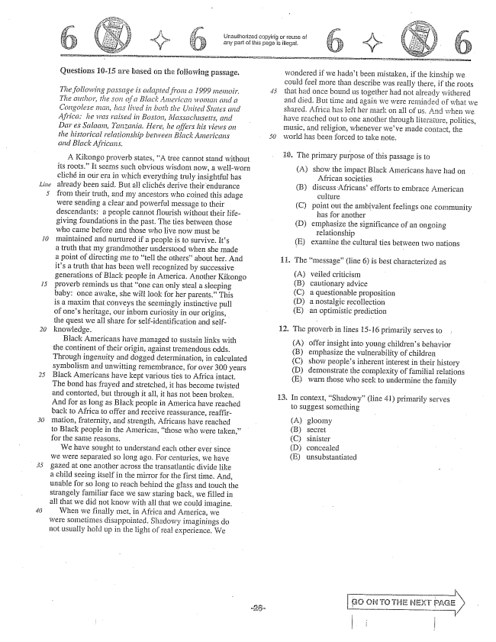

*15*

*30*

Questions 10-15 are based of the foliowing passage.

*The following passage is adapted from a 1999 mieinoir. The ailihor, the son of a Black Aliterican woman and a Congolese intin, has lived in both the United States and Africa: he was raised in Boston, Massachusetts, and Dar es Salaam, Tanzania. Here, he offers his vieis on the historical relationship between Black Americans and Black Africans.*

A Kikongo proverb states, A tree cannot stand without its roots.” It seems such obvious wisdom now, a well-worn cliché in our era in which everything truly insightful has already been said. But all clichés derive their endurance from their truth, and my ancestors who coined this adage were sending a clear and powerful message to their descendants: a people cannot flourish without their lifegiving foundations in the past. The ties between those who came before and those who live now must be maintained and nurtured if a people is to survive. its a truth that my grandmother understood when she inade a point of directing me to tell the othersabout her. And its a truth that has been well recognized by successive generations of Black people in America. Another Kikongo proverb reminds us that one can only steal a sleeping baby; once awake, she will look for her parents.” This is a maxim that conveys the Seemingly instinctive pull of ones heritage, our inborn curiosity in our origins, the quest we all share for Self-identification and selfknowledge. -

Black Americans have managed to sustain links with

the continent of their origin, against tremendous odds,

Through ingenuity and dogged determination, in calculated symbolism and unwitting remembrance, for over 300 years Black Americans have kept various ties to Africa intact, The bond has frayed and stretched, it has become twisted and contorted, but through it all, it has not been broken, And for as long as Black people in America have reached back to Africa to offer and receive reassurance, reaffirmation, fraternity, and strength, Africans have reached to Black people in the Americas, those who were taken, for the same reasons. - -

We have sought to understand each other ever since we were separated so long ago. For centuries, we have gazed at one another across the transatlantic divide like a child seeing itself in the mirror for the first time. And, unable for so long to reach behind the glass and touch the strangely familiar face we saw staring back, we filled in all that we did not know with all that we could imagine. When we finally met, in Africa and America, we were Sometimes disappointed. Shadowy imaginings do not usually hold up in the light of real experience. We

Unauthorized copying or reuse of any part of this page is illegal.

wondered ifwe hadn't beeri mistaken, ifthe kinship we could feel more than describe was really there, if the roots that had once bound us together had not already withered and died. But time and again we were reminded of what we shared. Africa has left her mark on all of us. And when we

have reached out to one another through literature, politics,

Imusic, and religion, whenever weve inade contact, the world has been forced to take note.

G. The primary purpose of this passage is to

(A) show the impact Black Americans have had on

African Societies (B) discuss Africans' efforts to embrace American

culturë (C) point out the ambivalent feelings one community

has for another (D) emphasize the significance of an ongoing

relationship (E) examine the cultural ties between two nations

. The message” (line ) is best characterized as

(A) veiled criticism (B) cautionary advice (C) a questionable proposition (D) a nostalgic recollection (E) an optimistic prediction

. The proverb in lines 15-16 primarily serves to

(A) offer insight into young childrens behavior (B) emphasize the vulnerability of children (C) show peoples inherent interest in their history (D) demonstrate the complexity of familial relations (E) warn those who seek to undermine the family

. In context, Shadowy” (line 41) primarily serves

to Suggest something

(A) (B) (C) (D) (E)

gloomy

SECTEt

sinister concealed unsubstantiated

| i

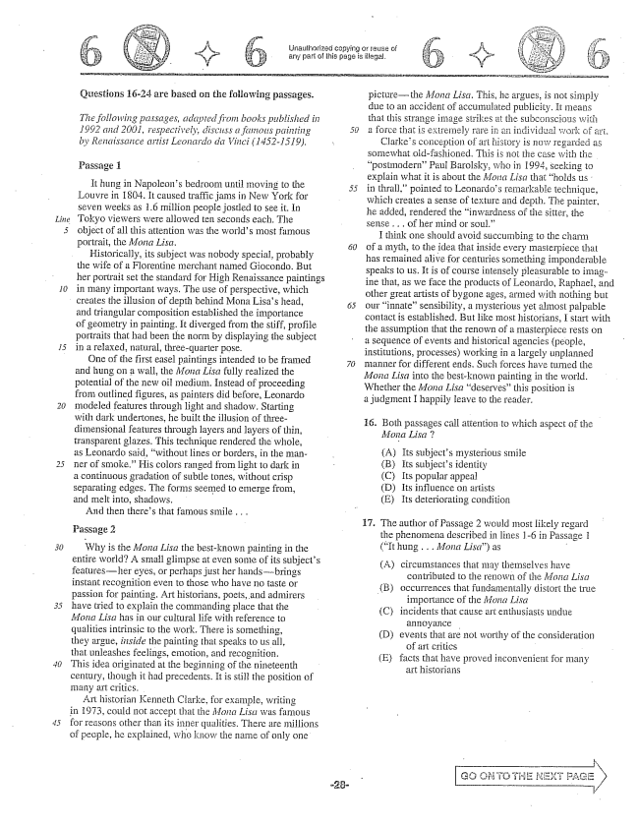

*Line*

*15*

*20*

Çuestions 16-24 are based on the following passages.

*The following passages, adapted front books published in 1992 and 2001, respectively, discuss a famous painting by Reiiciissance artisi Leonarda da Vinci ( 1452-1519).*

Passage 1

It hung in Napoleons bedroom until moving to the Louvre in 1804. It caused traffic jams in New York for seven weeks as 1.6 million people jostled to see it. In Tokyo viewers were allowed ten seconds each. The object of all this attention was the worlds most farmous portrait, the Mona Lisa.

Historically, its subject was nobody Special, probably the wife of a Floremtime merchant rhamed Giocondo. But her portrait set the standard for High Renaissance paintings in many important ways. The use of perspective, which creates the illusion of depth behind Mona Lisas head, and triangular composition established the importance of geometry in painting. It diverged from the stiff, profile portraits that had been the norm by displaying the subject in a relaxed, natural, three-quarter pose.

One of the first easel paintings intended to be framed and hung on a wall, the Mona Lisa fully realized the potential of the new oil medium. Instead of proceeding from outlined figures, as painters did before, Leonardo modeled features through light and shadow. Starting with dark undertories, he built the illusion of threedimensional features through layers and layers of thin, transparent glazes. This technique rendered the whole, as Leonardo said, without lines or borders, in the manner of smoke.” His colors ranged from light to dark in a continuous gradation of subtle tones, without crisp separating edges. The forms seemed to emerge from, and Inêlt into, shadows.

And then theres that famous smile . . .

Passage 2

Why is the Mona Lisa the bestknown painting in the entire world? A small glimpse at even some of its subjects featuresher eyes, or perhaps just her handsbrings instant recognition even to those who have no taste or passioil for painting, Art historians, poets, and admirers have tried to explain the commanding place that the Mona Lisa has in our cultural life with reference to qualities intrinsic to the work. There is something, they argue, inside the painting that speaks to us all, that unleashes feelings, emotion, and recognition. This idea originated at the beginning of the nineteenth century, though it had precedents. Itis stili ihe position of many art critics.

Art historian Kenneth Clarke, for example, writing in 1973, could not accept that the Adona Lisct was fannous for reasons other than its inner qualities. There are millions of people, he explained, who know the name of only one

Unaulhorized copying or reuse of any part of this page is illegal.

picturethe Mona Lisa. This, he , is mot simply due to an accident of accumulated publicity. It means that this Strange image strikes at the Subconscious with a force that is extremely rare an individual work of ari.

Clarkes conception of art history is now regarded as somewhat oldfashioned. This is not the case with the postmodernPaul Barolsky, who in 1994, seeking to explain what it is about the Mona Lisa that holds us in thrall,pointed to Leonardos remarkable technique, which creates a sense of texture and depth. The painter, added, Tendered the inwardness of the sitter, the Sense . . . of her mind or soul.”

I think One should avoid succumbing to the charm of a myth, to the idea that inside every masterpiece that has remained alive for centuries something imponderable Speaks to us. It is of course intensely pleasurable to imagine that, as we face the products of Leonardo, Raphael, and other great artists of bygone ages, armed with nothing but our innatesensibility, a rhysterious yet almost palpable contactis established. But Hike most historians, start with the assumption that the renown of a masterpiece rests on a sequence of events and historical agencies (people, institutions, processes) working in a largely unplanned manner for different ends. Such forces have turned the Mona Lisa into the bestknown painting in the world. Whether the Mona Lisa deservesthis position is a judgment I happily leave to the reader.

16. Both passages call attention to which aspect of the

*Mona Lisa ?*

(A) Its subjects mysterious smile (B) its subjects identity (CIts popular appeal (D) Its influence on artists (E) Its deteriorating condition

The author of Passage 2 would most likely regard the phenomena described in lines 1-6 in Passage 1 (It hung . . . Mona Lisa) as -

(A) circumstances that may themselves have

contributed to the rëngwn of the Matīti ListI

(B) occurrences that fundamentally distort the true

importance of the Moria Lisa

(C) incidents that cause art enthusiasts undue

annoyance -

(D) events that are not worthy of the consideration

of art critics -

E) facts that have proved inconvenient for many

art historians

N

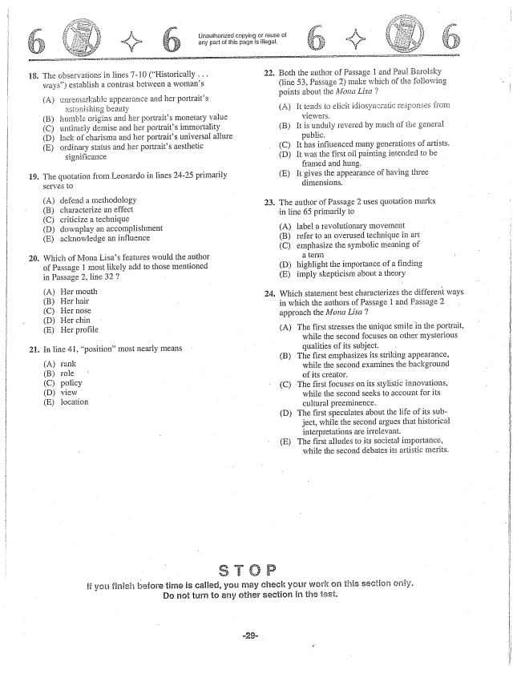

any part of lHis page is illegal.

18. The observations in lines -10 (Historically . . .

ways) establish a contrast between a womans

(A) unfernarkable appearance and her portraits

asionishing beauty

(B) humble origins and her portraits monetary value

(C) untimely demise and her portraits immortality

(D) lack of charisma and her portraits universal aliure

Eordinary status and her portraits aesthetic

significance

19. The quotation from Leonardo in lines 24-25 primarily

SETVEC)

(A) defend a methodology 23 (B) characterize an effect

(C) criticize a technique

(D) downplay an accomplishment

(E) acknowledge an influence

Which of Mona Lisas features wouid the author of Passage 1 most likely add to those mentioned in Passage 2, line 32

(A) Her mouth 24 (B) Her hair

C) Her nose

(D) Her chin

EHer profile

21. In line , position” most nearly means

(A) rank (B) role (C) policy (D) view (E) location

Unauthorized copying of reuse of

. Both the author of Passage í and Paul Barolsky

(line 53, Passage 2) make which of the following points about the Mona Lisa 2.

AIt tends to elicit idiosyncratic responses from

viewers.

(B) It is unduly revered by much of the general

public.

(C) It has influênced many generations of artists,

D) It was the first oil painting intended to be

framed and hung.

(E) It gives the appearance of having three

dimensions.

. The author of Passage 2 uses quotation marks

in line 65 primarily to

(A) label a revolutionary movement - B) refer to an overused technique in art (C) emphasize the symbolic meaning of

(D) highlight the importance of a finding (E) imply skepticism about a theory

. Which statement best characterizes the different ways

in which the authors of Passage 1 and Passage 2 approach the Mona Lisa

(A) The first stresses the unique smile in the portrait,

while the second focuses on other mysterious qualities of its subject. - (B) The first emphasizes its striking appearance, while the second examines the background of its creator. - (C) The first focuses on its stylistic innovations,

while the second seeks to account for its cultural preeminence. (D) The first speculates about the life of its sub

ject, while the second argues that historical interpretations are irrelevant. (E) The first alludes to its societal importance,

while the second debates its artistic merits.

if yoi finish before time is całied, you may check your on this sacticsi only. Do not turn to any other section in the iesi.

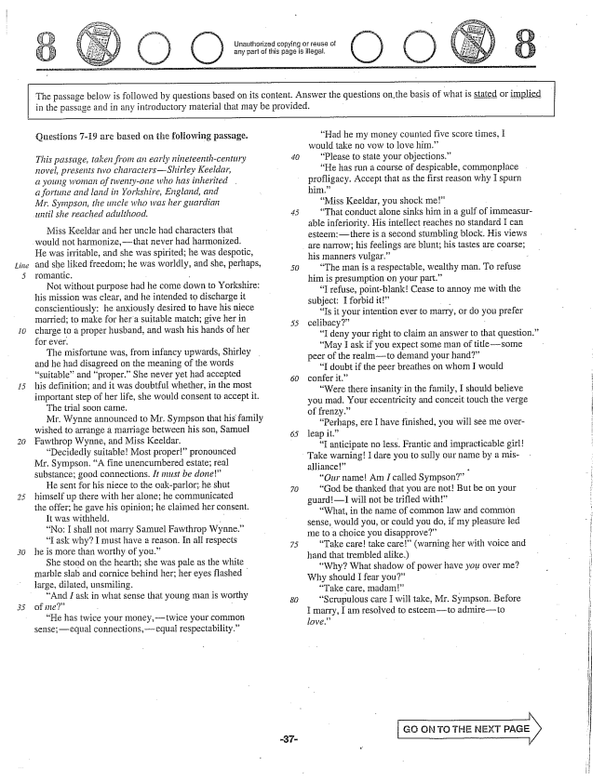

Unauthorized copying or reuse of any part of this page is illegal.

The passage below is followed by questions based on its content. Answer the questions on,the basis of what is stated or implied

in the passage and in any introductory material that may be provided,

*30*

Çttestions -19 are based on the foliowing passage.

*This passage, taken from an early nineteenth-century novel, presents two charactersShirley Keeldar, a young Wonian of twenty-one who has inherited a fortune and land in Yorkshire, England, and Mr. Sympson, the uncle who was her guardian until she reached adulthood.*

Miss Keeldar and her uncle had characters that

would not harmonize,-that never had harmonized.

He was irritable, and she was spirited; he was despotic, and she liked freedom; he was worldly, and she, perhaps, romantic. -

Not without purpose had he come down to Yorkshire: his mission was clear, and he intended to discharge it conscientiously: he anxiously desired to have his niece married; to make for her a suitable match; give her in charge to a proper husband, and wash his hands of her for ever.

The misfortune was, from infancy upwards, Shirley and he had disagreed on the meaning of the words suitableand proper.” She never yet had accepted his definition; and it was doubtful whether, in the most important step of her life, she would consent to accept it.

The trial soon came. Mr. Wynne announced to Mr. Sympson that his family wished to arrange a marriage between his son, Samuel Fawthrop Wynne, and Miss Keeldar.

Decidedly suitableMost proper” pronounced Mr. Sympson, A fine unencumbered estate; real substance; good connections. It must be done”

He sent for his niece to the oakparlor; he shut himself up there with her alone; he communicated the offerhe gave his opinion; he claimed her consent.

It was withheld. No: I shall not marry Samuel Fawthrop Wynne.” “I ask why? I must have a reason. In all respects he is more than worthy of you.”

She stood on the hearth; she was pale as the white marble slab and cornice behind her; her eyes flashed large, dilated, unsmiling.

And I ask in what sense that young man is worthy of ine” .

He has twice your money, twice your common Senseequal connections,equal respectability.”

*50*

*SO*

Had he my money counted five score times, I would take no vow to love him.”

“Please to state your objections.” “He has run a course of despicable, commonplace profligacy. Accept that as the first reason why I spurn him.”

“Miss Keeldar, you shock me” “That conduct alone sinks him in a gulf of immeasurable inferiority. His intellect reaches no standard I can esteemthere is a second stumbling block. His views are narrow; his feelings are blunt; his tastes are coarse; his Inanners vulgar.” -

The man is a respectable, wealthy man. To refuse him is presumption on your part.”

“I refuse, pointblankCease to annoy me with the subject: I forbid it” \* -

Is it your intention ever to marry, or do you prefer celibacy” -

I deny your right to claim an answer to that question.May I ask if you expect some man of title--some peer of the realmto demand your hand”

“I doubt if the peer breathes on whom I would confer it.”

“Were there insanity in the family, I should believe you mad. Your eccentricity and conceit touch the verge offrenzy.” -

Perhaps, ere I have finished, you will see me overleap it”

“I anticipate no less. Frantic and impracticable girl

Take warning! I dare you to Sully our name by a mis

alliance -

Our nameAm I called Sympson” “God be thanked that you are notBut be on your guardI will not be trifled with”

“What, in the name of common law and common sense, would you, or could you do, if my pleasure led me to a choice you disapprove”

“Take caretake care” (warning her with voice and hand that trembled alike.)

Why? What shadow of power have you over me? Why should I fear you”

“Take care, madam” - Scrupulous care I will take, Mr. Sympson. Before I marry, I am resolved to esteem-to admireto love.” -

GG ON TO THE NEXT PAGE

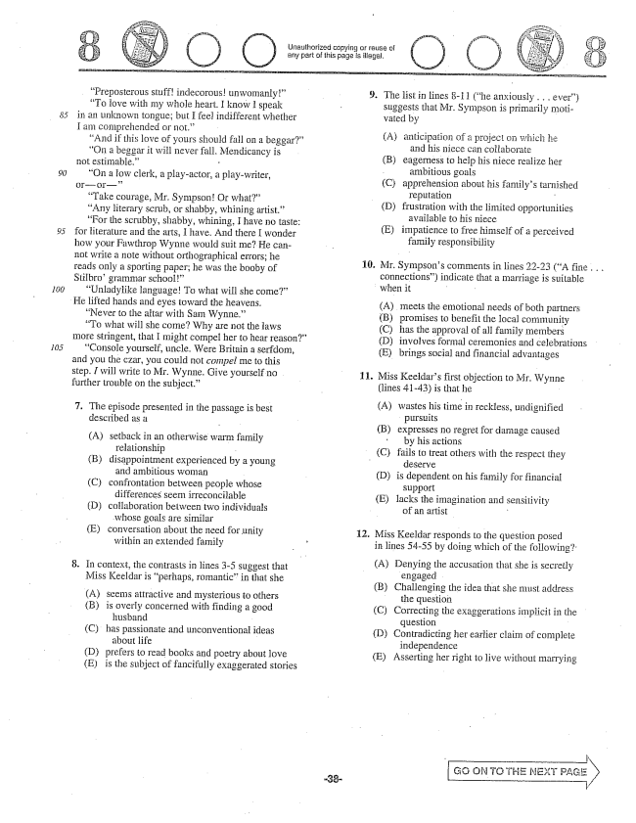

Preposterous stuffindecorousunwomanly” “To love with my whole heart. I know I speak in an unknown tongue; but I feel indifferent whether I am comprehended or not.”

“And if this love of yours should fall om a beggar” “On a beggar it will never fall. Mendicancy is not estimable.” -

On a low clerk, a play-actor, a play-writer, Oror

“Take courage, Mr. SympsonOr what” “Any literary scrub, or shabby, whining artist.” “For the scrubby, shabby, whining, I have no taste: for literature and the arts, I have. And there I wonder how your Fawthrop Wynne would suit me? He cannot write a note without orthographicaerTors; he reads only a sporting paper; he was the booby of Stilbrogrammar school”

“Unladylike languageTo what will she come”

He lifted hands and eyes toward the heavens.

Never to the aitar with Sam Wynne.”

“To what will she come? Why are not the laws more stringent, that I might compel her to hear reason”

“Console yourself, uncle. Were Britain a serfdom, and you the czar, you could not compel me to this step. I will write to Mr. Wynne. Give yourself no further trouble on the subject.”

. The episode presented in the passage is best

described as a

(A) setback in an otherwise warm family relationship - (B) disappointment experienced by a young

and ambitious woman (C) confrontation between people whose

differences seem irreconcilable (D) collaboration between two individuals

whose goals are similar (E) conversation about the need for unity

within an extended family

. In context, the contrasts in lines -5 suggest that

Miss Keeldar is perhaps, romanticin that she

(A) seems attractive and mysterious to others (B) is overly concerned with finding a good

husband - (C) has passionate and unconventional ideas

about life (D) prefers to read books and poetry about love (E) is the subject of fancifully exaggerated Stories

Unauthorized copying or reuse of any part of this page is illegal.

O O

. The list in Hines -i 1 (he anxiously . . . ever)

suggests that Mr. Sympson is primarily motiwated by

(A) anticipation of a project on which he and his niece can collaborate (B) eagerness to help his niece realize her

ambitious goals (Capprehension about his familys tarnished reputation - (D) frustration with the limited opportunities

available to his niece (E) impatience to free himself of a perceived

family responsibility

10. Mr. Sympsons comments in lines 22-23 (A fine . . . connections) indicate that a marriage is suitable when it -

A) meets the emotional needs of both partners (B) promises to benefit the local community (C) has the approval of all family members (D) involves formal ceremonies and celebrations (E) brings social and financial advantages

11. Miss Keeldars first objection to Mr. Wynne

(lines 41-43) is that he

(A) wastes his time in reckless, undignified

pursuits

(B) expresses no regret for darnage caused

by his actions (C) fails to treat others with the respect they deserye

(D) is dependent on his family for financial

support

(E) lacks the imagination and sensitivity

of an artist -

. Miss Keeldar responds to the question posed

in lines 5455 by doing which of the following'

(A) Denying the accusation that she is Secretly

engaged (B) Challenging the idea that she must address

the question (C) Correcting the exaggerations implicit in the

question (D) Contradicting her earlier claim of complete

independence (E) Asserting her right to live without marrying

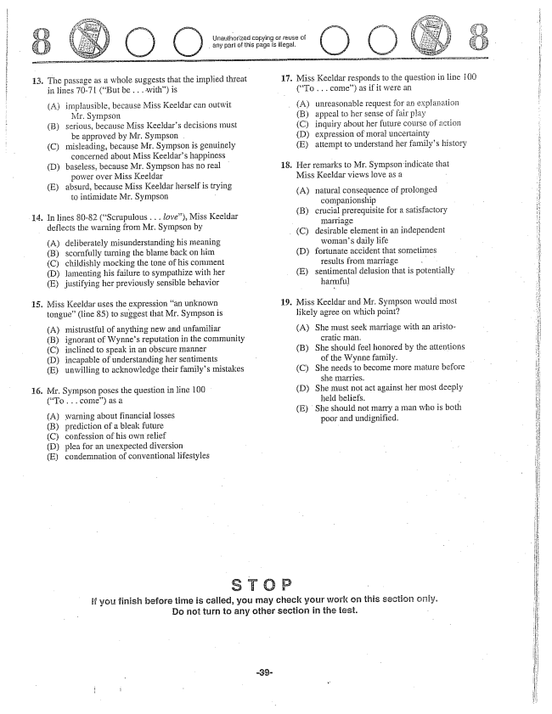

13. The passage as a whole suggests that the implied threat

14.

(A) implausible, because Miss Keeldar can outwit

Mr. Sympson (B) serious, because Miss Keeldars decisions must

be approved by Mr. Sympson . (C) misleading, because Mr. Sympson is genuinely

concerned about Miss Keeldars happiness (D) baseless, because Mr. Sympson has no real

power over Miss Keeldar (E) absurd, because Miss Keeldar herself is trying

to intimidate Mr. Sympson .

In lines 80-82 (Scrupulous .. love), Miss Keeldar deflects the warning from Mr. Sympson by

(A) deliberately misunderstanding his meaning (B) scornfully turning the blame back on him (C) childishly mocking the tone of his comment (D) lamenting his failure to sympathize with her (E) justifying her previously sensible behavior

. Miss Keeldar uses the expression an unknown

tongue" (line 85) to suggest that Mr. Sympson is

(A) mistrustful of anything new and unfamiliar (B) ignorant of Wynnes reputation in the community (C) inclined to speak in an obscure Inanner (D) incapable of understanding her sentiments (E) unwilling to acknowledge their familys mistakes

Mr. Sympson poses the question in line 100 (To . . . come) as a

(A) warning about financial losses (B) prediction of a bleak future (C) confession of his own relief (D) plea for an unexpected diversion (E) condemnation of conventional lifestyles

Urlauthorized copying or reuse of any part of this page is illegal,

O O ( )

17. Miss Keeldar responds to the question in line 100

(To . . . come) as if it were an

(A) unreasonable request for an explanation (B) appeal to her sense of fair play (C) inquiry about her future course of action (D) expression of moral uncertainty (E) attempt to understand her familys history

18. Her remarks to Mr. Sympsonindicate that

Miss Keeldar views love as a

A) natural consequence of prolonged

companionship -

(B) crucial prerequisite for a satisfactory

marriage

(C) desirable element in an independent

womans daily life

(D) fortunate accident that sometimes results from marriage

(E) sentimental defusion that is potentially

harmful

19. Miss Keeldar and Mr. Sympson would most

likely agree on which point

(A) She must seek marriage with an aristo

cratic man.

(B) She should feel honored by the attentions

of the Wynne family.

(C) She needs to become more mature before

she marries. (D) She must not act against her most deeply

held beliefs, (E) She should not marry a man who is both

poor and undignified.

if you finish before time is called, you may check your work on this section only. Do not turn to any other section in the test.

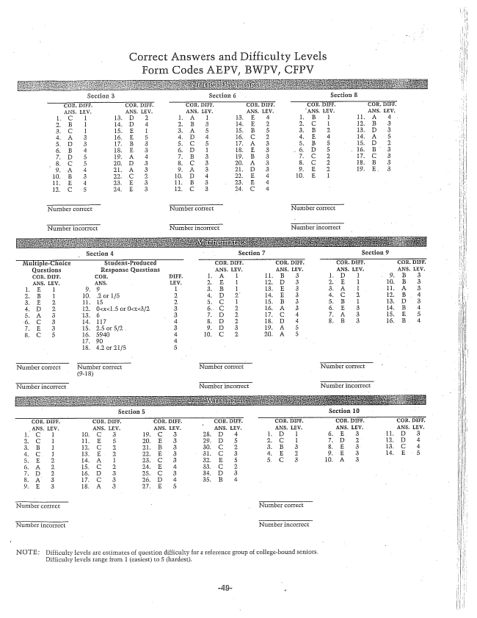

Correct Answers and Difficulty Levels

Section 3

Section 5 Section 10

NOTE: Difficulty levels are estimates of question difficulty for a reference group of collegebound seniors.

Eifficulty levels range from 1 (easiest) to 5 (hardest.