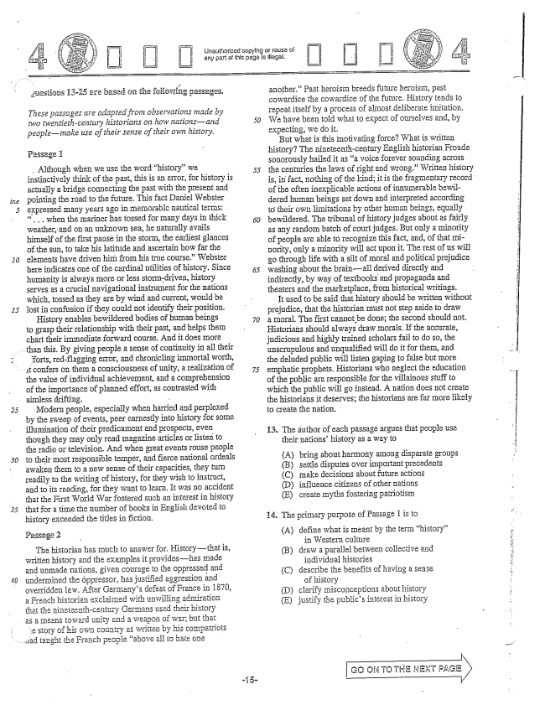

Juestions 13-35 are based on the following passages.

*These passages are adapted from observations made bi*

*- y two twentieth-centiury historians an how nationisand*

*peoplemake use of their sense of their own history.*

Passage 1

Although when we use the word history” we instinctively think of the past, this is an error, for history is actually a bridge connecting the past with the present and pointing the road to the future. This fact Daniel Webster expressed many years in memorable nautical terms: . . . when the Imariner has tossed for many days in thick weather, and On an unknown Sea, he naturally avails himself of the first pause in the Storm, the earliest glances of the sun, to take his latitude and ascertain how far the elements have driven him from his true course.” Webster here indicates one of the cardinal utilities of history. Since huDanity is always IHore or less Stormdriven, history Serves as a crucial navigational instrument for the nations which, tossed as they are by wind and current, would be lost in confusion if they could not identify their position,

History enables bewildered bodies of human beings

to grasp their relationship with their past, and helps them chart their immediate forward course. And it does more

than this. By giving people a sense of continuity in all their

forts, redflagging error, and chronicling immortal worth,

It confers on them a CGIISciousness of unity, a realization of

*30*

the value of individual achievement, and a comprehension of the importance of planned effort, as contrasted with aimless drifting. -

Modern people, especially when harried and perplexed by the sweep of events, peer earnestly into history for some illumination of their predicament and prospects, even though they Inay only read magazine articles Or listen to the radio of television. And when great events rouse people to their most Tesponsible temper, and fierce national ordeals awalen them to a new sense of their capacities, they turn readily to the writing of history, for they wish to instruct, and to its reading, for they want to learn. It was no accident that the First World War fostered such an interest in history that for a time the number of books in English dēvoted to history exceeded the titles in fiction.

Passage 2

The historiam has much to answer for. HistOrythatis, written history and the examples it provideshas made and unmade nations, given courage to the oppressed and undermined the Öppressor, has justified aggression and overridden law. After Germanys defeat of France in 1870, a French historian exclaimed with unwiiling admiration that the nineteenth-century Germans used their history as a toward unity and a weapon of warbut that

e story of his own country as written by his compatriots

..lad taught the French people above all to hate One

i

Linăuthorized copying Dr rause of any part of this page is Illegal.

*50*

口 口

another.” Past heroism breeds future heroism, past cowardice the cowardice of the future. History tends to repeat itself by a process of almost deliberate imitation. We have been told what to expect of ourselves and, by expecting, we do it. -

But what is this motivating force? What is written history? The nineteenth-century English historian Froude Sonorously hailed it as a voice forever Sounding across the centuries the laws of right and wrong.” Written history is, in fact, nDthing of the lind, it is the fragmentary record of the often inexplicable actions of innuInerable bewildered human beings set down and interpreted according to their own limitations by other human beings, equally bewildered. The tribunal of history judges about as fairly as any random batch of court judges. But only a minority Of people are able recognize this fact, and, of that minority, Only a minority will act upon it. The rest of us will go through Hife with a silt of moral and political prejudice washing about the brainall derived directly and indirectly, by way of textbooks and propaganda and theaters and the marketplace, from historical writings.

It used to be said that history should be written without prejudice, that the histOrian Imust not step aside to draw a moral. The first cannot be done; the second should not. Historians should always draw Imorals. Ifthe accurate, judicious and highly trained scholars fail to do so, the unscrupulous and unqualified will do it for them, and the deluded public will listen gaping to false but more emphatic prophets. Historians who neglect the education of the public are responsible for the villainous stuff to which the public will go instead. A nation does not create the historiansit deserves; the historians are far more likeiy to create the nation.

13. The āuthor of each passage argues that people use

their nationshistory as a way to

(A) (B) (C) (D) (E)

14. The primary purpose of Passage 1 is to

(A) define what is meant by the term history”

in Western culture (B) draw a parallel between collective and

individual histories (C) describe the benefits of having a sense

of history (D) clarify Imisconceptions about history (E) justify the publics interest in history

bring about harmony among disparate groups Settle disputes over important precedents Imake decisions about future actions influence citizens of other nations create myths fostering patriotism

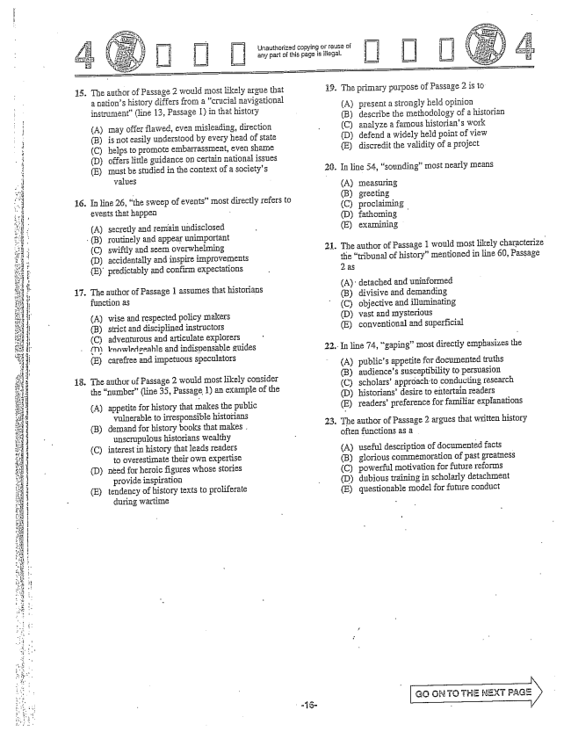

15. The author of Passage 2 would most likely argue that a nations history differs from a Crucial navigational instrument(line 13, Passage 1) in that history

(A) may offer flawed, even misleading, direction

(B) is Ilot easily understood by every head of state

(C) helps to promote embarrassment, even shame

(D) offers little guidance on certain national issues

(E) Inust be studied in the context of a societys

yalues

16. In line 26, the sweep of events” Inost directly refers to

events that happen

(A) secretly and remain undisclosed (B) routinely and appear unimportant (C) swiftly and seem overwhelming (D) accidentally and inspire improvements (E) predictably and confirm expectations

17. The author of Passage 1 assumes that historians

function as

(A) wise and respected policy makers (B) strict and disciplined instructors (C) adventurous and articulate explorers (T) knowledgeable and indispensable guides (E) carefree and impetuous speculators

13. The author of Passage 2 would most likely consider the number(line 35, Passage 1) an example of the

(A) appetite for history that Imakes the public

vulnerable to irresponsible historians

(B) demand for history books that makes.

unscrupulous historians wealthy

(C) interest in history that leads readers

to overestimate their own expertise

(D) need for heroic figures whose stories

provide inspiration

(E) tendency of history texts to proliferate

during wartime

Urlauthorized copying or reuse of any part of this page is illegal.

i. The primary purpose of Passage 2 is to

(A) present a strongly held opinion (B) describe the methodology of a historian (C) analyze a famous historians work (D) defend a widely held point of view (E) discredit the validity of a project

. In line 54, sounding” most nearly means

(A) measuring (B) greeting (C) proclaiming (D) fathoming (E) examining

. The author of Passage 1 would IIIost likely characterize

the tribunal of history” mentioned in line 60, Passage 2 as

(A) detached and uninformed (B) divisive and demanding (C) objective and illuminating (D) wast and Imysterious (E) conventional and superficial

In line 74, gaping” Imost directly emphasizes the

(A) publics appetite for documented truths (B) audiences susceptibility to persuasion (C) scholars' approach to conducing research (D) historians' desire to entertain readers (E) readers' preference for familiar explanations

The author of Passage 2 argues that written history often functions as a

(A) useful description of documented facts (B) glorious commemoration of past greatness (C) powerful motivation for future reforms (D) dubious training in scholarly detachment (E) questionable model for future conduct

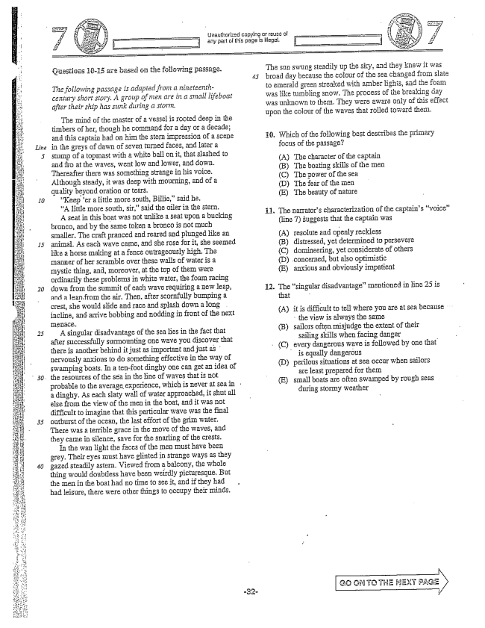

*Line*

*20*

ijestions 35 are based GH the foiewing passage.

*Gwing passage is adapted from a nineteenthThe following passage is adapted from a century short story. A group of Hien are in a small lifeboat after their ship has slink during a storm.*

The mind of the Inaster of a vessel is rooted deep in the timbers of her, though he command for a day or a decade; and this captain had on him the , impression of a scene in the greys of dawn of seven turned faces, and later a Stump of a topmast with a white ball On it, that slashed to and fro at the waves, went low and lower, and down. Thereafter there was something strange in his voice. Although steady, it was deep with InouTiling, and of a quality beyond oration or tears.

er a little Inore south, Billie,said he.

A little Inore South, sir,said the oiler in the Stern.

A Seat in this boat was not unlike a Seat upon a bucking bronco, and by the same token a bronco is not II uch Smaller. The craft pranced and reared and plunged like an animal. As each wave came, and she rose for it, she seemed like a horse making at a fence outrageously high. The manner of her scramble over these walls of water is a mystic thing, and, moreover, at the top of them were Ordinarily these problems in white water, the foam racing down from the Summit of each wave requiring a new leap, and a leapfrom the air. Then, after scornfully bumping a crest, she would slide and race and splash down a long incline, and arrive bobbing and nodding in front of the next IIIÉIlacè.

A singular disadvantage of the sea lies in the fact that after successfully surmounting one wave you discover that there is another behind it just as important and just as nervously anxious to do something effective in the way of Swamping boats. In a tenfoot dinghy one can get an idea of the resources of the sea in the line of waves that is not probable to the average experience, which is never at Sea in a dinghy. As each slaty wall of water approached, it shut all else from the view of the men in the boat, and it was not difficult to imagine that this particular wave was the final Outburst of the ocean, the last effort of the grin water. There was a terrible grace in the move of the waves, and they came in silence, save for the snarling of the crests.

In the wan light the faces of the men must have been grey. Their eyes Imust have glinted in strange ways as they gazed steadily astern. Viewed from a balcony, the whole thing would doubtless have been weirdly picturesque. But the ILen in the boat had no time to see it, and if they had had leisure, there were other things to occupy their IIlinds.

Unauthorized copying or reuse of

The Sun swung steadily up the sky, and they knew it was broad day because the colour of the sea changed from slate to emerald green streaked with amber lights, and the foam was like tumbling snow. The process of the breaking day was unknown to them. They were aware only of this effect upon the colour of the waves that rolled toward them.

. Which of the following best describes the primary

focus of the passage?

(A) The character of the captain (B) The boating skills of the Inen (C) The power of the Sea (D) The fear of the Inen (E) The beauty of nature

The narrators characterization of the captains voice (line ) suggests that the captain was

A) resolute and openly reckless (B) distressed, yet determined to persevere (C) domineering, yet considerate of others (D) concerned, but also optimistic (E) anxious and obviously impatient

The singular disadvantage” IIlentioned in line 25 is that

(A) it is difficult to tell where you are at sea because -

the view is always the same

(B) sailors often Inisjudge the extent of their sailing skills when facing danger

(C) every dangerous wave is followed by one that

is equally dangerous

(D) perilous situations at Sea occur when sailors

are least prepared for them

(E) small boats are often swamped by rough seas

during stormy weather

Go GNT: THE NEXT PAGE i



Unauthorized copying of reuse of

. In the last paragraph, the men in the boat” (line 42)

are described as

: In iine 25, Iies” most mearly mearis

(A) Teclimes - (B) resides (A) almost paralyzed by a sense of the inevitable (С) tтаces doorn facing thern : (D) deceives (B) keenly aware that the sea is both beautiful and

(E) extends - dangerous

(C) grateful to see daybreak because it signals. . The sentence in lines 40-41 (Viewed . . . a possibility of hope and rescue

picturesque) primarily indicates that (D) oblivious to some aspects of the world around

- thern detached might find the scene (E) so overcome by exhaustion that they have lost

aesthetically intriguing - the ability to respond to danger

(B) the men in the boat were not troubled by

the seas turbulence (C) the great distances involved at Sea can make

Inaintaining perspective difficult (D) only those with a keen sense of natural beauty

can truly appreciate the Sea (E) the best way to experience the seas vastness is

from an elevated position

*of*

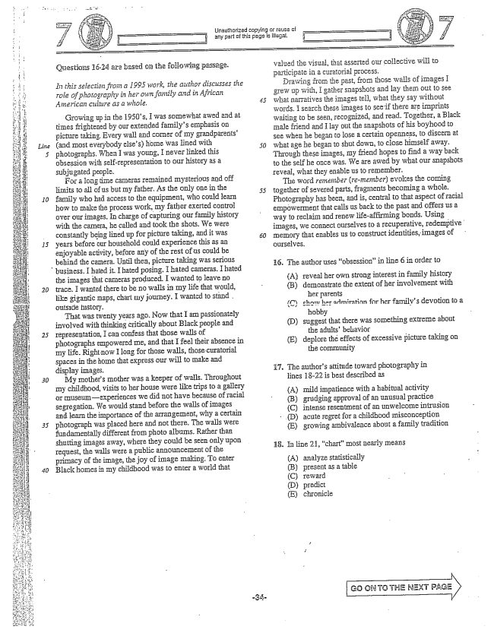

Çüestigiis 15-24 are based on the folio Wing passage.

*In this selection from a 1995 work, the author discusses the role of photography in her own family and in African American culture as a Whole.*

Growing up in the 1950s, I was somewhat awed and at times frightened by our extended familys emphasis on picture taking. Every wall and CDTIler of my grandparents(and Imost everybody elses) home was Hined with photographs. When I was young, I never linked this obsession with Self-representation to Our history as a Subjugated people.

For a long time cameras remained mysterious and off limits to all of us but my father. As the only one in the family who had access to the equipInent, who could learn how to make the process work, my father exerted control over our images. In charge of capturing our family history with the camera, he called and took the shots. We were constantly being lined up for picture taking, and it was years before Our household could experience this as an enjoyable activity, before any of the rest of us could be behind the camera. Until then, picture taking was serious business. I hated it. I hated posing. I hated cameras. I hated the images that cameras produced. I wanted to leave no trace. I wanted there to be no walls in IIIy life that would, like gigantic maps, chart IIly journey. I wanted to stand . outside history,

That was twenty years ago. Now that I am passionately involved with thinking critically about Black people and Iepresentation, I can confess that those walls of photographs empowered Ine, and that I feel their absence in my life. Rightnow Ilong for those walls, those curatorial spaces in the home that express Our will to make and display images.

My mothers mother was a keeper of walls. Throughout my childhood, visits to her house were like trips to a gallery or museumexperiences we did not have because of racial segregation. We would stand before the walls of images and learn the importance of the arrangeInent, why a certain photograph was placed here and not there. The walls were fundamentaly different from photo albums. Rather than shutting images away, where they could be seen only upon request, the walls were a public announcement of the primacy of the image, the joy of image making. To enter Black homes in my childhood was to enter a world that

Unauthorized copying or reuse of any part of this page is gal.

valued the visual, that asserted our collective will to participate in a curatorial process.

Drawing from the past, from those walls of images I grew up with, I gather Snapshots and lay them out to See what narTatives the images teil, what they say without words. I search these images to see if there are waiting to be seen, recognized, and read. Together, a Black Inale friend and Ilay Out the Snapshots of his boyhood to See when he began to lose a certain openness, to discern at what age he began to shut down, to close himself away. Through these images, my friend hopes to find a way back to the self he once was. We are awed by what our Snapshots reveal, what they enable us to remember.

The word renefiber (re-member) evokes the coining together of severed parts, fragments becoming a whole. Photography has been, and is, Central to that aspect of racial empowerment that calis us back to the past and offers us a way to reclaim and renew lifeaffirming bonds. Using images, we connect ourselves to a recuperative, redemptive memory that enables us to constructidentities, images of ourselves.

16. The author uses obsessionin line 6 in order to

(A) reveal her own strong interestin family history

(B) demonstrate the extent of her involvement with

her parents

(C) shots her admiratinn for her familys devotion to a

hobby (D) suggest that there was something extreme about

the adultsbehavior (E) deplore the effects of excessive picture taking on

the community

The authors attitude toward photography in lines 1822 is best described as

(A) (B) (C) (D) (E)

18. In line 21, chartmost nearly means

(A) analyze statistically (B) present as a table (C) reward

(D) predict (E) chronicle

17.

mild impatience with a habitual activity grudging approval of an unusual practice intense resentment of an unwelcome intrusion acute regret for a childhood Imisconception growing ambivalence about a family tradition

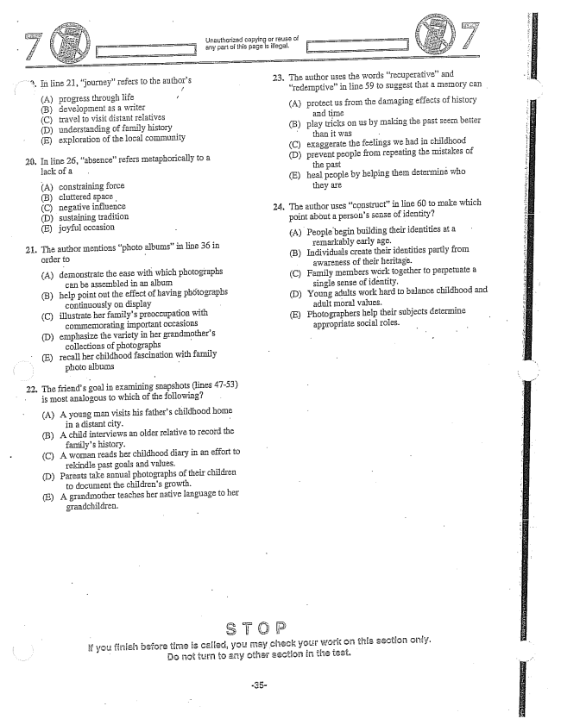

20,

2

, It iine 21, journey” refers to the authors

1.

iJnauthorized copying Dr rause Di

-- any part of this page is illegal.

. The author uses the words recuperative” and

redemptive” in line 59 to suggest that a memory can

(A) progress through life ,

B) development as a writer (A) protectus from the damaging effects of history

(C) travel to visit distant relatives and time (D) understanding of family history (B) play tricks on us by making the past seem better

than it was

(E) exploration of the local community

(C) exaggerate the feelings we had in childhood

In line 26, absence” refers metaphorically to a (D) prevent people from repeating the mistakes of

lack of a . the past - A) constraining force (E) heal people by helping them determine who (B) cluttered - they are ಸಿ 24. The author uses constructin line 60 to make which (E) joyful point about a persons Sense of identity?

- A) People begin building their identities at a

remarkably early age.

The author Inentions photo albums” in line 36 in

- (B) Individuals create their identities partly from

Order - - - - A) photographs to perpetuate a (B) having photographs (D) (C) illustrate her familys preoccupation with (E) subjects determine

COIIIHemorating important Occasions - (D) emphasize the her grandmothers appropriate Social IOles.

collections of photographs - E) recall her childhood fascination with family

photo albums -

. The friends goa in examining snapshots (lines 47-53)

is most analogous to which of the following?

(A) A young Inan visits his fathers childhood home in a distant city. -

(B) A child interviews an older relative to record the

familys history.

(C) A woman reads her childhood diary in an effort to

rekindle past goals and values.

(D) Parents take annual photographs of their children

to document the childrens growth.

(E) A grandmother teaches her native language to her

grandchildren.

If you firish before time is called, you may check your work on this section only. Do turn to coher section in the test.

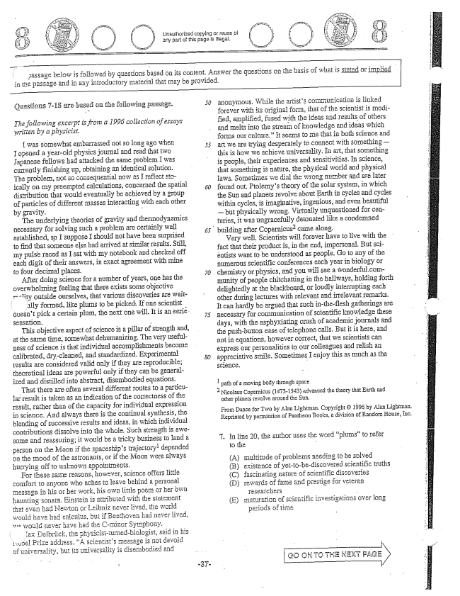

Questions -13 are jased on the feifowing passage.

*The following excerpt is from a 1995 collection of essays Written by a physicist.*

I was somewhat eII.barrassed not So long ago when F opened a year-old physics journal and read that two Japanese fellows had attacked the same problem I was currently finishing up, obtaining an identical solution. The problem, not so consequential now as I reflect stoically on IIIy preempted calculations, concerned the spatial distribution that would eventually be achieved by a group of particles of different Inasses interacting with each other by gravity. -

The underlying theories of gravity and thermodynamics necessary for solving Such a problem are Certainiy well established, so I suppose I should not have been surprised to find that someone else had arrived at similar results. Still, Iny pulse raced as I sat with my notebook and checked off each digit of their answers, in exact agreement with mine to four decimal places.

After doing science for a number of years, one has the overwhelming feeling that there exists some objective Tolity outside ourselves, that various discoveries are wait

illy formed, like plums to be picked. If one scientist doesn't pick a certain plum, the next one will. It is an eerië. Sensation. -

This objective aspect of science is a pillar of strength and, at the same time, somewhat dehumanizing. The very usefulness of science is that individual accomplishments become calibrated, dry-cleaned, and Standardized. Experimental results are considered valid only if they are reproducible; theoretical ideas are powerful only if they can be generalized and distilled into abstract, disembodied equations,

That there are often several different routes to a particular result is taken as an indication of the correctness of the result, rather than of the capacity for individual expression in science. And always there is the continual synthesis, the

blending of successive results and ideas, in which individual.

contributions dissolve into the whole. Such strength is aweSome and reassuring; it would be a tricky business to land a

person on the Moon if the spaceships trajectory depended ön the Inood of the astronauts, or if the Moon were always hurrying off to unknown appointinents.

For these same reasons, however, science offers little comfort to anyone who aches to leave behind a personal messagS in his Gr hSF work, his Own littie pDem OT her own

haunting sonata. Einstein is attributed with the statement that even had Newton of Leibniz never lived, the world wguid have had calculus, but if Beethoven had never lived, ve would never have had the C-minor Symphony.

i tax Leibrück, the physicistturnedbiologist, said in his 1sopel Prize address, A Scientists message is not devoid

of universality, but its universality is disembodied and

eiow is followed by questions based on its content. Answer the questions on the basis of what is in the passage and in any introductory material that may be provided.

*50*

anonymous. While the artists communication is linked forever with its original form, that of the scientist is Inodified, amplified, fused with the ideas and results of others and melts into the stream of knowledge and ideas which for Is Our culture.” It seeins to Ine that in both science and art we are trying desperately to connect with Something— this is how we achieve universality. In art, that Something is people, their experiences and sensitivities. In science, that something is nature, the physical world and physical laws. SDInetimes we dial the wrong number and are later found out. Ptolemys theory of the Solar system, in which the Sun and planets revolve about Earth in cycles and cycles within cycles, is imaginative, ingenious, and even beautiful — but physically WTOig. Virtually unquestioned for ceDturies, it was ungracefully detonated like a condemned

building after Copernicuscame along.

Very well, Scientists will forever have to live with the fact that their productis, in the end, impersonal. But Sciêntists want to be understood as people. Go to any of the numerous scientific conferences each year in biology or chemistry or physics, and you will See a wonderful.community of people chitchatting in the Hailways, holding forth delightedly at the blackboard, or loudly interrupting each other during lectures with relevant and irrelevant remarks. It can hardly be argued that such inthe-flesh gatherings are Hecessary for communication of Scientific knowledge these days, with the asphyxiating crush of academic journals and the push-button ease of telephone calls. But it is here, and not in equations, however correct, that we scientists can express our personalities to our colleagues and relish an appreciative Smile. Sometimes I enjoy this as much as the science. -

l path of a moving body through space - Nicolaus Copernicus (1473-1543) advanced the theory that Earth and

other planets revolve around the Sun.

From Dance for Two by Alan Lightman. Copyright © 1996 by Alan Lightman. Reprinted by permission of Pantheon Books, a division of Random House, fuc.

7. In line 20, the author uses the word plums” to refer

to the - A) multitude of problems needing to be solved (B) existence of yetto-bediscovered scientific truths (C) fascinating nature of Scientific discoveries (D) rewards of fame and prestige for veteran

- maturation of Scientific investigations over long

periods of time

(E)

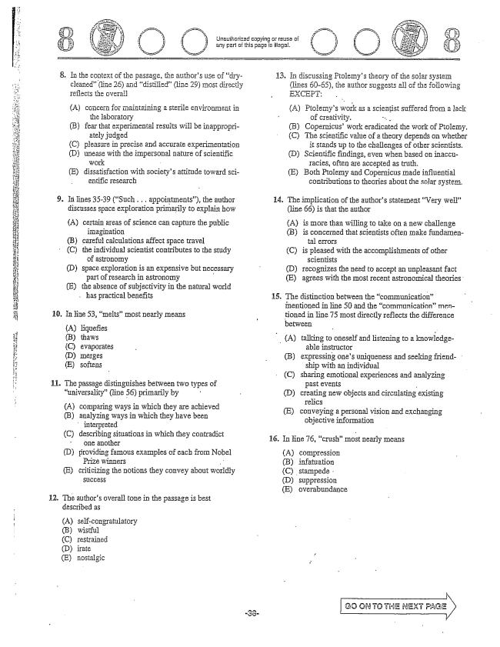

. In the context of the passage, the authors use of drycleaned(line 26) and distilled(line 29) Imost directly Teflects the overall

(A) CGIIceInfoT Inaintaining a ënviroIIIIlēIIt in

the laboratory

(B) fear that experimental results will be inappropri

ately judged

(C) pleasure in precise and accurate experimentation

(D) unease with the impersonal nature of scientific

work -

E) dissatisfaction with societys attitude toward sci

entific research

In lines 35-39 (Such .. appointments), the author discusses space exploration primarily to explain how

(A) certain areas of Science can capture the public

iTiagination

Uriuthorizad copying Gr reusa di any part of this page is illāgal,

13. In discussing Ptolemys theory of the Solar systein

(lines 60-55), the author suggests all of the following EXCEPT:

(A) Ptolemys work as a scientist suffered from a lack

of creativity. "... - (B) Copernicuswork eradicated the work of Ptolemy, C) The scientific value of a theory depends on whether

it stands up to the challenges of other Scientists. (D) Scientific findings, even when based on inaccu

racies, often are accepted as truth. (E) Both Ptolemy and Copernicus made influential

contributions to theories about the solar systern.

14. The implication of the authors statement Very well”

(line 66) is that the author

(A) is IHore than wiiling to take on a new challenge (B) is concerned that scientists often make fundamen

C) sharing emotional experiences and analyzing

B) careful calculations affect space travel tal errors

. (C) the individual scientist contributes to the study (C) is pleased with the accomplishments of other

of astronomy scientists

D) space exploration is an expensive but necessary (D) recognizes the need to accept an unpleasant fact

part of research in astronomy - E) agrees with the Inost recent astronomical theories. ខ្ញុំ (E) the absence of subjectivity in the natural world

has practical benefits 15. The distinction between the communication

mentioned in line 50 and the communicationmen

1. In line 53, melts" most nearly means t tioned in line 75 most directly reflects the difference

(A) liquefies - between -

B) thaws (A) talking to oneself and listening to a knowledge

C) evaporates - able instructor

(D) InēIges (B) expressing ones uniqueness and seeking friend(E) softens ship with an individual

H 11. The passage distinguishes between two types of past events

universality” (line 56) primarily by (Dcreating new objects and circulating existing

- - - relics (A) corpត្រាg way n which they are achieved (E) conveying a personal vision and exchanging (B) analyzing ways in which they have been objective information

interpreted (C) describing situations in which they contradict 16. În line 76, crush” mos nearly means

one another (D) providing famous examples of each from Nobel (A) compression

Prize winners (B) infatuation (E) criticizing the notions they convey about worldly

(D) suppression

(E) overabundance

12. The authors overall tone in the passage is best

described as

i (A) Self-congratulatory

(B) wistful

(C) restrained

(D) irate r

(E) nostalgic

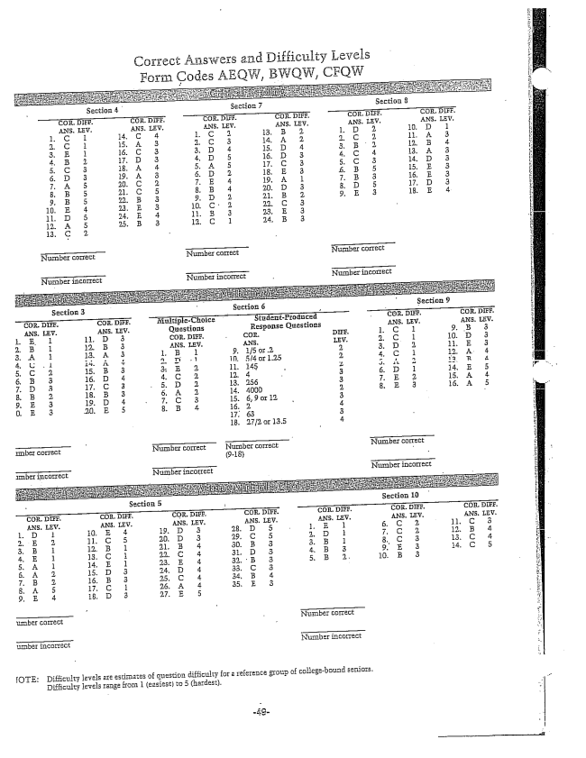

Correct Answers and Difficulty Levels

, BWOW, CFQw

Section 9

Triber correct NFLITriber CCITEct

umber incorrect Number incorrect

ICTE: Difficulty levels are estimates of question difficulty for a reference group of collegebound seniors,

Difficulty levels range from 1 (easiest) to 5 (hardest.