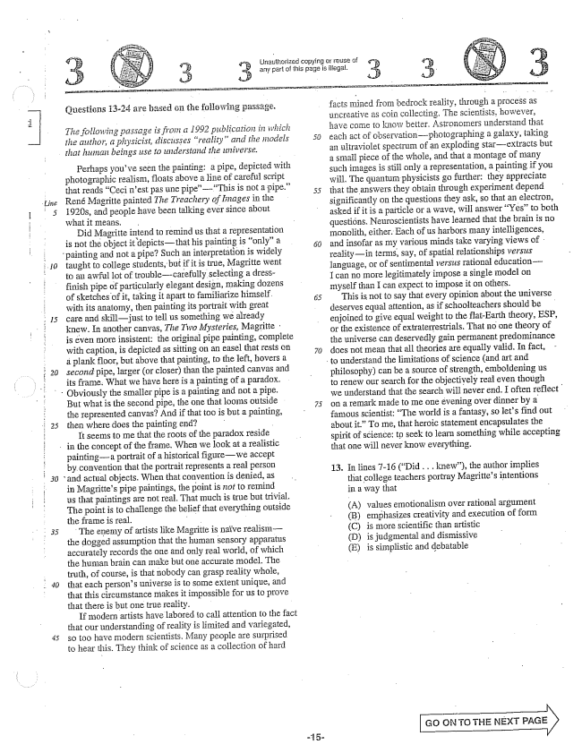

*10*

*15*

Questions -24 are based the following passage,

*The following passage is from a 1992 publication in which the author, a physicist, discusses reality" and the nodels*

*that human beings use to understand the universe.*

Perhaps youve seen the painting: a pipe, depicted with photographic realism, floats above a line of careful script that reads Ceci nest pas une pipeThis is not a pipe.” René Magritte painted The Treachery of Images in the 1920s, and people have been talking ever since about what it means.

Did Magritte intend to remind us that a representation is not the object it depictsthat his painting is only" a

painting and not a pipe? Such an interpretation is widely

taught to college students, but if it is true, Magritte went to an awful lot of troublecarefully selecting a dressfinish pipe of particularly elegant design, making dozens of sketches of it, taking it apart to familiarize himself. with its anatomy, then painting its portrait with great care and skilljust to tellus something we already knew. In another canvas, The Two Mysteries, Magritte : is even more insistent: the original pipe painting, complete with caption, is depicted as sitting on an easel that rests on a plank floor, but above that painting, to the left, howers a second pipe, larger (or closer) than the painted canvas and its frame. What we have here is a painting of a paradox.

Obviously the smaller pipe is a painting and not a pipe.

*30*

But what is the second pipe, the one that looms outside

the represented canvas? And if that too is but a painting,

then where does the painting end- -

It seems to me that the roots of the paradox reside

in the concept of the frame. When we look at a realistic

paintinga portrait of a historical figurewe accept by convention that the portrait represents a real person

and actual objects. When that convention is denied, as

in Magrittes pipe paintings, the point is not to remind us that paintings are not real. That much is true but trivial. The point is to challenge the belief that everything outside the frame is real. -

The enemy of artists like Magritte is naïve realismthe dogged assumption that the human sensory apparatus accurately records the one and only real world, of which the human brain can Inake but one accurate model. The truth, of course, is that nobody can grasp reality whole, that each persons universe is to some extent unique, and that this circumstance makes it impossible for us to prove that there is but one true reality.

If modern artists have labored to call attention to the fact that our understanding of reality is limited and variegated, So too have Hiodern Scientists, Many people are surprised to hear this. They think of ce as a collection of hard

Unauthorized copying of reuse of any part this paga is illegal.

*50*

***-***

.

- 15

facts mined from bedrock reality, through a process as uncreative as coin collecting. The Scientists, however, have come to know better. Astronomiers understand that each act of observationphotographing a galaxy, taking an ultraviolet spectrum of an exploding starextracts but a small piece of the whole, and that a montage of many such images is still only a representation, a painting if you will. The quantum physicists go further: they appreciate that the answers they obtain through experiment depend significantly on the questions they ask, so that an electron, asked if it is a particle of a wave, will answer Yes” to both questións. Neuroscientists have learned that the brain is no monolith, either. Each of us harbors many intelligences, and insofar as my various minds take varying views of realityin terms, say, of spatial relationships versus language, or of Sentimental versus rational educationI can no more legitimately impose a single model on myself than I can expect to impose it On others,

This is not to say that every opinion about the universe deserves equal attention, as if schoolteachers should be enjoined to give equal weight to the flatEarth theory, ESP, or the existence of extraterrestrials. That no one theory of the universe can deservedly gain permanent predominance does not mean that all theories are equally valid. In fact, -

to understand the limitations of science (and art and

philosophy) can be a source of strength, emboldening us to renew our search for the objectively real even though we understand that the search will never end. I often reflect on a remark made to me one evening over dinner by a famous scientist: The world is a fantasy, so lets find out about it.” To me, that heroic statement encapsulates the spirit of science: to seek to learn something while accepting that one will never know everything.

13. In lines -16 (Did .. knew), the author implies that college teachers portray Magrittes intentions in a way that

(A) (B) (C)

values emotionalism over rational argument emphasizes creativity and execution of form is more scientific than artistic is judgmental and dismissive is simplistic and debatable

GO CRJ TO THE NEXT PAGE

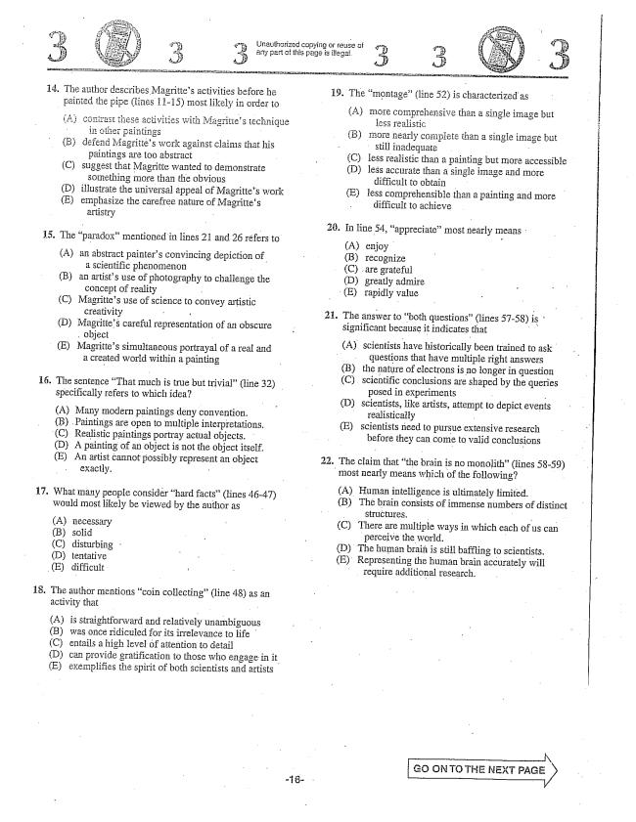

Unauthorized copying or reuse of

painted the pipe (lines i 1-15) most likely in order to

these activities with Magritiés technique

paintings s work against claims that his

paintings are too abstract (C) suggest that Magritte wanted to demonstrate

something more than the obvious (D) illustrate the universal appeal of Magrittes work (E) emphasize the carefree nature of Magrittes

artistry -

The paradox” mentioned in lines 21 and 26 refers to

(A) an abstract painters convincing depiction of

a scientific phenomenon

(Ban artists use of photography to challenge the

concept of reality -

(C) Magrittes use of science to convey artistic

creativity - -

(D) Magrittes careful representation of an obscure

object

(E) Magrittes simultaneous portrayal of a real and

16.

**17**

a created world within a painting

The sentence That much is true but trivial(line 32) specifically refers to which idea?

(A) Many rmodern paintings deny convention.

(B) Paintings are open to multiple interpretations.

(C) Realistic paintings portray actual objects.

(D) A painting of an object is not the object itself.

(E) An artist cannot possibly represent an object

exactly. -

What many people consider hard facts” (lines 4647) would most tikely be viewed by the author as

(A) necessary (B) solid (C) disturbing (D) tentative

(E) difficult :

18.

The author mentions coin collecting” (line 48) as an activity that -

Ais straightforward and relatively unambiguous (B) was once ridiculed for its irrelevance to life (C) entails a high lewel attention to detail (D) can provide gratification to those who engage in it. (E) exemplifies the spirit of both scientists and artists

(A) mGTe comprehensive than a single image btit

less realistic

B) InOTe nearly complete tham a single image but Still iliadequate -

C) less realistic than a painting but more accessible

(D) less accurate than a single image and more

difficult to obtain

(E) less comprehensible than a painting and more

difficult to achieve

In line 54, appreciate” most nearly means

(A) (B) (C) . (D) (E)

enjoy recognize are grateful greatly admire rapidly value

The answer to both questions(lines 57-58) is significant because it indicates that

(A) scientists have historically been trained to ask

questions that have multiple right answers the nature of electrons is no longer in question scientific conclusions are shaped by the queries

posed in experiments - Scientists, like artists, attempt to depict events

realistically - scientists need to pursue extensive research before they can come to valid conclusions

(C)

(D)

(E)

The claim that the brain is no monolith(lines 58-59) most nearly means which of the following?

2.

2.

(A) Human intelligence is ultimately limited. (B) The brain consists of immense numbers of distinct

- SİTLICÍllTES. - - (C) There are multiple ways in which each of us can

perceive the world. - D) The human brain is still baffling to scientists. (E) Representing the human brain accurately will

require additional research.

GG ÖN TO THE NEXT

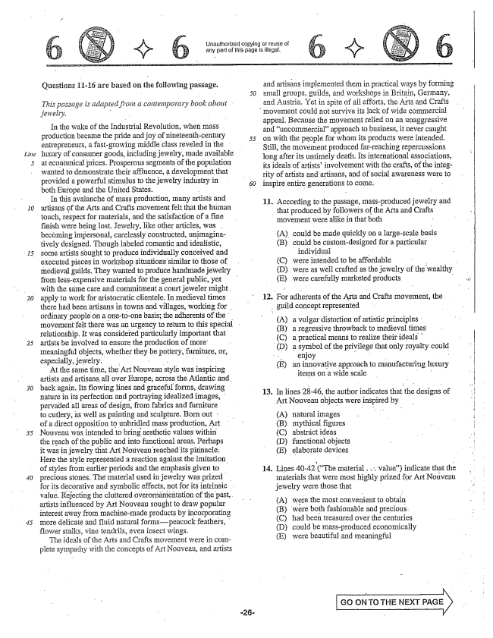

*10*

*30*

Questions 11-16 are based on the following passage.

*This passage is adapted from a contemporary book about . jewelry. -*

In the wake of the Industrial Revolution, when mass production became the pride and joy of nineteenth-century 55 entrepreneurs, a fastgrowing middle class reveled in the juxury of consumer goods, including jewelry, made available at economical prices. Prosperous segments of the population wanted to demonstrate their affluence, a development that provided a powerful stimulus to the jewelry industry in both Europe and the United States. - -

In this avalanche of mass production, many artists and artisans of the Arts and Crafts movement felt that the human touch, respect for materials, and the satisfaction of a fine finish were being lost. Jewelry, like other articles, was . becoming impersonal, carelessly constructed, unimaginatively designed. Though labeled romantic and idealistic, some artists sought to produce individually conceived and executed pieces in workshop situations similar to those of medieval guilds. They wanted to produce handmade jewelry from less-expensive materials for the general public, yet with the same care and commitment a court jeweler might. apply to work for aristocratic clientele. In medieval times . there had been artisans in towns and villages, working for ordinary people on a one-to-one basis; the adherents of the movement felt there was an urgency to return to this special relationship. It was considered particularly important that artists be involved to ensure the production of more meaningful objects, whether they be pottery, furniture, or, especially, jewelry. .

At the same time, the Art Nouveau style was inspiring artists and artisans all over Europe, across the Atlantic and, back again. Its flowing lines and graceful forms, drawing nature in its perfection and portraying idealized images, pervaded all areas of design, from fabrics and furniture to cutlery, as well as painting and sculpture. Born out : of a direct opposition to unbridled mass production, Art Nouveau was intended to bring aesthetic values within the reach of the public and into functional areas. Perhaps it was in jewelry that Art Nouveau reached its pinnacle. Here the style represented a reaction against the imitation.

of styles from earlier periods and the emphasis given to

precious stones. The material used in jewelry was prized for its decorative and symbolic effects, not for its intrinsic . .

value. Rejecting the cluttered overornamentation of the past,

artists influenced by Art Nouveau sought to draw popular interest away from machinemade products by incorporating more delicate and fluid natural forms---peacock feathers, flower stalks, vine tendrils, even insect wings. -

The ideals of the Arts and Crafts movement were in complete sympathy with the concepts of Art Nouveau, and artists

Urlauthorized copying or reuse of any part of this page is illegal,

and artisans implemented them in practical ways by forming small groups, guilds, and workshops in Britain, Germany, and Austria. Yet in spite of all efforts, the Arts and Crafts

movement could not survive its lack of wide commercial

appeal. Because the movement relied on an unaggressive and uncommercialapproach to business, it never caught on with the people for whom its products were intended. Still, the movement produced farreaching repercussions long after its untimely death. Its international associations, its ideals of artists' involvement with the crafts, of the integrity of artists and artisans, and of social awareness were to inspire entire generations to come. - -

11. According to the passage, mass-produced jewelry and that produced by followers of the Arts and Crafts movement were alike in that both -

A) could be made quickly on a largescale basis (B) could be customdesigned for a particular

individual (C) were intended to be affordable D) were as well crafted as the jewelry of the wealthy (E) were carefully marketed products -

12. For adherents of the Arts and Crafts movement, the

guild concept represented .. "

(A) a vulgar distortion of artistic principles (B) a regressive throwback to medieval times (C) a practical means to realize their ideals - D) a symbol of the privilege that only royalty could enjoy * - (E) an innovative approach to Inanufacturing luxury items on a wide scale " .

13. In lines 28-46, the author indicates that the designs

Art Nouveau objects were inspired by

(A) (B) (C) (D) (E)

14. Lines 40-42 (The material . . . value) indicate that the materials that were most highly prized for Art Nouveau jewelry were those that -

A) were the most convenient to obtain (B) were both fashionable and precious, C) had been treasured over the centuries (D) could be mass-produced economically (E) were beautiful and meaningful

natural images mythical figures absträct ideas functional objects elaborate devices

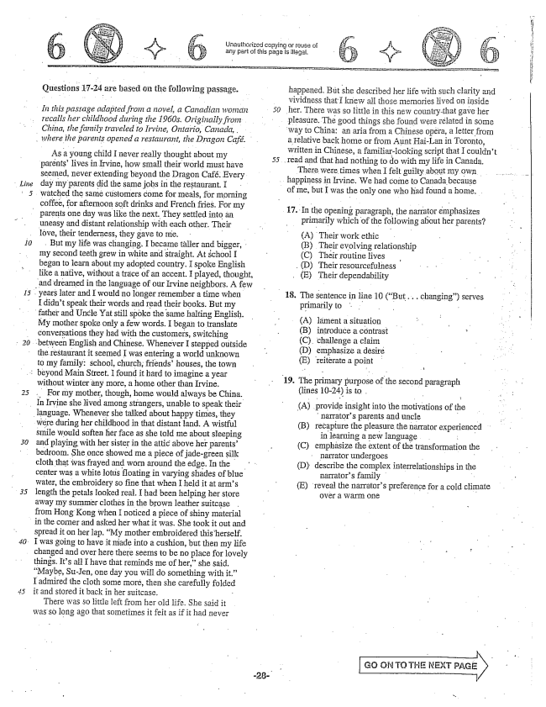

*Line*

Questions 17-24 are based on the following passage.

*In this passage adapted from a novel, a Canadian woman )*

*recalls her childhood during the 1960s. Originally from China, the family traveled to Irvine, Ontario, Canada, ,*

*where the parents opened a restaurant, the Dragon Café.*

As a young child I never really thought about my 55

parentslives in Hvine, how small their world must have

seemed, never extending beyond the Dragon Café. Every day my parents did the same jobs in the restaurant. I

watched the same customers come for meals, for morning coffee, for afternoon soft drinks and French fries. For my

parents one day was like the next. They settled into an

*10*

uneasy and distant relationship with each other. Their love, their tenderness, they gave to me. - -

But my life was changing, I became taller and bigger, my second teeth grew in white and straight. At School I began to learn about my adopted country. I spoke English like a native, without a trace of an accent. I played, thought,

and dreamed in the language of our Irvine neighbors. A few years later and I would no longer remember a time when

I didn't speak their words and read their books. But my

father and Uncle Yat still spoke the same halting English.

My mother spoke only a few words. I began to translate conversations they had with the customers, switching

between English and Chinese. Whenever I stepped outside

the restaurant it seemed I was entering a world unknown to my family: School, church, friends' houses, the town

3 beyond Main Street. I found it hard to imagine a year

*40.*

without winter any more, a home other than Irvine. .. For my mother, though, home would always be China.

Irvine she lived among strangers, unable to speak their language. Whenever she talked about happy times, they

were during her childhood in that distant land. A wistful smile would soften her face as she told me about sleeping and playing with her sister in the attic above her parentsbedroom. She once showed me a piece of jadegreen silk cloth that was frayed and worn around the edge. In the center was a white lottis floating in varying shades of blue water, the embroidery so fine that when I held it at arms length the petals looked real. I had been helping her store away my summer clothès in the brown leather suitcase from Hong Kong when I Doticed a piece of shiny material

in the corner and asked her what it was. She took it out and

spread it on her lap. My mother embroidered this herself. I was going to have it made into a cushion, but then my life changed and over here there seems to be no place for lovely things. Its all I have that reminds me of her,she said, Maybe, SuJen, one day you will do something with it.” I admired the cloth some moré, then she carefully folded it and stored it back in her suitcase. - There was so little ieft from her old life. She Said it was so long ago that sometimes it felt as if it had never

any part of this page is illegal.

happened. But she described her life with such clarity and vividness that I knew all those memories lived oil inside

her. There was so little in this new country that gave her

pleasure. The good things she found were related in Some

way to China: an aria from a Chinese opera, a letter from

a relative back home or from Aunt HaiLan in Toronto, written in Chinese, a familiarlooking script that I couldnt

. and that had nothing to do with my life in Canada.

There were times when I felt guilty about my .

happiness in Irvine. We had corne to Canada because

of me, but I was the only one who had found a home.

17. In the opening the narrator emphasizes

primarily which of the following about her parents?

(A) Their work ethic (B) Their evolving relationship (C) Their routine lives . . (D) Their resourcefulness (E) Their dependability

18. The sentence in line 10 (But... changing) serves

primarily to

(A) lament a situation - - B) introduce a contrast : (C) challenge a claim (D) emphasize a desire (E) reiterate a point

19. The primary purpose of the second paragraph

(lines 10-24) is to .

(A) provide insight into the motivations of the

narrators parents and uncle - - (B) recapture the pleasure the narrator experienced in learning a new language . . : (C) emphasize the extent of the transformation the

narrator undergoes -

(D) describe the complex interrelationships in til

narrators family (E) reveal the narrators preference for a cold climate

over a warm one

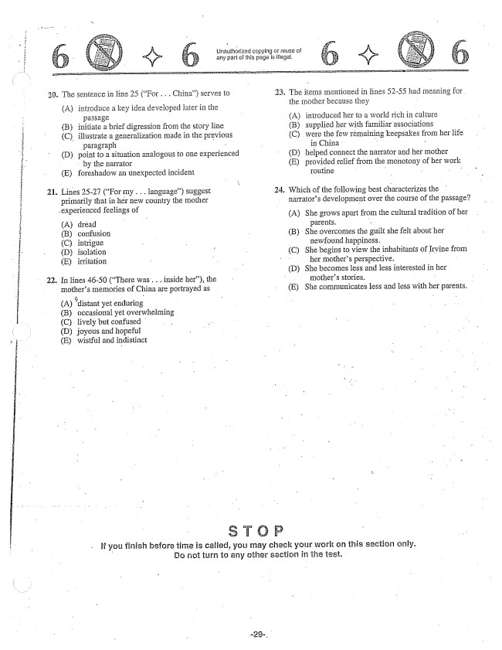

23. The sentence in line 25 (For . . . China) serves to

(A) introduce a key idea developed later in the

(B) initiate a brief digression from the story line (C) illustrate a generalization made in the previous

paragraph . - (D) point to a situation analogous to one experienced

by the narrator (E) foreshadow an unexpected incident

. Lines 25-27 (For my .. language) suggest

primarily that in her new country the mother

.experienced feelings of

(A) (B) confusion (C) intrigue (D) isolation (E) irritation

. In lines 46-50 (There was . . . inside her), the

mothers Enemories of China are portrayed as

(A) distant yet enduring (B) occasional yet overwhelming (C) lively but confused (D) joyous and hopeful (E) wistful and indistinct

Unauthorized copying of reuse of any part of this page is .

23. The items mentioned in lines 52-55 had meaning for .

the mother because they

(A) introduced her to a world rich in culture (B) supplied her with familiar associations (C) were the few remaining keepsakes from her life

in China . (D) helped connect the narrator and her mother (E) provided relief from the monotony of her work routine - -

. Which of the following best characterizes the

narrators development over the course of the passage?

(A) She grows apart from the cultural tradition of her

parents. (B) She overcomes the guilt she felt about her

newfound happiness, C) She begins to view the inhabitants of Irvine from

her mothers perspective. (D) She becomes less and less interested in her

mothers stories. (E) She communicates tess and less with her parents,

If you finish before time is , you may check your work on this section only. Do not turn to any other section in the test.

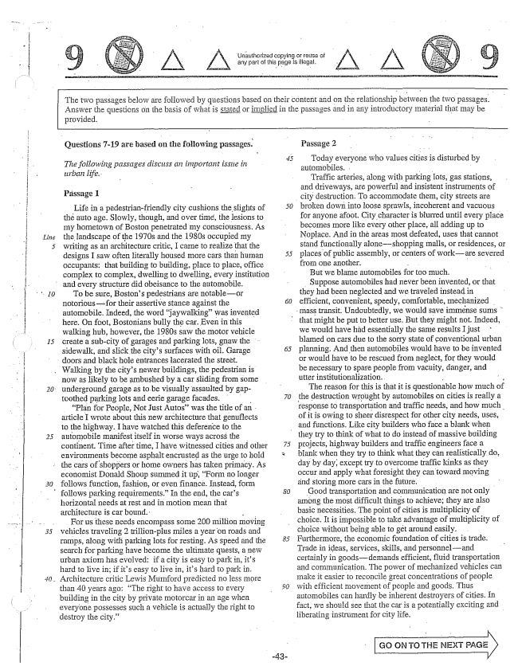

*Line*

*1.5*

Unauthorized copying or reuse of any part cithis page is illegal.

The two passages below are followed by questions based on their contest and on the relationship between the two passages. Answer the questions On the basis of what is Stated or implied in the pāSSages and in any introductory Inaterial that may be

provided.

Questions -19 are based on the following passages.

*The following passages discuss an important issue in urban life.*

Pässage I

Life in a pedestrianfriendly city cushions the slights of the auto age. Slowly, though, and over time, the lesions to my hometown of Boston penetrated my consciousness. As the landscape of the 1970s and the 1980s occupied my writing as an architecture critic, I came to realize that the designs I saw often literally housed more cars than human occupants: that building to building, place to place, office complex to complex, dwelling to dwelling, every institution and every structure did obeisance to the automobile.

To be sure, Bostons pedestrians are notableor notoriousfor their assertive stance against the automobile. Indeed, the word jaywalkingwas invented here. On foot, Bostonians bully the car. Even in this walking hub, however, the 1980s saw the motor vehicle create a subcity of garages and parking lots, gnaw the sidewalk, and slick the citys Surfaces with oil. Garage doors and black hole entrances lacerated the street. Walking by the citys newer buildings, the pedestrian is

- now as Hikely to be ambushed by a car sliding from some 20. Underground garage as to be visually assaulted by gap

toothed parking lots and eerie garage facades. Plan for People, Not Just Autoswas the title of an article I wrote about this new architecture that genuflects to the highway, I have watched this deference to the automobile manifest itself in worse ways across the continent. Time after time, I have witnessed cities and other environments become asphalt encrusted as the urge to hold

the cars of shoppers or home owners has taken primacy. As

economist Donald Shoup summed it up, Form no longer follows function, fashion, or even finance. Instead, form follows parking requirements.” In the end, the cars horizontal needs at Test and in motion mean that architecture is car bound.

For us these needs encompass some 200 million moving vehicles traveling 2 trillionplus miles a year on roads and ramps, along with parking lots for resting. As speed and the search for parking have become the ultimate quests, a new Urban axiom has evolved: if a city is easy to park in, its hard to live inif its easy to live in, its hard to parkin. Architecture critic Lewis Mumford predicted no less more than 40 years ago: The right to have access to every building in the city by private motorcar in an age when everyone possesses such a vehicle is actually the right to destroy the city.”

Passage 2

Today everyone who values cities is disturbed by automobiles, . - - -

Traffic arteries, along with parking lots, gas Stations, and driveways, are powerful and insistent instruments of

city destruction. To accommodate them, city streets are

broken down into loose sprawls, incoherent and vacuous

for anyone afoot. City character is blurred until every place

becomes more like every other place, all adding up to Noplace. And in the areas most defeated, uses that cannot stand functionally aloneshopping malls, or residences, or places of public assembly, or centers of workare severed from one another. - - -

But we blame automobiles for too much. Suppose automobiles had never been invented, or that they had been neglected and we traveled instead in efficient, convenient, speedy, comfortable, mechanized

mass transit. Undoubtedly, we would save immense sums

that might be put to better use. But they might not. Indeed, we would have had essentially the same results just blamed on cars due to the sorry state of conventional urban planning. And then automobiles would have to be invented or would have to be rescued from neglect, for they would be necessary to spare people from vacuity, danger, and utter institutionalization. - - The reason for this is that it is questionable how much of the destruction wrought by automobiles on cities is really a response to transportation and traffic needs, and how much of it is owing to sheer disrespect for other city needs, uses, and functions. Like city builders who face a blank when they try to think of what to do instead of massive building projects, highway builders and traffic engineers face a blank when they try to think what they can realistically do, day by day, except try to overcome traffic kinks as they occur and apply what foresight they can toward moving and storing more cars in the future,

Good transportation and communication are not only among the most difficult things to achievethey are also basic necessities. The point of cities is multiplicity of choice. It is impossible to take advantage of multiplicity of choice without being able to get around easily. Furthermore, the economic foundation of cities is trade. Trade in ideas, services, skills, and personneland certainly in goodsdemands efficient, fluid transportation and communication. The power of mechanized vehicles can make it easier to reconcile great concentrations of people with efficient movement of people and goods. Thus automobiles can hardly be inherent destroyers of cities. In fact, we should see that the car is a potentially exciting and liberating instrument for city life. -

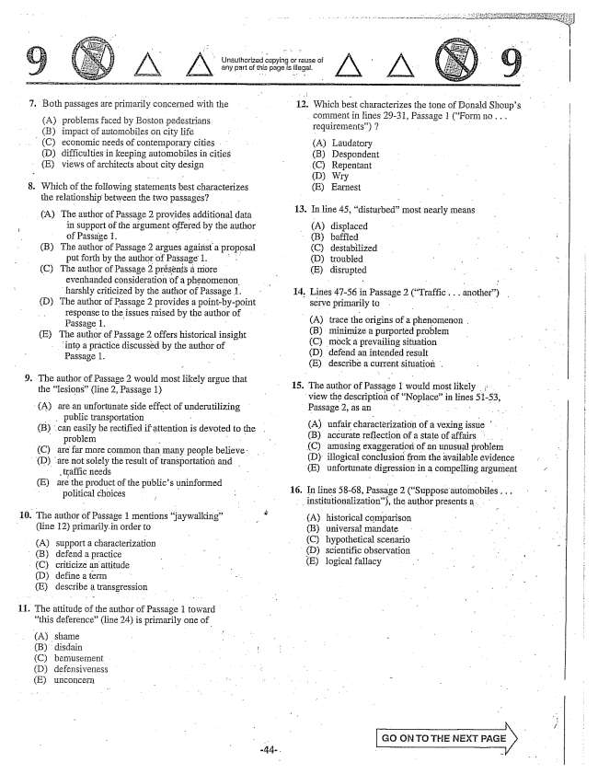

.

.

10.

**11.**

Both passages are primarily concerned with the

(A) problems faced by Boston pedestrians (B) impact of automobiles on city Hife (C) economic needs of contemporary cities . . (D) difficulties in keeping automobiles in cities (E) views of architects about city design

Which of the following statements best characterizes the relationship between the two passages?

(A) The author of Passage 2 provides additional data

in support of the argument offered by the author of Passage 1. - - - (B) The author of Passage 2 argues against a proposal

put forth by the author of Passage 1. . . . (C) The author of Passage 2 présents a more

- evenhanded consideration of a phenomenon. harshly criticized by the author of Passage 1. (D) The author of Passage 2 provides a pointby-point

response to the issues raised by the author of Passage 1. (E) The author of Passage 2 offers historical insight

into a práctice discussed by the author of Passage 1. - -

The author of Passage 2 would most likely argue that the lesions(line 2, Passage 1)

(A) are an unfortunate side effect of underutilizing

. . public transportation - (B) can easily be rectified if attention is devoted to the

problem - (C) are far more common than many people believe: (D) are not solely the result of transportation and

traffic needs - E) arë the product of the publics uninformed - political choices -

The author of Passage 1 Tnentions jaywalking” (line 12) primarily, in order to

(A) Support a characterization

(B) defend a practice

(C) criticize an attitude (D) define a term (E) describe a transgression

The attitude of the author of Passage 1 toward this deference” (line 24) is primarily one of

(A) shame (B) disdain (C) bemusernent . (D) defensiveness (E) unconcerii

Unauthorized copying or reuse of - - any part of this page is illegal.

12. Which best characterizes the tone Donald Shoups comment in lines 2931, Passage 1 (Form no. . . requirements) 7

(A) Laudatory (B) Despondent (C) Repentant (D) Wry (E) Earnest

- 13. În line 45, disturbed” most nearly means

(A) displaced

· (B) baffled (C) destabilized (D) troubled (E) disrupted

14. Lines 47-56 in Passage 2 (Traffic. . . another) serve primarily to : (A) trace the origins of a phenomenon (B) minimize a purported problem (C) mock a prevailing situation (D) defend an intended result (E) describe a current situation .

15. The author of Passage 1 would most likely

view the description of Noplacein lines 5153, Passage 2, as an - - - - - A) unfair characterization of a vexing issue (B) accurate reflection of a state of affairs (C) amusing exaggeration of an unusual problem (D) illogical conclusion from the available evidence E) unfortunate digression in a compelling argument

16. In lines 58-68, Passage 2 (Suppose automobiles - - -

- institutionalization), the author presents a

(A) historical comparison (B) universal mandate (C) hypothetical scenario

(D) scientific observation (E) logical fallacy

Go ON TOTHE NEXT -

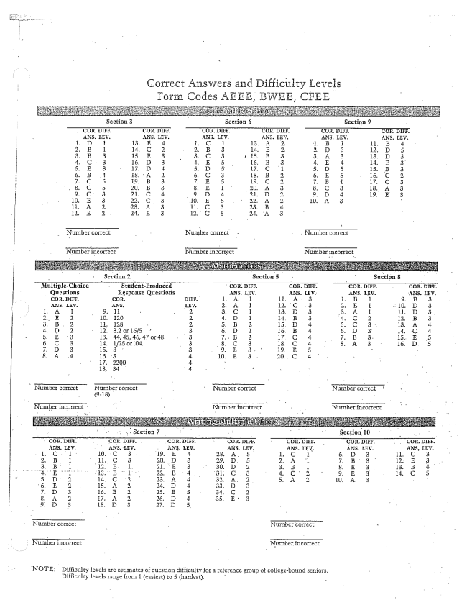

Section 3 r Section 6 Section 9

Nurminer correct Number correct

. Number incorrect Nurnber irigOrrect

NOTE: Difficulty levels are estimates of question difficulty for a reference group of collegebound seniors.

Difficulty levels range froTn (easiest) to 5 (hardest, -