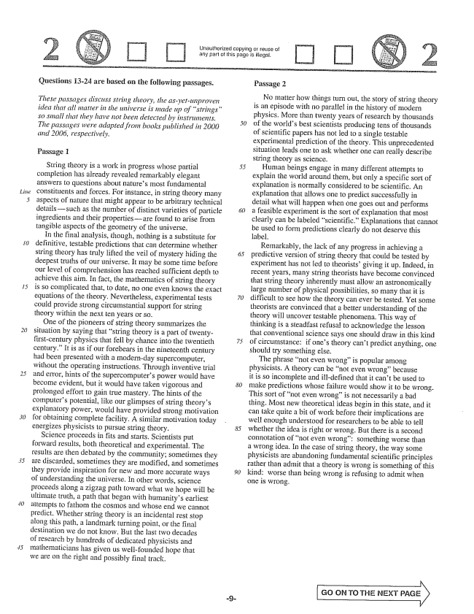

*line*

Unauthorized copying of reuse of any part of this page is illegal,

Questions 13-24 are based on the following passages.

*These passages discuss string theory, the asyetunproven idea that all matter in the universe is made up of strings" so small that they have not been detected by instruments. The passages were adapted from books published in 2000 2006, respectively.*

Passage 1

String theory is a work in progress whose partial completion has already revealed remarkably elegant answers to questions about natures most fundamental constituents and forces. For instance, in string theory many aspects of nature that might appear to be arbitrary technical detailssuch as the number of distinct varieties of particle ingredients and their propertiesare found to arise from tangible aspects of the geometry of the universe.

In the final analysis, though, nothing is a substitute for definitive, testable predictions that can determine whether string theory has truly lifted the veil of mystery hiding the deepest truths of our universe. It may be some time before our level of comprehension has reached sufficient depth to achieve this aim. In fact, the mathematics of string theory is so complicated that, to date, no one even knows the exact equations of the theory. Nevertheless, experimental tests could provide strong circumstantial support for string theory within the next ten years or so,

One of the pioneers of string theory summarizes the situation by saying that string theory is a part of twentyfirst-century physics that fell by chance into the twentieth century.” It is as if our forebears in the nineteenth century had been presented with a modernday supercomputer, without the operating instructions. Through inventive trial and error, hints of the Supercomputers power would have become evident, but it would have taken vigorous and prolonged effort to gain true mastery. The hints of the computers potential, like our glimpses of string theorys explanatory power, would have provided strong motivation for obtaining complete facility. A similar motivation today energizes physicists to pursue string theory.

Science proceeds in fits and starts. Scientists put forward results, both theoretical and experimental. The results are then debated by the community; sometimes they are discarded, sometimes they are modified, and sometimes they provide inspiration for new and more accurate ways of understanding the universe. In other words, science proceeds along a zigzag path toward what we hope will be ultimate truth, a path that began with humanitys earliest attempts to fathom the cosmos and whose end we cannot predict. Whether string theory is an incidental rest stop along this path, a landmark turning point, or the final destination we do not know. But the last two decades of research by hundreds of dedicated physicists and mathematicians has given us well-founded hope that we are on the right and possibly final track.

Passage 2

No matter how things turn out, the story of string theory is an episode with no parablel in the history of modern physics. More than twenty years of research by thousands of the worlds best scientists producing tens of thousands of Scientific papers has not led to a single testable experimental prediction of the theory. This unprecedented situation leads one to ask whether one can really describe String theory as science.

Human beings engage in many different attempts to explain the world around them, but only a specific sort of explanation is normally considered to be Scientific. An explanation that allows one to predict successfully in detail what will happen when one goes out and performs a feasible experiment is the sort of explanation that most clearly can be labeled scientific" Explanations that cannot be used to form predictions clearly do not deserve this label.

Remarkably, the lack of any progress in achieving a predictive version of string theory that could be tested by experiment has not led to theoristsgiving it up. Indeed, in recent years, many string theorists have become convinced that String theory inherently must allow an astronomically large number of physical possibilities, so many that it is difficult to see how the theory can ever be tested. Yet some theorists are convinced that a better understanding of the theory will uncover testable phenomena. This way of thinking is a steadfast refusal to acknowledge the lesson that conventional science says one should draw in this kind of circumstance: if ones theory cant predict anything, one should try something else.

The phrase not even wrongis popular among physicists. A theory can be not even wrong" because it is so incomplete and illdefined that it cant be used to make predictions whose failure would show it to be wrong. This sort of not even wrongis not necessarily a bad thing. Most new theoretical ideas begin in this state, and it can take quite a bit of work before their implications are well enough understood for researchers to be able to tell whether the idea is right or wrong. But there is a second connotation of not even wrong: something worse than a wrong idea. In the case of string theory, the way some physicists are abandoning fundamental scientific principles rather than admit that a theory is wrong is something of this kind: worse than being wrong is refusing to admit when one is wrong.

GO OFM TO THE NEXT PAGE

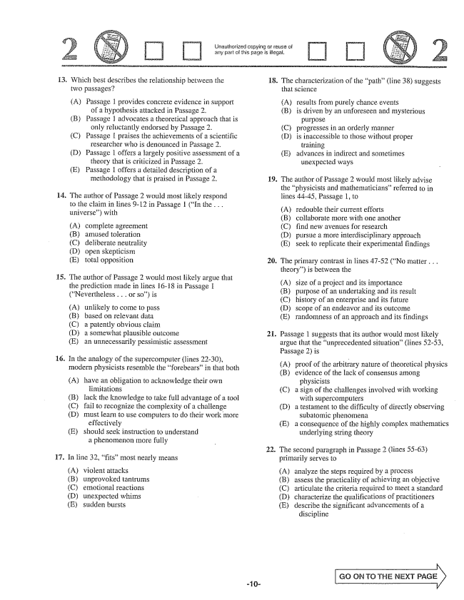

Unauthorized copying or reuse of any part of this page is illegal.

14.

**15.**

**16.**

17.

Which best describes the relationship between the wo passages?

(A) Passage 1 provides concrete evidence in support

of a hypothesis attacked in Passage 2. (B) Passage 1 advocates a theoretical approach that is

only reluctantly endorsed by Passage 2. (C) Passage I praises the achievements of a scientific

researcher who is denounced in Passage 2. (D) Passage 1 offers a largely positive assessment of a

theory that is criticized in Passage 2. (E) Passage 1 offers a detailed description of a methodology that is praised in Passage 2.

The author of Passage 2 would most likely respond to the claim in fines -12 in Passage 1 (In the . . . universe) with

complete agreement amused toleration deliberate neutrality open skepticism total opposition

The author of Passage 2 would most likely argue that the prediction made in lines 16-18 in Passage I (Nevertheless . . . or so) is

(A) (B) (C) (D) (E)

unlikely to come to pass based on relevant data a patently obvious chaim a somewhat piausible outcome an unnecessarily pessimistic assessment

In the analogy of the supercomputer (lines 22-30), modern physicists resemble the forebears” in that both

(A) have an obligation to acknowledge their own

limitations

lack the knowledge to take full advantage of a tool

fail to recognize the complexity of a challenge

must learn to use computers to do their work more

effectively

should seek instruction to understand

a phenomenon more fully

(B) (C) (D)

(E)

In line 32, fits” most nearly means

(A) (В) (C) (D) (E)

violent attacks unprovoked tantrums emotional reactions unexpected whims Sudden bursts

18. The characterization of the path(line 38) suggests

**19.**

21.

that science

(A) results from purely chance events

(B) is driven by an unforeseen and mysterious

purpose

(C) progresses in an orderly manner

(D) is inaccessible to those without proper

training

(E) advances in indirect and sometimes

unexpected ways

The author of Passage 2 would most likely advise the physicists and mathematiciansreferred to in lines 44-45, Passage 1, to

(A) (B) (C) (D) (E)

redouble their current efforts collaborate more with one another find new avenues for research pursue a more interdisciplinary approach seek to replicate their experimental findings

. The primary contrast in lines 47-52 (No matter . . .

theory) is between the

(A) size of a project and its importance (B) purpose of an undertaking and its result (C) history of an enterprise and its future (D) scope of an endeavor and its outcome (E) randomness of an approach and its findings

Passage 1 suggests that its author would most likely argue that the unprecedented situation(lines 52-53, Passage 2) is

(A) (B)

proof of the arbitrary nature of theoretical physics evidence of the Hack of consensus among

physicists a sign of the challenges involved with working

with supercomputers a testament to the difficulty of directly observing

subatomic phenomena (E) a consequence of the highly complex mathematics

underlying String theory

(C)

(ED)

. The second paragraph in Passage 2 (lines 55-63)

primarily serves to

(A) (B) (C) (D) (E)

analyze the steps required by a process

assess the practicality of achieving an objective

articulate the criteria required to meet a standard

characterize the qualifications of practitioners

describe the significant advancements of a

discipline

G...] ON TO THE NEXT PAGE

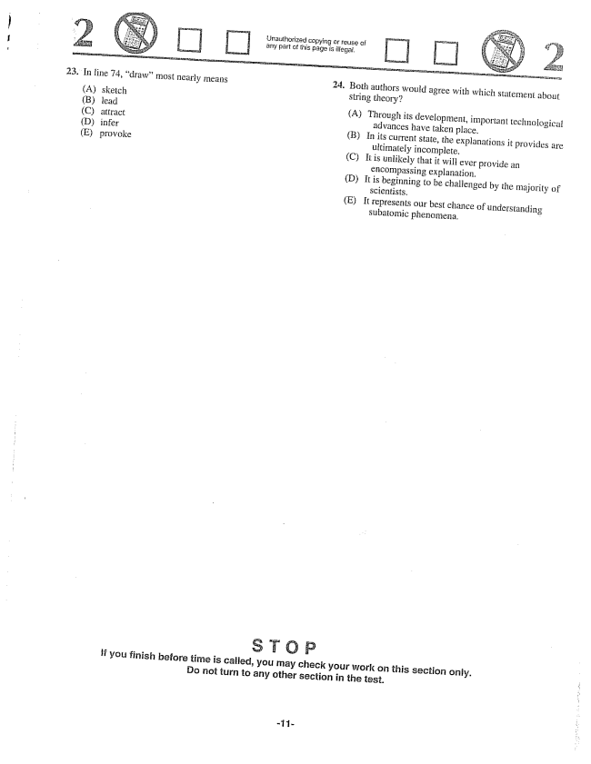

Unauthorized copying or reuse of any part of this page is illegal.

23. In line 74, drawmost nearly means 24. Both authors would agree with which statement about

(A) sketch String theory? (B) lead (A) Through its development, important technological (C) attract advances have taken place. (D) infer (B) In its current state, the explanations it provides are (E) provoke ultimately incomplete.

(C) It is unlikely that it will ever provide an

encompassing explanation.

(D) It is beginning to be challenged by the majority of

Scientists.

(E) It represents our best chance of understanding

subatomic phenomena.

If you finish before time is called, you may check your work on this section only. Do not turn to any other section in the test.

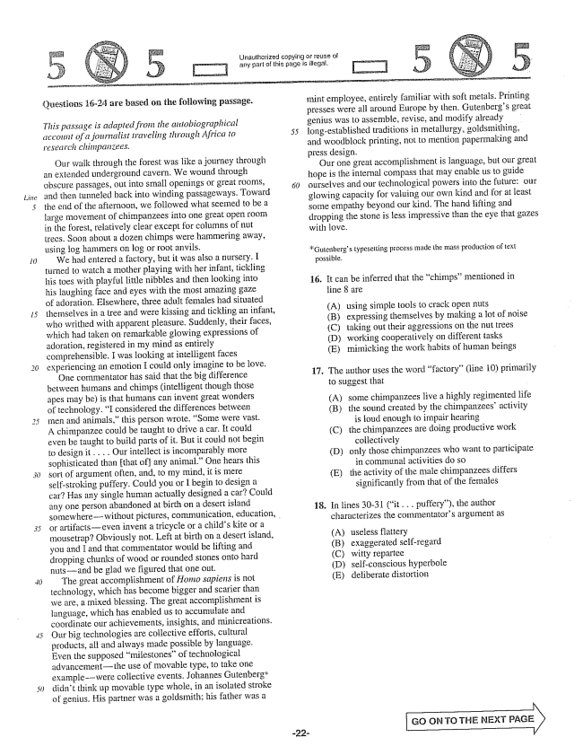

*Line*

*15*

25

Urlauthorized copying or reuse of any part of this page is illegal.

£uestions 16-24 are based on the following passage.

*This passage is adapted from the aittobiographical diccottist of a journalist traveling through Africa to research chimpanzees.*

Our walk through the forest was like a journey through an extended underground cavern. We wound through obscure passages, out into Small openings or great rooms, and then tunneled back into winding passageways. Toward the end of the afternoon, we followed what seemed to be a large movement of chimpanzees into one great open room in the forest, relatively clear except for columns of mut trees. Soon about a dozen chimps were hammering away, using log hammers on log or root anvils.

We had entered a factory, but it was also a nursery. I turned to watch a mother playing with her infant, tickling his toes with playful little nibbles and then looking into his laughing face and eyes with the most amazing gaze of adoration. Elsewhere, three adult females had situated themselves in a tree and were kissing and tickling an infant, who writhed with apparent pleasure. Suddenly, their faces, which had taken on remarkable glowing expressions of adoration, registered in my mind as entirely comprehensible. I was looking at intelligent faces experiencing an emotion I could only imagine to be love.

One commentator has said that the big difference between humans and chimps (intelligent though those apes may be) is that humans can invent great wonders of technology. I considered the differences between men and animals,this person wrote. Some were vast. A chimpanzee could be taught to drive a car. It could even be taught to build parts of it. But it could not begin to design it. . . . Our intellect is incomparably more sophisticated than that ofany animal." One hears this sort of argument often, and, to my mind, it is mere self-stroking puffery. Could you or I begin to design a car? Has any single human actually designed a carCould any one person abandoned at birth on a desert island somewherewithout pictures, communication, education, or artifactseven invent a tricycle or a childs kite or a mousetrap? Obviously not. Left at birth on a desert island, you and I and that commentator would be lifting and dropping chunks of wood or rounded stones onto hard nutsand be glad we figured that one out.

The great accomplishment of Homo sapiens is not technology, which has become bigger and scarier than we are, a mixed blessing. The great accomplishment is Hanguage, which has enabled us to accumulate and coordinate our achievements, insights, and minicreations. Our big technologies are collective efforts, cultural products, all and always made possible by language. Even the supposed milestonesof technological advancementthe use of movable type, to take one examplewere collective events. Johannes Gutenbergdidn't think up movable type whole, in an isolated stroke of genius. His partner was a goldsmith; his father was a

mint employee, entirely familiar with soft metals. Printing presses were all around Europe by then, Gutenbergs great genius was to assemble, revise, and Inodify already longestablished traditions in metallurgy, goldsmithing, and woodblock printing, not to mention papermaking and press design.

Our one great accomplishment is language, but our great hope is the internal compass that may enable us to guide ourselves and our technological powers into the future: our glowing capacity for valuing our own kind and for at least some empathy beyond our kind. The hand fifting and dropping the stone is less impressive than the eye that gazes with love.

Gutenbergs typesetting process made the mass production of text

possible.

16. It can be inferred that the chimps” mentioned in

line 8 are

(A) using simple tools to crack open nuts

(B) expressing themselves by making a lot of noise

(C) taking out their aggressions on the nut trees

(D) working cooperatively on different tasks

(E) mimicking the work habits of human beings

17. The author uses the word factory” (line 10) primarily

to suggest that

(A) some chimpanzees live a highly regimented life (B) the sound created by the chimpanzees' activity

is loud enough to impair hearing (C) the chimpanzees are doing productive work

collectively (D) only those chimpanzees who want to participate

in communal activities do so (E) the activity of the male chimpanzees differs

significantly from that of the females

18. In lines 30-31 (it . . . puffery), the author

characterizes the commentators argument as

useless flattery exaggerated Self-regard witty repartee self-conscious hyperbole deliberate distortion

GÖ ÖN TO THE NEXT PAGE

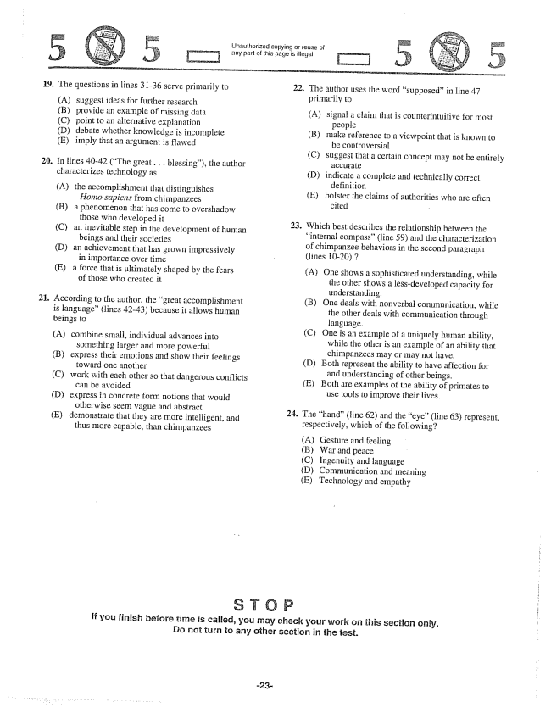

Jnauthorized copying or reuse of any part of this paga is illegal,

19. The questions in lines 31-36 serve primarily to

(A) suggest ideas for further research (B) provide an example of missing data (C) point to an alternative explanation (D) debate whether knowledge is incomplete (E) imply that an argument is flawed

20. In lines 40-42 (The great . . . blessing), the author

characterizes technology as

(A) the accomplishment that distinguishes

Homo sapiens from chimpanzees (B) a phenomenon that has come to overshadow

those who developed it (C) an inevitable step in the development of human

beings and their societies (D) an achievement that has grown impressively

in importance over time (E) a force that is ultimately shaped by the fears

of those who created it

21. According to the author, the great accomplishment

is language” (lines 42-43) because it allows human beings to

(A) combine Small, individual advances into

something farger and more powerful (B) express their emotions and show their feelings

toward one another (C) work with each other so that dangerous conflicts

can bë avoided (D) express in concrete form notions that would otherwise seem vague and abstract (E) demonstrate that they are more intelligent, and thus more capable, than chimpanzees

22. The author uses the word supposedin line 47

2

.

24

If you finish before time is called, you may check your work on this section only. Do not turn to any other section in the test.

primarily to

(A) signal a claim that is counterintuitive for most

people

(B) make reference to a viewpoint that is known to

be controversial

(C) suggest that a certain concept may not be entirely

(D) indicate a complete and technically correct

definition

(E) Bolster the claims of authorities who are often

cited -

Which best describes the relationship between the internal compass” (line 59) and the characterization of chimpanzee behaviors in the second paragraph (lines 10-20) 7

(A) One shows a sophisticated understanding, while

the other shows a less-developed capacity for understanding. (B) One deals with nonverbal communication, white

the other deals with communication through language. (C) One is an example of a uniquely human ability, while the other is an example of an ability that chimpanzees may or may not have. (D) Both represent the ability to have affection for

and understanding of other beings. (E) Both are examples of the ability of primates to

use tools to improve their lives.

The hand" (fine 62) and the eye(line 63) represent, respectively, which of the following?

(A) Gesture and feeling (B) War and peace (C) lingenuity and language (D) Communication and meaning (E) Technology and empathy

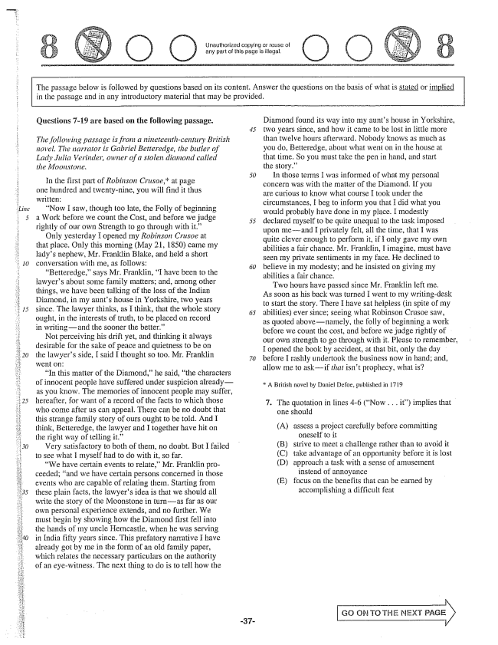

The passage below is followed by questions based on its content. Answer the questions on the basis of what is stated or implied in the passage and in any introductory material that may be provided.

**Questions -19 are based on the following passage.**

*The following passage is from a nineteenth-century British novel. The Harrator is Gabriel Betteredge, the butler of Lady Julia Werinder, owner of a stolen diamond called the Moonstone.*

In the first part of Robinson Crusoe,at page one hundred and twenty-nine, you will find it thus written:

Now I saw, though too late, the Foily of beginning a Work before we count the Cost, and before we judge 55 rightly of our own Strength to go through with it.”

Only yesterday I opened my Robinson Crusoe at that place. Only this morning (May 21, 1850) came my ladys nephew, Mr. Franklin Blake, and held a short conversation with me, as follows: £50

Betteredge,says Mr. Franklin, I have been to the lawyers about some family matters; and, among other things, we have been talking of the loss of the Indian Diamond, in my aunts house in Yorkshire, two years since. The Hawyer thinks, as F think, that the whole story

ought, in the interests of truth, to be placed on record in writingand the sooner the better.”

Not perceiving his drift yet, and thinking it always desirable for the sake of peace and quietness to be on the lawyers side, I said I thought so too. Mr. Franklin 70

In this matter of the Diamond,he said, the characters of innocent people have suffered under suspicion alreadyas you know. The memories of innocent people Inay suffer, hereafter, for want of a record of the facts to which those who come after us can appeal. There can be no doubt that this strange family story of ours ought to be told. And I think, Betteredge, the lawyer and I together have hit on the right way of telling it.”

Very satisfactory to both of thein, no doubt. But I failed to see what I myself had to do with it, so far.

We have certain events to relate,Mr. Franklin proceeded; and we have certain persons concerned in those events who are capable of relating them. Starting from these plain facts, the lawyers idea is that we should all write the story of the Moonstone in turnas far as our own personal experience extends, and no further. We must begin by showing how the Diamond first fell into the hands of my uncle Herncastle, when he was serving in India fifty years since. This prefatory narrative I have already got by me in the form of an old family paper, which relates the necessary particulars on the authority of an eyewitness. The next thing to do is to tell how the

Diamond found its way into my aunts house in Yorkshire, two years since, and how it came to be lost in little more than twelve hours afterward. Nobody knows as much as you do, Betteredge, about what went on in the house at that time. So you must take the pen in hand, and start the story.”

In those terms I was informed of what my personal concern was with the matter of the Diamond. If you are curious to know what course I took under the circumstances, I beg to inform you that I did what you would probably have done in my place. I modestly declared myself to be quite unequal to the task imposed upon meand I privately felt, all the time, that I was quite clever enough to perform it, if I only gave my own abilities a fair chance. Mr. Franklin, I imagine, must have seen my private sentiments in my face. He declined to believe in my modesty; and he insisted on giving my abilities a fair chance.

Two hours have passed since Mr. Franklin left me. As soon as his back was turned I went to my writingdesk to start the story. There I have sat helpless (in spite of my abilities) ever since; seeing what Robinson Crusoe saw, as quoted abovenamely, the folly of beginning a work before we count the cost, and before we judge rightly of our own strength to go through with it. Please to remember, I opened the book by accident, at that bit, only the day before I rashly undertook the business now in handand, allow me to askif that isn't prophecy, what is?

A British novel by Daniel Defoe, published in 1719

. The quotation in lines -6 (Now . . . it) implies that

one should

(A) assess a project carefully before committing

oneself to it (B) strive to meet a challenge rather than to avoid it (C) take advantage of an opportunity before it is lost (D) approach a task with a sense of amusement

instead of annoyance (E) focus on the benefits that can be earned by

accomplishing a difficult feat

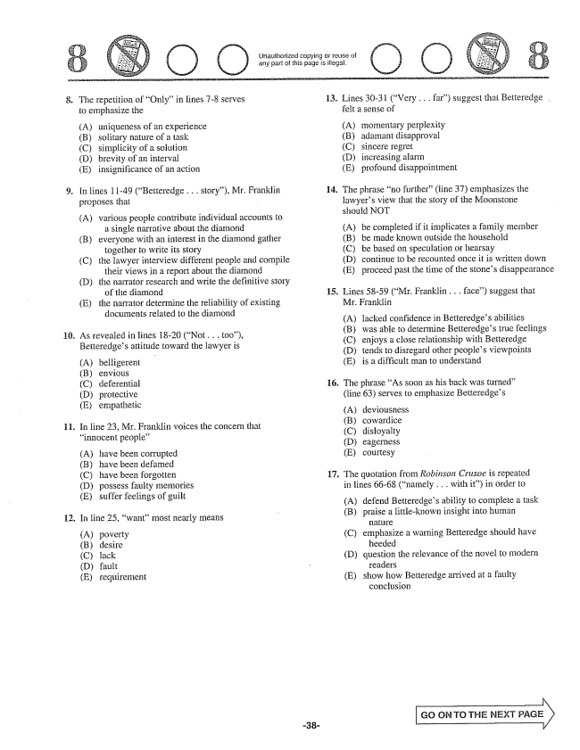

Unauthorized copying or reuse of any part of this page is illegal.

8.

**ii.**

The repetition of Only” in lines -8 serves to emphasize the

(A) (B) (C) (D) (E)

uniqueness of an experience Solitary nature of a task simplicity of a solution brevity of an interval insignificance of an action

In lines 11-49 (Betteredge . . . story), Mr. Franklin proposes that

(A) various people contribute individual accounts to

a single narrative about the diamond (B) everyone with an interest in the diamond gather

together to write its story (C) the lawyer interview different people and compile their views in a report about the diamond (Đ) the narrator research and write the definitive story

of the diamond (E) the narrator determine the reliability of existing

documents related to the diamond

As revealed in lines 18-20 (Not . . . too), Betteredges attitude toward the lawyer is

(A) (B) (C) (D) (E)

belligerent envious deferential protective empathetic

In line 23, Mr. Franklin voices the collcern that innocent people”

(A) have been corrupted (B) have been defamed (C) have been forgotten (D) possess faulty memories (E) suffer feelings of guilt

. In line 25, want” most nearly ineans

(A) poverty (B) desire (C) lack (D) fault (E) requirement

13.

**14.**

**16.**

17.

Lines 30-31 (Very .. far) suggest that Betteredge . felt a sense of

(A) (B) (C) (D) (E)

momentary perplexity adamant disapproval sincere regret increasing alarm profound disappointment

The phrase no further(line 37) emphasizes the lawyers view that the story of the Moonstone should NOT

(A) be completed if it implicates a family member (B) be made known outside the household (C) be based on speculation or hearsay (D) continue to be recounted once it is written down (E) proceed past the time of the stones disappearance

. Lines 5859 (Mr. Franklin . . . face) suggest that

Mr. Franklin

(A) (B) (C) (D) (E)

lacked confidence in Betteredges abilities was able to determine Betteredges true feelings enjoys a close relationship with Betteredge tends to disregard other peoples viewpoints is a difficult man to understand

The phrase As soon as his back was turned” (line 63) serves to emphasize Betteredges

(A) (B) (C) (D) (E)

deviousness cowardice disloyalty eagerness courtesy

The quotation from Robinson Crusoe is repeated in lines 66-68 (namely . . . with it) in order to

(A) defend Betteredges ability to complete a task

(B) praise a littleknown insight into human

H181

(C) emphasize a warning Betteredge should have

heeded

(D) question the relevance of the novel to modern

Teaders

(E) show how Betteredge arrived at a faulty

conclusion

GO ON TO THE NEXT



18. In line 67, cost” most nearly means 19. Ultimately, Betteredge regards the quotation from

(A) personal toll Robinson Crusoe as (B) legal obligation (A) an omen (C) moral fortitude (B) a cliché (D) financial expenditure (C) a metaphor (E) Social sacrifice (D) a paradox

Ea distraction

if you finish before time is called, you shay check your Work on this section only. Io not turn to any other section in the test,

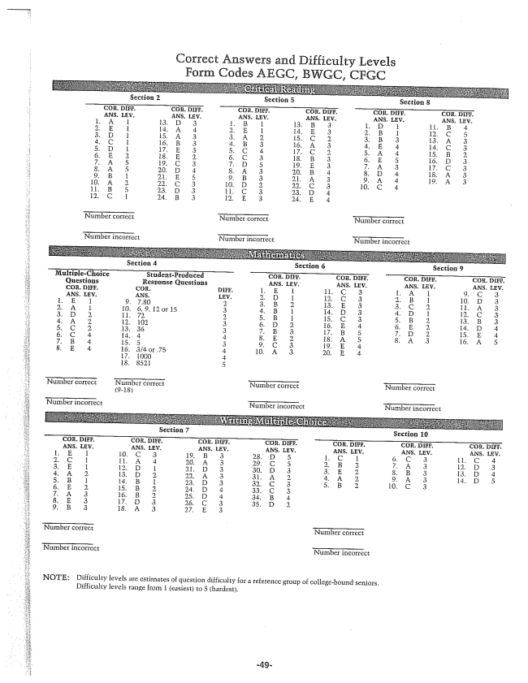

Correct Answers and Difficulty Levels Form Codes AEGC, BWGC, CFGC

**Section 4 Section 6 Section 9**

**Section 7 Section 10**

NOTE: Difficulty levels are estimates of question difficulty for a reference group of collegebound seniors.

Difficulty levels range from 1 (easiest) to 5 (hardest.