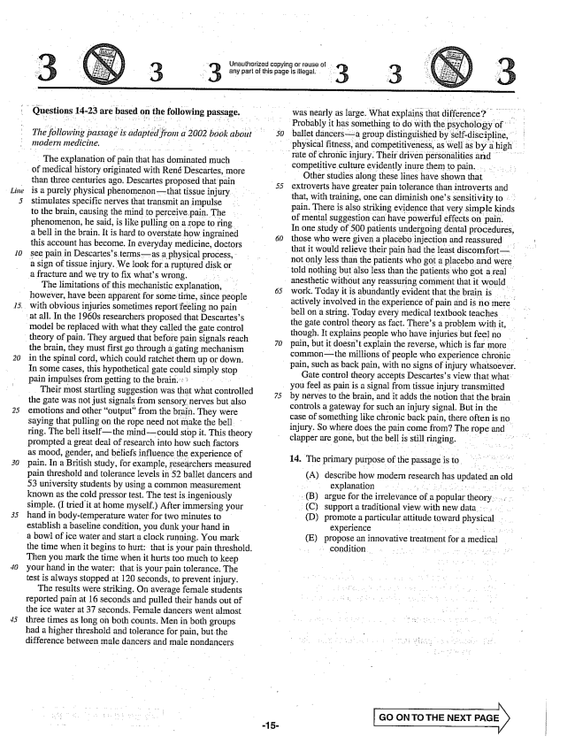

*30*

Unauthorized copying or reuse of any part of this page is illegal. - 3

Questions 14-23 are based on the following passage.

*The following passage is adapted from a 2002 book about*

*modern medicine,*

The explanation of pain that has dominated much

- of Inedical history originated with René Descartes, more

than three centuries ago. Descartes proposed that pain is a purely physical phenomenonthat tissue injury. stimulates specific nerves that transmit an impulse to the brain, causing the mind to perceive pain. The phenomenon, he said, is like pulling on a rope to ring a bell in the brain. It is hard to overstate how ingrained this account has become. In everyday medicine, doctors see pain in Descartess termsas a physical process, a sign of tissue injury. We look for a ruptured disk or a fracture and we try to fix whats wrong. . . . . . The limitations of this mechanistic explanation, however, have been apparent for sometime, since people

with obvious injuries sometimes reportfeeling no pain at all. In the 1960s researchers proposed that Descartess

model be replaced with what they called the gate control theory of pain. They argued that before pain signals reach the brain, they must first go through a gating mechanism in the spinal cord, which could ratchet them up or down. In some cases, this hypothetical gate could simply sto pain impulses from getting to the brain. . .

Their most startling suggestion was that what controlled the gate was not just signals from sensory nerves but also emotions and other output" from the brain. They were saying that pulling on the rope need not make the bell, ring. The bell itselfthe mindcould stop it. This theory prompted a great deal of research into how such factors as mood, gender, and beliefs influence the experience of pain. In a British study, for example, researchers measured pain threshold and tolerance levels in 52 ballet dancers and 53 university students by using a common measurement known as the cold pressor test. The test is ingeniously simple. (I tried it at home myself.) After immersing your hand in body-temperature water for two minutes to establish a baseline condition, you dunk your hand in a bowl of ice water and start a clock running. You mark

the time when it begins to hurt; that is your pain threshold.

Then you mark the time when it hurts too much to keep your hand in the water: that is your pain tolerance. The test is always stopped at 120 seconds, to prevent injury.

The results were striking. On average female students reported pain at 16 seconds and pulled their hands out of the ice water at 37 seconds. Female dancers went almost three times as long on both counts. Men in both groups had a higher threshold and tolerance for pain, but the difference between male dancers and male nondancers

was nearly as large. What explains that difference? . Probably it has something to do with the psychology of ballet dancersa group distinguished by self-discipline,

physical fitness, and competitiveness, as well as by a high rate of chronic injury. Their driven pèrsonalities and

competitive culture evidently inure them to pain. . . . . . . .

Other studies along these lines have shown that extroverts have greater pain tolerance than introverts and that, with training, one can diminish ones sensitivity to pain. There is also striking evidence that very simple kinds of mental suggestion can have powerful effects on pain. In one study of 500 patients undergoing dental procedures, those who were given a placebo injection and reassured that it would relieve their pain had the least discomfortnot only less than the patients who got a placebo and were told nothing but also less than the patients who got a real anesthetic without any reassuring comment that it would work. Today it is abundantly evident that the brain is actively involved in the experience of pain and is no mere bell on a string. Today every medical textbook teaches the gate control theory as fact. Theres a problem with it, though. It explains people who have injuries but feel no pain, but it doesn't explain the reverse, which is far more commonthe millions of people who experience chronic

pain, such as back pain, with no signs of injury whatsoever.

-15

Gate control theory accepts Descartess view that what

you feel as pain is a signal from tissue injury transmitted

by nerves to the brain, and it adds the notion that the brain controls a gateway for such an injury signal. But in the case of something like chronic back pain, there often is no injury. So where does the pain come from? The rope and clapper are gone, but the bell is still ringing.

14. The primary purpose of the passage isto

(A) describe how modern research has updated an old

explanation . . . . . . . . . . . . . . (B) argue for the irrelevance of a popular theory . ... (C) support a traditional view with new data. . . (D) promote a particular attitude toward physical

experience . . . . . . . . . (E) propose an innovative treatment for a medical

condition. .. . . . . . . .

**GO ON TO THE NEXT PAGE**

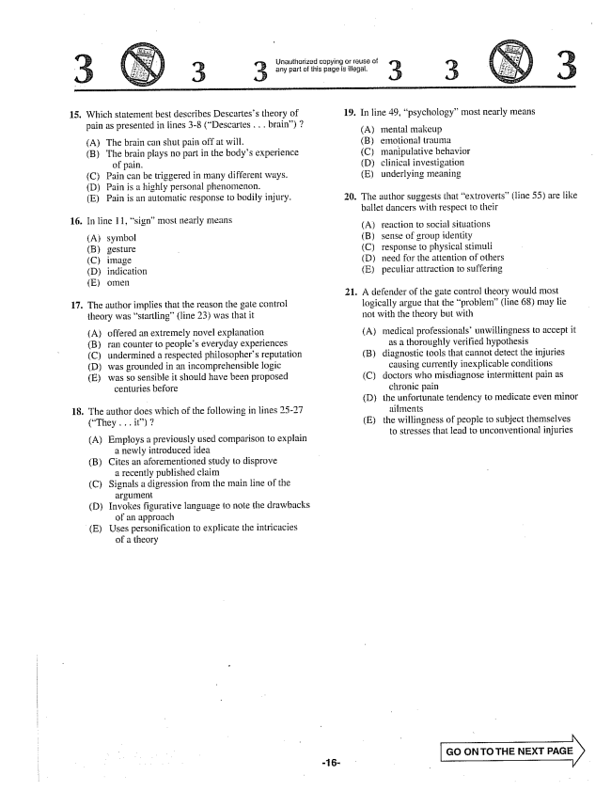

isnauthorized copying or reuse of -- 3 3 any part of this page is illegal. 3 3

15. Which statement best describes Descartess theory of 19. In line 49, psychology” most nearly means

(A) The brain can shut pain off at will. (B) emotional trauma (B) The brain plays no part in the bodys experience (C) manipulative behavior

of pain. (D) clinical investigation (C) Pain can be triggered in many different ways. (E) underlying meaning (D) Pain is a highly personal phenomenon. (E) Pain is an automatic response to bodily injury. 20. The author suggests that extroverts” (line 55) are like

ballet dancers with respect to their

16. In line 11, signmost nearly means - - - - - -

у (A) reaction to social situations

(A) symbol (B) sense of group identity

(B) gesture - C) response to physical stimuli

(C) image (D) need for the attention of others

(D) indication (E) peculiar attraction to suffering

(E) omen

21. A defender of the gate control theory would most

17. The author implies that the reason the gate control logically argue that the problem(line 68) may lie

theory was startling(line 23) was that it not with the theory but with

(A) offered an extremely novel explanation (A) medical professionalsunwillingness to accept it

(B) ran counter to peoples everyday experiences as a thoroughly verified hypothesis

(C) undermined a respected philosophers reputation (B) diagnostic tools that cannot detect the injuries

(D) was grounded in an incomprehensible logic causing currently inexplicable conditions

(E) was so sensible it should have been proposed (C) doctors who misdiagnose intermittent pain as

centuries before chronic pain

(D) the unfortunate tendency to medicate even minor

18. The author does which of the following in lines 25-27 ailments

(They .. it) (E) the willingness of people to subject themselves

- - to stresses that lead to unconventional injuries (A) Employs a previously used comparison to explain

a newly introduced idea (B) Cites an aforementioned study to disprove

a recently published claim (C) Signals a digression from the main line of the

argument D) Invokes figurative language to note the drawbacks

of an approach (E) Uses personification to explicate the intricacies

of a theory

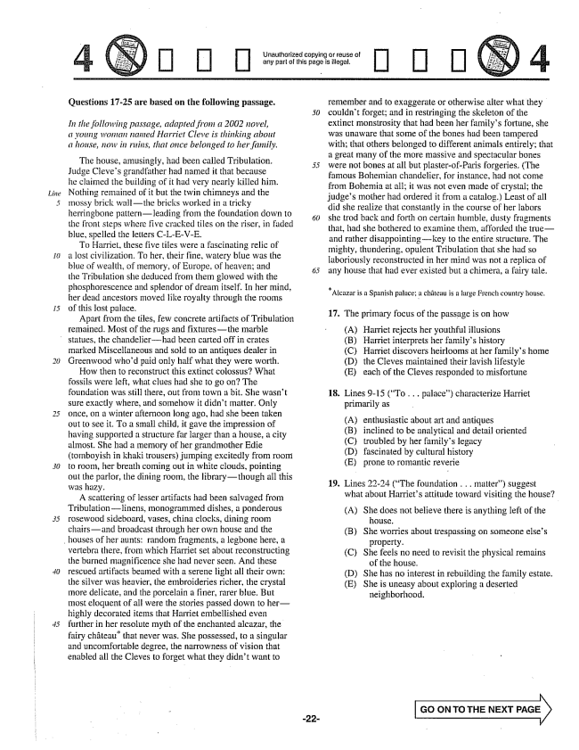

*Line*

*20*

] [I] []

Unauthorized copying or reuse of arly part of this page is tilegal.

[] [] []

**Questions 17-25 are based on the following passage.**

*In the following passage, adapted from a 2002 novel, a young woman named Harriet Cleve is thinking about a , now in ruins, that once belonged to her family.*

The house, amusingly, had been called Tribulation. Judge Cleves grandfather had named it that because he claimed the building of it had very nearly killed him. Nothing remained of it but the twin chimneys and the mossy brick wallthe bricks worked in a tricky herringbone patternleading from the foundation down to the front steps where five cracked tiles on the riser, in faded blue, spelled the letters CLE-VE.

To Harriet, these five tiles were a fascinating relic of a lost civilization. To her, their fine, watery blue was the blue of wealth, of memory, of Europe, of heaven; and the Tribulation she deduced from thern glowed with the phosphorescence and splendor of dream itself. In her mind, her dead ancestors moved file royalty through the rooms of this lost palace.

Apart from the tiles, few concrete artifacts of Tribulation remained. Most of the rugs and fixturesthe marble statues, the chandelierhad been carted off in crates marked Miscellaneous and sold to an antiques dealer in Greenwood whod paid only half what they were worth.

How then to reconstruct this extinct colossus? What fossils were left, what clues had she to go on? The foundation was still there, out from town a bit. She wasn't sure exactly where, and somehow it didn't matter. Only once, on a winter afternoon long ago, had she been taken out to see it. To a small child, it gave the impression of having supported a structure far larger than a house, a city almost. She had a memory of her grandmother Edie (tomboyish in khaki trousers) jumping excitedly from room to room, her breath coming out in white clouds, pointing out the parlor, the dining room, the librarythough all this was hazy.

A scattering of lesser artifacts had been salvaged from Tribulationlinens, monogrammed dishes, a ponderous rosewood sideboard, vases, china clocks, dining room chairsand broadcast through her own house and the

houses of her aunts; random fragments, a legbone here, a

vertebra there, from which Harriet set about reconstructing the burned magnificence she had never seen. And these rescued artifacts beamed with a serene light all their own: the silver was heavier, the embroideries richer, the crystal more delicate, and the porcelain a finer, rarer blue. But most eloquent of all were the stories passed down to herhighly decorated items that Harriet embellished even further in her resolute myth of the enchanted alcazar, the fairy château" that never was, She possessed, to a singular and uncomfortable degree, the narrowness of vision that enabled all the Cleves to forget what they didn't want to

*50*

remember and to exaggerate or otherwise alter what they couldn't forget; and in restringing the skeleton of the extinct monstrosity that had been her familys fortune, she was unaware that some of the bones had been tampered with; that others belonged to different animals entirely; that a great many of the more massive and spectacular bones were not bones at all but plasterof-Paris forgeries. (The famous Bohemian chandelier, for instance, had not come from Bohemia at all; it was not even made of crystal; the judges mother had ordered it from a catalog) Least of all did she realize that constantly in the course of her labors she trod back and forth on certain humble, dusty fragments that, had she bothered to examine them, afforded the trueand rather disappointingkey to the entire structure. The mighty, thundering, opulent Tribulation that she had so laboriously reconstructed in her mind was not a replica of any house that had ever existed but a chimera, a fairy tale.

**- - - -**

Alcazar is a Spanish palace; a château is a large French country house.

17. The primary focus of the passage is on how

(A) Harriet rejects her youthful illusions (B) Harriet interprets her familys history (C) Harriet discovers heirlooms at her familys home (D) the Cleves maintained their lavish fifestyle (E) each of the Cieves responded to misfortune

**18**

Lines -15 (To . . . palace) characterize Harriet primarily as

(A) (B) (C) (D) (E)

enthusiastic about art and antiques inclined to be analytical and detail oriented troubled by her familys legacy fascinated by cultural history prone to romantic reverie

19. Lines 22-24 (The foundation . . . matter) suggest

what about Harriets attitude toward visiting the house?

(A) She does not believe there is anything left of the

house.

(B) She worries about trespassing on someone elses

property.

(C) She feels no need to revisit the physical remains

of the house.

(D) She has no interest in rebuilding the family estate.

(E) She is uneasy about exploring a deserted

neighborhood.

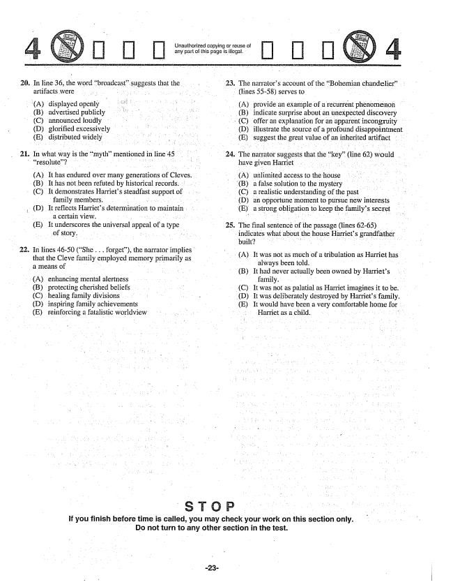

20. In line 36, the word broadcastsuggests that the artifacts were . . . . . . .

(A) displayed openly (B) advertised publicly

(C) announced loudly (D) glorified excessively (E) distributed widely . In what way is the mythmentioned in line 45

resolute? . . . . . . . . . . . . . . . .

(A) It has endured over many generations of Cleves.

(B) It has not been refuted by historical records. . . . . "

(C) It demonstrates Harriets steadfast support of family members. . . . (D) It reflects Harriets determination to maintain . a certain view. . T . (E) It underscores the universal appeal of a type

of story. . . . . . . .

. In lines 4650 (She . . . forget), the narrator implies"

that the Cleve family employed memory primarily as a means of .

(A) enhancing mental alertness . . (B) protecting cherished beliefs (C) healing family divisions (D) inspiring family achievements (E) reinforcing a fatalistic worldview

23.

--- . Unauthorized copying or reuse of . ; : any part of this page is illegal. .

The narrators account of the Bohemian chandelier. .

(lines 55-58) serves to

(A) provide an example of a recurrent phenomenon

(B) indicate surprise about an unexpected discovery

(C) offer an explanation for an apparent incongruity

(D) illustrate the source of a profound disappointment

(E) suggest the great value of an inherited artifact

. The narrator suggess that the key" (line 62) would

have given Harriet

(A) unlimited access to the house

(B) a false solution to the mystery

(C) a realistic understanding of the past . . . . (D) an opportune moment to pursue new interests

(E) a strong obligation to keep the familys secret

. The final sentence of the passage (lines 62-65)

indicates what about the house Harriets grandfather

(A. It was not as much of a tribulation as Harriet has

always been told. . . . (B) It had never actually been owned by Harriets

family. . . . . . . (C) It was not as palatial as Harriet imagines it to be.

(D) It was deliberately destroyed by Harriets family.

(E) It would have been a very comfortable home for

Harriet as a child. . . . . . . . . . . . .

**If you finish before time is called, you may check your work on this section only. Do not turn to any other section in the test.**

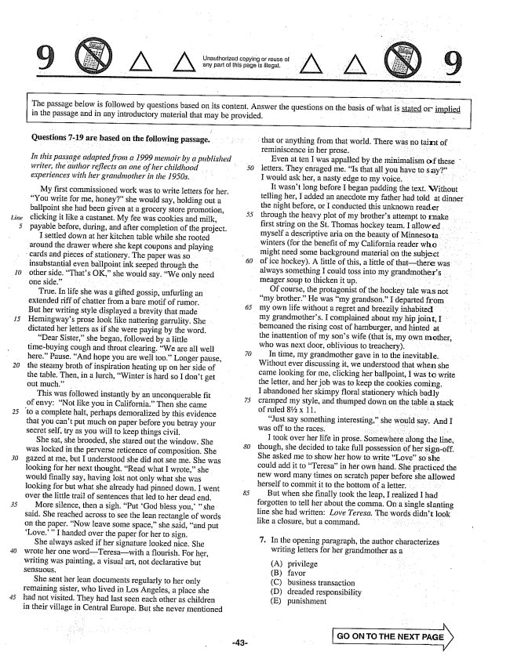

*15*

*30.*

Unauthorized copying or reuse of any part of this page is legal.

The passage below is followed by questions based on its content. Answer the questions on the basis of what is in the passage and in any introductory material that may be provided, -

stated or implied

**Questions -19 are based on the following passage.**

*In this passage adapted from a 1999 memoir by a published writer, the author reflects on one of her childhood*

*experiences with her grandmother in the 1950s.*

My first commissioned work was to write letters for her. You write forme, honey” she would say, holding out a ballpoint she had been given at a grocery store promotion, clicking it like a castanet. My fee was cookies and milk, payable before, during, and after completion of the project.

I settled down at her kitchen table while she rooted around the drawer where she kept coupons and playing

cards and pieces of stationery. The paper was so

insubstantial even ballpoint ink seeped through the other side. Thats OK,she would say, We only need one side.” - -

True. In life she was a gifted gossip, unfurling an extended riff of chatter from a bare motif of rumor. But her writing style displayed a brevity that made Hemingways prose look like mattering garrulity. She dictated her letters as if she were paying by the word.

Dear Sister,she began, followed by a little timebuying cough and throat clearing, We are all well here.” Pause. And hope you are well too” Longer pause, the steamy broth of inspiration heating up on her side of the table. Then, in a lurch, Winter is hard so I don't get out much.” . - -

This was followed instantly by an unconquerable fit of envy: Not like you in California.” Then she came

to a complete halt, perhaps demoralized by this evidence

that you cant put much on paper before you betray your secret self, try as you will to keep things civil.

She sat, she brooded, she stared out the window. She was locked in the perverse reticence of composition. She gazed at me, but I understood she did not see me. She was looking for her next thought. Read what I wrote,she would finally say, having lost not only what she was looking for but what she already had pinned down, I went over the little trail of sentences that led to her dead end.

More silence, then a sigh. Put God bless you," she said. She reached across to see the lean rectangle of words on the paper, Now leave some space,she said, and put Love." I handed over the paper for her to sign,

She always asked if her signature looked nice. She wrote her one wordTeresawith a flourish. For her, writing was painting, a visual art, not declarative but 1Sli. -

She sent her lean documents regularly to her only Temaining sister, who lived in Los Angeles, a place she had not visited. They had last seen each other as children in their village in Central Europe. But she never mentioned

that or anything from that world. There was no taint of

reminiscence in her prose. .

Even at ten I was appalled by the minimalism of these letters. They enraged me. Is that all you have to say” . I would ask her, a nasty edge to my voice. . . . . . . . It wasn't long before I began padding the text. Without telling her, I added an anecdote my father had told at dinner the night before, or I conducted this unknown reader through the heavy plot of my brothers attempt to Imake first string on the St. Thomas hockey team. I allowed . . . . myself a descriptive aria on the beauty of Minnesota . . winters (for the benefit of my California reader who might need some background material on the subject of ice hockey). A little of this, a little of thatthere was always something I could toss into my grandmothers meager soup to thicken it up.

Of course, the protagonist of the hockey tale was not my brother.” He was my grandson.” I departed from my own life without a regret and breezily inhabited . . my grandmothers. I complained about my hip joint, I

bemoaned the rising cost of hamburger, and hinted at

the inattention of my sons wife (that is, my own mother who was next door, oblivious to treachery). . . . . . . . .

In time, my grandmother gave in to the inevitable. Without ever discussing it, we understood that when she came looking for me, clicking her ballpoint, I was to write the letter, and her job was to keep the cookies coming. I abandoned her skimpy floral stationery which badly cramped my style, and thumped down on the table a stack of ruled % 11.

Just say something interesting,she would say. And I was off to the races.

I took over her life in prose. Somewhere along the line, though, she decided to take full possession of her signoff. She asked me to show her how to write Loveso she could add it to Teresain her own hand. She practiced the new word many times on scratch paper before she allowed herself to commit it to the bottom of a letter. . . -

But when she finally took the leap, I realized I had forgotten to tell her about the comma. On a single slanting line she had written: Love Teresa. The words didnt look like a closure, but a command. . . . . . . . . . .

. In the opening paragraph, the author characterizes

writing letters for her grandmother as a

(A) privilege

(B) favor (C) business transaction

(D) dreaded responsibility

(E) punishment

**GO ON TO THE NEXT**

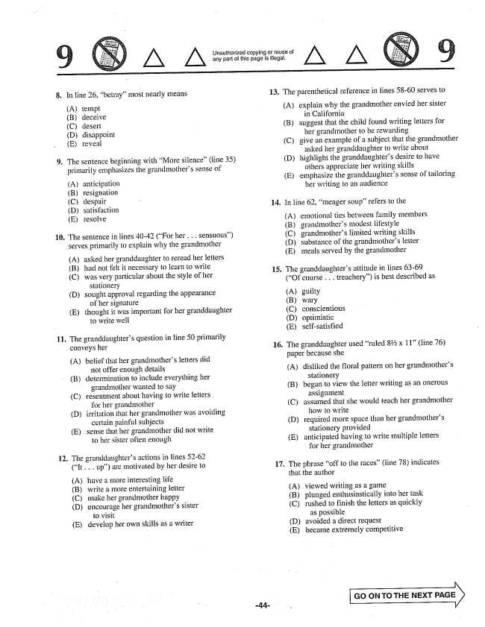

Unauthorized copying or reuse ol any part of this page is illegal.

**10.**

In line 26, betray” most nearly means

(A) tempt (B) deceive (C) desert (D) disappoint (E) reveal

The sentence beginning with More silence" (line 35) primarily emphasizes the grandmothers sense of

(A) anticipation (B) resignation (C) despair (D) Satisfaction (E) resolve

The sentence in lines 40-42 (For her . . . sensuous) serves primarily to explain why the grandmother

(A)

(B) (C)

asked her granddaughter to reread her letters had not felt it necessary to learn to write was very particular about the style of her

stationery sought approval regarding the appearance

of her signature thought it was important for her granddaughter to write well -

(D)

(E)

The granddaughters question in line 50 primarily conveys her

(A) belief that her grandmothers letters did

not offer enough details (B) determination to include everything her

grandmother wanted to say (C) resentment about having to write letters

for her grandmother (D) irritation that her grandmother was avoiding

certain painful subjects (E) sense that her grandmother did not write

to her sister often enough

. The granddaughters actions in lines 52-62

(It . . . up) are motivated by her desire to

(A) have a more interesting life (B) write a more entertaining letter (C) make her grandmother happy (D) encourage her grandmothers sister

to visit (E) develop her own skills as a writer

13. The parenthetical reference in lines 58-60 serves to

(A) explain why the grandmother envied her sister

in California suggest that the child found writing letters for

her grandmother to be rewarding give an example of a subject that the grandmother

asked her granddaughter to write about highlight the granddaughters desire to have

others appreciate her writing skills emphasize the granddaughters sense of tailoring

her writing to an audience

(B)

(C)

(D)

(E)

14. In line 62, meager soup” refers to the

(A) (В) (C) (D) (E)

emotional ties between family members grandmothers modest lifestyle grandmothers limited writing skills substance of the grandmothers letter meals served by the grandmother

15. The granddaughters attitude in lines 63-69

(Of course . . . treachery) is best described as

(A) guilty

(B) wary

(C) conscientious

(D) optimistic

(E) self-satisfied

16. The granddaughter used ruled % 11(line 76)

paper because she

(A) disliked the floral pattern on her grandmothers

stationery (B) began to view the letter writing as an onerous

assignment (C) assumed that she would teach her grandmother

how to write (D) required more space than her grandmothers

stationery provided (E) anticipated having to write multiple letters

for her grandmother

17. The phrase off to the races” (line 78) indicates

that the author

(A) viewed writing as a game (B) plunged enthusiastically into her task (C) rushed to finish the letters as quickly

as possible (D) avoided a direct request (E) became extremely competitive

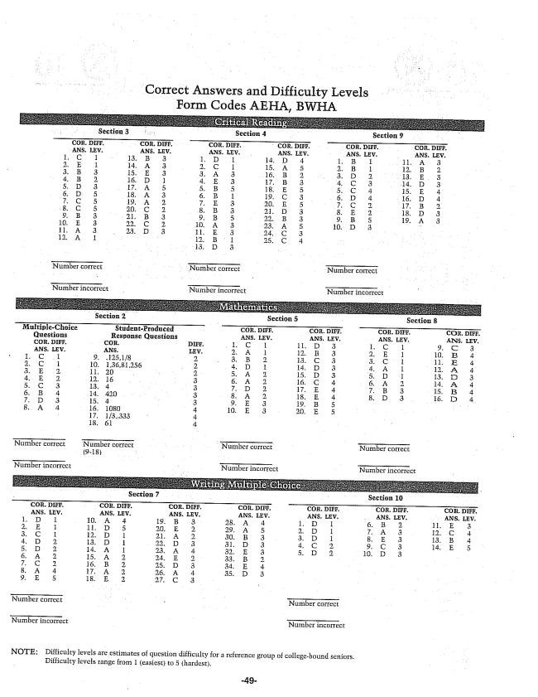

Correct Answers and Difficulty Levels Form Codes AEHA, BWHA

Section 2 - Section 8 MultipleChoice StudentProduced COR. DIEF. . DI, 20. . CUR. DIFF, Questions Response Questions ANS. I, EV. ANS, LEV. ANS. LEV, ANS, LEV, , COR, DIFF. DIFF. 1. C I . 1. C ANS, LEV. IEV. 2. A 1 11. B 3 1. E. LD,,4 I, C 1. 3. B. 2. 13. 3 3. C 1 4 l 10. 1,36,81,256 . ID 14. E. 3 . A 12. A 4 11, 20 - 2. . A 1 15. D 3 13. D 3 . E. 12. 16 3 . A 2. 16. C 4 . A 2. 14. A 4 . C 3 , 4 3 . H. 3 15, 4 . B. 4 14. 420 3 . A 18. E. 4 . D. 3. 4. . D 3 3 19, 5 . A 4 f. E 3 5

- 17, 13,333 4 4

Number correct Number correct Number correct

(9-18) -

Number incorrect - Number incurrect Number incorrect

**Section 7 - - - - - Section 10**

NOTE: Difficulty levels are estimates of question difficulty for a reference group of collegebound seniors.

Difficulty levels range from 1 (easiest) to 5 (hardest.