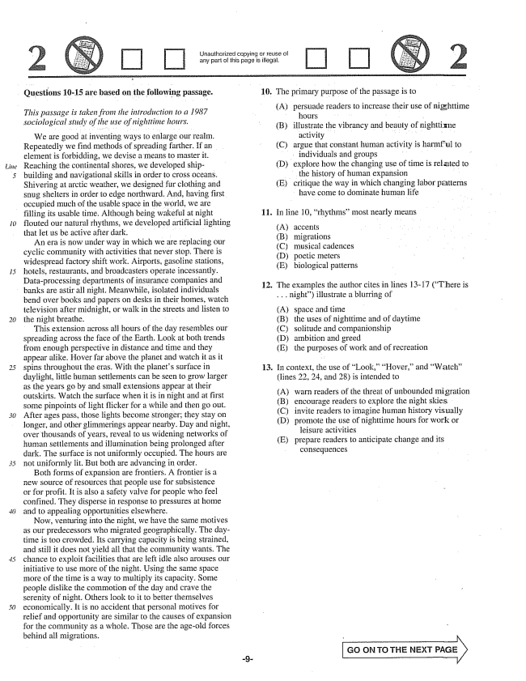

*Line*

*15*

Unauthorized copying or réise ci any part of this page is illegal.

**- Questions 10-15 are based on the following passage.**

*This passage is taken from the introduction to a 1987 sociological study of the itse of nighttime hours.*

We are good at inventing ways to enlarge our realm. Repeatedly we find methods of spreading farther. If an element is forbidding, we devise a means to master it. Reaching the continental shores, we developed shipbuilding and navigational skills in order to cross oceans. Shivering at arctic weather, we designed fur clothing and Snug shelters in order to edge northward. And, having first occupied much of the usable space in the world, we are filling its usable time. Although being wakeful at night flouted our natural rhythms, we developed artificial lighting that let lis be active after dark.

An era is now under way in which we are replacing our cyclic community with activities that never stop. There is widespread factory shift work. Airports, gasoline stations, hotels, restaurants, and broadcasters operate incessantly. Dataprocessing departments of insurance companies and

banks are all night. Meanwhile, isolated individuals

*20*

*30*

*45*

bend over books and papers on desks in their homes, watch television after midnight, or walk in the streets and listen to the night breathe. - . . . .

This extension across all hours of the day resembles our spreading across the face of the Earth. Look at both trends from enough perspective in distance and time and they appear alike, Hover far above the planet and watch it as it spins throughout the eras. With the planets surface in daylight, little human settlements can be seen to grow larger as the years go by and small extensions appear at their outskirts. Watch the surface when it is in night and at first some pinpoints of light flicker for a while and then go out. After ages pass, those lights become stronger; they stay on longer, and other glimmerings appear nearby. Day and night, over thousands of years, reveal to us widening networks of human settlements and illumination being prolonged after dark. The surface is not unifornly occupied. The hours are not uniformly lit. But both are advancing in order.

Both forms of expansion are frontiers. A frontier is a new source of resources that people use for subsistence or for profit. It is also a safety valve for people who feel confined. They disperse in response to pressures at home and to appealing opportunities elsewhere.

Now, venturing into the night, we have the same motives as our predecessors who migrated geographically. The daytime is too crowded. Its carrying capacity is being strained, and still it does not yield all that the community wants. The chance to exploit facilities that are left idle also arouses our initiative to use more of the night. Using the same space more of the time is a way to multiply its capacity. Some people dislike the commotion of the day and crave the Serenity of night. Others look to it to better themselves economically. It is no accident that personal motives for relief and opportunity are similar to the causes of expansion for the community as a whole. Those are the ageold forces behind all migrations.

10. The primary purpose of the passage is to

(A) persuade readers to increase their use of nighttime

hours - - illustrate the vibrancy and beauty of nighttime activity . . . . . . . . . - argue that constant human activity is harmful to

individuals and groups . . . explore how the changing use of time is related to the history of human expansion critique the way in which changing labor patterns

have come to dominate human life

(B)

(C)

(D)

(E)

**11**

In line 10, rhythms” most nearly means

(А) accents (B) migrations (C) musical cadences (D) poetic meters (E) biological patterns

The examples the author cites in lines 13-17 (There is . . . night) illustrate a blurring of

(A) (B) (C) (D) (E)

**12**

space and time the uses of nighttime and of daytime solitude and companionship ambition and greed the purposes of work and of recreation

In context, the use of Look,” “Hover,and Watch” (iines 22, 24, and 28) is intended to

(A) (B) (C) (D)

**13**

warn readers of the threat of unbounded migration

encourage readers to explore the night skies

invite readers to imagine human history visually

promote the use of nighttime hours for work or

leisure activities

prepare readers to anticipate change and its

consequences

(E)

GO ON TO THE NEXT PAGE

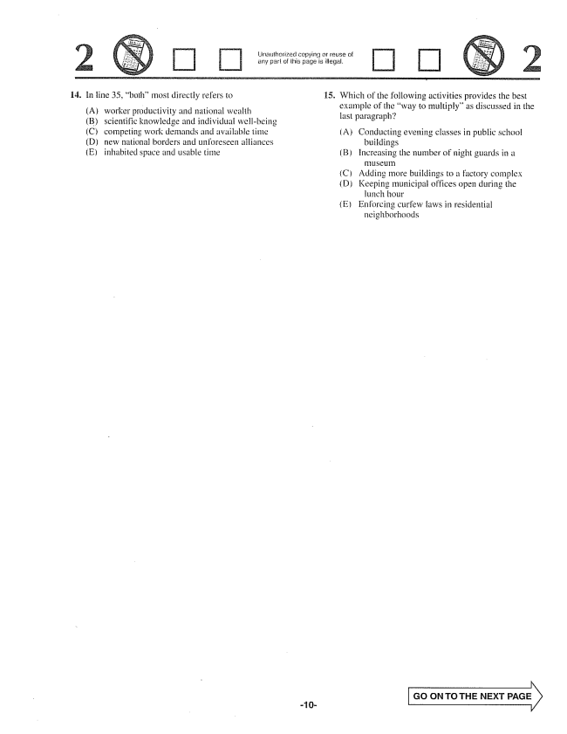

triatilhorized copying or reuse any part of this page is illegal.

14. In line 35, bothmost directly refers to 15. Which of the following activities provides the best

example of the way to multiply" as discussed in the

(A) worker productivity and national wealth ---

last paragraph

(B) scientific knowledge and individual well-being

(C) competing work demands and available time (A) Conducting evening classes in public school

(D) new national borders and unforeseen alliances buildings

(E) inhabited space and usable time (B) Increasing the number of night guards in a

(C) Adding more buildings to a factory complex

D) Keeping municipal offices open during the

lunch hour

(E) Enforcing curfew faws in residential

neighborhoods

GO ON TO THE NEXT PAGE

~ 10

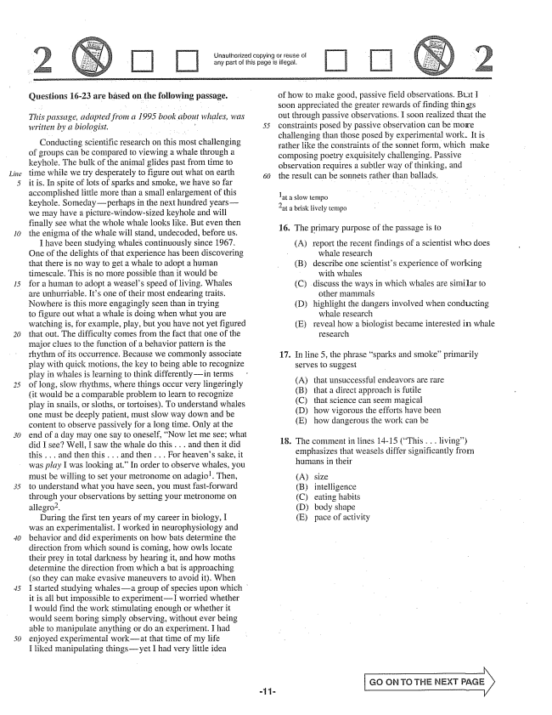

*Line*

**Questions 16-23 are based on the following passage.**

*This passage, adapted from a 1995 book about whales, was*

*written by a biologist. 55*

Conducting scientific research on this most challenging of groups can be compared to viewing a whale through a keyhole. The bulk of the animal glides past from time to time while we try desperately to figure out what on earth }

it is. In spite of lots of Sparks and smoke, we have so far accomplished little more than a small enlargement of this keyhole. Someday-perhaps in the next hundred yearswe may have a picturewindowsized keyhole and will finally see what the whole whale looks like. But even then the enigma of the whale will stand, undecoded, before us.

I have been studying whales continuously since 1967. One of the delights of that experience has been discovering that there is no way to get a whale to adopt a human timescale. This is no more possible than it would be for a human to adopt a weasels speed of living. Whales are unhurriable. Its one of their most endearing traits. Nowhere is this more engagingly seen than in trying to figure out what a whale is doing when what you are watching is, for example, play, but you have not yet figured that out. The difficulty comes from the fact that one of the major clues to the function of a behavior patterm is the rhythm of its occurrence. Because we commonly associate play with quick Inotions, the key to being able to recognize play in whales is learning to think differentlyin terms of long, slow rhythms, where things occur very lingeringly (it would be a comparable problem to learn to recognize play in snails, or sloths, or tortoises). To understand whales one must be deeply patient, must slow way down and be content to observe passively for a long time. Only at the end of a day may one say to oneself, Now let me see; what did I see? Well, I saw the whale do this . . . and then it did this . . . and then this . . . and then . . . For heavens sake, it was play I was looking at” In order to observe whales, you must be willing to set your metronome on adagio. Then, to understand what you have seen, you must fastforward through your observations by setting your metronome on allegro.

During the first ten years of my career in biology, I was an experimentalist. I worked in neurophysiology and behavior and did experiments on how bats determine the direction from which sound is coming, how owls locate their prey in total darkness by hearing it, and how moths determine the direction from which a bat is approaching (so they can make evasive maneuvers to avoid it. When I started studying whalesa group of species upon which it is all but impossible to experimentI worried whether H would find the work stimulating enough or whether it would seem boring simply observing, without ever being able to manipulate anything or do an experiment. I had enjoyed experimental workat that time of my life I liked manipulating thingsyet I had very little idea

of how to make good, passive field observations. But I soon appreciated the greater rewards of finding things out through passive observations. I soon realized that the constraints posed by passive observation can be more challenging than those posed by experimental work. It is rather like the constraints of the sonnet form, which make composing poetry exquisitely challenging. Passive observation requires a subtler way of thinking, and the result can be sonnets rather than ballads.

at a slow tempo at a brisk lively tempo

16. The primary purpose of the passage is to

(A) report the recent findings of a scientist who does

whale research (B) describe one scientists experience of working

with whales (C) discuss the ways in which whales are similar to

other mammals (D) highlight the dangers involved when conducting

whale research (E) reveal how a biologist became interested in whale

Tesearch .

17

In line , the phrase sparks and smoke” primarily Serves to suggest

(A) that unsuccessful endeavors are rare

(B) that a direct approach is futile

(C) that science can seem magical

(D) how vigorous the efforts have been

(E) how dangerous the work can be

18. The comment in lines 14-15 (This . . . living)

emphasizes that weasels differ significantly from humans in their

size intelligence eating habits body shape pace of activity

GO CR TO THE NEXT PAGE

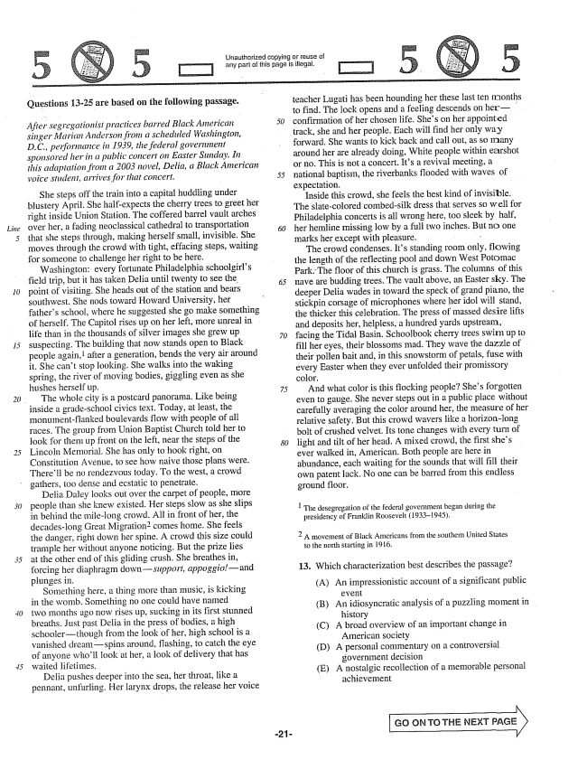

*Line*

Unauthorized copying or reuse of

any part of this page is illegal.

Questions 13-25 are based on the following passage.

*After segregationist practices barred Black American singer Marian Anderson from a scheduled Washington, DC., performance in 1939, the federal government sponsored her in a public concert on Easter Sunday. In this adaptation from a 2003 novel, Delia, a Black American voice student, arrives for that concert, . . . . . .*

She steps off the train into a capital huddling under blustery April. She half-expects the cherry trees to greet her right inside Union Station. The coffered barrel vault arches over her, a fading neoclassical cathedral to transportation that she steps through, making herself small, invisible. She moves through the crowd with tight, effacing steps, waiting for someone to challenge her right to be here.

Washington: every fortunate Philadelphia schoolgirls field trip, but it has taken Delia until twenty to see the point of visiting. She heads out of the station and bears southwest. She nods toward Howard University, her fathers school, where he suggested she go make something of herself. The Capitol rises up on her left, more unreal in life than in the thousands of silver images she grew up suspecting. The building that now stands open to Black people again, after a generation, bends the very air around it. She cant stop looking. She walks into the waking Spring, the river of moving bodies, giggling even as she hushes herself up.

The whole city is a postcard panorama. Like being inside a gradeschool civics text. Today, at least, the monumentflanked boulevards flow with people of all races. The group from Union Baptist Church told her to Hook for them up front on the left, near the steps of the Lincoln Memorial. She has only to hook right, on Constitution Avenue, to see how naive those plans were. Therell be no rendezvous today. To the west, a crowd gathers, too dense and ecstatic to penetrate. -

Delia Daley looks out over the carpet of people, more people than she knew existed. Her steps slow as she slips in behind the milelong crowd. All in front of her, the decadeslong Great Migrationcomes home. She feels the danger, right down her spine. A crowd this size could trample her without anyone noticing. But the prize lies at the other end of this gliding crush. She breathes in, forcing her diaphragm downsupport, appoggioand plungės in,

Something here, a thing more than Imusic, is kicking in the womb. Sornething no one could have named two months ago now rises up, sucking in its first stunned breaths. Just past Delia in the press of bodies, a high schoolerthough from the look of her, high school is a vanished dreamspins around, flashing, to catch the eye of anyone wholl look at her, a look of delivery that has waited lifetimes.

Delia pushes deeper into the sea, her throat, like a pennant, unfurling. Her larynx drops, the release her voice

teacher Lugati has been hounding her these last ten months to find. The lock opens and a feeling descends on herconfirmation of her chosen life. Shes on her appointed track, she and her people. Each will find her only way forward. She wants to kick back and call out, as so many around her are already doing, White people within earshot dr no. This is not a concert. Its a revival meeting, a national baptism, the riverbanks flooded with waves of expectation.

Inside this crowd, she feels the best kind of invisible. The slatecolored combedsilk dress that serves So well for Philadelphia concerts is all wrong here, too sleek by half, her hemline missing low by a full two inches. But no one marks her except with pleasure. :

The crowd condenses. Its standing room only, flowing the length of the reflecting pool and down West Potomac Park. The floor of this church is grass. The columns of this nave are budding trees. The vault above, an Easter sky. The deeper Delia wades in toward the speck of grand piano, the stickpin corsage of microphones where her idol will stand, the thicker this celebration. The press of massed desire lifts and deposits her, helpless, a hundred yards upstream, facing the Tidal Basin. Schoolbook cherry trees swirm up to fill her eyes, their blossoms mad. They wave the dazzle of their pollen bait and, in this snowstorm of petals, fuse with every Easter when they ever unfolded their promissory color,

And what color is this flocking people? Shes forgotten even to gauge. She never steps out in a public place without carefully averaging the color around her, the measure of her relative safety. But this crowd wavers like a horizonlong bolt of crushed velvet. Its tone changes with every turn of light and tilt of her head. A mixed crowd, the first shes ever walked in, American, Both people are here in abundance, each waiting for the sounds that will fill their own patent lack. No one can be barred from this endless ground floor,

| The desegregation of the federal government began during the

presidency of Franklin Roosevelt (19331945),

A movement of Black Americans from the southern United States

to the north starting in 1916.

13. Which characterization best describes the passage?

(A) An impressionistic account of a significant public

(B) An idiosyncratic analysis of a puzzling moment in

history

(C) A broad overview of an important change in

American society

(D) A personal commentary on a controversial

government decision

(E) A nostalgic recollection of a memorable personal

achievement

GO CN TO THE NEXT PAGE

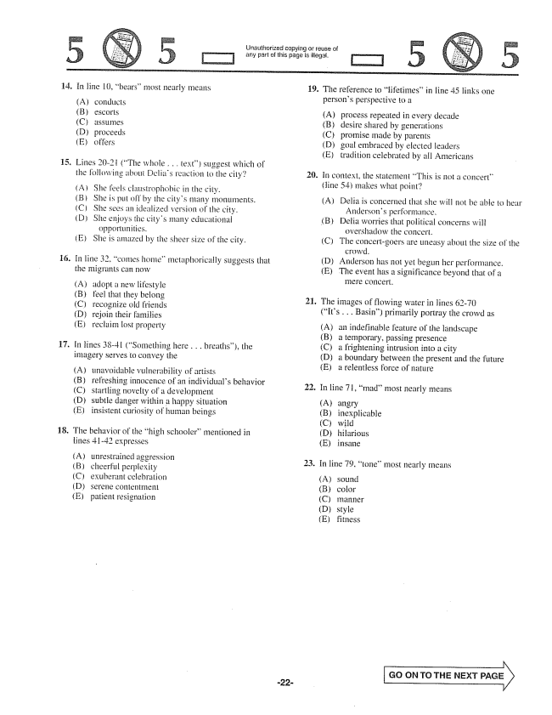

Unauthorized copying of reuse of

any part of this page is illegat,

14.

16.

17.

**18.**

In line 10, bears” most nearly means

() (B) (C) (D) (E)

Lines 20-2 i (The whole . . . text) suggest which of the following about Delias reaction to the city?

She feels claustrophobic in the city. She is put off by the citys many monuments. She sees an idealized version of the city. She enjoys the citys many educational

opportunities. (E) She is amazed by the sheer size of the city.

In line 32, comes home” metaphorically suggests that the migrants can now

(A) (B) (C) (D) (E)

adopt a new lifestyle feel that they belong recognize old friends rejoin their families

reclaim lost property

In lines 38-41 (Something here . . . breaths), the imagery Serves to convey the

unavoidable vulnerability of artists refreshing innocence of an individuals behavior startling novelty of a development subtle danger within a happy situation insistent curiosity of human beings

The behavior of the high schooler" mentioned in lines 41-42 expresses

(A) (C) (D) (E)

19. The reference to iifetimes” in line 45 links one

21.

persons perspective to a

process repeated in every decade desire shared by generations promise made by parents goal embraced by elected leaders tradition celebrated by all Americans

În context, the statement This is not a concert” (line 54) makes what point

(A) Delia is concerned that she will not be almie to hear

Andersons performance,

B) Defia worries that political concerns will

overshadow the concert.

(C) The concertgoers are uneasy about the size of the

crowd.

(D) Anderson has not yet begun her performance.

(E) The event has a significance beyond that of a

13 :.

The images of flowing water in lines 62-70 (Its . . . Basin) primarily portray the crowd as

(A) an indefinable feature of the landscape (B) a temporary, passing presence (C) a frightening intrusion into a city (D) a boundary between the present and the future Ea retentless force of nature

In line 71, mad” most nearly means

angry inexplicable wild hilarious insane

In line 79. tone” most nearly means

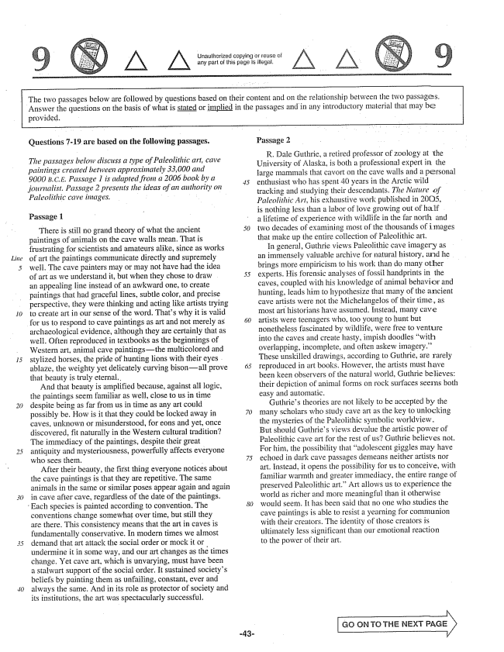

Unaulhorized copying or retise any part of this page is illegal.

The two passages below are followed by questions based on their content and on the relationship between the two passages. Answer the questions on the basis of what is stated or implied in the passages and in any introductory material that may be

provided.

*Linie*

26)

**Questions -19 are based on the following passages.**

*The passages below discuss a type of Paleolithic art, cave paintings created between approximately 33,000 and 9000 B.C.E. Passage 1 is adapted from a 2006 book by a journalist. Passage 2 presents the ideas of an authority on Paleolithic cave intages. - :*

Passage 1

There is still no grand theory of what the ancient paintings of animals on the cave walls mean. That is frustrating for scientists and amateurs alike, since as works of art the paintings communicate directly and Supremely well. The cave painters may or may not have had the idea of art as we understand it, but when they chose to draw an appealing fine instead of an awkward one, to create paintings that had graceful lines, subtle color, and precise perspective, they were thinking and acting like artists trying to create art in our sense of the word. Thats why it is valid for us to respond to cave paintings as art and not merely as archaeological evidence, although they are certainly that as well. Often reproduced in textbooks as the beginnings of Western art, animal cave paintingsthe multicolored and stylized horses, the pride of hunting lions with their eyes. ablaze, the weighty yet delicately curving bisonall prove that beauty is truly eternal.

And that beauty is amplified because, against all logic, the paintings seem familiar as well, close to us in time despite being as far from us in time as any art could possibly be. How is it that they could be locked away in caves, unknown of misunderstood, for eons and yet, once discovered, fit naturally in the Western cultural tradition? The immediacy of the paintings, despite their great antiquity and mysteriousness, powerfully affects everyone who sees them.

After their beauty, the first thing everyone notices about the cave paintings is that they are repetitive. The same animals in the same or similar poses appear again and again in cave after cave, regardless of the date of the paintings.

Each species is painted according to convention. The

conventions change somewhat over time, but still they are there. This consistency means that the art in caves is fundamentally conservative. In modern times we almost demand that art attack the social order or mock it or undermine it in Some way, and our art changes as the times change. Yet cave art, which is unvarying, must have been a stalwart Support of the social order. It sustained societys beliefs by painting them as unfailing, constant, ever and always the same. And in its role as protector of society and its institutions, the art was spectacularly successful.

*45*

Passage 2

R. Dale Guthrie, a retired professor of zoology at the University of Alaska, is both a professional expert in the large mammals that cavort on the cave walls and a personal enthusiast who has spent 40 years in the Arctic wild tracking and studying their descendants. The Nature of Paleolithic Art, his exhaustive work published in 2005, is nothing less than a labor of love growing out of half . a lifetime of experience with wildlife in the far north and two decades of examining most of the thousands of images that make up the entire collection of Paleolithic art.

In general, Guthrie views Paleolithic cave imagery as an immensely valuable archive for natural history, and he brings more empiricism to his work than do many other experts. His forensic analyses of fossil handprints in the caves, coupled with his knowledge of animal behavior and hunting, leads him to hypothesize that many of the ancient cave artists were not the Michelangelos of their time, as most arfhistorians have assumed. Instead, many cave artists were teenagers who, too young to hunt but nonetheless fascinated by wildlife, were free to venture into the caves and create hasty, impish doodles with overlapping, incomplete, and often askew imagery.” These unskilled drawings, according to Guthrie, are rarely reproduced in art books. However, the artists must have been keen observers of the natural world, Guthrie believes: their depiction of animal forms on rock surfaces seems both easy and automatic.

Guthries theories are not likely to be accepted by the many scholars who study cave art as the key to unlocking the mysteries of the Paleolithic symbolic worldview. But should Guthries views devalue the artistic power of Paleolithic cave art for the rest of usGuthrie believes not. For him, the possibility that adolescent giggles may have echoed in dark cave passages demeans neither artists nor art. Instead, it opens the possibility for us to conceive, with familiar warmth and greater immediacy, the entire range of preserved Paleolithic art.” Art allows us to experience the world as richer and more meaningful than it otherwise would seem. It has been said that no one who studies the cave paintings is able to resist a yearning for communion with their creators. The identity of those creators is ultimately less significant than our emotional reaction to the power of their art.

Go ON TO THE NEXT PAGE

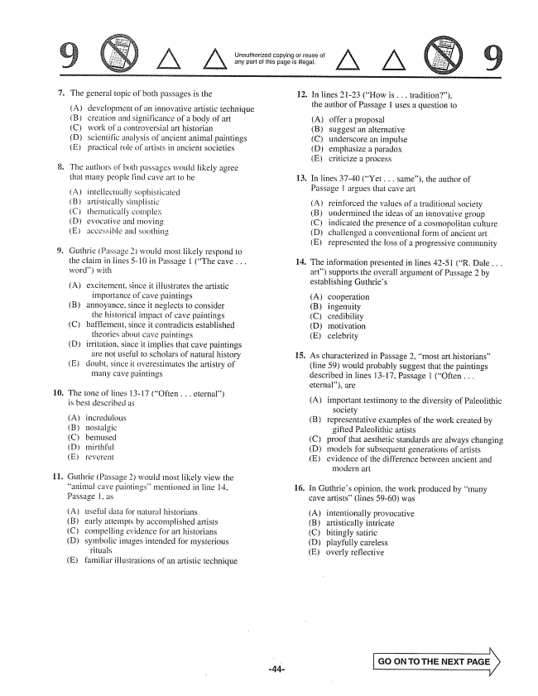

Unauthorized copying or reuse of any part of this page is illegal.

. The general topic of both passages is the

(A) development of an innovative artistic technique

(B) creation and significance of a body of art (C) Work of a controversial art historiam (D) scientific analysis of ancient animal paintings (E) practical rule of artists in ancient societies

. The authors of both passages would likely agree

that many people find cave art to be

(A) intellectually sophisticated (B) artistically simplistic (C) thematically complex (D) evocative and moving (E) accessible and soothing

. Guthrie (Passage 2would most likely respond to

the claim in lines -10 in Passage I (The cave . . . word) with

(A) excitement, since it illustrates the artistic

importance of cave paintings (B) annoyance, since it neglects to consider the historical impact of cave paintings (C) bafflement, since it contradicts established

theories about cave paintings (D) in ritation, since it implies that cave paintings are not useful to scholars of natural history Edoubt, since it overestimates the artistry of

many cave paintings

10. The tone of lines 13-17 (Often . . .

is besi described Is

eternal)

(A) incredulous (B) nostalgic (CbemliSed {}) mirthful (Ereverent

Guthrie (Passage 2) would most likely view the animal cave paintings” mentioned in line 14, Passage 1, as

(A) usefui data for natural historians (B) early attempts by accomplished artists (C) compelling evidence for art historians (D) symbolic images intended for mysterious

rituals (E) familiar illustrations of an artistic technique

**12.**

**14**

15

In lines 2123 (How is . . . tradition", the author of Passage 1 uses a question to

(A) offer a proposal (B) suggest an alternative (C) underscore un impulse (D) emphasize a paradox (E) criticize a process

In lines 37-40 (Yet . . . same), the author of Passage l argues that cave art

(A) reinforced the values of a traditional society (B) undermined the ideas of an innovative group (C) indicated the presence of a cosmopolitan culture (D) challenged a conventional form of ancient art (E) represented the loss of a progressive community

The information presented in lines 4251 (R. Dale . . . art) supports the overall argument of Passage 2 by establishing Guthries

(A) cooperation (B) ingenuity (C) credibility (D) motivation (E) celebrity

As characterized in Passage 2, most art historians” (line 59) would probably suggest that the paintings described in lines 13-17, Passage 1 (Often . . . eternal), are

(A) important testimony to the diversity of Paleolithic

society

(B) representative examples of the work created by

gifted Paleolithic artists

(C) proof that aesthetic standards are always changing

(D) models for subsequent generations of artists

(E) evidence of the difference between ancient and

motfern art

In Guthries opinion, the work produced by many cave artists” (lines 5960) was

(A) intentionally provocative (B) artistically intricate (C) bitingły satiric (D) playfully careless (E) overly reflective

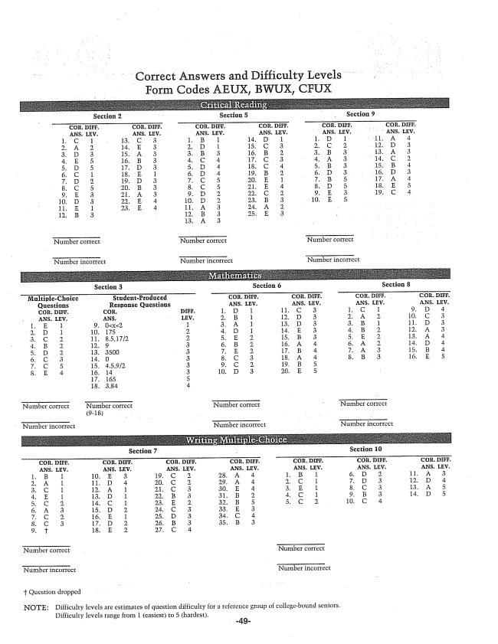

Correct Answers and Difficulty Levels Form Codes AEUX, BWUX, CFUX

**Section 3 Section 6 Section 8**

**Section 7 Section :**

NOTE: Đifficulty levels are estimates of question difficulty for a reference group of collegebound seniors,

Difficulty levels range from 1 (easiest) to 5 (hardest.

-49