**DESIGN AND DEVELOP OF PEDIATRIC MANAGEMENT SYSTEM**

A Project Development Study Presented to

The Faculty of College of Industrial Technology

BATANGAS STSTE UNIVERSITY

Balayan, Batangas

In Partial Fulfilment

Of the Requirements for the Degree of

Bachelor of Industrial Technology

Major in Computer Technology

By:

LITO CALBAYAR

APRIL MAE C. CALINGASAN

ROSE ISABEL G. MENDOZA

IVAN GABRIEL B. TALAOC

December 2020

**CHAPTER I**

**PROBLEM AND ITS BACKGROUND**

**Introduction**

To complete the word “family” in every couples, newly use they wish a child to fulfil their life and family needs. A mother has to carry a nine months old of baby on his womb and after that the baby would be take care through visiting a Doctor. This Doctor was called a paediatrician they are common person who taking a child from the age of month to 12 years old. Paediatrician threatening behavioural, physical and mental health of a child. The parent are the one who’s taking care of them. They provide for the infant crib, milk, clothes and other thing for them to have a healthy body. Nevertheless, unlike the adult, they can care for themselves and the infant are usually weak or having sensitive body when it comes to health. Therefore to ensure that the baby body is healthy the parents need to visit a paediatric clinic often times for a paediatrician to check their babies health condition.

Paediatrician are common throughout vaccinating childlike IPV, Varicella, Measles and DTAP and threatening minor to senior illness. Paediatrician has a big role and sometimes the record of children has misplace through many patient every day. This would lead another medical record or disorganize schedule. In visiting a paediatric clinic, parents must set an appointment to the paediatrician or to the receptionist of the clinic. The parents must go to the clinic to set a schedule of appointment. However, parents that are loyal in a paediatric clinic or an acquaintance of the paediatrician, set their appointment through phone call or text. The appointment depends on the preferred time and date of the parent or the available time and date of the paediatrician. When an appointment is set and scheduled, the parent together with their child is expected to return in the scheduled date for his/her appointment.

The process is the manual process among paediatrician. However, some parents are having a problem in scheduling an appointment to a paediatrician, especially does that are far from the paediatrician and does that are unable to go to paediatrician (for some personal reason) to set an appointment. Moreover, problem arise when the patient in the paediatrician rapidly increase. As the number of patient increase the waiting time of each patient also increase. And the longer the waiting time of patient, the higher the risk of them being dissatisfied with the paediatrician service.

Long waiting time and rapid increase of patients can also be a result of other problem like unorganized medical records. Prior to any operation or check-up, the paediatrician must check the medical record of his/her patients. However, there are times when paediatrician was not able to find due to unorganized large number of medical records. Therefore, the paediatrician must conduct a preliminary evaluation to the patient before the actual operation or check-up. This will increase the time in an appointment thus increasing the waiting time for other patients.

Moreover, like any other outpatient clinic, paediatric clinic also deals with patient no-show. When a patient did not appear for the appointment and made no prior contact with the clinic staff, it can result to long waiting time, practice discontinuity and lower patient satisfaction. Furthermore, it can also reduce the appointment availability for other patients and can potentially affect the revenue of the clinic.

These issues might be inevitable and may pose risk to the quality of paediatric clinic service. Furthermore, these issues can potentially decrease the revenue of the clinic because of the reduction in the system’s operational efficiency. Therefore an immediate solution is needed to alleviate these issues and help paediatrician to improve the efficiency and quality of their service.

With the problems specified the concept of Design and Develop of Paeditrics Management System is proposed.

**Objectives of the Study**

This study aims to design and develop Paediatric Management System for small dental clinics in Balayan.

Specifically the study aims to:

1. To evaluate the existing Paediatric management system in terms of:
   1. Design
   2. Operation
   3. Safety
2. To determine the appropriate design of Paediatric management system in terms of:
   1. Software Design
   2. Flow Chart
3. To determine the materials needed in development of the Design and Development of a Pediametric Management System
4. To develop the Paediatric management system.
5. To test and evaluate the developed Paediatric management system in terms of:
   1. Efficiency
   2. User friendliness
   3. User Satisfaction

**Scope, Limitation and Delimitation of the Study**

The researchers aim to develop a mobile application that can help paediatrician and receptionist manage and set appointments. It also aims to help patients to easily view, set, and cancel appointment for their preferred or available paediatrician. The main focus of this study is to evaluate the existing Paediatric management system based on their system components, system requirements, platform compatibility and user-friendliness. From the evaluation, the researchers will design the proposed application considering the application components, relational database model and user interface. Afterwards, the researchers will determine the appropriate tools needed in the development of the application and develop the mobile app. Lastly, the researchers will evaluate the developed mobile app in terms of efficiency user satisfaction and user friendliness.

The study is limited only for paediatrician. Functions are limited only in scheduling appointment and Paediatric management system. Storing data of patient are limited only in personal data, medical history, treatment plan and logs. Moreover, the study is limited only to android OS platform. And is limited to android version 5 (Lollipop) and higher.

Transactions such as billing and e-prescription is excluded in this study. Periodontal charting is also excluded in this study. Furthermore, other mobile operating system such as IOS, windows, blackberry OS etc. excluded in this study. And android versions lower than version 5 (Lollipop) is not part of the study.

**Significance of the study**

This study intends to benefit the following:

For the paediatrician, the study will help them in their day to day challenges in organizing both schedules and paediatric history of their patients. Even they are away from their clinic, in their home, even day or night, this study can help them manage their workload. Moreover, this study can help them decrease their idle time and increase productivity and profit.

For the receptionist, this study will help them set, cancel, manage the schedule of their paediatrician. They do not need to contact their dentist to remind on their upcoming scheduled appointment and vice versa.

For the patients, this study will give them convenience in scheduling appointment in their preferred or available paediatrician. Furthermore, it also gives them insight about their oral condition.

For the proponents, this study will help them gain knowledge and skills in mobile app development. Moreover, this study will give them experience in the field of mobile app development.

For the future researchers, this study will serve as reference material for their study and will provide new and valuable ideas that will help in the advancement of their study.

**Definition of terms**

The following terms are defined to have a better understanding in this study.

**Database Design Model.** It refers to the process of producing a diagram of relationships between various types of information that are to be stored in a database. (Wenson and Mays, 2012). In this study the term is used to describe the design of the database for the application.

**Platform Compatibility.** It refers to the ability of a certain website to appear fully functional on different browsers that are available in the market. (Conyngham, 2012). In this study the term is used to describe the ability of dental management system to function on different devices.

**System Components.** It refers to process, program, utility, or another part of a computer's operating system that helps to manage different areas of the computer. (Nazia, 2014). In this study the term is used to describe the functionalities of a system or application.

**System Requirements.** It refers to the required specifications a device must have in order to use certain [hardware](https://techterms.com/definition/hardware) or [software](https://techterms.com/definition/software). (Cornelius, 2015)

**Userfriendliness.** It is used to describe anything that is easy to learn how to use. (Sabri, 2012). In this study the term is used to determine how easy to use the system.

**CHAPTER II**

**REVIEW OF RELATED LITERATURE**

This chapter present the concept and literature that is used as the basis of the study.

**Conceptual literature**

The following discussion on scheduling system, mobile app development, database management system and waterfall methodology are used as basis in the design and development of Teeth Guardians for small dental clinics in Balayan.

**Scheduling System**

**Scheduling Sytem.** Scheduling interrupt themselves significantly, and most of their activities are triggered externally. Despite this, scheduling able to decide in most situations which activity to perform next. Scheduling spend more time on their informational role than on their decisional role, mostly at the requests of others, suggesting insufficient information system support to others in the organization. Scheduling other main role, besides making scheduling-related decisions, is to relay information. (Larco et al., 2017)

Based on Nazia and Sarda (2014) there are number of different methods are available to schedule appointments in the medical office. Double booking appointments is a basic technique for minimizing down time by ensuring that there always is a patient ready to be seen when the physician is available. It Increases physician productivity and creates an incentive for patients to arrive on time (first come, first-served). But the drawback is, it greatly relies on the physician’s innate ability to modulate time imbalances throughout the day and to “catch up” as needed to finish on time. Like Visits Together tends to increase when patients with similar health status or chronic conditions are scheduled close together. Industry long ago discovered that repetition of the same task eliminates set-up time, permits continuous work flow and accelerates process speed. This method is an efficient way to organize the repetitive services and it is more productive for scheduling certain categories of patient back-to back.

Ten Minute Increments, internists traditionally design schedules around 15-minute time increments, thus producing standard appointments of 15, 30 and 45 minute durations. In contrast, paediatric practices, and some family practice groups, tend to use 10 minute increments with resulting planned visits of 10, 20, 30 and 40 minutes. In this method physicians can reduce down time and the need for double booking by calibrating scheduled time closer to actual visit time. But it increases the complexity for scheduling personnel. Modified Wave Scheduling in a modified wave system, patient appointments overlap so that when one finishes early, another patient is waiting to be seen by the physician. In this way a constant flow of patients smooth out any imbalances in the lengths of visits. No patient is delayed by more than a few minutes beyond the scheduled appointment time.

If a modified wave schedule is not appropriate, some of the same benefits can be achieved by using staggered starts, staggering visits in five or 10 minute intervals. One patient can be scheduled for a 15-minute visit beginning at 9 a.m. and the next one at 9:05 a.m. If the first patient arrives late, only five minutes are lost before the second patient arrives. If the next set of patients is scheduled at 9:20 and 9:25, the physician hopefully can work in the late patient without delaying anyone else by more than five or 10 minutes. This approach is particularly useful at the beginning of a session to prevent the first patient from throwing off the whole day’s schedule by arriving late, or not showing at all. It also may be useful during the rest of the day in practice settings where patients tend to be late or the lengths of visits are particularly unpredictable. Visits still overlap, but the workload is spread out somewhat and patients are less aware of double bookings. While Group Meetings is a group scheduling is an alternate method of processing patients with similar, often chronic, conditions. By seeing such patients as a group, some physicians have found they can save time, create a highly supportive atmosphere, and devote more time to patient education and health issues than would be possible during traditional office visits.

In addition, Akinode et al. (2017) discuss the different processes of appointment scheduling mainly, single batch process. In this Appointment scheduling process, decisions are delayed until after receiving all appointment requests for a given period. This model is commonly used in surgery starting times, and allows scheduling with complete information, so that a perfect or near perfect solution can be found through discrete optimization or heuristic methods. Unit Process Appointments is a scheduling model, the process is assumed to come one at a time and are scheduled at the time of the request arrival. Through this process, a perfect solution will unlikely be found, but may be approximated if the distribution of appointment request types is learned.

Periodic Process Appointment. Requests are kept in a buffer of fixed size and are scheduled once the buffer is full. This allows a better approximation to the optimal solution by considering optimal or near optimal solutions at each period.

While LaGanga and Lawrence (2012), discussed the appointment scheduling model with over booking that balance the benefits of increased revenues and services with the expected cost of customer waiting and provider overtime. The scheduling in health care clinic can significantly improve patient service and provider productivity. However, we also show that the schedule pattern varies widely, so that it is not possible to draw general conclusion regarding how booked schedule should be constructed the circumstances of each clinic.

The customer or patient schedule appointment with service provider prior to service, as opposed to those operations where customer randomly arrived for immediate service according to their own volition. This objective trade off the benefits of servicing additional patients with the cost for keeping some patient waiting for service plus the expected cost of clinic overtime incurred when all scheduled patient cannot be seen during a clinic session.

El-Sharo et al. (2014) proposed the multiple provider appointment overbooking (MPAO) model that aims to maximize the clinic’s profit and minimize the patient waiting time and provider idle. Considering the no-shows, arrival rates of walk-in patients, fixed appointment duration and variable appointment duration, it was proven that MPAO model is better than other methods that are commonly utilized in outpatient clinics. Furthermore, it was proven applicable to multiple provider settings and appropriate for implementation in dental hygiene services.

Lastly, Anderson et al. (2014), developed an overlapping appointment scheduling (OLAS) model that calculate the optimal overlap period for each appointment. It can minimize the cost of patient waiting time and doctor idle time. Also the results from Monte Carlo simulation indicates that OLAS models can significantly reduce the cost for most clinical environments. And the model is applicable for real-life clinical environment and general service industry. Furthermore, it can also be used in single or multiple providers that can significantly benefit the clinics and patient.

**Mobile Application Develoment**

**Mobile Application Development.** Is the set of processes and procedure involve in writing software for small, wireless computing device. Like Web application development, mobile application development has its roots in more traditional software development. (Rouse, 2020)

Valdellon (2020), discussed the three basic types of mobile apps. These are native apps, web apps and hybrid apps. Native apps are built specifically for mobile device’s operating system (OS). They are built for a specific OS only, thus using an android app for IOS is not possible and vice versa. Web apps is similar to native apps but web apps are accessed via a web browser on a mobile device. Web apps are actually a responsive website that adapt to its user interface to the device used by the user. And lastly, the hybrid apps, these apps have the look and feel of native apps but they are really a web apps made to look native.

Valdellon added that, in developing an app, developers need to choose what type of app they will be developing. In choosing what type of app to be developed, developers must consider factors such as performance and resources. If the developer has limited resources such as time and money, then they can consider developing either web app or hybrid app. While if the developer prioritizes the performance and have enough resources for the development, then native app is the best choice.

In developing a mobile application, developers need to consider the application life cycle. Iversen and Eierman (2014), discussed the android life cycle. Android life cycle starts when a user touches an app’s icon. This action will call the onCreate method in the app’s initial activity to execute. This include initial loading stages like initializing variables and layout objects. After this, the onStart method is executed, after the activity has started the onResume method is executed. This method does not have to be implemented but it is a very useful the app to the running state that was in before `onPause`. When a user stops interacting with the app, the onPause method will be executed. This method should be used to stop the services that the app is using and store important state and information so that the user can start using the app exactly as they left it. If the app is about to become invisible, the onStop method will be executed to make sure important data is permanently stored. Finally, if the app is not restarted, the onDestroy method will be executed before the operating system takes away all the app’s resources.

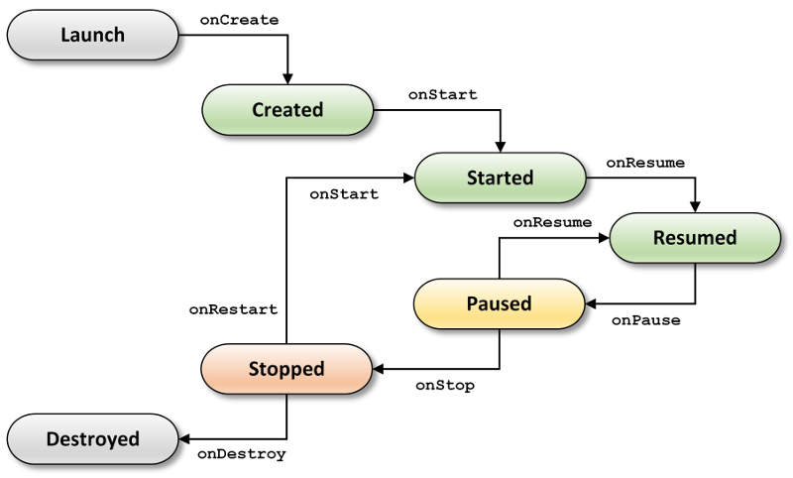

**Figure 1. Android lifecycle**

While Haije (2019), discussed the different integrated development environment (IDE) and programming languages used in mobile app development. The IDE needed in the development of a mobile app depends on the type of app the developer wants to develop. However, Haije focuses on the IDE needed for developing native apps, he states that developers can choose from different varieties of IDE for native app. But the most common IDE for developing native apps are Android Studio, Xcode and Xamarin. Android Studio is an android development software built by google. It is a powerful development software that provides drag and drop features and shortcut for coding and designing (intellisense). It uses java and/or kotlin to develop a native android app.

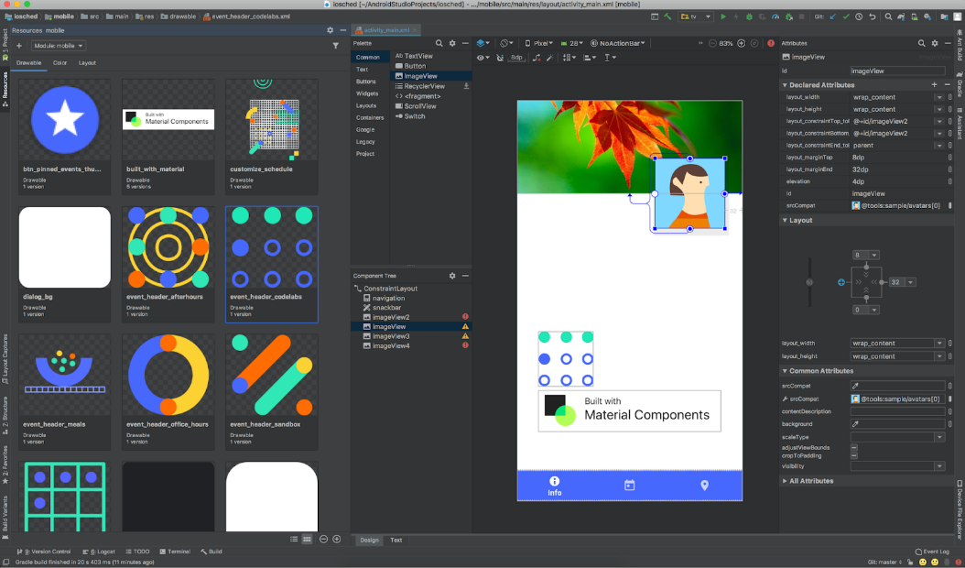

**Figure 2. Android Studio**

In the other hand, Xcode is an IOS development software that introduce a new way in designing and building software for IOS. It uses swift as the programming language and includes everything need to create applications for Mac, iPhone, iPad, apple TV and apple watch.

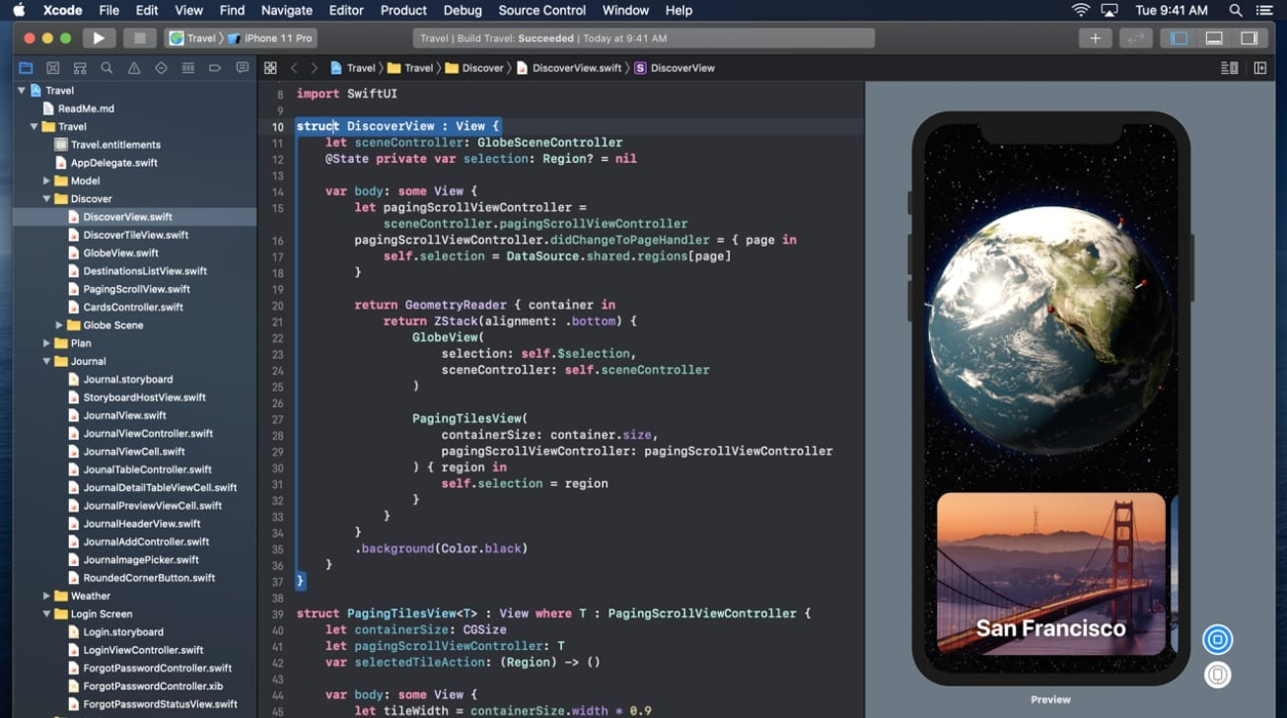

**Figure 3. Xcode**

Lastly, Xamarin, a mobile application platform that helps developer build native app for android, IOS and windows using a single share .NET code base. It offers a host of features including code editing, refactoring, debugging, testing and cloud publishing. Furthermore. it uses C# as the programming language.

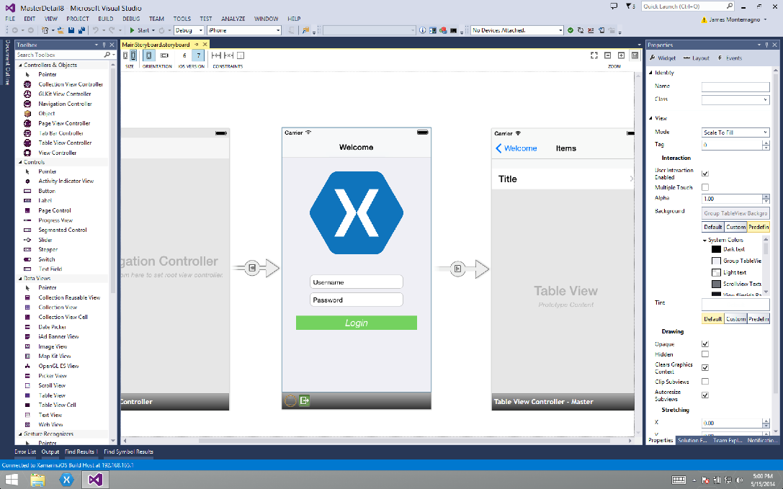

**Figure 4. Xamarin**

In addition to IDE and programming languages, developers need to learn programming principle like object oriented programming (OOP) in developing a mobile app. Onu et al. (2015), stated that all of the programming language used in mobile app development is based on object. Thus, it is essential to learn OOP when developing a mobile app.

Moreover, Shahbudin and Chua (2013), stated that to develop a well-designed application, developers need to consider the six different aspects in designing mobile application. First, developers need to decide which type of application they want to develop (eg. Native, web or hybrid). Next is to determine the minimum type of device to be supported and considering limited-bandwidth scenarios. Next is designing an appropriate design UI and layered architecture. And lastly, is to consider the device resource constraints.

Lastly, Pelykh (2019), stated that using a mobile app architecture will make the mobile app more sustainable and the source code will be more organized, flexible, more clear and simple. Furthermore, he discussed the three architecture design that can be use in mobile app development, namely MVC (model-view-controller), MVP (model-view-presenter) and MVVM (model-view-viewModel). MVC is one of the most common approach to build a mobile app. MVC separate user interface (UI) functionality from business/ application/ domain logic. MVC has three main components, the model, view and controller. Model handles the business logic and define rules to modify and operate data. View is the visual part and makes data from the model visible to the UI. And controller is the middleman of the two components. Based on the user input from the view, it could change the model and process data also the model can pass result to the controller to display to view. Similar to MVC, MVP also consist of three main components, the model, view and presenter. Each component behaves the same as in the MVC components however, the process flow in MVP starts with the view. View will notify the presenter on user actions then the presenter will update the model and send amend to the view.

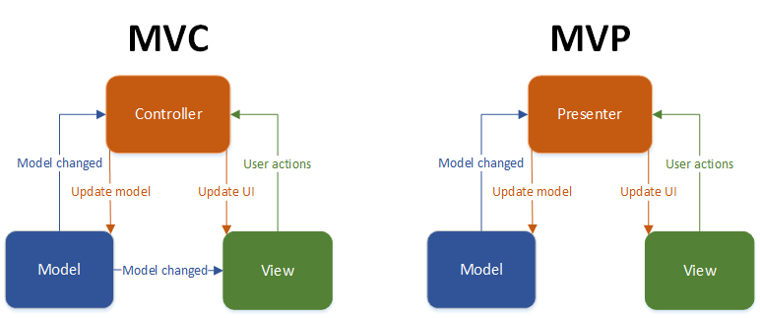

**Figure 6. MVC and MVP model**

Lastly, MVVM is an architecture design pattern that emerged from MVC and MVP. It is the upgraded version of the two. Although view and model is similar to the previous two, viewModel becomes the middleman. ViewModel is responsible for presentation logic and capturing data from the model. This way the UI is separated from the business logic code.

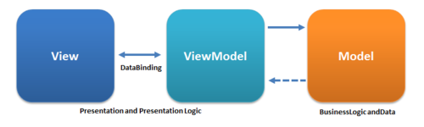

**Figure 7. MVVM model**

**Database Management System**

**Database Management System.** Refers to the technology solution used to optimize and manage the storage and retrieval of data from database. DBMS offers a systematic approach to manage database via interface for users as well as workload accessing the database via app. (Raza, 2018)

According to Aken (2017), database management system (DBMS) configuration tuning is an essential aspect of any data intensive application effort. But this historically a difficult task because DBMSs have hundred of configuration “knobs” that contro everything in the system, such as the amount of memory to use for caches and how often data is written to storage. Achieving good performance in DBMSs is non-trivial as they are complex system with many tunable option that control nearly all aspect of their runtime operation. We presented a techniques for tuninng DBMS knob configuration by reusing training data gathered from previous tuninng sessions.

According to Chopra (2010) a DBA is an idividual person or a group of person with an overview of one or more database so that he/she can control the design and the use of these database. A DBA is the highest salary paid person in an organization. A DBA provie the necessary technical support for implementing policy decision of database. A DBA is supported by a number of staff or a team of system programmers and other technical assistant.

Defining conceptual schema a DBA create the conceptual schema corresponding to the abstract level database design made by data administrator. Physical database design a DBA decide how the data is t be represented in the stored database. This process is called as the physical database design. Security and integrity checks a DBA is responsible for providing and authentication check so that no malicious user can access the database DBA must ensure the integrity of the databse also. Give backup and recovery strategies must define and implement an appropriate periodical recovery strategy to recover the database from all type of failure. Granting access to user regulate the usage of specific part of the database by various user. A DBA grant access to ue the database to it user.

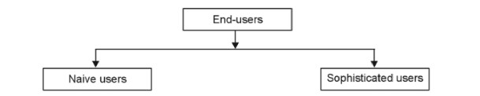

**Figure 8. Database Users**

Naive User, they are usually unaware of the DBMS. They access the database by using specially written application programs. They invoke database operation by entering simple command. Sophisticated User, end-user is familiar with the structure of the database and the facilities that DBMS provides. This type of user may use high-level query language such as SQL to perform the required operation. Some sophisticated end-user may even write application program for their own use.

Panwar (2020), discussed the three common type of database management system, the hierarchical database management system (HDBMS), network database management system (NDBMS) and relational database management system (RDBMS). In HDBMS, data is stored in a parent-children relationship node. It is organized into tree-like structure where data is stored in the form of a collection of fields which each field contains one value. Records are linked via parent-children relationship whereas each child record has only one parent, but parent can have multiple children.

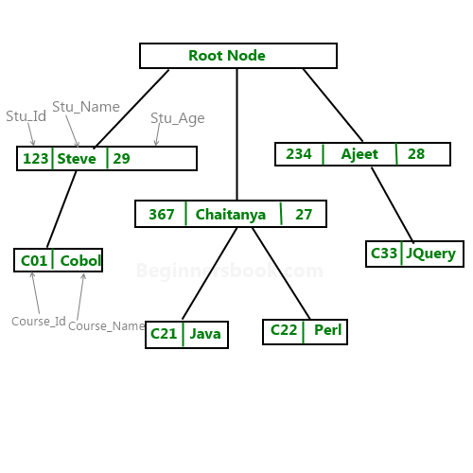

**Figure 9. Hierarchical database**

While NDBMS use a network structure to create a relationship between entities. It is mainly used on large digital computers. NDBMS are HDBMS but unlike HDBMS, one node can have a relationship with multiple entities. In NDBMS, children are called members and parent are called occupiers.

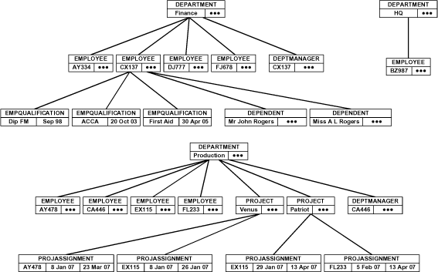

**Figure 10. Network database**

Lastly, RDBMS is the most popular database management system. The relationship between data is relational and is stored in tabular form f columns and rows. RDBMS use structured query language (SQL) to query data. Querying RDBMS includes inserting, updating, deleting and searching records. It works on each table using a key field that uniquely indicate each row. These key fields can be used to connect one table to another.

RDBMS is hard to construct especially when there are large data required in an application. To better understand and construct an RDBMS developers use an Entity-Relationship diagram (ER diagram). ER diagram is a design or blueprint of a database that can later be implemented as a database. It has two main components, the entity set and relationship set. Entity set is a group of similar entities. These entities can have attributes that is represented using rectangle. The attribute on the other hand is the data or information that each entity has. It is represented by ellipses, while relationship set shows the relationship between entities. (Singh, 2015)

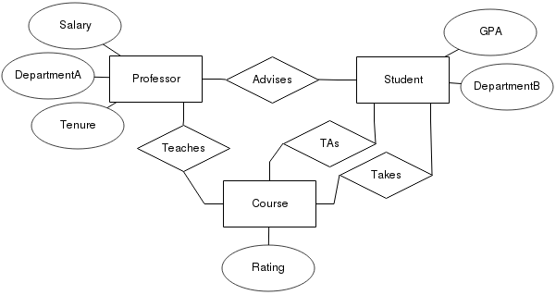

**Figure 11. Sample ER diagram**

**Waterfall Methodology**

**Waterfall Methodology.** The waterfall model is a liner, sequential approach to the software development life cycle (SDLC) that is popular in software engineering and product development and emphasize a logical progression of step. (Rouse, 2019)

According to Balaji and Dr. Marugaiyan (2012) that Waterfall model is the sequental development, in waterfall model each step in frozen before the next step, with this when the requirement is are frozen befor the design starts, and once the design is frozen the coding starts. Moreover, they added that the detect are found very late in the development life cycle as test team was not involved from the beginning of the project in the waterfall model. In waterfall model there are advantages mentioned. First, each phase is completed in the specified period of time after that it moves to next phase, second as its linear model it is easy to implement, third is the number of resources required to implement this model is minimal lastly is each phase proper documentation is followed for the quality of the development. The figure below shows the waterfall model life cycle which includes Analysis, Design, Development, Testing, Implementation and Maintenance.

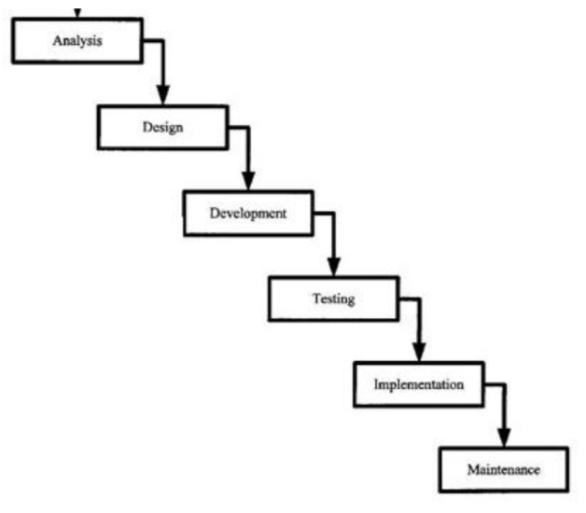  
**Figure 12. Waterfall Life Cycle**

According to Despa (2014) that Waterfall methodology is linear sequential process where every stage starts only after the previous has been completed. They added that Waterfall methodology is predictable and values rigorous software planning and architecture and they also mentioned that there are strengths and weaknesses in the waterfall methodology, the strengths are easily to manage and easily to understand for the project owner, while the weaknesses are the working code is delivered late in project, does not cope well with changing requirements and has low tolerance for design and planning errors. The figure below shows the different stage in Waterfall Methodology.

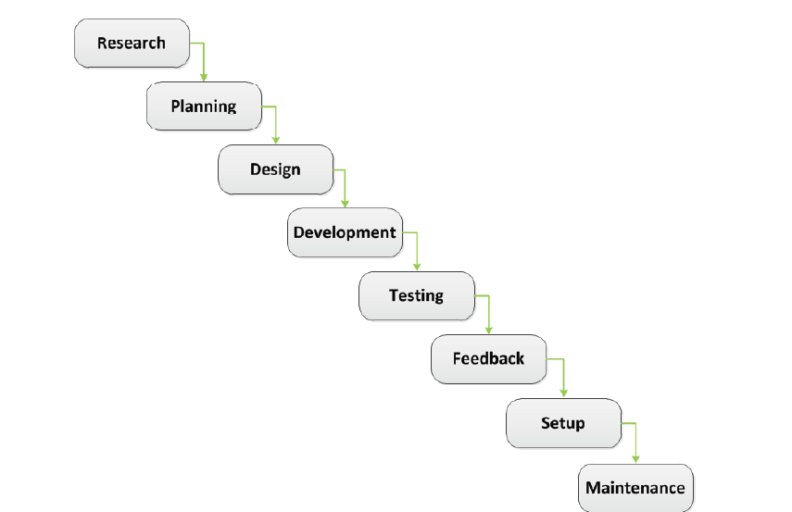

**Figure 13. Waterfall Methodology**

The Waterfall methodology contains different stage the Research, Planning, Design, Development, Testing, Set up and Maintenance and each stage has its own deliverables. The Research is the stage where the project owner, the project manager and the project team gather and exchange information, Planning is the stage where all the elements are set in order to develop the software product and its starts with defining the overall flow of the application. Next step is to breakdown the flow into smaller, easier to manage subassemblies. Design it is the stage where the layout of the application is created. Web applications and mobile applications tend to grant more impotence to layout than desktop applications. Development is s the stage where code is written and the software application is actually built. The development stage starts with setting up the development environment and the testing environment. The development environment and the test environment should be synchronized using always the same protocol. Code is written on the development environment and uploaded on the test environment using the synchronization protocol. Testing is the stage where programming and design errors are identified and fixed. Set up is the stage where the application is installed on the live environment. The setup stage precedes the actual exploitation of the software product. The setup entails configuring the live environment in terms of security, hardware and software resources. Maintenance is the stage that covers software development subsequent to the application setup and also the stage responsible for ensuring that the application is running within the planned parameters. Ensuring that the application is running properly is done by monitoring the firewall, mail, HTTP, FTP, MySQL and SSH error logs.

According to Säisä et al. (2018) that Waterfall project management focus on careful and detailed planning so when the project is ongoing, it is easy to just follow the plan or stages which is planning, design, develop, testing and maintenance. Waterfall is a linear approach where the phases of the project follow each other. Using waterfall as a project management methodology, project is planned and scheduled carefully beforehand. In a sense, project is easier to lead, when the waterfall methodology is used.

They mentioned the advantages and disadvantage of waterfall methodology, the advantage are the project goal is clear and implementation is linear, long-term goals make the big picture easier for students, resourcing is usually easy and they mentioned only one disadvantage which is change process is heavy. Waterfall project management methodology is more traditional and thus, more easy to adopt. For linear projects the waterfall methodology suits the best.

According to McCormick (2012) waterfall mode is a software engineering that was formally introduce as idea, it is an exmple of a flawed software develop method, its vulnerable due to many short coming waterfall model was inherited from hardware and construction that were in practice during in 1970’s.

The agile model is a software development. When developers decide to break from the traditional structured. The “Agile” or “lightweight” method is called were formally defined in research paper. Some of the prominent and ppular agile method is a software development it is subsequently.

According to Edeki (2015) the interactive has become vastly and effective in helping software developers to improve their skill in estimating the schedule the most difficult for developers issue are common and unpredictable in nature.

Today’s software development is becoming more important and keep the software stakeholder that affected the outcome of the software it’s important for software develop to identify the important and find the ways to connect with them. Agile promotes a constant short release cycle. It continual progress and make some suggestion and develop a new improved idea in software.

According to Steinke et al (2017) that waterfall system development methodology consists of major sequential steps or phases including analyse, design, build, test, and deploy, with the waterfall method, approval committees and project sponsor are required to sign-off at the conclusion of each phase in order for the project to proceed to a next sequential phase. While waterfall methodology is beneficial in identifying requirements before a system is developed. The figure below shows the design thinking can be combined into the waterfall method during the analysis and design phase.

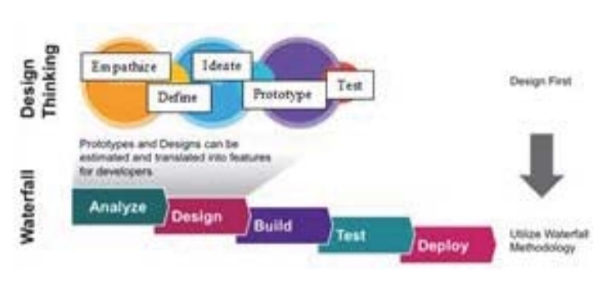

**Figure 14. Design Thinking and Waterfall Methodology**

In addition, the waterfall methodology does share similar steps to design thinking. The agile development methodology does not follow sequential development practices that traditional methodologies unlike the waterfall methodology that follows the sequential steps.

**Research literature**

In this section, related studies are discussed in support to the present study. It will serve as basis for the present study.

Dhanore et al. (2016), the proponents developed a dental clinic management system (DCMS) that aims to deliver faster and efficient services. The system was developed in ASP.net and uses SQL server as database. The researchers use C# as the programming language and visual studio 2010 as the IDE. Furthermore, the proposed system was tested by deploying the system in Mozilla firefox and internet explorer with a local host server. (missing)

In the study of Garko and Mahmud (2017), the researchers developed an outpatient management system for booking appointment and accessing medical record. The researchers used a use case diagram to present the system requirement of their proposed system. Use case diagram is used to describe the workflow of the system and explicitly describe the intentions and actions of the users. Moreover, the researchers use Window Interface Menu and Pointing device (WIMP) principle to design the user interface and to enhance the user-friendliness and user experience. The system was developed using VB.net and is based on the popular 3-tier architecture pattern that consist of presentation layer, application layer and database layer.

With the development of the system, patients are able to manage their own appointment with ease. The system will provide a quick view of their appointment and patients will be notified via SMS/email. However, the display of x-rays and laboratory result are not included in the system.

Moreover, in the study of Akinode and Oloruntoba (2017), the proponents developed an appointment and scheduling system that allows outpatient to register their details online, book and reject appointment. And in the system design, the researchers provided use case diagram for the system, the patient, doctors and receptionist in order to identify, clarify and organize the system requirement. Furthermore, database design is also included in the system design and it includes and relational data model.

In the development of the system, the researchers separate the system into two major components- frontend and backend. The frontend (client side) was developed using angular JS. And in the backend (server side) was developed using AJAX and PHP. While SQLITE and MYSQL was used for the development of system’s database and Apache server was used as server.

Lastly, the study of Teke et al. (2019) they developed a Dental Appointment Management System (DAMs) that facilitate patients at dental clinic to make an appointment with the dentist by using short messaging system (SMS0. DAMs were developed using Macromedia Dreamweaver 8 as platform to create interface to admin and MYSQL as the database. During the system development, Visual Studio 2010 is used in order to create interface and coding.

**Synthesis**

In this section of this chapter conceptual and research literature is further elaborate and explains its contribution in the study.

Nazia, Sarda and Akinode et al., both discussed the different varieties of scheduling in terms of method and process. And both discussions are essential for the development of the system. Choosing the right method and process of scheduling can potentially enhance the efficiency of the system and may further reduce the waiting time of the patient and provider idle time. While LaGanga and Anderson discussed the model that can be used to improve the setting of an appointment and can have major contribution in enhancing the effectiveness of scheduling. Either of the two models can be integrated into the system. And can potentially contribute in the efficiency of scheduling an appointment. However, El-Sharo argue that using multiple provider setting in overbooking model is much better for scheduling an appointment. The model discussed by El-Sharo can also be considered for choosing a scheduling model. Moreover, Valdellon discussed the different types of mobile app. This will help the researchers to determine what type of application the researchers intend to develop. While Haije discussed the different software development tools in developing a mobile app. This will help the researchers to determine the tools needed in developing the intend output. Moreover, Iversen, Eierman, Shahbudin, Chua and Onu et al. discussed the different aspects needed to consider and to learn before developing a mobile app. This will help the researchers to have a better understanding in mobile app and determine the specific concepts needed in developing a well-design mobile app.. Pelykh discussed the different software design pattern in developing a mobile app. This is essential in the development of the output in order to write an organized and simpler code. Dr. Marugaiyan, Balaji, Steinke and Despa briefly discussed the waterfall methodology and its components. It will help the researchers to better understand the components of waterfall methodology and how it can be implemented in the study. While Säisä et al. discussed the advantages and disadvantages of waterfall methodology. This will help the researchers to take advantage the strength of waterfall methodology and better understand how it can be implemented in the study. Lastly, Aken and Chopra both briefly discussed DBMS and its usage. It will help the researchers to better understand DBMS. While Panwar discussed the different types of DBMS, this is essential in order to determine what type of DBMS is applicable in the development of the proposed application. Moreover, Singh discussed the components of ER diagram. This will help the researchers to better understand how to design a relational database diagram.

The study of Dhanore and the present study is similar in terms of the output. However, the study of Dhanore differs in terms of the platform used and the IDE. Dhanore developed a web application and use Visual Studio 2010 to developed his output, while the present study will use Android Studio and will develop a mobile app.

The study of Garko and Mahmud and the present study is similar in terms of the design of the system components. However, they differ in terms of the output, IDE, design in user interface and architecture design. Garko and Mahmud developed an outpatient management system in VB.net and use the WIMP principle and 3-tier architecture while the present study will develop a mobile application in Android Studio and will use MVC for the software architecture.

The study of Akinode and Oloruntoba is similar to the present study in terms of the design of system components. However, it differs in terms of the output and programming language used. Akinode and Oloruntoba developed a web app and used Angular JS for the front end, they also used AJAX and PHP for the back end and they used SQLITE and MYSQL for the database. While in the present study, the proponents will develop a mobile app and will use Android Studio for the development of front end and back end of the app.

The study of Teke et, al. is similar to the present study in terms of the output. However, it differs in terms of the platform used, IDE and programming language used. The study of Teke et al. developed a web based application and used Dreamweaver 8 and Visual Studio 2010 as the IDE, PHP and C# for the programming language. While in the present study, the researchers will develop mobile application and will use Android Studio as the IDE and Java for the programming language.

**Conceptual Framework**

**INPUT PROCESS OUTPUT**

* Design and Develop of Pediatric Management System
* Designing
* Developing
* Testing and Evaluation
* Information and Financial Resources
* Gathered data and Information about dental clinics and mobile app development

**Figure 15. Conceptual Paradigm**

The first framework show the researchers input in developing the project that includes Time and Effort to make our output possible and finish at the given time, Information and Financial resources in order to build our desire output, Gathered data and Information about dental clinics and mobile app development to store and analyze important information that may help us to build the output, and lastly the Process of design in which to improve and meet the expectation of the possible user of the mobile app.

The second Frame is the researcher procedure include Designing, Planning, Developing, testing and Evaluation on which this is the second process in order to make the desire output of our project. The Designing, Planning, Developing, testing and Evaluation is very important factors in the procedure because it makes the output improve and to be develop.

The third column says that the researcher output which is the Design and Develop of Pediatric Management System.

**CHAPTER III**

**METHODOLOGY**

In this chapter the methods in the design and development of the web-based appointment scheduler and record management system for small dental clinic were discussed.

**Evaluation of the existing system**

The researchers gathered data from electronic sources and visited different clinics to evaluate the system components of each existing PMS. The researchers identify which components are common in different PMS and compare each PMS based on the key features they offer. Next, the researchers examine the user interface of each PMS and identify how each component is arranged in the user interface. Also the researchers try to figure out the design principle used in the user interface of each PMS. Moreover, the researchers determine the platform compatibility of each PMS. Lastly, the researchers try to find out what programming languages are used in the development of the PMS. From the evaluation of PMS, the researchers will identify other parts that need further enhancement.

**Designing Stage**

After the evaluation of the existing PMS, the researchers conduct the design. First, the researchers construct a use case diagram to be able to identify the application components of the proposed system. Afterwards, the researchers conduct the relational database model to identify the data and organize the database of the proposed system. Then, the researchers choose which software design pattern will be used. Lastly, the researchers construct the UI design for the blueprint of the user interface of the proposed application.

**Material Selection Stage**

After acquiring all the information needed for the study, the researchers determine the appropriate tool in developing the system. The researchers look for the appropriate programming language and IDE fit for the development of the system.

**Development Stage**

The development of the machine will primarily base on the design. The researchers will install the appropriate applications needed in developing the proposed application. Afterwards, the researchers can now develop the mobile app. First, the researchers will build the UI (User Interface) of the proposed app by implementing the user interface design. Afterwards, the researchers will build the database of the proposed system based on the relational database model. Lastly the researchers will develop the backend (server side) of the proposed app using the chosen software design pattern. Through the help of the server side, the UI can now be connected to the database.

**Testing and Evaluation Stage**

In this stage, the system will test and evaluate by the researchers in order to ensure the functionality of the whole system.

Series of testing will be conducted to determine the functionality and effectively of the mobile app in terms of efficiency, user friendliness and user satisfaction. First, the researchers will test each functions of the app to determine the efficiency of the app. The researchers will execute each function in multiple times to determine if bugs or errors may occur. Processing time of each function will also be evaluated to determine the efficiency of the code.

Lastly, the researchers will let some of the dentist to evaluate the system to determine the user satisfaction and user-friendliness of the system. First, the dentist will have a brief introduction on the app. Then the dentist will use and test the app. After that, the researchers will disseminate a survey questionnaire for the dentist to evaluate the system.

**Time Allotment**

The time allotment for the development of Pediatric Management System is for the execution of the procedure stated on the methodology of this study. The longest time allotted is for the submission and evaluation of thesis proposal and the finalization of Chapter 1, 2 and 3. The gathering information, design and planning will take a month to finish.

Gant Chart

The chart showed the time consume in every stage or level and the development and the progress of the project.

|  |  |  |  |  |  |
| --- | --- | --- | --- | --- | --- |
| Procedure | AUGUST | SEPTEMBER | OCTOBER | NOVEMBER | DECEMBER |
| Identify Research Problem |  |  |  |  |  |
| Gathering Information and Planning for thesis |  |  |  |  |  |
| Finalizing the Chapter 1, 2 and 3 |  |  |  |  |  |
| Preparation for Thesis defense |  |  |  |  |  |
| Submission and evaluation of thesis proposal |  |  |  |  |  |

**Table 1. Gant Chart**

In the month of August, we start to think and conceptualize the research topic. In the month of September and October the researchers gather information about the topic and research problem. Based on the research problem, the researchers plan the study and come up with the idea of developing a mobile app for Pediatric Management System. In the month of October and November, the researchers finalize the Chapter 1, 2 and 3. In addition, in the month of November, the researchers prepare for the thesis defence. Finally, in the month of December, the study is submitted and evaluated

**Bibliography**

1. **Articles in journals, magazines, and newspapers**

**Journal article, one author, accessed online**

Anderson, C., (2012) The Model-View-ViewModel (MVVM) Design Pattern. doi: <https://doi.org/10.1007/978-1-4302-3501-9_13>

Chopra R.(2010) Database Management system (DBMS) [https://books.google.com.ph/books?hl=en&lr=&id=FTUJNA4lLdAC&oi=fnd&pg=PR1&dq=info:ODQCscB8gpEJ:scholar.google.com/&ots=TWIzWbTWn2&sig=H_boXRss8xTN5PSBRy1SiNHT7YA&redir_esc=y#v=onepage&q&f=false](https://books.google.com.ph/books?hl=en&lr=&id=FTUJNA4lLdAC&oi=fnd&pg=PR1&dq=info:ODQCscB8gpEJ:scholar.google.com/&ots=TWIzWbTWn2&sig=H_boXRss8xTN5PSBRy1SiNHT7YA&redir_esc=y" \l "v=onepage&q&f=false)

Despa, M.L., (2014 Comparative study on software development methodologies *Database Systems Journal* vol. V, no. 3/2014). https:/scholar.google.com/scholar?start=70&q=waterfall+methodology&hl=en&as_sdt=0,5#d=gs_qabs&u=%23p%3DuelDEyoZRSOJ

Ediki C., Ph.D (2015) Agile Software Development Methodology Volume 2 No.1,2015 <http://www.idpublication.org/wp-content/upload/2015/Agile-Software-Development-Methodology.pdf>

McCormick M., (2012) Waterfall Vs. Agile Methodology <http://www.mccormickpcs.com/image/Waterfall_vs_Agile_Methodology.pdf>

Nyg˚ard, J., (2015) Single page architecture as basis for web applications.

<http://urn.fi/URN:NBN:fi:aalto-201509184388>

Rouse M., (2018) Integrated development environment (IDE) <https://www.google.com.ph/amp/s/searchsoftwarequality.techtarget.com/definition/integrated-development-environment%3famp=1>

Rouse M.(2019) Waterfall Model <http://www.google.com/amp/s/searchsoftwarequality.techtarget.com/definition/waterfall-model%3famp=1>

Sharan, K., (2015) Model-View- Controller pattern. doi: <https://doi.org/10.1007/978-1-4842-1142-7_11>

**Journal article, two authors, accessed online**

Akinode,John Lekan1 , Oloruntoba S.A (2017) Design and Implementation of a Patient Appointment and Scheduling System. Vol. 4, Issue 12, December 2017 DOI: 10.17148/IARJSET.2017.41203

[Almomani, A., &](https://www.sciencedirect.com/science/article/pii/S1876034116301447?via%3Dihub#!)  [AlSarheed, A.,](https://www.sciencedirect.com/science/article/pii/S1876034116301447?via%3Dihub#!) (2016) Enhancing outpatient clinics management software by reducing patients’ waiting time. [Volume 9, Issue 6](https://www.sciencedirect.com/science/journal/18760341/9/6" \o "Go to table of contents for this volume/issue), November–December 2016, Pages 734-743 doi: <https://doi.org/10.1016/j.jiph.2016.09.005>

[Begen](https://pubsonline.informs.org/action/doSearch?text1=Begen%2C+Mehmet+A&field1=Contrib), M., & [Queyranne](https://pubsonline.informs.org/action/doSearch?text1=Queyranne%2C+Maurice&field1=Contrib), M. (2011) Appointment Scheduling with Discrete Random Durations.Volume 36, Pages 185-376. <https://doi.org/10.1287/moor.1110.0489>

Charland, A., & Leroux, B., (2011) Mobile application development: web vs. Native. Volume 54, Number 5(2011), Pages 49-53 DOI: <http://doi.acm.org/10.1145/1941487.1941504>

Dan Ute, A., & Mahmud (2014) DESIGN AND IMPLEMENTATION OF AN ONLINE OUTPATIENT MANAGEMENT SYSTEM A CASE STUDY OF SOKOTO SPECIALIST HOSPITAL

Denuzi`er, L., & Granicz, A., (2015) Reactive Single-Page Applications with Dynamic Dataflow.  [Lecture Notes in Computer Science](https://link.springer.com/bookseries/558) book series (LNCS, volume 9131) doi: <https://doi.org/10.1007/978-3-319-19686-2_5>

Garko1, A. & Mahmud2, U., (2017) DESIGN AND IMPLEMENTATION OF OUTPATIENT MANAGEMENT SYSTEM. Vol. 3, Issue 6 (June 2017)

LaGanga, L.R, & Lawrence, S.R (2012) Appointment Overbooking in Health Care Clinics to Improve Patient Service and Clinic Performance. [Volume21, Issue5](https://onlinelibrary.wiley.com/toc/19375956/2012/21/5) September-October 2012 Pages 874-88 [**https://doi.org/10.1111/j.1937-5956.2011.01308.x**](https://doi.org/10.1111/j.1937-5956.2011.01308.x)

Maiellaro N., & Varasano A., (2017)One-Page Multimedia interactive Map. Journal/IJGI/Volume 6/ issue 2/ 10.3390/ijgi6020034. <http://doi.org/10.3390/ijgi6020034>

Nichols, J., & [Donaldson](https://patents.google.com/?inventor=Krista+Donaldson), K.,(2019) Web based system that allows users to log into websites without entering username and password information.

Säisä, M.,Tiura, K., & Roslöf, J.(2018) Waterfall Vs. Agile Project Management Methods In University-Industry Collaboration Project. DOI:<https://doi.org/10.24483/2018D010001>

Samorani, M. & Laganga, L.R(2015) Outpatient appointment scheduling given individual day-dependent no-show predictions. Omega, Volume 57, Part B, 2015, pp. 145-156 <https://doi.org/10.1016/j.ejor.2014.06.034>

Zhou, H., & Hou M. (2018) Research on an Electronic Medical Record System Based on the Internet. **doi:**[10.1109/ICDSBA.2018.00106](https://doi.org/10.1109/ICDSBA.2018.00106)

**Journal article, more than two authors, accessed online**

Adebayo, A.O., Kanyinsola, O., & David, T.(2014) Patient Record Management Information System. <https://publication.babcock.edu.ng/asset/docs/publications/COSC/9457/1887.pdf>

Aken D.V., Pavlo A., Gordon G.J., Zhang B., (2017) Automatic Database Management System Tuning Through Large-scale Machne Learning. May 2017 Page 1009-1024 <http://doi.org/10.1145/3035918.3064029>

[Anderson](https://www.sciencedirect.com/science/article/abs/pii/S221169231400054X?via%3Dihub#!), K., Zheng, B., Yoon, S.W. & Khasawneh M.T(2015) An analysis of overlapping appointment scheduling model in an outpatient clinic**.** [Operations Research for Health Care](https://www.sciencedirect.com/science/journal/22116923) [Volume 4](https://www.sciencedirect.com/science/journal/22116923/4/supp/C), March 2015, Pages 5-14. <https://doi.org/10.1016/j.orhc.2014.12.001>

Aniche, M., Bavota G., Deursen A.V.,(2017) Code smells for model-View-controller architecture. <http://doi.org/10.1007/s10664-017-9540-2>

Bali, A., Bali, D. & Iyer, M.(2011) Management of Medical Records: Facts and Figures for Surgeons. J Maxillofac Oral Surg. 2011 Sep; 10(3): 199-202. doi: 10.1007/s1263-011-0219-8

Chen, B., Patel, S., Buckley, T., Rednic, R., McClure, D., Shih, L., Tarsy, D., Welsh, M.& Bonato, P., (2011) A Web-Based System for Home Monitoring of Patients With Parkinson’s Disease Using Wearable Sensors. [IEEE Transactions on Biomedical Engineering](https://ieeexplore.ieee.org/xpl/RecentIssue.jsp?punumber=10) (Volume: 58, [Issue: 3](https://ieeexplore.ieee.org/xpl/tocresult.jsp?isnumber=5719220), March 2011). doi:[10.1109/TBME.2010.2090044](https://doi.org/10.1109/TBME.2010.2090044)

Dhanore P., Shaik A., & Ramtekkar P (2016) Dental Clinic Management System- A new Approach <https://scholar.google.com/scholar?hl=en&as_sdt=0%2C5&q=dental+clinic+management+system-+A+new+approach&btnG=#d=gs_qabs&u=%23p%3DHyak6cSnd-8J>

Fowler, S Dynamic Dataflow.  [Lecture Notes in Computer Science](https://link.springer.com/bookseries/558) book series (LNCS, volume 9131) doi: <https://doi.org/10.1007/978-3-319-19686-2_5>., Denuzière, S., & Granicz, A., (2015) Reactive Single-Page Applications with

Gadzama, W., Joseph, B., & Aduwamai, N.M (2020) Design and Implementation of a Secured Web based Medical Record Management System: A Case Study of Federal University Wukari (FUW) Clinic. [International Journal of Computer Applications](https://www.researchgate.net/journal/0975-8887_International_Journal_of_Computer_Applications) 177(41):27-33 doi: [10.5120/ijca2020919908](https://www.researchgate.net/deref/http%3A%2F%2Fdx.doi.org%2F10.5120%2Fijca2020919908)

Green, R., City, R., Papakipos, M., Alto, P., Kokkevis, E., Sunnyvale, Tavares, G., & Francisco, S. (2013) Web-based graphics rendering system

Gregersen E., Augustyn a., Lotha G., Das, D., (2020) Database Management System <http://www.britannica.com/technology/database>

Hammershøj. A., Sapuppo A., Tadayoni R., (2010) Challenge for Mobile Application Development <https://ieeexplore.ieee.org/abstract/document/5640893>

[He](https://www.sciencedirect.com/science/article/pii/S1876034119302485#!), X., [Ca](https://www.sciencedirect.com/science/article/pii/S1876034119302485#!)i, L., [Huang](https://www.sciencedirect.com/science/article/pii/S1876034119302485#!), S., [Ma](https://www.sciencedirect.com/science/article/pii/S1876034119302485#!), X., & [Zhou](https://www.sciencedirect.com/science/article/pii/S1876034119302485" \l "!) X. (2019) The design of electronic medical records for patients of continuous care. <https://doi.org/10.1016/j.jiph.2019.07.013>

Heitkötter H., Hanschke S., Majchrzak T.A., (2012) Evaluating Cross-Platform Development Approaches for Mobile Application. <http://doi.org/10.1007/978-3-642-36608-6_8>

Hirsh, S., Pereymer, A., & Rajpal S., System and methods for mobile application development and development platform. <https://patents.google.com/patent/US8261231B/en>

Kalelkar M., Churi P., Kalelkar D.,(2014) Implementation of Model-view-controller Architecture Pattern for Business Intelligence Architecture. International Journal of computer Application (0975-8887) Volume 102-no.12 citeseerx.ist.psu.edu

Mao, X,. Tan, J., & Zhou, Z. (2011) Method and system for integrating the existing web-based system.

Moran K., Cardenas C.B., Vasquez M.L., Poshyvanyk D., (2018) Overcoming Language Dichotomies: Toward Effective Program Comprehension for Mobile App Development. <http://doi.org/10.1145/3196321.3196322>

Mota J.M., Rube I.R., Dodero J.M., Sanchez A.A., Augmented Reality Mobile App development for All <http://doi.org/10.1016/j.ijhcs.2006.08.008>

Onu F.U., Ikedilo O.E., Nwoke B.O & Okafor P. (2015) Vol 17 The Importance of Object-Oriented Programming in This Era of Mobile Application Development DOI: 10.9790/0661-17613040

Pandey M., Litoriya R., Pandey P., (2019) Perception-Based Classification of Mobile Apps: A Critical Review <http://doi.org/10.1007/978-981-13-6295-8_11>

Shahbudin F. E. & Chua F. (2013) Design Patterns for Developing High Efficiency Mobile Application. DOI; 10.4172/2165-7866.1000122

Steinke, G.H., Al-Deen, M.S., & LaBrie, R.C. (2017) Innovating Information System Development Methodologies with Design Thinking. <https://opendata.uni-halle.de/bitstream/1981185920/12695/1/ICAIIT%20V%202_02%20Steinke_Al-Deen_LaBrie.pdf>

Teke A., Londh S., Oswal P., & Malwade SS. (2019) Online Clinic Management Syste Vol 4, [https://scholar.google.com/scholar?hl=en&as_sdt=0%2C5&q=web+based+about+clinic+scheduling+system+thesis&btnG=#d=gs_qabs&u=%23p%#Dd-dOKDpbSu0j](https://scholar.google.com/scholar?hl=en&as_sdt=0%2C5&q=web+based+about+clinic+scheduling+system+thesis&btnG=#d=gs_qabs&u=%23p%)

Vithani T., IAENG, KUMAR A., Modeling the Mobile Application Development Lifecycle 2014 Vol 1, IMECS 2014, March 12-14, 2014, Hong Kong iaeng.org

1. **Books**

**Two authors, in print**

Iversen J. & Eierman M (2014) learning Mobile App Development: A Hands-on Guide to Building App with iOS and Android. United States on recycled paper at R.R. Donnelley in Crawfordsville, Indiana.

1. **Undated Web site content, blogs, and data**

**Blog entry**

Haije E. G. (2020) Top 3 Mobile Development Tools: An Overview

<https://mopinion.com/mobile-development-tools-an-overview/>

Panwar A. (2020) Types of Database Management Systems <https://wwwc-sharpcorner.com/UploadFile/65fc13/types-of-database-management-systems/>

Pelkyh A. (2019) Designing the Archicture of Your Mobile Product: 3 Patterns To Choose Among <https://medium.com/@brainbeanapps/designing-the-architecture-of-your-mobile-product-4-patterns-to-choose-among-d47b7d3c2e06>

Raza M. (2018) An intro to Data Management Systems [https://www.bmc.com/blogs/dbms-database-management-systems/#:~:text=Database%20Management%20System%20(DBMS)%20refers,accessing%20the%20databases%20via%20apps](https://www.bmc.com/blogs/dbms-database-management-systems/" \l ":~:text=Database%20Management%20System%20(DBMS)%20refers,accessing%20the%20databases%20via%20apps)

Singh C. (2015) Entity Relationship Diagram- ER Diagram in DBMS <https://beginnersbook.com/2015/04/e-rmodel-in-dbms/>

Valdelon L. (2020) What Are the Different Types of Mobile Apps? And How Do You Choose? <https://clevertap.com/blog/types-of-mobile-apps/>