CNS 3370
Spring 2002

Programming Assignment 2
“Class-based Heaps”

DUE DATE: Tuesday, September 24, 2002

Programs are due by the start of class, and must be submitted as follows:
- A printed listing of the source code and execution output on paper, and
- “.cpp” and/or “.h” files of the source code emailed to passoff1250@uvsc.edu (no project, or .exe files)

All programs will be validated as needed by building an executable from your source code. A program that does not compile will receive no credit. Submissions without printed execution output will be penalized 20%. Please include your name and the phrase “[CNS 3370] Program 2” in the subject line.

As you know, every direct heap allocation via the new operator incurs some overhead so that the delete operator can properly clean up when you’re finished with the heap object. When a large number of heap objects are active at once, the wasted memory for the heap overhead can be excessive. The typical solution is to manage heaps on a class by class basis. The idea is to reserve enough space for a large number of objects with a single heap allocation (a “block”), and then return pointers to locations inside that array when the user requests a new object. You repeat the process as each block of objects gets used up.

In this assignment you will use good design techniques and separate the management of the memory pool from the class of objects to be allocated from the pool. The class of objects is named MyObject, and has the following data members:

int id;
string name;

To force users to only place MyObject objects on the heap, make the constructor private, and provide a static member function, create, which returns a pointer to a new heap object (this is the Factory Method design pattern). In other words, the MyObject class includes the following declarations:

private:
MyObject(int i, const string& nm)
: name(nm)
{
id = i;
}

public:
static MyObject* create(int id, const string& name) // Factory method
{
return new MyObject(id, name);
}

Define also a class named Pool, with at least the following member functions:

public:
Pool(size_t elemSize, size_t blockSize = 50, bool traceFlag = false);
~Pool();
void* allocate(); // Get a pointer inside a pre-allocated block for a new object
void deallocate(void*); // Free an object's slot (prepend the address to the “free list”)

You will provide class-based versions of operator new and operator delete in MyObject that call upon an instance of class Pool. Pool manages a dynamic array of blocks, as discussed above, where each block contains the number of bytes needed to hold blockSize elements, each of size elemSize. You will initialize each element cell in a block of cells to hold a pointer to its successor, essentially constituting a linked list. (This is not a traditional linked list, in that it has no separate “next” member – each cell just holds the address of the next list element in its first four bytes until that cell is put in use as a MyObject. See the next paragraph for more detail.) The Pool class contains a data member that holds a pointer to the head of the free list, as follows:

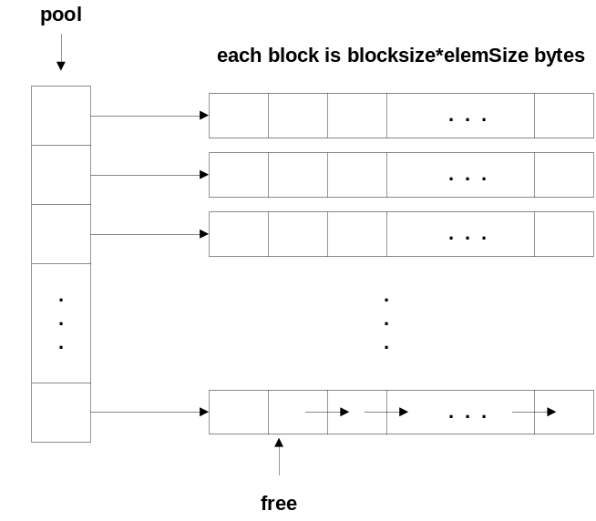

The MyObject class has a static Pool data member, initialized with elemSize equal to sizeof(MyObject). When MyObject::operator new executes, it merely calls Pool::allocate (via its static Pool object), which in turn returns the pointer to the next open slot, and also updates its internal free list pointer to point to the next open slot for the next call to allocate. When there are no more open slots, a Pool object automatically expands it array of blocks by 1 more block (or row, as depicted above), and initializes those pointers in linked-list fashion as you did in the first instance. When a MyObject is deleted, MyObject::operator delete simply calls Pool::deallocate, which in turn merely prepends the returned address to the head of the free list the pool manages (don’t bother to shrink the memory allocation in the pool). Pool’s destructor just needs to delete each block, and then delete the array holding the pointers to the blocks, just as you did in the freeArgs function Program 1. Disallow copy and assignment in both MyObject and Pool. MyObject also needs an output operator. See the test program in the file prog2.cpp for an example of how to use these classes. Place the class definitions and member functions for these classes in separate header and implementation files (i.e., Pool.h, Pool.cpp, MyObject.h, MyObject.cpp). Use prog2.cpp as your driver.

This is not a long program (about 150 lines or so). The tedious (but not overly difficult) part is doing the pointer arithmetic and casting when you initialize a new block as a linked list. Each block is just an array of bytes, so each element in the array pool is a char*, therefore pool itself is a char**. You can’t allocate an array of MyObjects directly for each row in Pool because, 1) Pool shouldn’t know about MyObject, and 2) the default constructor for MyObject would execute for each element in each row, which is totally unnecessary. The constructor for each MyObject runs when the object itself is created when MyObject::create invokes the new operator.

You will notice that there are two sample outputs from prog2.cpp. The first is when pool tracing is turned off (the default). After running it this way, go back and change the initialization for the pool object to turn tracing on (by adding a third argument of true to the Pool constructor) and run again. If you have inserted trace statements in the correct places in Pool’s member functions, your output will match the second sample output set. Turn in both sets of output. Set blockSize to 5 in both test cases. (In practice, of course, it will be much bigger).

