# Assignment 4 – Web Services: Gravatar Crawler

**Total Points: 100**

Gravatar is a service that allows to attach an image (avatar) to your email address that will be automatically retrieved by capable services.

It has a REST style API that allows you to retrieve JSON with the necessary information. <https://en.gravatar.com/site/implement/profiles/json/> (we want to use exactly this API, not the one where you can get an image by passing the hash) <https://en.gravatar.com/site/implement/hash/> (for calculating the hash function)

Without the use of external plugins (sorry, we want to write code, except for the HASH function, PLEASE use a plugin there or the .NET framework), using the aforementioned API implement:

A user should be able to type an email address and start a lookup. (10 pts)

If the email is not associated with a Gravatar the program should return this information to the user (you can have a message, the same form with empty data, etc) (30 pts)

A new “page” should open displaying the relevant information for the user (if available): (60 pts)

profileUrl, preferredUsername, givenName, familyName, currentLocation and the first photo.

For testing purposes you can see what happens with my email address (maurod@marshall.edu) where you should be able to retrieve my avatar (a gargoyle), and my other information.

To better specify what you need to retrieve for example with my email this is the json, and the value highlighted in blue is the one you want for the image.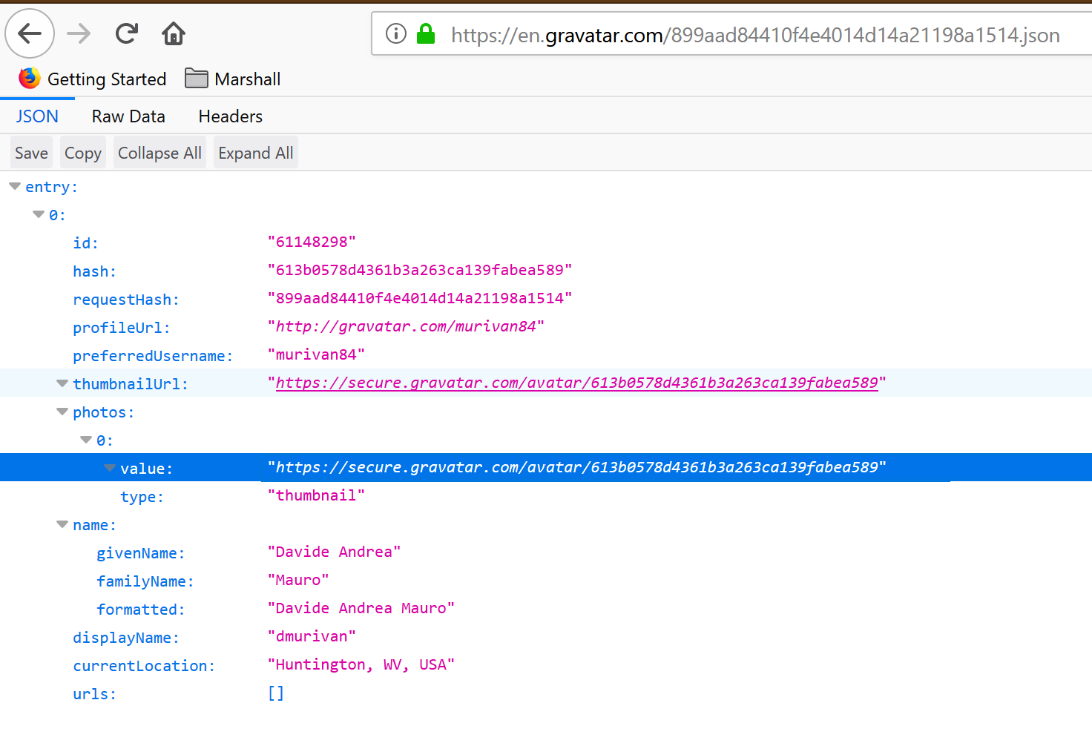

Submit the project and remember to reduce the size of the submission (removing bin and obj folders).

Submit the files to the assignment on MUOnline in a compressed (.zip) format. Include all the required files. The submission should follow the naming convention:

CIT414_*LastName_FirstInitial_*A4.zip