# Assignment 5 –Database Creation and Management

Based on the attached ERD implement in PostgreSQL the database:

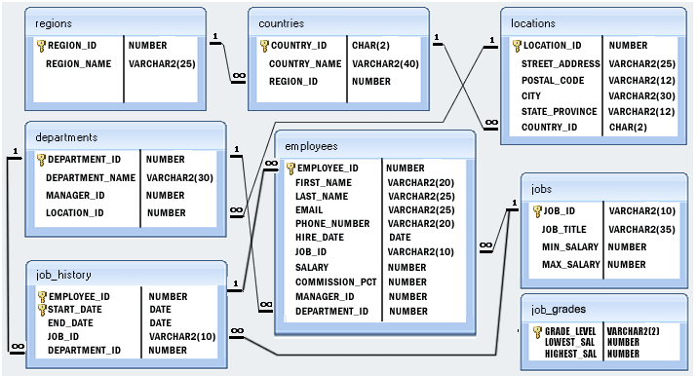

* Provide all the required statements (database creation, schema creation, table creations, constraint creation, default values)
* Create a database named BigCompany
* Create a schema named internal, all the tables should be declared within this schema.
* Employees has first_name, last_name and email that are NOT NULL. Email is also UNIQUE
* jobs and job_grades have default values of 0 for the low/min numbers and 1000000 for the high/max numbers.
* Provide 1 example of table alteration after the creation (e.g. to specify a constraint, to change a field)
* Provide INSERT statements to populate all the tables with some data (you can use a random data generators, or provide few meaningful records for each table)
* Provide 1 example of UPDATE and 1 example of DELETE
* If you have to/want to make any other assumption on the data or its constraints please document them.

The statements should execute without the need of extra operations, if you need extra steps please document them.

Submit the files to the assignment on MUOnline in a compressed (.zip) format. Include all the required files. The submission should follow the naming convention:

CIT466_*LastName_FirstInitial_*A5.zip