

MIDDLE EAST TECHNICAL UNIVERSITY

ELECTRICAL-ELECTRONICS ENGINEERING

DEPARTMENT

EE463

Static Power Conversion-I

EXPERIMENT#3

**Student Names - Student ID’s**

Emin Ün 2167476

Fatih Serdar Sağlam 2181828

**\* \***

**Introduction**

In this experiment, the objective is to investigate the three-phase full-bridge controlled rectifier with different firing angles and different loads. The measurements will be taken separately with 0o,60o and 75o firing angles. The power factor, THD, thyristor voltage, output voltage mean and peak-to-peak will be measured. In the first part, R load will be used. In the second part, RL load will be used. In the third part RL load will be used with line inductors. The effect of line inductances, which is called commutation, will be observed. In the fourth part, a freewheeling diode will be added before the load. The effect of the freewheeling diode will be observed.

**Equipment List**

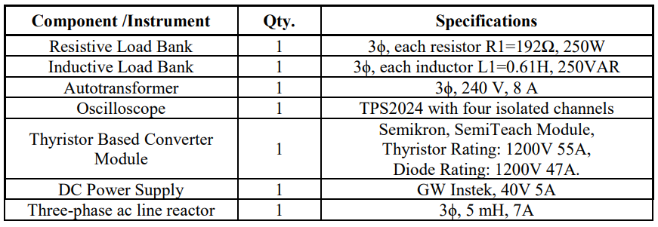

Table 1: Equipment List for Experiment 3

**Results and Conclusion**

**1.3.2 Three-Phase Full-Bridge Controlled Rectifier Feeding a Resistive Load**

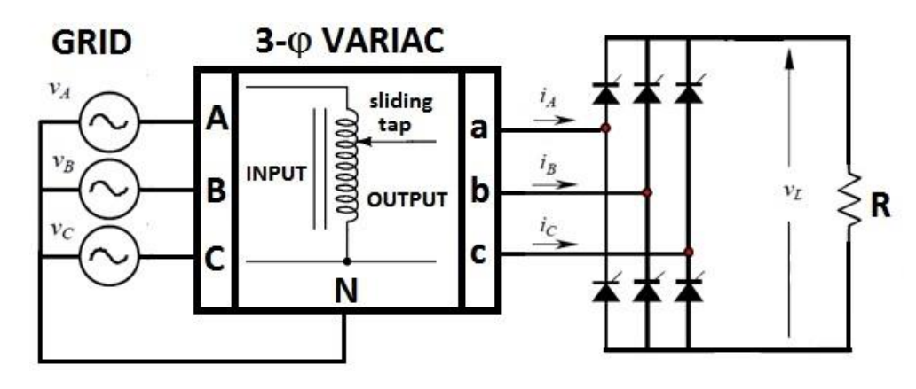

Figure 1:Three-Phase Full-Bridge Controlled Rectifier Feeding a Resistive Load

To simulate the three-phase full-bridge controlled rectifier, a gate controller is needed to make thyristors work. Therefore, a Thyristor,6-pulse generator is used in the simulation where alpha is the firing angle.

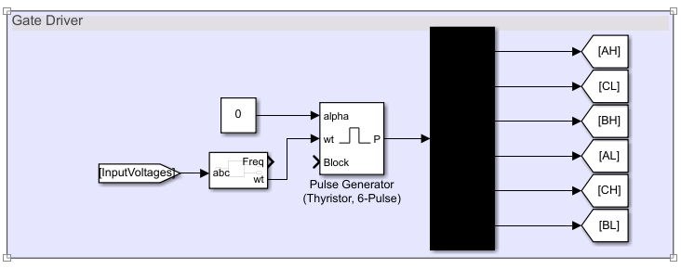

Figure 2: Gate Driver Blocks for Thyristors

Input voltage, input current, output voltage and output current values are observed with 0o and 60o degrees firing angle separately.

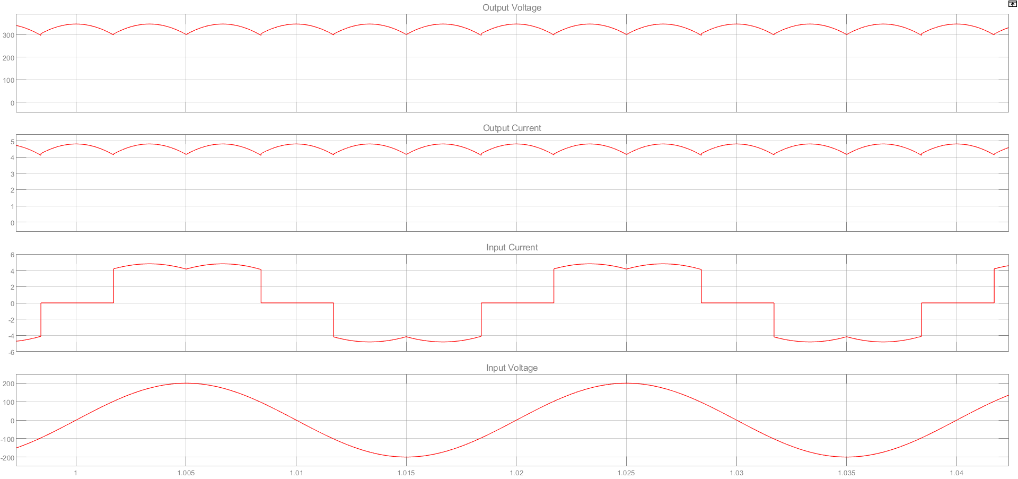

Figure 3: Input Voltage, Input current, Output Voltage and Output Current with 0odegree Firing Angle – Part 1.3.2

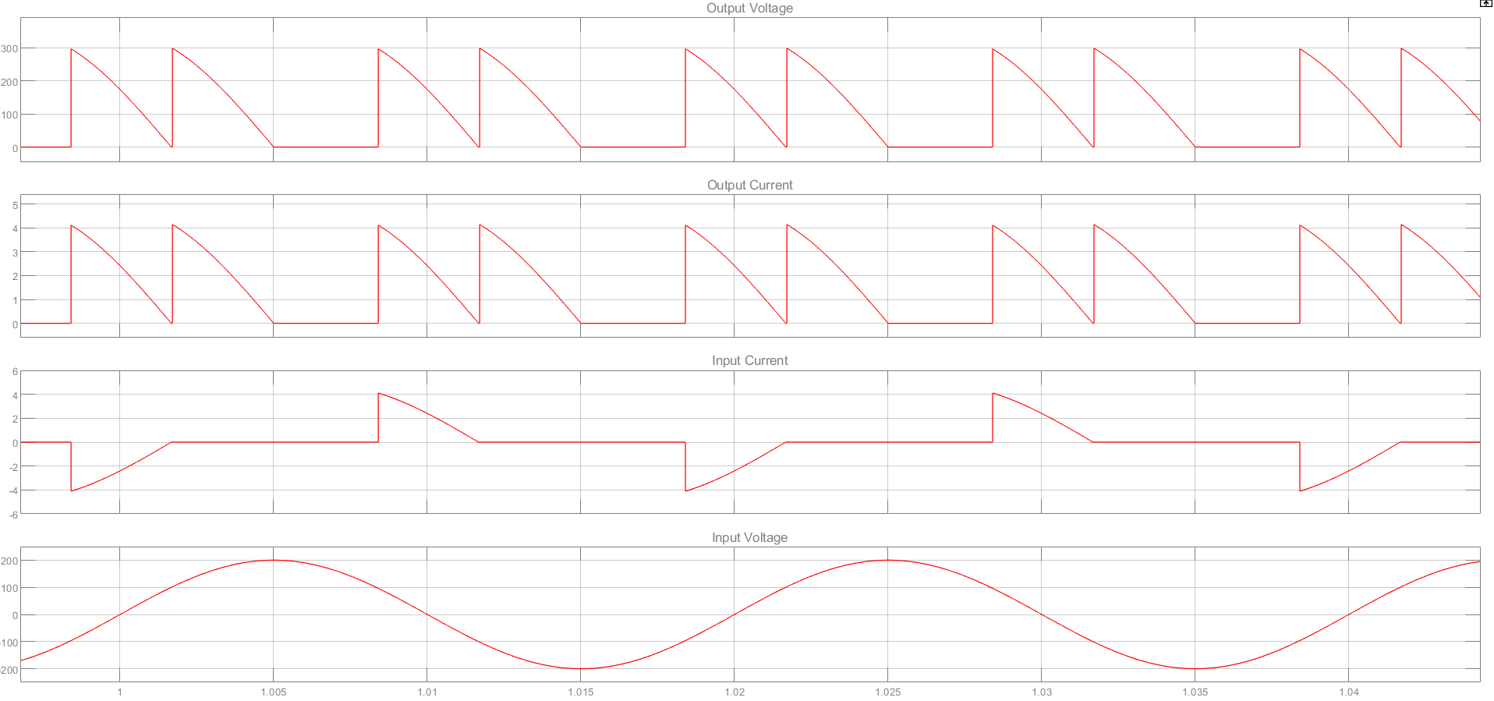

Figure 4:Input Voltage, Input current, Output Voltage and Output Current with 60o degree Firing Angle – Part 1.3.2

The measurement and calculations of both AC and DC sides are shown in the graph below.

|  |  |  |  |  |  |  |  |  |  |  |  |  |  |
| --- | --- | --- | --- | --- | --- | --- | --- | --- | --- | --- | --- | --- | --- |
|  |  | **AC SIDE (INPUT) MEASUREMENTS** | | | | | | | | **DC SIDE (OUTPUT) MEASUREMENTS** | | | |
|  |  | **VIN** | **IIN** | **PIN** | **QIN** | **P.F** | **Φ** | **IIN** | **IIN** | **VOUT** | **VO,RIPPLE** | **IOUT** | **POUT** |
|  |  | **(VRMS)** | **(ARMS)** | **(W)** | **(VAR)** |  |  | **THD-F %** | **THD-R %** | **(VAVG)** | **(VP-P)** | **(AAVG)** | **(W)** |
| **R Load** | *α = 0˚* | 141.4V | 3.599A | 1527W | 23.81VAR | 0.9999 | -0.8936° | %30.52 | %29.19 | 330.7V | 46.4V | 4.593A | 1519W |
| *α = 60* | 141.4V | 1.011A | 63.6W | 424VAR | 0.1484 | -81.47° | %104.7 | %72.3 | 114.4V | 300V | 1.594A | 182.3W |

Table 2: Simulation Results of Parameters for part 1.3.2

As we can see in Figure 3 and Figure 4, there is no commutation effect since there is not a line inductor in the circuit. However, the firing angle has changed input current, output current and output voltage shapes. The output voltage ripple is increased with the firing angle from 0 to 60 degree. Also, the average output voltage value is decreased with the firing angle from 0 to 60 degree. The output current is proportional to the output voltage. Therefore, the effect is the same on the output current. Moreover, the input current is not proportional to the output current, but the firing angle effect can be seen on Figure 4.

Additionally, the firing angle has more effect on the rectifier such as phase angle, THD values and power measurements.

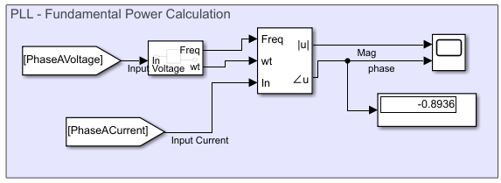 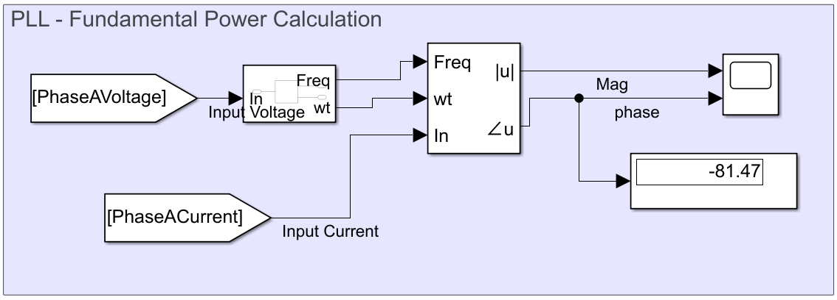

Figure 5: The Effect of Different Firing Angle on Phase Angle (Left->0odegree, Right->60odegree)

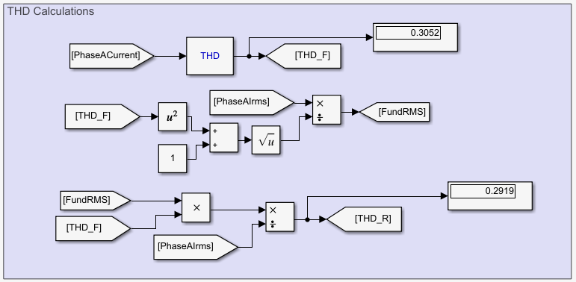

Figure 6: THD-F and THD-R Calculations for 0o Degree Firing Angle

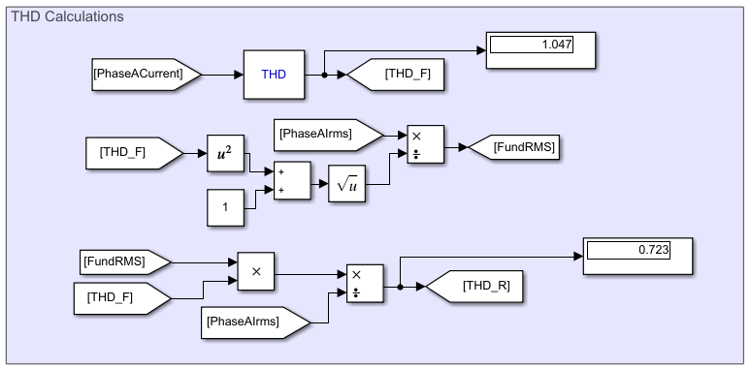

Figure 7:THD-F and THD-R Calculations for 60o Degree Firing Angle

As it can be seen in Figure 6 and 7, THD values are increased with increasing firing angle. The firing angle makes the output voltage and current more square-wave shaped and less sinusoidal shape. More sinusoidal shape in the wave means less THD value. This is the reason for increasing THD values.

In addition, the firing angle has an effect on power measurements.

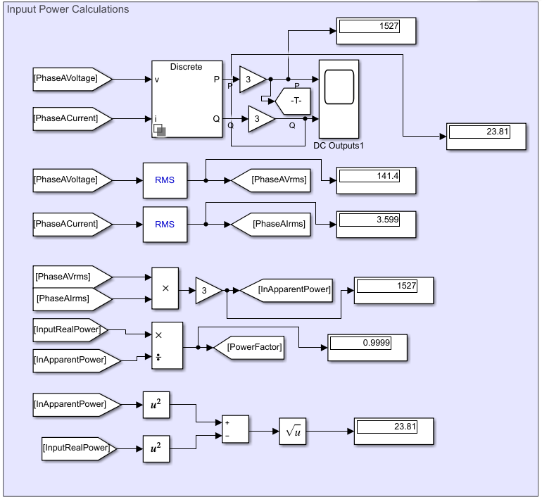

Figure 8: Power Measurements and Calculations for 0o Degree Firing Angle

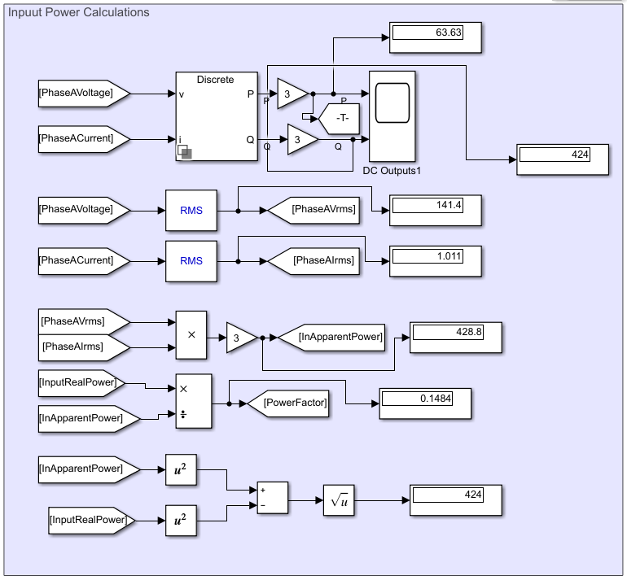

Figure 9: Power Measurements and Calculations for 60o Degree Firing Angle

As expected, with 0o degree firing angle, there is no reactive power and the active power is on its maximum. However, the active power decreased and the reactive power increased with increasing firing angle. Moreover, the rms value of line current decreased. Additionally, the power factor decreased with increasing firing angle.

**1.3.3 Three-Phase Full-Bridge Half-Controlled Rectifier Feeding an R-L Load**

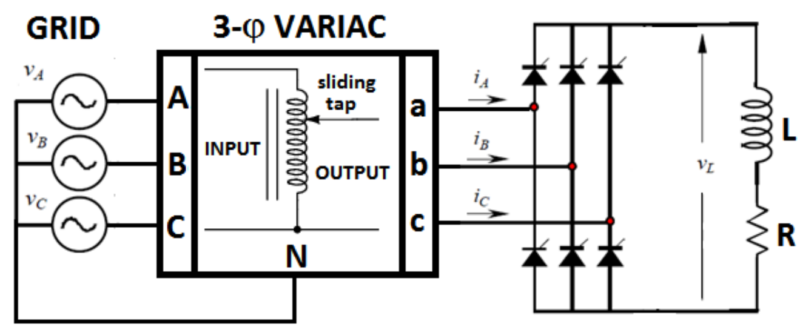

Figure 10: Three-Phase Full-Bridge Half-Controlled Rectifier Feeding an R-L Load

Input voltage, input current, output voltage and output current values are observed with 0o and 60o firing angle separately.

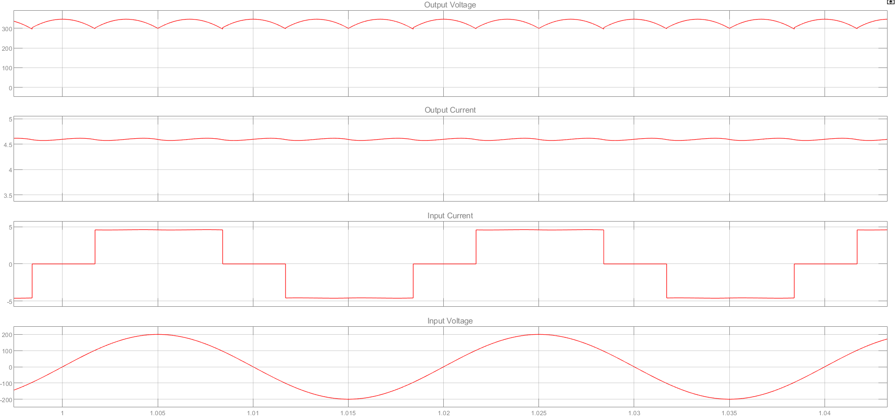

Figure 11: Input Voltage, Input current, Output Voltage and Output Current with 0odegree Firing Angle – Part 1.3.3

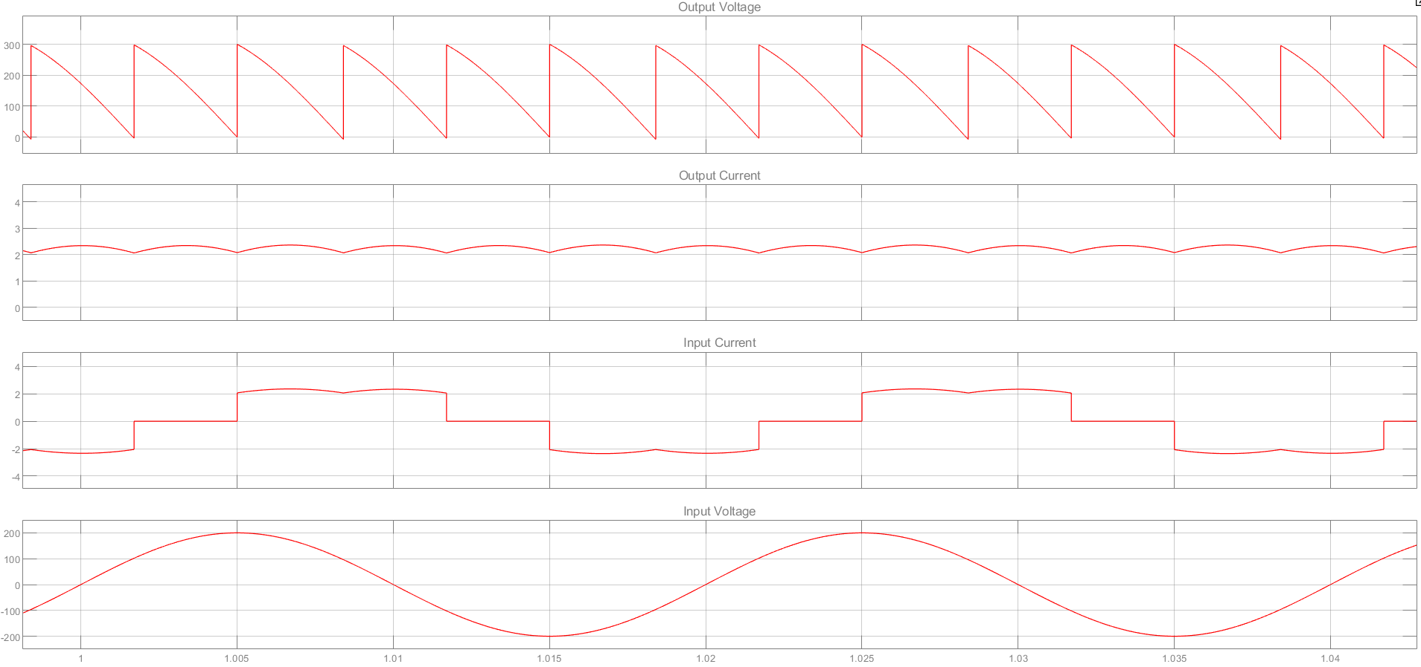

Figure 12: Input Voltage, Input current, Output Voltage and Output Current with 60odegree Firing Angle – Part 1.3.3

The measurement and calculations of both AC and DC sides are shown in the graph below. For comparison, the values without inductive load are also shown.

Table 1 Simulation Results of Parameters for part 1.3.3 and 1.3.2(for comparison)

|  |  |  |  |  |  |  |  |  |  |  |  |  |  |  |  |  |  |  |  |  |  |  |  |  |  |  |
| --- | --- | --- | --- | --- | --- | --- | --- | --- | --- | --- | --- | --- | --- | --- | --- | --- | --- | --- | --- | --- | --- | --- | --- | --- | --- | --- |
| **Simulation Results** | | | | | | | | | | | | | | | | | | | | | | | | | | |
|  |  | | **AC SIDE (INPUT) MEASUREMENTS** | | | | | | | | | | | | | | | | | **DC SIDE (OUTPUT) MEASUREMENTS** | | | | | | |
|  |  | | **VIN** | | **IIN** | | **PIN** | | **QIN** | | | **P.F** | | **Φ** | | **IIN** | | **IIN** | | **VOUT** | | **VO,RIPPLE** | | **IOUT** | **POUT** | |
|  |  | | **(VRMS)** | | **(ARMS)** | | **(W)** | | **(VAR)** | | |  | |  | | **THD-F %** | | **THD-R %** | | **(VAVG)** | | **(VP-P)** | | **(AAVG)** | **(W)** | |
| **R Load** | *α = 0˚* | | 139V | | 3.537A | | 491.6W | | 7.688VAR | | | 0.9999 | | -0.8936° | | %30.52 | | %29.19 | | 325.1V | | 45.34V | | 4.515A | 1467W | |
| *α = 60* | | 139V | | 1.745A | | 154.2W | | 187.1VAR | | | 0.6359 | | -50.51 | | %62.8 | | %53.18 | | 156.3V | | 292.4V | | 2.173A | 339.6W | |
| **R-L Load** | *α = 0˚* | | 138V | | 3.507A | | 483.8W | | 8.783VAR | | | 0.9998 | | -1.04° | | %30.89 | | %29.51 | | 322.7V | | 45.02V | | 4.483A | 1447W | |
| *α = 60* | | 138V | | 1.723A | | 118.1W | | 206.4VAR | | | 0.4965 | | -60.23 | | %30.59 | | %29.25 | | 155.1V | | 292.1V | | 2.199A | 341W | |
| **Experimental Results** | | | | | | | | | | | | | | | | | | | | | | | | | | | |
|  | |  | | **AC SIDE (INPUT) MEASUREMENTS** | | | | | | | | | | | | | | | **DC SIDE (OUTPUT) MEASUREMENTS** | | | | | | | | |
|  | |  | | **VIN** | | **IIN** | | **PIN** | | **QIN** | **P.F** | | **Φ** | | **IIN** | | **IIN** | | **VOUT** | | **VO,RIPPLE** | | **IOUT** | | | **POUT** |
|  | |  | | **(VRMS)** | | **(ARMS)** | | **(W)** | | **(VAR)** |  | |  | | **THD-F %** | | **THD-R %** | | **(VAVG)** | | **(VP-P)** | | **(AAVG)** | | | **(W)** |
| **R Load** | | *α = 0˚* | | 139 | | 3.44 | | 464 | | 177 | 0.93 | | 21 | | 28.7 | | 27.6 | | 323 | | 64 | | 4.07 | | | 1350 |
| *α = 60* | | 140 | | 2.03 | | 130 | | 245 | 0.47 | | 62 | | 105 | | 41 | | 145 | | 280 | | 1.87 | | | 375 |
| **R-L Load** | | *α = 0˚* | | 138 | | 3.12 | | 404 | | 161 | 0.93 | | 22 | | 28.4 | | 27.3 | | 320 | | 68 | | 3.64 | | | 1190 |
| *α = 60* | | 139 | | 1.35 | | 83 | | 170 | 0.44 | | 64 | | 29.9 | | 28.7 | | 142 | | 476 | | 1.6 | | | 233 |

The load type in terms of sole resistive and resistive-inductive is analyzed with comparison of simulation and experimental results in Table 1. The mean of output voltage and ripple is adjusted with firing angle. As the firing angle increases, ripple of the output voltage increases and mean of the output voltage decreases. The resistive load sinks a current which is proportional to the output voltage and in phase with the output voltage. However, R-L load behaves like a current source. Hence, adding a R-L load provides the controlled rectifier with greater efficiency compared to R load when the output voltage is distorted due to increase in firing angle. In addition to enhancement of efficiency, the R-L load decreases the THD of input current since R-L load behaves like a current source.

The increase in firing angle for R-L load does not affect the THD value of input current, which causes due to characteristic of inductive load. R-L load with a great inductance behaves like a constant current source even if output voltage ripple is high. Also increase in firing angle decreases the power factor for the both R and R-L load since the current is shifted with firing angle.

The discrepancy between simulation and experimental results in terms of value of voltage ripple may result from the measurement of oscilloscope or some transient disturbances in circuitry since the output voltage ripple is calculated as around 300V by inspection from the output waveform.

**1.3.4 Three-Phase Full-Bridge Half-Controlled Rectifier Feeding an R-L Load with AC Line Reactor**

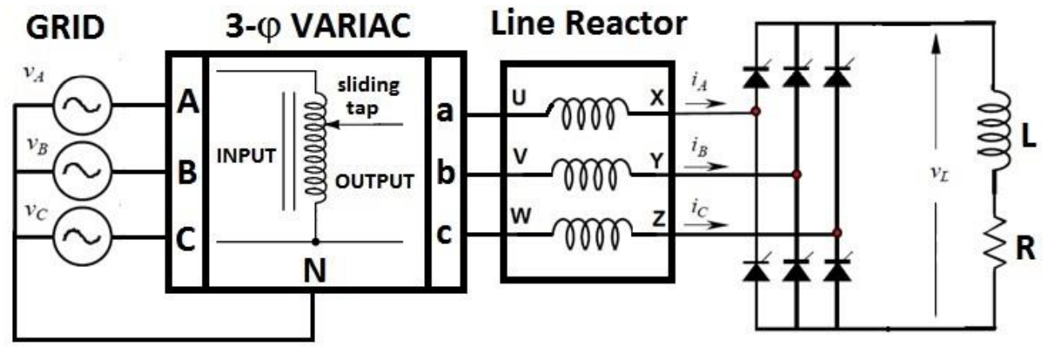

Figure 13: Three-Phase Full-Bridge Half-Controlled Rectifier Feeding an R-L Load with AC Line Reactor

Input voltage, input current, output voltage and output current values are observed with 0o, 60o and 75 o firing angle separately.

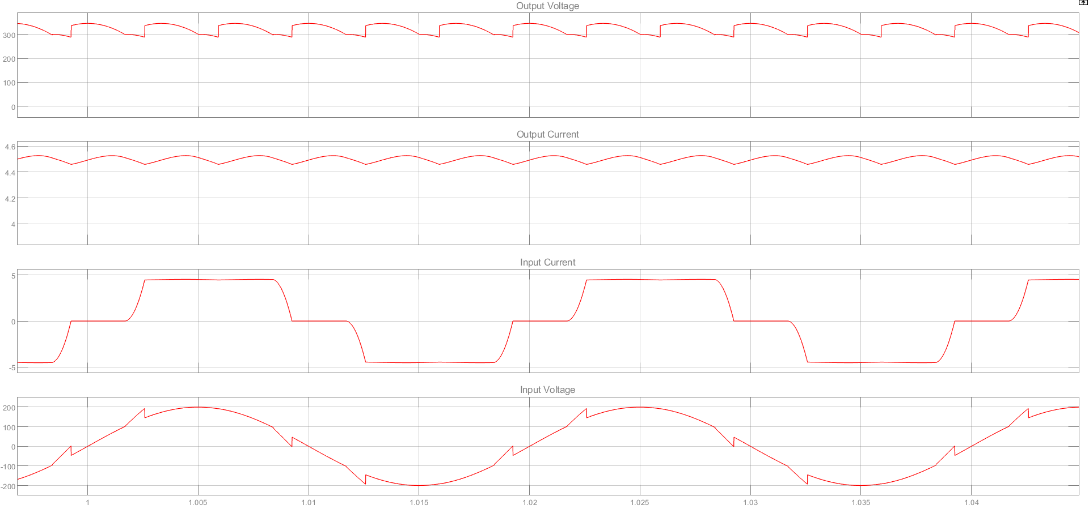

Figure 14: Input Voltage, Input current, Output Voltage and Output Current with 0odegree Firing Angle – Part 1.3.4

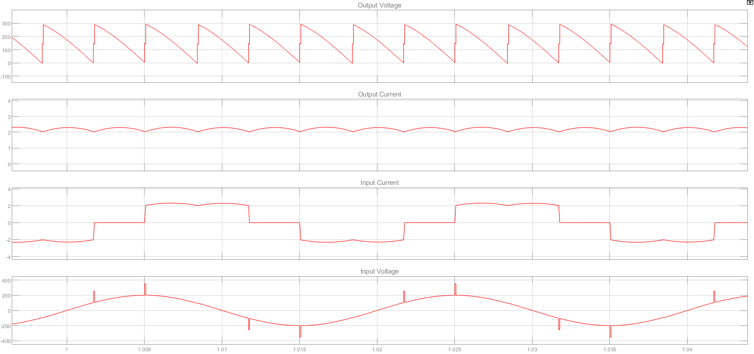

Figure 15: Input Voltage, Input current, Output Voltage and Output Current with 60odegree Firing Angle – Part 1.3.4

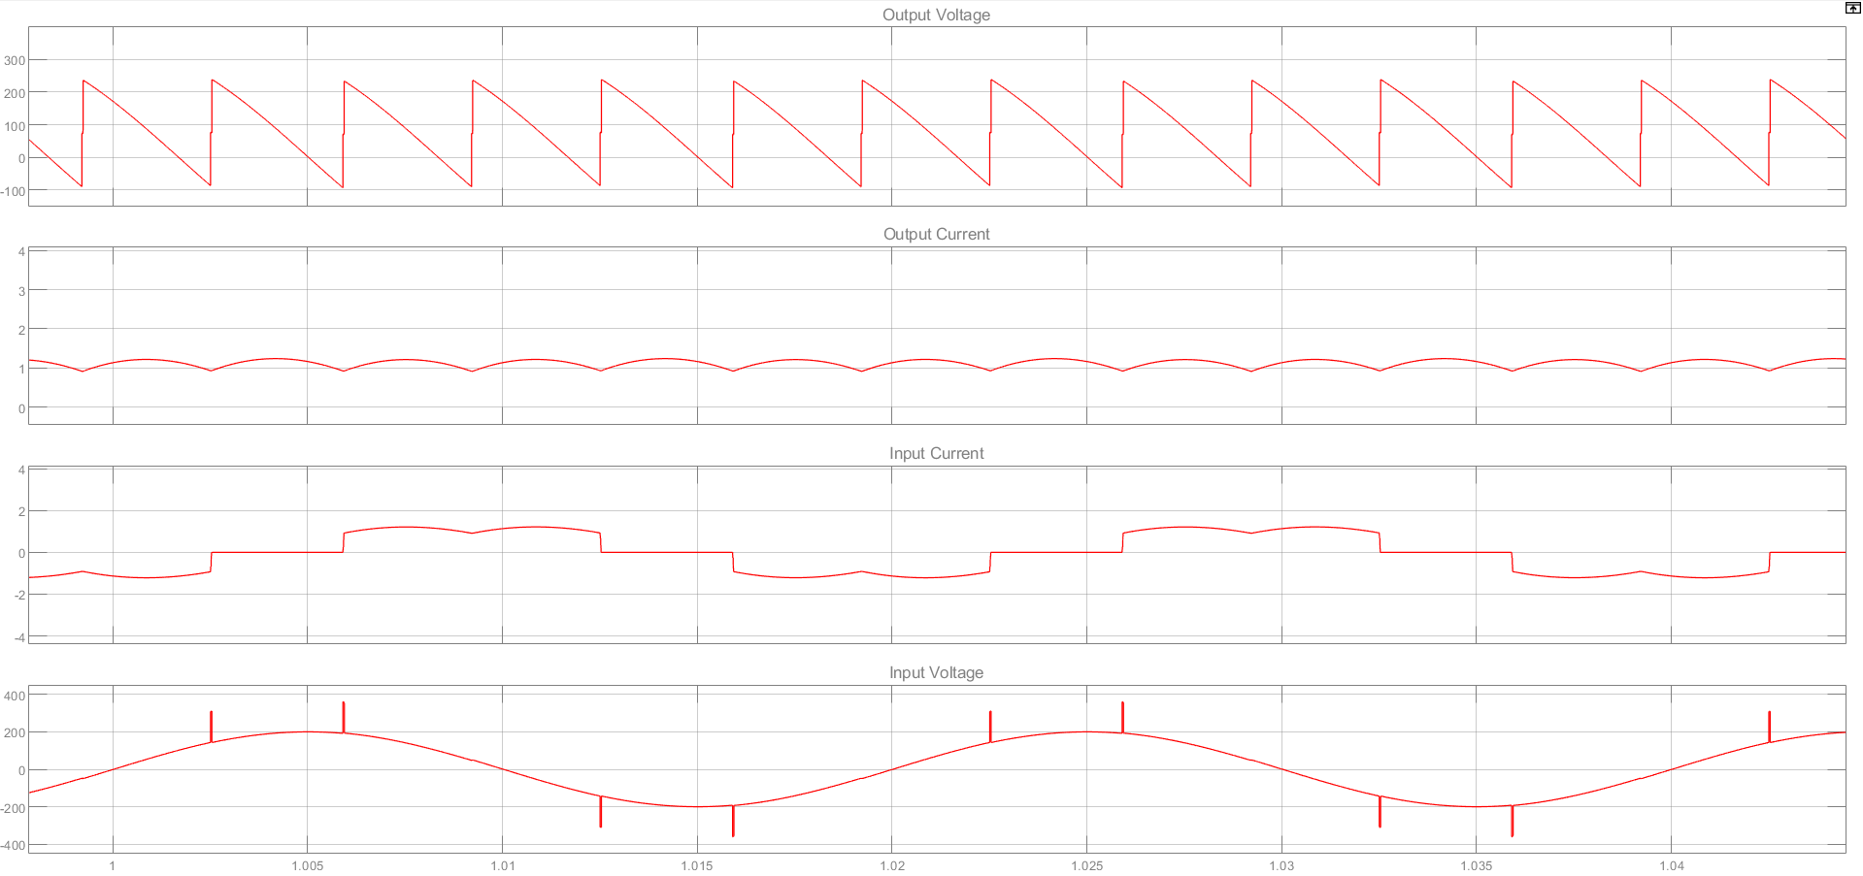

Figure 16: Input Voltage, Input current, Output Voltage and Output Current with 75odegree Firing Angle – Part 1.3.4

The measurement and calculations of both AC and DC sides are shown in the graph below. For comparison, the values without AC line inductor are also shown.

Table 2 Simulation Results of Parameters for part 1.3.4 and 1.3.3(for comparison)

|  |  |  |  |  |  |  |  |  |  |  |  |  |  |  |  |  |  |  |  |  |  |  |  |  |  |  |  |
| --- | --- | --- | --- | --- | --- | --- | --- | --- | --- | --- | --- | --- | --- | --- | --- | --- | --- | --- | --- | --- | --- | --- | --- | --- | --- | --- | --- |
| **Simulation Results** | | | | | | | | | | | | | | | | | | | | | | | | | | |  |
|  |  | | **AC SIDE (INPUT) MEASUREMENTS** | | | | | | | | | | | | | | | | **DC SIDE (OUTPUT) MEASUREMENTS** | | | | | | | |  |
|  |  | | **VIN** | **IIN** | | **PIN** | | **QIN** | | | **P.F** | | **Φ** | | **IIN** | | **IIN** | | **VOUT** | | **VO,RIPPLE** | | **IOUT** | | **POUT** | |  |
|  |  | | **(VRMS)** | **(ARMS)** | | **(W)** | | **(VAR)** | | |  | |  | | **THD-F %** | | **THD-R %** | | **(VAVG)** | | **(VP-P)** | | **(AAVG)** | | **(W)** | |  |
| **R-L Load** | *α = 0˚* | | 138V | 3.507A | | 483.8W | | 8.783VAR | | | 0.9998 | | -1.04° | | %30.89 | | %29.51 | | 322.7V | | 45.02V | | 4.483A | | 1447W | |  |
| *α = 60* | | 138V | 1.723A | | 118.1W | | 206.4VAR | | | 0.4965 | | -60.23 | | %30.59 | | %29.25 | | 155.1V | | 292.1V | | 2.199A | | 341W | | **Commutation** |
| **R-L Load and LAC** | *α = 0˚* | | 130V | 3.22A | | 410.9W | | 80.23VAR | | | 0.9815 | | -11.05° | | %24.84 | | %24.11 | | 297.8V | | 44.37V | | 4.137A | | 1232W | | 810usec |
| *α = 60* | | 130V | 1.593A | | 101W | | 180.7VAR | | | 0.4879 | | -60.8° | | %30.09 | | %28.81 | | 143.3V | | 264.9V | | 2.033A | | 291.2W | | 70usec |
| *α = 75˚* | | 135V | 0.827A | | 27.21W | | 108.2VAR | | | 0.2438 | | -75.89 | | %31.46 | | %30.01 | | 76.63V | | 314.0V | | 1.061A | | 81.23W | | 25usec |
| **Experimental Results** | | | | | | | | | | | | | | | | | | | | | | | | | |  | |
|  | |  | | **AC SIDE (INPUT) MEASUREMENTS** | | | | | | | | | | | | | | **DC SIDE (OUTPUT) MEASUREMENTS** | | | | | | | |  | |
|  | |  | | **VIN** | **IIN** | | **PIN** | | **QIN** | **P.F** | | **Φ** | | **IIN** | | **IIN** | | **VOUT** | | **VO,RIPPLE** | | **IOUT** | | **POUT** | |  | |
|  | |  | | **(VRMS)** | **(ARMS)** | | **(W)** | | **(VAR)** |  | |  | | **THD-F %** | | **THD-R %** | | **(VAVG)** | | **(VP-P)** | | **(AAVG)** | | **(W)** | |  | |
| **R-L Load** | | *α = 0˚* | | 138 | 3.12 | | 404 | | 161 | 0.93 | | 22 | | 28.4 | | 27.3 | | 320 | | 68 | | 3.64 | | 1190 | |  | |
| *α = 60* | | 139 | 1.35 | | 83 | | 170 | 0.44 | | 64 | | 29.9 | | 28.7 | | 142 | | 476 | | 1.6 | | 233 | | **Commutation (us)** | |
| **R-L Load and LAC** | | *α = 0˚* | | 130 | 2.81 | | 348 | | 116 | 0.95 | | 18.5 | | 25.0 | | 24.3 | | 299 | | 72 | | 3.40 | | 1050 | | 720 | |
| *α = 60* | | 130 | 1.23 | | 66 | | 146 | 0.41 | | 66 | | 30.1 | | 28.9 | | 130 | | 344 | | 1.49 | | 201 | | 80 | |
| *α = 75˚* | | 135 | 0.38 | | 7.6 | | 50.9 | 0.147 | | 82 | | 47.1 | | 42.5 | | 40 | | 336 | | 0.63 | | 29.1 | | 21 | |

The R-L load is unchanged and line inductance are added to input in Part 1.3.4. The R-L load w/o line inductance and R-L load with line inductance of controlled rectifiers are simulated and experienced to observe effects of firing angle and line inductance.

The significant effect of line inductance is distortion on the input and output voltage, which results from commutation. Commutation period is the required interval to discharge and charge line inductances according to the firing of thyristor. The relation between firing angle, load current, input voltage, value of line inductance and commutation period can be seen in Equation (1). The increase in firing angle results in decrease in commutation period according to Equation (1). In other words, commutation is similar to a payment should be done and it can be paid fast or slowly according to firing angle. As firing angle increase, the voltage difference between previous and next line-to-line voltage increases, so that the rate of charge and discharge of line inductance increase. Hence as firing angle increases the commutation period decreases. As a note, load current adds a nonlinear effect to calculation of commutation period as firing angle changes if load current is not constant.

|  |  |  |
| --- | --- | --- |
|  |  | (1) |

Line inductance decreases the THD of input current. Reactance of line inductance increases as frequency of signal passing through increases. Thus, high frequency components are attenuated and line inductance filters high frequency components of input current. The 120° square-wave shaped input current have not even and triplen harmonics. When the firing angle reaches up to 75°, the square wave is distorted and even and some triplen harmonics arise, which increases the THD of input current.

While the supplied input power and output power decreases as firing angle increases, the power factor also decreases. Firing the thyristors with a delay results in a phase shift between input voltage and current, so the reactive power increases when the real power is decreases due to diminish of mean of the output voltage.

**1.3.5 Three-Phase Full-Bridge Half-Controlled Rectifier Feeding an R-L Load with AC Line Reactor and Free-Wheeling Diode**

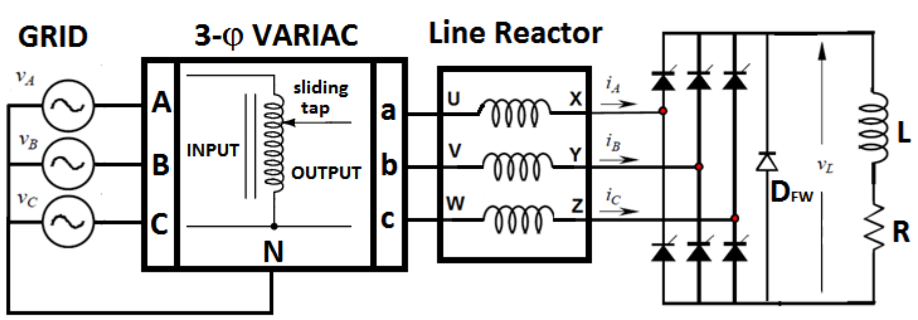

Figure 17: 3-Phase Full-Bridge Half-Controlled Rectifier Feeding an R-L Load with AC Line Reactor and Free-Wheeling Diode

Input voltage, input current, output voltage and output current values are observed with 0o, 60o and 75 o firing angle separately.

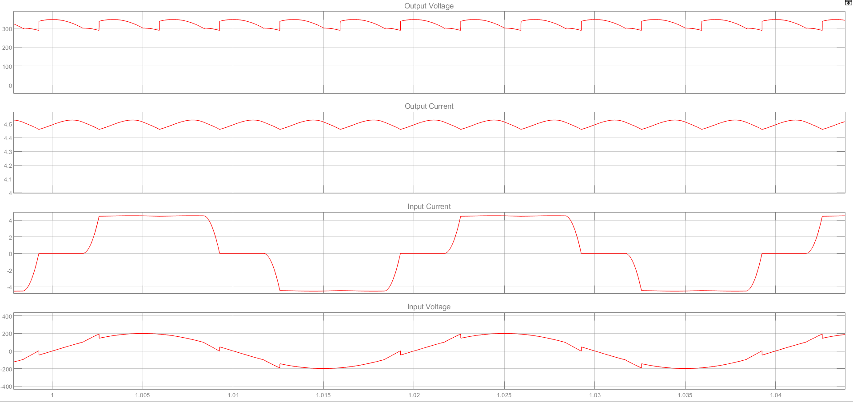

Figure 18: Input Voltage, Input current, Output Voltage and Output Current with 0odegree Firing Angle – Part 1.3.5

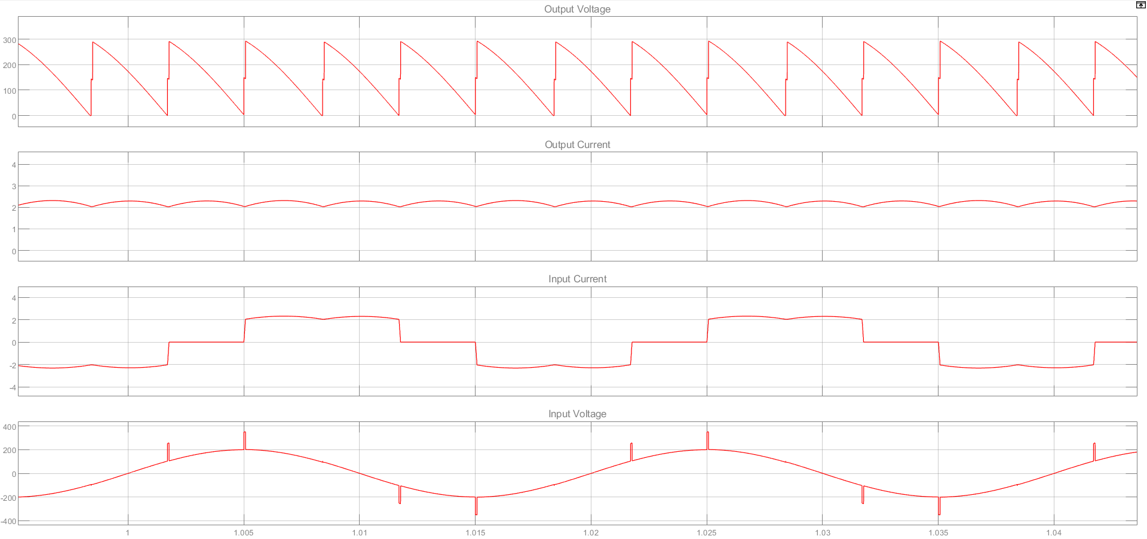

Figure 19: Input Voltage, Input current, Output Voltage and Output Current with 60o degree Firing Angle – Part 1.3.5

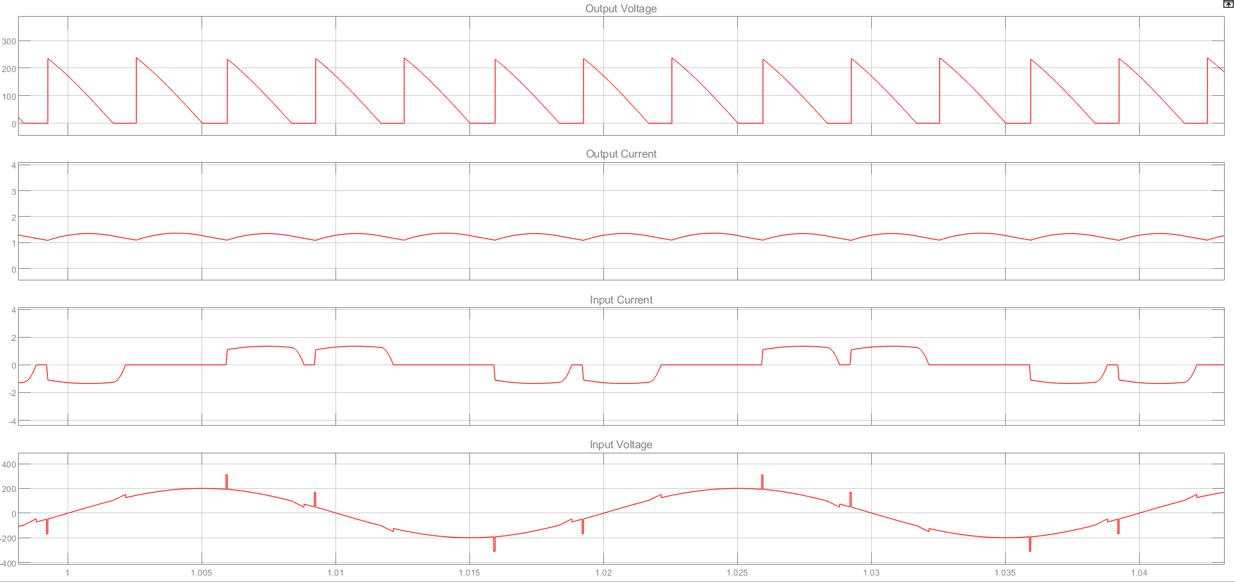

Figure 20: Input Voltage, Input current, Output Voltage and Output Current with 75o degree Firing Angle – Part 1.3.5

The measurement and calculations of both AC and DC sides are shown in the graph below. For comparison, the values without free-wheeling diode are also shown.

|  |  |  |  |  |  |  |  |  |  |  |  |  |  |
| --- | --- | --- | --- | --- | --- | --- | --- | --- | --- | --- | --- | --- | --- |
|  |  | **AC SIDE (INPUT) MEASUREMENTS** | | | | | | | | **DC SIDE (OUTPUT) MEASUREMENTS** | | | |
|  |  | **VIN** | **IIN** | **PIN** | **QIN** | **P.F** | **Φ** | **IIN** | **IIN** | **VOUT** | **VO,RIPPLE** | **IOUT** | **POUT** |
|  |  | **(VRMS)** | **(ARMS)** | **(W)** | **(VAR)** |  |  | **THD-F %** | **THD-R %** | **(VAVG)** | **(VP-P)** | **(AAVG)** | **(W)** |
| **R-L Load and LAC** | *α = 0˚* | 141.4V | 3.503A | 1459W | 284.9VAR | 0.9815 | -11.05° | %24.84 | %24.11 | 323.9V | 57.52V | 4.5A | 1458W |
| *α = 60* | 141.4V | 1.732A | 358.6W | 641.6VAR | 0.4879 | -60.8° | %30.09 | %28.81 | 155.9V | 288.8V | 2.211A | 344.7W |
| *α = 75˚* | 141.4V | 0.866A | 89.58W | 356.3VAR | 0.2438 | -75.89 | %31.46 | %30.01 | 80.28V | 322.6V | 1.111A | 89.21W |
| **R-L Load and LAC with F.W.D.** | *α = 0˚* | 141.4V | 3.503A | 1459W | 284.8VAR | 0.9815 | -11.05° | %24.84 | %24.11 | 323.9V | 57.6V | 4.5A | 1458W |
| *α = 60* | 141.4V | 1.732A | 358.6W | 641.6VAR | 0.4879 | -60.8° | %30.09 | %28.81 | 155.9V | 288.9V | 2.211A | 344.7W |
| *α = 75˚* | 141.4V | 0.8351A | 111.5W | 336.3VAR | 0.3147 | -71.66° | %50.82 | %45.31 | 90.28V | 234.2V | 1.25A | 112.9W |

Table 3: Simulation Results of Parameters for part 1.3.5 and 1.3.4(for comparison)

As is seen, there is no effect of the free-wheeling diode to the measurement at all, for firing angles of 0o and 60o. Yet, it does matter when firing angle becomes 75o. Because the aim of putting a FWD to the rectifier is to block negative output DC voltage. When, DC output voltage goes negative, the diode becomes ON and it by-passes the remaining circuit. So, when firing angle is less than an angle between 60o to 75o, the output voltage never goes negative. So, the diode never goes ON stage. And we do note observe any change.

In the DC (output) side, from the Figure 16 and 20, it is seen that output voltage is kept at 0 voltage for a while when the FWD is added. Therefore, we expect an increase in the average DC output value and we observe an increase from 80V to 90V. The ripple is also squeezed from the negative side, from 322V to 234V. The average output current is also increased by 13% when the diode is inserted, because, in ON stage, there is an additional current that feeds the load. The diode enables the inductance to discharge its stored energy into the resistance. The increase in current and voltage implies that the output power also increases from 89W to 113W.

In the AC (input) side, after 180o, a reverse-voltage appear across thyristor. When freewheeling diode is omitted, during the negative portion of the supply voltage, thyristor returns the energy stored in the load inductance to the supply line. When FWD is presented, no power is returned to the source. Therefore, the ratio of reactive power of input to the total power in load is less for the circuit with a FWD. To sum up, the FWD improves the input power-factor. In simulation, adding a FWD for 75o firing angle increases power factor by 33%. Since a FWD eliminates the effect of reverse voltage mode, the phase of the fundamental power decreases. Adding a FWD at 75o firing angle decreases the phase Φ by 4 degree. By observing input currents from the figures, we see that, adding a FWD reduces input current to zero when diode is in on stage and the waveform again becomes more square-wave and distorted. Therefore, a FWD increases the distortion when in on stage.

**CONCLUSION HERE**

|  |  |  |  |  |  |  |  |  |  |  |  |  |  |
| --- | --- | --- | --- | --- | --- | --- | --- | --- | --- | --- | --- | --- | --- |
|  |  | **AC SIDE (INPUT) MEASUREMENTS** | | | | | | | | **DC SIDE (OUTPUT) MEASUREMENTS** | | | |
|  |  | **VIN** | **IIN** | **PIN** | **QIN** | **P.F** | **Φ** | **IIN** | **IIN** | **VOUT** | **VO,RIPPLE** | **IOUT** | **POUT** |
|  |  | **(VRMS)** | **(ARMS)** | **(W)** | **(VAR)** |  |  | **THD-F %** | **THD-R %** | **(VAVG)** | **(VP-P)** | **(AAVG)** | **(W)** |
| **R Load** | *α = 0˚* | 141.4V | 3.599A | 1527W | 23.81VAR | 0.9999 | -0.8936° | %30.52 | %29.19 | 330.7V | 46.4V | 4.593A | 1519W |
| *α = 60* | 141.4V | 1.011A | 63.6W | 424VAR | 0.1484 | -81.47° | %104.7 | %72.3 | 114.4V | 300V | 1.594A | 182.3W |
| **R-L Load** | *α = 0˚* | 141.4V | 3.594A | 1524W | 27.67VAR | 0.9998 | -1.04° | %30.89 | %29.51 | 330.7V | 46.5V | 4.594A | 1519W |
| *α = 60* | 141.4V | 1.766A | 371.9W | 650.3VAR | 0.4965 | -60.23 | %30.59 | %29.25 | 158.9V | 297.7V | 2.254A | 358.1W |
| **R-L Load and LAC** | *α = 0˚* | 141.4V | 3.503A | 1459W | 284.9VAR | 0.9815 | -11.05° | %24.84 | %24.11 | 323.9V | 57.52V | 4.5A | 1458W |
| *α = 60* | 141.4V | 1.732A | 358.6W | 641.6VAR | 0.4879 | -60.8° | %30.09 | %28.81 | 155.9V | 288.8V | 2.211A | 344.7W |
| *α = 75˚* | 141.4V | 0.866A | 89.58W | 356.3VAR | 0.2438 | -75.89 | %31.46 | %30.01 | 80.28V | 322.6V | 1.111A | 89.21W |
| **R-L Load and LAC with F.W.D.** | *α = 0˚* | 141.4V | 3.503A | 1459W | 284.8VAR | 0.9815 | -11.05° | %24.84 | %24.11 | 323.9V | 57.6V | 4.5A | 1458W |
| *α = 60* | 141.4V | 1.732A | 358.6W | 641.6VAR | 0.4879 | -60.8° | %30.09 | %28.81 | 155.9V | 288.9V | 2.211A | 344.7W |
| *α = 75˚* | 141.4V | 0.8351A | 111.5W | 336.3VAR | 0.3147 | -71.66° | %50.82 | %45.31 | 90.28V | 234.2V | 1.25A | 112.9W |