

ELECTRICAL AND ELECTRONICS ENGINEERING DEPARTMENT

EE464 POWER ELECTRONICS – II

Homework III

**Yunus Çay 2166148**

Table of Contents

A. Plant Characteristics 3

1. Examination of Transfer Function 3

2. Bode Plot of the Plant 3

B. Controller Design 4

3. Identification of Poles and Zeros 4

4. Crossover Frequency 4

5. Compensator Selection 5

6. Component Selection of Compensator 5

7. Bode Plot of Loop Transfer Function 7

C. Simulation 9

8. Full Load to Half Load 9

9. Half Load to Full Load 10

10. Drop in Input Voltage 11

11. Comparison of Designed Compensators 12

12. Bonus 12

D. References 12

# Plant Characteristics

## Examination of Transfer Function

Transfer function is mathemetical function that represent the relation between output and input theoretically. In other words, transfer function models the plant.

Input voltage and duty cycle are inputs and output voltage is output. When the system is linearized, superposition can be applied to find transfer function. Inputs can be found in model as current sources, voltage sources. The superposition is applied to eliminate other input. Hence, control-to-output and input-to-output transfer function represents how the system behaves according to the applied inputs. Although superposition is applied, still transfer function can have DC component of the other input.

## Bode Plot of the Plant

Figure 1 shows the bode diagram for control-to-output transfer function of buck converter with and without ESR of the capacitor. Both system are similar up to a point where the zero is located due to the ESR of the capacitor. Since the ideal system doesn’t have zero, phase of ideal system continues to decrease and slope of gain decreases with -40dB. On the other hand, non-ideal system gain reduces with -20dB after the zero of the non-ideal plant.

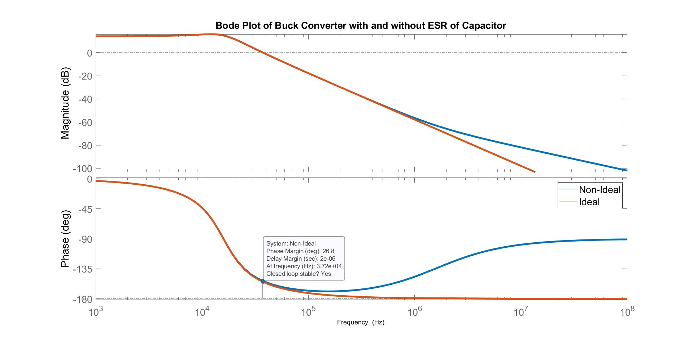

Figure Bode diagram for control-to-output transfer function of buck converter with and without ESR of the capacitor

Theoretically, both ideal and non-ideal plant does not have gain margin since their phases does not reach -180°. Ideal system, however, is very close to the -180° so that gain margin of ideal plant can be calculate at 106 Hz as 58.2 dB. On the other hand, their phase margins are calculated at 37.2 kHz which is also named crossover frequency. The phase margins are 25.3° and 26.8° for ideal and non-ideal plants, respectively. That the difference in phase margins is small is because zero of the non-ideal plant is far away from the cross-over frequency.

# Controller Design

## Identification of Poles and Zeros

According to given control-to-output transfer function zeros and poles are found in Equation (1). The non-ideal plant has one zero and one double pole. The calculations for poles are not exact poles theoretically, since the ESR affects the poles location in neglible amount. Hence, the pole is approximated as purely resonanance frequency.

|  |  |  |
| --- | --- | --- |
|  | $$Zero=\frac{1}{{2πR}_{ESR}C}=1.592 {10}^{6} Hz$$ $$Poles_{1,2}=\frac{1}{2π\sqrt{LC}}=15.84 {10}^{3} Hz$$ | (1) |

## Crossover Frequency

*‘...F0 is the zero crossover frequency defined as the frequency when loop gain equals unity. F0 is also called “the bandwidth of the loop” or “the bandwidth of the system*”’. (International Rectifier, AN - 1162)

Typical limitation is done based on switching frequency. Crossover frequency is selected as 1/10~1/5 of switching frequency to attenuate switching noise sufficiently. The phase margin is also defined at the crossover frequency and typical phase margin is 45°.

Besides, there is a relation between crossover frequency and transient response. The gain of the loop is positive before the crossover frequency and negative after the crossover frequency. As the crossover frequency gets higher, gain becomes positive and high for wide range of frequency. Error signal amplified for wide range in great amount, which makes the system fast.

The crossover frequency is selected as 20kHz in order to make high attenuation of switching noise. There is no need further reduction in crossover frequency. Also, selection of crossover frequency lower than the resonance frequency since there is an amplification at resonance frequency.

The crossover frequency for other compensator is selected as 40kHz for the sake of comparison of two compansator having different crossover frequencies.

## Compensator Selection

The double pole at resonance frequency makes the gain slope -40dB, which makes placing a zero before crossover frequency is compulsary in order to get higher crossover frequency. The constraint on crossover frequency affects the gain at high frequencies which are desired to be attenuated. Therefore, some poles should be placed after the crossover frequency.

The phase of frequency response should be also considered. Phase margin is compansated with double pole at resonance frequency and zeros that should be placed for the sake of desired crossover frequency. However, number of the poles and zeros should not be so unbalanced before the crossover frequency that the phase margin gets closer to the -180°.

Figure 2 is taken from the application note by International Rectifier (AN - 1162). Type 3-B compensator is selected. Other types of compensators are not appropriate for the plant. Therefore, the type-3B compensators with different crossover frequencies and phase margins are compared.

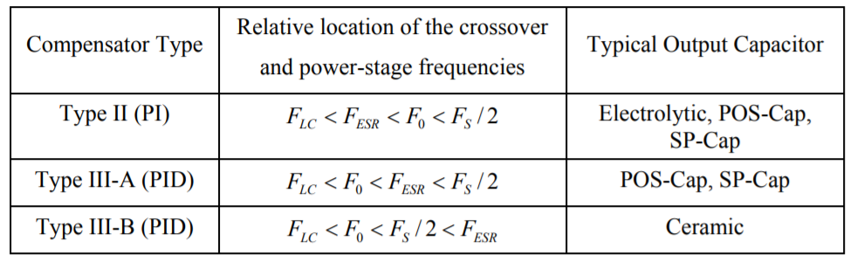

Figure Selection parameters of compansator types based on significant frequency values

## Component Selection of Compensator

The circuit schematic of type III-B compensator is shown in Figure 3.

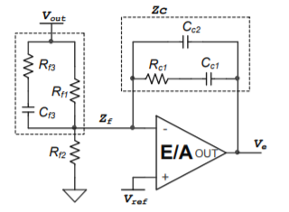

Figure Circuit schematic of type III-B compensator

The tranfer function of compensator is given in Equation (2).

|  |  |  |
| --- | --- | --- |
|  | $$H\left(s\right)=\frac{\left(1+sC_{c1}R_{c1}\right)\left(1+sC_{f3}\left(R_{f1}+R_{f3}\right)\right)}{sR_{f1}\left(C_{c1}+C_{c2}\right)\left(1+sR_{c1}\left(\frac{C_{c1}C_{c2}}{C_{c1}+C_{c2}}\right)\right)\left(1+sC_{f3}R_{f3}\right)}$$ | (2) |

The calculation of poles and zeros of type III-B compensator is done in Equation (3).

|  |  |  |
| --- | --- | --- |
|  | $$F_{p1}=0$$ $$F_{p2}=\frac{1}{2πC_{f3}R_{f3}}$$ $$F_{p2}=\frac{1}{2πC_{c2}R_{c1}}$$ $$F_{z1}=\frac{1}{2πC_{c1}R_{c1}}$$ $$F_{p2}=\frac{1}{2πC_{f3}\left(R_{f1}+R_{f3}\right)}$$ | (3) |

The selection of poles and zeros are done according to application note by International Rectifiers (AN - 1162). The angle, theta, in selection 2nd zero and pole represents the maximum phase lead at crossover frequency. Typical value of phase lead is 70°. Selection of poles and zeros are shown in Equation (4).

|  |  |  |
| --- | --- | --- |
|  | $$F_{p3}={fsw}/2$$ $$F_{p2}=F_{0}\sqrt{\frac{1+\sin{θ}}{1-\sin{θ}}}$$ $$F_{z2}=F_{0}\sqrt{\frac{1-\sin{θ}}{1+\sin{θ}}}$$ $$F_{z1}={F_{z2}}/2$$ | (4) |

Table 1 shows the calculated zeros, poles and component values. Practical values of components are verified from Digikey.

Table Calculated zeros, poles and component values of the plant at 40kHz and 20kHz crossover frequency

|  |  |  |  |  |
| --- | --- | --- | --- | --- |
| **Description** | **40kHz Crossover Frequency** | | **20kHz Crossover Frequency** | |
| **FP1** | 0 Hz | | 0 Hz | |
| **FP2** | 226.85 kHz | | 113.43 kHz | |
| **FP3** | 100 kHz | | 100 kHz | |
| **FZ1** | 3.527 kHz | | 1.763 kHz | |
| **FZ2** | 7.053 kHz | | 3.527 kHz | |
|  | **Theoretical** | **Practical** | **Theoretical** | **Practical** |
| **Cf3** | 2.2 nF | 2.2 nF | 2.2 nF | 2.2 nF |
| **Rf3** | 318.9 Ω | 320 Ω | 637.8 | 634 |
| **Rf1** | 9.937 kΩ | 10 kΩ | 19.88 k | 20 k |
| **Rf2** | 5.714 kΩ | 5.69 kΩ | 11.43 k | 11.5 k |
| **RC1** | 4.113 kΩ | 4.12 kΩ | 2.06 k | 2.05 k |
| **CC1** | 10.95 nF | 12 nF | 44.03 nF | 47 nF |
| **CC2** | 386.3 pF | 390 pF | 776.4 pF | 750 pF |

## Bode Plot of Loop Transfer Function

Figure 4 shows the bode plot of loop transfer function for 40kHz crossover frequency. 20.5dB and 67° are gain and phase margins for 41.1 kHz crossover frequency. System is stable. Phase margin of the system is below the defined maximum phase angle, theta. The phase margin creates a delay or as the phase margin grows, response time decreases. However, the calculation of delay in seconds depends on the crossover frequency because the phase margin is defined at crossover frequency. That is, the response time in seconds depends on both phase margin and crossover frequency.

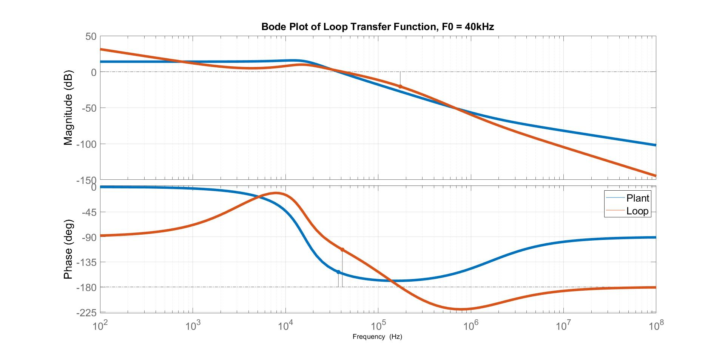

Figure Bode plot of loop transfer function for 40kHz crossover frequency

Figure 5 shows the bode plot of loop transfer function for 20kHz crossover frequency. 23.3dB and 101° are gain and phase margins for 23.9 kHz crossover frequency. System has 3 phase crossover point at 496Hz, 9.66kHz and 23.9kHz. System is stable because the phase margins are not close to the zero at crossover frequencies. The compensator with 20kHz crossover is expected to be slow against applied changes.

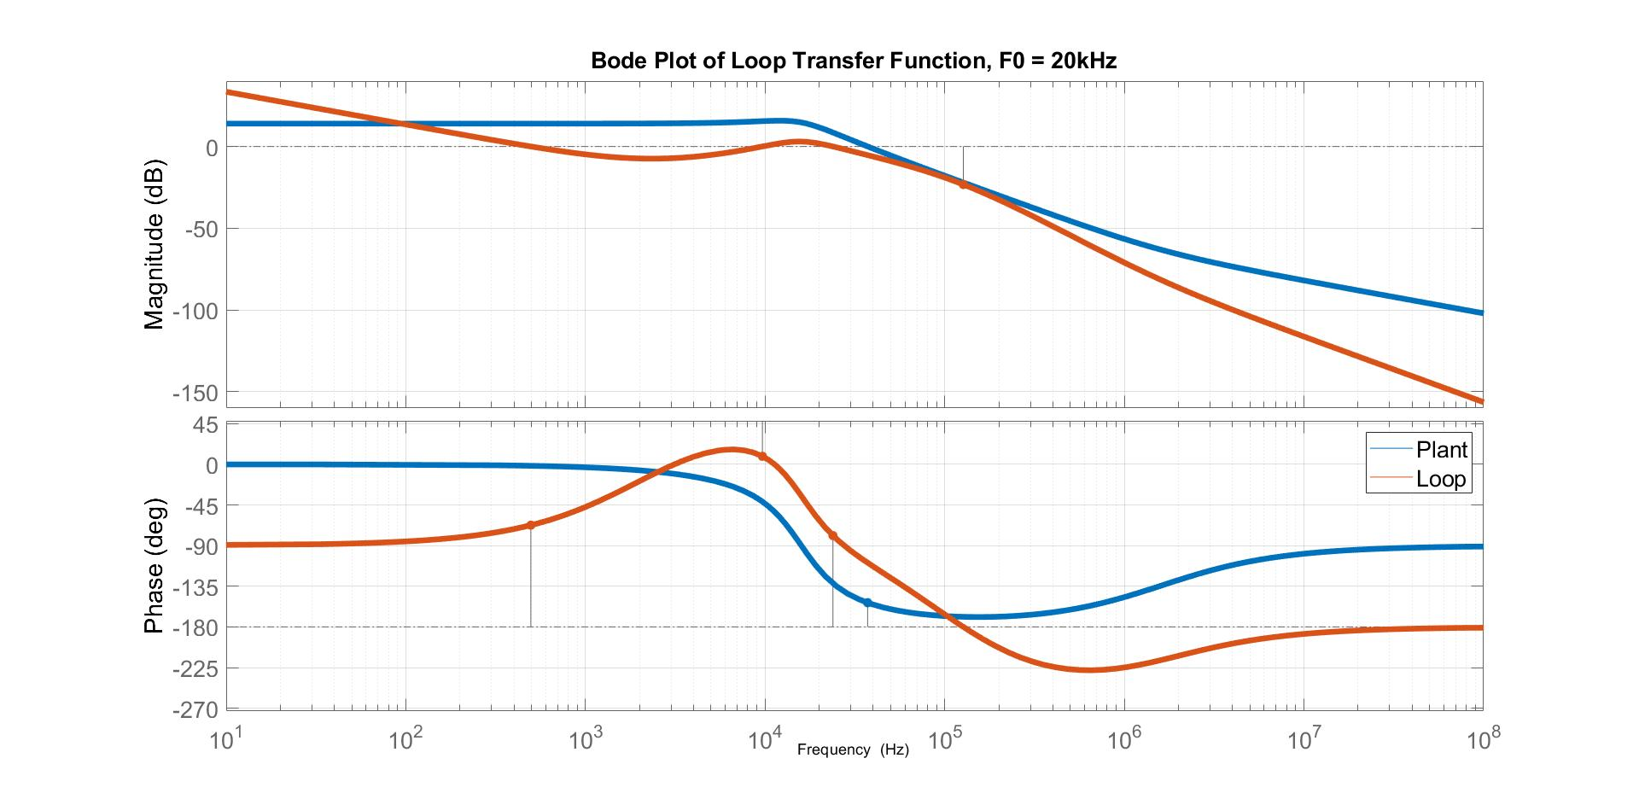

Figure Bode plot of loop transfer function for 20kHz crossover frequency

# Simulation

## Full Load to Half Load

Figure 6 shows the transient waveforms of IL, Vo, and D for the compensator with 40kHz crossover frequency when the load is changed from full to half. When the load diminishes by half, inductor current decreases by half so that decrease in high amount of inductor current creates high voltage at output. Then, compensator decreases duty cycle and stored energy of inductor supplies output current instead of input. When the output voltage change becomes negative, compensator starts to increase duty cycle, which is due to the derivative of PID control. Finally, output voltage becomes stable at desired voltage level, 3.3V. The ringing is not observed in output voltage.

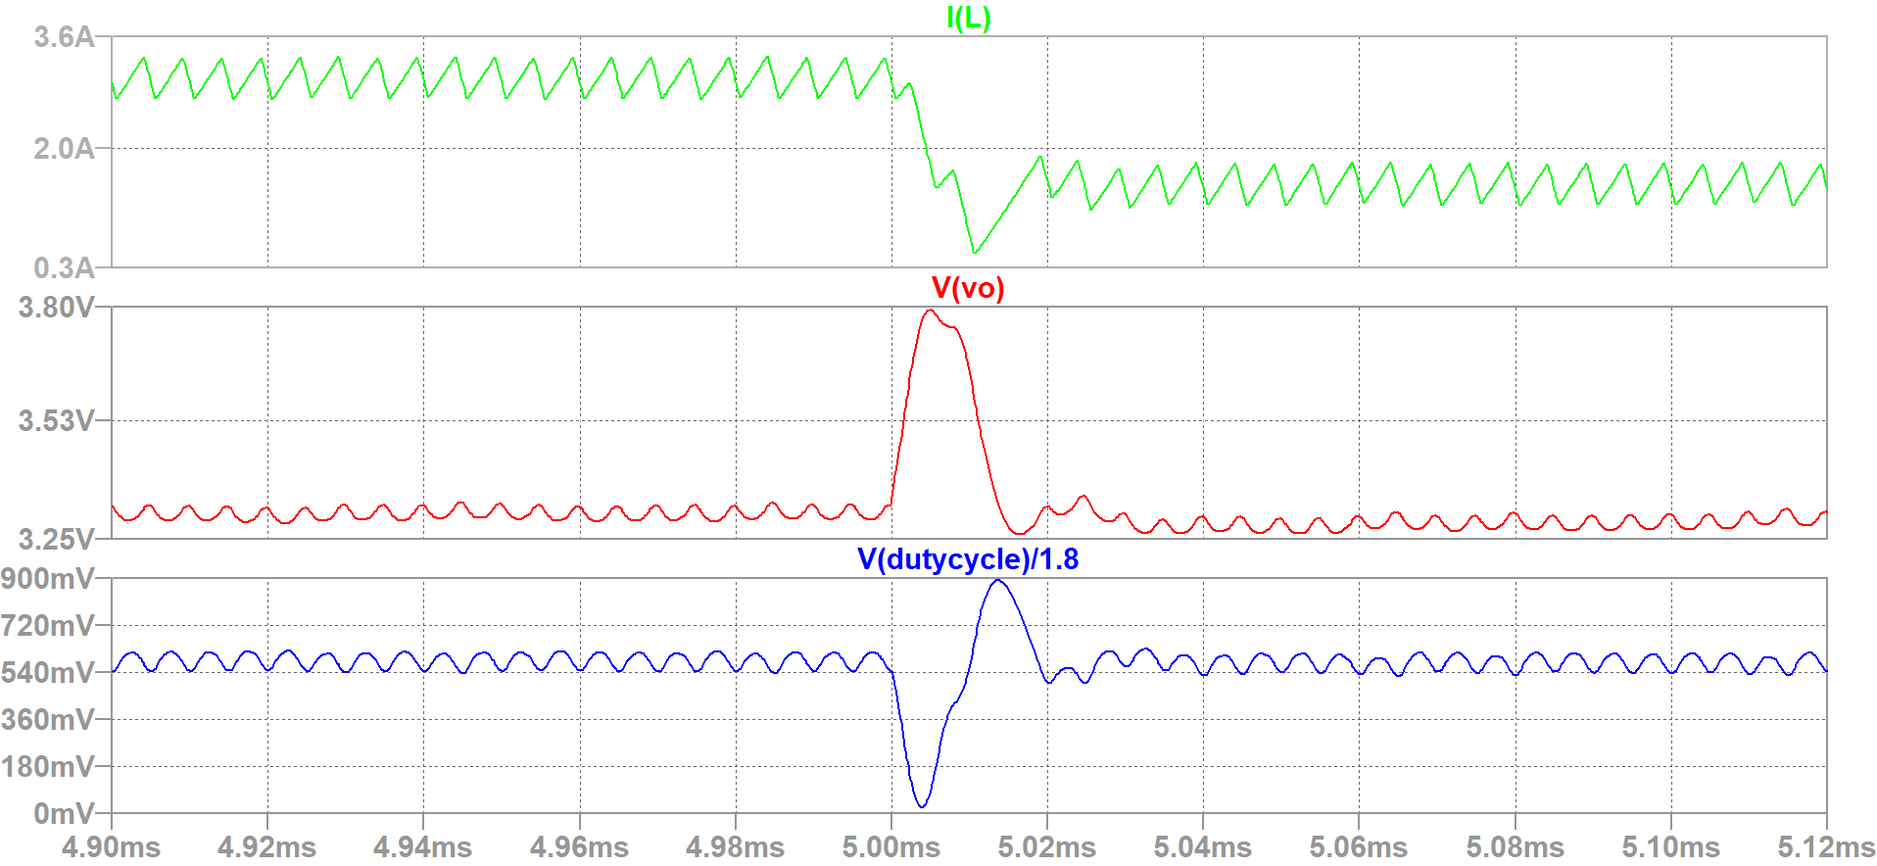

Figure Full-to-half load, transient waveforms of Vo, IL and D for compensator with 40kHz crossover frequency

Figure 7 shows the transient waveforms of IL, Vo, and D for the compensator with 20kHz crossover frequency when the load is changed from full to half.

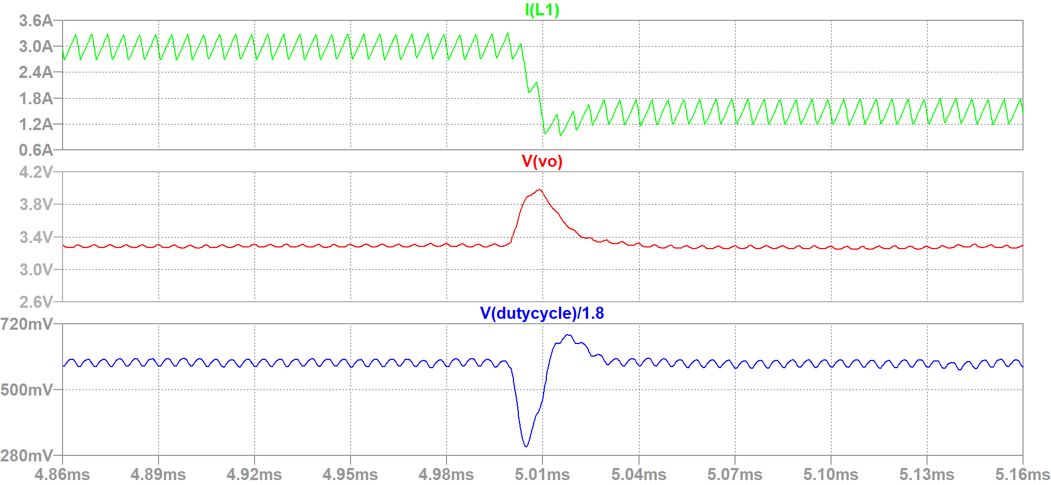

Figure Full-to-half load, transient waveforms of Vo, IL and D for compensator with 20kHz crossover frequency

## Half Load to Full Load

Figure 8 shows the transient waveforms of IL, Vo, and D for the compensator with 40kHz crossover frequency when the load is changed from half to full. When the load is increased to full, output voltage decreases since the inductor current and output capacitor voltage can not be changed immediately. When the slope of output voltage becomes positive, duty cycle starts to decrease and output voltage reached to steady-state value, 3.3V. The ringing is not observed in output voltage.

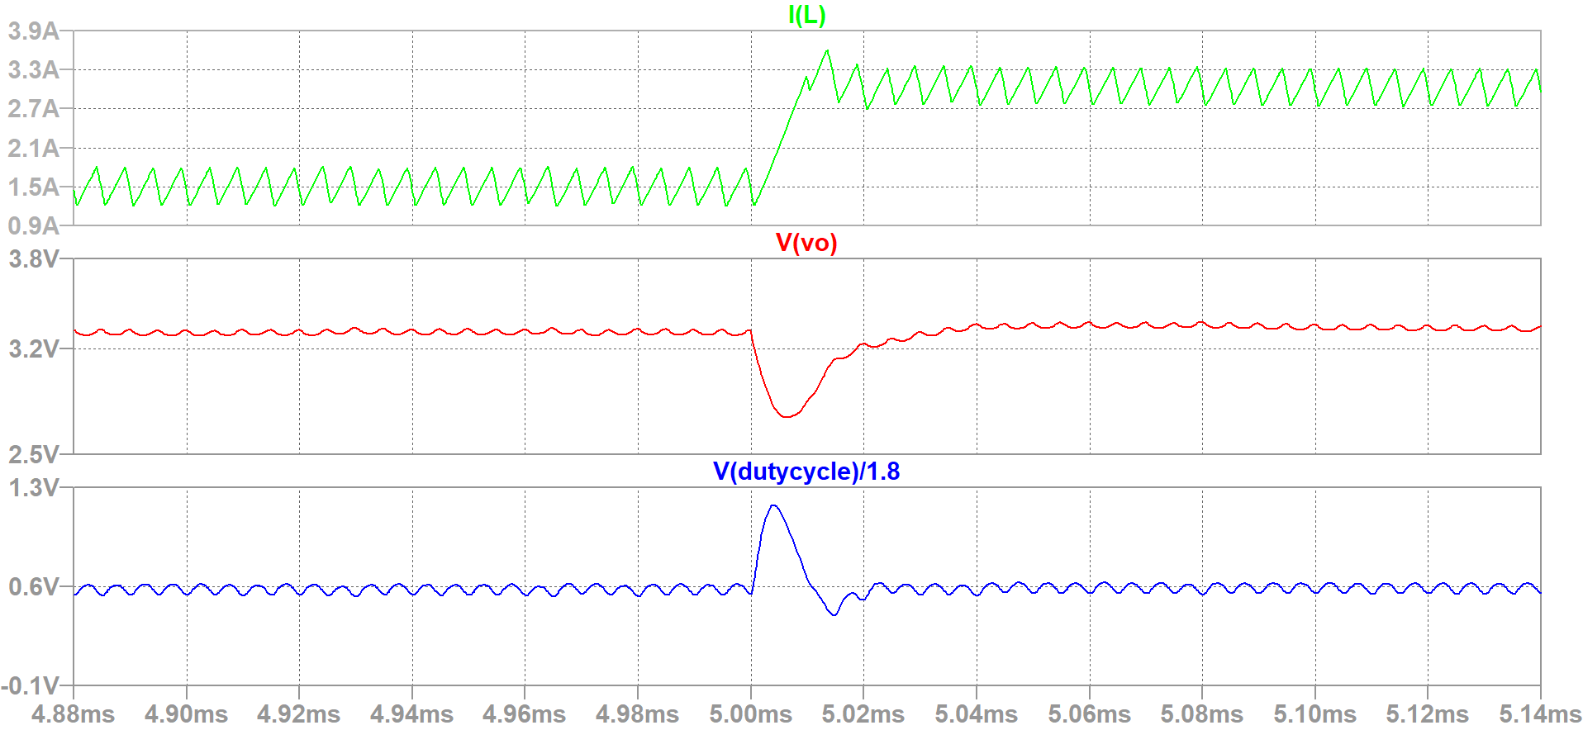

Figure Half-to-full load, transient waveforms of Vo, IL and D for compensator with 40kHz crossover frequency

Figure 9 shows the transient waveforms of IL, Vo, and D for the compensator with 20kHz crossover frequency when the load is changed from half to full.

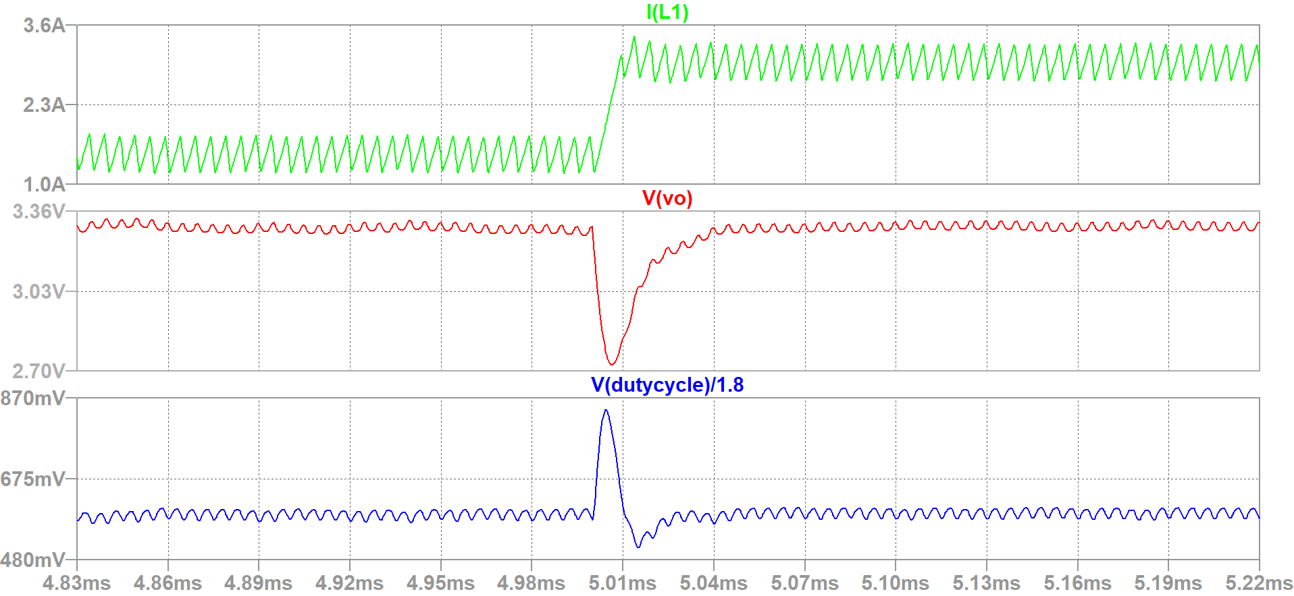

Figure Half-to-full load, transient waveforms of Vo, IL and D for compensator with 20kHz crossover frequency

## Drop in Input Voltage

Figure 10 shows the transient waveforms of IL, Vo, Vin, and D for the compensator with 40kHz crossover frequency when the input voltage is dropped to 4V. Drop in input voltage results in drop in output voltage since compensator cannot immediately respond the changes from input, which can be proved by waveform of inductor current. The amount of increase in inductor current is low when the step change is applied. While the duty cycle is constant, voltage difference on the inductor becomes due to drop in input voltage. That there is a small overshoot in duty cycle waveform may be caused by derivative of PID control. Compensator still helps to regulate output voltage.

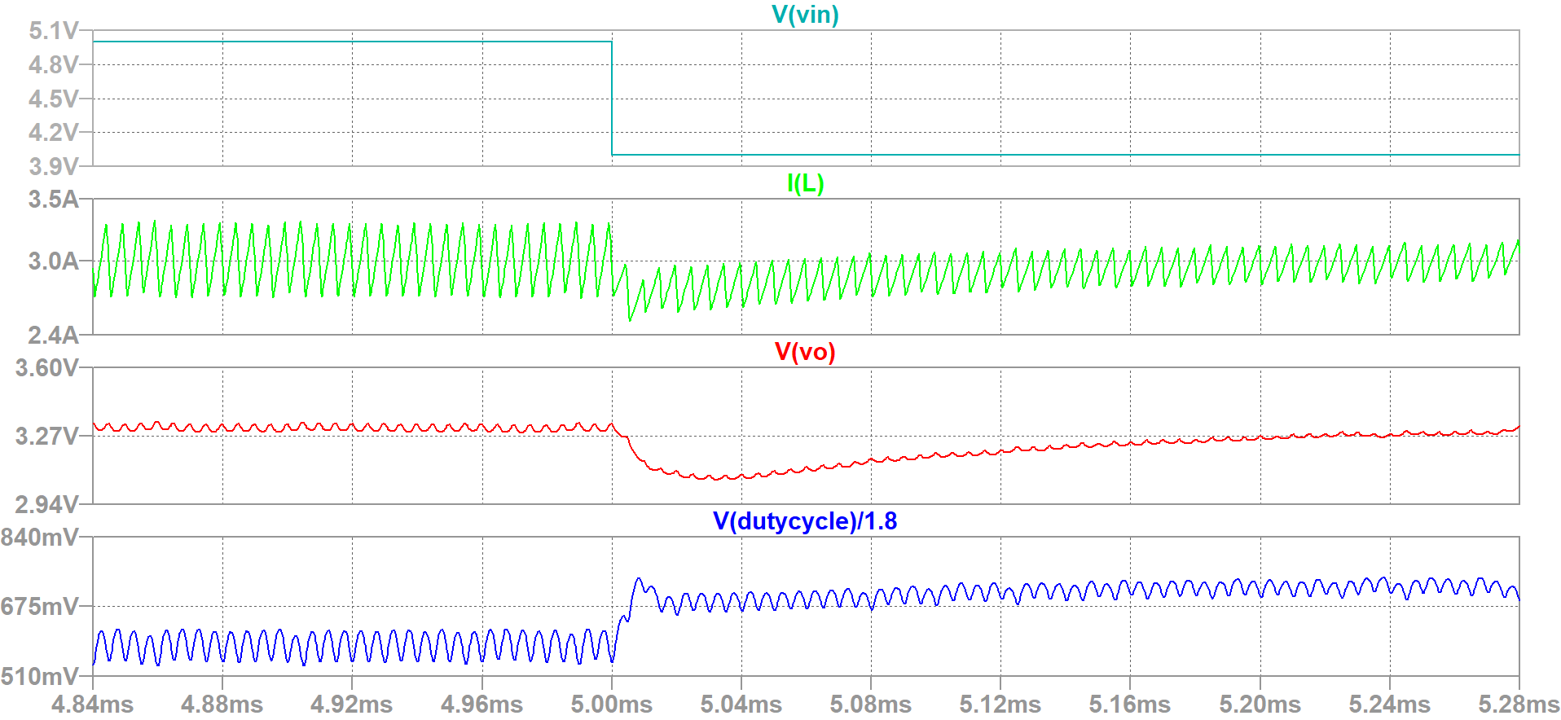

Figure Step change in input voltage 5V-to-4V, transient waveforms of Vo, Vin, IL and D for compensator with 40kHz crossover frequency

Figure 11 shows the transient waveforms of IL, Vo, Vin, and D for the compensator with 20kHz crossover frequency when the input voltage is dropped to 4V.

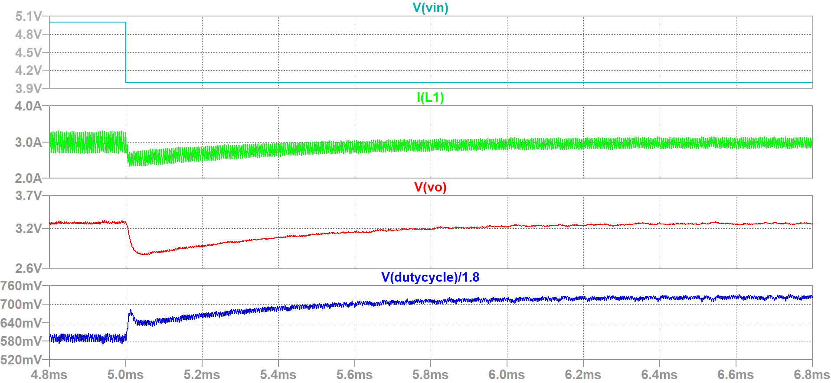

Figure Step change in input voltage 5V-to-4V, transient waveforms of Vo, Vin, IL and D for compensator with 20kHz crossover frequency

## Comparison of Designed Compensators

Both of the designed compensator are type III-B, but their crossover frequencies are different. The parameters affecting the performance of the compensators are crossover frequency, gain margin and phase margin.

Both of the compensator has overshoot or undershoot based on applied changes. However, there is no significant oscillation in output voltage, while the duty cycle has small oscillations. The duty cycle oscillations are attenuated on the plant, especially due to LC filter at output of the buck converter.

The settling time of the output voltage for 20kHz crossover frequency is higher than the settling time of compensator with 40kHz crossover frequency. The expected result for speed of response is agree with simulation results. The compensator with 20kHz has lower response speed since the gain of the frequency range up to crossover for 20kHz crossover is smaller than the case of 40kHz. On the other hand, compensator with 40kHz can not attenuate the switching frequency much compared to the compensator with 20kHz.

## Bonus

Spend time : 19 Hours

# References

Rahimi, A. M., Parto P., Asadi P. Application Note, AN – 1162. International Rectifiers

<https://www.infineon.com/dgdl/an-1162.pdf?fileId=5546d462533600a40153559a8e17111a>