Q1 – Analytical Calculations

# Q1 – Analytical Calculations

## Part A - Inductance

Minimum and maximum reluctance occurs in the electro-magnetic system when a rotating part is at 0° and 90°, respectively. Reluctance can be calculated using length of mean magnetic path, area of magnetic path and relative permeability of materials. The calculatiom of minimum reluctance and is shown in Equation xx.

|  |  |  |
| --- | --- | --- |
|  |  | 1.1 |

The rotating part angle at 90° results in maximum reluctance in electromagnetic system. Since the arc of rotor cannot cover the stationary part at 90°, flux area will be less than the case at 0°. Straight lines of rotor under the arc of stator are %12 of width of stator, 15mm. However, the area reduction should not be approximated as %12, but &6 because the arc of stationary part is still included in flux area. Reluctance calculation at 90° is shown in Equation xx.

|  |  |  |
| --- | --- | --- |
|  |  | 1.2 |

Minimum and maximum inductance, reluctance are given in Table xx.

|  |  |  |
| --- | --- | --- |
| Angle | Reluctance (1/H) | Inductance (mH) |
| 0° degree | 2.356 E06 | 26.528 |
| 90° degree | 1.253 E07 | 4.988 |

The sinusoidal approximation for inductance variation is plotted in Figure xx and sinusoidal approximation is given in Equation xx.

|  |  |  |
| --- | --- | --- |
|  |  | 1.3 |

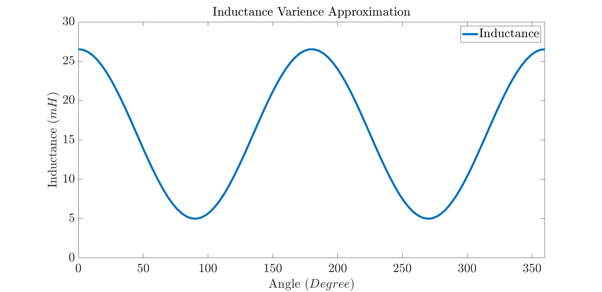

## Part B – Torque

Torque for DC excited variable inductance electromagnetic systems is derived based on Equation xx.

|  |  |  |
| --- | --- | --- |
|  |  | 1.3 |

The plot of derived torque expression with respect to angle can be seen in Figure xx.

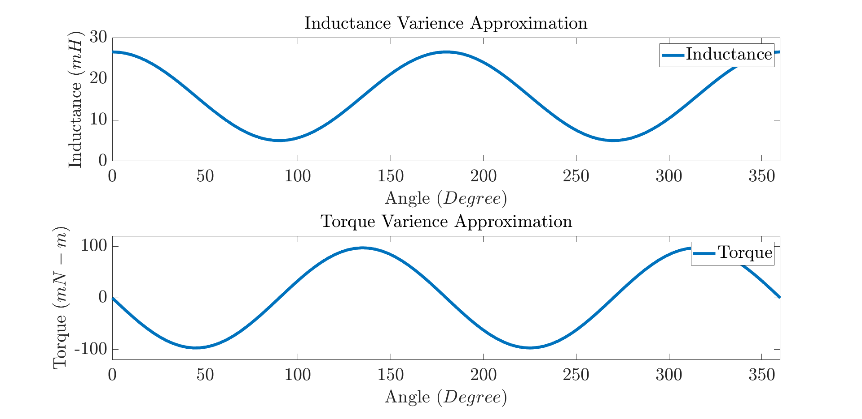

## Improvement in Analytical Approximation

Flux density inner side of core is higher than the outer side since inner side of the core has smaller reluctance, which may cause saturation, so the reluctance of the electromagnetic system could be higher. Fringing flux in air-gap region crosses the air-gap through the non-direct ways and flux area increases a bit. Hence fringing flux could decrease the reluctance ance Carter’s method or drawing flux tubes for approximation could be alternatives to better approximation for system reluctance calculation. Besides, the reluctance calculation at 90° is not good approximation. This can be enhanced with reluctance functions depends on angle. Finally, the alternative way, of course, is finite element analysis of the electromagnetic system.

# 2D Linear Material Finite Element Analysis

## Flux Density Vectors

The flux density vectors for positions 0°, 45°, and 90° are given in Figure xx ,xx, xx, respectively. Relative permeability of linear material is taken as 2250.

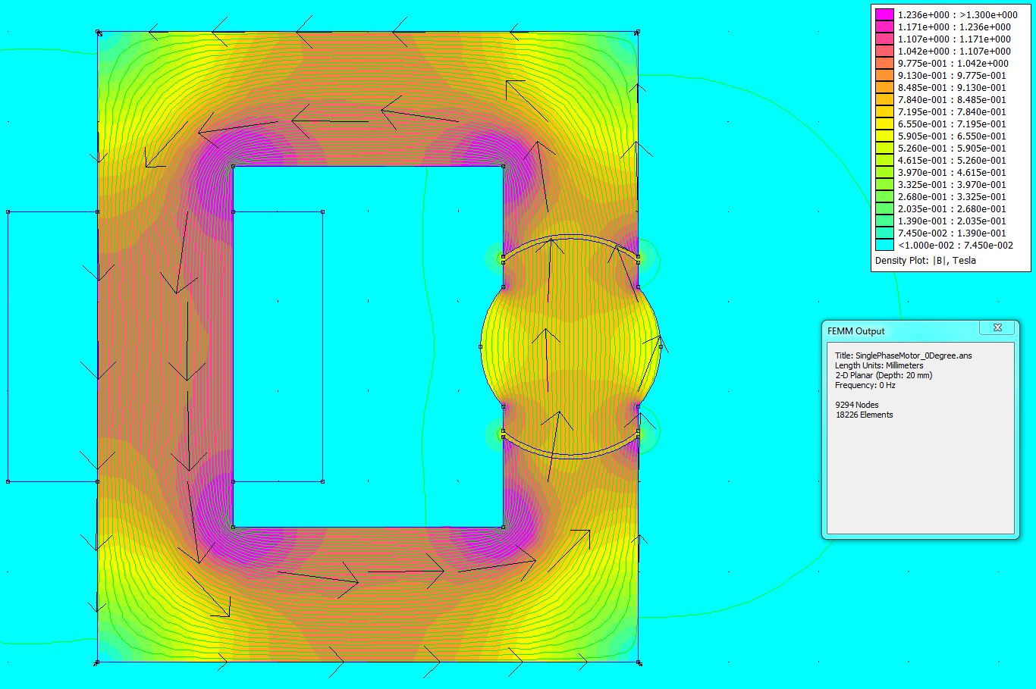

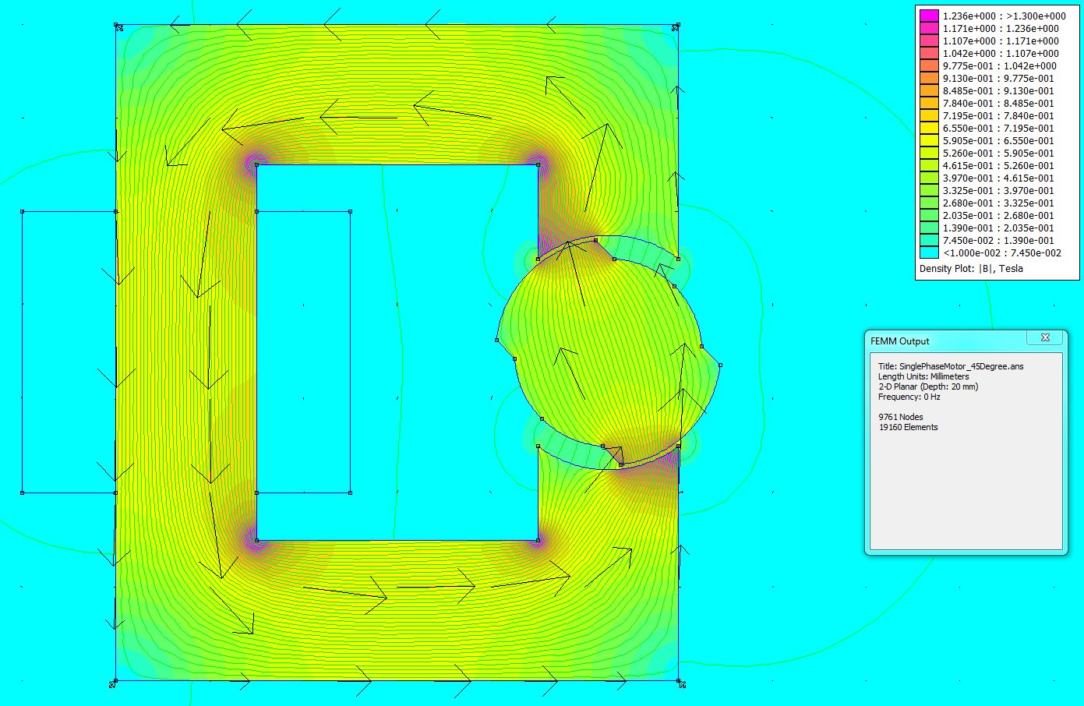

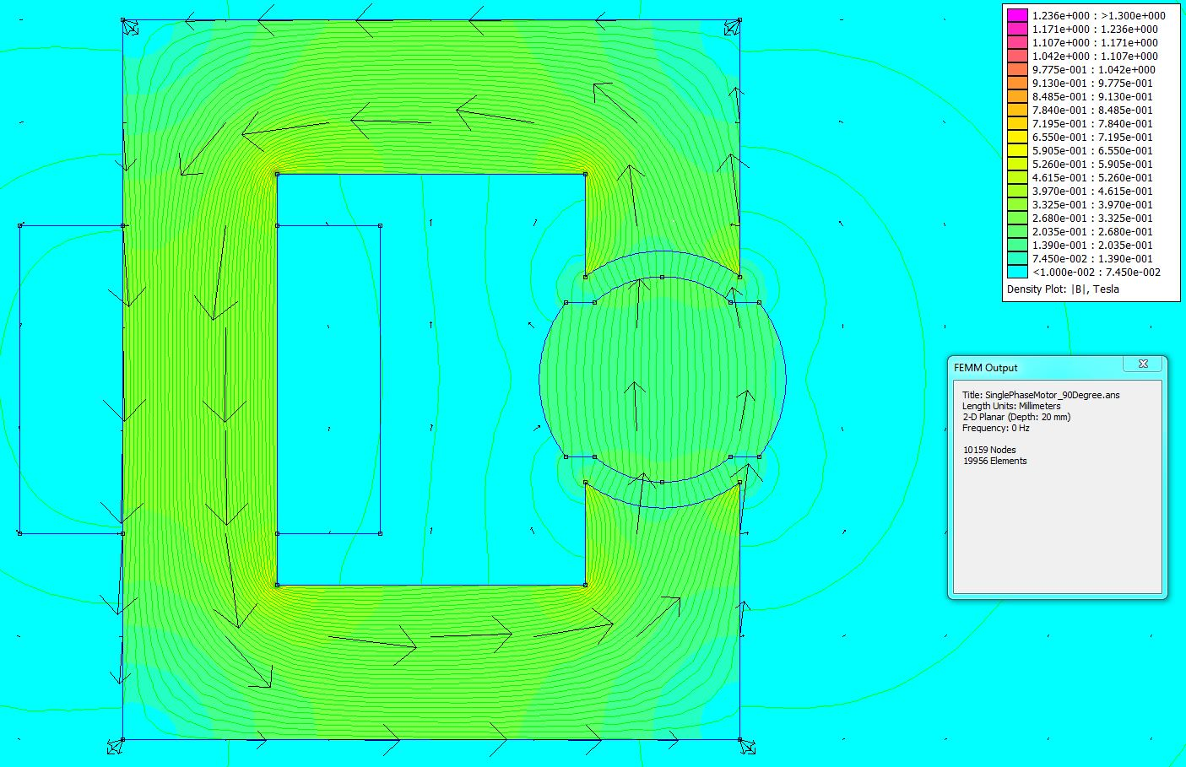

## Part B – Inductance and Energy Calculation

Inductance values of electromangtic system for rotor positions at 0°, 45°, and 90° are calculated with finite element analysis and founded values have some discrepancies with analytical results in terms of inductance values and sinusoidal variance approximation.

Stored energy of the magnetic system is calculated in Equation xx.

|  |  |  |
| --- | --- | --- |
|  |  | 2.1 |

Inductance values calculated with FEA and stored energy are given in Table xxx for rotor positions 0°, 45°, and 90°

|  |  |  |
| --- | --- | --- |
| Angle | Inductance | Energy |
| 0° | 27.194 mH | 122.373 mJ |
| 45° | 17.537 mH | 78.917 mJ |
| 90° | 8.854 mH | 39.843 mJ |

Calculated inductance values from 2D linear material FEA are drawn with apply of interpolation in Figure xx.

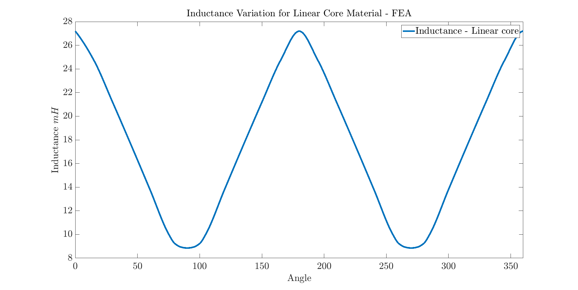

## Part C – Torque

Numeric Derivative not working now

1. 2D Non-linear Material Finite Element Analysis

## Part A – Flux Density Vectors

The flux density vectors for positions 0°, 45°, and 90° are given in Figure xx ,xx, xx, respectively. Core material is selected as M50. B-H curve of M50 steel can be seen in Figure xx.

B-H cureve

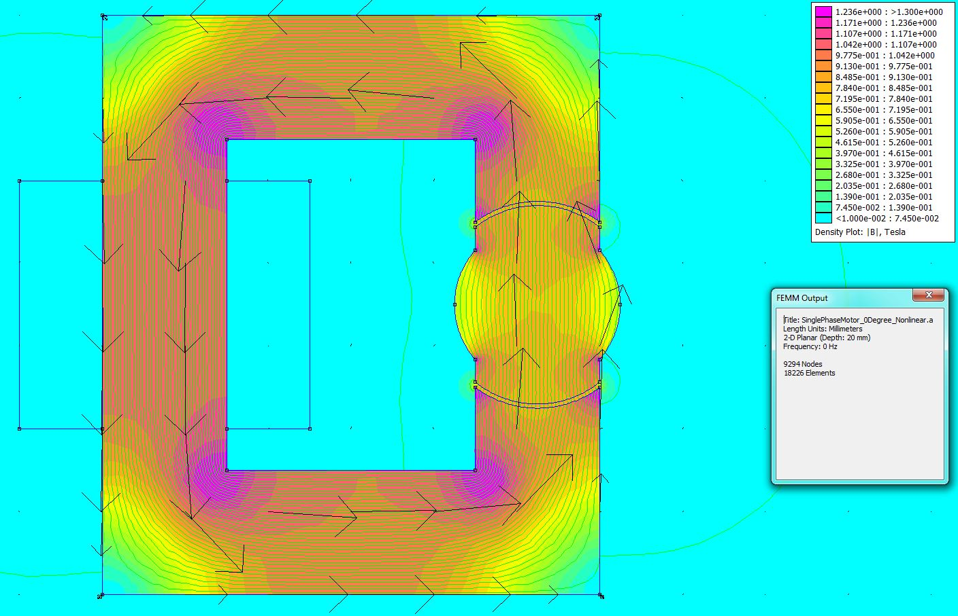

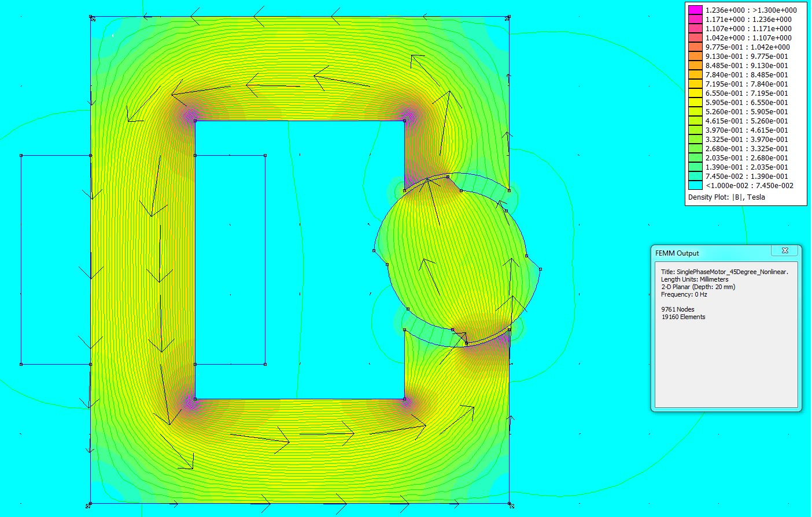

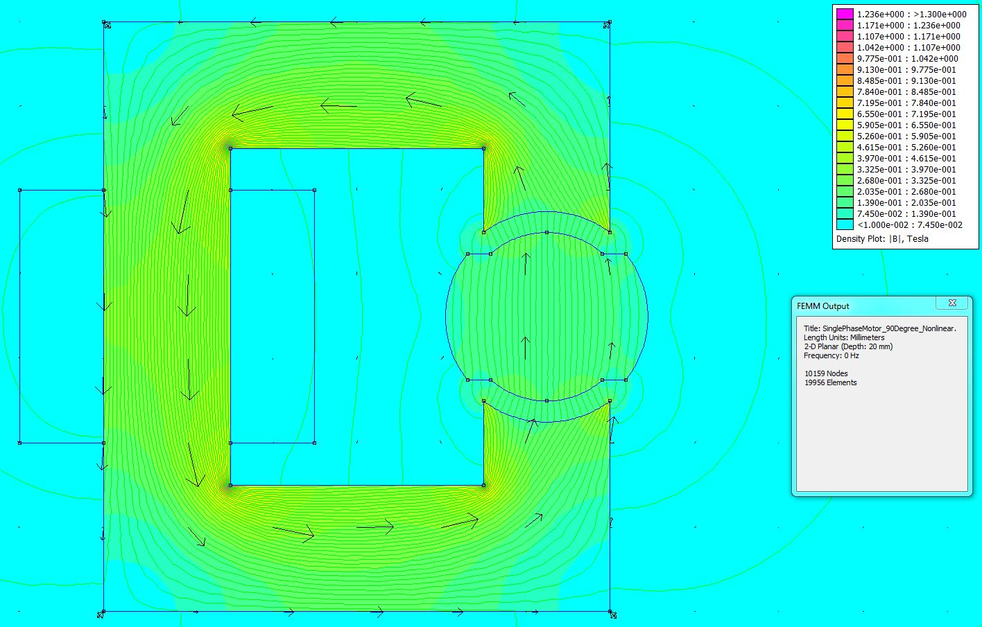

## Part B – Inductance and Energy Calculation

Inductance values of electromangtic system for rotor positions at 0°, 45°, and 90° are calculated with finite element analysis. Non-linearity of material cause reduction inductance values slightly since observed flux density values doesn’t make obvious non-linearity of M50 material.

|  |  |  |
| --- | --- | --- |
| Angle | Inductance | Energy |
| 0° | 27.025 mH | 121.625 mJ |
| 45° | 17.416 mH | 78.372 mJ |
| 90° | 8.748 mH | 39.366 mJ |

Inductance variation figure

## Part C – Torque

Numeric Derivative

## Part D – Nonlinear Comparsion

Compare

# Q4 – Control Method