# Q1 – Integral Slot Winding

## Full-pitched Winding

Table 1 Full-pitched winding of 6-pole, 72 slot and 3-phase machine

|  |  |  |  |  |  |  |  |  |  |  |  |
| --- | --- | --- | --- | --- | --- | --- | --- | --- | --- | --- | --- |
| A | A | A | A | -C | -C | -C | -C | B | B | B | B |
| A | A | A | A | -C | -C | -C | -C | B | B | B | B |

Distribution factor is calculated based on Equation 1.1.

|  |  |  |
| --- | --- | --- |
|  | $$k_{d}\left(n\right)=\frac{\sin\left(qn\frac{α}{2}\right)}{q\sin\left(n\frac{α}{2}\right)}$$ | 1.1 |

Pitch factor is calculated based on Equation 1.2.

|  |  |  |
| --- | --- | --- |
|  | $$k_{p}\left(n\right)=\sin\left(n\frac{λ}{2}\right)$$ | 1.2 |

Winding factor is calculated based on Equation 1.3.

|  |  |  |
| --- | --- | --- |
|  | $$k_{w}\left(n\right)=k_{d}\left(n\right)×k_{p}(n)$$ | 1.3 |

Calculated distribution, pitch and winding factors for full-pitched winding of the machine is given in Table 2.

Table 2 Distribution, pitch and winding factors of full-pitched winding for fundamental, third and fifth harmonics

|  |  |  |  |
| --- | --- | --- | --- |
|  | Fundamental | 3rd | 5th |
| Pitch factor | 1 | -1 | 1 |
| Distribution factor | 0.9577 | 0.6533 | 0.2053 |
| Winding factor | 0.9577 | -0.6533 | 0.2053 |

## 11/12 Short-pitched Winding

Table 3 11/12 short-pitched winding of 6-pole, 72 slot and 3-phase machine

|  |  |  |  |  |  |  |  |  |  |  |  |
| --- | --- | --- | --- | --- | --- | --- | --- | --- | --- | --- | --- |
| A | A | A | A | -C | -C | -C | -C | B | B | B | B |
| A | A | A | -C | -C | -C | -C | B | B | B | B | -A |

Table 4 Distribution, pitch and winding factors of short-pitched winding for fundamental, third and fifth harmonics

|  |  |  |  |
| --- | --- | --- | --- |
|  | Fundamental | 3rd | 5th |
| Pitch factor | 0.9914 | -0.9239 | 0.7934 |
| Distribution factor | 0.9577 | 0.6533 | 0.2053 |
| Winding factor | 0.9495 | -0.6036 | 0.1629 |

# Q2 – Fractional Slot Winding

## 20 Poles & 30 Slots

Number of poles selected as 20

Number of slots selected as 30

double layer since phase angle is equal to slot winding

Table 5 Electrical phase angle of slots for the machine with 20 poles and 30 slots

|  |  |  |  |  |  |  |  |  |  |  |  |  |  |  |  |
| --- | --- | --- | --- | --- | --- | --- | --- | --- | --- | --- | --- | --- | --- | --- | --- |
|  | 1 | 2 | 3 | 4 | 5 | 6 | 7 | 8 | 9 | 10 | 11 | 12 | 13 | 14 | 15 |
| 1st | 0 | 120 | 240 | 0 | 120 | 240 | 0 | 120 | 240 | 0 | 120 | 240 | 0 | 120 | 240 |
| 3rd | 0 | 0 | 0 | 0 | 0 | 0 | 0 | 0 | 0 | 0 | 0 | 0 | 0 | 0 | 0 |
| 5th | 0 | 240 | 120 | 0 | 240 | 120 | 0 | 240 | 120 | 0 | 240 | 120 | 0 | 240 | 120 |
|  | A | B | C | A | B | C | A | B | C | A | B | C | A | B | C |
|  | -C | -A | -B | -C | -A | -B | -C | -A | -B | -C | -A | -B | -C | -A | -B |

|  |  |  |  |  |  |  |  |  |  |  |  |  |  |  |  |
| --- | --- | --- | --- | --- | --- | --- | --- | --- | --- | --- | --- | --- | --- | --- | --- |
|  | 16 | 17 | 18 | 19 | 20 | 21 | 22 | 23 | 24 | 25 | 26 | 27 | 28 | 29 | 30 |
| 1st | 0 | 120 | 240 | 0 | 120 | 240 | 0 | 120 | 240 | 0 | 120 | 240 | 0 | 120 | 240 |
| 3rd | 0 | 0 | 0 | 0 | 0 | 0 | 0 | 0 | 0 | 0 | 0 | 0 | 0 | 0 | 0 |
| 5th | 0 | 240 | 120 | 0 | 240 | 120 | 0 | 240 | 120 | 0 | 240 | 120 | 0 | 240 | 120 |
|  | A | B | C | A | B | C | A | B | C | A | B | C | A | B | C |
|  | -C | -A | -B | -C | -A | -B | -C | -A | -B | -C | -A | -B | -C | -A | -B |

The phase angle of the induced voltage in each slot is found based on Equation 2.1. Electrical phase difference between slots is found as 120°. Also, the angle between phase windings is selected as 120°, which should be an integer multiple of slot angle. Hence, double layer design is required.

|  |  |  |
| --- | --- | --- |
|  | $$α_{z}\left(n\right)=n\frac{360°×p}{Q}$$ | 2.1 |

Pitch factor is calculated with coil span which determined as 120°. Distribution factor is found as unity since there is no distributed windings.

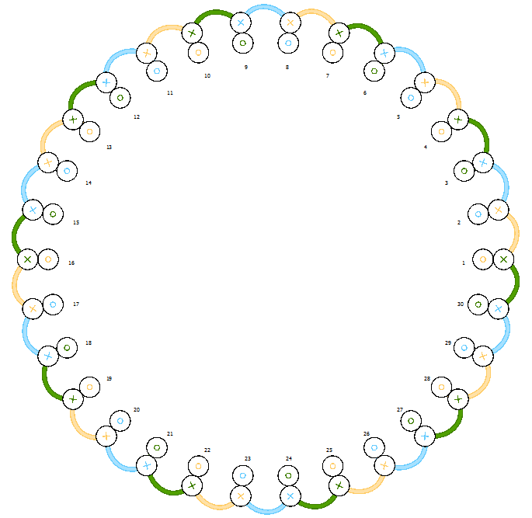

Figure 1 Winding diagram of the machine with 30 slots, 20 poles and 2-layers

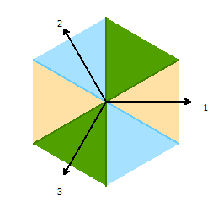

Figure 2 Phasor diagram of machine with 30 slots and 20 poles

Distribution factor, pitch factor and, winding factor are calculated. These calculations are shown in Table 6 for fundamental, third and fifth harmonics.

Table 6 Distribution, pitch and winding factors of fractional slot winding (30 slots &20 poles) for fundamental, third and fifth harmonics

|  |  |  |  |
| --- | --- | --- | --- |
|  | Fundamental | 3rd | 5th |
| Pitch factor | 0.866 | 0 | -0.866 |
| Distribution factor | 1 | 1 | 1 |
| Winding factor | 0.866 | 0 | -0.866 |

## 20 Poles & 21 Slots

Number of poles selected as 20 - Number of slots selected as 21 - Throw = 7

Table 7 Electrical phase angle of slots for the machine with 20 poles and 21 slots

|  |  |  |  |  |  |  |  |  |  |  |  |
| --- | --- | --- | --- | --- | --- | --- | --- | --- | --- | --- | --- |
|  | 1 | 2 | 3 | 4 | 5 | 6 | 7 | 8 | 9 | 10 | 11 |
| 1st | 0° | 171.4° | 342.9° | 154.3° | 325.7° | 137.1° | 308.6° | 120° | 291.4° | 102.9° | 274.3° |
| 3rd | 0° | 154.3° | 308.6° | 102.9° | 257.1° | 51.43° | 205.7° | 0° | 154.3° | 308.6° | 102.9° |
| 5th | 0° | 137.1 | 274.3° | 51.43° | 188.6° | 325.7° | 102.9° | 240° | 17.14° | 154.3° | 291.4° |
|  | -C7 | -A1 | A2 | -A3 | A4 | -A5 | A6 | -A7 | -B1 | B2 | -B3 |
|  | A1 | -A2 | A3 | -A4 | A5 | -A6 | A7 | B1 | -B2 | B3 | -B4 |

|  |  |  |  |  |  |  |  |  |  |  |  |
| --- | --- | --- | --- | --- | --- | --- | --- | --- | --- | --- | --- |
|  | 12 | 13 | 14 | 15 | 16 | 17 | 18 | 19 | 20 | 21 |  |
| 1st | 85.71° | 257.1° | 68.57° | 240° | 51.43° | 222.9° | 34.29° | 205.7° | 17.14° | 188.6° |  |
| 3rd | 257.1° | 51.43° | 205.7° | 0° | 154.3° | 308.6° | 102.9° | 257.1° | 51.43° | 205.7° |  |
| 5th | 68.57° | 205.7° | 342.9° | 120° | 257.1° | 34.29° | 171.4° | 308.6° | 85.71° | 222.9° |  |
|  | B4 | -B5 | B6 | -B7 | -C1 | C2 | -C3 | C4 | -C5 | C6 |  |
|  | B5 | -B6 | B7 | C1 | -C2 | C3 | -C4 | C5 | -C6 | C7 |  |

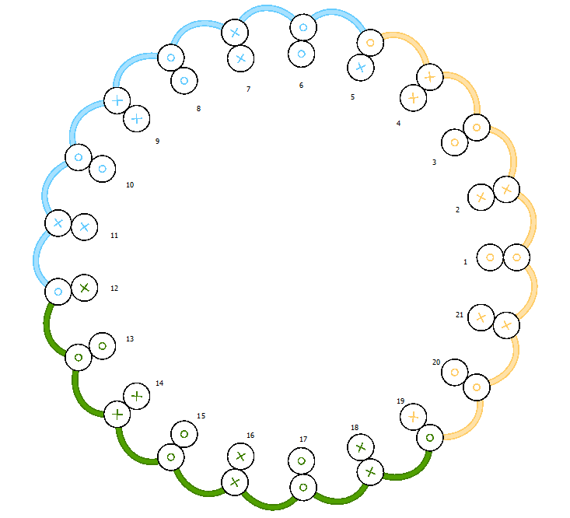

Figure 3 Winding diagram of the machine with 21 slots, 20 poles and 2-layers

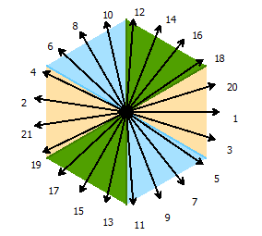

Figure 4 Phasor diagram of machine with 21 slots and 20 poles

Table 8 Distribution, pitch and winding factors of fractional slot winding (21 slots &20 poles) for fundamental, third and fifth harmonics

|  |  |  |  |
| --- | --- | --- | --- |
|  | Fundamental | 3rd | 5th |
| Pitch factor | 0.9972 | -0.975 | 0.931 |
| Distribution factor | 0.9531 | 0.626 | 0.182 |
| Winding factor | 0.9505 | -0.6102 | 0.1694 |

# 2D FEA Modeling

Example design in Rmxprt program is used. The original design has different slot number and pole number. Machine is adjusted with desired parameters. Winding diagram and 2D drawing of the machine can be seen in Figure 5 and Figure 6, respectively. Machine rated power, speed and voltage are given in Table 9.

Table 9 Parameters of the example machine in Rmxprt program

|  |  |
| --- | --- |
| Parameter | Value |
| Rated voltage | 127 V |
| Rated power | 550 W |
| Rated speed | 1500 rpm |

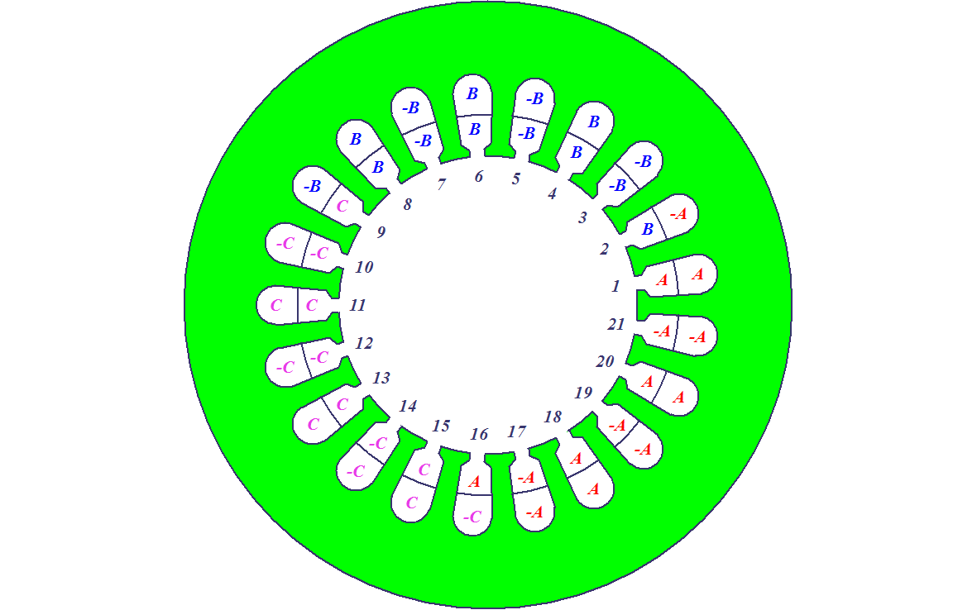

Figure 5 2D Winding diagram of PMSM with 21 slots & 20 poles

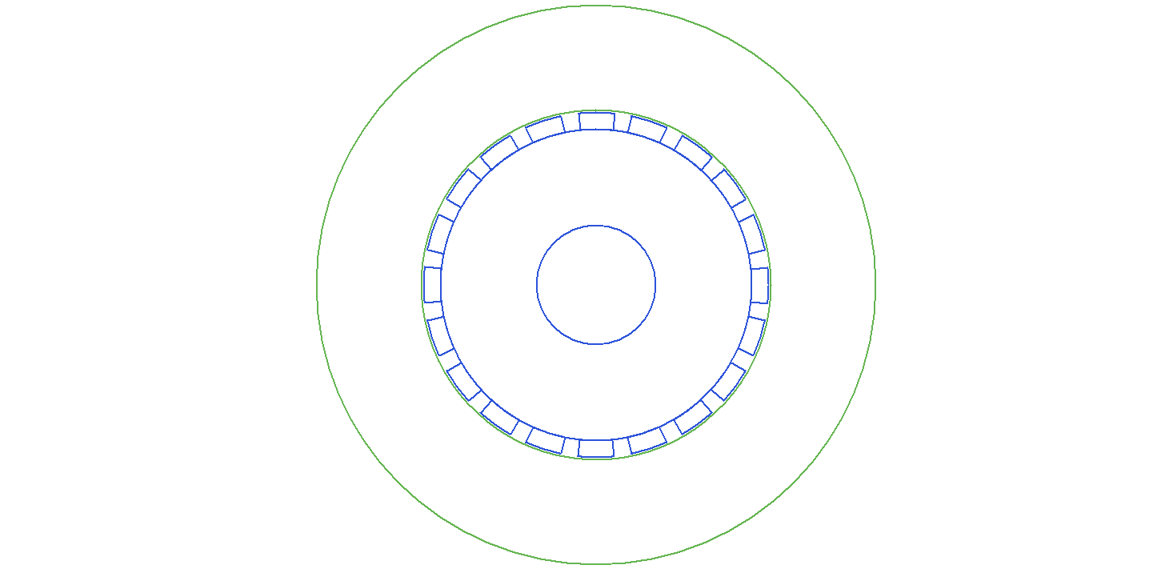

Figure 6 2D drawing of PMSM

Winding factor of the machine is given in Figure 7. The analytical calculation and simulation result agrees. However, there is a tiny discrepancy. Simulation result is the same as analytically calculated distribution factor. Since the analytical calculation of pitch factor is close to one, the discrepancy is not important.

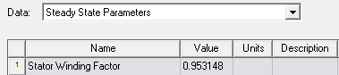

Figure 7 Resultant winding factor, kw, of the machine with 21 slots & 20 poles

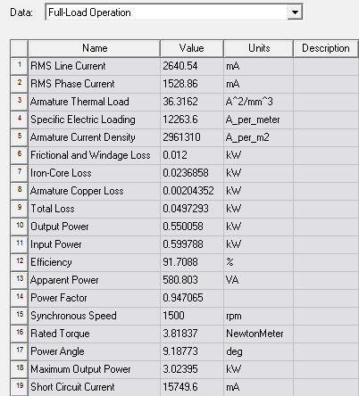

Figure 8 Full load operation results of the machine with 21 slots & 20 poles

Waveform of cogging torque is given in Figure 9. The period of the cogging torque is 9° . Hence frequency of cogging torque is 40Hz which is times of the pole number.

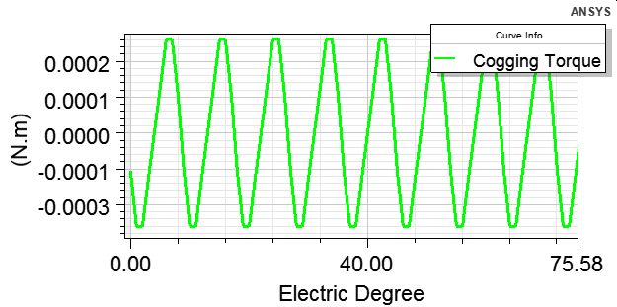

Figure 9 Cogging torque waveform of the machine

Air-gap flux density is given in Figure 10. Maximum flux density is approximately 0.75T. The effect of third harmonic can be examined inspectionally.

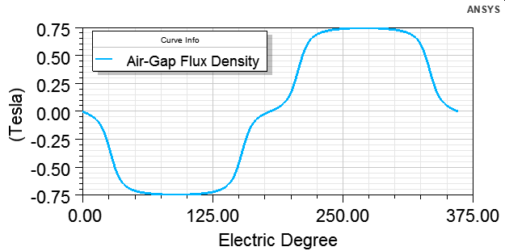

Figure 10 Air-gap flux density of the machine

Induced phase voltage of the designed machine is given in Figure 11.

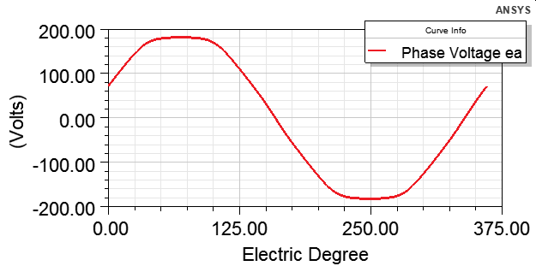

Figure 11 Induced phase voltage of the machine