Q2

Number of poles selected as 20

Number of slots selected as 30

double layer since phase angle is equal to slot winding

|  |  |  |  |  |  |  |  |  |  |  |  |  |  |  |  |
| --- | --- | --- | --- | --- | --- | --- | --- | --- | --- | --- | --- | --- | --- | --- | --- |
|  | 1 | 2 | 3 | 4 | 5 | 6 | 7 | 8 | 9 | 10 | 11 | 12 | 13 | 14 | 15 |
| 1st | 0 | 120 | 240 | 0 | 120 | 240 | 0 | 120 | 240 | 0 | 120 | 240 | 0 | 120 | 240 |
| 3rd | 0 | 0 | 0 | 0 | 0 | 0 | 0 | 0 | 0 | 0 | 0 | 0 | 0 | 0 | 0 |
| 5th | 0 | 240 | 120 | 0 | 240 | 120 | 0 | 240 | 120 | 0 | 240 | 120 | 0 | 240 | 120 |
|  | A | B | C | A | B | C | A | B | C | A | B | C | A | B | C |
|  | -C | -A | -B | -C | -A | -B | -C | -A | -B | -C | -A | -B | -C | -A | -B |

|  |  |  |  |  |  |  |  |  |  |  |  |  |  |  |  |
| --- | --- | --- | --- | --- | --- | --- | --- | --- | --- | --- | --- | --- | --- | --- | --- |
|  | 16 | 17 | 18 | 19 | 20 | 21 | 22 | 23 | 24 | 25 | 26 | 27 | 28 | 29 | 30 |
| 1st | 0 | 120 | 240 | 0 | 120 | 240 | 0 | 120 | 240 | 0 | 120 | 240 | 0 | 120 | 240 |
| 3rd | 0 | 0 | 0 | 0 | 0 | 0 | 0 | 0 | 0 | 0 | 0 | 0 | 0 | 0 | 0 |
| 5th | 0 | 240 | 120 | 0 | 240 | 120 | 0 | 240 | 120 | 0 | 240 | 120 | 0 | 240 | 120 |
|  | A | B | C | A | B | C | A | B | C | A | B | C | A | B | C |
|  | -C | -A | -B | -C | -A | -B | -C | -A | -B | -C | -A | -B | -C | -A | -B |

The phase angle of the induced voltage in each slot is found based on Equation xx. Electrical phase difference between slots is found as 120°. Also, the angle between phase windings is selected as 120°, which should be an integer multiple of slot angle. Hence, double layer design is required.

|  |  |  |
| --- | --- | --- |
|  | $$α_{z}\left(n\right)=n\frac{360°×p}{Q}$$ | **Hata! Belgede belirtilen stilde metne rastlanmadı.**.1 |

Pitch factor is calculated with coil span which determined as 120°. Distribution factor is found as unity since there is no distributed windings.

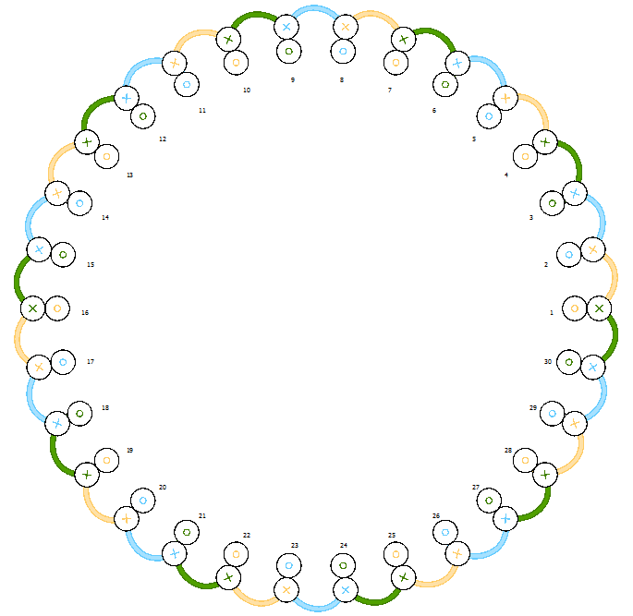

Figure 1 Winding diagram of the machine with 30 slots, 20 poles and 2-layers

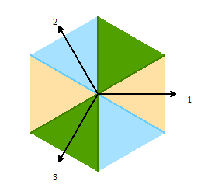

Figure 2 Phasor diagram of machine with 30 slots and 20 poles

Distribution factor, pitch factor and, winding factor are calculated. These calculations are shown in Table xx for fundamental, third and fifth harmonics.

|  |  |  |  |
| --- | --- | --- | --- |
|  | Fundamental | 3rd | 5th |
| Pitch factor | 0.866 | 0 | -0.866 |
| Distribution factor | 1 | 1 | 1 |
| Winding factor | 0.866 | 0 | -0.866 |

**Second design with different Slot number (Q=21)**

Number of poles selected as 20

Number of slots selected as 21

Throw = 7

|  |  |  |  |  |  |  |  |  |  |  |  |
| --- | --- | --- | --- | --- | --- | --- | --- | --- | --- | --- | --- |
|  | 1 | 2 | 3 | 4 | 5 | 6 | 7 | 8 | 9 | 10 | 11 |
| 1st | 0° | 171.4° | 342.9° | 154.3° | 325.7° | 137.1° | 308.6° | 120° | 291.4° | 102.9° | 274.3° |
| 3rd | 0° | 154.3° | 308.6° | 102.9° | 257.1° | 51.43° | 205.7° | 0° | 154.3° | 308.6° | 102.9° |
| 5th | 0° | 137.1 | 274.3° | 51.43° | 188.6° | 325.7° | 102.9° | 240° | 17.14° | 154.3° | 291.4° |
|  | -C7 | -A1 | A2 | -A3 | A4 | -A5 | A6 | -A7 | -B1 | B2 | -B3 |
|  | A1 | -A2 | A3 | -A4 | A5 | -A6 | A7 | B1 | -B2 | B3 | -B4 |

|  |  |  |  |  |  |  |  |  |  |  |  |
| --- | --- | --- | --- | --- | --- | --- | --- | --- | --- | --- | --- |
|  | 12 | 13 | 14 | 15 | 16 | 17 | 18 | 19 | 20 | 21 |  |
| 1st | 85.71° | 257.1° | 68.57° | 240° | 51.43° | 222.9° | 34.29° | 205.7° | 17.14° | 188.6° |  |
| 3rd | 257.1° | 51.43° | 205.7° | 0° | 154.3° | 308.6° | 102.9° | 257.1° | 51.43° | 205.7° |  |
| 5th | 68.57° | 205.7° | 342.9° | 120° | 257.1° | 34.29° | 171.4° | 308.6° | 85.71° | 222.9° |  |
|  | B4 | -B5 | B6 | -B7 | -C1 | C2 | -C3 | C4 | -C5 | C6 |  |
|  | B5 | -B6 | B7 | C1 | -C2 | C3 | -C4 | C5 | -C6 | C7 |  |

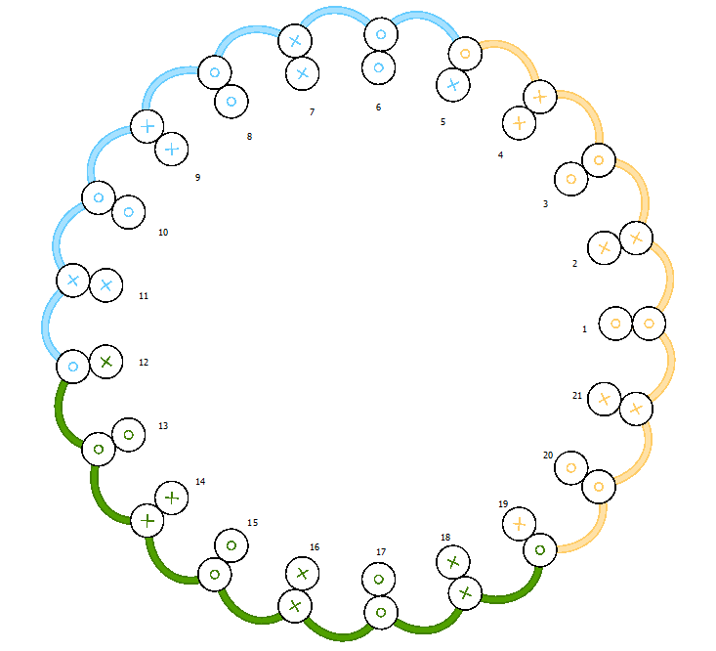

Figure 3 Winding diagram of the machine with 21 slots, 20 poles and 2-layers

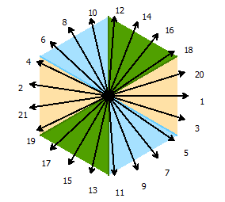

Figure 4 Phasor diagram of machine with 21 slots and 20 poles

|  |  |  |  |
| --- | --- | --- | --- |
|  | Fundamental | 3rd | 5th |
| Pitch factor | 0.9972 | -0.975 | 0.931 |
| Distribution factor | 0.9531 | 0.626 | 0.182 |
| Winding factor | 0.9505 | -0.6102 | -0.1694 |

Name Value Unit "Evaluated Value" Description Read-only

"Winding Layers" 2 "Number of winding layers" false

"Winding Type" Whole-Coiled "Stator winding type" false

"Parallel Branches" 1 "Number of parallel branches of stator winding" false

"Conductors per Slot" 0 0 "Number of conductors per slot, 0 for auto-design" false

"Coil Pitch" 1 "Coil pitch measured in number of slots" false

"Number of Strands" 2 2 "Number of strands (number of wires per conductor), 0 for auto-design" false

"Wire Wrap" 0 mm "Double-side wire wrap thickness, 0 for auto-pickup in the wire library" false

"Wire Size" "Diameter: 0.1426mm" "Wire size, 0 for auto-design" false