Example design in Rmxprt program is used. The original design has different slot number and pole number. Machine is adjusted with desired parameters. Winding diagram and 2D drawing of the machine can be seen in Figure 1 and Figure 2, respectively. Machine rated power, speed and voltage are given in Table 1.

Table 1 Parameters of the example machine in Rmxprt program

|  |  |
| --- | --- |
| Parameter | Value |
| Rated voltage | 127 V |
| Rated power | 550 W |
| Rated speed | 1500 rpm |

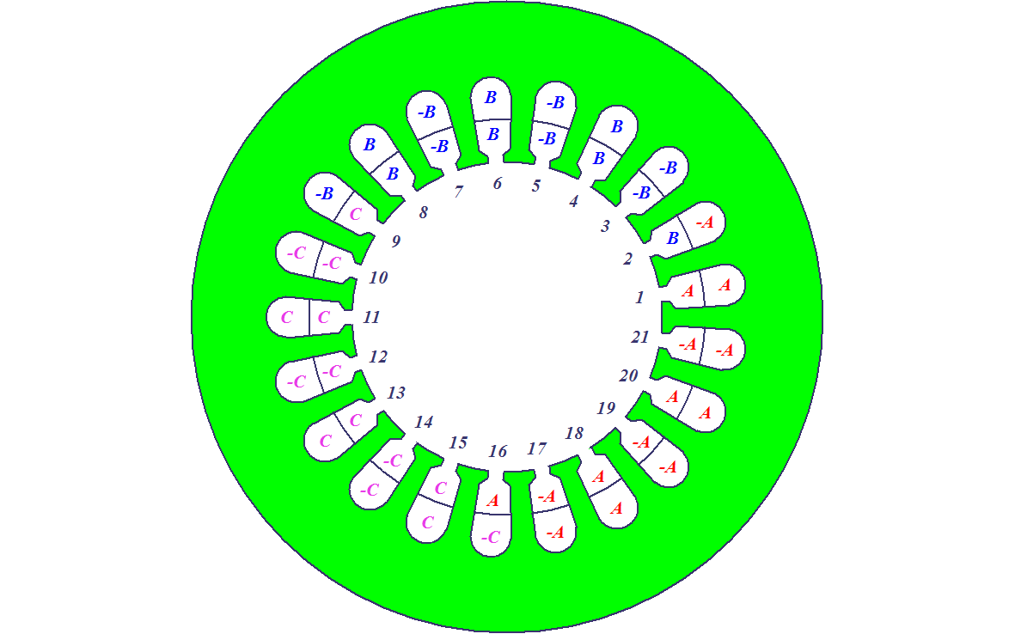

Figure 1 2D Winding diagram of PMSM with 21 slots & 20 poles

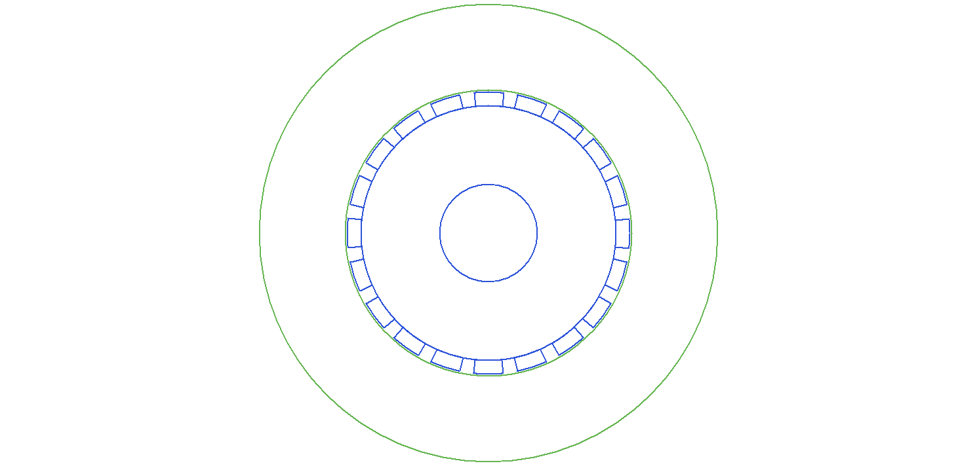

Figure 2 2D drawing of PMSM

Winding factor of the machine is given in Figure 3. The analytical calculation and simulation result agrees. However, there is a tiny discrepancy. Simulation result is the same as analytically calculated distribution factor. Since the analytical calculation of pitch factor is close to one, the discrepancy is not important.

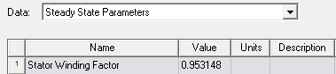

Figure 3 Resultant winding factor, kw, of the machine with 21 slots & 20 poles

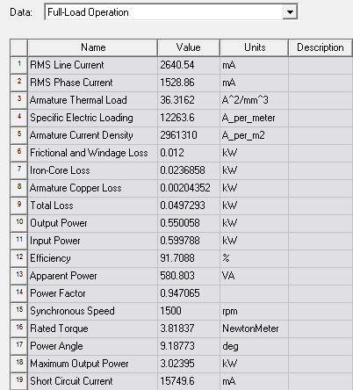

Figure 4 Full load operation results of the machine with 21 slots & 20 poles

Waveform of cogging torque is given in Figure 5. The period of the cogging torque is 9° . Hence frequency of cogging torque is 40Hz which is times of the pole number.

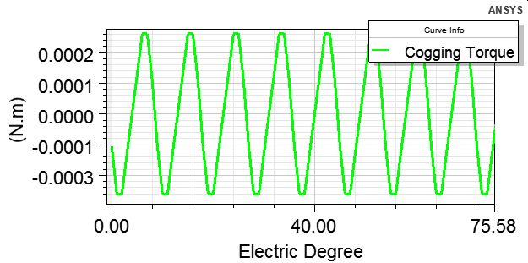

Figure 5 Cogging torque waveform of the machine

Air-gap flux density is given in Figure 6. Maximum flux density is approximately 0.75T. The effect of third harmonic can be examined inspectionally.

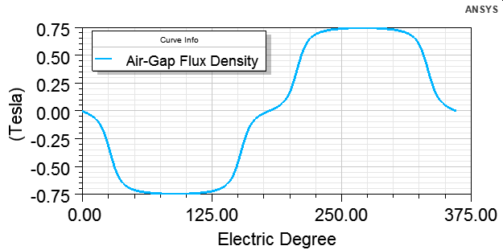

Figure 6 Air-gap flux density of the machine

Induced phase voltage of the designed machine is given in Figure 7.

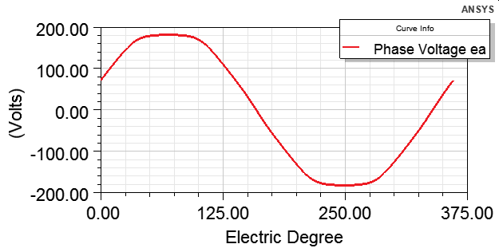

Figure 7 Induced phase voltage of the machine