

**Middle East Technical University**

Electrical and Electronics Engineering Department

EE568 - Project 3 Report

44 MVA Salient Pole Hydro Generator Design and Analysis

July 11, 2022

Yunus Çay

# Literature Review

Hydro generators have been produced in MVA range scale to generate electricity from potential and kinetic energy of the rivers. Most of the produced hydro-generators in the middle of last century were sized generously by today’s standars, which generally permits significant increase in their ratings. [1] In this literature review, the refurbisment and upratings of the standard hydro-generators are given to narrow down the research. On the other hand, the comparison of hydro-generators and turbo generators, induction machines, differences between low power generators and high power generators could be the branches to expand research.

Literature review, although, begun with attention on performance metrics such as efficiency, reliablity, cost and, maintainance, the refurbishment and uprating of the hydro-generators are mainly based on winding design of stator, insulation materials, core materials and, new mechanical parts of machine. Therefore, winding design of the machine to reduce harmonics and end windings lengths, efficient core material replacement, utilizing better insulation materials for the sake of better reliability, better thermal management and uprating of the machine are the main topics which are discussed briefly.

Generators have been compared with a coefficient called output coefficient to realize in how efficient machine size is utilized to get maximum power. This output coefficient is calculated based on the Equation 1.1. [1]

|  |  |  |
| --- | --- | --- |
|  |  | 1.1 |

The output coefficient of the generators increased 12 times in the last 85 years, which is mainly due to the enhancements on insulation materials and core materials. [2] New core materials allows higher magnetic loading without saturation and less core loss. On the other hand, the enhancements in insulation materials provides the machines with thinner and more durable insulation materials, which increase the fill factor and thermal performance of the machines. The comparison between old and new insulation material thickness is given in Figure 1. [1]



Figure 1 Comparison between old and new insulation materials in electrical machines [1]

Winding design is the another important aspect for refurbishment of hydro-generators. The winding factor of fundamental and harmonics, end winding length, slot number and width are the main parameters affecting the performance of winding design in electrical machines. The selection between integer and fractional slot winding design changes the winding factor and end winding length. Moreover, lap winding or wave winding has impact on end winding length and maintenance of the machine. The paper [3] discuss the optimization of end winding lengths for three phase large scale machines. The computational algorithm for different slot per phase per pole selections is constructed to optimize end-winding length. Also, bypassing some windings in fault conditions to diminish the cost of faults is discussed for reasonable and easy maintenance. Figure 2 show the optimized wave winding of the

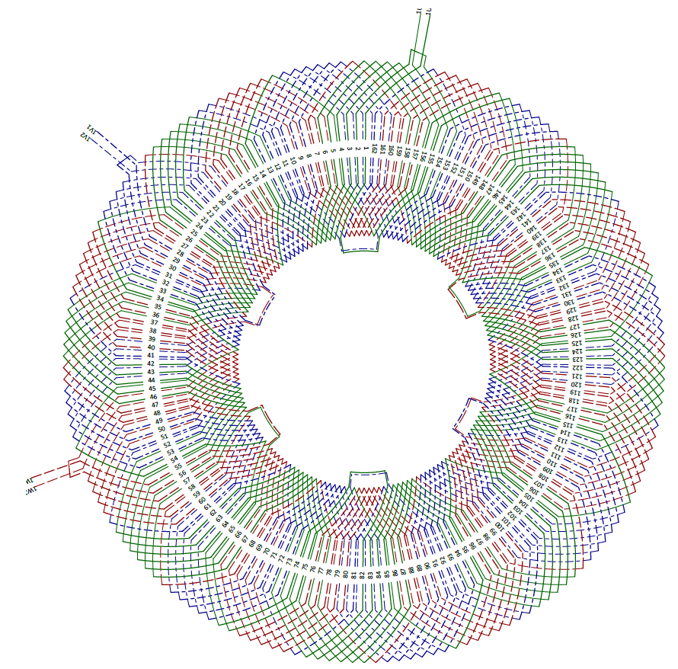

Figure 2 Optimized wave winding, 3 phase q=27/8

Other than papers, there are also some design guides. In the design guide, published by IEEE, there are some important points and observation about insulation materials. Decrease in insulation thickness provides the machine with more area for copper and better thermal performance, but PD, partial discharge, could occur more probably when comparing with old technology insulation materials. [4]

All in all, the produced hydro-generators in the last century are closing their half-life time or end-of-life. There will be many projects related with refurbishment and uprating of hydro-generators. Hence, the projects could be great advantage for researchers and engineers to use them as experimental setups to contribute literature in hydro-generators and large scale electrical generators.

# Analytical Calculations

The design of hydro-generator can be iniated with selection of electrical loading, magnetic loading and current density for armature windings so that main sizes of the generator such as bore diameter, outer diamater of the stator and length of the machine could be determined. The selection of former parameters which are used to select proper dimensions for machine based on the power rating are seen in Table 1.

Table 1 Initial parameter selection for machine design

|  |  |  |
| --- | --- | --- |
| Parameter | Range | Selection |
| Electrical loading – A (kA/m) | 35 – 65 kA/m | 65 kA/m |
| Air-gap flux density – B (T) | 0.85 – 1.05 T | 1 T |
| Current density – J (A/mm2) | 2.5 – 4 A/mm2 | 3 A/mm2 |

Power rating of the machine is the related with machine constant, rotor volume and, synchronous frequency. Besides, machine constant is determined based on selected electrical and magnetic loadings. Equation 2.1 shows the relation between power rating, machine constant and rotor volume.

|  |  |  |
| --- | --- | --- |
|  |  | 2.1 |

Machine constant and power rating provides the total rotor volume. Length and rotor diamater, however, should be determined with aspect ratio. The aspect ratio is determined in Equation 2.2.

|  |  |  |
| --- | --- | --- |
|  |  | 2.2 |

After finding rotor diameter and length, outer diameter can be selected based on poles number, which is given in Figure 3 Pole number and Do/Di relation. The determined values for rotor diamater, length and outer diameter can be seen in Table 2.

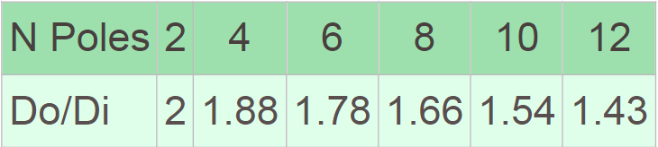

Figure 3 Pole number and Do/Di relation

Table 2 Main dimensions of designed generator

|  |  |
| --- | --- |
| Parameter | Value |
| Rotor diameter – D (m) | 5.43 m |
| Effective core length – l’ (m) | 1.06 m |
| Outer diamater – Do (m) | 5.97 m |

Air-gap is selected based on Equation 2.3, which provides the air-gap with minimum length. Air-gap flux density and electrical loading is the origion of Equation 2.3. Air-gap is selected as 16mm to reduce surface losses and increase safety margin for mechanical vibrations.

|  |  |  |
| --- | --- | --- |
|  |  | 2.3 |

The flux per pole is, now, calculated from selected air-gap flux density and main dimensions of the generator. Flux per pole calculation applies based on Equation 2.4.

|  |  |  |
| --- | --- | --- |
|  |  | 2.4 |

Simple equation for induced voltage shown in Equation 2.5 is used to calculate turns per phase.

|  |  |  |
| --- | --- | --- |
|  |  | 2.5 |

Before moving on MMF calculation, the slot and tooth width are calculated to whether tooth flux density is acceptable. The tooth width and slot width can be calculated. The slot pitch is shared on the side of tooth majorly not to saturate core. While portion of the share on the side of tooth is %60, %40 of slot pitch is taken by slot, which is done in purposely since the insulation materials are enhanced. Calculated slot width, tooth width, slot area, back-core height, tooth flux density and, back-core flux density are given in Table 3.

Although the flux densities in Table 3 can be seen as excessively high, these are the peak value of sinusoial flux density waveform. The flux density, however, doesn’t reach sinusoidal peak value, but the value 0.85 (cos30) times of sinusoidal peak value. Also, effective length of the core becomes more when the ducts are placed due to the carter coefficient approximation. Hence, the flux density in tooth and back core slighlty decreases. The length, bore diamater and outer diameter can be increased, which can be a good and safe solution against saturation in tooth and back-core.

Table 3 Stator slot, tooth dimensions and flux density values

|  |  |
| --- | --- |
| Parameter | Value |
| Slot pitch | 56.9 mm |
| Slot area | 2727 mm2 |
| Slot width | 22.7 mm |
| Tooth width | 34.1 mm |
| Back-core height | 146 mm |
| Tooth flux density (Peak) | 1.75 T (1.52 T – cos30°) |
| Back-core flux density | 1.92 T (1.66 T – cos30°) |

Excitation current or field current is determined based on MMF drop on air-gap since MMF drops on stator core and rotor core is neglible if cores are not saturated. MMF created by field current at no load condition is not sufficient induce rated phase voltage due to armatüre reaction. The effect of armature reaction is shown in Figure 4.

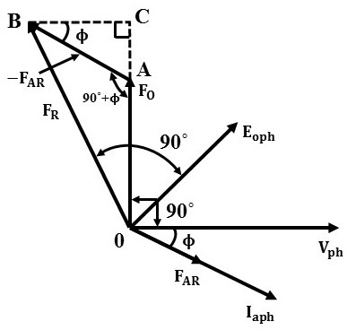

Figure 4 Synchronous machine armature and field MMF relation and phasor diagram

MMF created by armature is taken into account to find required field MMF. The calculation of field MMF is given in Equation 2.6. The calculated MMF is multiplied with 1.2 to consider leakage, holes of damper windings and possible permeability changes in cores.

|  |  |  |
| --- | --- | --- |
|  |  | 2.6 |

The total MMF created by field current is known. Selection of field turn number and field current is given in Table 4. Current density for field current is also selected as 3 A/mm2 and fill factor of field winding is selected as 0.5 since there is no harsh environment to increase insulation width.

Table 4 Total excitation MMF and field winding details

|  |  |
| --- | --- |
| Parameter | Value |
| MMF of field | 26500 At |
| Turns number of field winding – Nf | 10 |
| Field current – If | 2650 A |
| Field fill factor | 0.5 |
| Field slot area | 8800 mm2 |

# FEA Results

Air-gap flux density distribution of the designed hydro-generator is given in Figure 5. The air-gap flux density peak value is 1.18T which is a bit higher than the selected peak flux density, 1.05T. Also, Figure 6 shows only air-gap flux distribution.

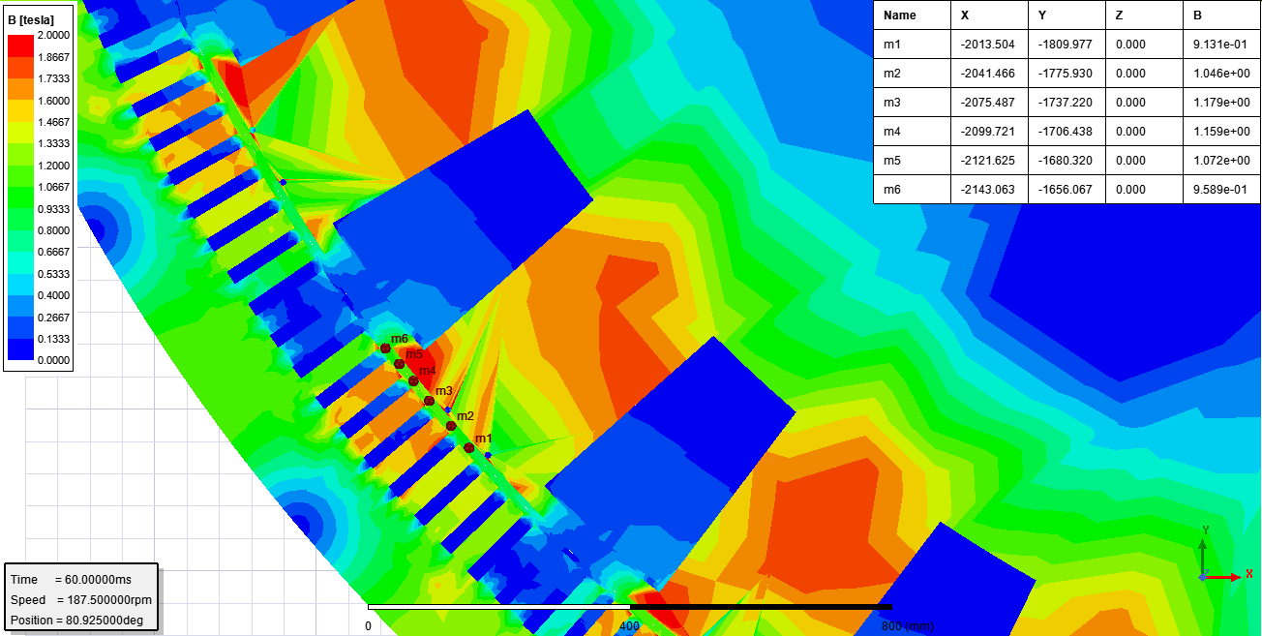

Figure 5 Air-gap flux density distribution of designed generator with markers

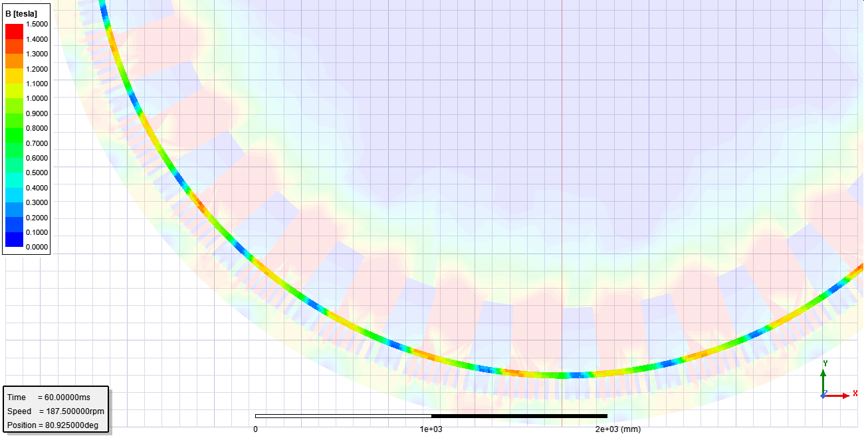

Figure 6 Air-gap flux density distribution of designed generator

Flux density distribution in the tooths of the stator are given in Figure 7. Although the calculated peak flux density is 1.75T based on sinusoidal flux distribution, approximation of the flux density in the tooths is around 1.52T. In the Figure 7, the peak flux density in the tooths is 1.65T.

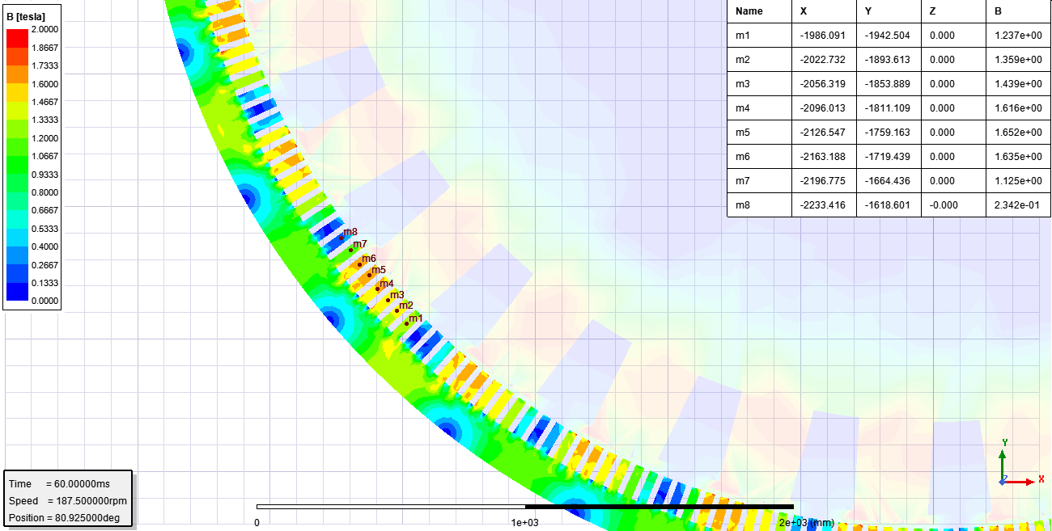

Figure 7 Stator tooth flux density distribution of designed generator

Figure 8 represents the some flux density values at different points such as stator teeth, backcore iron and rotor teeth iron.

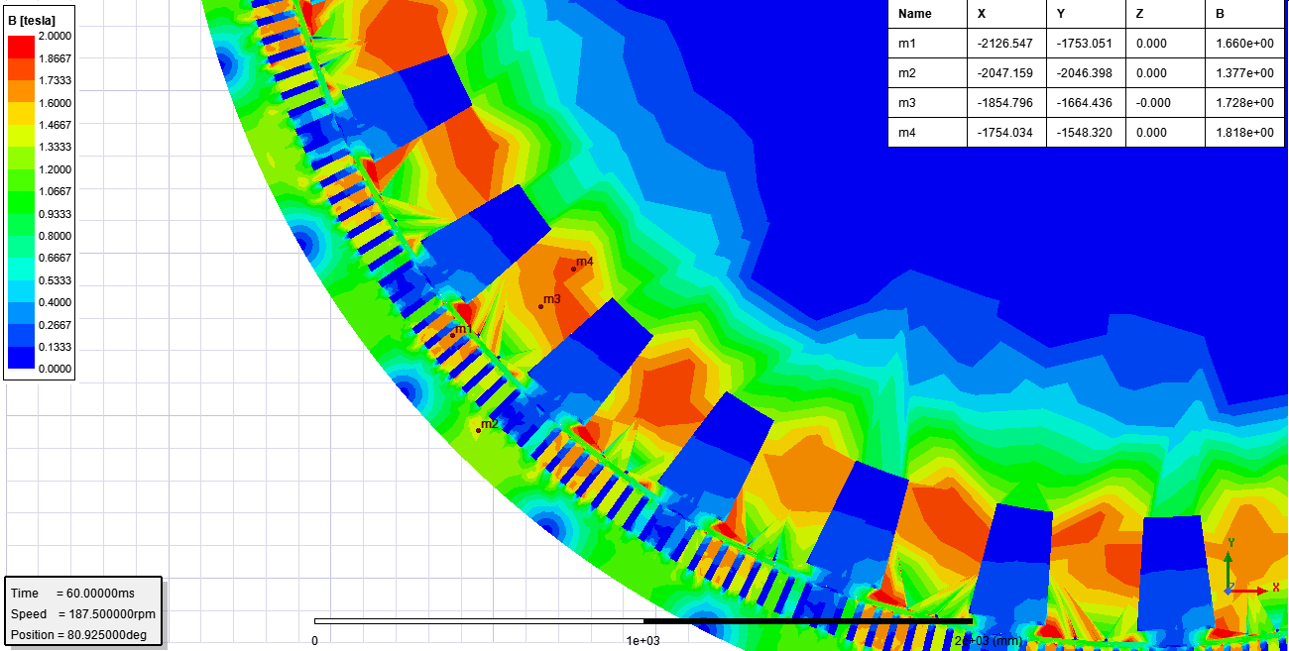

Figure 8 Stator, rotor and air-gap flux density distribution of designed generator

Voltage drop on phase resistance and inductance can be calculated from the induced phase voltage, current and input phase voltage. However, the seperation of voltage drops on resistance and inductance requires more information. The required knowledge could be the flux linkage of phase coils. Figure 9, Figure 10 and Figure 11 shows the induced phase voltage, phase current and flux linkage of phase coils.

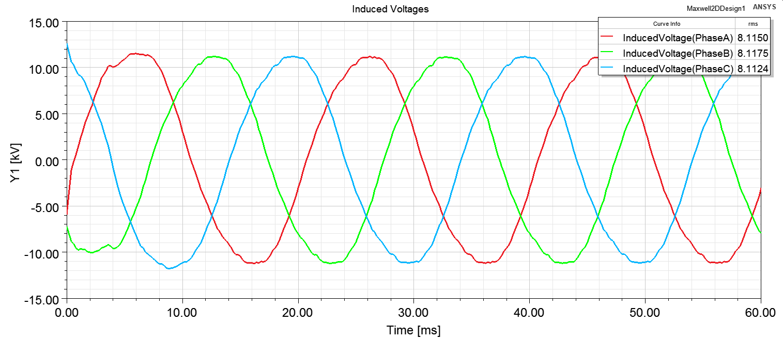

Figure 9 Induced phase voltages of designed generator

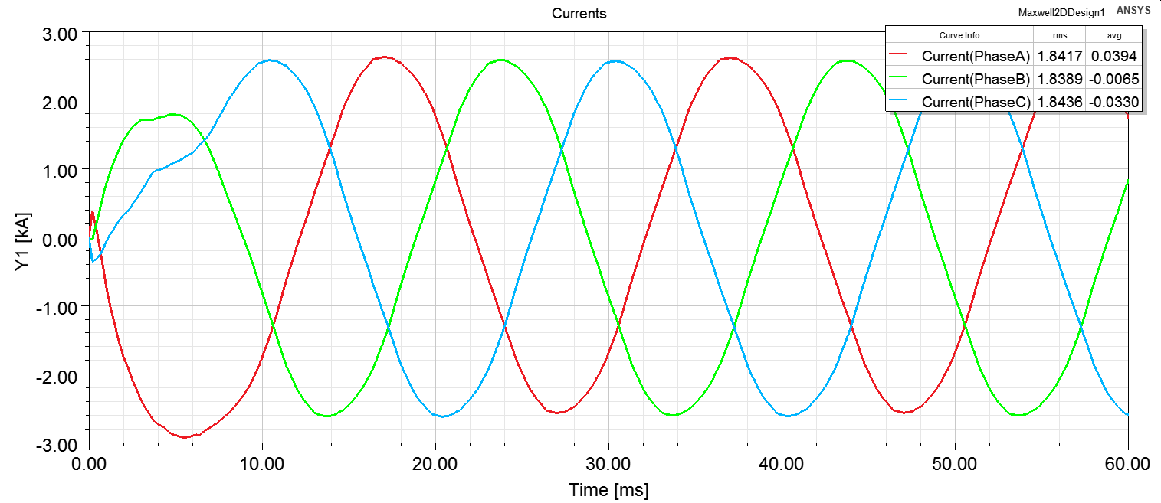

Figure 10 Phase currents of designed generator

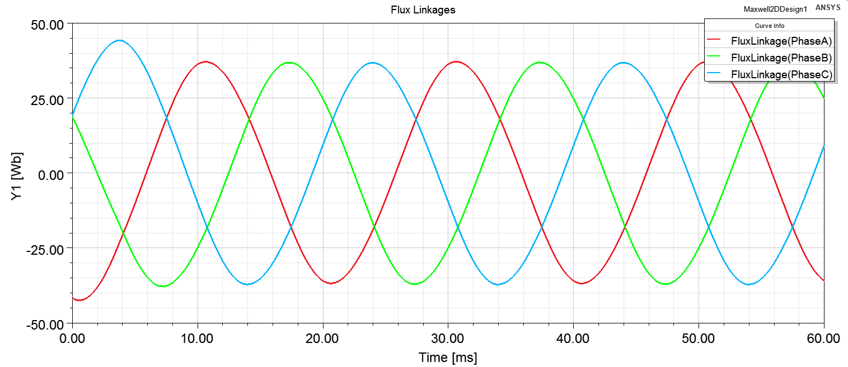

Figure 11 Flux linkage of phase coils of designed generator

The quadrature and direct axis inductance are given in Figure 12.

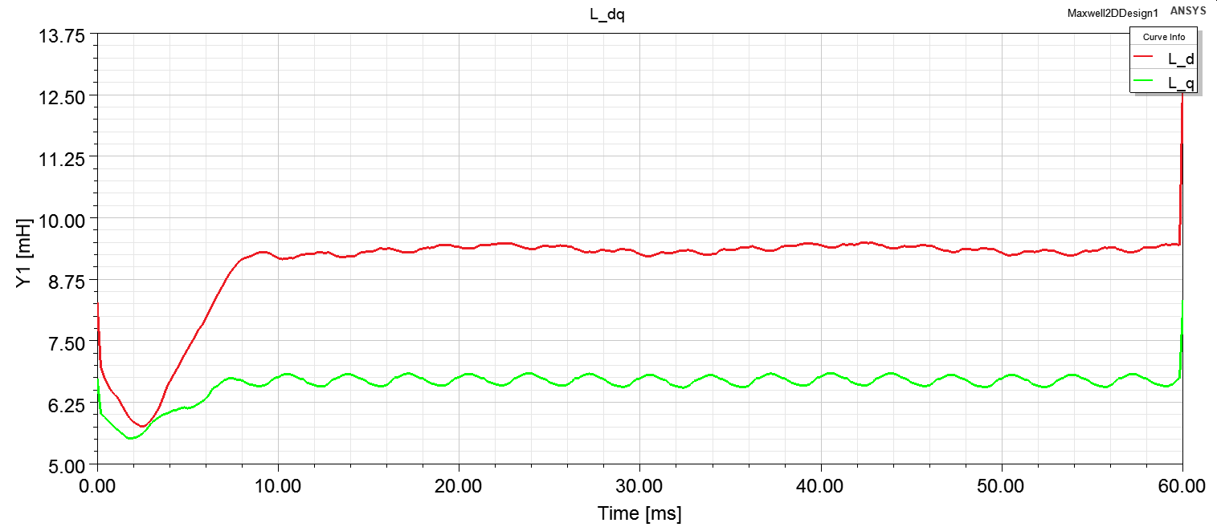

Figure 12 Direct, d, and quadrature, q, axis inductances of designed generator

Electrical and mechanical power is given in Figure 13.

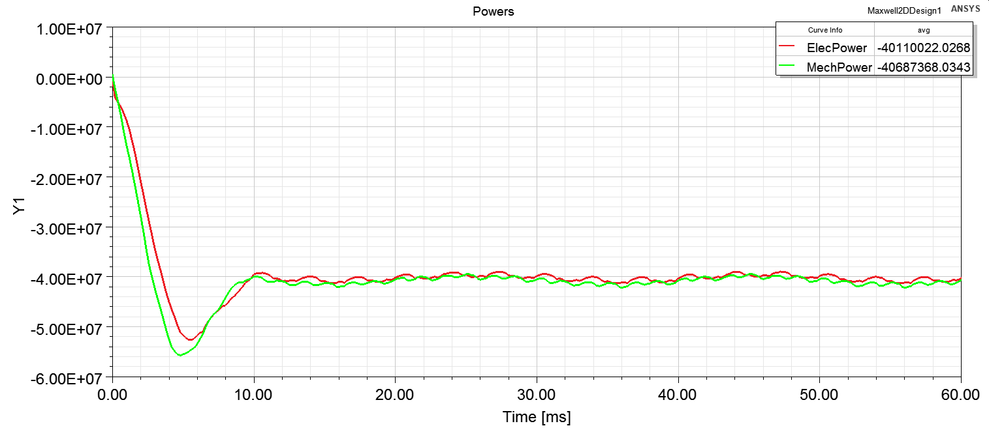

Figure 13 Electrical and mechanical rated power of designed machine

# Comparison and Discussion

Designed motor seems feasible in terms of magnetic loading, electrical loading and power loss. The calculated efficiency is approximately %98. However, some main dimension can be changed to see their effects. Stator teeths and rotor teeths have slightly high magnetic flux density. Main dimensions of the designed generator and expected changes are given in Table 5.

Table 5 Designed generator parameters and changed parameters for iteration

|  |  |  |  |
| --- | --- | --- | --- |
| Parameter | Designed M/C | Changes | Reason |
| Bore diameter | 5431 mm | 5500 mm | Decrease in magnetic loading |
| Outer diameter | 5974 mm | 6050 mm | Decrease in magnetic loading |
| Core length | 1066 mm | 1100 mm | Decrease in magnetic loading |
| Air-gap length | 16.5 mm | 18 mm | Mechanical vibrations in turbine |
| Slot number | 300 | - |  |
| Pole number | 32 | - |  |
| Desired B peak air | 1.05T | 1.0T | High B at stator and rotor teeths |
| Desired Electrical loading A | 65 kA/m | - |  |
| Armature Current density - J | 2.58 A/mm2 | - |  |
| Field Current density - J | 2.91 A/mm2 | 2.5 A/mm2 | Desire to decrease copper loss |

Flux density of in stator teeths, rotor teeths, stator back iron and air-gap is slightly reduced by decreasing magnetic loading approximately %5 and increasing core length as seen in Figure 14. Although the flux density in the rotor doesn’t cause hystresis loss, the high flux density in rotor affects the rotor core material. Using rotor core material other than stator core materials in such a large machines could be reasonable because the material left after stator production is still huge to sell back someone or the material left can be still used anywhere.

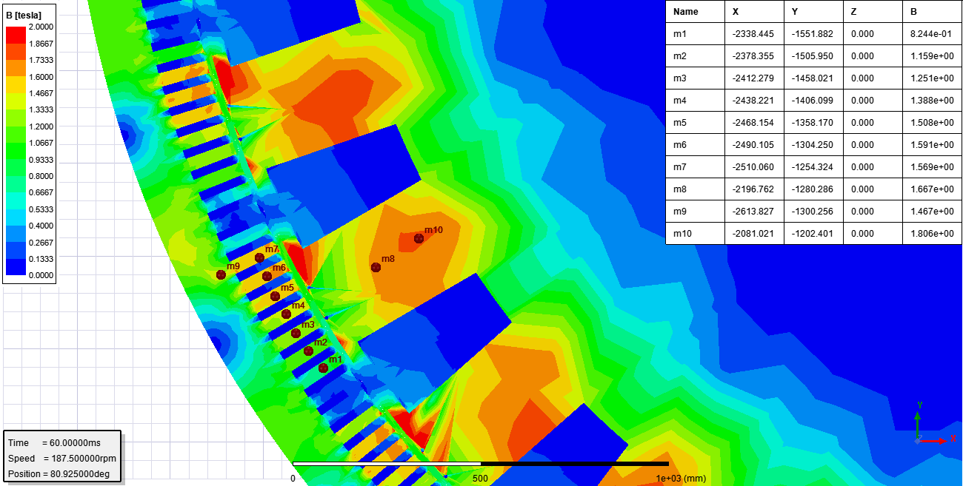

Figure 14 Iterated generator design for magnetic loading FEA result

After revealing some comparison between two generators based on magnetic loading, challenges and some realizations in this project can be written. Before narrowing down the literature research, the generator design or machine design has so many parameters that cannot be fixed or determined easily. Efficiency, reliability, failures, maintenance and cost are the main branches that should be prioritized by customer and designer cooperation. Also, magnetic material and conductors requires boost in their technology to make more compact electrical machines like in power electronics. Power electronics, however, has advantage in compactness due to high frequency switching.

Secondly, the designed machine has many parameters that should be examined detailly. For example, winding of the machine has effect on end-winding length, winding factors, slot number. However, we have selected it with just considering winding factor only. Besides, mechanical issues has not been covered. Therefore, the designed machine can be sufficiently good and may be superior, but the ensuring the all issues is tough.

Final challenge is using design programs and FEA. The proper and fast simulations can be possible with such a programs. However, these programs can also be misleading if they are not known well. For example, using rmxprt design in maxwell 2d causes a power problem. The electrical power becomes 1.5 times of rated power when the analysis is done in ansys maxwell, which is caused by power angle. Power angle is somehows determined in ansys maxwell, but it doesn’t give the correct power outputs. I have struggled to solve problem with applying change of Ld,Lq by changing rotor teeth dimensions. However, I just need to change power angle from the machine command in ansys maxwell, which diminishes the phase current.

Finally, designed motor dimensions is considerably smaller than the some real machine produced in the mid of last century, 1950s. Hence, as seen in literature review, the machines produced in the last century are sized genereously by today’s standards due to insulation materials and enhancements in core materials. Approximately %98 efficiency is taken from the designed generator. The efficiency can be enhanced by slight increase in dimensions because copper area can be increased. Also, optimum point can be found for magnetic losses.

# References

[1] Znidarich, M. M. 2013, “Upgrading and uprating of hydro generators: An Australian perspective”, Australian Journal of Electrical & Electronics Engineering, Vol. 10, No. 1, pp. 75-84, <http://dx.doi.org/10.7158/E11-047.2013.10.1>.

[2] Glew, C. N. 1998, “The Next Generation – A Review of the Factors Infl uencing the Output of Electrical Machines in the New Millennium”, INSUCON/ISOTEC’98, The 8th BEAMA International Insulation Conference, Zurich, 23-24 November, pp. 231-242.

[3] G. Traxler-Samek and M. Lecker, "Three-Phase Winding Design for Large Hydro-Generators," 2020 International Conference on Electrical Machines (ICEM), 2020, pp. 2657-2663, doi:10.1109/ICEM49940.2020.9271049.

[4] IEEE Guide for the Rewind of Synchronous Generators, 50 Hz and 60 Hz, Rated 1 MVA and Above," in IEEE Std 1665-2009 , vol., no., pp.1-98, 12 Feb. 2010, doi:10.1109/IEEESTD.2009.5415857.