Air-gap flux density distribution of the designed hydro-generator is given in Figure xx. The air-gap flux density peak value is 1.18T which is a bit higher than the selected peak flux density, 1.05T. Also, figure xx shows only air-gap flux distribution.

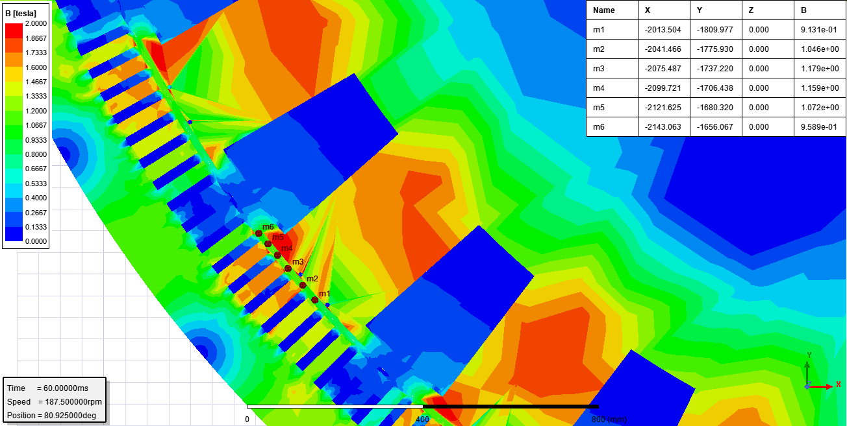

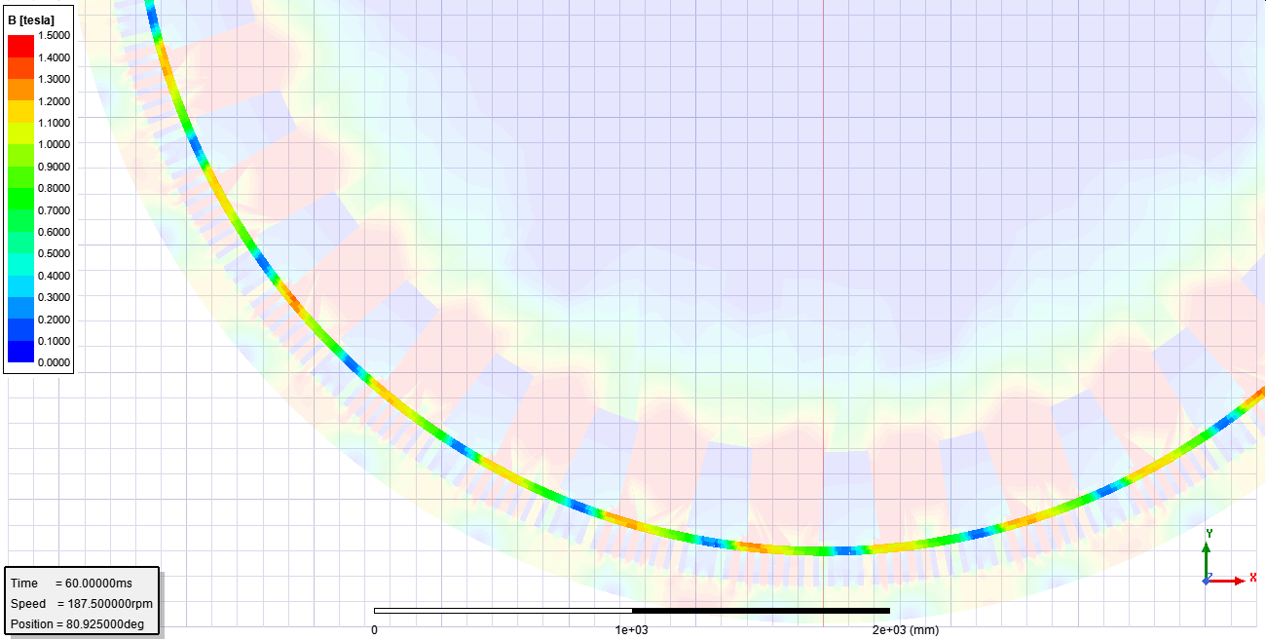

Flux density distribution in the tooths of the stator are given in Figure xx. Although the calculated peak flux density is 1.75T based on sinusoidal flux distribution, approximation of the flux density in the tooths is around 1.52T. In the figure xx, the peak flux density in the tooths is 1.65T.

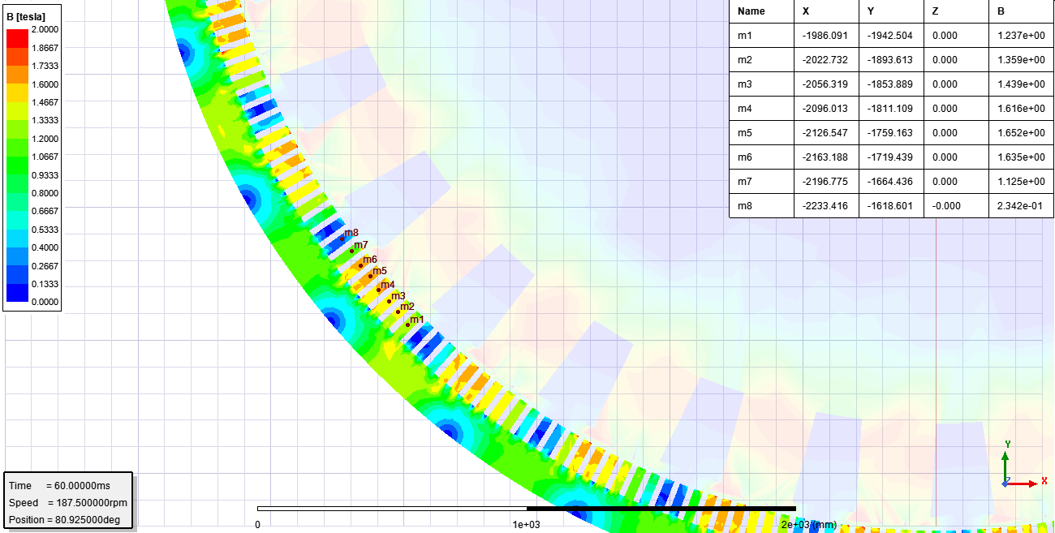

Figure xx represents the some flux density values at different points such as stator teeth, backcore iron and rotor teeth iron.

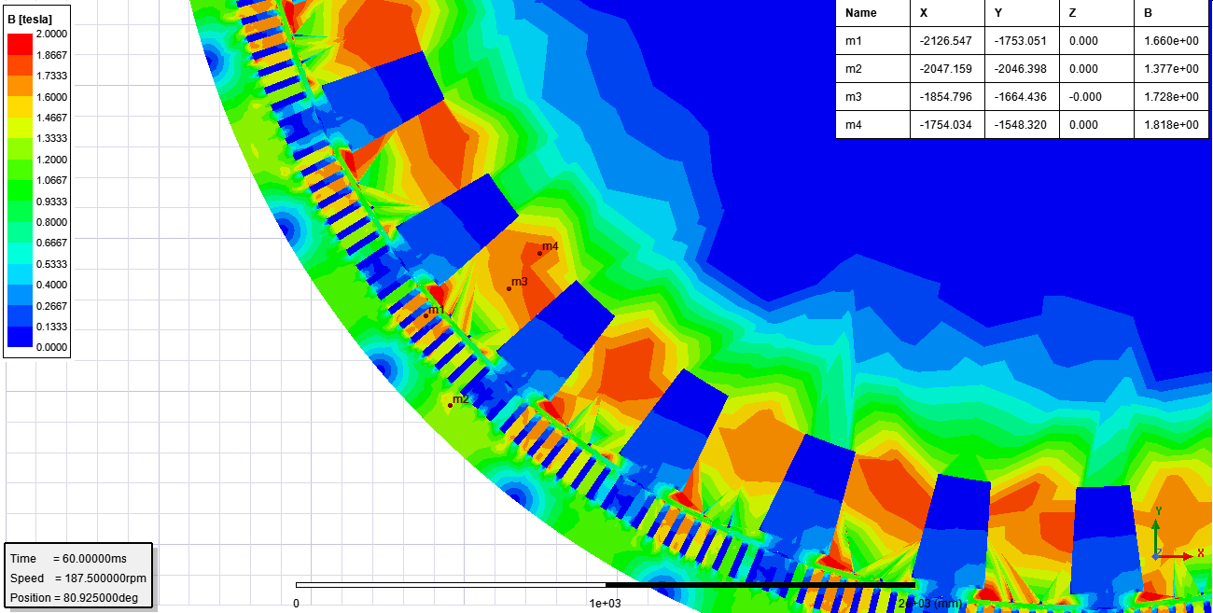

Voltage drop on phase resistance and inductance can be calculated from the induced phase voltage, current and input phase voltage. However, the seperation of voltage drops on resistance and inductance requires more information. The required knowledge could be the flux linkage of phase coils. Figure xx, Figure xx abd Figure xx shows the induced phase voltage, phase current and flux linkage of phase coils.

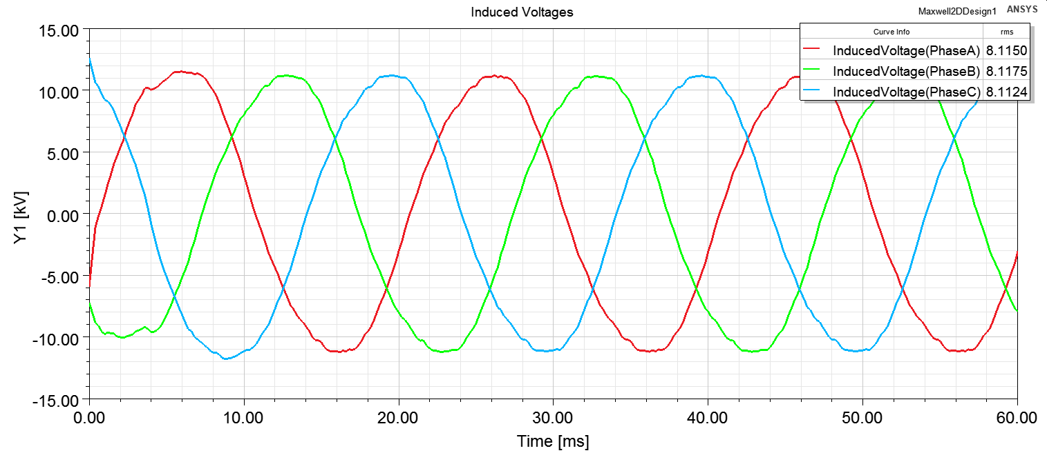

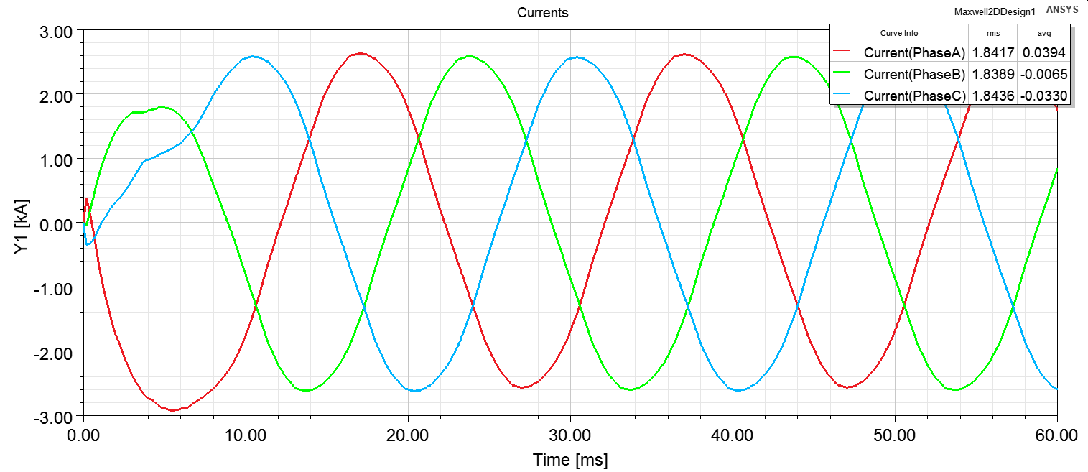

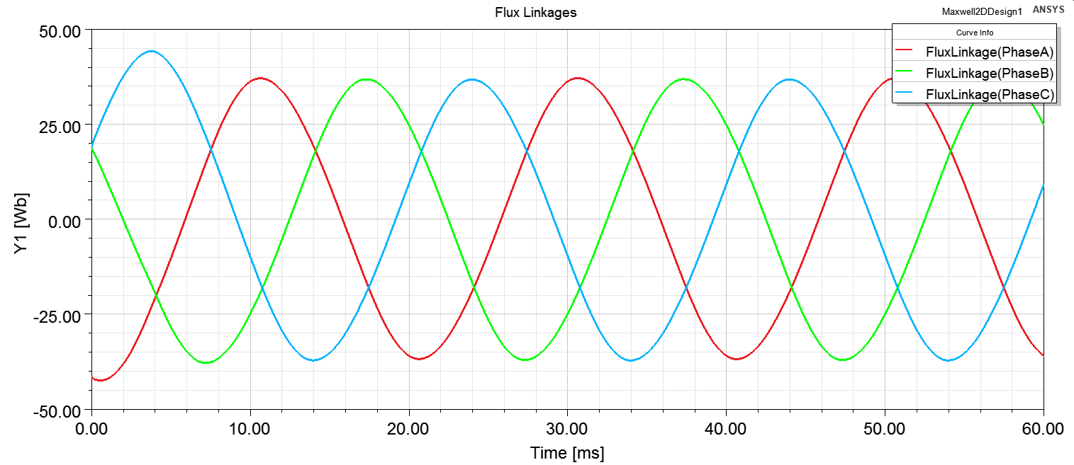

The quadrature and direct axis inductance are given in Figure xx.

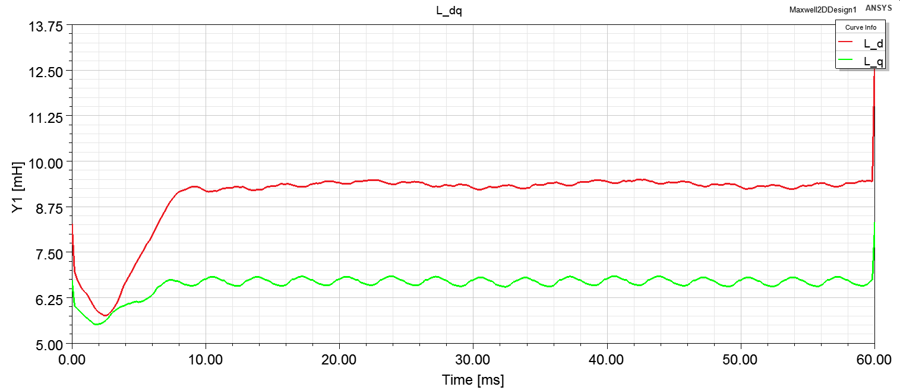

Electrical and mechanical power is given in Figure xx.

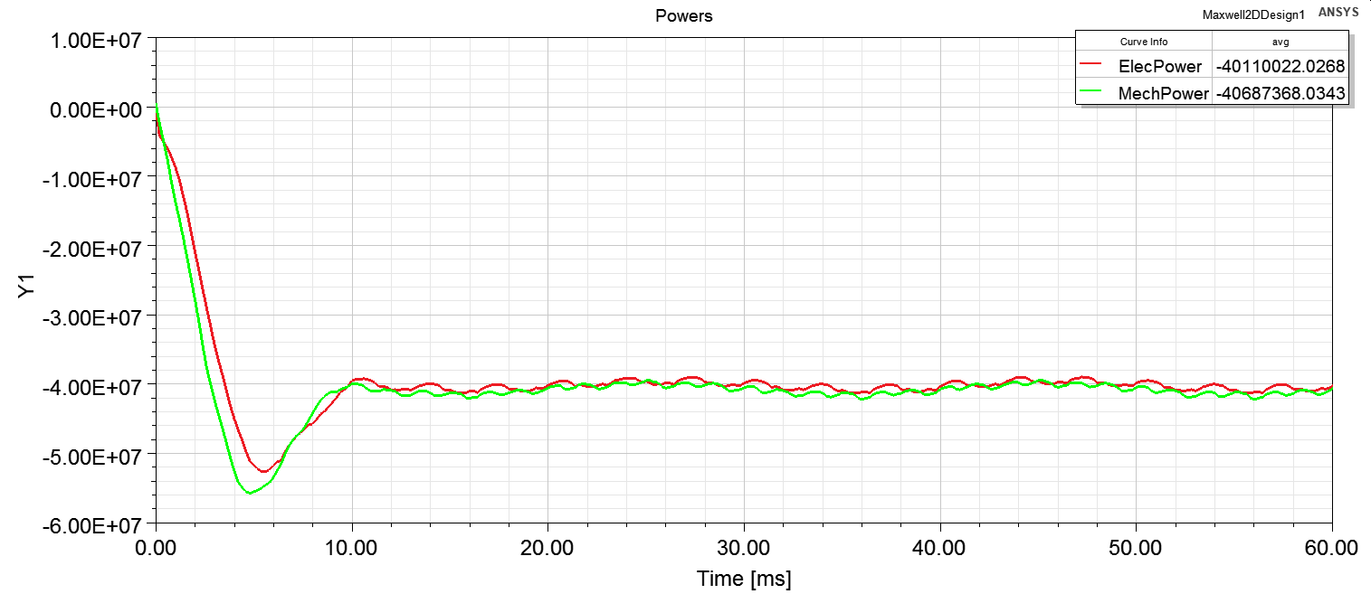

Comparison and Discussion

Designed motor seems feasible in terms of magnetic loading, electrical loading and power loss. The calculated efficiency is approximately %98. However, some main dimension can be changed to see their effects. Stator teeths and rotor teeths have slightly high magnetic flux density.

Main dimensions of the designed generator and expected changes are given in Table xx.

|  |  |  |  |
| --- | --- | --- | --- |
| Parameter | Designed M/C | Changes | Reason |
| Bore diameter | 5431 mm | 5500 mm | Decrease in magnetic loading |
| Outer diameter | 5974 mm | 6050 mm | Decrease in magnetic loading |
| Core length | 1066 mm | 1100 mm | Decrease in magnetic loading |
| Air-gap length | 16.5 mm | 18 mm | Mechanical vibrations in turbine |
| Slot number | 300 | - |  |
| Pole number | 32 | - |  |
| Desired B peak air | 1.05T | 1.0T | High B at stator and rotor teeths |
| Desired Electrical loading A | 65 kA/m | - |  |
| Armature Current density - J | 2.58 A/mm2 | - |  |
| Field Current density - J | 2.91 A/mm2 | 2.5 A/mm2 | Desire to decrease copper loss |

Flux density of in stator teeths, rotor teeths, stator back iron and air-gap is slightly reduced by decreasing magnetic loading approximately %5 and increasing core length. Although the flux density in the rotor doesn’t cause hystresis loss, the high flux density in rotor affects the rotor core material. Using rotor core material other than stator core materials in such a large machines could be reasonable because the material left after stator production is still huge to sell back someone or the material left can be still used anywhere.

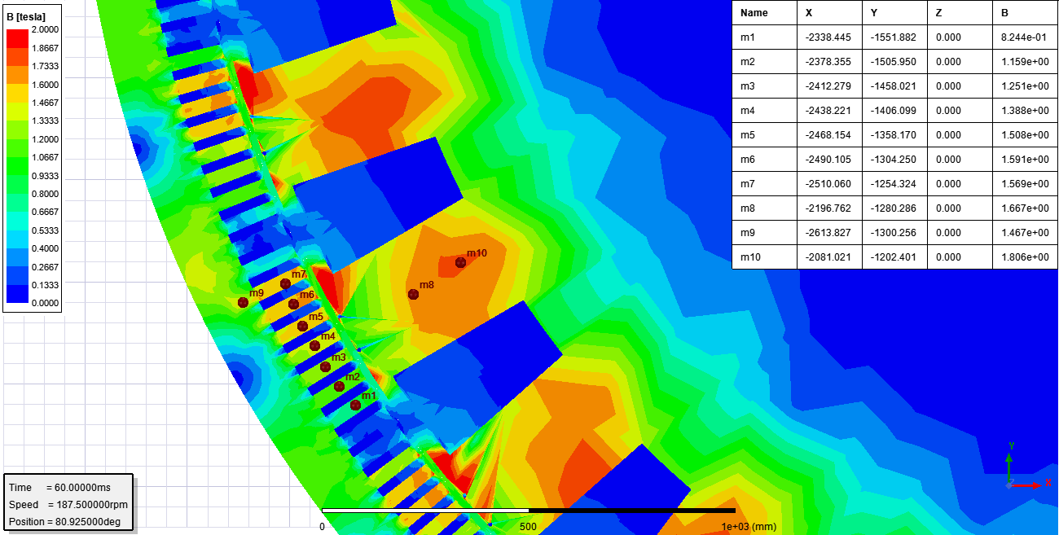

After revealing some comparison between two generators based on magnetic loading, challenges and some realizations in this project can be written. Before narrowing down the literature research, the generator design or machine design has so many parameters that cannot be fixed or determined easily. Efficiency, reliability, failures, maintenance and cost are the main branches that should be prioritized by customer and designer cooperation. Also, magnetic material and conductors requires boost in their technology to make more compact electrical machines like in power electronics. Power electronics, however, has advantage in compactness due to high frequency switching.

Secondly, the designed machine has many parameters that should be examined detailly. For example, winding of the machine has effect on end-winding length, winding factors, slot number. However, we have selected it with just considering winding factor only. Besides, mechanical issues has not been covered. Therefore, the designed machine can be sufficiently good and may be superior, but the ensuring the all issues is tough.

Final challenge is using design programs and FEA. The proper and fast simulations can be possible with such a programs. However, these programs can also be misleading if they are not known well. For example, using rmxprt design in maxwell 2d causes a power problem. The electrical power becomes 1.5 times of rated power when the analysis is done in ansys maxwell, which is caused by power angle. Power angle is somehows determined in ansys maxwell, but it doesn’t give the correct power outputs. I have struggled to solve problem with applying change of Ld,Lq by changing rotor teeth dimensions. However, I just need to change power angle from the machine command in ansys maxwell, which diminishes the phase current.

Finally, designed motor dimensions is considerably smaller than the some real machine produced in the mid of last century, 1950s. Hence, as seen in literature review, the machines produced in the last century are sized genereously by today’s standards due to insulation materials and enhancements in core materials. Approximately %98 efficiency is taken from the designed generator. The efficiency can be enhanced by slight increase in dimensions because copper area can be increased. Also, optimum point can be found for magnetic losses.