Q2-

The design of hydro-generator can be iniated with selection of electrical loading, magnetic loading and current density for armatüre windings so that main sizes of the generator such as bore diameter, outer diamater of the stator and length of the machine could be determined. The selection of former parameters which are used to select proper dimensions for machine based on the power rating are seen in table xx.

|  |  |  |
| --- | --- | --- |
| Parameter | Range | Selection |
| Electrical loading – A (kA/m) | 35 – 65 kA/m | 65 kA/m |
| Air-gap flux density – B (T) | 0.85 – 1.05 T | 1 T |
| Current density – J (A/mm2) | 2.5 – 4 A/mm2 | 3 A/mm2 |

Power rating of the machine is the related with machine constant, rotor volume and, synchronous frequency. Besides, machine constant is determined based on selected electrical and magnetic loadings. Equation xx shows the relation between power rating, machine constant and rotor volume.

|  |  |  |
| --- | --- | --- |
|  | $$S=CD^{2}l^{'}f_{syn}=44MVA$$ $$C= \frac{π^{2}}{\sqrt{2}}k_{w1}A{\hat{B}}_{δ}=405kW-s/m^{3}$$ | **Hata! Belgede belirtilen stilde metne rastlanmadı.**.1 |

Machine constant and power rating provides the total rotor volume. Length and rotor diamater, however, should be determined with aspect ratio. The aspect ratio is determined in Equation xx.

|  |  |  |
| --- | --- | --- |
|  | $$X= \frac{l^{'}}{D}=\frac{π}{4×P }\sqrt{P}≅0.2$$ | **Hata! Belgede belirtilen stilde metne rastlanmadı.**.2 |

After finding rotor diameter and length, outer diameter can be selected based on poles number, which is given in Figure xx. The determined values for rotor diamater, length and outer diameter can be seen in table xx.

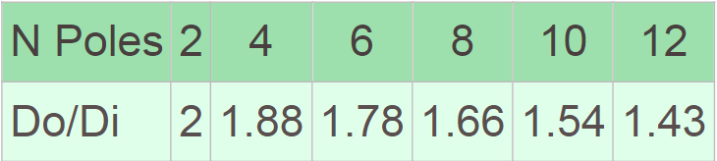

|  |  |
| --- | --- |
| Parameter | Value |
| Rotor diameter – D (m) | 5.43 m |
| Effective core length – l’ (m) | 1.06 m |
| Outer diamater – Do (m) | 5.97 m |

Air-gap is selected based on equation xx, which provides the air-gap with minimum length. Air-gap flux density and electrical loading is the origion of equation xx. Air-gap is selected as 16mm to reduce surface losses and increase safety margin for mechanical vibrations.

|  |  |  |
| --- | --- | --- |
|  | $$δ≥γτ_{p}\frac{A}{{\hat{B}}_{δ}}=13.2mm$$ | **Hata! Belgede belirtilen stilde metne rastlanmadı.**.3 |

The flux per pole is, now, calculated from selected air-gap flux density and main dimensions of the generator. Flux per pole calculation applies based on equation xx.

|  |  |  |
| --- | --- | --- |
|  | $$ϕ_{pole}={\hat{B}}_{δ}\frac{2}{π}A_{pole}$$ | **Hata! Belgede belirtilen stilde metne rastlanmadı.**.4 |

Simple equation for induced voltage shown in Equation xx is used to calculate turns per phase.

|  |  |  |
| --- | --- | --- |
|  | $$N_{ph}=\frac{E_{ph}}{\frac{2π}{\sqrt{2}}f_{e}{ϕ_{pole}k}_{w1}}$$ | **Hata! Belgede belirtilen stilde metne rastlanmadı.**.4 |

Before moving on MMF calculation, the slot and tooth width are calculated to whether tooth flux density is acceptable. The tooth width and slot width can be calculated. The slot pitch is shared on the side of tooth majorly not to saturate core. While portion of the share on the side of tooth is %60, %40 of slot pitch is taken by slot, which is done in purposely since the insulation materials are enhanced. Calculated slot width, tooth width, slot area, back-core height, tooth flux density and, back-core flux density are given in table xx.

Although the flux densities in Table xx can be seen as excessively high, these are the peak value of sinusoial flux density waveform. The flux density, however, doesn’t reach sinusoidal peak value, but the value 0.85 (cos30) times of sinusoidal peak value. Also, effective length of the core becomes more when the ducts are placed due to the carter coefficient approximation. Hence, the flux density in tooth and back core slighlty decreases. The length, bore diamater and outer diameter can be increased, which can be a good and safe solution against saturation in tooth and back-core.

|  |  |
| --- | --- |
| Parameter | Value |
| Slot pitch | 56.9 mm |
| Slot area | 2727 mm2 |
| Slot width | 22.7 mm |
| Tooth width | 34.1 mm |
| Back-core height | 146 mm |
| Tooth flux density (Peak) | 1.75 T (1.52 T – cos30°) |
| Back-core flux density | 1.92 T (1.66 T – cos30°) |

Excitation current or field current is determined based on MMF drop on air-gap since MMF drops on stator core and rotor core is neglible if cores are not saturated. MMF created by field current at no load condition is not sufficient induce rated phase voltage due to armatüre reaction. The effect of armature reaction is shown in Figure xx.

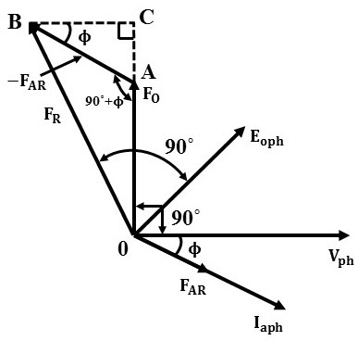

MMF created by armature is taken into account to find required field MMF. The calculation of field MMF is given in Equation xx. The calculated MMF is multiplied with 1.2 to consider leakage, holes of damper windings and possible permeability changes in cores.

|  |  |  |
| --- | --- | --- |
|  | $$ϕ_{pole}R_{airgap}=MMF_{field,no load}$$ $$MMF_{armature}=2.7I_{ph}N_{ph}k_{w1}/p$$ $$MMF_{field}={1.2N}_{f}I_{f}=\sqrt{{\left(MMF_{field,no load}+MMF_{armature}\sin{θ}\right)}^{2}+{(MMF_{armature}\cos{θ)}}^{2}}$$ | **Hata! Belgede belirtilen stilde metne rastlanmadı.**.6 |

The total MMF created by field current is known. Selection of field turn number and field current is given in table xx. Current density for field current is also selected as 3 A/mm2 and fill factor of field winding is selected as 0.5 since there is no harsh environment to increase insulation width.

|  |  |
| --- | --- |
| Parameter | Value |
| MMF of field | 26500 At |
| Turns number of field winding – Nf | 10 |
| Field current – If | 2650 A |
| Field fill factor | 0.5 |
| Field slot area | 8800 mm2 |