What I have learned from the Autralian designer articles?

* The generated electricity and capability to produce more electricity from the hydro generators is great.
* There are many hydro-generators produced 30-40 years ago may need refurbishment and uprating.
* Patent rights on winding types
  + North America – Lap winding
  + Europe – Wave winding
* Hydro-generators up to 500MVA – Indirect cooling (medium air)
* ‘Pole phase groups are always arranged with 60° phase belts’ Look for phase belt
* ‘The pre-formed term refers to the coils or bars that are fully formed and insulated before insertion into the stator core slot’
  + Preformed multi-turn coils – Only lap wound
  + Preformed single turn bars – lap or wave wound
* There are thermal ageing threshold for isolation materials
  + After thermal ageing threshold, each 10°C increase in isolation material cause diminish %50 life time of insulation material.

PART-4

* Generator half-life can be reached after 30-60 years of its operation.
* Decrease in insulation thickness as time goes by

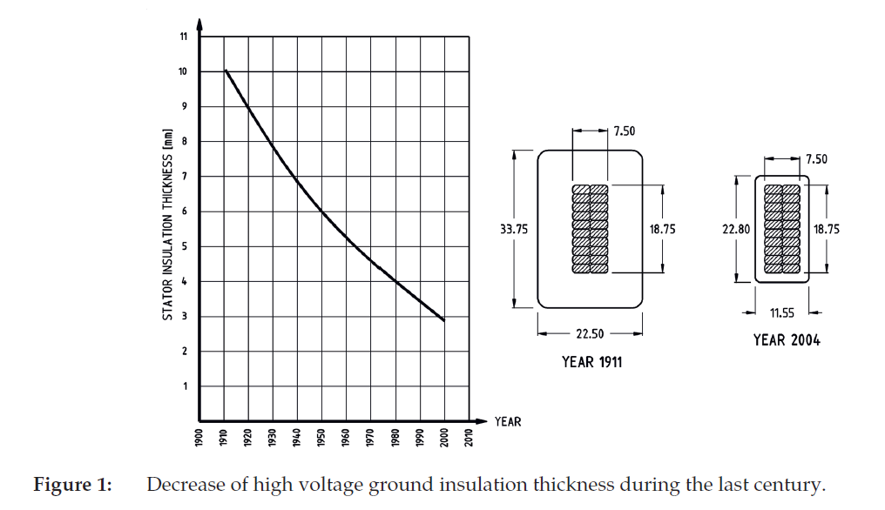

* ‘The end of a hydro generator’s useful life occurs at the end of its second half-life, and is indicated by complete failure of active electrical components, static mechanical components, as well as rotating components (rotor rim, rotor spider, etc.).’
* Hydro-generator output coefficient is given in the following eqn.

|  |  |  |
| --- | --- | --- |
|  | $$ξ={10}^{12}\frac{S_{gen}}{D_{g}^{2}L_{c}N}$$ | **Hata! Belgede belirtilen stilde metne rastlanmadı.**.1 |

where ξ is the generator output coeffi cient; Sgen is the generator output capacity (apparent power) [MVA]; Dg is the inside diameter of stator core [mm]; Lc is the gross stator core length [mm]; and N is the generator rated speed [revolutions/minute].

‘According to data presented by Glew (1998), the electrical machine output coeffi cient has increased 12 times in the last 85 years, or 4.2 times in the last 33 years. This was mainly due to advances in electrical insulations and magnetic core materials.’

* Change of insulation materials from ‘thermoplastic’ to ‘thermoset’

**IEEE Guide for the Rewind of Synchronous Generators, 50 Hz and 60 Hz, Rated 1 MVA and Above**

* Modern insulating materials
  + the thermal resistance of the groundwall is reduced because of thinner material
  + potential electrical uprate, due to the thinner material, which allows more copper to be included in the winding
  + X Disadvantage: thinner ground wall designs may result in higher partial discharge (PD) energy levels, which may reduce the winding life expectancy
* Class B and Class F selection for winding insulation
  + typical replacement winding today will have Class 155 (F) insulation that can operate continuously at higher temperature
  + Mechanical issues:
    - For example, the risk of stator core buckling should be evaluated
    - the allowable hotter stator temperature may have a negative impact on the rotor winding insulation and the stator core lamination insulation
  + Therefore, it is quite common today for a rewind specification to call for the modern Class 155 (F) insulation, but to operate within the Class 130 (B) temperature range

**What can be compared and researched for hydro-generators?**

* Losses
  + Stator core losses
  + Rotor core losses
  + Stator (Armature) copper losses
  + Stator copper eddy losses
* Insulation
  + Turn-turn isolation
  + Line-ground (Suppose groundwall) isolation
  + Strand-strand isolation
  + PD protective isolation
* Slot width – tooth width
* Core material – magnetic loading
* Electrical loading and cooling system
* Air-gap length and windage losses
* Winding design
* Mechanical considerations
  + Bearings and journals
* Surge arresters and surge capacitors