Hydro generators have been produced in MVA range scale to generate electricity from potential and kinetic energy of the rivers. Most of the produced hydro-generators in the middle of last century were sized generously by today’s standars, which generally permits significant increase in their ratings. [1] In this literatüre review, the refurbisment and upratings of the standard hydro-generators are given to narrow down the research. On the other hand, the comparison of hydro-generators and turbo generators, induction machines, differences between low power generators and high power generators could be the branches to expand research.

Literature review, although, begun with attention on performance metrics such as efficiency, reliablity, cost and, maintainance, the refurbishment and uprating of the hydro-generators are mainly based on winding design of stator, insulation materials, core materials and, new mechanical parts of machine. Therefore, winding design of the machine to reduce harmonics and end windings lengths, efficient core material replacement, utilizing better insulation materials for the sake of better reliability, better thermal management and uprating of the machine are the main topics which are discussed briefly.

Generators have been compared with a coefficient called output coefficient to realize in how efficient machine size is utilized to get maximum power. This output coefficient is calculated based on the equation xx. [1]

|  |  |  |
| --- | --- | --- |
|  | $$ξ={10}^{12}\frac{S_{gen}}{D_{g}^{2}L_{c}N}$$ | **Hata! Belgede belirtilen stilde metne rastlanmadı.**.1 |

The output coefficient of the generators increased 12 times in the last 85 years, which is mainly due to the enhancements on insulation materials and core materials. [2] New core materials allows higher magnetic loading without saturation and less core loss. On the other hand, the enhancements in insulation materials provides the machines with thinner and more durable insulation materials, which increase the fill factor and thermal performance of the machines. The comparison between old and new insulation material thickness is given in Figure xx. [1]



Figure 1 Comparison between old and new insulation materials in electrical machines [1]

Winding design is the another important aspect for refurbishment of hydro-generators. The winding factor of fundamental and harmonics, end winding length, slot number and width are the main parameters affecting the performance of winding design in electrical machines. The selection between integer and fractional slot winding design changes the winding factor and end winding length. Moreover, lap winding or wave winding has impact on end winding length and maintenance of the machine. The paper [3] discuss the optimization of end winding lengths for three phase large scale machines. The computational algorithm for different slot per phase per pole selections is constructed to optimize end-winding length. Also, bypassing some windings in fault conditions to diminish the cost of faults is discussed for reasonable and easy maintenance. Figure xx show the optimized wave winding of the

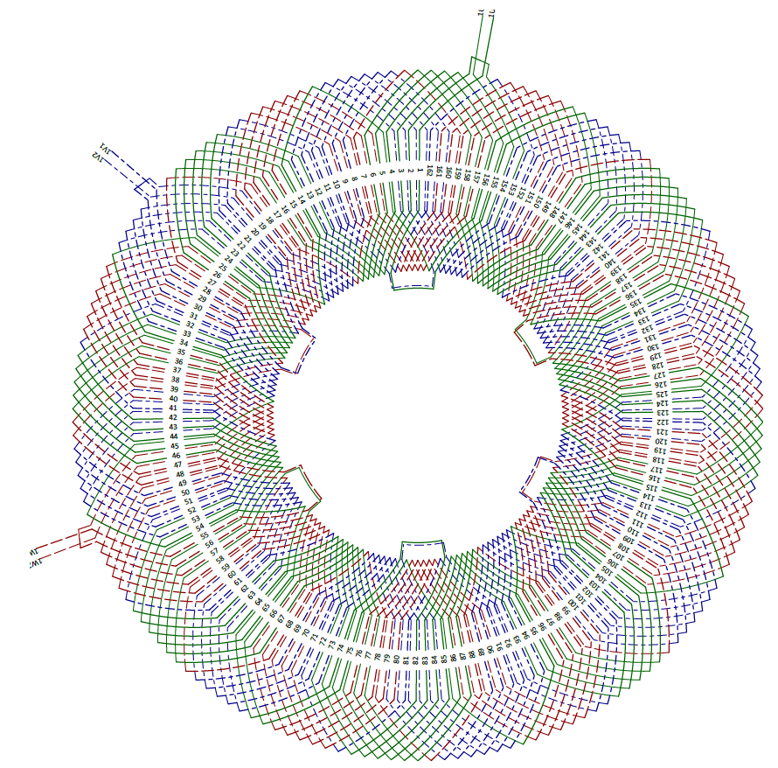

Figure 2 Optimized wave winding, 3 phase q=27/8

Other than papers, there are also some design guides. In the design guide, published by IEEE, there are some important points and observation about insulation materials. Decrease in insulation thickness provides the machine with more area for copper and better thermal performance, but PD, partial discharge, could occur more probably when comparing with old technology insulation materials. [4]

All in all, the produced hydro-generators in the last century are closing their half-life time or end-of-life. There will be many projects related with refurbishment and uprating of hydro-generators. Hence, the projects could be great advantage for researchers and engineers to use them as experimental setups to contribute literature in hydro-generators and large scale electrical generators.

[1] Znidarich, M. M. 2013, “Upgrading and uprating of hydro generators: An Australian perspective”, Australian Journal of Electrical & Electronics Engineering, Vol. 10, No. 1, pp. 75-84, <http://dx.doi.org/10.7158/E11-047.2013.10.1>.

[2] Glew, C. N. 1998, “The Next Generation – A Review of the Factors Infl uencing the Output of Electrical Machines in the New Millennium”, INSUCON/ISOTEC’98, The 8th BEAMA International Insulation Conference, Zurich, 23-24 November, pp. 231-242.

[3] G. Traxler-Samek and M. Lecker, "Three-Phase Winding Design for Large Hydro-Generators," 2020 International Conference on Electrical Machines (ICEM), 2020, pp. 2657-2663, doi:10.1109/ICEM49940.2020.9271049.

[4] IEEE Guide for the Rewind of Synchronous Generators, 50 Hz and 60 Hz, Rated 1 MVA and Above," in IEEE Std 1665-2009 , vol., no., pp.1-98, 12 Feb. 2010, doi:10.1109/IEEESTD.2009.5415857.