Arc Fault Circuit Interrupter (AFCI)

Standard

“Huawei inverters with the AFCI function meet the requirements of UL 1699B-2018 "Safety Standard for PV DC Arc Fault Circuit Protection."” [1]

The majority of PV plant fire accidents are caused by DC arcing.

Types of DC arcs:

* Series arcs (probability of series arc is around %80) (most common)
* Parallel arcs
* Arcs to ground

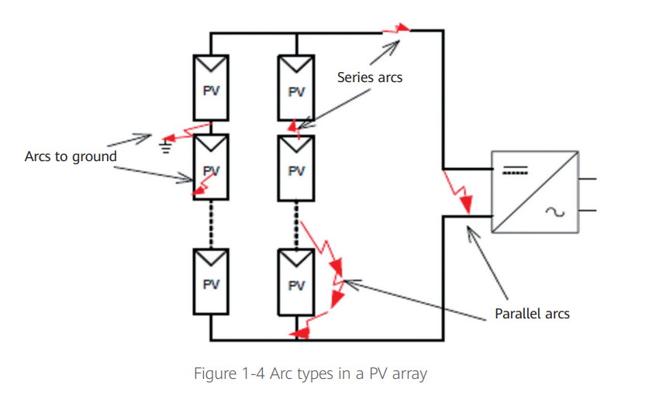

Arc approximate circuit model is seen below. It is modeled as a series connection between variable resistor and voltage source.

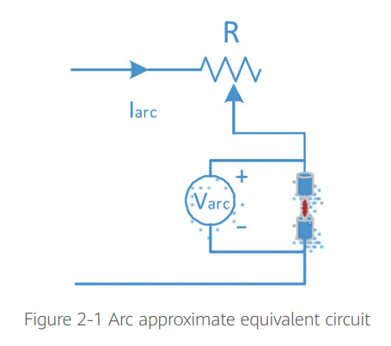

The arc model is a time-varying non-linear model. An arc signal is similar to a white noise signal and the energy of the arc signal is distributed on almost all spectrums.

My comments: The spectrum of current or voltage is analyzed. For example, DC current of string array is sampled with high sampling rate ADCs. Then, sampled/digitized signal is processed with FFT analysis. The arc is nonlinear element. Behaviour of the arc could be different. For example, kind of arc type could be modelled with some combination of series/parallel connection of inductors, capacitors and resistor. However, the conditions of ambient, cable etc could change the characteristic of arc.

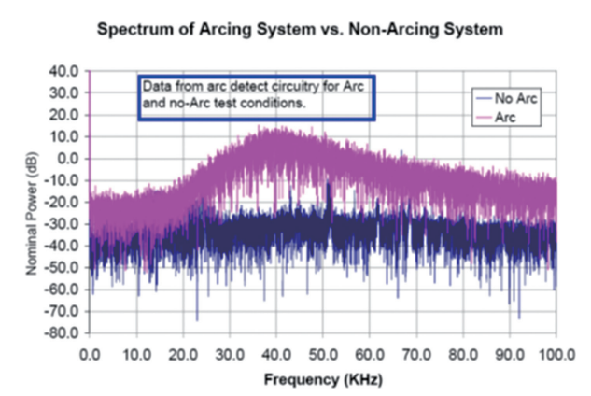

Figure Ref [2]

Huawei Solution

Huawei is proposed an solution for the arc detection problem with AI based enhancements. Neural network is used to learning arc signals. The many labeled arc signals are used to detect arc signals in real time.

[1] Arc Fault Circuit Interrupter (AFCI) for PV Systems, Technical White Paper, Joint release by China General Certification Center (CGC) and Huawei. <https://solar.huawei.com/la/news/la/2020/10/Technical-White-Paper-Arc-Fault-Circuit-Interrupter-for-PV-Systems>

[2] Implementing Arc Detection in Solar Applications: Achieving Compliance with the new UL 1699B Standard, Texas Instruments <https://www.ti.com/lit/wp/spry209/spry209.pdf?ts=1684414758584&ref_url=https%253A%252F%252Fwww.ti.com%252Fproduct%252FTMS320F2800137>