# Start Voltage

This voltage is the minimum voltage on DC-input of the inverter for operation. Start voltage may affect the operation time of the inverter during a day. (Grid-connection) The voltage generated by the string could be too low due to lack of irradiance early in the morning. [1] This could be seen also from the table below. [2] As seen on the Table, the voltage output and light intensity is related at low irradiance level. After 200W/m2 radiance, output voltage is almost the same.

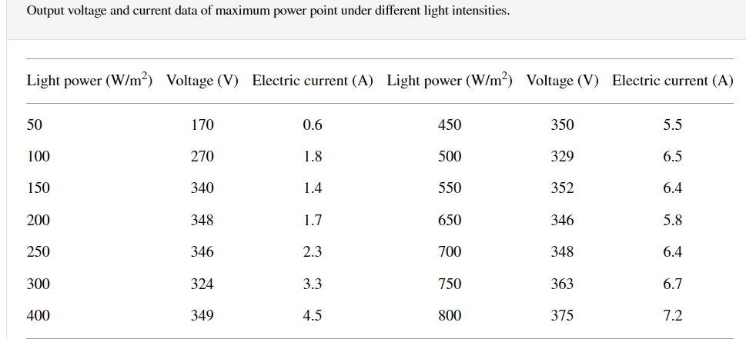

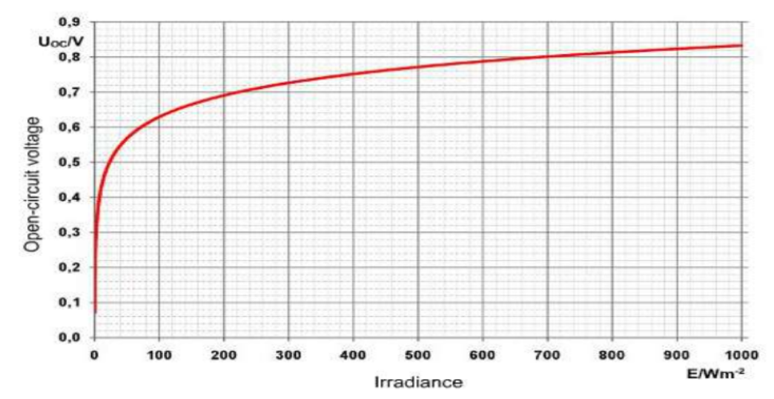

Figure 1 Ref [4]

## Starting Voltage and Minimum Operating Voltage

Generally, solar inverters have higher start voltage than min operating voltage. Why? The reason is that open circuit voltage of solar cells is greater than the MPP voltage. If the start voltage and min operating voltage was defined as the same the inverter could stop and start operation in many times for the case which solar panel oc voltage is around min operating voltage. [3]

[1] <https://www.saurenergy.com/solar-energy-news/solis-seminar-inverter-starts-up-late-find-possible-causes-troubleshoot-problem#:~:text=For%20example%2C%20the%20startup%20voltage,to%20work%20at%20different%20times>.

[2] Li, Zhe, Jian Yang, and Pouya Asareh Nejad Dezfuli. “Study on the Influence of Light Intensity on the Performance of Solar Cell.” Edited by Hafiz Muhammad Ali. International Journal of Photoenergy 2021 (February 1, 2021): 6648739. <https://doi.org/10.1155/2021/6648739>.

[3] Why is the starting voltage of the inverter higher than the minimum voltage? <http://www.xingdunpower.com/displaynews.html?id=3339424436405056&mdId=com_456>

[4] Mirzaev, Uchkun & Abdullaev, Elnur. (2020). Experiment of Open-circuit Voltage in -EPH 2 Advanced Photovoltaics Trainer‖ Laboratory and Types of PV Cell. 4. 41-46.

# Cooling

Cooling type varies on power level