Tutorial

Basic wander behaviour

In this tutorial you will create a simple wander behaviour using the unity interface.

Step 1 Download and install Unity3D.

This can be found at the Unity3D website for free. Premium accounts can be bought that include more features inside the game engine but it is not needed for this project.

Step 2 Download mono and the interface.

Mono can be downloaded from its website

The interface can be accessed from my website, will be posted later when I get it setup.

Step 3 Open the project.

I have provided you with a basic project to show you how to start using the interface. The interface should be inside the same folder as the project. This project provides the basic skeleton code that gives the user some basic idea how it should work. But you will have to write a little code yourself. When you open it up in Unity it should look like the following

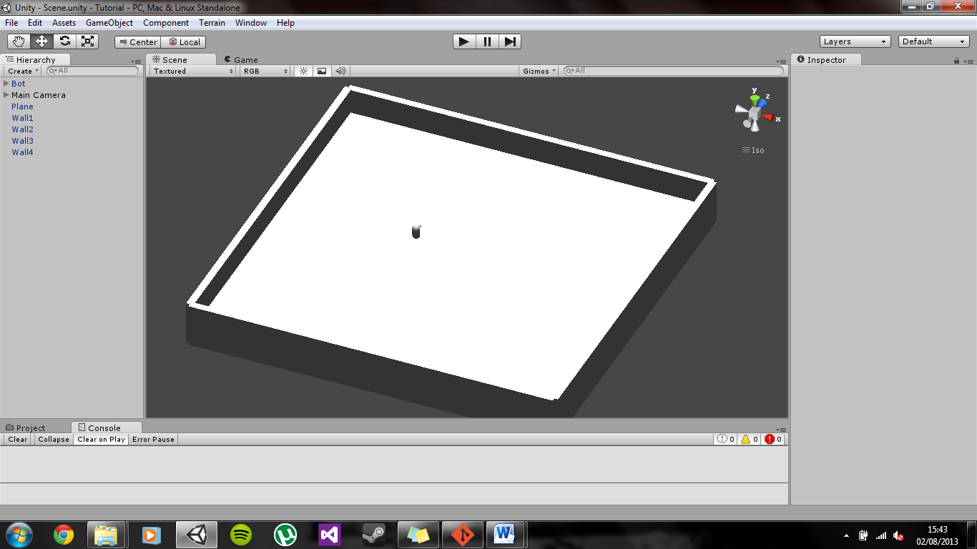

Leave this for now, we will come back to it soon.

Step 4 Start server

To start the server you need to open the mono command line. It should look something like this.

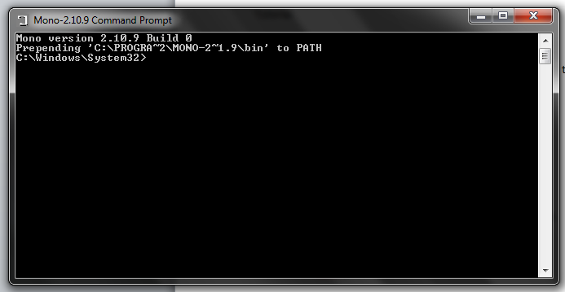

In the command line, change to the correct directory. Use the “cd” command. For me the command is.



When you are in the correct directory you need to start the server. To start the server you need to run the “xsp” command. Once this command has run you should see the following.

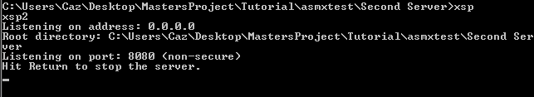

Step 5 Wdsl the file

Now we need to generate the C# code to allow the Unity gameobject to access the server.

Leave the server up just now. Open up a second mono command line.

Change directory again to the correct folder.

Now run the following command

wsdl -out:MyService.cs <http://localhost:8080/MyService.asmx?wsdl>

This generates the a C# file called MyService.cs. This file contains all the code that will allow the gameobject in unity to connect to the server.

Step 6 Transfer the wdsl generated file

Now we go back to unity. You can close the mono command line that you used to generate the C# file. Now you need to move the MyService.cs file into the assets folder in unity.

Step 7 Write a script to call the server during runtime.

Open up the file called ClientObject within the WebClient folder in the assets. Here you will find some basic code that I have written.

Find the Update section and copy the following code into the function.

*float randomDir = service.Rand(r,10,-10);*

*Vector3 direction = new Vector3(transform.rotation.x,transform.rotation.y,transform.rotation.z);*

*transform.Rotate(new Vector3(0,direction.y + randomDir,0));*

*transform.Translate(Vector3.forward \* (Time.deltaTime\* speed));*

This basically calls the interface and calls the Rand function with the paramenters 10 and -10. This serves as the range you want the bot to rotate. Play about with it as you please. Next I get all the rotations of the bot, then I add the amount to rotate to it. Lastly the bot moves forward at all time, therefore it must translate forward. If you multiply speed by the time it gives a smoother result.

Step 7 Play about with it.

It doesn’t do everything, therefore it is up to you to edit it and add new features.