Acceptance Test Case Executions With Screen Shots

TESTCASE 1

Initial input file

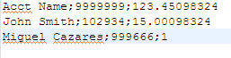
Sorts account in increasing ID order
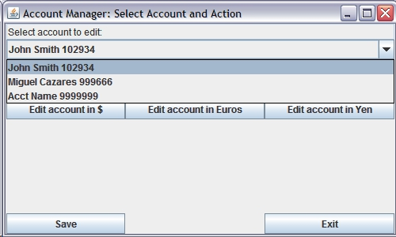
Rounds input number to two decimal places
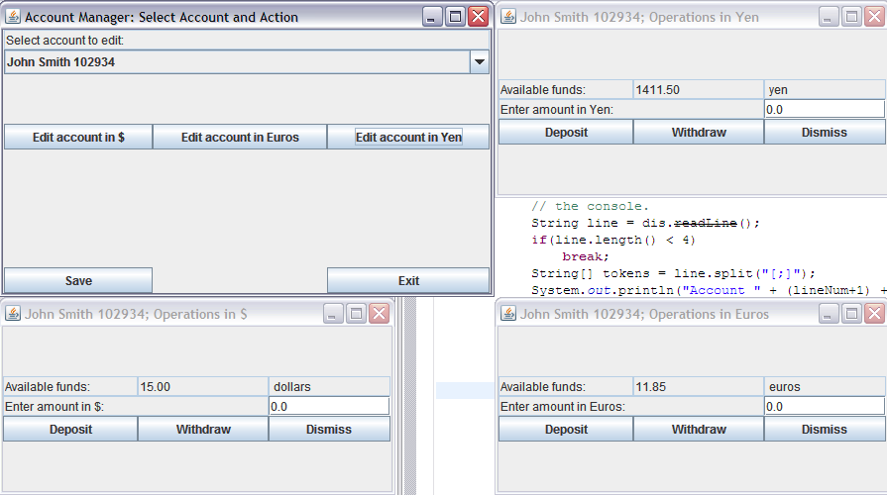
Generates pop up window for negative deposit
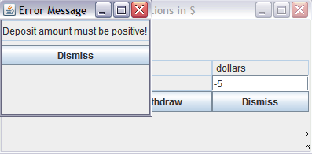
Generates pop up window for negative withdraw
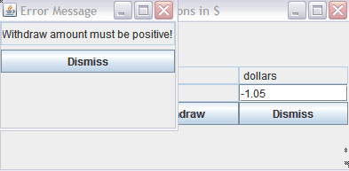
On pressing exit, windows close, no modification made, so no save, just exit

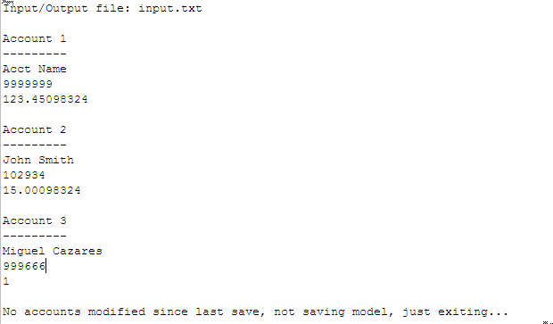
TESTCASE 2

Deposit 5 dollars
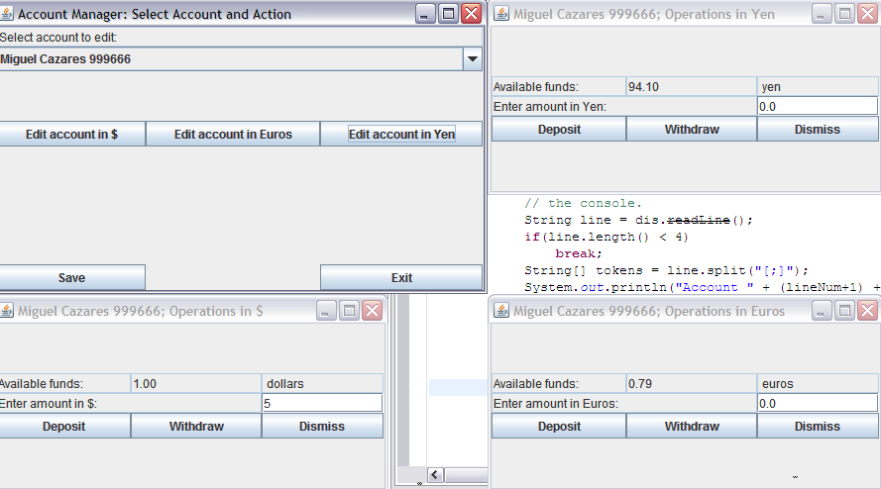
Result of depositing 5 dollars

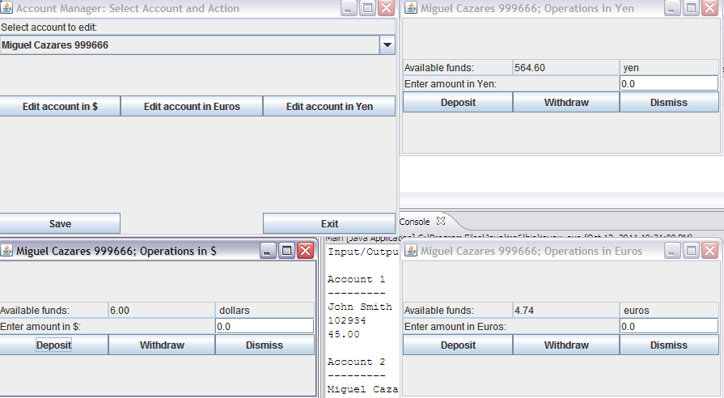

Attempt to withdraw more than available
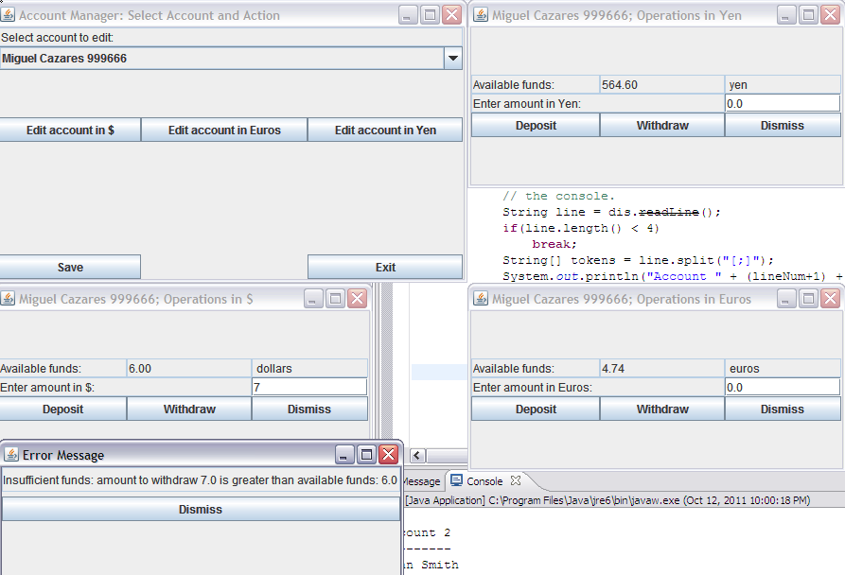

TESTCASE 3

Deposit amounts into all accounts
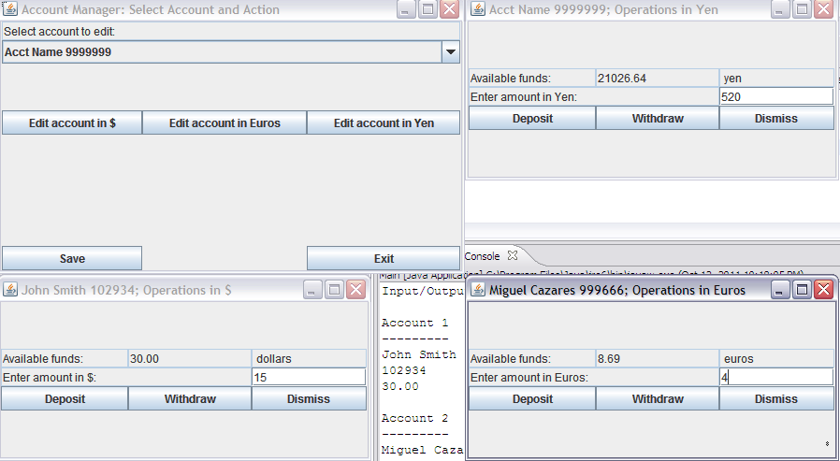

Result of deposits
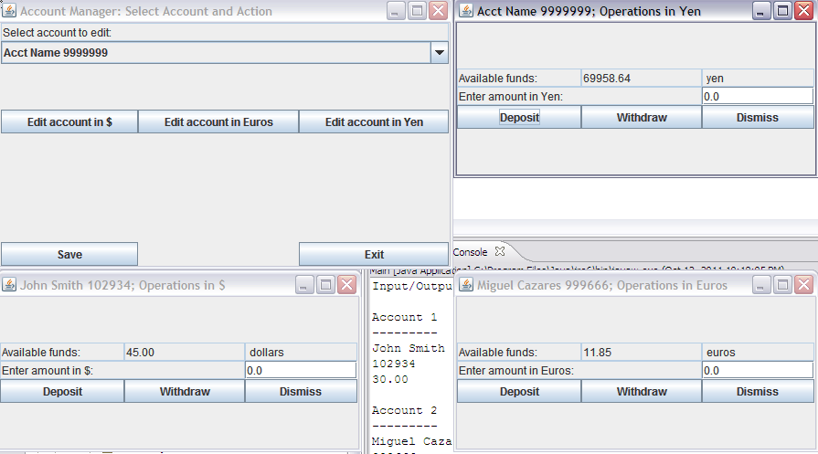
Console output after exiting with “exit” button
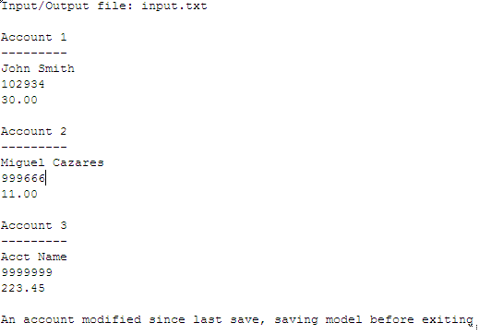
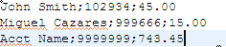
Input file at end of test case (ioFile)

