- What was the biggest bank at the end of 2009?
Citibank (South Dakota), N.A.

- What trends do you observe in net charge offs over time?
The mean and standard deviation increase overtime and it seems to exist a seasonal component, which boost net charge offs at the end of the year. Also it is noteworthy to mention the existence of extreme outliers in the upside.
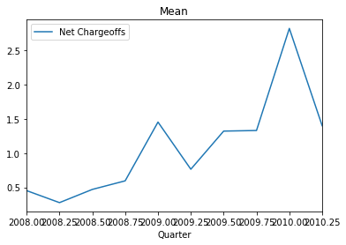
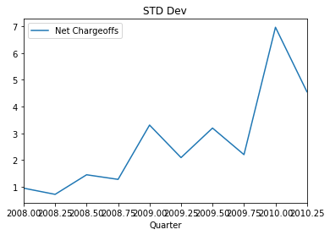
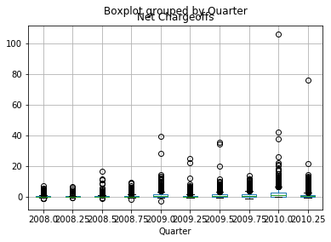

- Is there a correlation between level of profitability of a bank’s investments in securities (here measured by fair value of investments over cost basis) and bank failure?
Judging from the different histograms for banks that failed and did not fail, there does not seem to be a correlation.
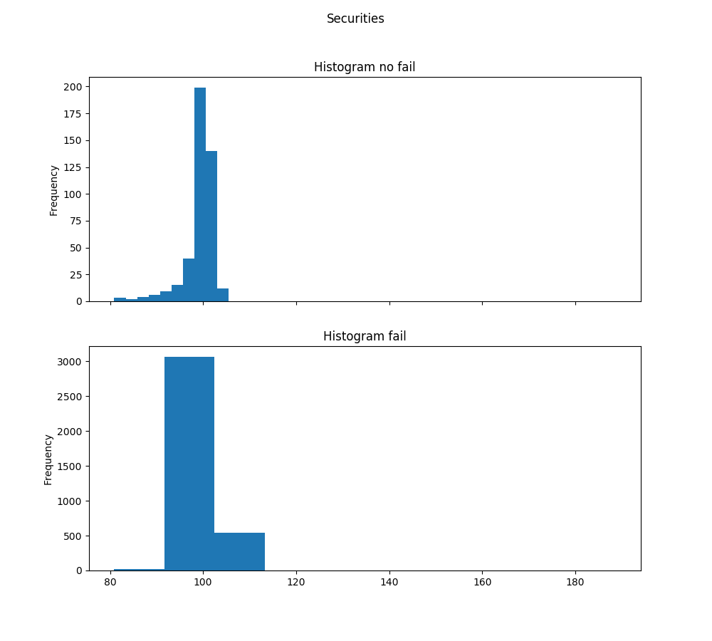
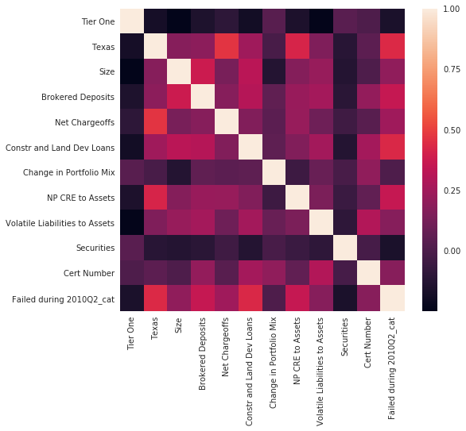
This is backed by the correlation heatmap

- What are the top two predictors of bank failure?

- Which banks are most likely to fail in the near future (and why)?

