**HARSH GUPTA  
Task 1:**

Scan Your Local Network for Open Ports Objective: Learn to discover open ports on devices in your local network to understand network exposure.

**Tools**: Nmap (free), Wireshark (optional)

Nmap is a tool used for network mapping.

Which already comes pre installed in kali linux package.

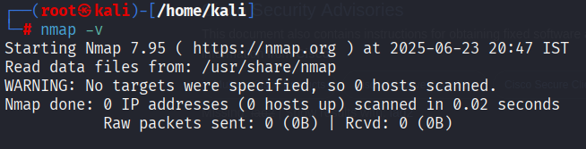

Now in order to know my virtual machine ip I have to run the command “ifconfig” to know my ip address

Here my ip address is 192.168.26.130 so I will nmap scan 192.168.26.0/24 to look for all open ports on my network using -sS (Stealth Scan)

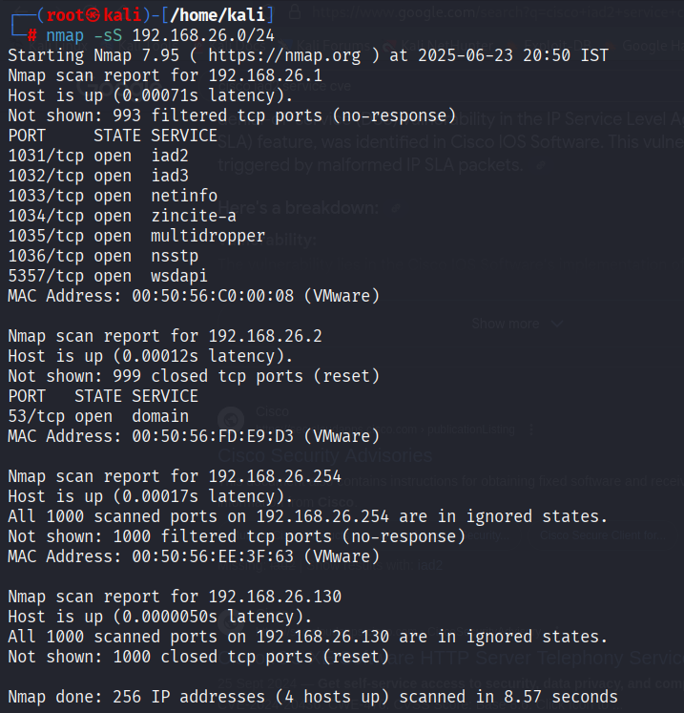

After the scan result we get all the open ports and on further researching on browser iad2 is an cisco service which has an cve and can easily be exploited using an DOS attack which stands for Denial Of Service.  
The same process can be repeated for all the open ports services in order to make sure that it is exploitable or not.