Business Objective
Hubble is aimed to make Chargebee an extensible platform with deep possible integrations. Hubble is envisioned to provide set of self serve to enable internal or external developers faster. ## Guiding Principles ## * We will actively discourage the word integrations. Integration becomes an implementation and needlessly decreases the business efficiency by adding technical debt in the system. Eg-We will not say we are integrating with RevLock, we will say we are enhancing with Revenue Recognition Capability. This identifies and promotes the true problem to be solve for. * Any business enablement we will think in terms of composition of capabilities. * Any capabilitiy we will define in terms of Open Interfaces. This promotes bounded context. This also demands clean and simpler interfaces. Clean interface is one which does not reveal the implementation detail thus discouraging accidental complexity seepint into the system. * Capabilities that can be extensible are expressable and readable by machine. This is needed to automate * Capabilities expressed hides the implementation details. There can be multiple implementation for the same capability * We measure inconvenience in terms of our in adaptability to change or too many changes because of underlying implementation. Higher the inconvenience further we are from the goal! * Capability Interfaces are most of the time backward compatible, are versioned and promotes selectivity
* We will use the above principles for evaluation Commercial Off the Shelf (COTS) as well.

Overall Context
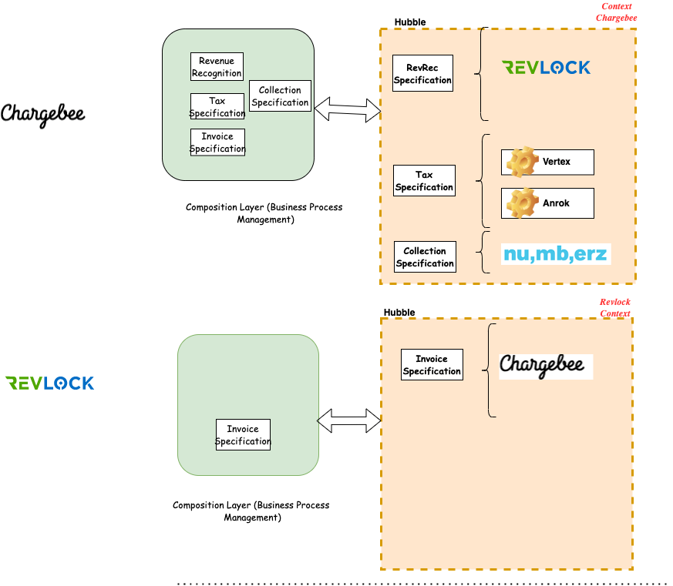
image

Usecases

Key Architecture Decisions
- Solution will be built with multi tenant and multi organization hosting goal
- Solution will be built using contract first approach to facilitate clear separation between components

System Diagram

Components

List of Proof Of Concept

Plan Of Attack - RoadMap

