Start screen: you can press story button or flash card button.

Story button goes to world selection screen. Flash card button goes to flashcard set selection screen.

World selection screen: You can select a world. This will then go to level selection screen.

Level selection screen: You can select levels or go back to the world selection screen or start screen.

After selecting a level, you will play same game modes.

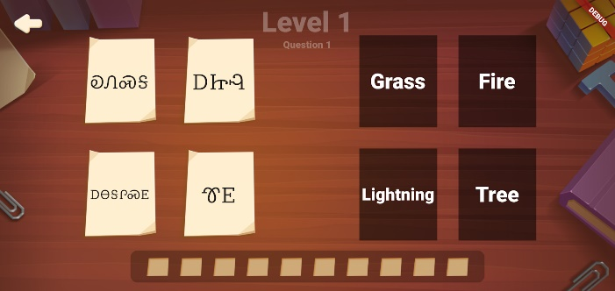

On mix and match game mode, you can drag Cherokee terms to English definition.

On question answer, you can select an answer option.

Flashcard set selection screen: you can create or view flashcard sets.

Flashcard grid view screen: you can view, edit, or add flashcards to the selected flashcard set.

Flashcard viewing screen: you can swipe to go to the next card, tap the card to flip the card.