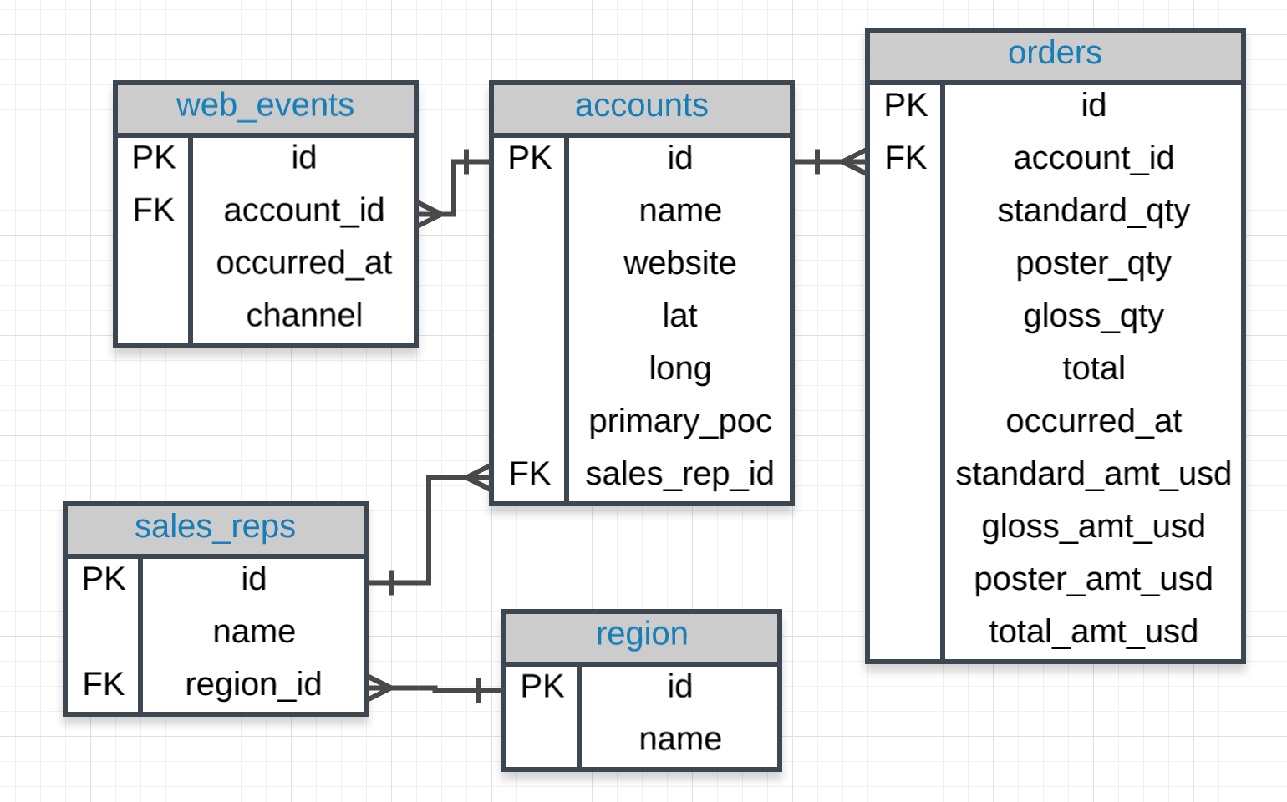

1. Provide a table that provides the **region** for each **sales_rep** along with their associated **accounts**. This time only for the Midwest region. Your final table should include three columns: the region **name**, the sales rep **name**, and the account **name**. Sort the accounts alphabetically (A-Z) according to account name.
2. Provide a table that provides the **region** for each **sales_rep** along with their associated **accounts**. This time only for accounts where the sales rep has a first name starting with S and in the Midwestregion. Your final table should include three columns: the region **name**, the sales rep **name**, and the account **name**. Sort the accounts alphabetically (A-Z) according to account name.
3. Provide a table that provides the **region** for each **sales_rep** along with their associated **accounts**. This time only for accounts where the sales rep has a **last** name starting with K and in the Midwestregion. Your final table should include three columns: the region **name**, the sales rep **name**, and the account **name**. Sort the accounts alphabetically (A-Z) according to account name.
4. Provide the **name** for each region for every **order**, as well as the account **name** and the **unit price**they paid (total_amt_usd/total) for the order. However, you should only provide the results if the **standard order quantity** exceeds 100. Your final table should have 3 columns: **region name**, **account name**, and **unit price**. In order to avoid a division by zero error, adding .01 to the denominator here is helpful total_amt_usd/(total+0.01).
5. Provide the **name** for each region for every **order**, as well as the account **name** and the **unit price**they paid (total_amt_usd/total) for the order. However, you should only provide the results if the **standard order quantity** exceeds 100 and the **poster order quantity** exceeds 50. Your final table should have 3 columns: **region name**, **account name**, and **unit price**. Sort for the smallest **unit price** first. In order to avoid a division by zero error, adding .01 to the denominator here is helpful (total_amt_usd/(total+0.01).
6. Provide the **name** for each region for every **order**, as well as the account **name** and the **unit price**they paid (total_amt_usd/total) for the order. However, you should only provide the results if the **standard order quantity** exceeds 100 and the **poster order quantity** exceeds 50. Your final table should have 3 columns: **region name**, **account name**, and **unit price**. Sort for the largest **unit price**first. In order to avoid a division by zero error, adding .01 to the denominator here is helpful (total_amt_usd/(total+0.01).
7. What are the different **channel**s used by **account id** 1001? Your final table should have only 2 columns: **account name** and the different **channel**s. You can try **SELECT DISTINCT** to narrow down the results to only the unique values.
8. Find all the orders that occurred in 2015. Your final table should have 4 columns: **occurred_at**, **account name**, **order total**, and **order total_amt_usd**.

/* First Request

*/

SELECT

r.name region_name

,sr.name sales_rep_name

,a.name account_name

FROM

region r

JOIN

sales_reps sr

ON

sr.region_id = r.id

JOIN

accounts a

ON

a.sales_rep_id = sr.id

WHERE

r.name = 'Midwest'

ORDER BY

a.name;

/* Second Request

*/

SELECT

r.name region_name

,sr.name sales_rep_name

,a.name account_name

FROM

region r

JOIN

sales_reps sr

ON

sr.region_id = r.id

JOIN

accounts a

ON

a.sales_rep_id = sr.id

WHERE

r.name = 'Midwest'

AND sr.name LIKE 'S%'

ORDER BY

a.name;

/* Third Request

*/

SELECT

r.name region_name

,sr.name sales_rep_name

,a.name account_name

FROM

region r

JOIN

sales_reps sr

ON

sr.region_id = r.id

JOIN

accounts a

ON

a.sales_rep_id = sr.id

WHERE

r.name = 'Midwest'

AND name LIKE '% K%'

ORDER BY

a.name;

/* Fourth Request

*/

SELECT

r.name region_name

,a.name account_name

,total/(total_amt_usd+.01) unit_price

FROM

region r

JOIN

sales_reps sr

ON

sr.region_id = r.id

JOIN

accounts a

ON

a.sales_rep_id = sr.id

JOIN

orders o

ON

o.account_id = a.id

WHERE

standard_qty > 100;

/* Fifth Request

*/

SELECT

r.name region_name

,a.name account_name

,total/(total_amt_usd+.01) unit_price

FROM

region r

JOIN

sales_reps sr

ON

sr.region_id = r.id

JOIN

accounts a

ON

a.sales_rep_id = sr.id

JOIN

orders o

ON

o.account_id = a.id

WHERE

standard_qty > 100

AND poster_qty > 50

ORDER BY

total/(total_amt_usd+.01) asc;

/* Sixth Request

*/

SELECT

r.name region_name

,a.name account_name

,total/(total_amt_usd+.01) unit_price

FROM

region r

JOIN

sales_reps sr

ON

sr.region_id = r.id

JOIN

accounts a

ON

a.sales_rep_id = sr.id

JOIN

orders o

ON

o.account_id = a.id

WHERE

standard_qty > 100

AND poster_qty > 50

ORDER BY

total/(total_amt_usd+.01) desc;

/* Seventh Request*/

SELECT DISTINCT

a.name account_name

,we.channel

FROM

accounts a

JOIN

web_events we

ON

we.account_id = a.id

WHERE

a.id = 1001;

/* Eight Request */

SELECT

a.name account_name

,o.occurred_at

,o.total as "order total"

,o.total_amt_usd

FROM

accounts a

JOIN

orders o

ON

o.account_id = a.id

WHERE

extract(year from o.occurred_at) = 2015;