DATA STRUCTURES FOR OPTIMAL TRANSPORT NETWORK OPERATIONS

Prerequisites

In order to represent in a consistent, robust way a transport network, we have to well define node and link data structures, respectively. The aforementioned data structures should be equal in terms of data representation and expression and one should be able to fully convert its network, without losses, from one form to the other.

An important aspect of our data structures is the way the data are represented. Except for the data storage, it is important to have a representation which permits a set of operations on network's data in a straightforward way. Ideally, this representation should not have big costs in terms of computational complexity. In a transport network we are especially interested in the operations of
(a) inserting a node in the network
(b) deleting a node from the network
(c) traversing the network with a variety of ways (for example, one may be interested in finding the shortest path from a city to another. She could also be interested in the 4-best paths from a city to another, in terms of distance and cost).

Furthermore, we are interested in representing, containing and processing an increasingly amount of information about the transport networks. Thus, the required data structures should be able to contain future needs and information which is not existent the very moment the structures are being created. For example, a node could initially represent a railway station, but after a few months, the user needs to explicitly declare that in this very point, there is a bus station too. To get things worse, another user wants to add information to the specific point about the city which is found, which is a big city of 200000 people. All this information should be added and manipulated without adding data complexity or affecting the network in global, strange ways.

Hence, the following prerequisites should be met:
- robust representation without losses
- ability to convert from one structure to the other
- flexibility (in terms of future data insertions)
- robustness (in terms of network consistency)

Data Structure

With the prerequisites described above in mind, we present two data structures, a node-based and a link-based one.

Node:
The node should be a data structure containing:
- a list of the links (just ids) which are connected to it.
- a data structure Position which holds the position of the node. It currently contains its x and y dimension, with an optional z dimension too, but it could further be expanded.
- a variable importance that indicates the importance of the node (it could be either computed on-the-fly or set with a predefined value)
- a variable type which indicates the type of the node (sea, land, air, etc) and its value is set through a predefined set of values.
- a dictionary of Properties consisting of <key:value> pairs that attach some additional information to the node. For example, we could have pairs of <city:Athens>, <population: 50000> etc.

Example: This works as demonstrated in the following example.
Let us imagine 3 nodes as follow:
Node ID: 34563 Properties: <city:Athens> <population:5000000> <station:railway>
Node ID 654332 Properties: <city:Thessaloniki> <population:1000000> <station:railway, bus> <has_sandwich:true>
Node ID 456532 Properties: <city:Larissa> <population:200000> <station:bus> <has_sandwich:false>

Now let us say the user needs a railway route between Athens and Thessaloniki. With the data structure described above, an iterator iterates through properties and extracts the cities required, with the additional info of a railway station existence. Athens and Thessaloniki come up (as in this example, Larissa does not have a railway station).
If the user then wants all the cities with a bus station, and a good sandwich to eat, then only Thessaloniki comes up. Note the following:
Larissa has a bus station, but the has_sandwich field is false.
Athens has no "has_sandwich" field. It is not a problem though because the non-existence of a field equals a false return in our approach.

Link:

In addition to the node data structure, a link-based data structure is presented too.

The link data structure has the following fields:
- from variable (nodeID)
- to variable (nodeID)
- boolean variable bidirectional
- well defined set type (sea, air, land)
- int cost
- int importance
- data structure Properties which functions in the same way as the node's Properties data structure works.

In order to further explain our data structures, the Position and Properties data structures are presented:

- Data Structure Position: <int x, int y, int z>
That's pretty straightforward, but we have it as a data structure because of a future expansion.
- Properties:
This is a dictionary which contain unique keys connected with one or more values. If more values correspond to a unique key, then the values are added to a list.
Hence, we could imagine it as a dictionary of lists.

Below, uml diagrams are presented:

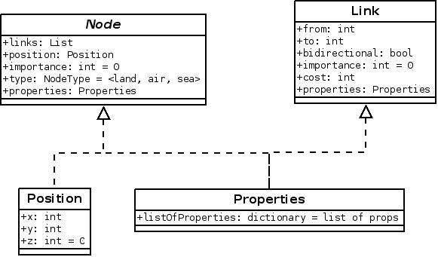

Below, the flow chart of the operations and the interactions between the data structures and the database, as well as the main program, are exhibited respectively.

