We look at data provided by Robeco’s Pim van Vliet and Jan de Koning on their private research website[1]. The data set covers the US stock market and extends back to the year 1929, offering great insights into more than 90 years of low-volatility investing.

Figure 1 below shows the performance of the ten decile portfolios created by sorting the largest 1000 stocks on the NYSE, AMEX and NASDAQ, according to their historical 36-month volatility. The positions are rebalanced quarterly and weighted equally within in each decile portfolio (weight of 1% per stock).

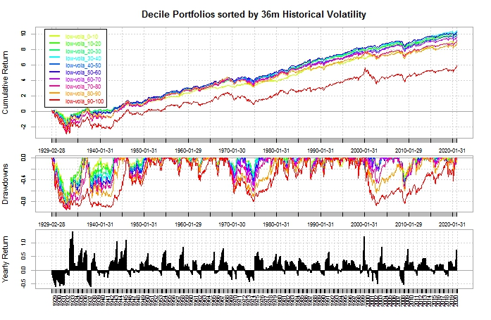

<https://www.paradoxinvesting.com/data/>

1. Data available on https://www.paradoxinvesting.com/data/