Report

Caleb Badour

Team members:

Floyd, Xavier Sterling.

Scott, TJ

Ellington, Zach

Instructions:

To run program:

1. run IndexBuilderTest.
2. Enter absolute corpus directory
3. Choose from the 4 options
4. Enter 4 to exit

Corpus directory

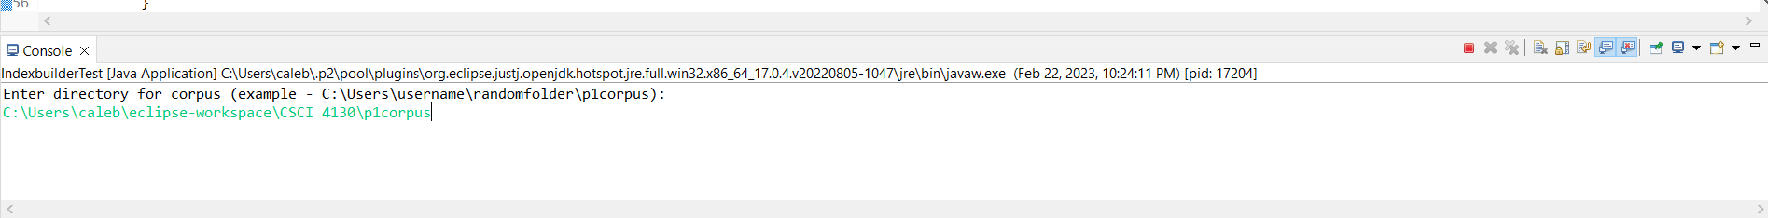

Word search

Intersecting Algorithim

Print inverted index

